- INTRODUCTION
radiation PARTITIONING WITH THE LUMPS MODEL IN MURRAY

Adair Kovac
University of Utah

J1.4

The LUMPS model partitions all-wave radiation into fluxes of storage, sensible, and latent heat in urban environments. It combines a modified Priestley-Taylor partition of latent and sensible heat flux with the Objective Hysteresis Model (OHM) estimation of stored energy. A number of studies have examined the LUMPS model or parts of it in various settings.
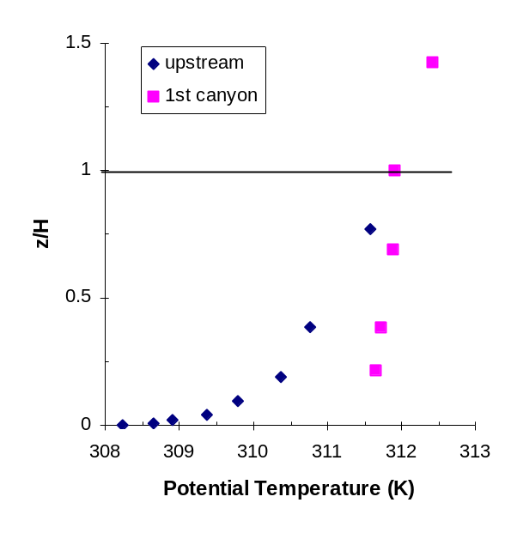
Fig. 1: Ten minute averages of potential temperature profiles upstream and within the first canyon at 19:50 Local Daylight time (LDT) during MUST.
In this project, an implementation of the LUMPS model is applied to data from a suburban setting in Utah on a clear summer day in 2005. Additionally, shortwave radiation observed on that day is compared to a radiation model based on solar geometry. While shortwave radiation proves easy to model, significant challenges remain in partitioning the urban energy balance.

- Methods

Weather data is taken from (Ramamurth and Pardyjak, 2011) for a residential surbuban site near the center of the semi-arid Salt Lake Valley. Solar radiation is taken from the closest MesoWest station, MSI01. In both cases, we use the 24-hour data from August 20, 2005, a mostly cloud-free day in the summer.
Following Grimmond and Oke (2002), our model uses the object hysteresis model add math stuff of Grimmond et al. (1991). The model has to be parameterized using empirical data of the surface cover and regression coefficients from other studies for each surface cover material. Land surface cover data for 73% of the 1km x 1km area around the measurement tower were provided by Eric Pardyjak. Table make a table shows the way each land cover type was mapped to a set of coefficients from a given source study.
Some stuff about priestley-taylor and whatever variants we end up using. The coefficients alpha and beta were chosen by minimizing the average squared error of L_{E} and L_{H}, in terms of number of standard deviations. Give values and average squared error

- RESULTS

The clear skies and weak synoptic conditions that prevailed during MUST resulted in trials that were largely conducted under stably-stratified conditions outside of the building array. Figure 1 shows vertical profiles of potential temperature upstream of the building array and within the first canyon. Upstream of the array, the potential temperature data indicate the existence of strong stable stratification near the surface before sunset (sunset was 19:25 LDT). Upstream balloon profiles showed that as early as 19:00 LDT, a stably stratified layer (buoyancy frequen-cy, N~0.05 s⁻¹) existed up to about 40 m.
Figure 1 contains several interesting features associated with the canyon flow field. The wake is slightly stably stratified, but nearly neutral at the time shown. It is, however, much warmer than the ambient air at the same level upstream. This warm thermal plume is likely a result of heat being transferred from the large steel containers. The thermal plume lasts long into the night; as a result, the temperatures within the array remain warmer than the upstream flow and the flow at rooftop level. As cooling continues throughout the night the stability within the canyon increases and becomes strongly stable (N> 0.05s⁻¹). This stable stratification periodically breaks down (on time scales ~ 30 minutes) and rebuilds throughout the night becoming neutral at times.
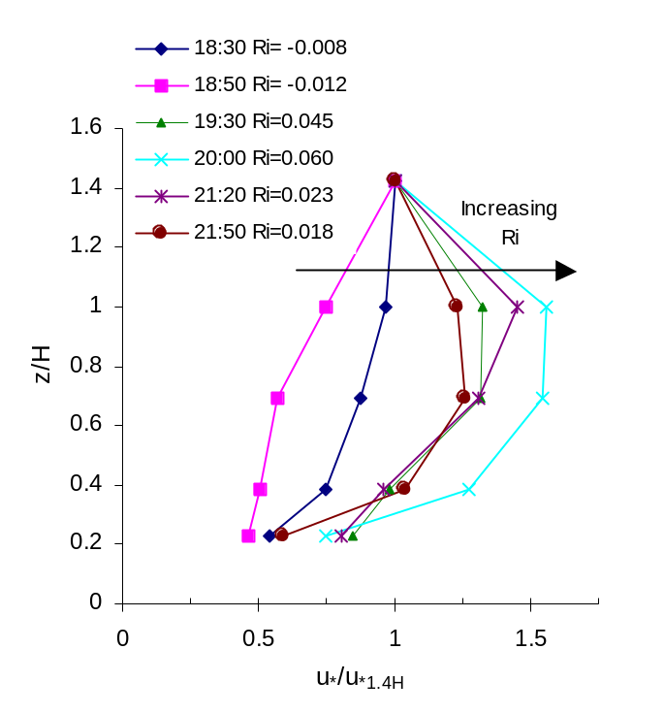
Fig. 2: Local friction velocity normalized by the friction velocity above the building level (z = 1.4H) as function of gradient Richardson number (10 min. averaging time).
Figure 2 is a plot of the normalized local friction velocity 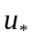, as function of non-dimensional height within and above the street canyon, where
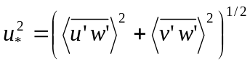
is a measure of the turbulent shear stress. The local friction velocity has been normalized by the friction velocity measured at z=1.4H. The turbulent stress is shown over a range of stabilities (-0.012<Ri<0.060). Several features are evident: (1) the height of maximum turbulent shear stress appears to drop with increasing stability from z/H>1.4 in the unstable case to z/H~1 in the more stable cases; (2) The ratio of the maximum stress to the stress at 1.4H increases with stability; (3) As a result of (1) the stress gradients (responsible for turbulent transport) within the canopy increase. It appears that the strong stable stratification above the buildings is confining most of the turbulence to within the canopy.

- SUMMARY

Several interesting features associated with flow in the first canyon of the array under stable atmospheric conditions (for the night analyzed) have been identified, including: the existence of a persistent warm thermal plume in the wake of the building and a well-mixed wake with strong stable stratification above the building height associated with the upstream flow. During the nighttime period studied, however, the air within the canyon is stably stratified. This stable-stratification effects the turbulent stress distribution within the canopy by lowering the height of the peak shear stress level.

5. REFERENCES

Biltoft, C.A., 2001: Customer report for Mock Urban Setting Test. Report No. WDTC-FR-01-121, U.S. Army Dugway Proving Ground, Dugway, UT.

Biltoft, C.A., Yee, E. and Jones, C.D., 2002: Overview of the Mock Urban Setting Test (MUST). Proceedings of the Fourth Symposium on the Urban Environment. May 20-24, Norfolk, VA.

Steggel, N. and Casto, I.P., 1998: Effects of stable stratification on flow behind a two-dimensional fence submerged in a turbulent boundary layer. U. Frisch (ed.), Advances in Turbulence VII, 487-490.

