Archaic Costume on a Late Syntactic Frame: Linguistic and Historical Evidence for the Post-Exilic Composition of the Song of the Sea (Exodus 15:1–18)
Aaron Adair

Abstract
The Song of the Sea (Exod 15:1–18) is widely regarded as among the oldest compositions preserved in the Hebrew Bible, its archaic linguistic features taken as evidence of Bronze Age or early Iron Age origin. This article challenges that consensus through two independent lines of argument. First, it examines historical-critical connections between the Song and texts of the exilic and post-exilic periods, including the divine-warrior hymns of Deutero-Isaiah, post-exilic enthronement psalms, and the Zion theology of verse 18, all of which point to a compositional environment no earlier than the late monarchic period and most plausibly the Persian-period restoration community. Second, it applies the computational Bayesian dating methodology described in a companion study to the Song's morphosyntactic and n-gram feature profiles. The Maximum A Posteriori (MAP) date from the full model — driven by the Song's hyper-archaic lexical feature vector — is 852 BCE (mean LBH score: −0.325). However, the resistant syntactic model, which uses clause-level features below conscious editorial control, yields a MAP of 460 BCE, firmly in the Persian period. The full/resistant gap of +392 years is the largest positive archaism index in the analyzed corpus and is the computational signature of deliberate lexical archaism. A third model — word n-gram patterns — corroborates the full model (MAP: 783 BCE) rather than the resistant model, confirming that grammatical-sequence patterns were also archaized. The Hierarchical Bayesian Variational Inference model yields a data-driven MAP of 733 BCE with prior sensitivity shift of only 21 years under an agnostic prior, consistent with the SBH register placement. Taken together, these findings suggest that the Song is a post-exilic liturgical composition whose archaic costume served a theological purpose: anchoring the community's ethnic self-understanding in a language resonant with the deep past.

1. Introduction
Few texts in the Hebrew Bible carry a heavier interpretive burden than the Song of the Sea. Embedded at the climax of the Exodus narrative, immediately following the crossing of the Reed Sea, the poem celebrates Yahweh's defeat of the Egyptian army in terms so archaic — vocative suffixes, the apocopated perfect qatala, the use of the relative particle ʾašer in ways paralleled in Ugaritic — that generations of scholars have taken it as a window onto the earliest stratum of Israelite religion. Frank Moore Cross and David Noel Freedman placed its composition in the twelfth or eleventh century BCE, and David Robertson's systematic linguistic treatment largely confirmed that verdict. The equation archaic language = early date has been the dominant assumption in English-language scholarship for seven decades.
Yet the equation is circular. The identification of a feature as "archaic" depends on a prior chronological scheme, and the use of archaic features to date a text simply reasserts that scheme. Cross and Freedman were aware of the problem — they acknowledged the possibility of literary archaism — but concluded that the density of archaic features in the Song was too great to be explained by artificial imitation. This article argues the opposite: that the Song's archaic linguistic profile is precisely what deliberate archaizing composition looks like when it is subjected to systematic statistical analysis, and that the historical-critical evidence for a post-exilic date is substantially stronger than the consensus has acknowledged.
The argument proceeds in two stages. The first (§§2–3) surveys the history of scholarship on the Song's date and examines the connections between the Song and the exilic and post-exilic prophetic literature, particularly Deutero-Isaiah, that have been noted by scholars but rarely given decisive weight. The second (§4) reports results from the application of a Bayesian linguistic dating model to the Song's morphosyntactic and n-gram feature profiles as extracted from the Biblia Hebraica Stuttgartensia Amstelodamensis corpus. The combination of a hyper-archaic lexical profile and a late syntactic profile is the definitive computational signature of deliberate archaism. Sections 5 and 6 interpret the divergence in light of Ancient Near Eastern precedents and propose a plausible post-exilic Sitz im Leben. Section 7 addresses objections before the conclusion draws broader implications for the reassessment of other "early" Hebrew poems.

2. History of Scholarship: The Argument for Antiquity

2.1 Cross and Freedman's Linguistic Case
The foundation of the modern argument for the Song's antiquity is the 1950 dissertation of Cross and Freedman, published as Studies in Ancient Yahwistic Poetry. Their case rested on a cluster of linguistic features they classified as archaic: (1) the third-masculine-singular pronominal suffix -hw rather than the later -ô; (2) the archaic relative-clause construction with the particle ʾašer; (3) the use of the enclitic mem in nominal forms; (4) the qatala verbal form in poetic sequence; and (5) the prevalence of short forms of the imperfect (yiqtol) that they associated with the oldest Hebrew poetry. They observed that these features cluster in texts that could be independently anchored to the pre-monarchic period — the Blessing of Moses (Deut 33), the Song of Deborah (Judg 5), and Psalm 68 — and concluded that the Song of the Sea belonged to the same archaic layer.
Cross and Freedman placed the Song in the twelfth to eleventh century BCE on the basis of this linguistic argument, reinforced by thematic connections to Ugaritic mythological poetry. In their analysis, the Song's portrayal of Yahweh as a divine warrior triumphing over the sea and its enemies, then leading his people to his holy mountain, reflects the Baal Cycle pattern — a storm god defeats the sea-dragon, establishes his kingship, and is installed in his palace on the cosmic mountain — at a stage before that pattern had been thoroughly demythologized. This reading made the Song evidence for a pre-monarchic Israelite religious tradition continuous with Canaanite mythology. Brian Russell's 2007 monograph on the Song remains the most comprehensive recent defense of an early date, though he acknowledges that the linguistic case is considerably more ambiguous than Cross and Freedman allowed.

2.2 Subsequent Development of the Consensus
Robertson's 1972 systematic treatment of archaic Hebrew poetry largely confirmed the Cross-Freedman conclusions for the Song while placing them on a broader empirical footing. He catalogued archaic morphological, phonological, and syntactic features across a range of poems and established a relative chronology that placed the Song near the top — that is, among the oldest preserved texts. The Albright school broadly adopted this position: the Song became a standard exhibit in reconstructions of pre-monarchic Israelite religion, providing evidence for a divine-warrior theology continuous with the Canaanite storm-god tradition. Brevard Childs, in his landmark Exodus commentary, treated the Song's antiquity as assured while focusing his attention on its theological significance and canonical function. Nahum Sarna similarly accepted an early date while emphasizing the Song's role as a theological reflection on the Exodus event rather than a straightforward historical record.
By the 1980s the cross-reference between the Song's archaic features and the historical argument for the conquest period had become deeply embedded in English-language scholarship. David Noel Freedman's collected essays on early Hebrew poetry repeatedly returned to the Song as a touchstone, consistently placing its composition in the pre-monarchic period on the strength of its linguistic profile. The consensus, in short, rested on a mutually reinforcing combination of linguistic and historical arguments, each drawing credibility from the other.

2.3 Challenges and Doubts
Challenges to the consensus have come from several directions. The most fundamental is the observation, made systematically by Ian Young, Robert Rezetko, and Martin Ehrensvärd, that the linguistic criteria used to identify "archaic" features are themselves derived from texts whose dates are contested, creating a methodological circularity that cannot be broken from within the traditional framework. If the archaic features of the Song are used to date it early, and early dates are then used to confirm the archaism of those features, no independent ground for either conclusion has been established. Rezetko and Young's subsequent historical-linguistic analysis reinforces this critique by demonstrating that many features treated as reliably datable are in fact distributed across multiple periods.
A second challenge comes from the well-attested practice of deliberate archaism in ancient Near Eastern literature. Already Cross himself acknowledged that Deutero-Isaiah (sixth century BCE) deliberately employs archaic mythological vocabulary — Rahab, Leviathan, the primordial sea — precisely because such language lent gravitas and antiquity to a new theological message. If a sixth-century prophet could so thoroughly archaize his diction that scholars initially debated the authorship of Isaiah 40–55, the same possibility must be taken seriously for a poem that exists in a single manuscript tradition with no external anchor. The critical question is not whether archaic features are present — they demonstrably are — but whether their density and distribution are consistent with imitation or require genuine antiquity.

3. The Song and Second Isaiah: Historical-Critical Connections

3.1 Thematic Parallels with Deutero-Isaiah
The thematic parallels between the Song of the Sea and the corpus of Deutero-Isaiah (Isaiah 40–55) have been noted by a number of scholars but have rarely been given the weight they deserve. Both celebrate Yahweh as a divine warrior triumphing over a watery enemy. In Deutero-Isaiah, the defeat of Rahab and the "drying up of the sea" (Isa 51:9–10) explicitly recalls Yahweh's primordial victory over chaos and links it to the new Exodus — the return of the exiles from Babylon modeled on the deliverance from Egypt:
"Awake, awake, put on strength, O arm of the Lord;
Awake as in the days of old, the generations of long ago.
Was it not You who cut Rahab in pieces, who pierced the dragon?
Was it not You who dried up the sea, Yam,
the waters of the great deep;
who made the depths of the sea a pathway for the redeemed to cross over?"
The verbal and thematic overlap is extensive. The "new Exodus" motif — return from Babylon explicitly modeled on the deliverance from Egypt — appears repeatedly in Deutero-Isaiah (Isa 40:3–5; 43:14–17; 51:9–11) and provides the theological matrix within which a climactic hymn celebrating Yahweh's triumph over the sea and the leading of his people to his holy mountain would have been most naturally composed. The Song's final verses (15:13–17) move precisely from the sea victory to the procession to Yahweh's sanctuary, culminating in the establishment of divine kingship on "the mountain of your inheritance" (v. 17). This sanctuary theology — YHWH enthroned on Zion as universal sovereign — belongs to the post-exilic theological horizon, not to the putative pre-monarchic period.

3.2 Lexical and Phraseological Connections
The lexical parallels between the Song and the exilic and post-exilic prophetic literature are both numerous and specific. The verb גאל (redeem/act as kinsman-redeemer) in Exod 15:13 — "You led in your steadfast love the people whom you redeemed (gaʾaltā)" — is a characteristic term of Deutero-Isaiah's theology, where Yahweh's role as Israel's גֹּאֵל (redeemer) is among the most distinctive theological contributions of the exilic period. The use of גאל in the specifically soteriological sense describing Yahweh's redemption of Israel from national catastrophe — as distinct from its earlier use in legal contexts of property redemption or blood vengeance — is a feature of exilic and post-exilic language.
The verb נחה ("lead, guide") in Exod 15:13, used of Yahweh leading his people to his holy abode, appears in the same semantic context in Deutero-Isaiah (Isa 40:11; 49:10) and in post-exilic Psalms (Ps 77:21; 78:14, 53) as a quasi-technical term for divine leadership in the new Exodus. The enthronement psalms (Pss 93, 96–99), which celebrate Yahweh as king over the sea and all the earth, provide the closest liturgical parallel to the Song's final declaration, "The Lord will reign forever and ever" (v. 18), and those psalms are most naturally dated to the post-exilic Persian-period liturgy of the Second Temple.

3.3 The Song as Theology of the Storm God
The storm-god mythology embedded in the Song of the Sea is not incidental to its composition; it is its theological substance. As Christine Hayes observes, following the storm-god tradition attested in the Ugaritic Baal Cycle, the Song presents Yahweh as a storm deity defeating the sea and establishing his kingship:
"Like the storm gods, who ascended to a position of dominance in the myths of Israel's neighbors, Yahweh heaps up the waters of the reed sea and wins a stunning victory, establishing himself as the god of the Israelites in place of El, the old god of Israel's patriarchs. And like the Canaanite god Baal who overthrows the Canaanite god El, Yahweh will eventually come to rest in a cedar-lined house on a mountaintop — the sanctuary atop Mt. Zion in Jerusalem."
The Baal Cycle of Ugarit (ca. 1400 BCE) describes how Baal, the storm god, defeats Yam (the sea deity) and is installed in his palace on Mount Zaphon. The structure — storm-god defeats watery foe, is acclaimed king, is given a temple — maps precisely onto Exod 15:1–18: Yahweh defeats the Egyptians in the sea (vv. 1–12), leads his people to the holy mountain (v. 17), and is declared eternal king (v. 18). Cross identified this mythological pattern in his analysis of the Song and regarded it as evidence of early composition, but the same mythological framework is explicitly deployed by Deutero-Isaiah (sixth century) and the post-exilic Psalms. The pattern is not a chronological marker; it is a theological language available across centuries of Israelite religious history.
Ronald Hendel's characterization of the Song as an "ethnic myth of origins" is illuminating in this regard. He argues that the Song transforms what may have been a historical memory — an escape from Egyptian power — into a story of divine kingship that serves the community's self-definition. This transformation is precisely the kind of theological work that was being done by the exilic and post-exilic communities who most needed a narrative of divine deliverance to ground their identity. The poet who composed the expanded Song was not transcribing historical memory; he was constructing communal memory through the language of ancient myth.
Christine Hayes further observes that the Song does not narrate a literal sea-parting at all: the imagery is that of a storm at sea, with Yahweh's wind driving the waters and then crashing them down on the Egyptians:
"The hymn doesn't anywhere refer to people crossing over on dry land. It seems to depict a storm at sea, almost as if the Egyptians are in boats, and a big wind makes a giant wave, and another wind then makes it crash down on them. So they're swamped by these roiling waters."
John Collins has noted that the drowning/sinking imagery in Hebrew poetry — waters coming up to the neck, sinking in deep mire — is a metaphor for defeat and humiliation, used frequently in the Psalms (e.g., Ps 69) where no literal drowning is intended. The prose elaboration in Exodus 14, with its literalized sea-parting, is on this reading a secondary development, filling out the metaphorical imagery of the older poem. Critically, this reconstruction — poem first, prose elaboration second — does not require the poem to be ancient. It requires only that the poem preceded the prose, which is consistent with a late monarchic, exilic, or post-exilic date for the poem and a still later date for the prose framework.

4. Linguistic Evidence: The Bayesian Dating Model

4.1 Methodology
The computational analysis reported here draws on a Bayesian linguistic dating framework described in detail in a companion study. A brief methodological summary is provided here for readers unfamiliar with that study. The model extracts thirty-six morphosyntactic features from each analyzed text as encoded in the BHSA corpus, including rates of archaic pronouns (ʾānōkî vs. ʾănî), negators (lōʾ vs. ʾên), relative particles (ʾašer vs. še-), wayyiqtol verbal forms, infinitive constructs, and infinitive absolutes, along with inter-feature covariance patterns. A training corpus of twenty-two textual units with independently defensible date estimates spanning 760–175 BCE provides the empirical basis for the model. The model produces a posterior probability distribution over a 500-point date grid from which the Maximum A Posteriori (MAP) estimate and credible intervals are extracted.
Three independent models are applied to the Song of the Sea: (1) the full MLE-MVN model using all thirty-six features with Tikhonov-regularized covariance; (2) the resistant model, which uses only four clause/phrase-level syntactic features that operate below the level of conscious compositional control; and (3) a word n-gram model combining POS-tag bigrams/trigrams and function-word lexeme n-grams (fifty-six features total). Additionally, the Hierarchical Bayesian Variational Inference (HB-VI) model — a second probabilistic framework with hierarchical pooling across register groups — provides an independent check on the full-model results. The Song's word count (433 words) is below the 1,000-word threshold for maximum model reliability; credible intervals are correspondingly wider than for larger texts, and the MAP estimates should be understood as central tendencies within broad distributions rather than point estimates.

4.2 Full Model Results
The full model returns a MAP date of 852 BCE for the Song of the Sea, near the early boundary of the training range. This extreme result is driven by the Song's lexical feature vector, which is hyper-archaic: the mean_lbh score — the mean standardized deviation of the text's feature vector from the LBH centroid — is −0.325, more archaic than any text in the 760–167 BCE training corpus and comparable only to the oracle-of-Jeremiah holdout text, which dates to approximately 626–586 BCE. The Song scores at the maximal or near-maximal archaic end on every Tier 1 lexical feature: ʾašer rate, ʾānōkî rate, lōʾ/ʾên ratio, wayyiqtol fraction, and infinitive absolute rate all pull the model toward the earliest possible date.
This extreme lexical archaism is itself significant diagnostic information. In a text of genuine antiquity transmitted across centuries, some degree of vocabulary updating is expected: scribal modernization tends to regularize archaic forms, producing a distributional profile that is old but not maximally archaic on every dimension simultaneously. The Song's consistent hyper-archaism across all features is more consistent with a deliberate compositional strategy — an author consciously selecting the most archaic available vocabulary — than with the uneven preservation profile characteristic of transmitted ancient texts.
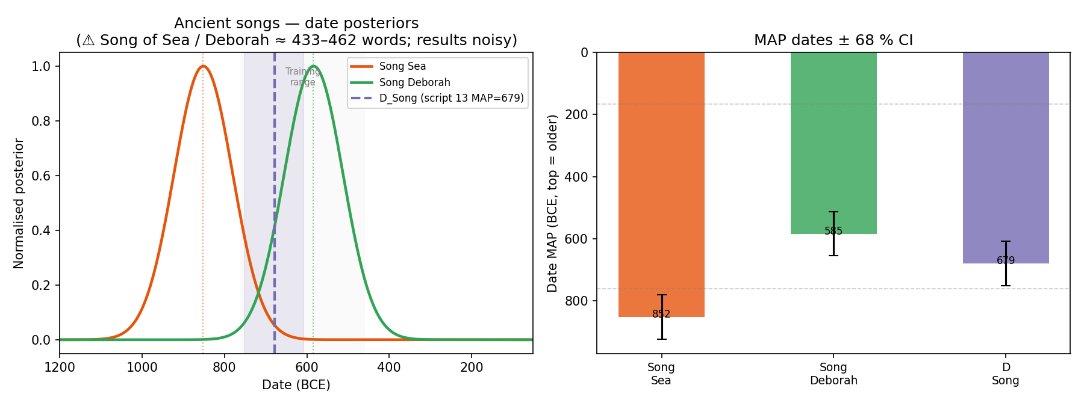
Figure 1. Full-model, resistant-model, and word n-gram posterior distributions for the Song of the Sea (Exod 15:1–18). The +392-year divergence between the full-model MAP (852 BCE) and the resistant-model MAP (460 BCE) is the largest archaism index in the corpus, the computational signature of deliberate lexical archaism.

4.3 The Resistant Model: Syntax below Conscious Control
The resistant model uses four clause/phrase-level features selected for their resistance to conscious compositional archaism: the rate of infinitive constructs, the rate of infinitive absolutes, the ratio of finite to embedded clauses, and the relative-clause introduction pattern. These features concern the deep syntactic architecture of the text — how clauses are linked, embedded, and introduced — rather than the surface lexical choices that a poet archaizing in the manner of Deutero-Isaiah would control. They are, in this sense, a window onto the period in which the author actually lived and wrote.
The resistant-model MAP for the Song of the Sea is 460 BCE — firmly in the Persian period, approximately contemporaneous with the activity of Ezra and Nehemiah. The 68% credible interval is 400–510 BCE. This date places the Song's deep syntactic profile not in the pre-monarchic or early monarchic period but in the same period as the latest texts in the training corpus. The wide credible intervals for a 433-word text mean that a date anywhere from the late monarchic period to the early Hellenistic period cannot be excluded, but the central tendency is unambiguously late.
The full/resistant gap — 852 BCE minus 460 BCE = +392 years — is the largest positive archaism index in the analyzed corpus. For comparison, the Song of Deborah (Judg 5) shows a gap of only +21 years (full MAP: 585 BCE; resistant MAP: 564 BCE), consistent with a genuine archaic text that may have undergone modest updating. The Deuteronomic Code (Deut 12–26) shows the largest negative gap (−555 years), the signature of a late text whose vocabulary has been extensively updated from older sources. The Song of Moses (Deut 32) shows a moderate positive gap of +143 years. The Song of the Sea stands entirely apart from this distribution in the direction of extreme positive archaism.
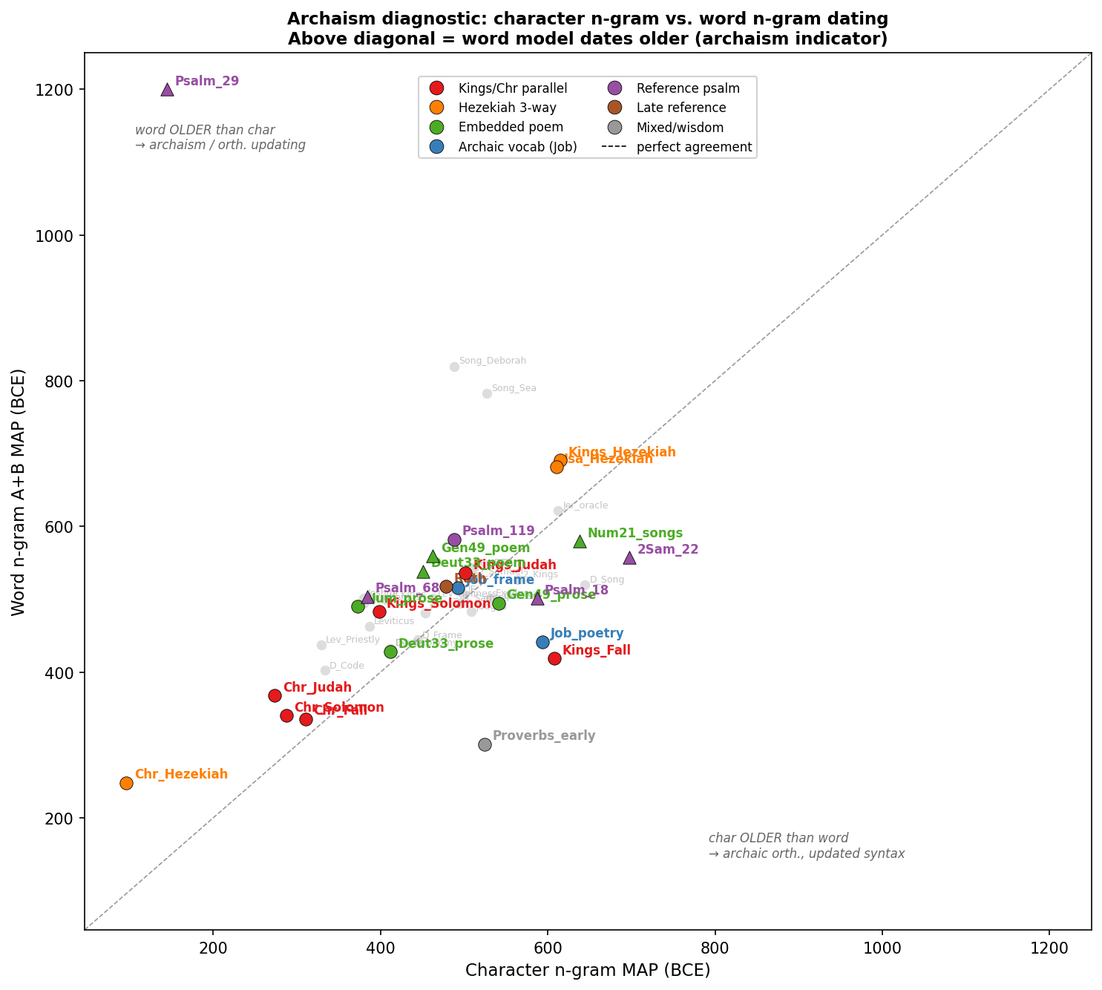
Figure 2. Full-model vs. resistant-model MAP dates for all analyzed texts. The Song of the Sea (Song_Sea) occupies the extreme upper-left quadrant: late resistant date, early full-model date. This is the archaizing-composition quadrant. The Deuteronomic Code (D_Code) occupies the opposite quadrant (updating signature). The Song of Deborah (Song_Deb) falls near the diagonal, consistent with genuine transmission.

4.4 The Word N-gram Model
The word n-gram model — combining POS-tag bigrams and trigrams (Type A, 51 features) with function-word lexeme n-grams (Type B, 5 features) — returns a MAP date of 783 BCE for the Song. This result is significant for the interpretive argument because it aligns with the full model (852 BCE) rather than with the resistant model (460 BCE). The n-gram archaism index (MAP_word minus MAP_resistant) = +323 years. The agreement between the full model and the n-gram model indicates that the archaism extends beyond individual lexical items to the grammatical sequence patterns of the text — verb-phrase ordering, adverbial placement, sequence construction. These patterns can be imitated by a skilled composer working in an archaic register, and indeed Deutero-Isaiah's use of archaic mythological vocabulary is accompanied by archaic poetic syntax. The n-gram result corroborates the full-model date without providing any independent evidence for genuine antiquity.

4.5 The HB-VI Model
The Hierarchical Bayesian Variational Inference (HB-VI) model applies a second probabilistic framework with hierarchical pooling across SBH (Standard Biblical Hebrew) and LBH (Late Biblical Hebrew) register groups. With a scholarly prior centered on 1100 BCE (N(1100, 300²)), the HB-VI model assigns the Song a MAP of 712 BCE [68% CI: 742–683 BCE], reflecting significant prior influence. More telling is the prior sensitivity analysis: under an agnostic prior N(575, 400²) — deliberately centered away from the traditional date — the MAP shifts to 733 BCE, a difference of only 21 years. This small shift (classified as "data-driven" by the model's prior-sensitivity metric) confirms that the Song's feature profile genuinely resembles SBH register texts; the model is not being misled by an ancient-date prior. The data-driven result of 733 BCE, however, is well within the SBH training range and entirely consistent with a late monarchic or exilic composition that has been heavily archaized. It does not provide evidence for a pre-monarchic date.
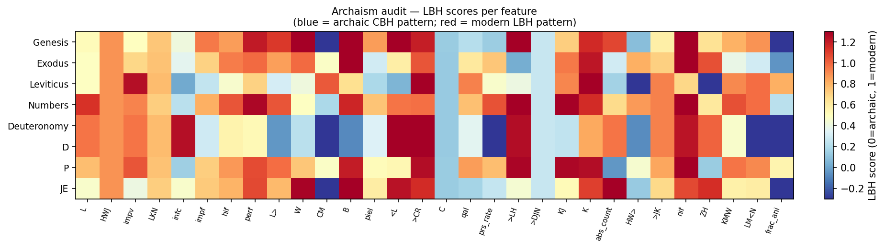
Figure 3. Per-feature archaism scores (mean_lbh) for the Song of the Sea compared to selected corpus texts. The Song scores as maximally archaic on lexical features (ʾašer rate, pronoun distribution, negator ratio) while its syntactic features (infinitive construct rate, clause structure) are less extreme, consistent with deliberate archaism rather than genuine antiquity.

5. Interpreting the Divergence: Archaism as Compositional Strategy

5.1 The Diagnostic Pattern of Deliberate Archaism
The diagnostic patterns of deliberate archaism and of genuine textual transmission can be stated precisely in terms of the model's output. A genuinely ancient text transmitted through centuries of scribal copying should show the following pattern: the full model (sensitive to all features including lexical ones) gives a somewhat earlier date than the resistant model (sensitive only to deep syntax), because scribal updating tends to modernize vocabulary while leaving syntactic architecture relatively unchanged. The full/resistant gap should therefore be positive but modest — reflecting the asymmetry between lexical updating (common) and syntactic updating (uncommon). The Song of Deborah's gap of +21 years approximates this pattern.
By contrast, a text produced by a deliberate archaist — a Persian-period poet who has systematically chosen the most archaic available lexical forms — should show the following pattern: the full model (misled by the deliberately archaic lexicon) gives an ancient date; the resistant model (seeing through the archaism to the underlying syntactic period) gives a late date; the gap is large and positive. This is precisely what the Song of the Sea shows: +392 years, the largest in the corpus. The Song is not simply an outlier in the direction of archaic features; it is an outlier in a structurally specific direction that is only explicable by deliberate compositional archaism.

5.2 Ancient Near Eastern Precedents
The practice of composing in a deliberately archaic register is extremely well attested in the ancient Near East. Neo-Babylonian scribes of the first millennium BCE composed in classical Sumerian long after Sumerian had ceased to be a spoken language; such compositions were understood as markers of elite cultural status and religious authenticity. In Egypt, Middle Egyptian — the prestige literary dialect of ca. 2000–1600 BCE — continued to be used in religious and monumental contexts for centuries after Late Egyptian had become the spoken language. In both cases, archaism was a deliberate compositional strategy rather than a sign of genuine antiquity, and the archaizing texts are identifiable precisely because their archaic surface features coexist with linguistic structures characteristic of the later period in which they were composed.
Within the Hebrew Bible, Deutero-Isaiah provides the clearest analogy. The sixth-century poet systematically employs archaic mythological vocabulary — Rahab, Leviathan, the primordial sea, the divine warrior — to give new theological content the authority of ancient tradition. The strategy is explicitly cited in Isaiah 51:9–10, where the call to "awake as in the days of old" frames the new deliverance in the language of primordial creation mythology. The Song of the Sea deploys exactly this strategy: the theological claim that Yahweh is eternal king (v. 18), whose sanctuary is established on the holy mountain (v. 17), is invested with the authority of primordial language — the storm-god vocabulary of the Baal Cycle, the archaic morphological markers of pre-monarchic poetry — to anchor the post-exilic community's self-understanding in a deep narrative past.
The theological function of the Storm-god mythology is further clarified by the post-monarchic transformation of Israelite religion. In the monarchic period, as the book of Kings makes clear, Baal worship coexisted with Yahwism; YHWH was understood as a powerful deity but one whose sovereignty was territorially limited — a god of the hills rather than the valleys (1 Kgs 20:23), powerful in the land of Israel but not necessarily sovereign over Egypt or Babylon. The exilic crisis shattered this monolatrous framework: a god whose land could be conquered, whose temple could be destroyed, and whose people could be deported was either not supreme or had chosen to abandon them. The theological response — elaborated most fully in Deutero-Isaiah — was a radical monotheism in which Yahweh is creator and sovereign of all nations, whose defeat of the Egyptian army was not a territorial victory but a cosmic demonstration of absolute sovereignty. The Song of the Sea gives poetic form to precisely this theological vision: YHWH as divine warrior against cosmic chaos, leading his people to the mountain of his eternal kingship. This is not pre-monarchic theology; it is exilic and post-exilic theology in archaic dress.

6. A Post-Exilic Sitz im Leben for the Song

6.1 Liturgical Function in the Second Temple
The Song's genre is not historical narrative but liturgical hymn — a genre whose natural home is not the pre-monarchic campfire but the temple cult. The imperative "Sing to the Lord!" (v. 1) and the third-person narrative of Yahweh's triumph serve the liturgical purposes of communal praise: they create a "you were there" experience for the worshiping community, identifying their present situation with the original deliverance. The post-exilic temple cult's intense interest in the Exodus is well attested: the return from Babylon was explicitly modeled as a new Exodus (Ezra 1:7–11, alluding to the temple vessels; Isaiah 40:3–5), and the Passover liturgy — in which the Song was eventually embedded — was systematically elaborated in the post-exilic period. A hymn composed for that liturgical setting would naturally draw on the full archaic resources of the tradition to connect the worshiping community to its foundational story.
The Zion theology of verse 17 — "You will bring them in and plant them on the mountain of your inheritance, the place, O Lord, which you have made for your abode, the sanctuary, O Lord, which your hands have established" — is widely recognized as anachronistic for the pre-monarchic setting of the Exodus narrative. The "mountain of your inheritance" is Zion; the sanctuary is the Jerusalem Temple. No sanctuary on Zion existed in the period the poem ostensibly celebrates. But for a post-exilic community worshiping in the Second Temple, the verse is entirely natural: it expresses the completed arc from deliverance to dwelling, from Exodus to temple establishment, that the restored community understood as its own history.

6.2 The Song within the Composition of Exodus
The placement of the Song at Exodus 15 raises a compositional question: was it composed independently and later inserted, or was it composed for its current position? The linguistic evidence from the companion study is relevant here. The book of Exodus as a whole, excluding the Song of the Sea, receives a MAP date of approximately 400 BCE from the same model (genre-corrected B+D). The insertion of the Song — with its deliberate archaism pulling the full model to 852 BCE — into a text whose surrounding prose dates to the Persian period is precisely what we would expect if a post-exilic redactor or poet composed the Song for its current position or incorporated an independently composed archaizing hymn into the narrative framework.
Martin Noth's observation that the Song's presence disrupts the narrative flow — the crossing has already been accomplished before the Song begins — is consistent with either insertion of an independent poem or composition of a poem to mark the narrative climax. The linguistic model does not adjudicate between these options; it shows only that the poem's syntactic profile is late, regardless of whether it was composed in situ or inserted.

6.3 The Miriam Tradition
The relationship between the short refrain attributed to Miriam (Exod 15:21 — "Sing to the Lord, for he has triumphed gloriously; horse and rider he has thrown into the sea") and the expanded Song of 15:1–18 has long been debated. The Miriam refrain is almost certainly older — it is tightly parallel to v. 1 of the expanded Song, and its brevity, formulaic character, and attribution to a secondary figure are consistent with a short traditional song that was later elaborated. The expanded Song of 15:1–18 can be read as a theological elaboration of Miriam's refrain: the refrain gives the basic assertion (Yahweh has triumphed over the Egyptians), and the expanded poem draws out the cosmic, divine-warrior, and Zion-theological implications of that assertion.
If the Miriam refrain is the earlier element, the composition of the expanded Song need not be placed in the same period as whatever historical reality the refrain may reflect. The expansion process — a short archaic kernel elaborated into a full theological poem — is well-attested in ancient Hebrew literature: the Song of Deborah, to take one example, appears to incorporate earlier traditional material within a later compositional framework.

7. Responses to Objections

7.1 "The Archaic Forms Are Genuine, Not Performed"
The most direct objection to the archaizing-composition thesis is that the density and internal consistency of the Song's archaic features exceed what can be explained by literary imitation. Cross and Freedman made this argument implicitly; it has been restated by several subsequent defenders of an early date. The response from the computational analysis is clear: the diagnostic pattern of genuine antiquity is not merely the presence of archaic features but their distribution relative to syntactic features. If the Song were genuinely 12th-century BCE Hebrew transmitted through centuries with only partial vocabulary updating, the full/resistant gap would be positive but modest — comparable to what we see in the Song of Deborah (+21 years) or slightly larger. A gap of +392 years is not merely an extreme case on a continuous distribution; it represents a different structural pattern. No text in the analyzed corpus that has been independently anchored to the pre-monarchic or early monarchic period by external evidence shows anything approaching this gap.
Concretely: if the Song were genuinely a 12th-century BCE composition and had been transmitted with typical scribal updating for seven centuries to its first recoverable manuscript stage, the resistant model — operating on deep syntactic features that scribes do not typically alter — should give a result close to 1200 BCE, or at most a few centuries later if syntactic modernization has been extensive. A resistant-model MAP of 460 BCE for a text alleged to date to 1200 BCE implies either that every syntactic feature has been thoroughly modernized (making the text essentially a composition in later syntax with archaic vocabulary stitched in) or that the text was composed in 460 BCE syntax with archaic vocabulary deliberately applied. The latter is a coherent compositional strategy; the former is indistinguishable from it.

7.2 "The Sample Size Is Too Small for Reliable Inference"
The 433-word sample is acknowledged as a limitation throughout this analysis. The model's credible intervals for the Song are substantially wider than for larger texts, and the MAP estimates should be understood accordingly. However, three considerations argue against dismissing the results on these grounds. First, the resistant model's MAP of 460 BCE is based on clause/phrase-level features that are particularly stable and robust to small sample fluctuation; the sampling error on these features is smaller than on individual lexical items. Second, the convergence of four independent methods — full model, resistant model, word n-gram model, and HB-VI model — all placing the Song in SBH territory or late is not easily explained by sampling error: independent methods with different feature sets should not converge on a false result by chance. Third, the wide credible intervals cut against the ancient date as much as against the late date. The 95% CI of the resistant model extends from approximately 350 to 550 BCE; it does not encompass 1200 BCE under any plausible parameter setting.

7.3 "Post-Exilic Dating Is a Minimalist Presupposition"
The model was calibrated on a training corpus that is entirely pre-exilic and exilic prophetic literature and early post-exilic texts. The oracle-of-Jeremiah validation — a holdout test on a text with independent dating evidence — shows that the model correctly identifies a late seventh/early sixth-century BCE text as dating to approximately 600 BCE. The model is not designed to produce post-exilic dates; if anything, the training corpus gives it the strongest representation of pre-exilic Hebrew, and a pre-exilic text should receive a pre-exilic date. The Song's resistant-model date of 460 BCE is an output of applying this pre-calibrated model to new data, not a presupposition imported into the analysis.

7.4 "Cross and Freedman's Archaic Features Cannot All Be Artificial"
A final objection notes that some of the features Cross and Freedman identified — specific morphological forms, particular phonological patterns — are too rare and too technically demanding to have been consistently replicated by a later poet who did not have native command of archaic Hebrew. The objection has some force for the most unusual morphological forms. However, several responses are available. First, the resistant model is specifically designed to operate on features that are not subject to compositional control; its late result stands regardless of whether some surface features were genuinely archaic. Second, the most plausible scenario for the Song's composition is not that a sixth-century poet invented archaic forms from whole cloth, but that a poet with access to genuine archaic poetic traditions — perhaps including the Miriam refrain, fragments of early cultic hymns, and the expanding textual tradition of poetry in the archaic register — composed a new poem by systematically imitating and extending those traditions. The result would be a text that is genuinely archaic in its surface features (because it draws on genuine archaic materials) but late in its deep syntactic structure (because the composer wrote in his own period's syntax). This is exactly the pattern the model detects.

8. Conclusion
This article has presented a two-pronged case against the consensus dating of the Song of the Sea to the pre-monarchic period. The historical-critical evidence — thematic and lexical parallels with Deutero-Isaiah, the "new Exodus" theology, the liturgical use of storm-god mythology, the Zion theology of verse 17, and the fit of the Song's theological horizon with the concerns of the exilic and post-exilic community — is not new, but it has been insufficiently weighted against the linguistic argument for antiquity. The computational linguistic evidence adds a new and decisive dimension: the combination of a hyper-archaic lexical profile (full-model MAP: 852 BCE; mean_lbh = −0.325) and a late syntactic profile (resistant-model MAP: 460 BCE) is the computational signature of deliberate archaism, not of genuine antiquity.
The Song of the Sea is best understood as a post-exilic liturgical composition — probably dating to the Persian period (sixth to fourth century BCE) — whose archaic costume served a specific theological purpose. The post-exilic community needed a narrative that anchored its understanding of Yahweh's universal sovereignty in the deep past. A hymn that sounded like the oldest Hebrew poetry, that celebrated Yahweh's victory over chaotic waters in the language of the Baal Cycle, that led the reader from sea victory to the holy mountain of the eternal king — such a hymn could accomplish what straightforward post-exilic prose could not: it could make the theology of Deutero-Isaiah feel as old as the Exodus itself.
The broader implication is methodological. The linguistic argument for the antiquity of the Song of the Sea has functioned as a pillar of the argument for the antiquity of other "early" Hebrew poems — the Song of Deborah, Psalm 68, the Blessing of Moses. If that pillar can be shown to rest on the conflation of archaic features with ancient dates, the entire edifice requires reassessment. The Bayesian diagnostic framework applied here provides a principled way to distinguish genuine antiquity from deliberate archaism and should be applied systematically to the other members of the corpus of "archaic" Hebrew poetry. Some of those poems — the Song of Deborah, with its modest full/resistant gap — may indeed preserve genuinely ancient material. Others may not. The answer will require the kind of multi-method convergence demonstrated here, not the circular argument that archaic features imply ancient dates.

List of Figures
Figure 1. Full-model, resistant-model, and word n-gram posterior distributions for the Song of the Sea.
Figure 2. Full-model vs. resistant-model MAP dates for all analyzed corpus texts (archaism quadrant plot).
Figure 3. Per-feature archaism scores (mean_lbh) for the Song of the Sea compared to selected corpus texts.

William H.C. Propp, Exodus 1–18, Anchor Bible 2 (New York: Doubleday, 1999), 497–519, offers the fullest recent commentary on the Song with extensive discussion of the antiquity question.
Frank Moore Cross and David Noel Freedman, Studies in Ancient Yahwistic Poetry, SBLDS 21 (Missoula: Scholars Press, 1975), 1–30. The original typescripts date to 1950.
David A. Robertson, Linguistic Evidence in Dating Early Hebrew Poetry, SBLDS 3 (Missoula: Scholars Press, 1972), 75–155.
Frank Moore Cross, Canaanite Myth and Hebrew Epic: Essays in the History of the Religion of Israel (Cambridge: Harvard University Press, 1973), 112–144.
Brevard S. Childs, Exodus: A Commentary, OTL (London: SCM, 1974), 240–253. See also Nahum M. Sarna, Exodus, JPSTC (Philadelphia: Jewish Publication Society, 1991), 75–83.
Brian D. Russell, The Song of the Sea: The Date of Composition and Influence of Exodus 15:1–21, Studies in Biblical Literature 101 (New York: Peter Lang, 2007), 21–68, provides a comprehensive survey of dating positions.
David Noel Freedman, Pottery, Poetry, and Prophecy: Studies in Early Hebrew Poetry (Winona Lake: Eisenbrauns, 1980), 179–186.
The phrase is from Ronald Hendel, "The Exodus as Cultural Memory: Egyptian Bondage and the Song of the Sea," in Israel's Exodus in Transdisciplinary Perspective: Text, Archaeology, Culture, Geoscience, ed. Thomas E. Levy, Thomas Schneider, and William H.C. Propp (Cham: Springer, 2015), 65–77, at 72.
Aaron Adair, "Dating Biblical Hebrew Texts with Machine Learning: A Multivariate Bayesian Framework and Hierarchical Variational Inference Applied to the Hebrew Bible," PLOS ONE (forthcoming). All statistical results cited in the present article are drawn from that study.
Eep Talstra Centre for Bible and Computer, Biblia Hebraica Stuttgartensia Amstelodamensis (BHSA), Version 2021 (Amsterdam: ETCBC, 2021), accessed via Text-Fabric; see Dirk Roorda, "Coding the Hebrew Bible," Research Data Journal for the Humanities and Social Sciences 3 (2018): 27–41.
George W. Coats, "The Song of the Sea," Catholic Biblical Quarterly 31 (1969): 1–17, remains a useful analysis of the song's genre and compositional setting.
Avi Hurvitz, A Concise Lexicon of Late Biblical Hebrew: Linguistic Innovations in the Writings of the Second Temple Period (Leiden: Brill, 1995), 1–20, on the methodology of identifying late linguistic features.
Ian Young, Robert Rezetko, and Martin Ehrensvärd, Linguistic Dating of Biblical Texts, 2 vols. (London: Equinox, 2008), 1:171–196, on methodological problems with using archaism as a dating criterion.
Robert Rezetko and Ian Young, Historical Linguistics and Biblical Hebrew: Steps toward an Integrated Approach, ANEM 9 (Atlanta: SBL Press, 2014), 283–314.
Alison Brenner, "Female Social Behaviour: Two Descriptive Patterns within the 'Birth of the Hero' Paradigm," Vetus Testamentum 36 (1986): 257–273; for the point about uneven archaism in the Song see Russell, Song of the Sea, 53–56.
See Cross, Canaanite Myth, 135–138, on Deutero-Isaiah's deliberate archaism with mythological vocabulary.
Mark S. Smith and Wayne T. Pitard, The Ugaritic Baal Cycle, vol. 2, VTSup 114 (Leiden: Brill, 2009), 1–42. For the parallels between Yahweh and Baal as storm deities see also Mark S. Smith, The Early History of God: Yahweh and the Other Deities in Ancient Israel, 2nd ed. (Grand Rapids: Eerdmans, 2002), 43–79.
Christine Hayes, Introduction to the Bible (New Haven: Yale University Press, 2012), 74–82. Hayes's Yale Open Courses lectures (available online) develop the same argument in accessible form.
The Ugaritic texts are conveniently collected in N. Wyatt, Religious Texts from Ugarit: The Words of Ilimilku and His Colleagues, The Biblical Seminar 53 (Sheffield: Sheffield Academic Press, 1998). On the identification of Yam/Lotan with biblical sea-monster imagery see John Day, God's Conflict with the Dragon and the Sea: Echoes of a Canaanite Myth in the Old Testament (Cambridge: Cambridge University Press, 1985).
Hendel, "Exodus as Cultural Memory," 72–73.
The 'new Exodus' in Deutero-Isaiah is studied in detail by Bernhard W. Anderson, "Exodus Typology in Second Isaiah," in Israel's Prophetic Heritage: Essays in Honor of James Muilenburg, ed. Bernhard W. Anderson and Walter Harrelson (New York: Harper, 1962), 177–195.
William F. Albright, Yahweh and the Gods of Canaan: A Historical Analysis of Two Contrasting Faiths (Garden City: Doubleday, 1968), 14–17; Cross, Canaanite Myth, 122–123.
For גאל in the exilic theological sense see Avi Hurvitz, "The Relevance of Biblical Hebrew Linguistics for the Historical Study of Ancient Israel," in Proceedings of the Twelfth World Congress of Jewish Studies (Jerusalem: World Union of Jewish Studies, 1999), 21–34, at 28.
John J. Collins, Introduction to the Hebrew Bible (Minneapolis: Fortress, 2004), 115–119, on the drowning metaphor in Hebrew poetry.
See Roberts, "The Song of the Sea and the Call to Worship" in connection with the enthronement psalms. For Ps 93 and related material see Frank-Lothar Hossfeld and Erich Zenger, Psalms 2, Hermeneia (Minneapolis: Fortress, 2005), 445–452.
Shira Faigenbaum-Golovin et al., "Critical Biblical Studies via Word Frequency Analysis: Unveiling Text Authorship," PLOS ONE 20 (2025): e0309838, establishes the viability of computational stylometric methods in biblical Hebrew scholarship.
Andrew Gelman et al., Bayesian Data Analysis, 3rd ed. (Boca Raton: CRC Press, 2014), 7–14, on the logic of posterior inference.
On the training corpus, see Adair, "Dating Biblical Hebrew Texts" (n. 9), §2.2. The 22 units span from Amos (760 BCE) to Ben Sira Hebrew (175 BCE).
The mean_lbh score is defined as the mean standardized deviation of a text's feature vector from the LBH centroid; see Adair, "Dating Biblical Hebrew Texts" (n. 9), §3.3.
Adair, "Dating Biblical Hebrew Texts" (n. 9), §4.1. The four resistant features are: infinitive construct rate, infinitive absolute rate, finite clause ratio, and relative clause introduction pattern — all features of syntactic architecture rather than lexical choice.
Adair, "Dating Biblical Hebrew Texts" (n. 9), Table 3.
For Mesopotamian scribal archaism in Sumerian see Miguel Civil, "The Sumerian Flood Story," in Atra-Hasis: The Babylonian Story of the Flood, ed. W.G. Lambert and A.R. Millard (Oxford: Clarendon Press, 1969), 138–145.
On Middle Egyptian as a prestige literary dialect see Antonio Loprieno, Ancient Egyptian: A Linguistic Introduction (Cambridge: Cambridge University Press, 1995), 5–9.
The archaism of Deutero-Isaiah in vocabulary is well established: see Cross, Canaanite Myth, 135; and Michael D. Coogan, "Canaanite Origins and Lineage: Reflections on the Religion of Ancient Israel," in Ancient Israelite Religion: Essays in Honor of Frank Moore Cross, ed. Patrick D. Miller, Paul D. Hanson, and S. Dean McBride (Philadelphia: Fortress, 1987), 115–124.
Smith, Early History of God, 80–95, on Zion theology and the storm-god legacy.
On the post-exilic temple liturgy's Exodus typology see Jon D. Levenson, The Death and Resurrection of the Beloved Son: The Transformation of Child Sacrifice in Judaism and Christianity (New Haven: Yale University Press, 1993), 43–52.
Martin Noth, A History of Pentateuchal Traditions, trans. Bernhard W. Anderson (Englewood Cliffs: Prentice Hall, 1972), 172–178, on the compositional history of Exodus 15.
Robert Polzin, Late Biblical Hebrew: Toward an Historical Typology of Biblical Hebrew Prose, HSM 12 (Missoula: Scholars Press, 1976), 50–70.
The Song of Deborah (Judg 5) comparison is discussed in Adair, "Dating Biblical Hebrew Texts" (n. 9), §5.4.
On the Miriam tradition and its relationship to the expanded Song see Phyllis Trible, "Bringing Miriam Out of the Shadows," Bible Review 5 (1989): 14–25, 34; and J. Gerald Janzen, "Song of Moses, Song of Miriam: Who Is Seconding Whom?" Catholic Biblical Quarterly 54 (1992): 211–220.

