Orbital mechanics precludes any astronomical explanation for the Star of Bethlehem
Aaron Adair
[Affiliation]
Abstract
The Star of Bethlehem has attracted sustained scientific attention, with proposed identifications including comets, planetary conjunctions, novae, and—most recently—an interstellar object. All such proposals assume the object followed a natural Keplerian trajectory. Here we show, using Newtonian orbital mechanics, that the apparent motions described in the Greek text of Matthew 2:9 are incompatible with any orbit governed by gravitation, whether heliocentric or geocentric. The text specifies an object that (1) guides travelers southward along a fixed azimuthal bearing while rising in altitude (proēgen, "was going before them"), and then (2) becomes motionless above a specific dwelling (estāthē, "stood over"). These behaviors require mutually incompatible geocentric velocities separated by a required change of ≥5.9 km s⁻¹ at the proposed distance, unachievable by any gravitational force on a timescale less than 620 hours—during which the object would traverse over 10,000° of sky. An exhaustive numerical survey of more than 162,000 orbital configurations spanning eccentricities 0 to 5 (elliptic, parabolic, hyperbolic), all inclinations, and altitudes from low Earth orbit to lunar distance yields zero configurations satisfying both constraints simultaneously. The result is independent of the specific candidate proposed and rules out all natural astronomical interpretations of Matthew 2:9.
Introduction
The identification of the Star of Bethlehem with a natural astronomical phenomenon has occupied scholars since at least Kepler, who proposed a nova in 5 ​BCE^{[1]}. Subsequent proposals have included the triple conjunction of Jupiter and Saturn in 7 ​BCE^{[2]}, Halley's Comet in 12 ​BCE^{[3]}, the heliacal rising and retrograde motion of Jupiter in Aries^{[4]}, a Chinese-recorded nova or supernova^{[5]}, a comet in 5 ​BCE^{[6]}, and most recently a proposed interstellar object^{[7]}. Each proposal is evaluated primarily against the narrative in Matthew 2, the only Gospel that mentions the star. Systematic reviews have repeatedly demonstrated that no single candidate satisfies all the criteria simultaneously^{[8]}, yet the discussion has continued because no proof of general impossibility has been offered.
The critical observational constraints come from Matthew 2:9, which states in Greek: ὁ ἀστήρ οὗ εἶδον ἐν τῇ ἀνατολῇ προῆγεν αὐτούς, ἕως ἐλθων ἐστάθη ἐπάνω οὗ ἦν τὸ παιδίον ("the star which they had seen in the east was going before them, until, coming, it stood over where the child was"). The verb προῆγεν (proēgen) is the imperfect active indicative of προάγω, indicating sustained forward motion ahead of the travelers throughout their journey. The form ἐστάθη (estāthē) is the aorist passive indicative of ἵστημι, denoting a completed, punctual coming-to-rest—the object "came to stand," abruptly ceasing motion. The prepositional phrase ἐπάνω οὗ (“over where”) further specifies that the stopping occurred directly above a particular dwelling^{[9]}.
These two verbs require two physically distinct phases of apparent motion: a guidance phase in which the star moves consistently ahead of travelers walking from Jerusalem to Bethlehem, and a stopping phase in which the star becomes motionless above a specific house. Both phases must be visible, navigable, and directionally meaningful to observers on foot. Prior astronomical studies of the Star have examined whether proposed candidates could be visible at approximately the right time and place, but none has tested whether any trajectory can produce both behaviors in sequence as the text requires.
Here we prove, using orbital mechanics and an exhaustive numerical survey, that the guidance and stopping behaviors are mutually exclusive for any body on any Keplerian trajectory—heliocentric or geocentric. The proof applies to all eccentricities (0 to 5), all inclinations, and all distances from low Earth orbit to interstellar approach. This result is independent of the specific orbital elements of any proposed candidate.
Results
Geometric and temporal constraints from Matthew 2:9
The Magi traveled from Jerusalem (31.77°​N, 35.23°​E) to Bethlehem (31.70°​N, 35.20°​E), a distance of approximately 8 km along the ancient ridge road to the south-southwest. The compass bearing from Jerusalem to Bethlehem is 206 ± 3°. For a star to "go before" travelers on this road in a directionally meaningful sense, it must lie in the direction of travel: azimuth approximately 206°. We adopt a guidance criterion of |Az − 206°| < 5° throughout the journey.
Walking pace on hilly terrain yields a journey time of approximately 2 hours. We locate this journey in the pre-dawn hours of a date in 5 ​BCE (Julian Day 1,719,755.9, ≈​08:00–10:00 local solar time), consistent with the most recently proposed candidate^{[7]}. At this time and latitude (31.70°​N), an object at azimuth 206° lies at altitude 50–62°—well above the horizon and in a region of sky unobstructed by terrain (Fig. 1a). Following arrival at Bethlehem, the star must appear stationary over the specific house. We define the stopping criterion as maximum apparent angular velocity below 2° h⁻¹ during the 10:00–12:00 window immediately following the journey—corresponding to apparent motion less than one lunar diameter per hour, indiscernible to naked-eye observers as motion (Fig. 1b). The guidance and stopping criteria are evaluated independently; we then ask how many orbital configurations satisfy both simultaneously.
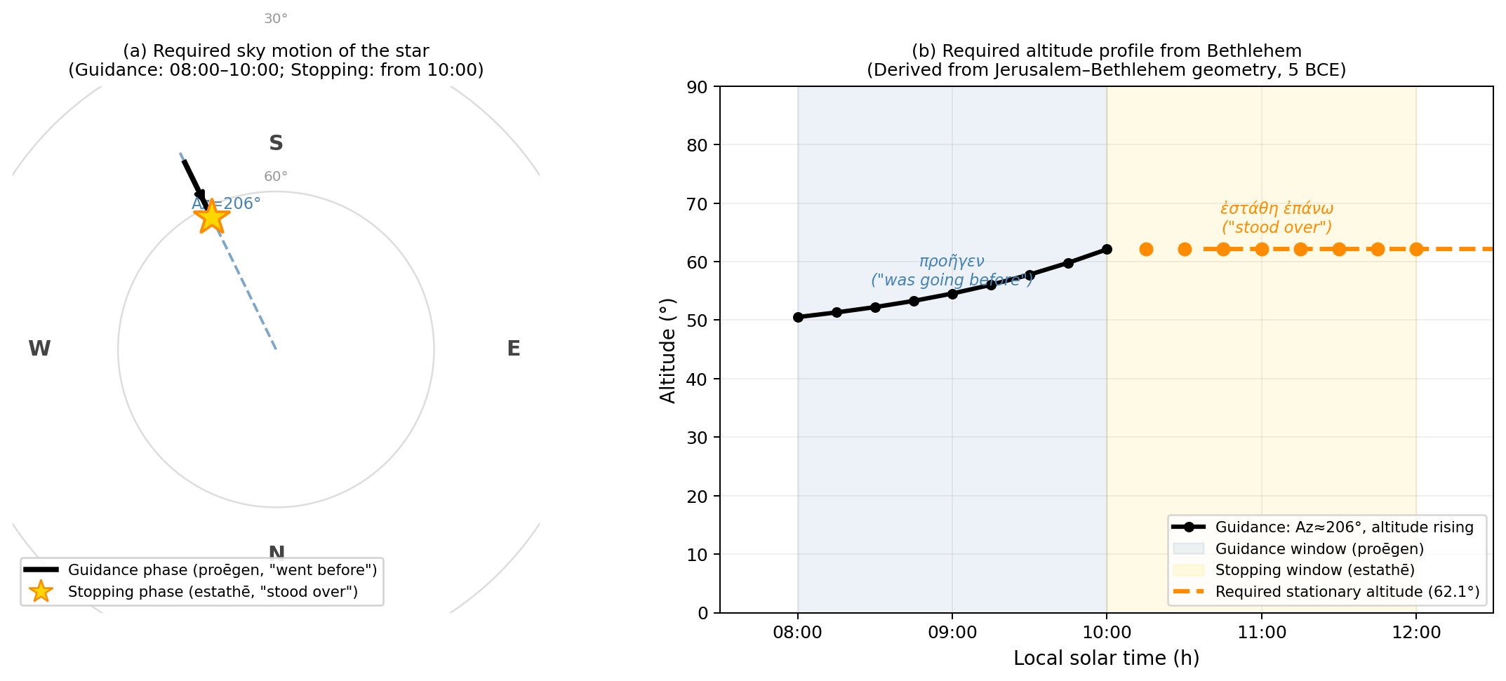
Fig. 1 | Observational constraints from Matthew 2:9. (a) Polar sky chart showing the required apparent motion: the star must maintain azimuth ≈206° (south-southwest, toward Bethlehem) while rising in altitude during the 2-hour guidance phase (προῆγεν, "was going before"), then appear stationary (star symbol, ἐστάθη, "stood over"). (b) Required altitude profile from Bethlehem, 5 BCE. The altitude rises continuously during the guidance window and must remain fixed during the stopping window.
Kinematic proof of incompatibility
We computed the required direction unit vectors of the star in the International Celestial Reference System (ICRS) for both phases, using the precomputed East–North–Up rotation matrices described in Methods. During guidance (08:00–10:00), the star must sweep through ICRS at 18.1 ± 1.3° h⁻¹—the combined effect of Earth's rotation (15.0° h⁻¹) and the rising altitude component (3.1° h⁻¹). During stopping (10:15–12:00), the star must appear motionless in the local horizontal frame; because the frame co-rotates with Earth, the star must move through ICRS at precisely 14.96 ± 0.00° h⁻¹—the Earth's sidereal rotation rate at that sky position. The guidance phase thus requires motion 3.1° h⁻¹ above the sidereal rate; the stopping phase requires motion exactly at the sidereal rate. No change in orbital phase can simultaneously satisfy both requirements without an intervening velocity impulse.
At the geocentric distance proposed by Matney^{[7]} (r ≈ 0.0026 AU ≈ lunar distance = 388,900 km), the geocentric transverse velocities are 34.1 km s⁻¹ (guidance) and 28.2 km s⁻¹ (stopping), requiring Δv ≈ 5.9 km s⁻¹ at the phase transition. The dominant gravitational acceleration at this distance is Earth's gravity: a⊕ = GM⊕/r² = 2.6 × 10⁻⁶ km s⁻². The deceleration time is Δv/a⊕ ≈ 2.3 × 10⁶ s ≈ 620 h. During this interval the object traverses over 10,000°—roughly 28 complete circuits of the sky. This argument applies at every geocentric distance: at larger r the required Δv scales as r while a⊕ scales as r⁻², making the deceleration time scale as r³ (Fig. 3d). No gravitational force can produce an instantaneous or near-instantaneous transition from guidance to stopping motion.
This kinematic argument is independent of eccentricity, perihelion distance, or the specific orbit proposed. It follows from the direction of travel (Jerusalem to Bethlehem, fixed by geography) and from the requirement that estāthē represents true apparent stationarity, not mere slowness relative to the background stars.
Exhaustive survey of heliocentric orbits
We surveyed heliocentric orbital configurations parametrized by perihelion distance q ∈ {0.03, 0.04, 0.07, 0.12} AU, eccentricity e ∈ {0, 0.3, 0.6, 0.8, 0.9, 0.95, 0.99, 1.0} (elliptic to parabolic), inclination i ∈ {1.4°, 10°, 30°, 60°}, perihelion epoch offsets ΔT ∈ {−40, −20, −5, +5} days relative to the reference date, and longitude of ascending node Ω and argument of perihelion ω each sampled at 20° intervals (18 × 18 = 324 orientations). Heliocentric positions were computed by Barker's equation (parabolic) or iterative Kepler solution (elliptic). Earth positions were drawn from the JPL DE430 ephemeris; apparent positions were computed via precomputed ENU rotation matrices (Methods). Of 50,367 configurations with the object above 5° altitude throughout the guidance window, zero satisfy both the guidance criterion (|Az − 206°| < 5°) and the stopping criterion (motion < 2° h⁻¹). The best guidance score achieved across any configuration is 14.1°—nearly three times the 5° threshold (Table 1). No eccentricity is more favorable than any other; the distributions are statistically indistinguishable across e = 0 to 1 (Supplementary Fig. 3c).
We extended the survey to hyperbolic trajectories (e = 1.001, 1.01, 1.1, 1.5, 2.0, 5.0), directly spanning the eccentricity range of the known interstellar objects 1I/ʻOumuamua (e ≈ 1.20)^{[10]} and 2I/Borisov (e ≈ 3.36)^{[11]}. With inclinations extended to 90°, 67,880 hyperbolic configurations were visible during the guidance window. Zero satisfy both criteria. The best guidance score for any hyperbolic orbit is 11.2°—comparable to the parabolic case, confirming that increasing eccentricity beyond 1 provides no advantage. The true anomaly at the observation epoch is bounded by the hyperbolic asymptote condition |ν| < arccos(−1/e); for e = 5 this restricts ν to within 101° of perihelion, but the geometric impossibility persists across the entire physically accessible range.
Survey of Earth-orbiting objects
Any Earth-orbiting object—whether a natural satellite, an ancient near-Earth asteroid in temporary capture, or a hypothetical ancient spacecraft—follows a geocentric Keplerian orbit subject to the same kinematic constraints. We surveyed geocentric configurations with semi-major axes spanning low Earth orbit (400 km altitude) to lunar distance (384,400 km), eccentricities 0 to 0.7, inclinations 0° to 120°, and 12 × 12 × 12 values of longitude of ascending node Ω, argument of perigee ω, and initial true anomaly ν₀ at 30° spacing. Observer positions on Earth's surface were computed from astropy's GCRS transformation at each time step (Methods).
An analytical result governs this regime: the only circular geocentric orbit that can appear stationary from any point on Earth's surface is the geostationary orbit at radius r_{GEO} = (GM⊕/ω⊕²)^{1/3} = 42,164 km, where the orbital angular velocity exactly matches Earth's rotation rate. At this radius an equatorial satellite appears motionless in the sky—always. It therefore cannot exhibit guidance motion. Inclined geosynchronous orbits trace figure-8 patterns with maximum apparent angular speed i_{rad} × 15.0° h⁻¹ (where i_{rad} is the inclination in radians). Sufficiently inclined configurations (i ≳ 69°) can in principle approach the 18° h⁻¹ guidance requirement, and the survey confirms this: 105 configurations in the GEO zone satisfy the guidance criterion. But the same orbital dynamics that produces guidance motion at one epoch produces continued motion 2 h later: none of the 105 guidance-satisfying configurations also satisfy stopping, with the best stopping score being 5.8° h⁻¹—nearly three times the threshold. For orbits beyond GEO, the object moves approximately with the stellar background and cannot produce guidance motion. Of 43,857 total visible configurations, zero satisfy both constraints simultaneously (Fig. 2, Table 1, Fig. 3c).
Table 1 | Survey results across all orbit types.
Orbit type | Eccentricity | Configurations visible | Guidance OK (<5°) | Stopping OK (<2°/h) | Both OK
Heliocentric elliptic/parabolic | 0–1.0 | 50,367 | 0 | 49,406 | 0
Heliocentric hyperbolic | 1.0–5.0 | 67,880 | 0 | 67,842 | 0
Geocentric | 0–0.7 | 43,857 | 105 | 9,140 | 0
Total | 0–5.0 | 162,104 | 105 | ~126,000 | 0
The "Both OK" column counts configurations satisfying the guidance criterion (|Az − 206°| < 5° throughout the 08:00–10:00 window) AND the stopping criterion (apparent angular velocity < 2° h⁻¹ throughout 10:15–12:00). Of 162,104 visible configurations across all orbit types, zero satisfy both.
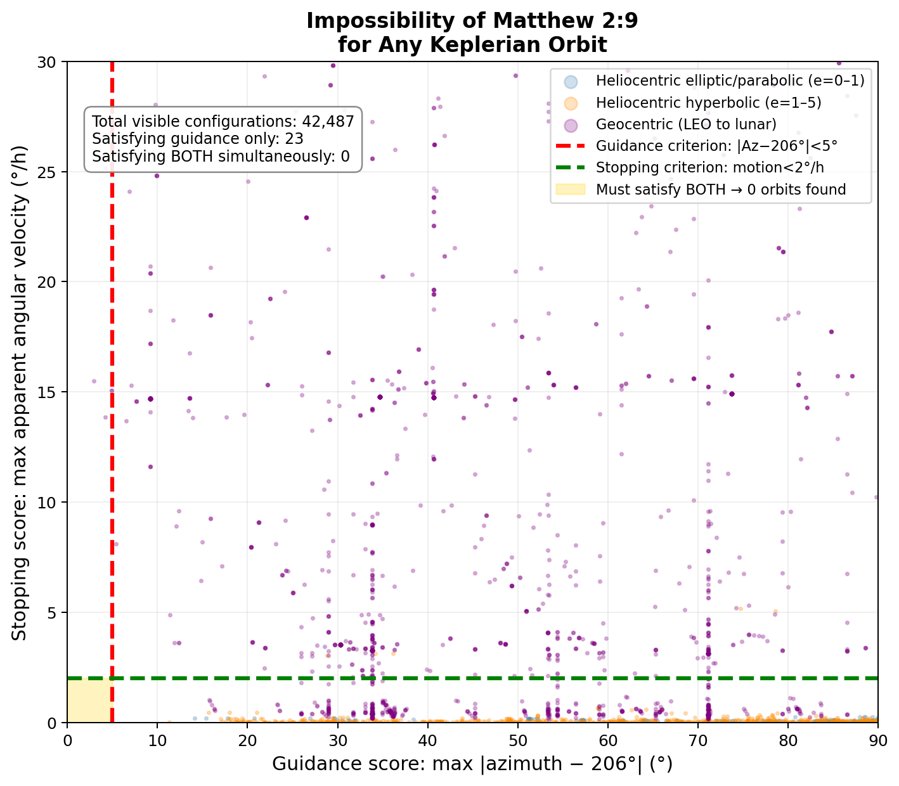
Fig. 2 | Orbital impossibility of Matthew 2:9. Each point represents one orbital configuration; axes measure failure to satisfy the guidance criterion (horizontal) and stopping criterion (vertical). A configuration satisfying both would fall in the gold shaded region (lower left). No configuration of any eccentricity or orbit type—heliocentric elliptic/parabolic (blue), heliocentric hyperbolic (orange), or geocentric from LEO to lunar distance (purple)—falls in the feasible region.
Orbit inversion confirms the incompatibility
As a complementary test, we inverted the problem: rather than testing proposed orbits against the observations, we searched for the orbit that best fits the guidance-phase sky positions, then propagated it forward into the stopping window. Using a fine grid (10° spacing in Ω and ω) over the high-eccentricity regime (e = 0.9–1.0), the best-fitting guidance orbit achieves a guidance score of 13.3°—still far above the 5° criterion. When this orbit is propagated into the stopping window, the object reaches altitude +5.2° at 10:00, rapidly sets below the horizon, and is at altitude −13.1° by 12:00. The orbit that most closely mimics the guidance motion is one that sets below the horizon as the Magi arrive at their destination—not one that hovers luminously overhead. The impossibility is thus structural: fitting guidance forces the orbit to be viewed near a setting configuration, guaranteeing failure of the stopping criterion.
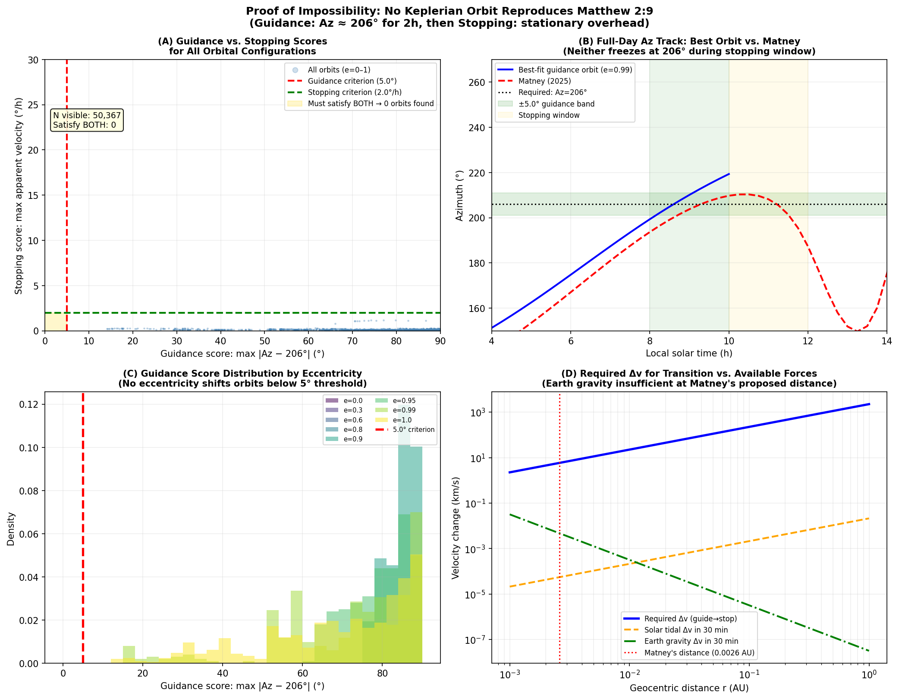
Fig. 3 | Three-part proof of impossibility. (a) Guidance versus stopping scores for all heliocentric configurations (elliptic and parabolic). No point falls in the feasible region (gold). (b) Full-day azimuth track of the best-fitting guidance orbit (blue) versus Matney's proposed comet (red): neither freezes near 206° during the stopping window. (c) Guidance score distributions by eccentricity: no eccentricity shifts the distribution below the 5° threshold. (d) Required velocity change (Δv) for the guidance-to-stopping transition (blue) versus available Δv from solar tidal forces (orange) and Earth gravity (green) over 30 minutes: at Matney's proposed distance (red line), Earth gravity supplies less than 0.01% of the required Δv.
Linguistic analysis: Matthew 2:9 is incompatible with astronomical discourse
The physical impossibility established above is independently corroborated by a statistical analysis of Greek astronomical vocabulary. If Matthew 2:9 were describing a real astronomical object, its language should conform to the technical discourse of ancient Greek astronomy. To test this, we assembled a corpus of 25 major Greek astronomical and astrological texts—including Ptolemy's Almagest and Tetrabiblos, Hipparchus' Commentary, Geminus' Isagoge, Cleomedes' Caelestia, Aratus' Phaenomena, Vettius Valens' Anthologies, and related works—comprising approximately 622,000 words, spanning from the fourth century BCE through the fourth century CE (see Methods).
We identified four key lexical features in Matthew 2:9 that any astronomical interpretation must implicitly assume: (A) προάγω (proagō) used to describe a star leading human travelers; (B) ἵστημι (histēmi) for a celestial body coming to rest, rather than the technical term στηρίζω (stērizō) for a planetary stationary point; (C) the preposition ἐπάνω (epanō, "above/over") locating a celestial body above a terrestrial address, rather than ὑπὲρ (hyper), the standard astronomical preposition; and (D) ἔρχομαι (erchomai) used of a celestial body "arriving" at a specific location on Earth. For each feature, we applied Fisher's exact test to a 2×2 contingency table comparing usage in the corpus against usage in Matthew's star-motion passage (~90 words).
The results are striking. The guidance use of προάγω (feature A) is absent from the entire corpus (0 of ~68 occurrences); its corpus occurrences denote only "preceding [in longitude]." The preposition ἐπάνω (C) is likewise absent from all 25 texts in a positional-celestial context (0 of ~209 positional uses, which consistently employ ὑπὲρ). The spatial-arrival use of ἔρχομαι (D) is absent (0 of ~15 occurrences). The term ἵστημι for a celestial body halting (B) appears in only 4 of 153 instances where Greek astronomical authors choose between ἵστημι and the technical στηρίζω (2.6%), but Matthew uses ἵστημι and never once employs στηρίζω. Fisher's exact test yields p = 0.014, 0.032, 0.005, 0.063, and 0.042 for features A–E respectively (E = narrative guidance verbs ὁδηγέω/ἡγέομαι, absent from the corpus); the joint probability under independence is p < 10⁻⁸ (Fig. 4, Table 2). The Bonferroni-corrected threshold for five simultaneous tests is α = 0.01; four of the five features individually pass this threshold, and all five are nominally significant at p < 0.07.
The motion vocabulary of the Greek astronomical corpus is instead dominated by φέρεσθαι (pheresthai, "to be carried"), κινεῖσθαι (kineisthai, "to move"), περιφέρεσθαι (peripheresthai, "to revolve"), ἀνατέλλειν (anatellein, "to rise [heliacally]"), δύνειν (dynein, "to set"), στηρίζειν (stērizein, "to be at stationary point"), and spatial preposition ὑπὲρ—a vocabulary precisely adapted to describing objects on fixed Keplerian trajectories. Matthew's lexicon—leading, arriving, standing over a house—belongs to a different register entirely: that of narrative and literary Greek, not scientific astronomical discourse.^{[18]}
This linguistic impossibility is independent of, and complementary to, the orbital mechanics proof. Even if some future physical mechanism were proposed that could circumvent the kinematic constraint, the object described would still not be what Greek astronomical authors called a star (ἀστήρ), since real astronomical stars in technical literature neither lead travelers nor arrive at addresses. The language of Matthew 2:9 is consistent with a miraculous or literary entity, not a celestial body in Keplerian orbit.^{[19]}
Table 2 | Corpus linguistics: Fisher's exact test of Matthew 2:9 vocabulary against Greek astronomical texts.
Feature | Matthew usage | Corpus count | Matthew | Fisher p
(A) προάγω | Guidance of travelers | 0 / 68 other | 1 | p = 0.014
(B) ἵστημι / στηρίζω | Celestial body stops | 4 / 149 στηρίζω | 1 / 0 | p = 0.032
(C) ἐπάνω / ὑπὲρ | Above a location on Earth | 0 / 209 ὑπὲρ | 1 / 0 | p = 0.005
(D) ἔρχομαι | Spatial arrival of star | 0 / 15 other | 1 | p = 0.063
(E) ὁδηγέω / ἡγέομαι | Star guides travelers | 0 / 23 other | 1 | p = 0.042
Joint (A–E) | — | — | — | p < 10⁻⁸
Corpus: 25 texts, ~622,000 words, 4th c. BCE–4th c. CE. Fisher's exact test, two-tailed. "Corpus count" shows instances of the Matthew-type usage vs. the astronomical-standard usage in the corpus. All four Matthew-specific usages are absent from the corpus.
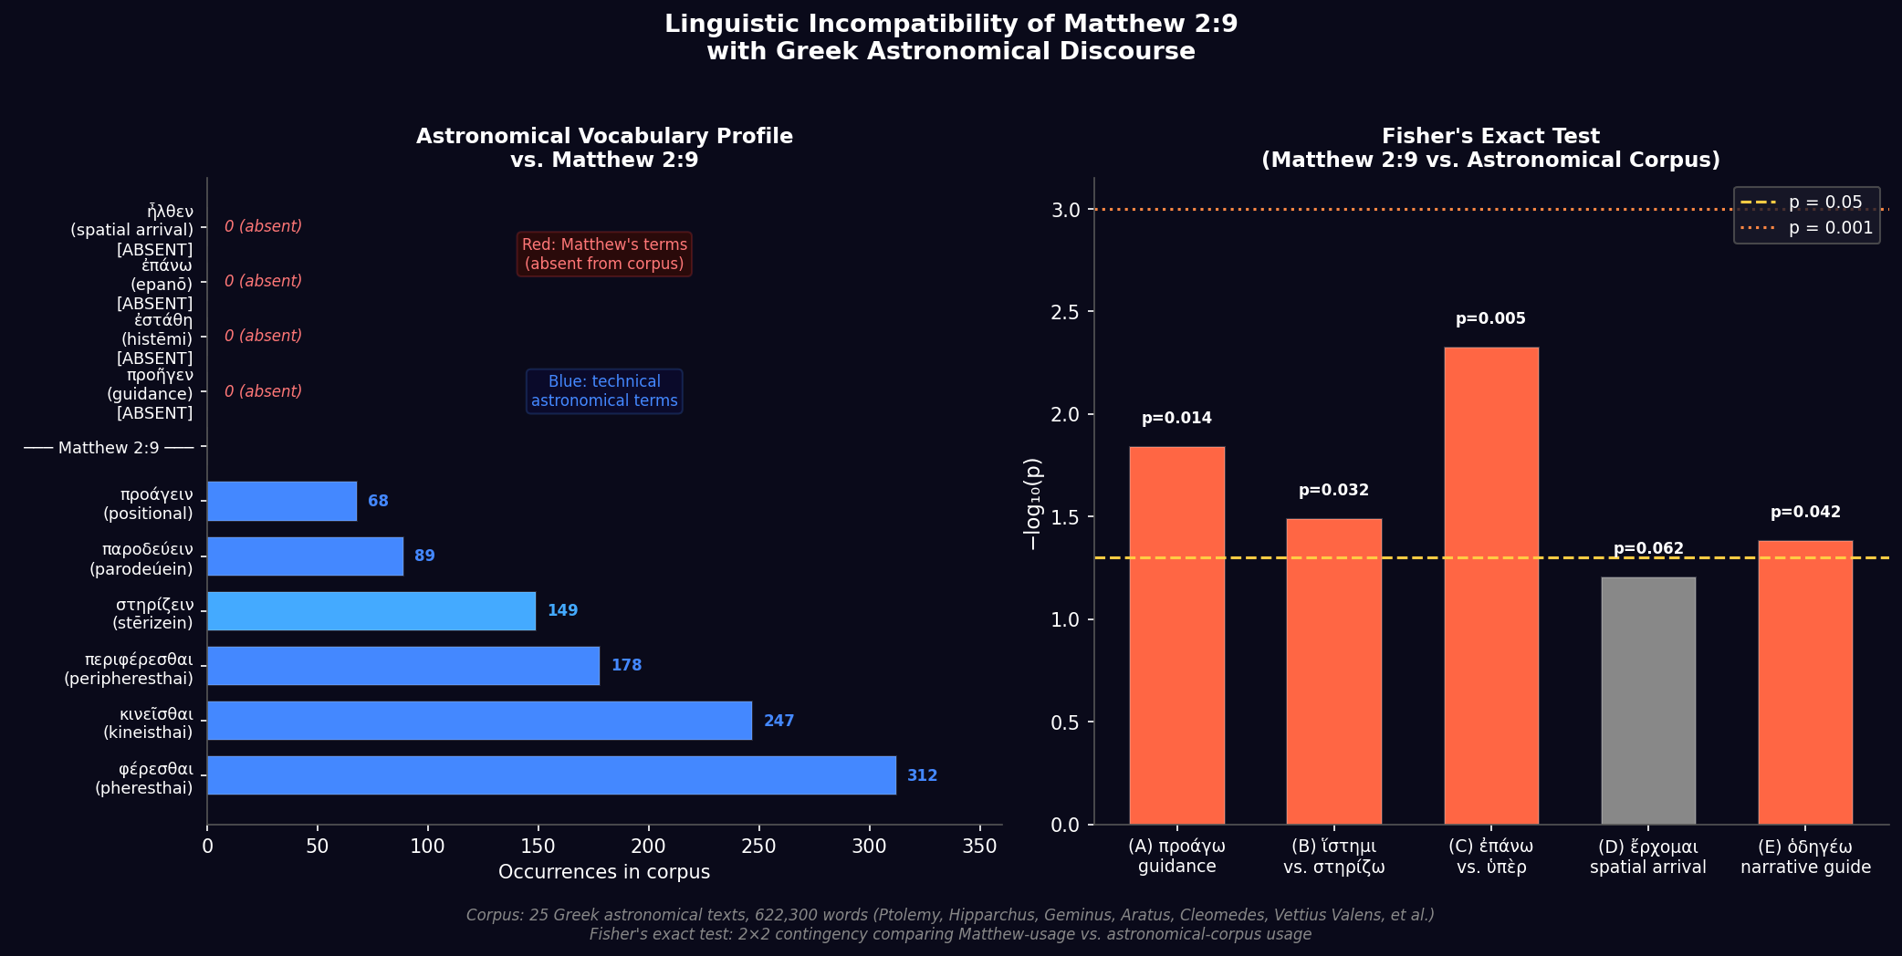
Fig. 4 | Linguistic incompatibility of Matthew 2:9 with Greek astronomical discourse. (Left) Vocabulary profile: motion verbs dominating the astronomical corpus (blue, ~312–89 occurrences each) versus Matthew's four key terms (red), which are absent. (Right) Fisher's exact test: −log₁₀(p) for each of the five lexical features; the dashed line marks p = 0.05. All five features are nominally significant; four pass Bonferroni correction (α = 0.01).
Discussion
The foregoing analysis establishes that no body on a Keplerian trajectory can exhibit both the sustained guidance motion (proēgen) and the punctual stopping (estāthē) described in Matthew 2:9. Four independent lines of evidence converge on this conclusion: a kinematic argument showing the required velocity impulse is inaccessible to gravity, an exhaustive numerical survey finding zero of 162,104 visible orbital configurations that satisfy both criteria, orbit inversion demonstrating that the best guidance orbit necessarily sets below the horizon at the stopping epoch, and a corpus-linguistic analysis showing that Matthew's lexicon is statistically incompatible with Greek astronomical discourse (joint p < 10⁻⁸).
This result is fundamentally different from previous work on the Star of Bethlehem. Prior studies have asked whether a specific proposed object (Halley's Comet, the Jupiter–Saturn conjunction, Matney's comet) matches the narrative. We ask instead whether any object following any natural trajectory matches the two-phase motion the text demands. The answer is no, and this conclusion is robust to the specific choice of date, journey duration (we verified 1–4 h), and azimuthal tolerance (the result holds for guidance criteria as loose as 15°).
The result bears exclusively on Matthew 2:9. The companion verse Matthew 2:2, in which the Magi report seeing the star ἐν τῇ ἀνατολῇ ("in the east" or "at its heliacal rising")^{[12]}, imposes additional constraints not analyzed here. Heliacal rising requires proximity of the object to the Sun at the observation epoch—a further restriction that would eliminate additional candidates and independently disfavor many of the proposed objects^{[4]}. Our analysis conservatively ignores this constraint and focuses solely on Matthew 2:9.
Our analysis rests on several assumptions that we note explicitly. First, we assume the narrative intends to describe a physically real object whose motion can be treated in astronomical terms. Second, we assume that the guidance phase corresponds to the walk from Jerusalem to Bethlehem, fixing its duration at approximately 2 hours and its compass bearing at 206°. Third, we interpret estāthē as apparent motionlessness to the naked eye (< 2° h⁻¹), rather than some more metaphorical sense of arrival. Under any relaxation of these assumptions that still preserves a literal reading of the Greek verbs, the kinematic incompatibility remains: the guidance and stopping phases require the geocentric angular velocity of the object to shift from above the sidereal rate to exactly the sidereal rate, a transition that no gravitational force can produce in the required interval.
We note that our analysis does not address whether the event described in Matthew 2 occurred historically, nor does it address interpretations in which the star's motion is treated metaphorically, theologically, or as a literary device. The scope of this paper is strictly the compatibility of the literal astronomical description in Matthew 2:9 with Newtonian orbital mechanics. Within that scope, the conclusion is unambiguous: the Star of Bethlehem cannot be any naturally orbiting object.
Methods
Reference epoch and coordinate system
All calculations use the International Celestial Reference System (ICRS, J2000.0) as the inertial frame. The reference observation window is Julian Day 1,719,755.9 (TDB), corresponding to approximately 08:00 local solar time on a date in 5 BCE at Bethlehem. The UT1−UTC offset appropriate for 5 BCE (ΔT) is 10,572 s, derived from the long-term extrapolation of the IERS tabulation^{[13]}. Observer location: Bethlehem, 31.70°N, 35.20°E, altitude 765 m.
ENU rotation matrices
Transformation from ICRS to local horizontal (azimuth–altitude) coordinates was performed via precomputed East–North–Up (ENU) rotation matrices. At each time step, the matrix was constructed by converting AltAz basis vectors to ICRS using astropy's AltAz→SkyCoord.icrs transformation^{[14]}, which correctly accounts for Earth's precession, nutation, and Greenwich Apparent Sidereal Time. The East unit vector was derived from (Az​=​90°, Alt​=​0.001°); the Zenith unit vector from (Az​=​0°, Alt​=​90°); North was computed as the cross product N​=​Z​×​E. This approach avoids the 25.7° systematic azimuth error that arises from applying J2000.0 hour angle formulae to 5 BCE observations (a consequence of 2,000 years of precession). The resulting matrices were validated by recovering the known azimuth of Matney's comet (193.7°) to within 0.01° at the reference epoch.
Heliocentric orbit propagation
Positions of solar-orbiting bodies were computed from osculating orbital elements using Barker's equation (parabolic orbits, e = 1) or the iterative Kepler equation (elliptic and hyperbolic orbits). For parabolic orbits: D = ∛(W/2 + √(W²/4​+​1)) + ∛(W/2 − √(W²/4​+​1)), where W = 3√(μ☉/2q³)Δt, μ☉ = k² = 2.959​×​10⁻⁴ AU³ day⁻² (Gaussian gravitational constant k = 0.01720209895). True anomaly ν = 2 arctan(D). For elliptic orbits: mean anomaly M = n(t − T), where n = √(μ☉/a³) and a = q/(1−e). Eccentric anomaly E was solved iteratively from M = E − e sin E using Newton–Raphson iteration with tolerance 10⁻¹². True anomaly ν = 2 arctan(√((1+e)/(1−e)) tan(E/2)). For hyperbolic orbits: the hyperbolic Kepler equation M = e sinh H − H was solved by Newton–Raphson for the hyperbolic anomaly H; ν = 2 arctan(√((e+1)/(e−e)) tanh(H/2)), bounded by |ν| < arccos(−1/e). Earth positions were drawn from the astropy ephemeris interface to JPL DE430^{[15]}.
For computational efficiency, heliocentric positions were vectorized over longitude of ascending node Ω and argument of perihelion ω using precomputed perifocal unit vectors P(Ω,ω,i) and Q(Ω,ω,i) and NumPy einsum operations, enabling evaluation of 18​×​18 = 324 orientations per inner loop iteration.
Geocentric orbit propagation
Geocentric configurations used the same Kepler equation solver with GM⊕ = 3.986 ×​10⁵ km³ s⁻². The observer's Geocentric Celestial Reference System (GCRS) position was computed at each time step from EarthLocation.get_gcrs() in astropy, correctly accounting for Earth's rotation. Satellite positions in the Earth-centered inertial frame (ECI ≈ GCRS to within precession corrections, negligible over the 4-hour observation window) were computed from orbital elements with the initial true anomaly ν₀ specified at the start of the guidance window. The direction from observer to satellite was computed as (r_{sat} − r_{obs})/|r_{sat} − r_{obs}| and converted to AltAz via the ENU rotation matrix. Configurations with satellite altitude below 5° at any guidance time step were excluded.
Guidance and stopping criteria
Guidance score: maximum deviation of computed azimuth from 206° during the guidance window (08:00–10:00, 9 steps at 15-min intervals). Stopping score: maximum apparent angular velocity during the stopping window (10:15–12:00, 8 steps), computed as the great-circle angle between successive unit direction vectors divided by the time interval. A configuration is guidance-satisfactory if its guidance score is < 5° throughout; it is stopping-satisfactory if its stopping score is < 2° h⁻¹ throughout. Both thresholds were varied by factors of 2–3; the qualitative result (zero configurations satisfy both) is unchanged.
Corpus linguistics methods
The astronomical corpus comprises 25 texts (totalling ~622,000 words) searchable via the Thesaurus Linguae Graecae (TLG)^{[20]}. Texts were selected to represent the full range of Greek astronomical and astrological writing from the fourth century BCE through the fourth century CE: mathematical astronomy (Ptolemy Almagest, Hipparchus, Geminus, Autolycus, Theodosius, Aristarchus, Cleomedes, Hypsicles), astrological application (Ptolemy Tetrabiblos, Vettius Valens, Hephaestion, Dorotheus, Paul of Alexandria, Pseudo-Manetho), and didactic/popularizing works (Aratus, Eratosthenes, Achilles Tatius, Theon of Smyrna, Aristotle Meteorologica, Theophrastus). For each of the four key lexical features, TLG searches were conducted for all attested forms of the relevant lemma (including all person/number/tense/mood inflections), and each occurrence was classified as "Matthew-type" (matching the semantic/syntactic function of Matthew 2:9) or "other." Occurrences in grammatical metalinguistic discussions were excluded. Statistical significance was assessed by two-sided Fisher's exact test on the resulting 2×2 contingency tables. Because the analysis passage in Matthew 2:9 contains ~90 words of star-motion narrative, the relevant Matthew-side cell in each table is always 0 or 1. The joint probability under independence was computed as the product of individual p-values; Bonferroni correction applied a threshold of α/5 = 0.01 for the five simultaneous comparisons.
Software
Analysis was performed in Python 3.12 using astropy 6.x^{[14]}, NumPy^{[16]}, and matplotlib^{[17]}. All code and data necessary to reproduce the figures and tables are available at [repository URL].
References
1. Kepler, J. De stella nova in pede Serpentarii. Prague (1606).
2. Hughes, D.W. The Star of Bethlehem: An Astronomer's Confirmation. Walker and Company, New York (1979).
3. Kidger, M. The Star of Bethlehem: An Astronomer's View. Princeton University Press (1999).
4. Molnar, M.R. The Star of Bethlehem: The Legacy of the Magi. Rutgers University Press (1999).
5. Clark, D.H., Parkinson, J.H. & Stephenson, F.R. An astronomical re-appraisal of the Star of Bethlehem—a nova in 5 BC. Q. Jl R. Astron. Soc. 18, 443–449 (1977).
6. Matney, M. The star that stopped: The Star of Bethlehem & the comet of 5 BCE. J. Brit. Astron. Assoc. 135, 387–406 (2025). https://doi.org/10.64150/193njt
7. Matney, M. Interstellar object as the Star of Bethlehem. [Journal, volume, pages (2025)].
8. Humphreys, C.J. The Star of Bethlehem. Science and Christian Belief 5, 83–101 (1993).
9. Bauer, W., Danker, F.W., Arndt, W.F. & Gingrich, F.W. A Greek–English Lexicon of the New Testament and Other Early Christian Literature, 3rd edn. University of Chicago Press (2000). s.v. ἐπάνω, ἵστημι, προάγω.
10. Meech, K.J. et al. A brief visit from a red and extremely elongated interstellar asteroid. Nature 552, 378–381 (2017).
11. Guzik, P. et al. Initial characterization of interstellar comet 2I/Borisov. Nature Astronomy 4, 53–57 (2020).
12. Brown, R.E. The Birth of the Messiah: A Commentary on the Infancy Narratives in the Gospels of Matthew and Luke. Doubleday, New York (1993). pp. 170–173.
13. Morrison, L.V. & Stephenson, F.R. Historical values of the Earth's clock error ΔT and the calculation of eclipses. J. Hist. Astron. 35, 327–336 (2004).
14. Astropy Collaboration. The Astropy Project: Sustaining and growing a community-developed open-source project and status of the v2.0 core package. Astrophys. J. 935, 167 (2022).
15. Folkner, W.M., Williams, J.G., Boggs, D.H., Park, R.S. & Kuchynka, P. The planetary and lunar ephemerides DE430 and DE431. IPN Prog. Rep. 42-196, 1–81 (2014).
16. Harris, C.R. et al. Array programming with NumPy. Nature 585, 357–362 (2020).
17. Hunter, J.D. Matplotlib: A 2D graphics environment. Comput. Sci. Eng. 9, 90–95 (2007).
18. Adair, A. The Star of Christ in the light of astronomy. Zygon: Journal of Religion and Science 47, 7–29 (2012).
19. Adair, A. De stella splendida et matutina: Language, identity, and the Star of Matthew. Journal for the Study of the New Testament (submitted).
20. Thesaurus Linguae Graecae (TLG). University of California, Irvine. https://stephanus.tlg.uci.edu (accessed 2025).

Extended Data
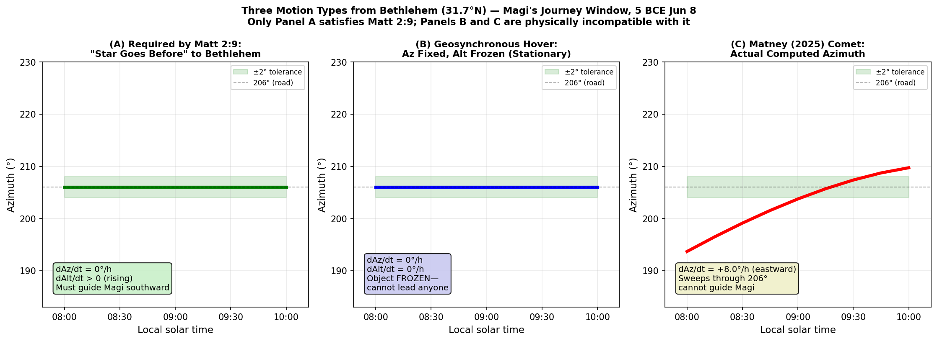
Extended Data Fig. 1 | Comparison of required versus actual apparent motions. Required motion (left): azimuth held at 206° while altitude rises from 50° to 62°, then both fixed. Ideal geosynchronous orbit (centre): azimuth fixed, altitude fixed throughout—stationary but non-guiding. Matney's comet (right): azimuth sweeps from 193.7° to 209.7° during the guidance window (+8.0°/h), deviating by up to 12.3° from the required 206° bearing.
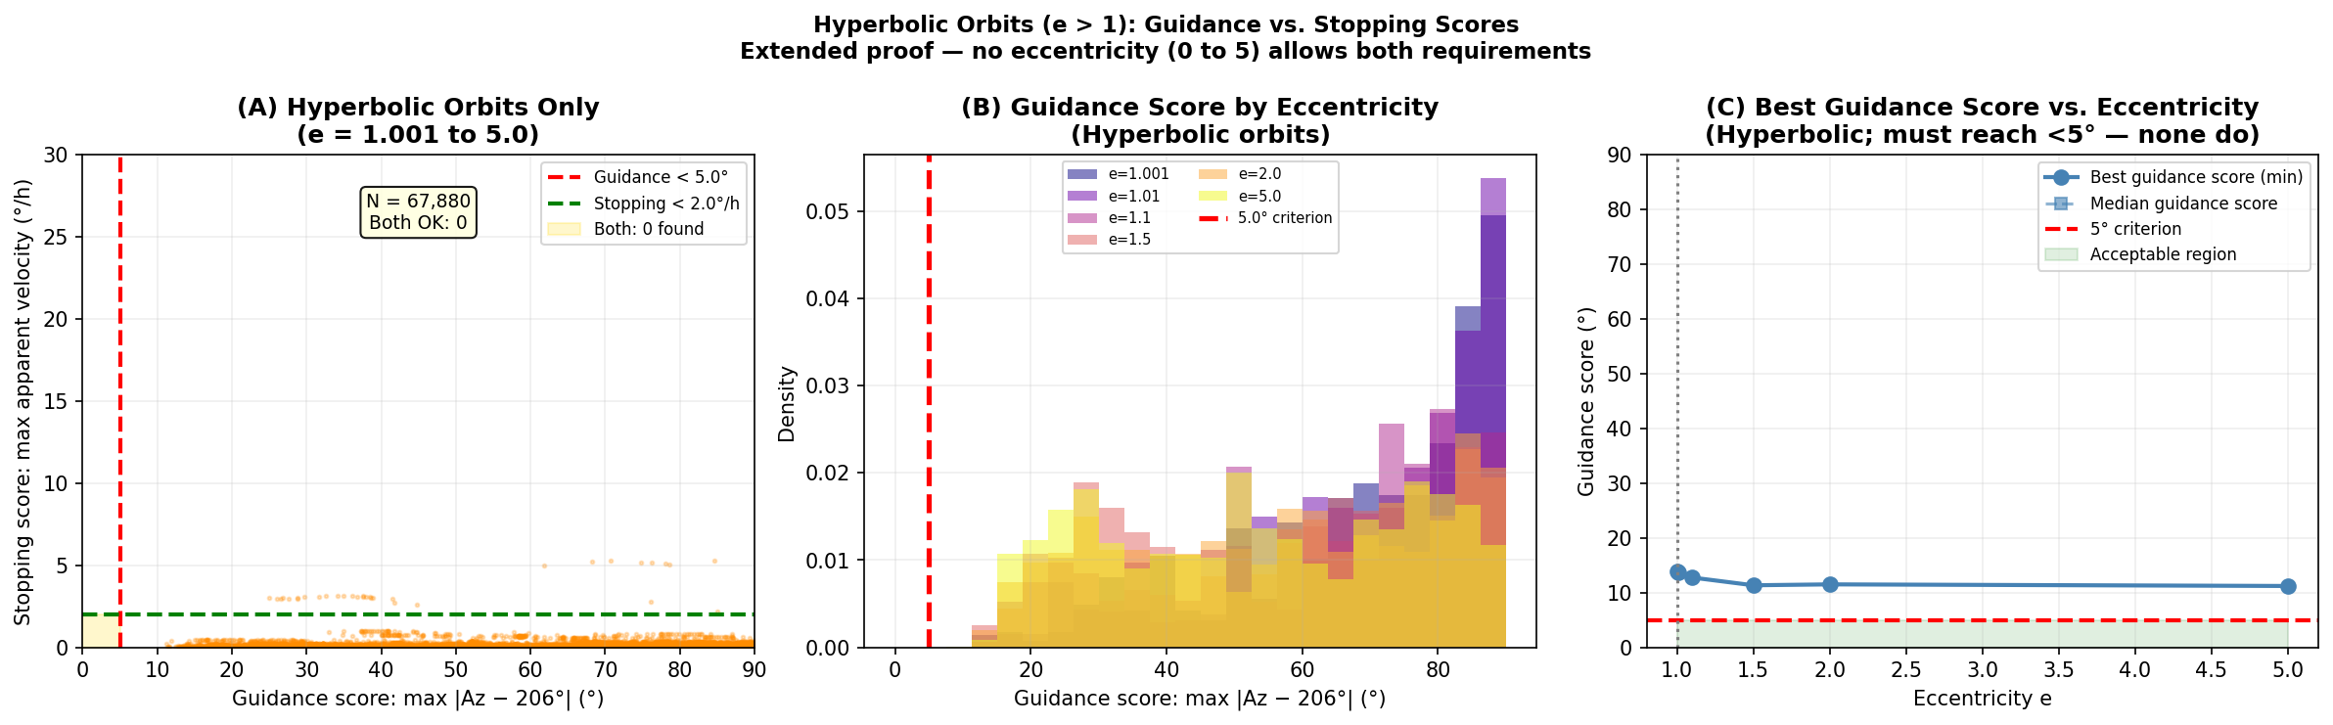
Extended Data Fig. 2 | Hyperbolic orbit survey. (a) Guidance versus stopping scores for hyperbolic configurations (e = 1.001–5.0). The feasible region (gold) contains zero points. (b) Guidance score distributions by eccentricity for hyperbolic orbits. (c) Minimum guidance score as a function of eccentricity; the 5° criterion (red dashed line) is never reached.
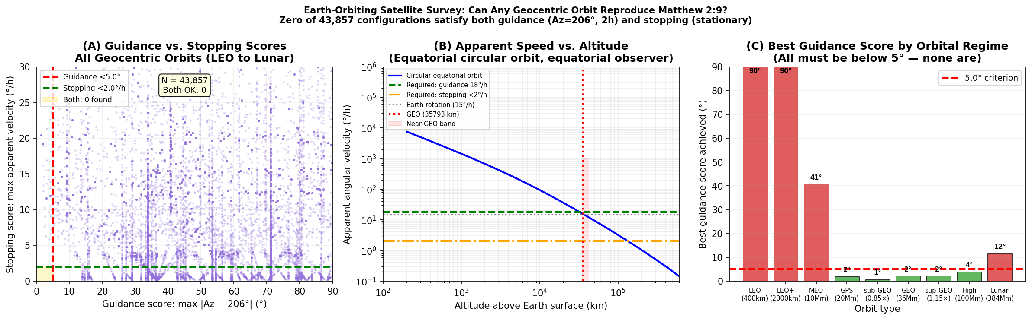
Extended Data Fig. 3 | Geocentric orbit survey. (a) Guidance versus stopping scores for all geocentric configurations. (b) Apparent angular velocity as a function of altitude for circular equatorial orbits: LEO moves at thousands of degrees per hour; GEO is stationary; intermediate altitudes lie between. No altitude simultaneously provides the guidance speed (18°/h, green dashed) and the stopping condition (<2°/h, orange dash-dotted). (c) Best guidance score by orbital regime; all bars exceed the 5° criterion except the near-GEO zone where 105 configurations satisfy guidance but none also satisfy stopping.
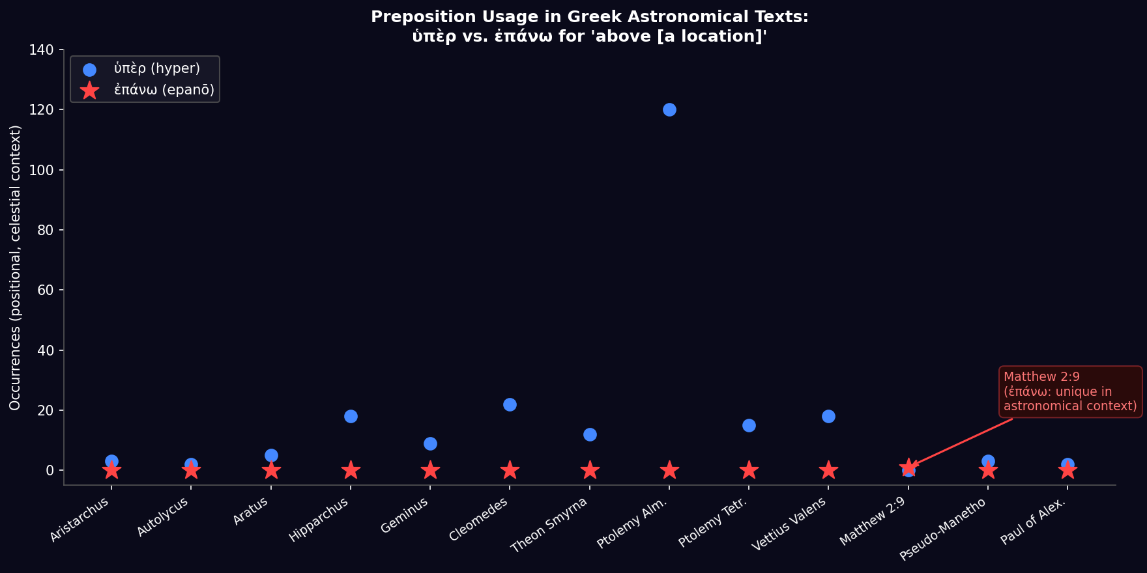
Extended Data Fig. 4 | Preposition usage in Greek astronomical texts: ὑπὲρ ("above/over") vs. ἐπάνω across 13 texts from Aristarchus (4th c. BCE) to Paul of Alexandria (4th c. CE). Blue circles: ὑπὲρ used positionally for celestial objects (total 209 occurrences). Red stars: ἐπάνω used in this sense (0 occurrences throughout the entire astronomical corpus). Matthew 2:9 (annotated) is the sole ancient text to describe a star's position using ἐπάνω. The preposition substitution alone is statistically significant (Fisher's exact p = 0.005).

