Title

TOC Heading

Title 2

Authors 2

Description 2

Hypotheses 3

Design Plan 4

Study type 4

Blinding 4

Is there any additional blinding in this study? 4

Study design 4

Randomization 5

Sampling Plan 6

Existing Data 6

Explanation of existing data 6

Sample size 7

Sample size rationale 7

Stopping rule 7

Variables 7

Manipulated variables 7

Measured variables 8

Analysis Plan 9

Statistical models 9

Transformations 9

Inference criteria 9

Data exclusion 10

Missing data 10

Exploratory analysis 10

Other 12

Other 12

# Heading 1

## Heading 2

Main body text main body text main body text main body text main body text main body text main body text main body text main body text main body text main body text main body text main body text main body text main body text main body text main body text.

## Heading 2

Main body text main body text main body text main body text main body text main body text main body text main body text main body text main body text main body text main body text main body text main body text main body text main body text main body text.

#### Heading 4

##### Heading 5

Normal text normal text normal text normal text normal text normal text normal text

Rossion, B., & Pourtois, G. (2004). Revisiting Snodgrass and Vanderwart’s Object Pictorial Set: The Role of Surface Detail in Basic-Level Object Recognition. Perception, 33(2), 217–236. <https://doi.org/10.1068/p5117>

summary(cars)

## speed dist   
## Min. : 4.0 Min. : 2.00   
## 1st Qu.:12.0 1st Qu.: 26.00   
## Median :15.0 Median : 36.00   
## Mean :15.4 Mean : 42.98   
## 3rd Qu.:19.0 3rd Qu.: 56.00   
## Max. :25.0 Max. :120.00

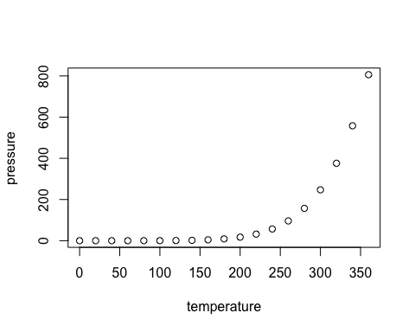

Note that the echo = FALSE parameter was added to the code chunk to prevent printing of the R code that generated the plot.