Exploratory Analysis of the Relationship between Antenatal Variables and Pregnancy Risk Classification: A Data Visualization Approach
by Ihechukwu Clara Nzeako
Date: October 2026 | Tools Used: Excel | Dataset Source: Kaggle
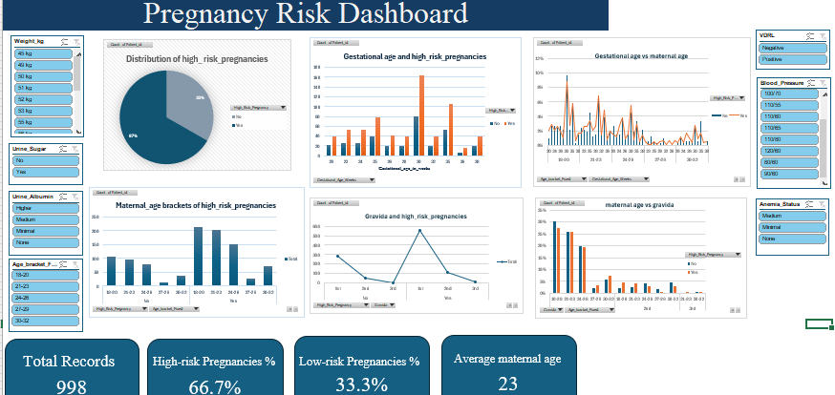
- Introduction & Background
Pregnancy is a physiological process accompanied by several maternal adaptations that require appropriate monitoring throughout gestation. Although many pregnancies progress without significant complications, some are associated with an increased likelihood of adverse maternal and fetal outcomes.
Antenatal care is medical care and support women receive from health professionals during pregnancy. During antenatal care, pregnant women are closely monitored and undergo routine clinical assessments and evaluation of relevant demographic and physiological parameters. Variables like maternal age, gravida status, maternal blood pressure, anemic status and urine albumin.
Maternal risk is the likelihood that a mother and child are likely to experience harmful outcomes during the pregnancy and labor period. High-risk pregnancy refers to a clinical classification for pregnant women at an elevated risk of complications or adverse outcomes affecting mothers and/or neonates.
With the increasing availability of healthcare data, analytical tools offer opportunities to explore relationships between clinical variables and health outcomes or classifications. Data analysis and visualization can facilitate the identification of patterns, comparison of patient groups, and communication of findings in an accessible format.
This project therefore employs exploratory data analysis and visualization to investigate the relationships between selected antenatal variables and existing pregnancy risk classifications. Using Microsoft Excel, the dataset was cleaned, analyzed, and presented through an interactive dashboard to examine how demographic and physiological characteristics vary between high-risk and low-risk pregnancy categories.
- Project Objectives
The objectives of this project were to:
- To examine the distribution of demographic and clinical variables within the dataset.
- To compare antenatal variables between high-risk and low-risk pregnancy categories.
- To investigate the association between maternal age and pregnancy risk classification.
- To examine the relationship between selected physiological parameters and pregnancy risk classification.
- To visualize the observed patterns and communicate the findings through an interactive dashboard.

- Data description and methodology

  - Data source:
The dataset was gotten from Kaggle.net
It contains 998 records and contains 18 variables, including maternal age, gravida, gestational age, blood pressure, anemia status, jaundice status, fetal position, fetal heart rate, urine sugar, urine albumin, VDRL, and HRsAG relevant to maternal health and antenatal care.

3.2 Data Preparation and Cleaning
The dataset was reviewed to assess its completeness, consistency, and suitability for analysis.
The data preparation process involved:
- Checking for duplicate records.
- Identifying missing values.
- Reviewing inconsistent entries and data formats.
- Converting variables into appropriate formats where necessary.
- Creating additional analytical categories where appropriate.
- Validating calculations and transformed variables.
The following transformations were performed:
- Grouping the ages into age brackets.
- Removing the names to protect patient identity and replacing each of them with a unique patient ID.
- Separating the blood pressure values into systolic and diastolic blood pressure.

3.3 Analytical Methods
Microsoft Excel was used to perform the analysis.
The methods included:
- Data cleaning.
- Data transformation.
- Descriptive statistics.
- Exploratory data analysis.
- Cross-tabulation.
- Data visualization.
- Interactive filtering.

3.4 Dashboard Design
The dashboard was developed to present the key indicators in an accessible visual format.
It includes:
- Distribution of risk pregnancies chart.
- The relationship between gestational age and risk pregnancies chart.
- The relationship between gravida status and risk pregnancies chart.
- Distribution of risk pregnancies across different age-brackets chart.
- A few KPI showing percentages of high- and low- risk pregnancies, and average maternal age.
- Some filters like anemic status, urine albumin, etc.
The dashboard was designed to help users identify distributions, compare categories, and explore the available data.

4. KEY FINDINGS AND DASHBOARD INTERPRETATION
4.1 Demographic Analysis
The average age of women in the dataset was 23 years. Women aged 18-20 accounted for the largest proportion of both high-risk (32.1%) and low-risk (32.5%) pregnancies. Women aged 21-23 constituted the second-largest group in both categories. Women aged 27-29 had the lowest representation, accounting for 3.9% in both categories. The age distribution was relatively similar across the high-risk and low-risk groups.
Interpretation: The findings indicate that the study population was predominantly made up of young women, with those aged 18-23 accounting for the largest proportion of pregnancies. The relatively similar age distribution across both risk categories suggests that maternal age groups were represented comparably among high-risk and low-risk pregnancies in this dataset. No substantial difference in age distribution was observed between the two categories.
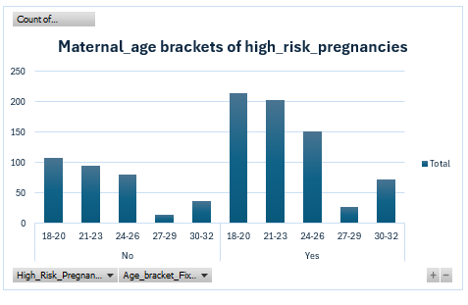
4.2 Comparative Analysis
4.2.1. Gestational Age and High-Risk Pregnancies
Findings
- High-risk pregnancies were recorded across different gestational ages.
- The highest number of high-risk pregnancy records occurred at 30 weeks(24%).
- This was followed by 35 weeks(16%) and 25 weeks(12%).
- Among low-risk pregnancies, 25 and 30 weeks had relatively high patient counts.
- Some gestational ages had considerably fewer recorded cases.
Interpretation
The distribution indicates that high-risk pregnancies occurred across different stages of gestation, with a noticeable concentration around 30 weeks.
The relatively high number of cases at this gestational age suggests that a substantial proportion of the high-risk records in the dataset were associated with pregnancies at approximately 30 weeks.
However, this does not establish that 30 weeks carries a higher risk of pregnancy complications. Further analysis of the percentage of high-risk pregnancies at each gestational age would be required.
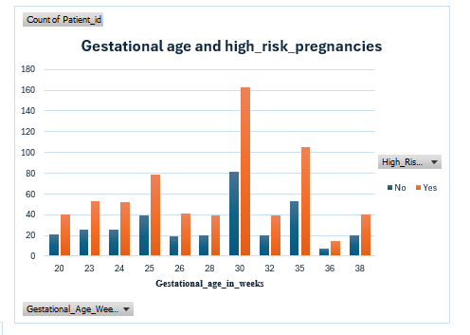
4.2.2. Gestational Age Versus Maternal Age
Findings
- The 18–20-year age bracket recorded a relatively high number of pregnancies.
- The 21–23 and 24–26-year age brackets also accounted for considerable patient counts.
- Patient counts generally decreased across the older maternal age categories.
- High-risk pregnancies were recorded across different maternal age and gestational age categories.
Interpretation
The findings indicate that the study population was predominantly composed of younger pregnant women, particularly those aged 18–26 years.
The decreasing patient counts across the older age brackets suggest that older women were less represented in the dataset.
The presence of high-risk pregnancies across different age groups indicates that high-risk pregnancy classification was not limited to a particular maternal age category.

4.2.3. Gravidity and High-Risk Pregnancies
Findings
- Primigravida accounted for the highest number of recorded pregnancies.
- Secundigravida had considerably fewer records than primigravida.
- Tertigravida had the lowest number of recorded pregnancies.
- High-risk pregnancy records were highest among primigravida(84%).
- The number of high-risk records decreased across the subsequent gravidity categories.
Interpretation
The findings demonstrate that primigravida constituted the largest group within the study population.
The higher number of high-risk pregnancy records among primigravida indicates that first pregnancies contributed the greatest number of high-risk cases in the dataset.
However, this may partly reflect the higher representation of primigravida in the study population.
It is therefore necessary to compare the proportion of high-risk pregnancies within each gravidity category before determining whether gravidity is associated with high-risk pregnancy classification.
g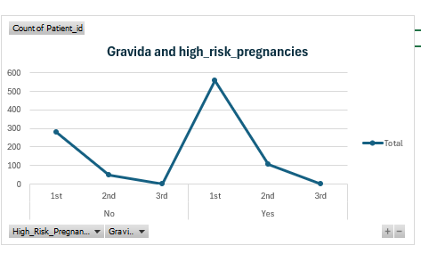
4.2.4. Maternal Age Versus Gravidity
Findings
- Among primigravida, the 18–20 and 21–23-year age brackets recorded the highest patient counts.
- Secundigravida were distributed across different maternal age categories, with fewer records than primigravida.
- Tertigravida accounted for the lowest number of records.
- High-risk pregnancy records were observed across different combinations of maternal age and gravidity.
- The distribution of gravidity varied across maternal age categories.
Interpretation
The findings suggest a relationship between maternal age and gravidity in terms of their distribution within the study population. The predominance of primigravida among younger women is consistent with the expectation that younger pregnant women are more likely to be experiencing their first pregnancy. The representation of secundigravida and tertigravida across older age categories reflects the variation in reproductive history across maternal age groups. The presence of high-risk pregnancies across different age and gravidity combinations also suggests that neither variable alone adequately describes the distribution of high-risk pregnancies.

Overall Summary
General Findings
- High-risk pregnancies were recorded across different gestational ages.
- The majority of pregnant women in the dataset belonged to the 18–26-year age categories.
- Primigravida accounted for the highest number of pregnancies and high-risk pregnancy records.
- Maternal age and gravidity showed variations in their distribution across the study population.
- High-risk pregnancies occurred across different maternal age, gestational age and gravidity categories.
General Interpretation
The comparative analysis demonstrates variations in the distribution of high-risk pregnancies across selected maternal demographic and obstetric characteristics. Younger maternal age groups and primigravida were more represented in the dataset, and these groups also contributed a substantial number of high-risk pregnancy records. However, the observed differences in patient counts do not independently establish an increased likelihood of high-risk pregnancy. Further statistical analysis is necessary to determine whether maternal age, gestational age and gravidity are significantly associated with high-risk pregnancy classification.

5. Limitations
The analysis was subject to the following limitations:
- The dataset may not represent the wider population of interest.
- The accuracy of the findings depends on the quality and completeness of the recorded information.
- The available variables may not explain all factors associated with the observed patterns.
- The dataset focused mostly on younger population and women within similar physiological characteristics like weight and height.
- Some variables like accurate average blood pressure across the pregnancy timeline were not available.

6. Executive Summary.
This project involved the analysis and visualization of a dataset containing 998 records relating to maternal health.
The primary objective was to clean and analyze the data, and understand the relationship amongst the variables. Microsoft Excel was used to clean and transform the data, calculate relevant indicators, perform exploratory analysis, and develop an interactive dashboard.
The analysis examined the maternal age groups, gravida status and gestational age relationships with high-risk pregnancies. The key findings include: the average age of women in the dataset was 23 years and the majority of pregnant women in the dataset belonged to the 18–26-year age categories, primigravida accounted for the highest number of pregnancies and high-risk pregnancy records, and high-risk pregnancies were recorded across different maternal age and gestational age categories.
The dashboard provides a visual summary of the analyzed indicators and supports the identification of patterns within the dataset. However, the findings are limited by lack of representation of wider population of interest.

