Daniel Adalaid

Mayumi Luque

**Report**

**Part 1**

**Part 2**

*Iris Dataset*

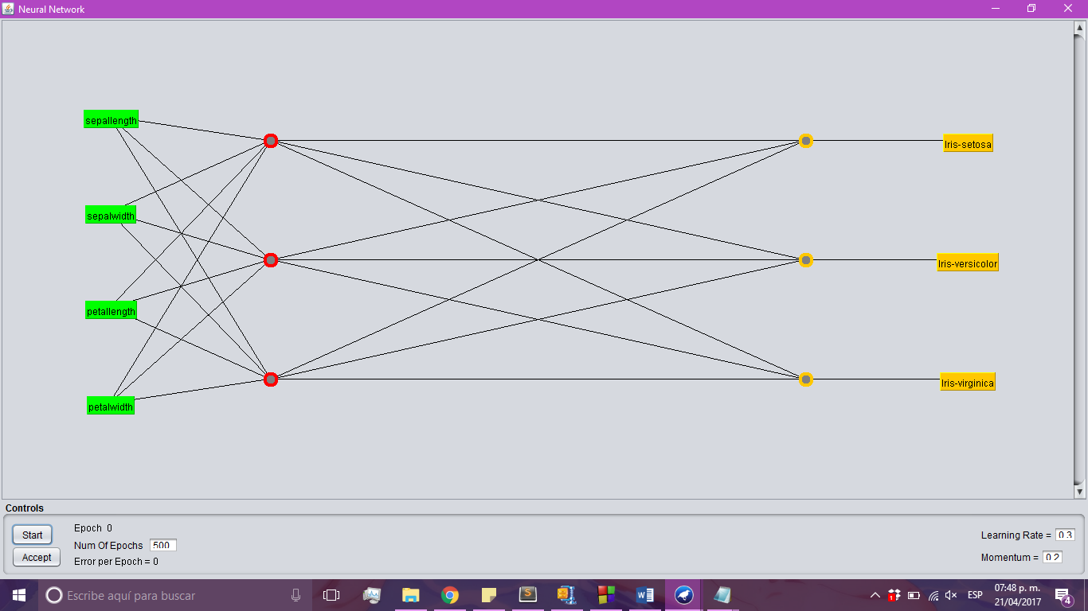

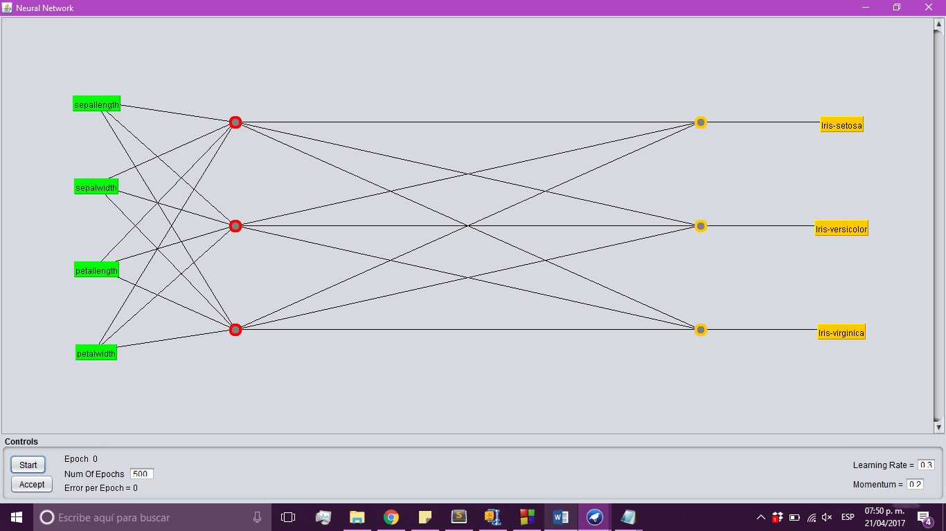

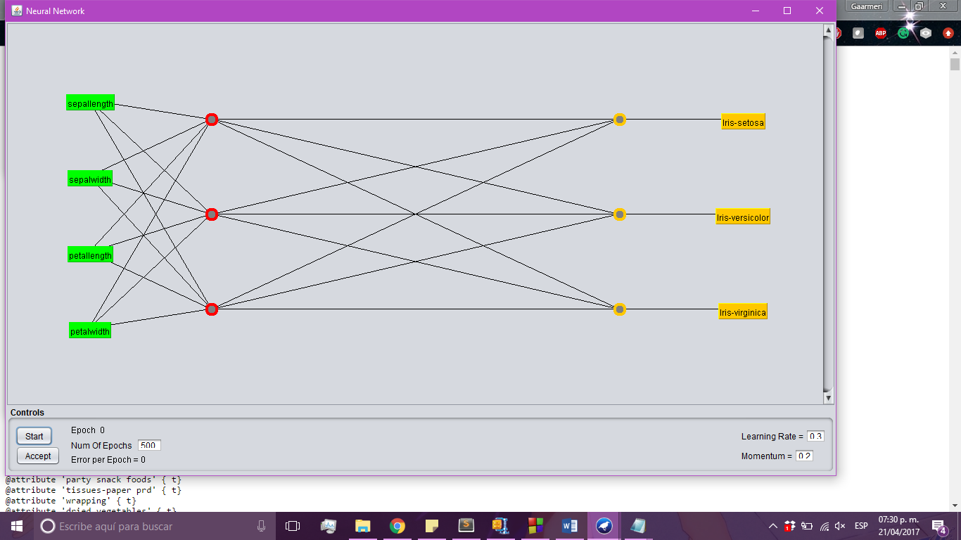

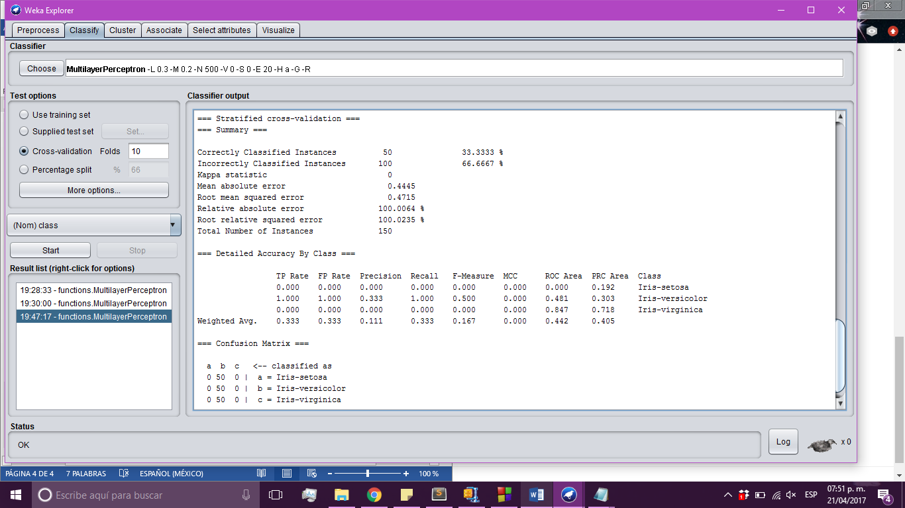

* **Explanations as to what are ANNs good for.** As ANNs are nonlinear models that easy to use and understand, when used with a back propagation learning algorithm, they are used to solve various classification and forecasting problems. This said, their major advantage is solving problems like image and sound recognition, text and time series analysis and others.
* **Where would you use them?** We’d use them for classification, as it’s great in recognizing patters and sequences. Another area where they can be used, is robotics. This are especially useful in prosthesis. Also, function approximation and regression analysis.
* **Are they worth the effort implementing or not?** Is anything worth the effort? No, but really, it is totally dependent on the problem. You won’t want to implement and ANN where another simpler algorithm can be used. Like any other problem in programming, you have to weigh the pros and the cons against each other.
* **What kinds of problems do they not solve?** World hunger and cancer. Oh, that wasn’t what you meant, was it? Well, ANN are accurate, yes, but they are often tedious to train since they require time and effort. They also lack explanatory power, which means you’ll be likely to stay in the dark when they reach a certain conclusion.