PATIENT SYMPTOM PRE-SCREENER
AI-Powered Medical Triage System

Technical System Design Report
April 2026
Lyna Adalet

Tasnim Ben Dhia

Junior IT/BA

Step 1: Project Analysis & System Requirements

A. Functional Requirements — What the System Does

# | Requirement | Description | Priority
FR-01 | Patient Intake | Allows users to enter personal details (age, biological sex) and structured medical history including known conditions and documented allergies. | Critical
FR-02 | Symptom Description | Provides a free-text area for detailed symptom narratives alongside Quick Select chips for common symptoms, enabling both thorough and rapid input. | Critical
FR-03 | AI Analysis | Transmits the captured patient data to the Gemini API, which returns identified possible medical categories and an urgency triage level. | Critical
FR-04 | Doctor Summary | Auto-generates a structured, professional summary for medical staff, including chief complaint, key history flags, AI-assessed categories, urgency level, and a concise Doctor Note. | Critical

B. Non-Functional Requirements — How the System Performs

NFR | Category | Requirement Statement
NFR-01 | Security | Patient data must be encrypted during transit to protect privacy and ensure regulatory alignment with healthcare data standards.
NFR-02 | Performance | AI analysis and summary generation must complete within an acceptable wait time for users who may be in physical distress.
NFR-03 | Usability | The interface must be navigable by non-technical users, including elderly patients and those experiencing symptoms.

Step 2: Use-Case Diagrams

A. Actors
Actor | Type | Description | Interaction Mode
Patient | Primary | The individual presenting with symptoms. May be anxious, in pain, or non-technical. Primary data producer. | Enters information via frontend UI
Doctor / Clinical Staff | Secondary | Healthcare professional who receives the AI-generated summary at the point of care. Consumes, not inputs. | Views results screen / printed summary
AI System | External System | The intelligent processing engine. Receives structured prompts and returns categorised, prioritised medical summaries. | Communicates via HTTPS REST API

B. Use-Case Descriptions
Use Case | Actor | Trigger | Outcome
UC-01: Enter Personal Info | Patient | Patient opens the app for the first time in a session | System captures age, sex, conditions, and allergies
UC-02: Select / Describe Symptoms | Patient | Patient proceeds to the symptom screen | System stores free-text and chip selections
UC-03: Analyze Data | AI System | Patient taps 'Analyze with AI' | Gemini returns categories, urgency, and Doctor Note
UC-04: View Prioritized Summary | Doctor | System renders results | Doctor receives a structured, ready-to-review triage summary
UC-05: Print / Export Summary | Doctor | Doctor taps print or share | Summary is formatted for handoff or record entry

C. Use-Case Diagram

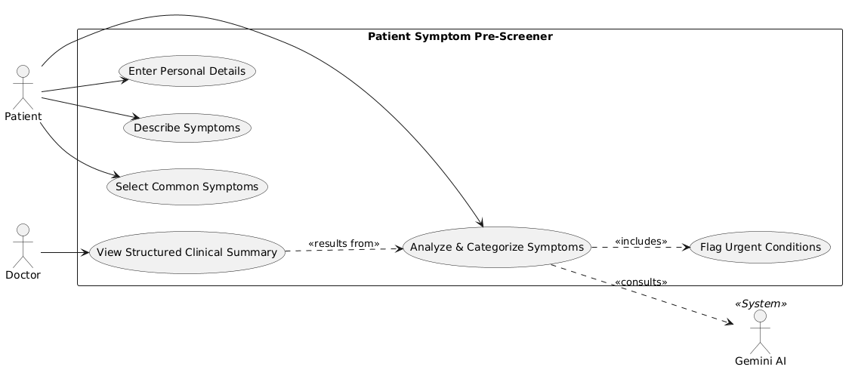

Step 3: System Design & Architecture

A. Architecture Overview
The system adopts a three-tier Client-Server architecture, which separates concerns cleanly and ensures that sensitive API credentials never reside on the user's device.

Layer | Recommended Technology | Purpose & NFR Compliance
Frontend (Mobile) | Jetpack Compose | NFR-03: Simplifies creating 44x44dp touch targets and managing WCAG-compliant color contrast using Material 3 themes.
Networking (Client) | Ktor Client (or Retrofit) | NFR-01: Enforces TLS 1.3 for all outgoing requests to the middleware.
Backend Middleware | Ktor Server (Kotlin JVM) | NFR-01 & 02: Acts as a secure proxy. Constructed in Kotlin for high performance and low-latency prompt building.
Data Handling | Kotlinx.serialization | NFR-01: Handles JSON in-memory only. Ensures patient data is never persisted to a database beyond the active session.
AI Engine | Gemini | NFR-02: Chosen specifically for speed to ensure the 95th percentile latency stays under 5 seconds.
AI Integration | Google AI Kotlin SDK | NFR-02: Provides native support for streaming responses, reducing perceived wait time for the user.

B. Sequence Diagram
The sequence diagram below details the complete lifecycle of a single AI analysis request, from the moment the patient taps 'Analyze with AI' to the display of the results screen.

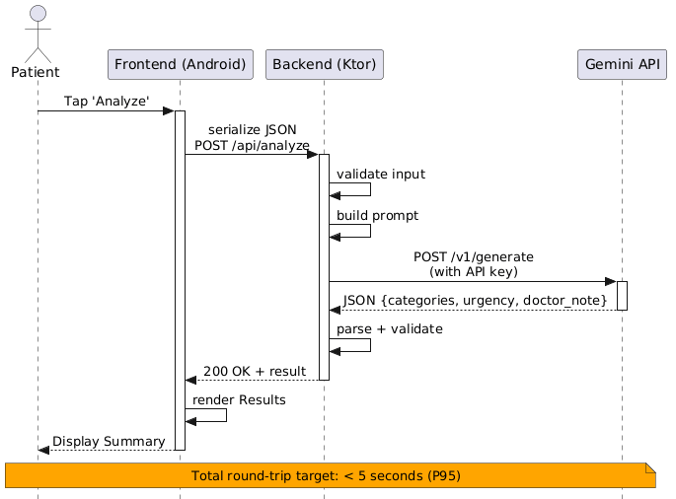

Prompt Engineering Strategy
The backend constructs a structured system prompt that instructs the Gemini model on output format and medical framing. The user turn contains a templated summary of the patient data. An example prompt structure is shown below:

System Prompt:
You are a medical triage assistant. Respond ONLY in JSON format with keys: possible_categories (array of strings), urgency_level (one of: 'Immediate', 'Urgent', 'Semi-Urgent', 'Non-Urgent'), doctor_note (string, max 100 words). Do not add any explanation outside the JSON.

User Prompt Template:
Patient: {age} year old {sex}. Known conditions: {conditions}. Allergies: {allergies}. Symptoms reported: {symptom_text}. Quick-select tags: {tags}.

Step 4: Interface Prototypes
The interface prototype consists of four sequential screens that guide the patient from initial welcome through to the AI-generated clinical summary. Each screen is presented below with descriptive annotations. Screens annotated with an AI marker indicate content generated dynamically by the Gemini API.

Screen 1: Welcome & Disclaimer
SCREEN 1 | Purpose: Orient the user and obtain informed consent to proceed.  Key Elements: App logo, tagline, medical disclaimer, 'Get Started' CTA button.  UX Note: Disclaimer is non-negotiable; user must scroll to reveal the button, ensuring awareness.

🏥 PATIENT SYMPTOM PRE-SCREENER
AI-assisted triage to help clinical staff prioritize your care
Important Medical Disclaimer
This tool does NOT replace a doctor's diagnosis. It is designed solely to assist healthcare staff in prioritizing patient assessments. In case of emergency, dial emergency services immediately.
[ I Understand — Get Started ]

Screen 2: Patient Information
SCREEN 2 | Purpose: Capture demographic and medical history data (FR-01).  Key Elements: Age field, sex selector, known conditions text area, allergies text area, 'Next' button.  UX Note: All fields optional — patient may not know full history. Placeholder text guides input.

Step 1 of 3 — Your Information
Age
[ Enter your age ]
Biological Sex
( ) Male ( ) Female ( ) Prefer not to say
Known Medical Conditions (optional)
[ e.g., Diabetes, Hypertension, Asthma... ]
Known Allergies (optional)
[ e.g., Penicillin, Sulfa drugs, Aspirin... ]
[ Next: Describe Symptoms → ]

Screen 3: Symptom Description
SCREEN 3 | Purpose: Collect symptom detail via free text and Quick Select chips (FR-02).  Key Elements: Free-text area, Quick Select chip grid, 'Analyze with AI' button with loading state.  UX Note: Chips are additive — selecting a chip appends the term to the text area, visible to the patient.

Step 2 of 3 — Describe Your Symptoms
Tell us how you're feeling
[ Describe your symptoms in your own words. When did they start? How severe? ]
[ ]
[ ]
Quick Select — Common Symptoms
[ Fever ] [ Chest Pain ] [ Shortness of Breath ] [ Nausea ]
[ Headache ] [ Dizziness ] [ Vomiting ] [ Back Pain ]
[ 🔍 Analyze with AI ]

Screen 4: AI-Generated Results Summary
AI Content Annotation: The following screen contains two sections generated entirely by the Gemini API (highlighted): 'Possible Medical Categories' and 'Doctor Note'. All other fields are derived from patient-entered data. This distinction is critical: clinical staff must not treat AI-generated content as diagnosis.

SCREEN 4 | Purpose: Display structured AI output for clinical review (FR-03, FR-04).  AI-Generated Sections: Possible Categories, Urgency Level badge, Doctor Note paragraph.  Static Sections: Patient demographics, selected Quick Select tags, raw symptom text (as entered).

Step 3 of 3 — AI Analysis Results
Patient Profile (entered by patient)
Age: 42 | Sex: Male | Conditions: HTN | Allergies: None

Reported Symptoms (entered by patient)
Sudden tightness in my chest and left arm pain for the past 20 minutes. Feeling very sweaty.
Quick Select Tags: Chest Pain | Shortness of Breath | Dizziness

✦ AI-GENERATED ANALYSIS ✦ Powered by Gemini API
Urgency Level:
🔴 IMMEDIATE — Requires urgent physician evaluation
Possible Medical Categories ← GEMINI-GENERATED
1. Acute Coronary Syndrome | 2. Myocardial Infarction (MI)
3. Angina Pectoris | 4. Aortic Dissection

Doctor Note ← GEMINI-GENERATED
42-year-old hypertensive male presenting with acute-onset substernal chest tightness and left arm radiation over 20 minutes, accompanied by diaphoresis. Symptom constellation is highly suggestive of an acute cardiac event. Recommend immediate ECG, troponin panel, and cardiology consult. Do not leave patient unattended.

[ 🖨 Print Summary ] [ ← New Assessment ]

Conclusion
This report defines the Patient Symptom Pre-Screener through requirements, use cases, architecture, and prototyping. The system successfully balances functional clinical workflows with strict non-functional standards for security (TLS 1.3), performance (< 5s latency), and accessibility (WCAG 2.1 AA).
The three-tier architecture ensures sensitive data and API credentials remain secure on the backend, while the interface prototypes confirm a low-friction, accessible user journey. Collectively, these specifications provide a robust and defensible design ready for the implementation phase.

