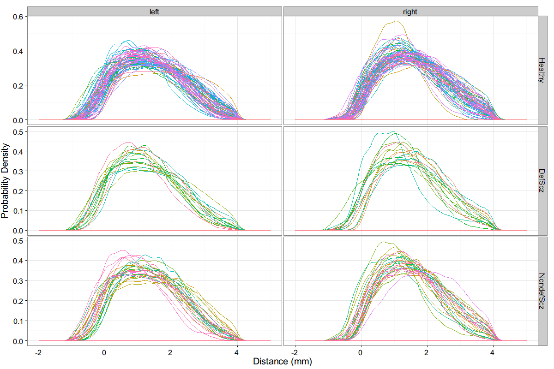

Figure 1 shows the density estimates of the distributions of the LCDM statistics for each subject. We observe that there is significant variation between subjects in the same diagnosis groups, even between left and right hemisphere for the same population. There are also noticeable number of outlier subjects in both deficit schizophrenia and nondeficit schizophrenia diagnosis groups which could indicate a test based on the LCDM statistics can provide satisfactory sensitivity for the schizophrenia condition.



Table 1 lists the descriptive statistics for the three summary LCDM measures: Surface Area and 0.95 quantiles of Volume and Thickness. We observe that for Volume and Surface Area measures, the means of the statistics for the left side (hemisphere) is smaller, while for the thickness measure, the means for the right side is smaller.



In fact, all three LCDM summary statistics are associated with side, significant at a level of p=0.005. The Diagnosis variable has no main effect on the LCDM measure, and there is no interaction effect of side and diagnosis at a significant level for any of the three LCDM measures.

There was no significant correlation between the PT measures and age of onset of illness, estimated IQ, SANS/SAPS subscales, number of times hospitalized, educational level, left/right handedness and race medications.



In addition, the different statistical tests using the pooled LCDM statistics indicate that there is a significant difference between the PT measure distributions for the different diagnosis populations. Kruskal-Wallis and ANOVA F-test were applied to the samples for all three groups to test whether they come from the same population. Kolmogorov-Smirnov tests were performed on pairs of groups to test for difference of measure distributions of the two groups. Welch’s t-test and Mann-Whitney U test were applied to test for difference of means. In case of significance of these two-sided tests, one-sided versions of the same tests were applied to determine the direction of significance. The implications of the one-sided tests are listed in Table 3.

Following Ceyhan et al., the pooled LCDM statistics were censored at growing intervals, with the right endpoint increasing in increments of 0.01 mm. The results for the Mann-Whitney U-test and Welch’s t-test with the censored statistics show that for all censoring distances larger than 0, there is clear pairwise difference between diagnosis groups. The same is true also for one-way ANOVA and Kruskal-Wallis test applied to the all three groups.