|  |  |
| --- | --- |
| Date | Update |
| 07/19/2022 | Modified how source code appears so that there is space between the end of the code and the next line. (Thus, do not need to add <br> after code chunks that print results.  Added example source code and table to quickly identify the corresponding style, so that it can be modified. |

This document contains the word styles to be used when knitting an R markdown file to Word. It should be **saved in the same location as the markdown file** in order to pull the styles.

This template was created following the directions at the links below:

<https://bookdown.org/yihui/rmarkdown-cookbook/word-template.html>

<https://vimeo.com/110804387>.

The styles were modified from the SAP template on the Core website:

<https://biostat.duke.edu/sites/biostat.duke.edu/files/SAP%20template%202021%207%2023.pdf>

Tips for using this template are given on the following pages and in the rmd file.

Created February 2022, email [tina.davenport@duke.edu](mailto:tina.davenport@duke.edu) with questions or feedback.

**TIP**: switch to “visual markdown editor” to fill in the tables of variable descriptions in markdown.

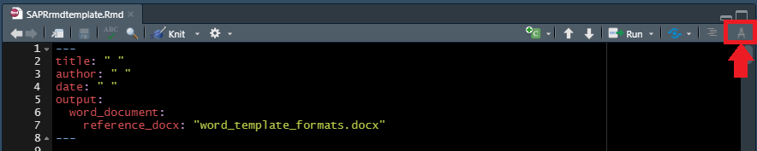

I updated RStudio and in looks like this now:

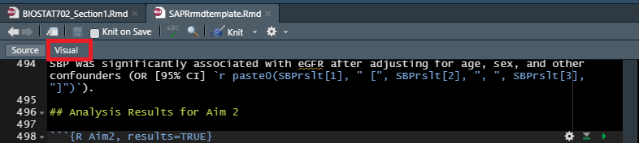

The table looks like this in visual editor and can be filled in as one would in Word:

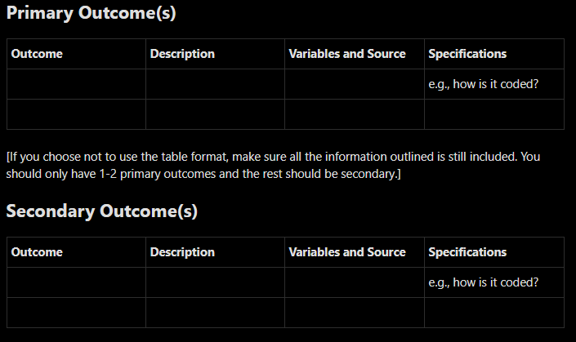

If you don’t like the style of the tables (Arial Narrow font, etc.) you can change them in this document following the directions here: <https://bookdown.org/yihui/rmarkdown-cookbook/word-template.html>.

Use the table below to identify the table style in order to modify. Highlight the table:

|  | Overall | Arm_High | Arm_Low |
| --- | --- | --- | --- |
| n | 29 | 6 | 13 |
| AGE N= | 29 | 6 | 13 |
| AGE Mean (SD) | 56.22 (13.36) | 45.63 (7.76) | 59.99 (16.38) |
| AGE Median [IQR] | 56.8 [49.1-65.4] | 44.8 [39.38-50.45] | 62.1 [49.3-73] |
| AGE (Min, Max) | (32.9, 89.1) | (37.5, 56.8) | (32.9, 89.1) |

Then click on the additional Styles button – the current style should be pre-selected in this list. See screenshot:

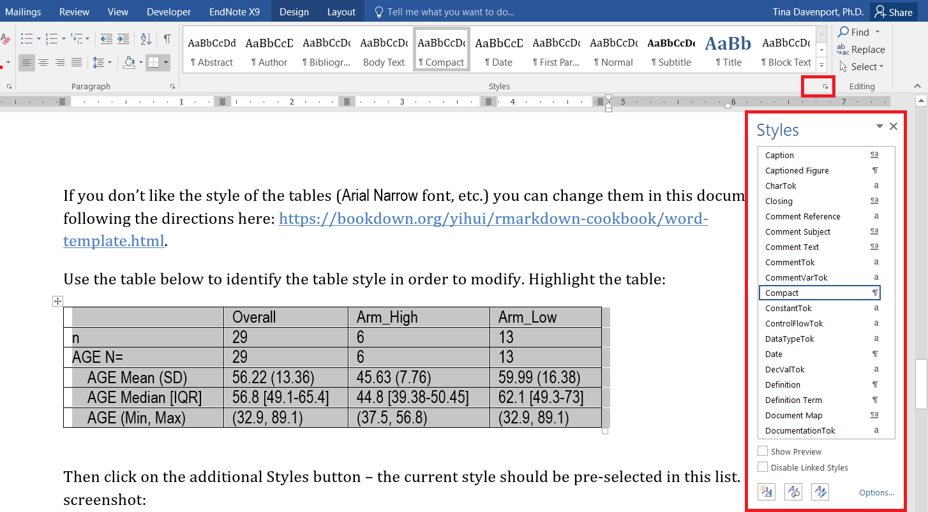

You can then modify the “Compact” style so that tables appear as you like.

Similarly, highlight the code chunk below to identify and modify the way source code appears.

##   
## Call:  
## lm(formula = eGFR ~ SBP + AGE + SEX + CM + A1C, data = dat, x = TRUE,   
## y = TRUE)  
##   
## Residuals:  
## Min 1Q Median 3Q Max   
## -23.872 -6.823 2.268 7.733 15.937   
##   
## Coefficients:  
## Estimate Std. Error t value Pr(>|t|)   
## (Intercept) 187.7600 26.1049 7.193 2.53e-07 ***  
## SBP -0.4173 0.1545 -2.700 0.01278 *   
## AGE -0.6158 0.1872 -3.290 0.00321 **   
## SEXM -7.7790 4.9145 -1.583 0.12711   
## CM 0.2539 0.1732 1.466 0.15625   
## A1C -4.6440 1.5201 -3.055 0.00561 **   
## ---  
## Signif. codes: 0 '***' 0.001 '**' 0.01 '*' 0.05 '.' 0.1 ' ' 1  
##   
## Residual standard error: 12.29 on 23 degrees of freedom  
## Multiple R-squared: 0.6698, Adjusted R-squared: 0.598   
## F-statistic: 9.331 on 5 and 23 DF, p-value: 5.818e-05

