1. Linked lists can potentially outperform vectors for sorting or insertion operation when the number of elements numbers very large (in the millions). However, this performance is still subject to the caveats of potential non-locality of memory addresses for the given linked list, where even large amounts of elements only partially mitigates this issue. A vector of pointers can then easily outperform a linked list.
2. Given a constant growth of:

$α_{i}=\frac{s_{i}}{log\left(1+s_{i}\right)}$

The following graph compares the average run times over one-thousand trials of one-hundred twenty-eight repetitions of appending to both the custom vector (using the growth constant above) and standard vector over various sizes of N (ranging from 128,00 to 2,048,000). The size of N was doubled over each trial.

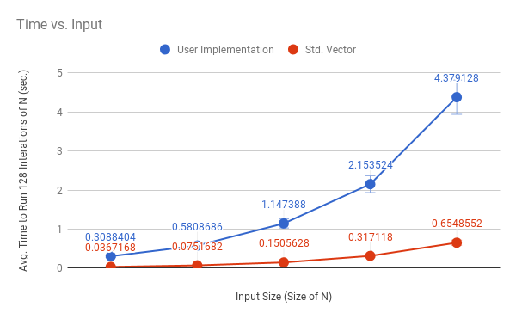

Clearly the growth constant above provides inferior performance to that of standard vector (and therefore to a multiplicative growth scheme, as (per reading) λ = 1.5 provided notable performance gain when compared to standard vector). The above, additive growth scheme fails to account for the overhead incurred by the number of reallocations necessary to store large inputs.