ECE1188 Lab 4 Report

Adam Brower



25% Duty Cycle: 2.7ms Period

50% Duty Cycle: 1.5ms Period

75% Duty Cycle: .5ms Period



Since one motor’s desired RPMs is higher than the other you would expect a small discrepancy between the curves and average values for the tach outputs as seen in the graph above.



As I tuned the Ki gain value it took a while to see any changes in the error values I was seeing because I was increasing the gain in increments that were too small. I started with a Ki value of 1 and increased it by 10-50 and no change was being output in the time it took for the system to stabilize. It wasn’t until I got to a value above 5000 that I saw changes in the error values. In the end I landed on a Ki gain of 8000.



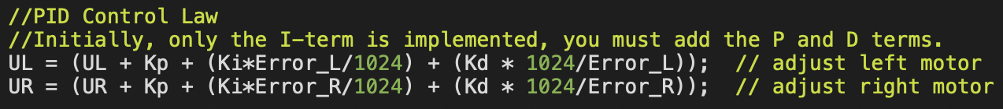

As I integrated the PID controller and tried to tune the gain values I never got an iteration that performed better than my part 3 I controller. This could be due to me not fully understanding how to tune PID controllers (sorry Nate). Therefore, my P and D gains are 0 and my I gain is the same as part 2 at 8000.



The outputs I was reading from the tach were close to what I was expecting, all outputs are slightly higher than expected by around 15-30 units. The 100mm reading was accurate though.



Video Demo: <https://youtube.com/shorts/OJ2yjE5QYxc>