ECE1188 Lab 5

Adam Brower



* After typing AT in the serial terminal the response is ‘OK’

ajk179 is my pitt id



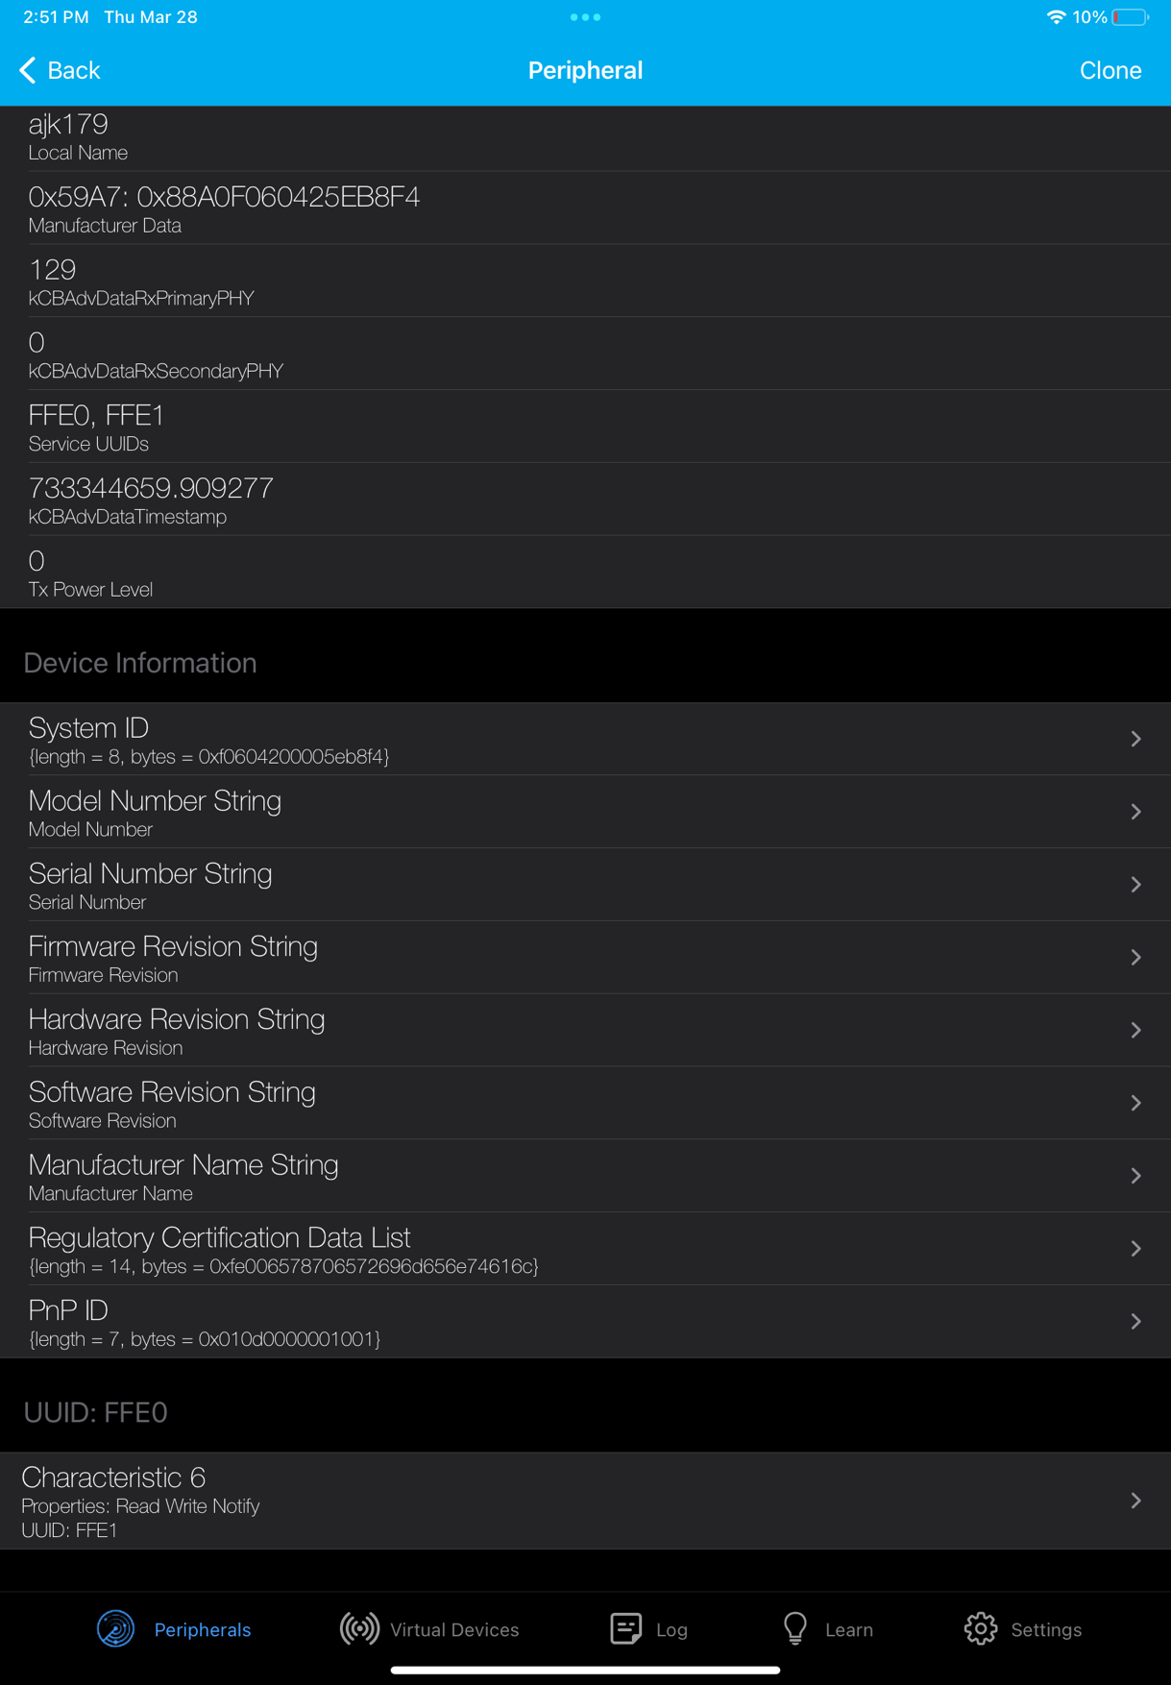

There are 2 services with UUIDs of FFE0 and FFE1 and one characteristic with UUID of FFE1 with read, write, and notify permissions.



My name is being transmitted after newline and carriage returns.



Here you can see the messages from the terminal come into the app as HEX characters: <https://youtu.be/Z0zzwTOtNgI>



<https://youtu.be/D482NzzBgCQ>