ECE 1188 Lab 6 Report

Adam Brower



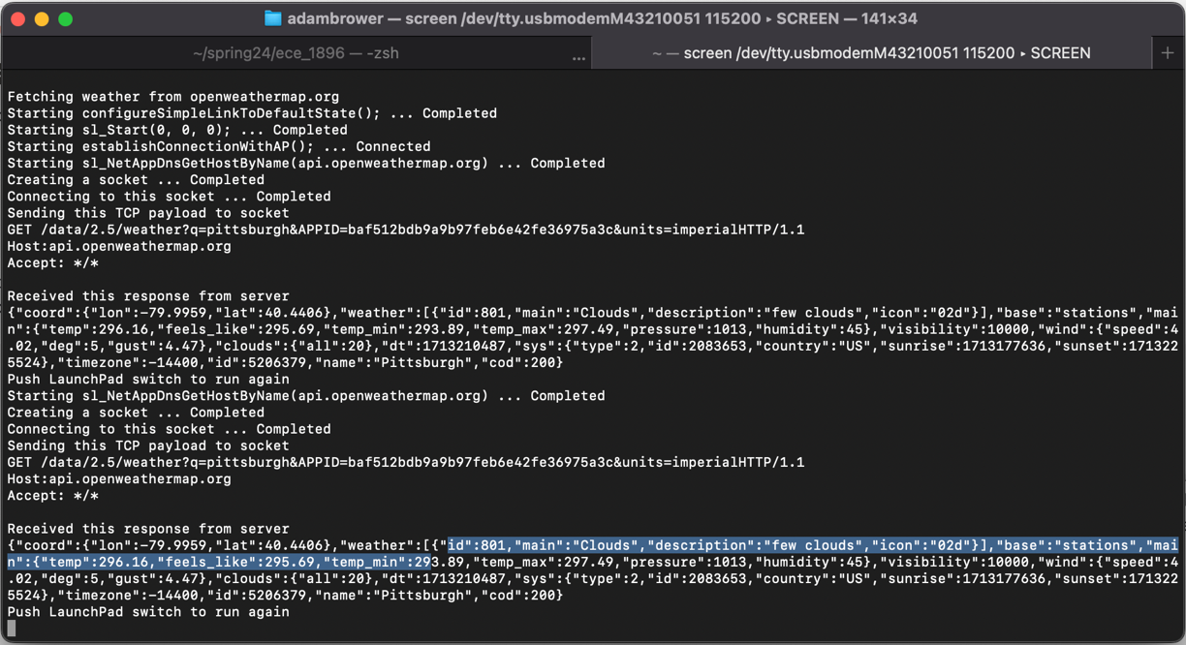



At router RSSI : -37

5 foot RSSI: -41

10 foot RSSI: -43

The RSSI value decreased the further from the router I got



MQTT Communication: <https://youtube.com/shorts/BoqOnz72ZCU?feature=share>



I will be submitting late for part 5 because of EXPO thank you so much