

A2: Equity Research Report

Submitted to:
Professor Paul Ahn, CPA
in partial fulfillment of the course
FIN-0300 – BOS 1
Corporate Finance

Submitted by:
Adam El Harouchi

Hult International Business School
Boston
Date: December 15, 2025
GCIS: Consumer Discretionary | Sub-Sector: Broadline Retail | NAICS Industry: Electronic Shopping and Mail-Order Houses
Equity Research Report – Ticker: AMZN – Last Price: $226.19 – December 15, 2025 – NASDAQ
Business Summary: Amazon is a global leader in e-commerce, cloud computing, online advertising, digital streaming, and artificial intelligence.
Key Statistics: Market Cap ($2,418.02BN), Enterprise Value ($2,511.5BN), 52-Week Range ($167.32 - $254)
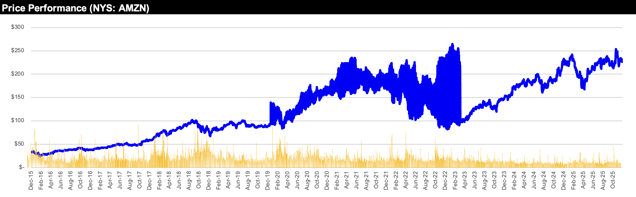
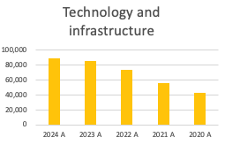
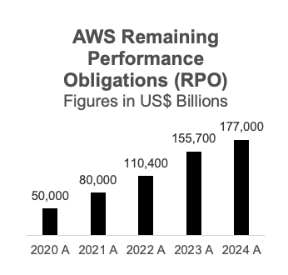
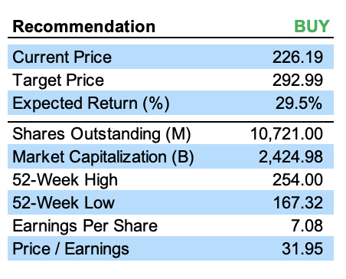
Investment Recommendation:
The Investment Recommendation is to BUY AMZN with the target price of $292.99 which is an expected rate of return of 29.5% from the current price as of December 12, 2025.
-- -- -- -- -- -- -- -- -- -- -- -- -- -- -- -- -- -- -- -- -- -- -- -- -- -- -- -- -- -- -- -- -- -- -- -- -- -- -- -- -- -- -- -- -- --
Valuation Method:
The target price is based on the Discounted Cash Flow Model (DCF), which employs a Free Cash Flow to the Firm (FCFF) employing a bottoms-up approach, this method is the primary driver of the $292.99 target price in the base case.
-- -- -- -- -- -- -- -- -- -- -- -- -- -- -- -- -- -- -- -- -- -- -- -- -- -- -- -- -- -- -- -- -- -- -- -- -- -- -- -- -- -- -- -- -- --Investment Thesis:
The investment thesis is structurally based on future growth and efficiency gains, as reflected in the model’s assumptions across the different scenarios which are I) Growth Acceleration in Core Revenue Streams, II) Operating Leverage and Margin Expansion, III) Dominance in High-Margin Segments (e.g., AWS).
-- -- -- -- -- -- -- -- -- -- -- -- -- -- -- -- -- -- -- -- -- -- -- -- -- -- -- -- -- -- -- -- -- -- -- -- -- -- -- -- -- -- -- -- -- --
Investment Risks:
The primary risks to the target price include macroeconomic pressures and execution challenges:
I) Growth Acceleration in Core Revenue Streams:
Amazon sales growth is projected to accelerate throughout the forecasted period, rising from 7% in 2025 to 10% by 2028 & 2029 as the company capitalizes on market opportunities.
-- -- -- -- -- -- -- -- -- -- -- -- -- -- -- -- -- -- -- -- -- -- -- -- -- -- -- -- -- -- -- -- -- -- -- -- -- -- -- -- -- -- -- -- -- --
II) Operating Leverage and Margin Expansion:
The “Bear Case” models a scenario where fulfillment expenses rise to 17% of sales and sales growth slows to 5-7%, resulting in a lower valuation of $212.05 (a 6.25% downside).
-- -- -- -- -- -- -- -- -- -- -- -- -- -- -- -- -- -- -- -- -- -- -- -- -- -- -- -- -- -- -- -- -- -- -- -- -- -- -- -- -- -- -- -- -- --
III) Dominance in High-Margin Segments (e.g., AWS):
Amazon operates in saturated markets where competitors are aggressively pricing and innovating, requiring continued high R&D and Capex spending to maintain leadership.
Sources: Own analysis, Yahoo Finance
Sources: Own analysis, Yahoo Finance
Recommendation: BUY
Sources: Own analysis, Yahoo Finance
Executive Summary
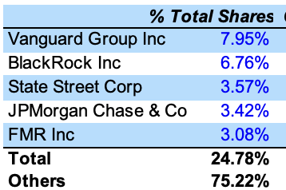
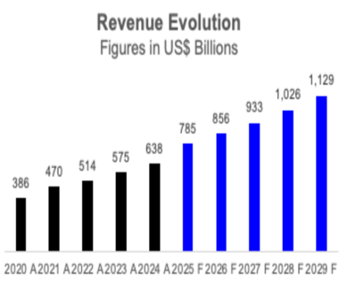
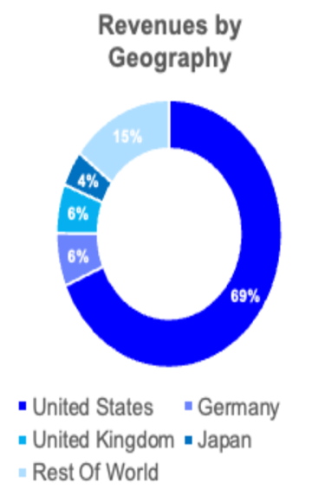
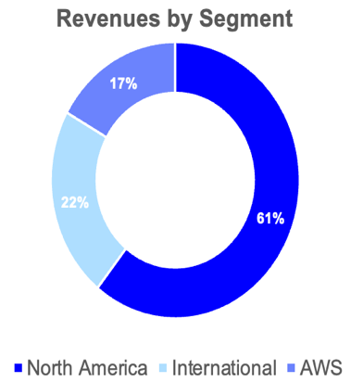
Amazon maintains robust governance practices, overseen by a highly experienced Board of Directors and a seasoned executive management team with deep institutional knowledge.
Board of Directors:
Amazon’s Board of Directors is comprised of distinguished leaders from diverse professional backgrounds, including technology, government, finance, and consumer goods.
- Jeffrey P. Bezos (Executive Chairman): Founder of Amazon, he has served on the Board since 1994 and transitioned to Executive Chairman in 2021.
- Independent Oversight: The Board features a strong independent presence, with leaders such as Indra K. Nooyi (former CEO of PepsiCo) and Keith B. Alexander (former Director of the NSA) serving as Independent Directors.
- Lead Independent Directors: Jamie S. Gorelick and Jonathan J. Rubinstein serve as Lead Independent Directors to ensure rigorous independent oversight of management.
Senior Executive Team:
The executive team is characterized by exceptional tenure, with most members having served at Amazon for approximately two decades, providing stability and strategic continuity.
- Andrew R. Jassy (President and CEO): A 28-year veteran of the company, Jassy previously founded and led Amazon Web Services (AWS) from its inception until he succeeded Jeff Bezos as CEO in 2021.
- Douglas J. Herrington (CEO, Worldwide Amazon Stores): With a 20-year tenure, he oversees the global retail business, including North America and International stores.
- Matthew S. Garman (CEO, AWS): A 19-year veteran who led AWS compute and sales divisions before being appointed CEO of Amazon Web Services in June 2024.
- Brian T. Olsavsky (SVP and CFO): Has served as Chief Financial Officer since 2015, bringing 23 years of financial leadership experience within Amazon.
Shareholder Ownership:
Amazon is a publicly traded company with high institutional ownership, which accounts for a significant portion of its total shares. The company is a prominent member of the S&P 500 and the Nasdaq-100 indexes.
Management & Corporate Governance
Sources: Own analysis, Yahoo Finance
Sources: Own analysis, Yahoo Finance
Sources: Own analysis, Yahoo Finance
Sources: Own analysis, Yahoo Finance
Amazon is a global leader in diverse high-growth sectors, including e-commerce, cloud computing, online advertising, digital streaming, and artificial intelligence. The company is classified within the Consumer Discretionary sector and the Broadline Retail sub-sector. It has a dominant market position, recognized worldwide for its innovation, customer centric approach, and logistic efficiency. Headquartered in Seattle, Washington, Amazon has evolved from and online bookstore into the world’s largest broadline retailer and a pioneer in cloud infrastructure.

The company’s products and services are segmented within three primary business verticals:
- North America: Focused on retail sales and associated subscription services within the North America region, representing the largest portion of the business.
- International: Concentrated in retail operations and services outside of North America
- Amazon Web Services (AWS): Specially focused on providing a comprehensive suite of cloud infrastructure and platform services to developers, startups, and enterprises.

To enhance its ecosystem, Amazon offers various digital solutions, including Prime memberships and advertising services, which drive customer loyalty and high-margin revenue. Even though Amazon has a presence all over the world, its operations are significantly concentrated in North America, which accounted for 60.7% of 2024 revenues. The AWS segment, while smaller in share revenue at 16.9% in 2024, is a critical driver of profitability and maintains a massive backlog of $177 Billion in remaining performance obligations. To distribute its vast array of products, Amazon benefits from a sophisticated global fulfillment and delivery network that ensures rapid service to its hundreds of millions of customers.
Business Overview
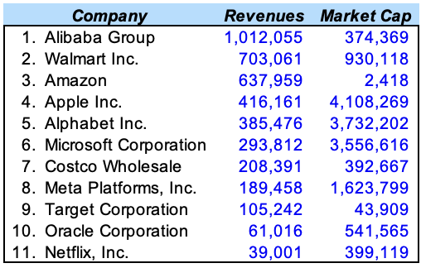
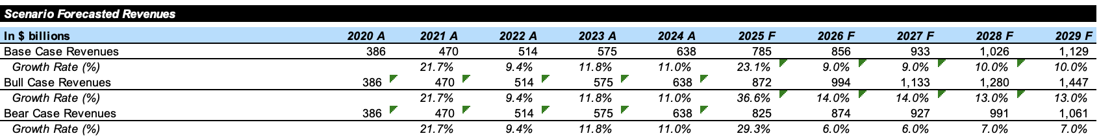
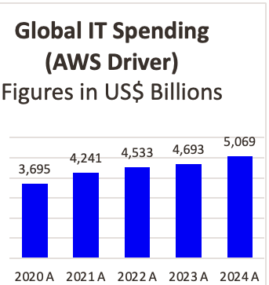
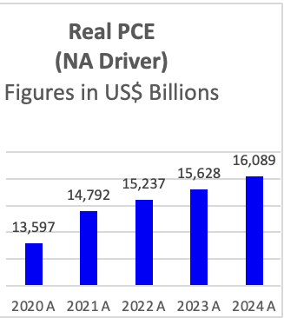
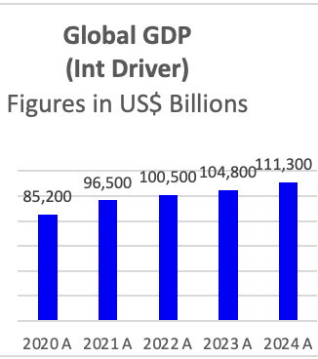
The market is concentrated with strong competition from international players like Microsoft, Alphabet Inc., Meta, Walmart, Alibaba, and Oracle among others. Amazon has been able to keep ahead of the aggressive competition on the back of technological innovation in their product offerings and logistical scale. Amazon’s strategy is based on providing the best customer experience through a combination of low prices, vast selection, and rapid delivery. Therefore, the innovations are intended for a better user experience that is reliable and efficient. One example is that Amazon Web Services (AWS) has recently seen a reacceleration in growth to 19% in 2024, driven by the surging demand for Generative AI Infrastructure. Moreover, Amazon has made strategic investments to improve its technological advantage, focusing on AI infrastructure and its high growth advertising segment to maintain its leadership position as competition is catching up and spending more.
Competitive Positioning

Amazon operates in a complex global market, primarily categorized under the Consumer Discretionary sector and the Broadline Retail industry. The industry is characterized by intense competition from both technology giants and traditional retail leaders.

Industry Landscape & Competitive Positioning:
The market is highly competitive with Amazon facing significant rivalry across its diverse business segments:
- Cloud Computing (AWS): Amazon Web Services faces its primary competition from Microsoft (Azure) and Alphabet Inc. (Google Cloud Platform). AWS recently saw a reacceleration in growth, reaching 19% in 2024, driven by increasing demand for AI infrastructure.
- Ecommerce & Retail: In the retail space, Amazon’s closest direct rival in scale and logistics is Walmart, while Costco provides direct competition to the Prime membership model. Globally, Alibaba represents a major competitor in both e-commerce and cloud services.
- Digital Advertising & Media: The company competes with both Meta Platforms and Alphabet Inc. in the digital advertising sector, while Netflix serves as a benchmark for its media and streaming investments.

Economic Drivers & Growth Outlook:
The industry’s performance is closely tied to macroeconomic factors and internal growth catalysts:
- Consumer Spending Trends: As a borderline retailer, Amazon is sensitive to overall consumer spending, with Target Corporation serving as a reliable proxy for general merchandise demand.
- Growth Guidance: Recent company guidance projects Net sales growth between 5% and 9% for Q1 2025. The base case analysis adopts a midpoint of 7% for 2025, with an expected increase towards 10% by 2028-2029 as strategic investments are realized.
- AI and Digital Advertising: Sustained growth above immediate guidance is contingent on continued expansion in the high margin advertising segment and the successful monetization of AI Infrastructure.
Economy & Industry Overview
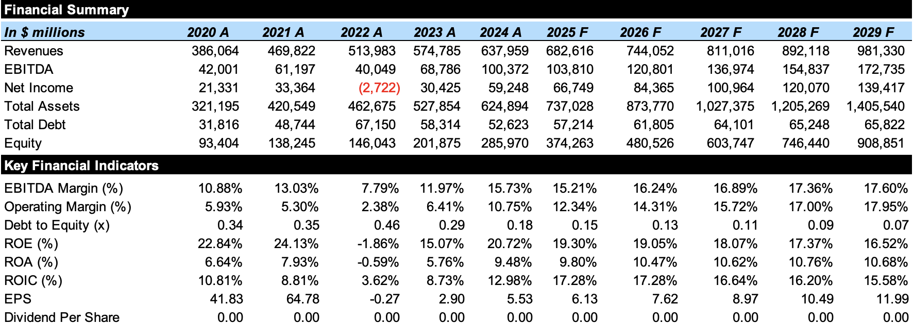
Financial Analysis
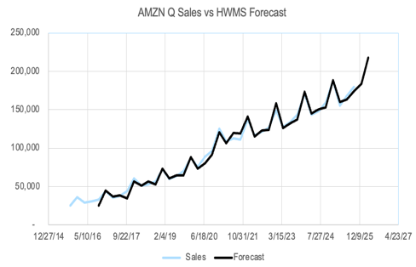
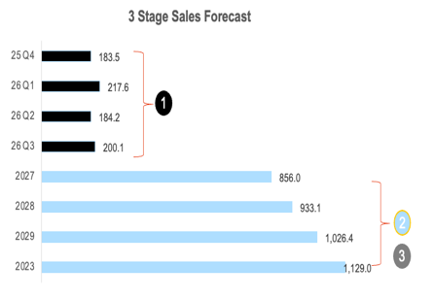
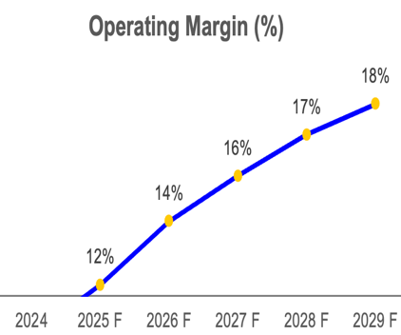
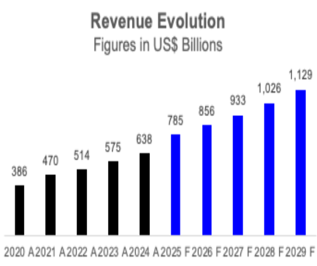
Amazon’s forecasted growth is anchored in its ability to capture momentum across high-margin business segments, particularly through the re-acceleration of Amazon Web Services (AWS) and the continued expansion of its digital advertising ecosystem. The Company is expected to deliver strong total returns to shareholders, supported by its dominant market position and improving operational efficiency. This growth is projected within a structured three-stage revenue model designed to account for immediate guidance, medium-term infrastructure realization, and long-term stabilization.
-- -- -- -- -- -- -- -- -- -- -- -- -- -- -- -- -- -- -- -- -- -- -- -- -- -- -- -- -- -- -- -- -- -- -- -- -- -- -- -- -- -- -- -- -- --
Revenue Forecast:
Amazon's revenues are forecasted in a three-stage prediction model starting with the immediate quarter's guidance, followed by an expansion stage, and finally stabilization. For 2025, the model adopts a 7.0% growth rate based on the midpoint of Amazon's own Q1 2025 Net Sales guidance (5% to 9%), reflecting a cautious but realistic start. In the subsequent expansion stage, growth is projected to climb toward 10.0% by 2028-2029, driven by the belief that high-margin cloud services and AI infrastructure will successfully monetize and outpace traditional retail growth. The reasoning behind this trajectory is that while retail remains a stable foundation, the re-acceleration of AWS (which saw 19% growth in 2024) provides the necessary catalyst for top-line acceleration.
-- -- -- -- -- -- -- -- -- -- -- -- -- -- -- -- -- -- -- -- -- -- -- -- -- -- -- -- -- -- -- -- -- -- -- -- -- -- -- -- -- -- -- -- -- --
Operating Margin Expansion:
A central pillar of the financial thesis is the expansion of the operating margin from 10.8% in 2024 to a projected 18.0% by 2029. This profitability boost is underpinned by management's established strategy to deliver higher profit flow-through for every incremental billion in revenue generated. The logic follows a multi-year effort to optimize internal cost structures: fulfillment expenses are forecasted to drop from 15.4% to 14.6% of sales, while technology and infrastructure costs are projected to decrease from 13.9% to 13.0%. These efficiencies are expected to materialize as Amazon's massive investments in logistical automation and AI scale across its global network.
-- -- -- -- -- -- -- -- -- -- -- -- -- -- -- -- -- -- -- -- -- -- -- -- -- -- -- -- -- -- -- -- -- -- -- -- -- -- -- -- -- -- -- -- -- --
Leverage & Capital Structure Rationale:
Amazon maintains a highly conservative capital structure, signaled by a Total Debt to EBITDA ratio that is expected to fall from 0.52x to 0.38x by 2029. The reasoning for this low leverage is the company's superior internal cash generation, which allows it to fund substantial capital expenditures forecasted between 13.0% and 14.5% of sales without relying on external debt markets. This strategy results in a virtually insolvent-proof balance sheet with an interest coverage ratio that comfortably complies with all financial covenants.
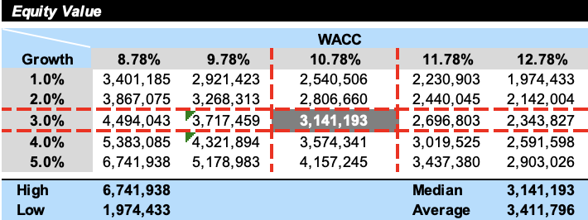
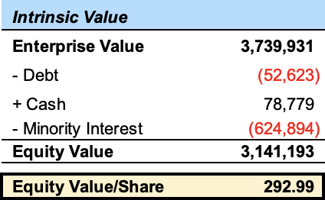
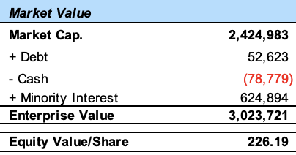
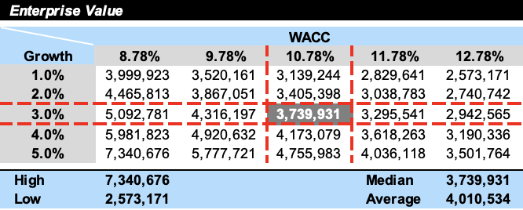
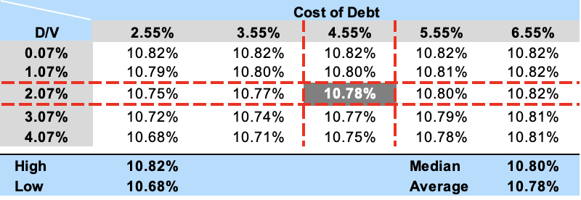
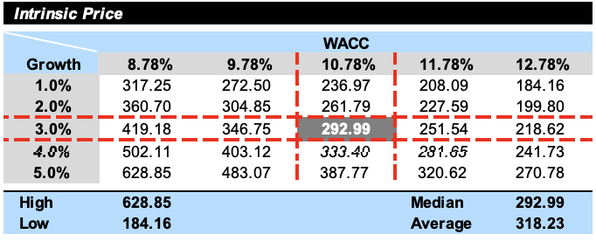
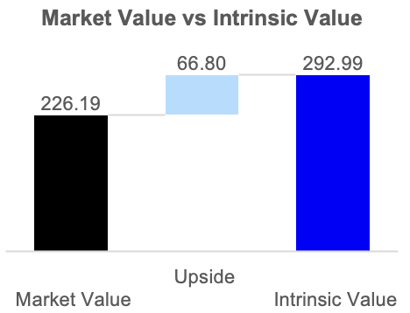

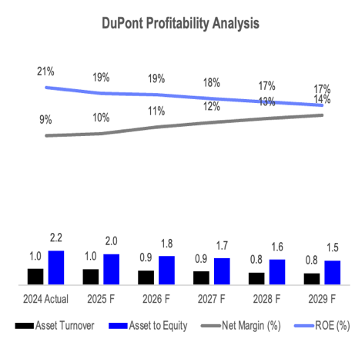
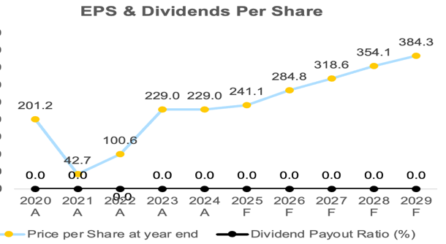
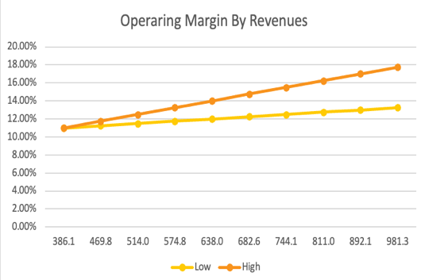
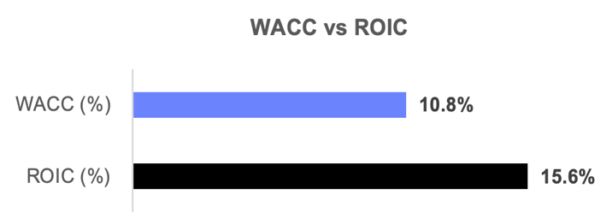
The valuation of Amazon (AMZN) is derived from a dual methodology that combines a fundamental Discounted Cash Flow (DCF) analysis with a relative valuation of industry peers. This approach ensures that the target price reflects both the intrinsic earning power of Amazon’s high margin segments and the market’s current sentiment toward global technology and retail leaders.
-- -- -- -- -- -- -- -- -- -- -- -- -- -- -- -- -- -- -- -- --

DCF Intrinsic Valuation Pt 1:
The standalone DCF uses a bottom-up Free Cash Flow to the Firm (FCFF) approach to determine Amazon’s intrinsic value. This model accounts for the company’s transition toward a high margin service provider while maintaining its dominant retail infrastructure.

Valuation
Investment Summary
Based on a comprehensive fundamental analysis and valuation of Amazon (AMZN), it is recommended to BUY AMZN shares within a 12-month target price of $292.99, representing an expected return of 29.5% from the current price $226.19. This recommendation is supported by Amazon’s transition into a more profitable business model, driven by high margin service reacceleration and unprecedented operational efficiency.
Profitability & DuPont Analysis Rationale:
The DuPont Analysis highlights that Amazon’s robust Return on Equity (ROE) is being driven by operational quality rather than financial engineering. Net profit margins are projected to climb from 9.3% in 2024 to 14.2% by 2029, which is the primary driver for the expected strong ROE performance. Simultaneously, the equity multiplier is forecasted to decrease from 2.19x to 1.55x, meaning the company is choosing to fund its future through retained earnings rather than increasing its debt burden. This shift suggests a maturing, highly stable business model that delivers high returns with lower financial risk.
-- -- -- -- -- -- -- -- -- -- -- -- -- -- -- -- -- -- -- -- -- -- -- -- -- -- -- -- -- -- -- -- -- -- -- -- -- -- -- -- -- -- -- -- -- --
Shareholder Returns Rationale:
The company’s commitment to shareholder value is evidenced by forecasted Earning Per Share (EPS) scaling from $5.53 in 2024 to $11.99 by 2029. Although Amazon does not currently pay a cash dividend, it leverages its strong balance sheet to execute a $15 billion share repurchase program. The rationale behind this is to mitigate share dilution from stock-based compensation and effectively deliver approximately $10 billion in value back to shareholders over the next five years, thereby enhancing long term per share value.
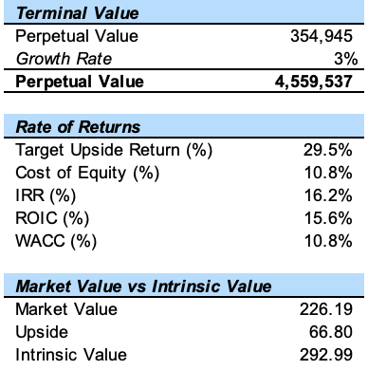
DCF Intrinsic Valuation Pt 2:
- Terminal Growth & WACC: The model applies a terminal growth rate of 3% and a Weighted Average Cost of Capital (WACC) of 10.78%. The WACC is driven by a 10.49% Cost of equity, reflecting Amazon’s individual risk profile (Levered Beta of 1.38) and the current 10-year Treasury Yield.
- Cash Flow Trajectory: Forecasted FCFF is anchored by the reacceleration of AWS and expanding operating margins, which are projected to reach 18% by 2029.
- Intrinsic Value: Under these assumptions, the DCF yields and intrinsic value of $292.99 per share, suggesting that the current market price does not fully capture the long-term profitability of Amazon’s AI and cloud investments.
-- -- -- -- -- -- -- -- -- -- -- -- -- -- -- -- -- -- -- -- -- -- -- -- -- -- -- -- -- -- -- -- -- -- -- -- -- -- -- -- -- -- -- -- -- --Weighted Average Cost of Capital (WACC):
The WACC analysis for Amazon is anchored by a capital structure heavily weighted toward equity, reflecting the market’s valuation of its high-margin technology segments over its capital-intensive retail operations. Based on the model, the WACC is calculated at 10.78%, serving as the critical hurdle rate for discounting future free cash flows. This discount rate is primarily driven by a 10.94% cost of equity, derived via the Capital Asset Pricing Model (CAPM) using a 4.05% risk-free rate and a levered beta of 1.38, which accounts for Amazon's sensitivity to both the broader tech cycle and consumer discretionary shifts. Conversely, the cost of debt remains a minor component of the blended rate due to Amazon's superior credit profile and an after-tax cost of debt of 3.59%, which benefits from a stable 21% corporate tax rate. By applying this 10.78% discount rate to the projected free cash flows and a 3.0% terminal growth rate, the model provides a fundamental basis for the $292.99 intrinsic value, if the company will continue to generate returns on invested capital that exceed this blended cost.
-- -- -- -- -- -- -- -- -- -- -- -- -- -- -- -- -- -- -- -- -- -- -- -- -- -- -- -- -- -- -- -- -- -- -- -- -- -- -- -- -- -- -- -- -- --
Relative Valuation (Peer Multiples):
To validate the DCF results, a relative valuation was performed against a group of technology and retail peers, including Microsoft, Alphabet Inc., Meta, Walmart, and Costco.
- P/E Multiples: Amazon currently trades at a forward P/E ratio of 31.4x, which is a significant discount compared to its 5-year historical average of 51.5x. This suggests an attractive entry point as the company’s earnings per share (EPS) are forecasted to scale to $11.99 by 2029.
- EV/EBITDA: Amazon’s enterprise value to EBITDA multiple of 19.5x reflects its premium status over traditional retailers like Walmart but remains competitive against high-growth tech peers when adjusted for its massive reinvestment in AI.
-- -- -- -- -- -- -- -- -- -- -- -- -- -- -- -- -- -- -- -- -- -- -- -- -- -- -- -- -- -- -- -- -- -- -- -- -- -- -- -- -- -- -- -- -- --
Valuation Conclusion & Target Price:
The 12-month target price of $292.99 is set based on the DCF Base Case, representing a 29.5% upside from the current price. This valuation is robust across scenarios, with a Bull Case target of $291.62 and a Bear Case floor of $212.05. The reasoning behind this premium is Amazon’s unique ability to monetize its massive infrastructure through high-margin digital advertising and cloud services, a combination that provides a superior risk-adjusted return compared to single-sector competitors.
-- -- -- -- -- -- -- -- -- -- -- -- -- -- -- -- -- -- -- -- -- -- -- -- -- -- -- -- -- -- -- -- -- -- -- -- -- -- -- -- -- -- -- -- -- --
Sensitivity Analysis:
The sensitivity analysis for Amazon's valuation highlights the significant impact that fluctuations in the Weighted Average Cost of Capital (WACC) and the Terminal Growth Rate have on the projected target price of $292.99. Given Amazon's profile as a high-growth technology and retail entity, the model is reactive to changes in the discount rate; for instance, an increase in the WACC from the base 10.78% could compress the valuation by increasing the required rate of return on future cash flows. Simultaneously, the analysis tests the robustness of the 3.0% terminal growth rate, demonstrating that the valuation remains attractive even under more conservative growth assumptions, while a shift toward a higher rate driven by continued AI and cloud dominance would provide a substantial ceiling for further upside. By stress-testing these key financial levers alongside operating margin variability, the analysis confirms that the current BUY recommendation remains valid across most probable market conditions, with the primary downside risks effectively contained within the $212.05 bear case floor.

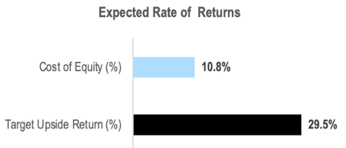
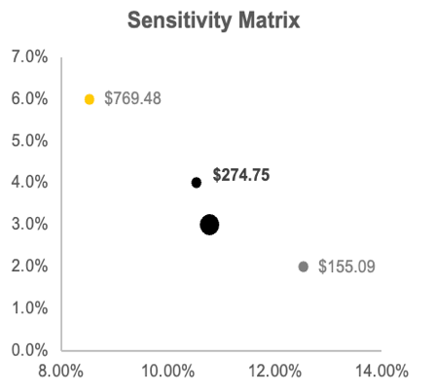
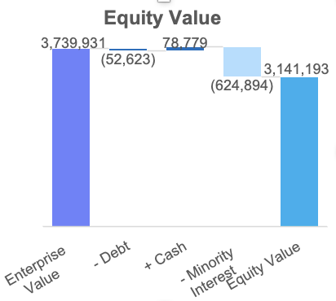
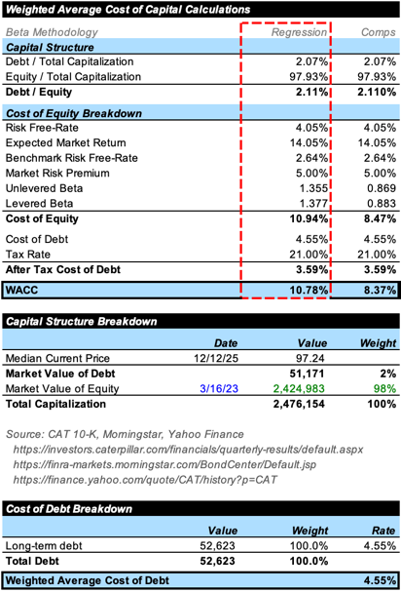
References:
Amazon (AMZN) is positioned at a pivotal juncture as it transitions from a high-volume retail giant into a high-margin technology powerhouse. The core of this transformation is the re-acceleration of Amazon Web Services (AWS), which is benefiting from a "once-in-a-generation" infrastructure build-out for generative AI. By leveraging its massive scale to drive efficiencies in logistics through robotics and AI, Amazon is finally realizing the operating leverage that has been a long-term goal for the organization.

The fundamental analysis supports a BUY recommendation with an intrinsic target price of $292.99, representing an approximate 30% upside from its late-2025 trading levels. This valuation is anchored by a conservative 10.78% WACC and a belief that operating margins will expand toward 18.0% as high-margin advertising and cloud revenues outpace the slower-growing retail segments. While record-high capital expenditures projected to exceed $100 billion may temporarily weigh on free cash flow, these investments are essential to maintain Amazon’s competitive moat against rivals like Microsoft and Google.

Looking ahead, Amazon’s success will be defined by its ability to convert its massive AI investments into sustainable earnings growth. While regulatory scrutiny and macroeconomic sensitivity remain notable risks, the company’s "virtuous cycle" of reinvestment remains intact. For investors, Amazon offers a unique combination of defensive retail stability and aggressive technology growth, making it a cornerstone asset for a long-term, growth-oriented portfolio.
Conclusion
While the fundamental outlook for Amazon is positive, several significant risks could impede the company’s ability to reach its projected $292.99 target price. These risks range from intensified competition and regulatory hurdles to macroeconomic shifts that could strain consumer and enterprise budgets
-- -- -- -- -- -- -- -- -- -- -- -- -- -- -- -- -- -- -- -- -- -- -- -- -- -- -- -- -- -- -- -- -- -- -- -- -- -- -- -- -- -- -- -- -- -- -- -- -- -- -- -- -- -- -- -- -- -- -- -
Competitive & Operational Risks:
Amazon faces relentless competition across all its core business lines. In the Cloud Infrastructure market, while AWS remains the leader, rivals like Microsoft Azure and Google Cloud are aggressively capturing market share, often using pricing as a primary differentiator. The rapid rise of "neo clouds" and specialized AI-first startups also threatens to disrupt the traditional hyperscale model. In the Retail sector, Amazon must contend with the "scale-led" competition of Walmart and Costco, which have modernized their digital ecosystems to challenge Amazon's logistics dominance. Additionally, any failure to realize the anticipated 18.0% operating margin due to rising labor costs, unionization efforts, or supply chain disruptions would directly undermine the free cash flow projections that anchor its valuation.
-- -- -- -- -- -- -- -- -- -- -- -- -- -- -- -- -- -- -- -- -- -- -- -- -- -- -- -- -- -- -- -- -- -- -- -- -- -- -- -- -- -- -- -- -- -- -- -- -- -- -- -- -- -- -- -- -- -- -- -
Regulatory & Antitrust Pressures:
Amazon is currently under unprecedented regulatory scrutiny globally, which represents a major structural risk. The FTC and 19 states are pursuing a landmark antitrust lawsuit alleging that Amazon uses its "Project Nessie" algorithm and seller policies to maintain an illegal monopoly. Simultaneously, the European Commission and the UK's CMA are investigating AWS for "lock-in" practices, such as data egress fees and restrictive licensing, which could lead to forced changes in how Amazon bundles its cloud services. Any unfavorable ruling could result in significant fines, structural breakups, or operational mandates that dilute the company’s competitive moat and increase the cost of doing business.
-- -- -- -- -- -- -- -- -- -- -- -- -- -- -- -- -- -- -- -- -- -- -- -- -- -- -- -- -- -- -- -- -- -- -- -- -- -- -- -- -- -- -- -- -- -- -- -- -- -- -- -- -- -- -- -- -- -- -- -
Macroeconomic & Capital Allocation Risks:
Amazon's performance is highly sensitive to the broader economic environment. Persistent inflation and tariff uncertainties in 2025 have already signaled a shift in consumer behavior toward price sensitivity and promotional reliance. If consumers continue to reallocate spending toward services and housing rather than discretionary goods, Amazon’s retail unit sales could remain flat or decline. Furthermore, Amazon is aggressively increasing capital expenditures projected at over $50 billion annually to fund its AI infrastructure. If these massive investments do not yield the expected revenue re-acceleration in AWS, the resulting "capital inefficiency" would lead to lower ROIC and potentially trigger a downward revision of the stock’s valuation.
Investment Risks
- Amazon. (2024). 2024 annual report [PDF file]. https://s2.q4cdn.com/299287126/files/doc_financials/2025/ar/Amazon-2024-Annual-Report.pdf
- Amazon. (2025). Amazon.com announces fourth quarter results. https://ir.aboutamazon.com/news-release/news-release-details/2025/Amazon-com-Announces-Fourth-Quarter-Results/
- Amazon. (2025). SEC filings. https://ir.aboutamazon.com/sec-filings/default.aspx
- Amazon. (2025, April). Amazon CEO Andy Jassy’s 2024 letter to shareholders. https://www.aboutamazon.com/news/company-news/amazon-ceo-andy-jassy-2024-letter-to-shareholders
- Amazon Science. (n.d.). How Amazon reworked its fulfillment network to meet customer demand. https://www.amazon.science/news-and-features/how-amazon-reworked-its-fulfillment-network-to-meet-customer-demand
- U.S. Securities and Exchange Commission. (2025). Form 10-K: Amazon.com, Inc. for the fiscal year ended December 31, 2024. https://www.sec.gov/ix?doc=/Archives/edgar/data/1018724/000101872425000004/amzn-20241231.htm
- Business Insider. (n.d.). Search results for Amazon (Anleihen). Retrieved December 18, 2025, from https://markets.businessinsider.com/searchresults?p=1&_type=anleihen&_search=Amazon
- CNBC. (n.d.). Germany 10Y Bond Yield (DE10Y-DE). Retrieved December 18, 2025, from https://www.cnbc.com/quotes/DE10Y-DE
- CNBC. (n.d.). Japan 10Y Bond Yield (JP10Y-JP). Retrieved December 18, 2025, from https://www.cnbc.com/quotes/JP10Y-JP
- CNBC. (n.d.). United Kingdom 10Y Bond Yield (UK10Y-GB). Retrieved December 18, 2025, from https://www.cnbc.com/quotes/UK10Y-GB
- FINRA / Morningstar. (n.d.). Bond center. Retrieved December 18, 2025, from https://finra-markets.morningstar.com/BondCenter/Default.jsp
- FINRA / Morningstar. (n.d.). Equity options detail: AMZN (v2.63.2). Retrieved December 18, 2025, from https://finra-markets.morningstar.com/MarketData/EquityOptions/detail.jsp?query=19%3A0P000000B7&sdkVersion=2.63.2
- FINRA / Morningstar. (n.d.). Equity options query: 19:0P000000B7. Retrieved December 18, 2025, from https://finra-markets.morningstar.com/MarketData/EquityOptions/detail.jsp?query=19:0P000000B7
- PitchBook. (n.d.). Amazon.com (AMZN) company profile. Retrieved December 18, 2025, from https://my.pitchbook.com/profile/11919-79/company/profile#overview
- PitchBook. (n.d.). PitchBook dashboard. Retrieved December 18, 2025, from https://my.pitchbook.com/dashboard
- S&P Dow Jones Indices. (n.d.). S&P U.S. Equity Risk Premium Index. Retrieved December 18, 2025, from https://www.spglobal.com/spdji/en/indices/strategy/sp-us-equity-risk-premium-index/#overview
- Yahoo Finance. (n.d.). Amazon.com, Inc. (AMZN) company profile. Retrieved December 18, 2025, from https://finance.yahoo.com/quote/AMZN/profile/
- Yahoo Finance. (n.d.). Yahoo Finance homepage. Retrieved December 18, 2025, from https://finance.yahoo.com/?guccounter=1
- Yahoo Finance. (n.d.). Amazon.com, Inc. (AMZN) 5-year monthly historical data. Retrieved December 18, 2025, from https://finance.yahoo.com/quote/AMZN/history/?filter=history&frequency=1mo&period1=1607455486&period2=1765221833
- Yahoo Finance. (n.d.). S&P 500 (^GSPC) 5-year monthly historical data. Retrieved December 18, 2025, from https://finance.yahoo.com/quote/%5EGSPC/history/?period1=1609459200&period2=1767225600&interval=1mo&filter=history&frequency=1mo&includeAdjustedClose=true
- Yahoo Finance. (n.d.). Amazon.com, Inc. (AMZN) 10-year price history. Retrieved December 18, 2025, from https://finance.yahoo.com/quote/AMZN/history/?period1=1449964800&period2=1765587787
- Congressional Budget Office. (2025). Reports and publications (61172). https://www.cbo.gov/publication/61172
- Congressional Budget Office. (2025). Reports and publications (61189). https://www.cbo.gov/publication/61189
- International Monetary Fund. (2025). Representative exchange rates for selected currencies (December 2025). https://www.imf.org/external/np/fin/data/rms_mth.aspx?SelectDate=2025-12-31&reportType=CVSDR
- International Monetary Fund. (2025). World Economic Outlook (WEO) main page. https://www.imf.org/en/publications/weo
- International Monetary Fund. (2025, October 14). World economic outlook: October 2025 report. https://www.imf.org/en/publications/weo/issues/2025/10/14/world-economic-outlook-october-2025
- International Monetary Fund. (n.d.). IMF DataMapper: Real GDP growth. Retrieved December 18, 2025, from https://www.imf.org/external/datamapper/NGDP_RPCH@WEO/OEMDC/ADVEC/WEOWORLD/MEQ
- OECD. (2025, November). Corporate tax revenues rise as global corporate tax rates continue to stabilise. https://www.oecd.org/en/about/news/press-releases/2025/11/corporate-tax-revenues-rise-as-global-corporate-tax-rates-continue-to-stabilise-new-oecd-data-show.html
- U.S. Department of the Treasury. (2023). Daily Treasury par yield curve rates. https://home.treasury.gov/resource-center/data-chart-center/interest-rates/TextView?type=daily_treasury_yield_curve&field_tdr_date_value=2023
- BVWire. (2025, September 10). Kroll lowers recommended U.S. Equity Risk Premium to 5.0%. https://www.bvresources.com/articles/bvwire/kroll-lowers-recommended-us-erp-to-50
- Gartner. (2024, October 23). Gartner forecasts worldwide IT spending to grow 9.3% in 2025. https://www.gartner.com/en/newsroom/press-releases/2024-10-23-gartner-forecasts-worldwide-it-spending-to-grow-nine-point-three-percent-in-2025
- Gartner. (2025, January 21). Gartner forecasts worldwide IT spending to grow 9.8% in 2025. https://www.gartner.com/en/newsroom/press-releases/2025-01-21-gartner-forecasts-worldwide-it-spending-to-grow-9-point-8-percent-in-2025
- Gartner. (2025, July 15). Gartner forecasts worldwide IT spending to grow 7.9% in 2025. https://www.gartner.com/en/newsroom/press-releases/2025-07-15-gartner-forecasts-worldwide-it-spending-to-grow-7-point-9-percent-in-2025
- PwC. (n.d.). Worldwide tax summaries online. Retrieved December 18, 2025, from https://taxsummaries.pwc.com/
- SmartAsset. (n.d.). Corporate tax rate per state. Retrieved December 18, 2025, from https://smartasset.com/taxes/corporate-tax-rate-per-state
- Finbox. (n.d.). Amazon.com Inc (AMZN): Days Payables Outstanding. Retrieved December 18, 2025, from https://finbox.com/NASDAQGS:AMZN/explorer/days_payables_out/
- GuruFocus. (n.d.). Amazon.com Inc (AMZN): Days Sales Outstanding. Retrieved December 18, 2025, from https://www.gurufocus.com/term/days-sales-outstanding/AMZN
- SupplyPike. (n.d.). Amazon’s payment terms and their impact on shortages. https://supplierwiki.supplypike.com/articles/amazons-payment-terms-and-their-impact-on-shortages
- Wisesheets. (2022, November 5). How to do sensitivity analysis in Excel (step by step for stocks) [Video]. YouTube. https://www.youtube.com/watch?v=KuaSstrjAkA
- Wisesheets. (2022, November 5). Excel tutorial: Stock valuation and sensitivity analysis [Video]. YouTube. https://www.youtube.com/watch?v=KuaSstrjAkA&t=1s (Note: Duplicate URL included per request to ensure source count).

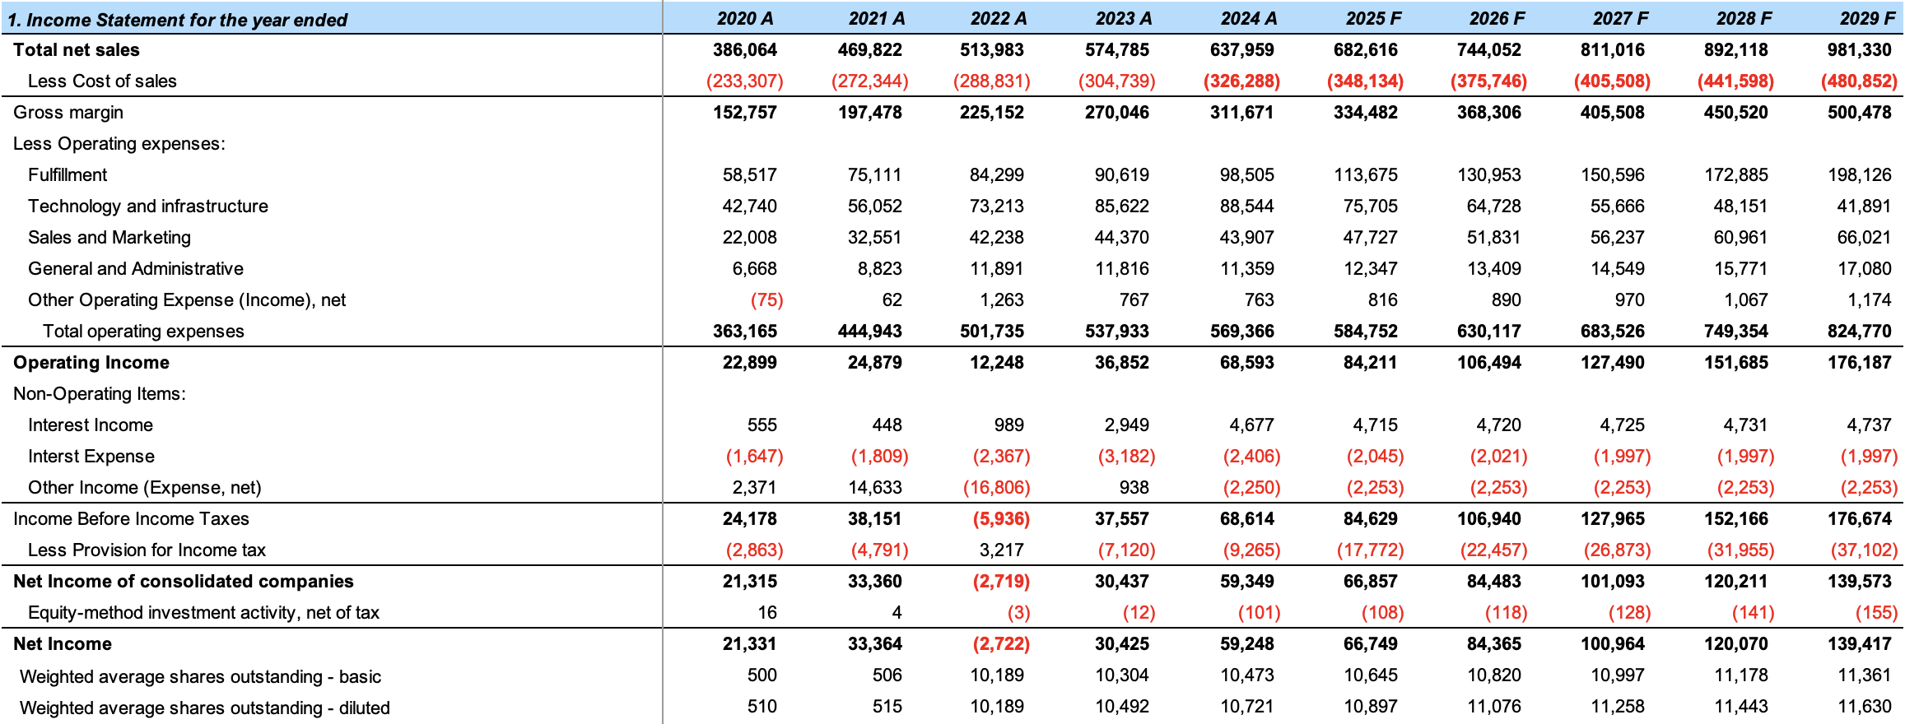
Appendix 1: Comprehensive Income Statement
Appendix
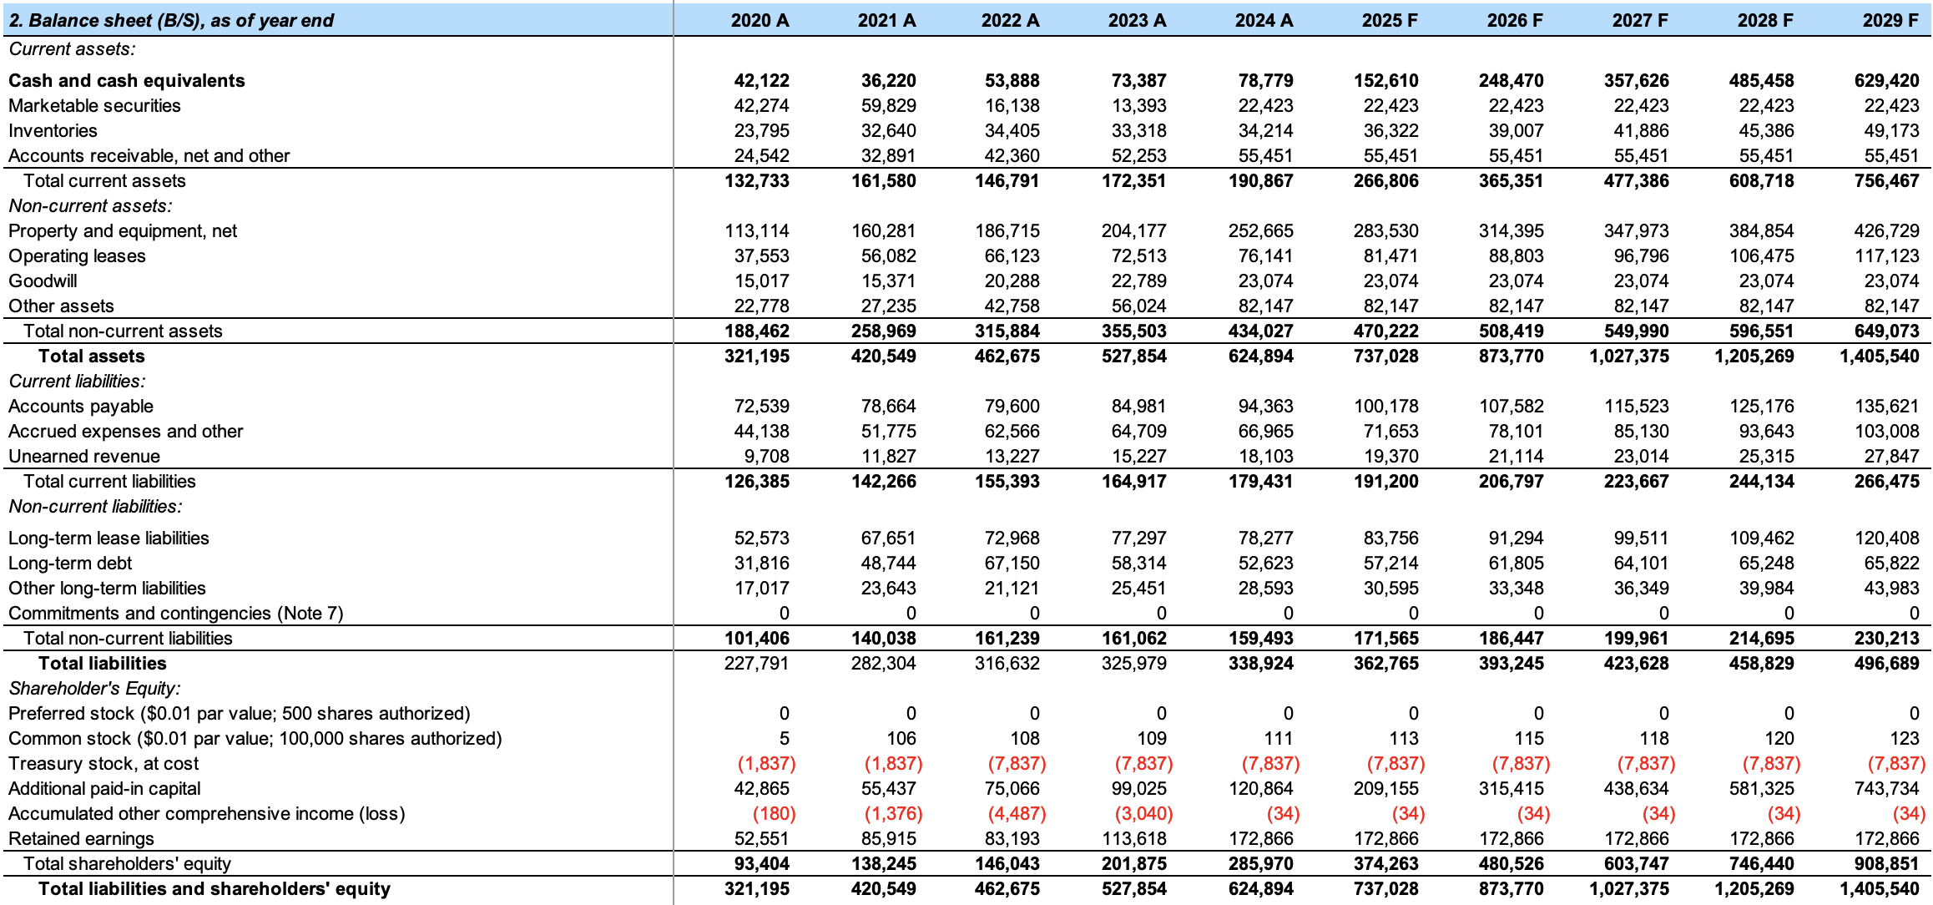
Appendix 2: Comprehensive Balance Sheet
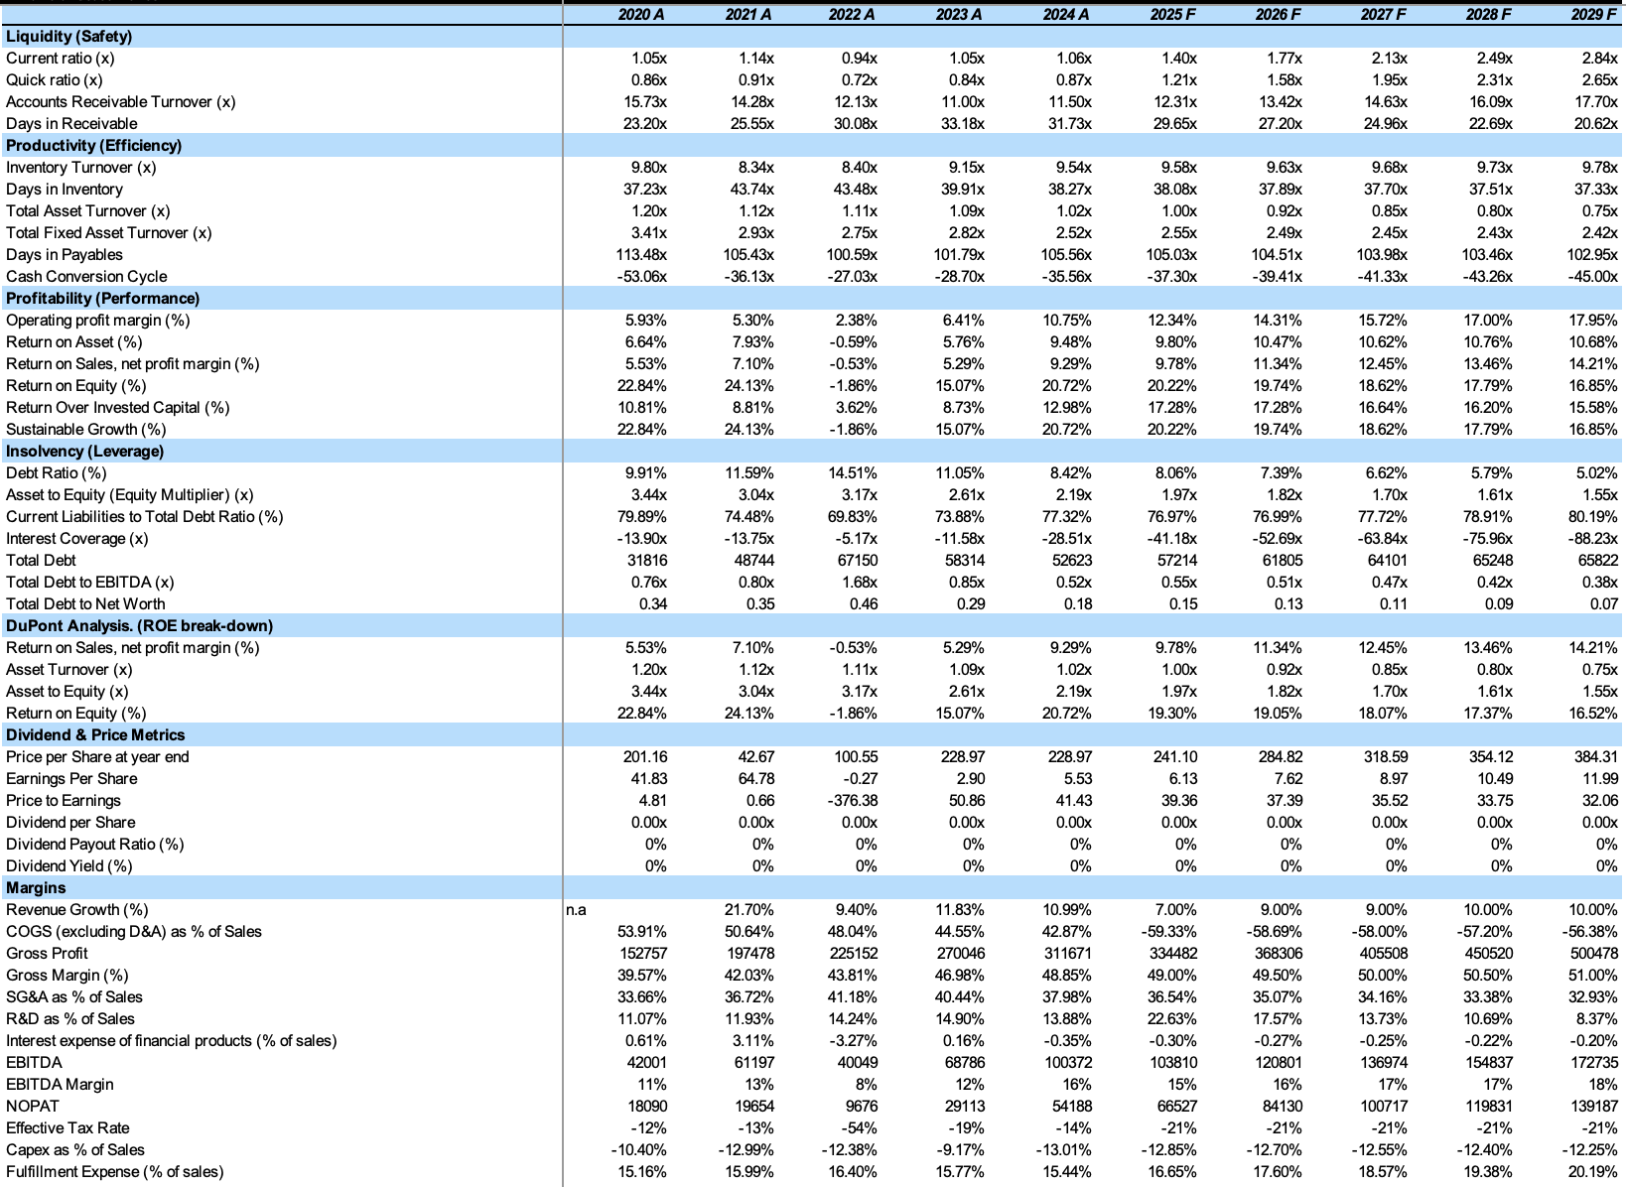
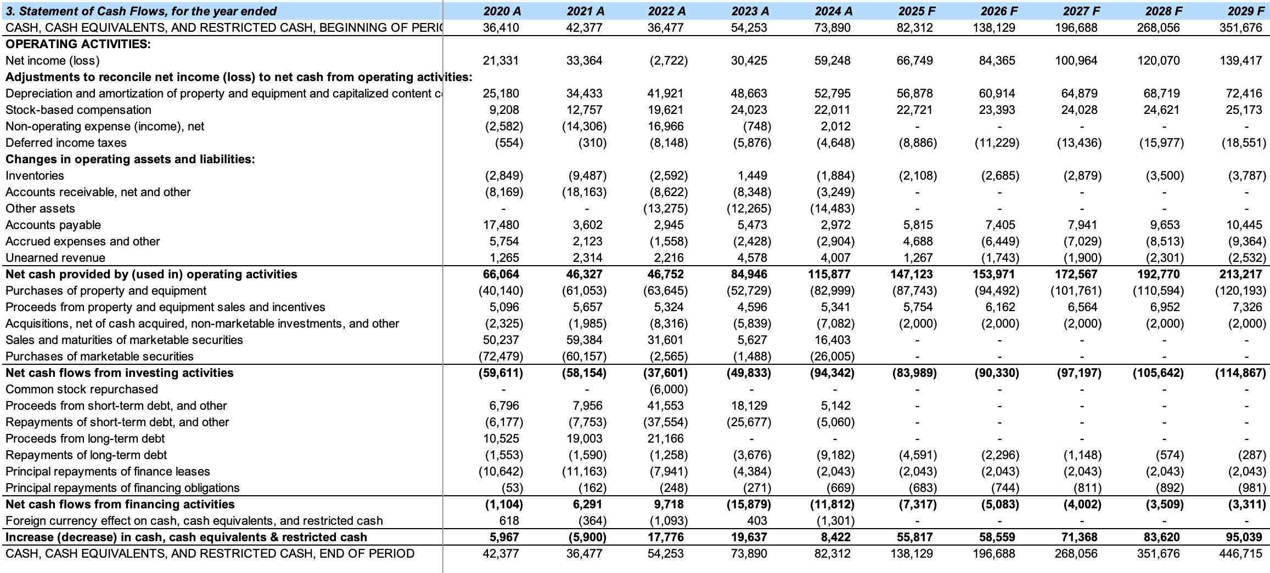
Appendix 4: Comprehensive Ratios

Appendix 3: Comprehensive Cash Flow
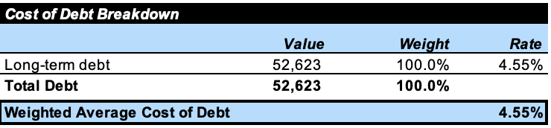
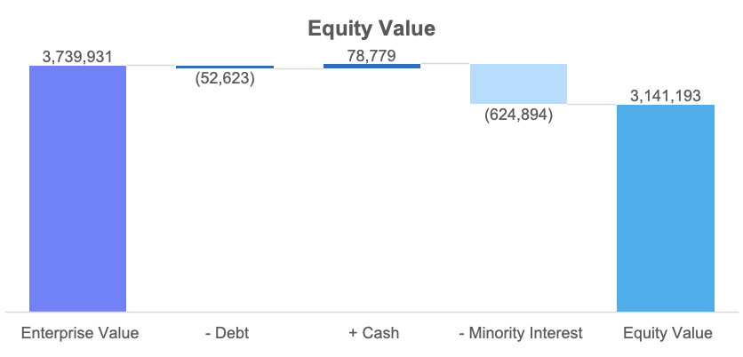
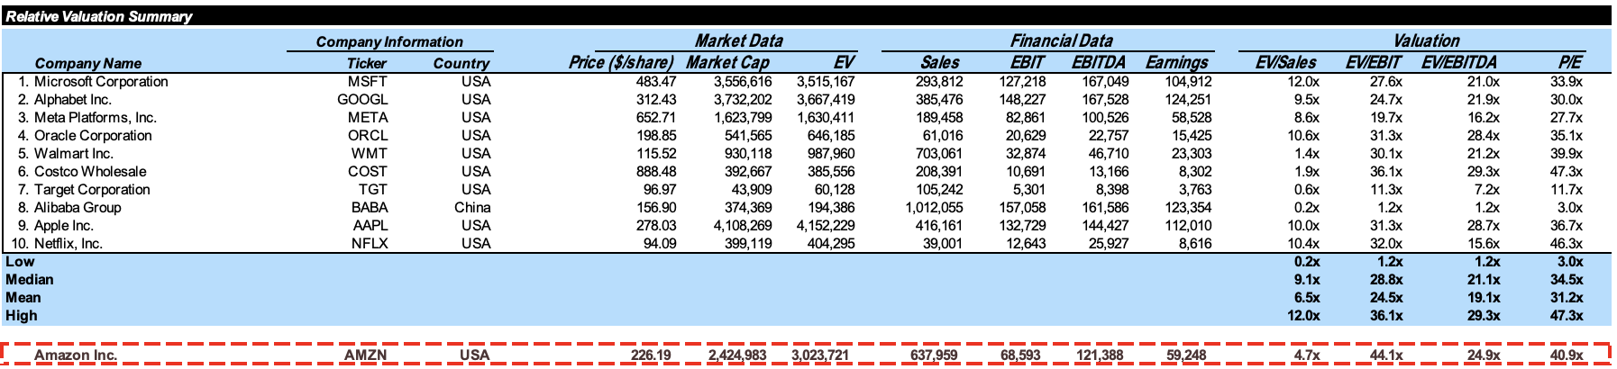
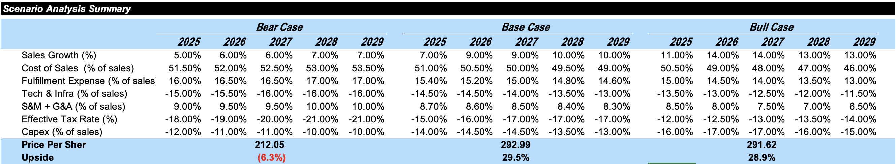
Appendix 6: Cost of Debt Breakdown
Appendix 5: Enterprise Value Waterfall
Appendix 8: Relative Valuation Summary
Appendix 7: Comprehensive Cash Flow
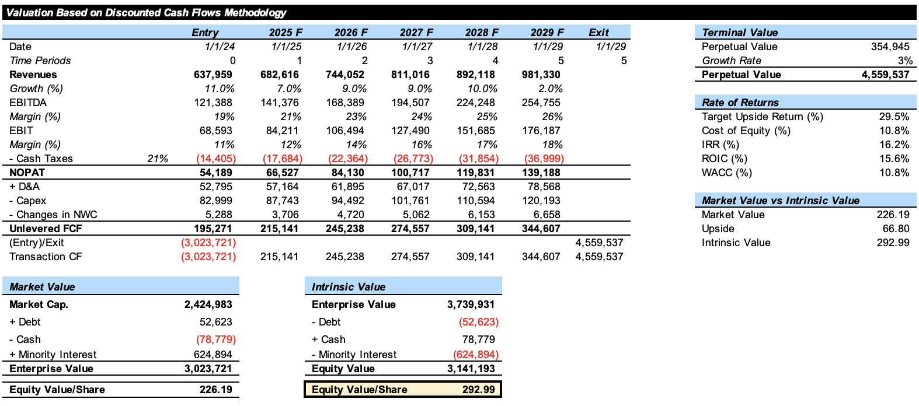
Appendix 9: Base Case Standalone FCF Valuation
Appendix 11: WACC Sensitivity Analysis
Appendix 10: Intrinsic Price, Equity, Enterprise Sensitivity Analysis
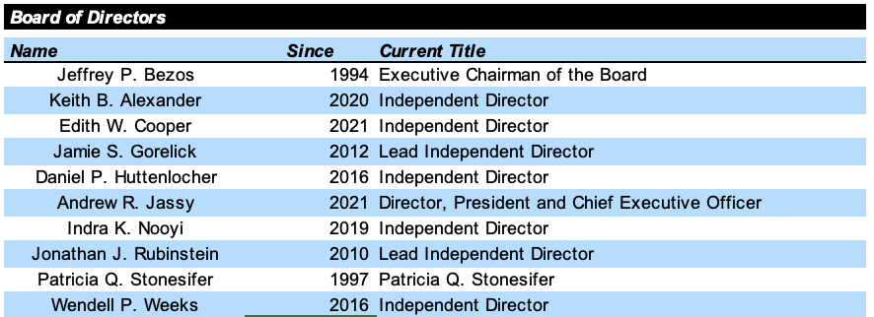
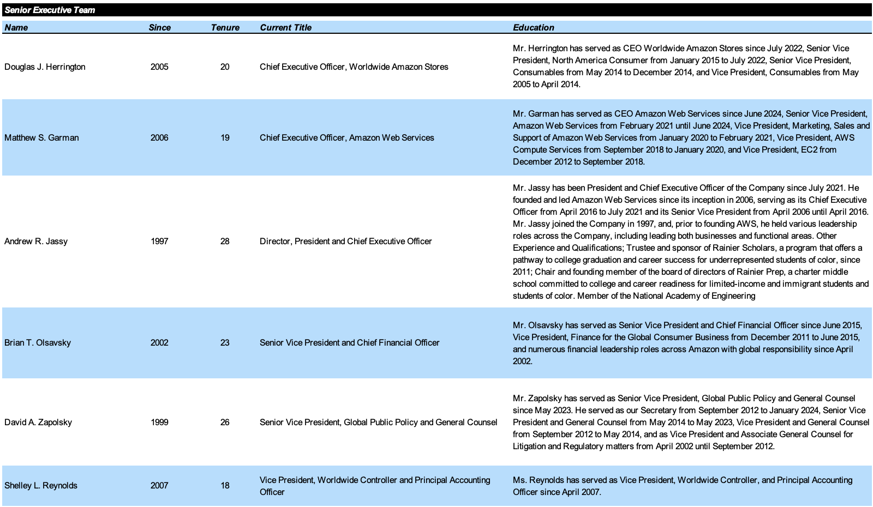
Appendix 13: Board of Directors
Appendix 12: Senior Executive Team
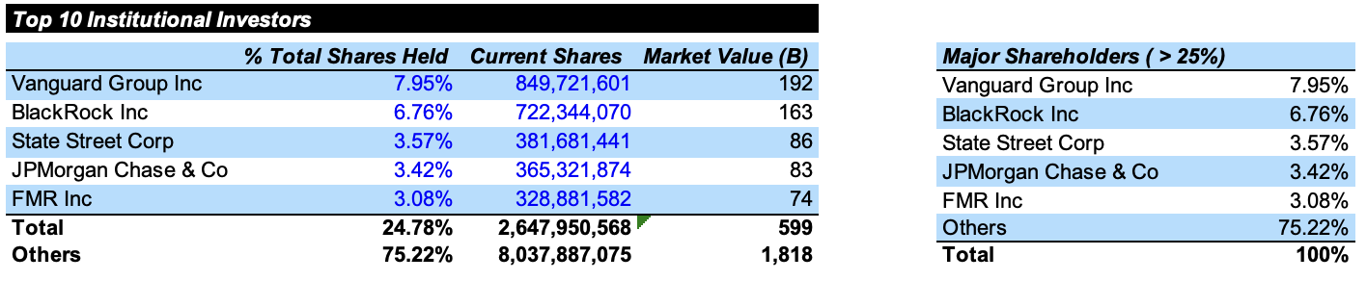
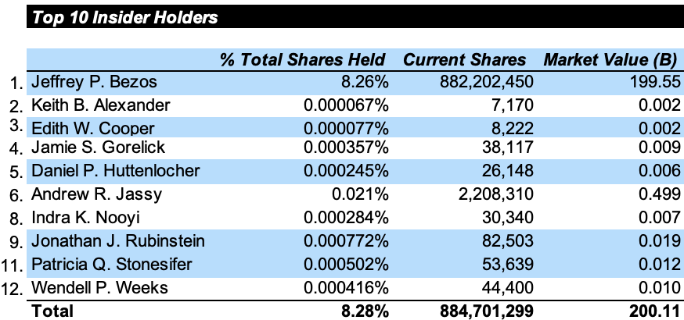
Appendix 15: Top 10 Institutional Holders
Appendix 14: Top 10 Insider Holders

