Adam El Harouchi, Candela Yang Arregui Sola, Daniil Rusanyuk, Katie Liang
12/16/2025
Dr. Seni Hazzan
Asset Valuation & Financial Analysis - FIN-0305 - BOS1

Final Team Project

Company Overview

The Coca-Cola Company is a well-known international beverage company with its headquarters located in Atlanta, Georgia. Its origins date back to the late 19th century, when the company was founded and Coca-Cola was invented in 1886. It is one of the most well-known consumer brands in the world and has operations in more than 200 countries and territories. Its primary goal is sometimes described as “refreshing the world” while generating long-term profit for stakeholders, including shareholders.

Coca-Cola is a “total beverage” company, offering a broad portfolio that spans sparkling soft drinks, water and hydration, sports drinks, teas and coffers, juices, dairy, and plant-based beverages. The sparkling market is anchored by iconic brands like Coca-Cola, Diet Coke/Coke Zero Sugar, Sprite snd Fanta, while platforms like Minute Maid, Simply, Powerade, Dasani, Costa Coffee, and several local brands expand its reach into a variety of consumption contexts and price points. The company is well-positioned to withstand economic cycles and changing customer tastes, such as the increasing demand for sugar-free and low-sugar products, thanks to its diverse portfolio.

The global “Coca-Cola system,” which keeps concentrated production apart from the majority of bottling, packaging, and distribution operations, is the foundation of the company’s business strategy. While independent and partially owned bottling partners manage local manufacturing and route-to-market execution, Coca-Cola primarily produces concentrates and syrups and licenses its brands. High gross and operating margins, robust free cash flow, and the ability to swiftly adapt to local market dynamics, regulatory changes, and input-cost fluctuations are all supported by this asset-light structure.

Strategically, management emphasizes a “topline flywheel” of Marketing → Innovation → Revenue Growth Management → Integrated Execution. Disciplined pricing and packaging design, extensive brand marketing and sponsorships, and continuous product innovation all contribute to stable organic revenue growth as opposed to quick expansion. In order to increase exposure to faster-growing segments and take advantage of its worldwide distribution scale, the firm supplements this with targeted mergers, acquisitions, and partnerships in categories like coffee, energy drinks, and premium hydration.

Financially speaking, Coca-Cola is seen as a well-established, superior consumer staple company with comparatively steady cash flows and modest growth prospects. It is especially well-known as an income investment because it has been paying dividends for decades and has raised its payout annually for almost 60 years in a row, giving it the title of payout King. As a worldwide blue-chip, its shares are traded on the New York Stock Exchange under the symbol "KO" and are included in important indices, including the Dow Jones Industrial Average and the S&P 500. Coca-Cola is under constant scrutiny for things like sugar content, plastic waste, and water usage, which it aims to resolve through packaging initiatives, portfolio changes, and more general sustainability commitments.
Comparables
Comparables, or "comps," is a valuation technique used to estimate a company's stock value and compare it with that of its competitors. In this case, Coca-Cola's (KO) competitors are PepsiCo, Keurig Dr Pepper, and Monster Beverage Corporation, to name a few.
Price and Market Data
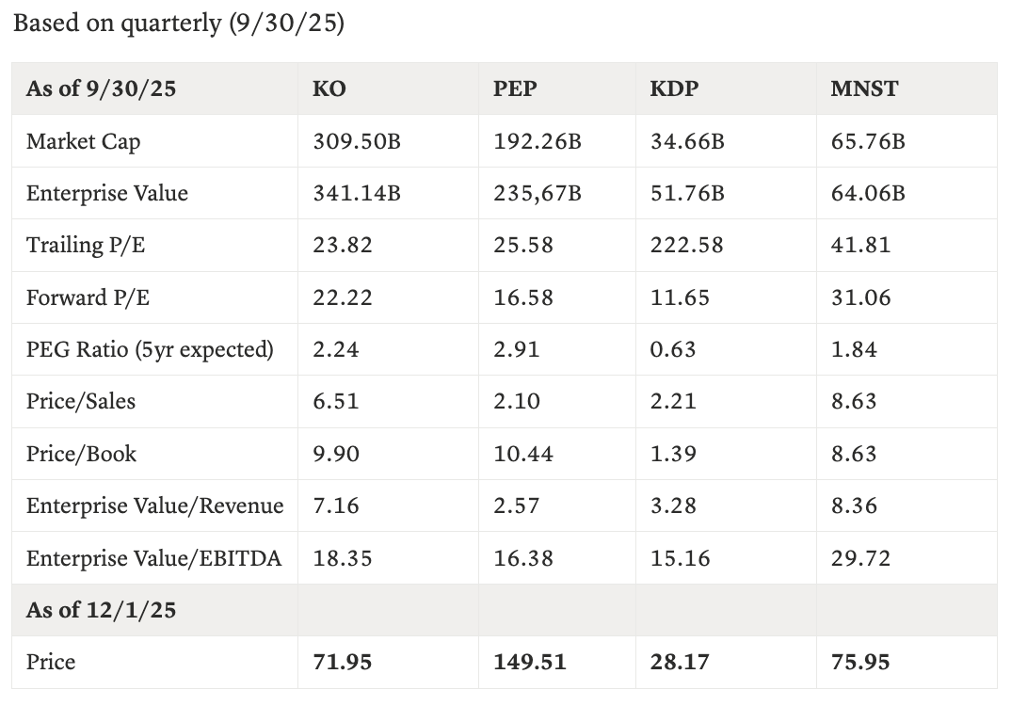
Financials
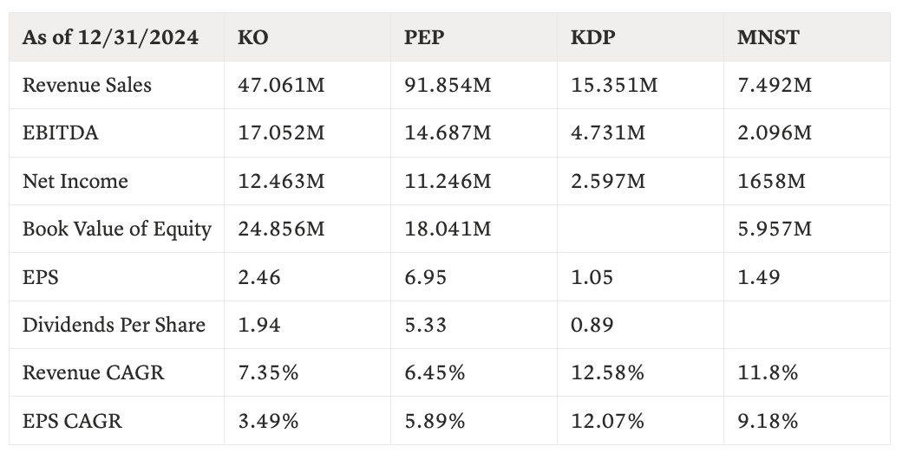
KO has a good revenue growth; however, the company has a worse EPD growth. In turn, it can be seen that KO’s growth is more due to strong branding and global diversification, predictable cash flows with long dividend increases, and lower perceived risk.
Multiples & Summary
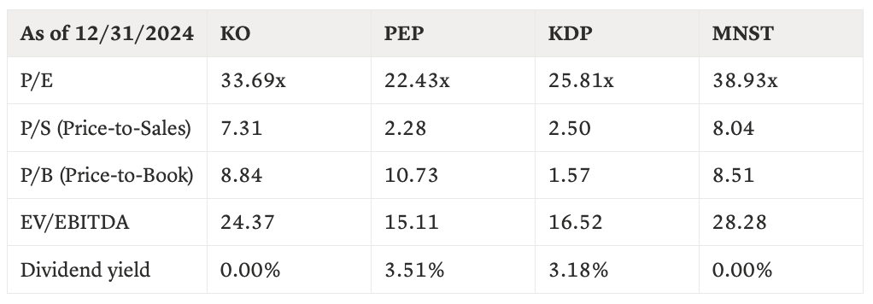
KO versus Peer Averages
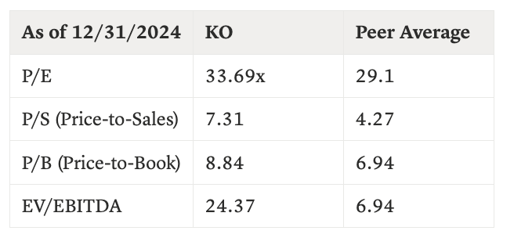
KO is consistently above the peer average, with the largest gap being P/S, in which investors are paying 3x its peer. Only MNST has a higher P/S. However, KO is on the lower end of dividend payers, which is expected with a stock that has a “richer” pricer.
In terms of fair value, KO’s price is US$71.95, while the peer-average implied value from the P/E multiple is about US$71.50. This suggests KO is fairly priced relative to the average of PEP, KDP, and MNST. However, peer EV/EBITDA multiple to KO’s EBITDA indicates that KO is modestly undervalued on a cash-flow basis.
Based on comparables, Coca-Cola (KO) trades at the top end of the beverage peer group on all major valuation metrics. KO’s multiples are roughly 15–25% above the peer averages and are substantially above their peers. At the same time, KO offers the lowest dividend yield among the dividend payers (≈2.7% vs 3.2–3.6%), and its EPS growth has been slower than that of PEP, KDP, and MNST. This suggests that investors are paying a quality and safety premium for KO’s highly diversified global franchise, strong brand equity, and long history of stable dividends, rather than for superior growth.
Applying the peer average P/E multiple to KO’s EPS yields an implied fair value of roughly US$71–72 per share, very close to the current market price of US$71.95, so KO appears fairly valued on an earnings basis. In contrast, applying the peer EV/EBITDA multiple to KO’s EBITDA produces an implied value above the current price, pointing to upside from current levels. Even though more conservative benchmarks (such as the peer median or only PEP and KDP) give a slightly lower fair-value range, the overall comparables analysis supports the view that Coca-Cola is fairly valued on P/E but modestly undervalued on a cash-flow basis, and therefore slightly undervalued relative to its peer group.

DDM Analysis

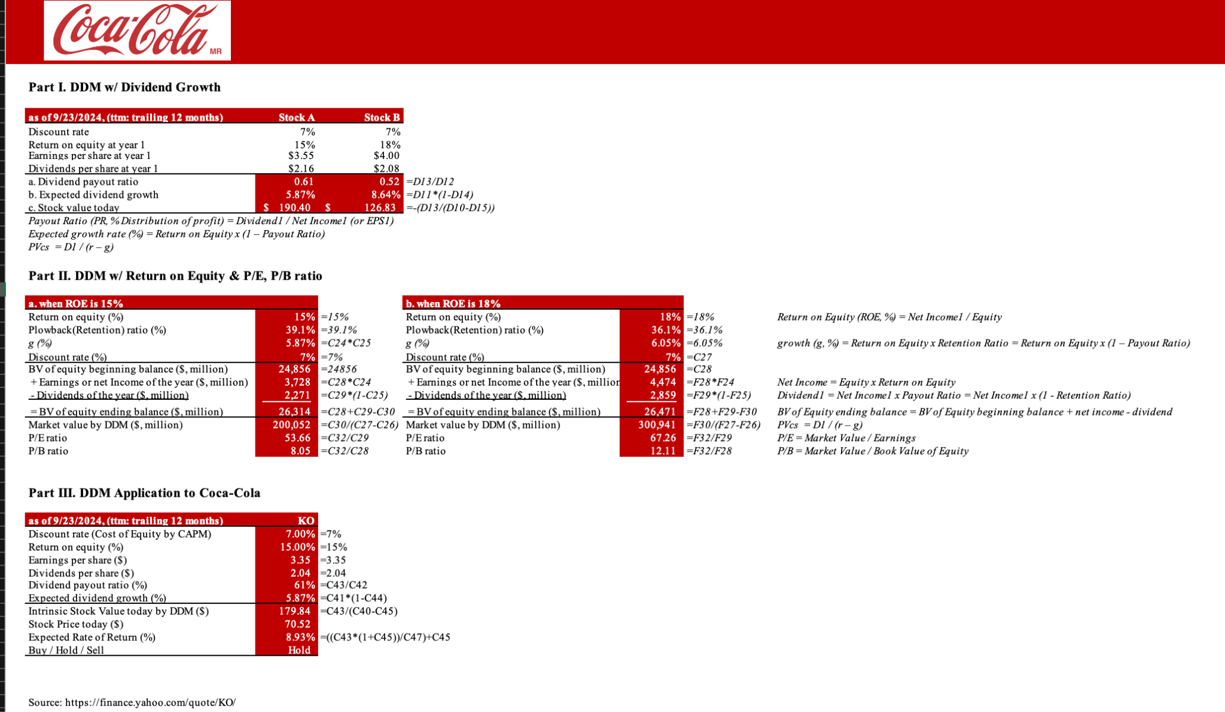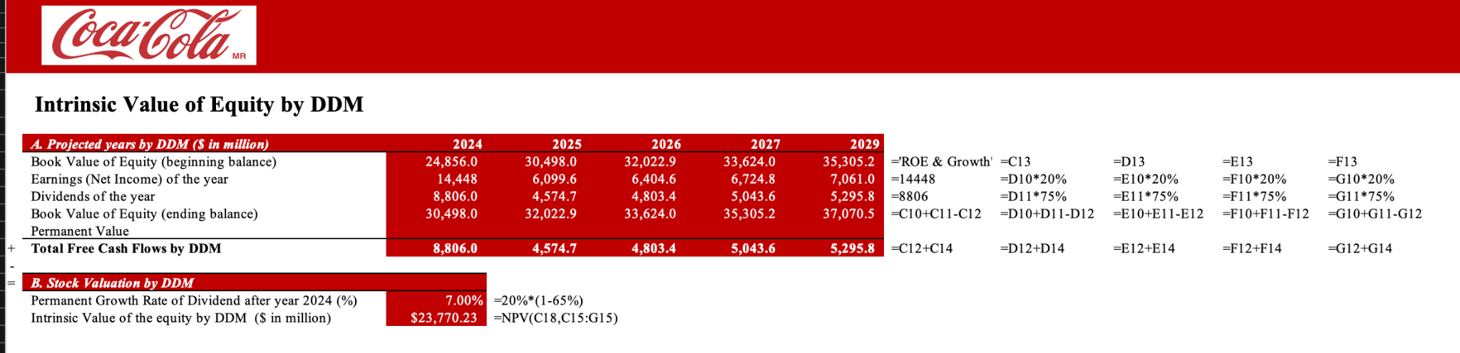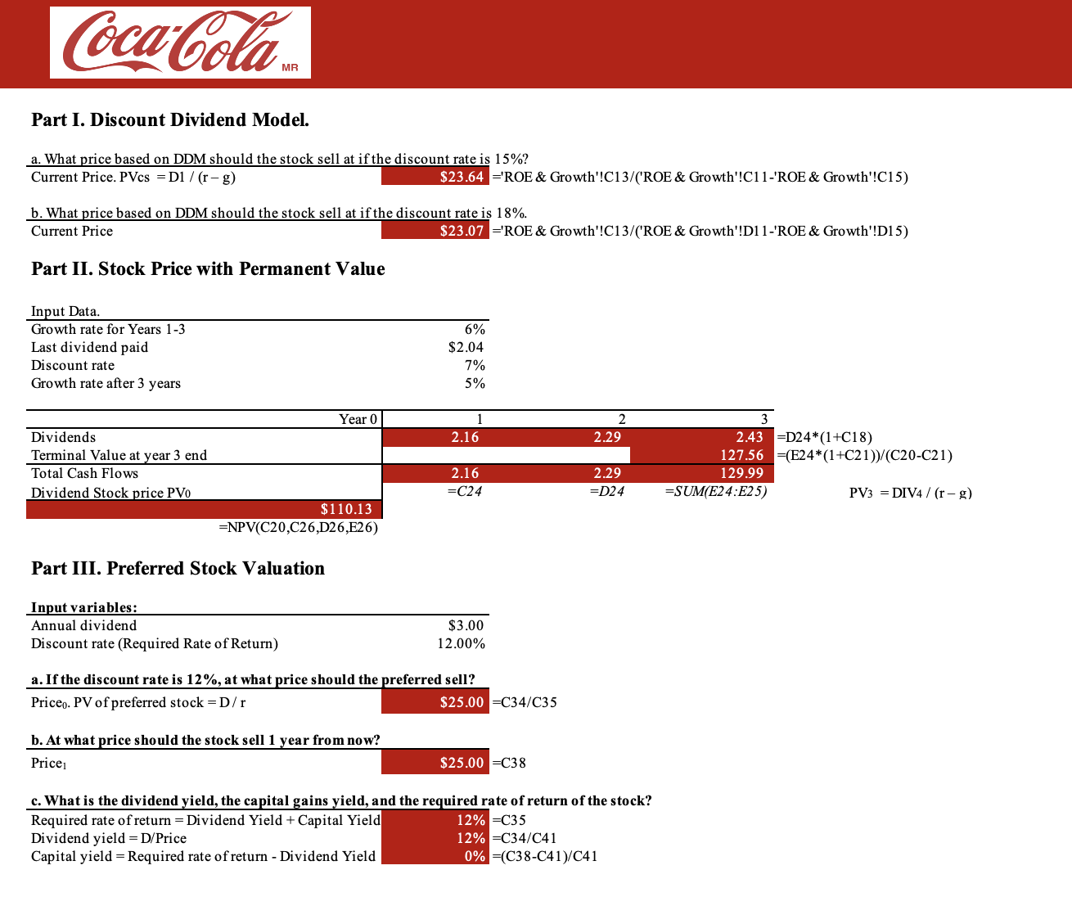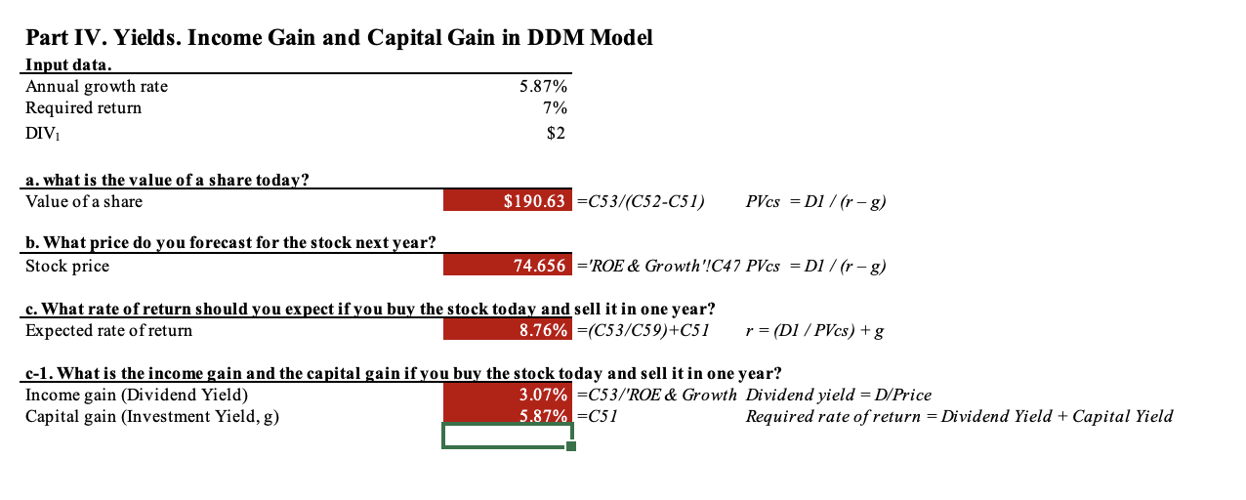

The Dividend Discount Model (DDM) analysis indicates that the company is undervalued relative to its current market price. Under the constant-growth DDM, assuming a required rate of return of 7% and a sustainable long-term dividend growth rate of 5.87%, the estimated intrinsic value of the stock ranges between $180 and $190 per share, which is significantly higher than the observed market price of approximately $70.50. This large valuation gap suggests that the market may be undervaluing the firm’s ability to generate and grow future dividend cash flows. From a return perspective, the stock offers an expected total return of about 8.9%, exceeding the required return, with roughly 3.1% derived from dividend yield and 5.9% from capital gains driven by dividend growth. This return decomposition reinforces the view that investors are being compensated not only through stable income but also through long-term growth. However, it is important to note that the DDM outcome is highly sensitive to assumptions, particularly the narrow spread between the discount rate and the growth rate; even small increases in the required return or reductions in expected growth would materially lower the intrinsic value estimate. Despite this sensitivity, under the stated assumptions, the analysis supports the conclusion that the stock is undervalued and offers attractive long-term return potential.

Market Sentiment on The Coca-Cola Company (KO)
Right now Coca-Cola is treated much more like a “steady compounder” and not like a high-growth stock. Most investors seem to own it for a mix of predictable dividends and slow-but-reliable earnings growth, and that comes through pretty clearly in recent analyst reports and articles.
What Wall Street thinks?
Most Wall Street analysts' reviews on KO are clearly positive. Recent consensus data shows “Buy” to “Strong Buy” as the average rating, with an average 12-month price target around $78–80 per share, versus a current price around $70. This is roughly 10–13% expected upside on top of the dividend.
Several large banks have continued with Buy ratings this fall. For example, Bank of America recently raised its target price from $78 to $80 while maintaining a Buy rating, citing continued confidence in Coke’s long-term prospects.
TipRanks (https://www.tipranks.com/stocks/ko/forecast) :

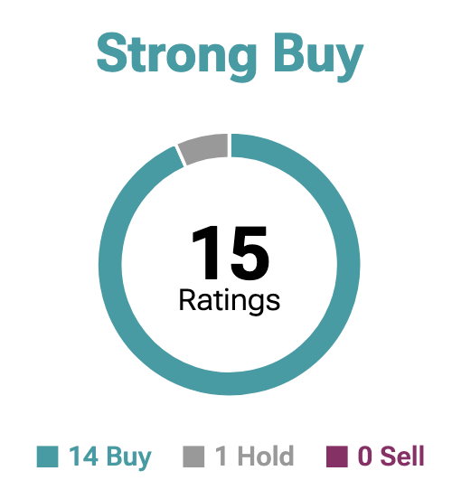
MarketBeat (https://www.marketbeat.com/stocks/NYSE/KO/forecast/) :

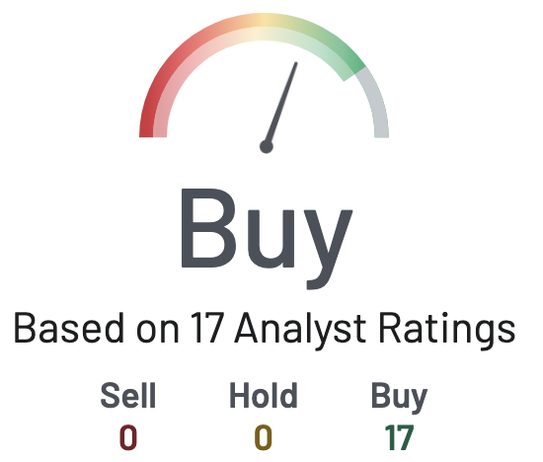

Dividends

On the income side, it's even stronger. In February 2025, Coca-Cola’s board approved its 63rd consecutive annual dividend increase, lifting the quarterly dividend by about 5.2%, from $0.485 to $0.51 per share. That’s $2.04 per share annually, up from $1.94 in 2024, and the company paid $8.4 billion in dividends in 2024 alone.

And dividend investors always point to KO as a classic “buy and hold forever” name

A recent Motley Fool article (via Nasdaq) highlighted that Coca-Cola hasn’t missed a sales or EPS estimate in at least five years, and has grown its dividend at about 4–5% per year over the last decade, arguing that this combination of steady earnings and rising payouts can deliver a around 55% total return over five years when you combine price appreciation and dividends.

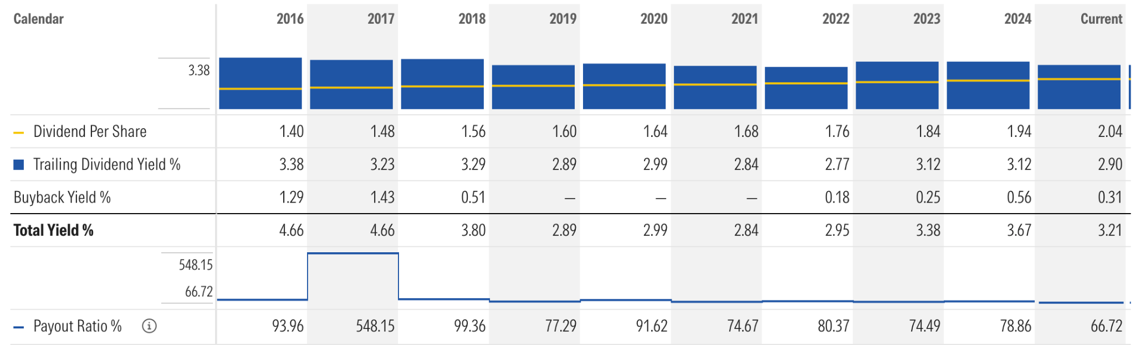

Performance and narrative in the market

Fundamentally, Coke has given investors a reason to stay positive. For 2024, the company reported 12% organic revenue growth, driven mostly by pricing, with modest volume growth and a 7% increase in comparable EPS. Several news outlets note that Coke has outperformed the broader Consumer Staples sector in 2025, even though staples as a group have lagged the market (Yahoo Finance).

Recent articles highlight that KO has slightly outperformed the S&P 500 over the past month and has been holding up better than many peers in a tricky consumer environment.

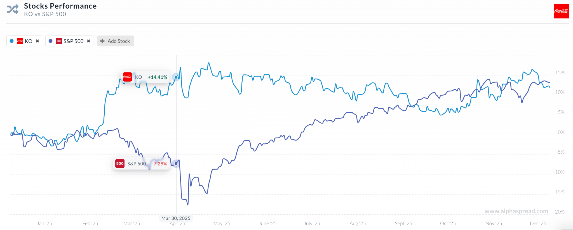

So all in all, Coke is a high-quality, defensive name with very reliable cash flows and dividends. It’s not screamingly cheap, but at current levels most analysts think there is still upside plus a decent yield, especially if you’re willing to own it for several years.

That kind of profile lines up quite well with a family office that is more focused on capital preservation and steady compounding than on short-term trading.

Overall Investment Summary for the Family Office

Fit with income goal: KO offers a roughly 3% dividend yield with a 60+ year streak of increases, which strongly matches the family’s requirement for regular, predictable income from US equities.

Fit with growth goal: Management and analysts are aligned around steady, mid-single-digit earnings growth, which supports gradual capital appreciation rather than speculative upside.

How our valuation compares to sentiment:
Our DDM work and comparable analysis suggest KO is somewhere between fairly valued and modestly undervalued at current prices. That lines up well with external sentiment: analysts see a bit of upside over the next 12 months, but no one is claiming it’s a deep bargain.

Key things the family should keep in mind:

- This is not a high-growth tech stock; returns will likely come from a mix of dividend income plus slow but steady compounding, not from multiple expansion.
- There are a couple long term risks like sugar taxes, changing consumer tastes or emerging-market risk but the brand strength and pricing power give Coke a lot of room to adapt.
- Given the size of the mandate ($10B), KO is best used as a core, defensive position within a broader portfolio of names, rather than the only stock they buy.
Overall, current market sentiment paints Coca-Cola as a high-quality, dependable compounder. Not exciting, but very aligned with a family office that wants to protect capital, earn reliable income, and still participate in equity market growth.

References:

Company Overview:

- Bullfincher. (2025, August 31). Coca-Cola company overview. https://bullfincher.io/companies/coca-cola-company/overview
- CNBC. (2025, October 21). Coca-Cola tops earnings and revenue estimates but says demand for drinks is still soft. https://www.cnbc.com
- Fortune. (2023, December 16). Coca-Cola (KO) company profile. https://fortune.com/company/coca-cola
- Nasdaq. (2024, March 18). Dividend growth master class: Coca-Cola strategy. https://www.nasdaq.com
- Sure Dividend. (2024, February 5). Dividend kings list: 50+ years of dividend increases. https://www.suredividend.com/dividend-kings-ko
- The Coca-Cola Company. (2025a). About us. https://www.coca-colacompany.com/about-us
- The Coca-Cola Company. (2025b, October 20). Coca-Cola reports third quarter 2025 results [Press release]. https://investors.coca-colacompany.com
- World Benchmarking Alliance. (2023, December 18). The Coca-Cola Company – Food and Agriculture Benchmark. https://www.worldbenchmarkingalliance.org/publication/food-agriculture/companies/the-coca-cola-company-2

Market Sentiment + Summary:
- https://www.marketbeat.com/stocks/NYSE/KO/forecast/
- https://www.gurufocus.com/news/3195365/b-of-a-securities-maintains-buy-on-cocacola-ko-raises-price-target-to-80-ko-stock-news
- B of A Securities Maintains Buy on Coca-Cola (KO), Raises Price Target to $80 | KO Stock Newshttps://investors.coca-colacompany.com/news-events/press-releases/detail/1129/board-of-directors-of-the-coca-cola-company-approves-63rd-consecutive-annual-dividend-increase
- https://www.businesswire.com/news/home/20250220733936/en/Board-of-Directors-of-The-Coca-Cola-Company-Approves-63rd-Consecutive-Annual-Dividend-Increase
- https://stockanalysis.com/stocks/ko/dividend/
- https://www.nasdaq.com/articles/prediction-coca-cola-stock-will-soar-over-next-5-years-heres-1-reason-why
- https://finance.yahoo.com/news/coca-cola-stock-ko-outperforming-145752489.html

Comparbales
- https://www.consainsights.com/company-profile/coca-cola/competitors
- https://finance.yahoo.com/quote/KO/

