Introduction
This report explores how customers interact with Café Nero, a mid-scale, a European inspired coffee chain located within a busy mall environment. The visit aimed to observe real consumer behavior and understand how environmental and operational factors influence satisfaction and repeat visits.
JTBD Statement:
“The customer is trying to secure a quick, reliable coffee and snack experience that fits seamlessly into a fast-paced daily routine.”
Café Nero positions itself as a dependable stop-in for commuters and mall workers. Yet, behind its functional success lie design and service bottlenecks that prevent deeper brand attachment. Using the Jobs-to-Be-Done lens and environmental behavior theories (Mehrabian & Russell, 1974), this study converts field observations into evidence-based recommendations to improve efficiency and emotional connection.

Methods

Setting & Timing:
Field observations were conducted at the Café Nero branch located inside the Prudential Center in Boston during two different time slots: morning (8–10 a.m.) and midday (12–1 p.m.) on separate weekdays. Each session lasted approximately 45 minutes and included direct observation of customer entry, ordering behavior, seating, and departure patterns.
Participants & Interviews:
Three informal interviews were conducted with patrons to capture qualitative insights:
- Participant A – Female, 28, corporate employee: “It’s right on my way; I don’t think about other cafés.”
- Participant B – Male, 32, office staff: “They’re reliable. Not special, but consistent.”
- Participant C – Male, 23, retail worker: “I grab the bacon roll; it’s filling and lighter than a sandwich.”
Data Collection:
Twelve time-stamped observations were recorded to measure service duration and customer dwell time. Average wait time was five minutes for beverages and eight to ten minutes for food. Approximately 70% of customers stayed under twenty minutes, often using laptops or mobile phones while waiting. Photographs were also taken to document the store’s layout, signage, and pickup counter design.
Ethical Note:
All interviews were voluntary and anonymous. No minors were approached or included in the research.
Rationale:
Café Nero was selected because it represents a fast-paced, high-traffic urban café environment, ideal for studying how convenience and routine shape consumer decision-making.

Findings
Customer Patterns:
Solo visitors dominated (≈ 70 %), primarily commuters or professionals seeking efficiency. Few stayed beyond 30 minutes, underscoring the brand’s transactional nature.
Atmosphere & Layout:
Warm wood finishes and European décor produce a cozy yet functional tone. Lighting is moderate, with music kept low. The queue for ordering is orderly, but the pickup station forms a bottleneck during peak hours.
Customer Quotes
- “I don’t come for vibes; I come because it’s fast.” (Participant A)
- “Never had a bad cup, and that’s what matters.” (Participant B)
- “The breakfast roll keeps me coming back.” (Participant C)
Contradictions Observed
- Speed vs. Space: Quick service offset by cramped pickup zone.
- Reliability vs. Emotion: Predictable quality, but low brand enthusiasm.
- Routine vs. Community: Regular use without social engagement.
These patterns echo Baker et al. (1994), who found that store environment cues shape perceived quality and loyalty. Café Nero excels at the cognitive “ease” of decision-making but falls short on emotional resonance.

Analysis
Functional, Emotional, and Social Jobs
- Functional – Acquire caffeine and food rapidly with consistent results.
- Emotional – Feel efficient, composed, and “on schedule.”
- Social – Portray professionalism and self-discipline in public.
Customer Journey
Trigger → Entry → Order → Pickup → Consume → Exit
- Trigger: Morning rush or break between work tasks.
- Entry: Driven by proximity and habit.
- Order: Predictable and swift.
- Pickup: Pain point due to limited counter area.
- Consume: Functional experience with minimal interaction.
- Exit: Customers depart promptly after consumption.
According to Hanks et al. (2017), social and physical cues jointly influence satisfaction. Café Nero’s efficiency encourages retention, but its lack of emotional triggers restrains advocacy. The store’s affective environment (Mehrabian & Russell, 1974) elicits calm but little pleasure or arousal—dimensions critical to deep satisfaction (Bigné et al., 2005).
Forces of Progress
- Push: Need for speed and routine.
- Pull: Consistent product quality and predictable experience.
- Anxieties: Long lines or running late.
- Habits: Daily commute reinforces loyalty loop.
Segmentation:
- Time-Pressed Professionals – value efficiency and familiarity.
- Mall Workers & Students – seek affordable comfort for short breaks.
This aligns with Wakefield & Blodgett (1999), who highlight how both tangible and intangible elements of services shape loyalty through perceived convenience and affect.

Recommendations
Insight 1: Pickup Efficiency
Customers appreciate speed but encounter congestion at the pickup point; therefore, Café Nero should implement a separate mobile-order pickup shelf or wider counter design, because improving flow reduces wait time and enhances perceived control (Wakefield & Blodgett, 1999). → 7Ps: Process / Physical Evidence.
Insight 2: Health & Choice Expansion
The bacon roll drives repeat behavior; the brand should broaden its healthy menu with protein and low-sugar items to increase perceived variety and pleasure (Bigné et al., 2005). This reinforces functional loyalty while attracting new segments. → 7Ps: Product / Promotion.
Insight 3 – Emotional Connection
Loyalty is habit-based, not affect-based; introduce “personal touch” moments such as name greetings or digital thank-you messages via the app. Magnini and Pizam (2022) note that subtle social-servicescape enhancements can elevate perceived warmth and belonging. → 7Ps: People / Process.
Operational Feasibility
- Pickup redesign ≈ $2 – 3 K (minor carpentry).
- Menu update requires minimal inventory adjustments.
- App messaging is already supported within the existing CRM platform.
→ Projected impact: +15 % loyalty app usage and +10 % return frequency within a quarter.

Conclusion
Café Nero’s field analysis reveals a brand sustained by habit, consistency, and convenience. While its environment meets core functional jobs, the experience lacks high-arousal elements that convert efficiency into affection. Applying Mehrabian and Russell’s (1974) environment-emotion model shows that small sensory and social enhancements can significantly raise satisfaction.
Conducting this safari enabled direct observation of how layout and service rhythm shape perceived control and satisfaction. It confirmed that routine behavior—not brand attachment—drives daily café choice. Future research should test new layout prototypes and track app engagement to measure emotional lift after interventions.

References
Baker, J., Grewal, D., & Parasuraman, A. (1994). The influence of store environment on quality inferences and store image. Journal of the Academy of Marketing Science, 22(4), 328–339. https://doi.org/10.1177/0092070394224002
Bigné, E., Andreu, L., & Gnoth, J. (2005). The theme park experience: An analysis of pleasure, arousal and satisfaction. Tourism Management, 26(6), 833–844. https://doi.org/10.1016/j.tourman.2004.05.006
Hanks, L., Line, N. D., & Mattila, A. S. (2017). The impact of service context and social servicescape on customer satisfaction. International Journal of Hospitality Management, 61, 35–45. https://doi.org/10.1016/j.ijhm.2016.10.009
Magnini, V. P., & Pizam, A. (2022). Hospitality servicescapes: A critical review of the literature and future research agenda. International Journal of Hospitality Management, 102, 103168. https://doi.org/10.1016/j.ijhm.2022.103168
Mehrabian, A., & Russell, J. A. (1974). An approach to environmental psychology. Cambridge, MA: MIT Press.
Wakefield, K. L., & Blodgett, J. G. (1999). Customer response to intangible and tangible service factors. Journal of Services Marketing, 13(6), 422–441. https://doi.org/10.1108/08876049910298713
OpenAI ChatGPT. (2025). Used for outline refinement and language polishing; all field analysis and observations are original. https://chat.openai.com

Appendix
Figure 1. Storefront and queue layout.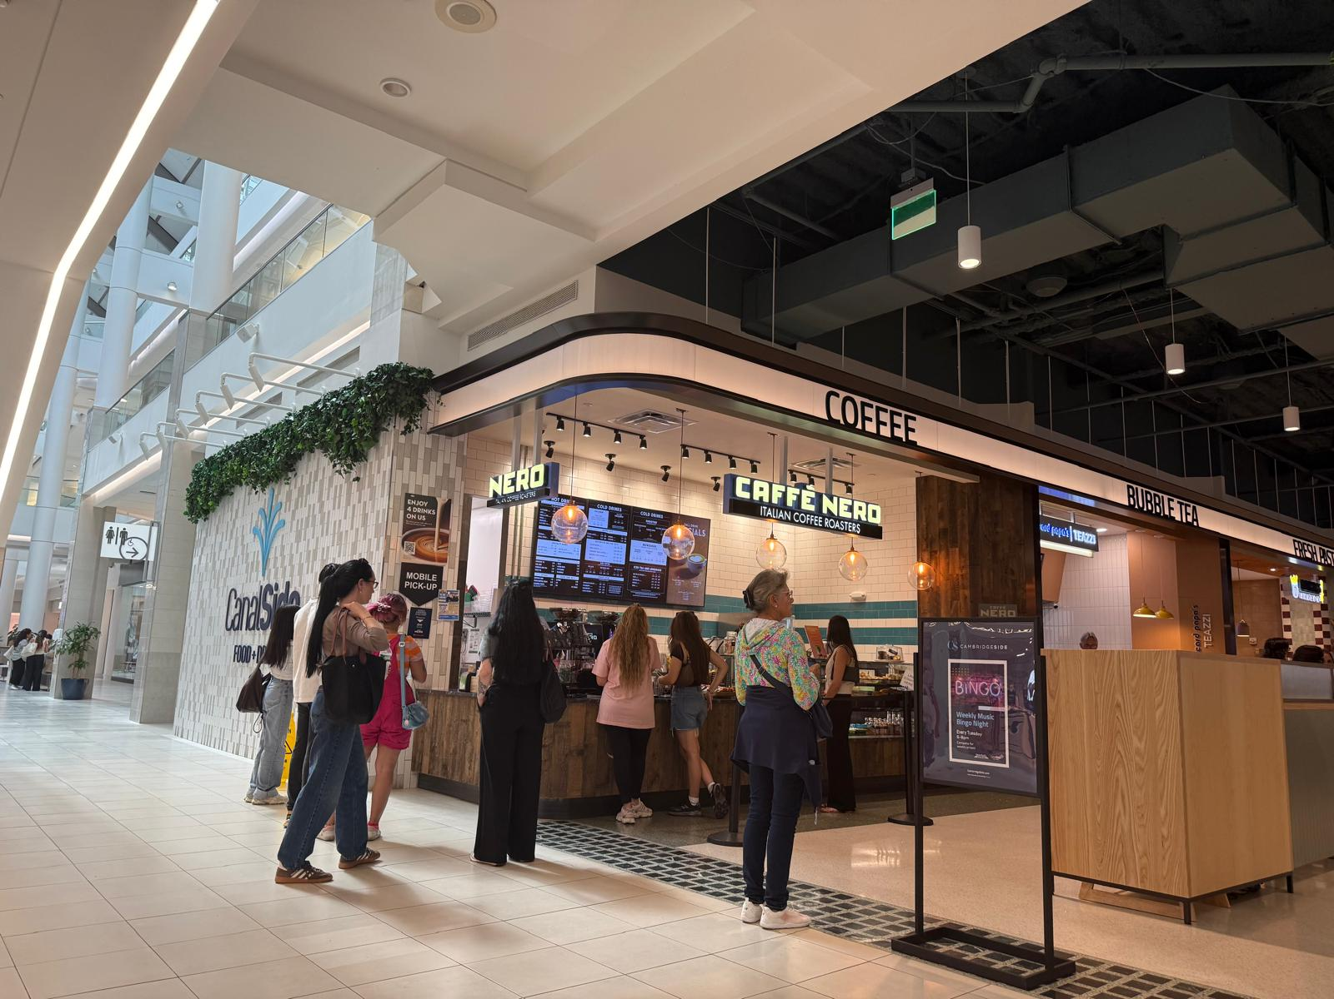
Figure 2. Barista handoff zone and pickup counter.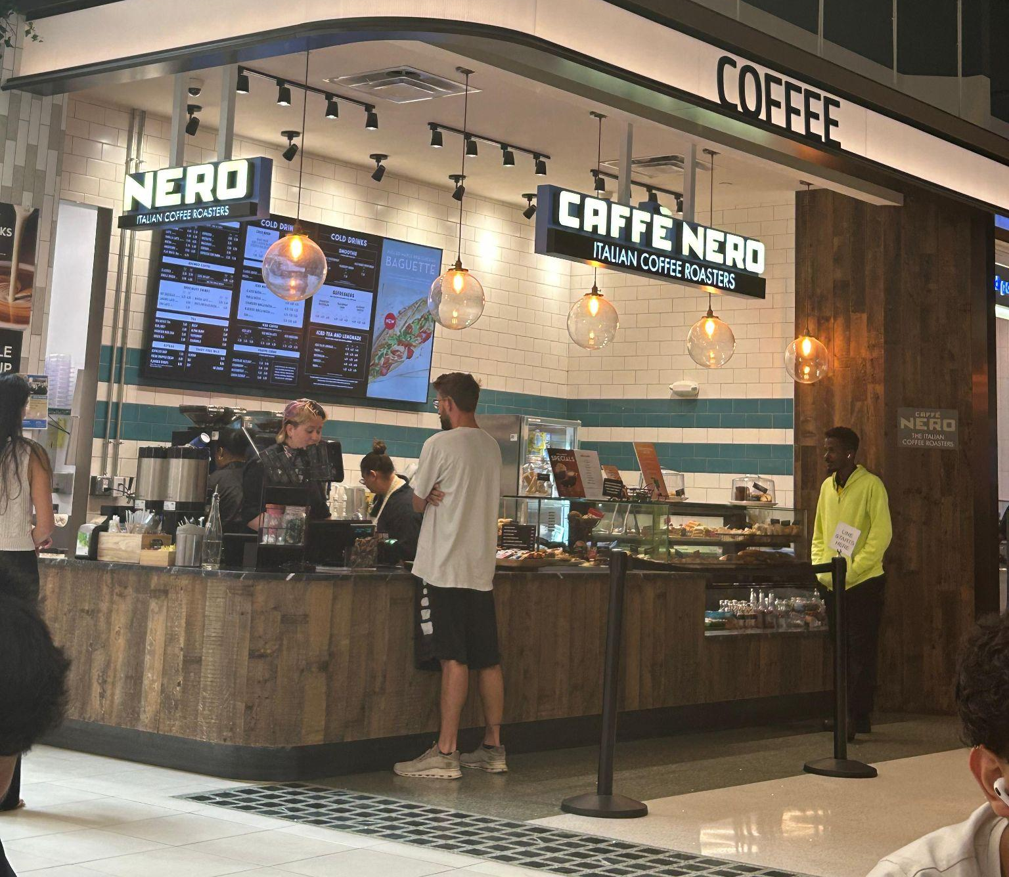
Figure 3. Menu board highlighting breakfast options.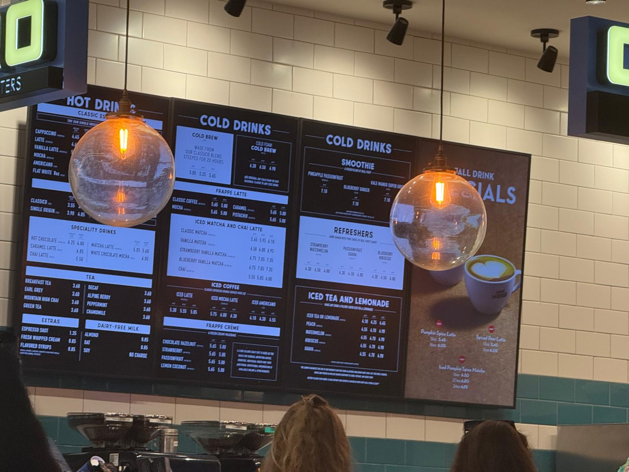
Figure 4. Digital loyalty promotion signage.
Figure 5. Mixed seating and work areas.