
AMPLIRAIL 2.0
Master Development Document
Version 3.7 complete edition: start guide, architecture, security, 54 screens, 10 diagrams, prompts and full backlog for eDataPay PHP developers and AI coding agents
Version 3.7 | October 4, 2026
Status Controlling document. Replaces the V1 Master PRD and all earlier V3 files (V3 to V3.5).
Business owner Adam Elisha, President and CEO, AmpliPay Group Inc.
Technical owner Lead eDataPay PHP Developer
Repository amplirail-unified-commerce (company-owned GitHub organization)
Sources merged V1 Master PRD; RoboRiskAnalysis specification v1.1; AmpliPay PCI Fast-Track Plan; Mastercard SDP FAQ (2024); Visa PCI DSS validation review; Unified Commerce Platform Architecture (Sep 26); Elavon / U.S. Bank Integration Brief; eDataPay AI Security Review Standard; Architecture Review (Sep 30); AmpliRail Platform Screens V3 prototype (54 screens)
Confidential. Internal development control document. Legal, accounting, PCI and processor certification conclusions remain subject to the appropriate advisers and provider requirements.

Contents
Start here: step-by-step guide for the eDataPay PHP Developer (GitHub, Claude Code, first four weeks)
0. How to use this document
1. Mission and non-negotiable rules
2. Decisions locked for Phase 1
3. System boundaries, repositories and subdomains
4. Architecture
5. Roles, portals, tenancy and identity
6. Canonical domain model and state machines
7. Connector framework
8. Orchestration and routing
9. Ledger, settlement, reconciliation, payouts and residuals
10. Onboarding saga and RoboRiskAnalysis
11. Events, outbox and webhooks
12. Product screens and acceptance
13. API standards and MVP endpoints
14. Security architecture
15. Database security
16. Backup, disaster recovery and incident response
17. Environments and CI/CD gates
18. AI agent operating model
19. Phased build plan
20. Milestone #1 acceptance test
21. Definition of done (every ticket)
22. Elavon and NMI implementation rules
23. Product success metrics
24. IP and ownership gate (before material coding)
25. Open items for Adam
26. Kickoff checklist (start of development)
Appendix A: AGENTS.md (repo root)
Appendix B: CLAUDE.md (repo root)
Appendix C: SECURITY.md (repo root)
Appendix D: Prompt library (docs/prompts/PROMPT_LIBRARY.md)
Appendix E: Sprint 0 tickets (docs/SPRINT_0_TICKETS.md)
Appendix F: Ticket template (docs/TASK_TEMPLATE.md)
Appendix G: Pull request template (.github/pull_request_template.md)
Appendix H: Full backlog (docs/BACKLOG.md)
Appendix I: GitHub files (CODEOWNERS)
Appendix J: CI workflow (.github/workflows/ci.yml)
Appendix K: Claude Code safety settings (.claude/settings.json)
Appendix L: Ticket issue template (.github/ISSUE_TEMPLATE/ticket.md)
Appendix M: Daily report template (docs/DAILY_REPORT_TEMPLATE.md)
Figures 1 to 10: developer diagrams (in Sections 4, 7.5, 7.8, 9.4, 9.6, 9.8, 10.2, 14.1)
Appendix N: Screen gallery (all 54 screens from the canvas)

Start here: step-by-step guide for the eDataPay PHP Developer
Read this first. It tells you exactly what to do, in order, from GitHub setup to Milestone #1. The rest of this document is the full reference the steps point to.

0. What you have and the goal
You have four things:
Item | What it is
AmpliRail 2.0 Master Development Document V3.7 (Word) | The controlling document. It wins any conflict.
AmpliRail Repo Starter Pack V3.7 (zip) | Files for the repository root: AGENTS.md, CLAUDE.md, SECURITY.md, docs, prompts, backlog, GitHub templates, CI workflow, Claude Code settings
AmpliRail Platform Screens canvas | 54 screens; each screen name shows its ticket numbers
This guide | The exact steps, in order

Goal for the first 4 weeks: Milestone #1 passing in sandbox. A merchant is created, a sandbox is provisioned automatically, a $100 payment runs through the simulator, the ledger balances, a signed webhook is sent, and the timeline shows in the admin console.
How to move fast safely: you decide, AI builds, tests prove, you merge. Run two or three AI sessions in parallel on different tickets (Step 14). Never let speed skip a review gate.

Part A: GitHub setup (Day 1, about 2 hours)

Step 1. Create the company-owned organization
- Sign in to GitHub with your own account.
- Go to github.com, click your profile picture, then Your organizations, then New organization.
- Choose a paid plan (Team plan) so you get protected branches, required reviewers and code owners on private repositories.
- Organization name: amplirail (or the name Adam approves). Contact email: a company address.
- When asked who owns it, choose that it belongs to a business and enter the legal entity Adam confirms (for example AmpliPay Group Inc.).
- Invite Adam (adam.e@amplipay.ai) and make him an Owner. There must always be at least two owners: Adam and you.
IP GATE: Do not put any code in a repository owned by a personal account. Every developer and contractor signs the IP assignment before getting access (master document Section 24).

Step 2. Lock down organization security
In Organization settings:
- Authentication security: turn on Require two-factor authentication for everyone.
- Member privileges: set Base permissions to No permission. Turn off repository creation for members and turn off forking of private repositories.
- Actions, General: allow only actions created by GitHub and verified creators, plus the ones listed in ci.yml. Set Workflow permissions to Read repository contents.
- Code security: enable Dependabot alerts and Dependabot security updates for all new repositories. If your plan includes secret scanning and push protection, turn both on; if not, the gitleaks job in CI covers secret detection.

Step 3. Create the teams
Team | Members | Access
rail-owners | Lead eDataPay PHP Developer, Adam | Admin on AmpliRail repositories
security-reviewers | Adam plus a named second reviewer | Write; required on sensitive paths through CODEOWNERS
rail-developers | Developers and contractors (after IP assignment) | Write
read-only | Anyone who only needs to look | Read

Step 4. Create the three private repositories
- amplirail-unified-commerce (the rail, this project)
- roboriskanalysis (merchant risk platform, runs separately; see master document Section 10.2)
- mvpay (media and merchant growth)
All private. Add a README. Give each team its access from Step 3.

Step 5. Protect the main branch with a ruleset
In amplirail-unified-commerce: Settings, Rules, Rulesets, New branch ruleset. Target: the default branch (main). Turn on:
- Restrict deletions.
- Block force pushes.
- Require a pull request before merging: 1 approval, dismiss stale approvals when new commits are pushed, require review from Code Owners, require conversation resolution.
- Require status checks to pass: add test and secrets (the jobs in ci.yml) after the first CI run.
- Require linear history.
- Bypass list: empty. Not even owners bypass.

Step 6. Create environments
Settings, Environments: create sandbox, staging and production.
Environment | Required reviewers | Secrets
sandbox | None | Sandbox AWS role only
staging | Lead eDataPay PHP Developer | Staging AWS role only
production | Lead eDataPay PHP Developer and Adam | Production AWS role only; deploy only from main

Use short-lived AWS credentials through GitHub OIDC roles rather than long-lived AWS keys stored as secrets.

Step 7. Commit the starter pack
git clone git@github.com:amplirail/amplirail-unified-commerce.git
cd amplirail-unified-commerce
unzip ~/Downloads/AmpliRail_Repo_Starter_Pack_V3_6.zip -d .
git checkout -b ar-003-starter-pack
git add AGENTS.md CLAUDE.md SECURITY.md docs .github .claude
git commit -m "AR-003: add AmpliRail starter pack V3.7"
git push -u origin ar-003-starter-pack
Open the pull request, have Adam approve, and merge. From now on nobody pushes to main directly.

Step 8. Load the backlog as GitHub Issues
- Create labels: ticket, sprint-0 through sprint-7, pre-launch, security-relevant, plan-first.
- Create one Issue per row of docs/SPRINT_0_TICKETS.md and docs/BACKLOG.md using the AmpliRail ticket template. Title format: "AR-004: Laravel 12 skeleton and module layout".
- Create a GitHub Project board with columns Backlog, Ready, In progress, In review, Done.
Tip: ask Claude Code to draft the Issues for you from BACKLOG.md with the GitHub CLI (gh issue create), and review them before creating.

Part B: Your machine (Day 1, about 1 hour)

Step 9. Install the tools
Tool | Version
Git and GitHub CLI (gh) | Latest
Docker Desktop | Latest
PHP and Composer | PHP 8.3+, Composer 2
Node.js | Current LTS
gitleaks | Latest (also runs in CI)

Step 10. Install and sign in to Claude Code
macOS, Linux or WSL:
curl -fsSL https://claude.ai/install.sh | bash
claude --version
Windows PowerShell:
irm https://claude.ai/install.ps1 | iex
Then run claude inside the repository folder and sign in with the company Claude account Adam provides (a business plan, not a personal one). Official setup guide: code.claude.com/docs/en/setup.

Step 11. Check the Claude Code safety settings
The starter pack includes .claude/settings.json. It stops the agent from reading .env files and secret folders, from force pushing, from pushing to main, and from running terraform apply or AWS commands. Keep this file in the repository so every session uses it. Change it only by pull request.

Part C: The AI build loop (every ticket)

Step 12. Run one ticket end to end
- Pick the top Ready Issue. Move it to In progress.
- Create a branch: git checkout -b ar-004-laravel-skeleton
- Start Claude Code in the repository: claude
- Paste prompt P0 (session bootstrap) from docs/prompts/PROMPT_LIBRARY.md. Check its summary of the hard rules.
- Paste prompt P1 with the full Issue text. For plan-first tickets, read the plan and the file list, correct it, then say "approved, go ahead".
- Let it write tests and code, and run: composer test, composer stan, composer arch, composer contract, composer audit, gitleaks.
- Ask it to push the branch and open the pull request with the template filled in (gh pr create).
- Open a new, separate Claude Code session and run prompt P6 (independent review) on the pull request. For security-relevant tickets also run P5 (security review).
- Fix what the reviews find (back in the builder session), wait for CI to go green, then review the diff yourself and merge.
- Move the Issue to Done and note it in your daily report.
Human gates you never skip: reading the plan before code on plan-first tickets, your own review of the diff, a second human reviewer on Identity, Tenancy, Ledger, Payments, connectors, infra and migrations (CODEOWNERS enforces this), and approval of every production deployment.

Step 13. Useful Claude Code habits
- One ticket per session. Start fresh for the next ticket so the context stays clean.
- Ask for the plan first on anything touching money, identity or the database.
- If it drifts outside the allowed files, stop it and restate the ticket scope.
- Never paste secrets, production data or real card numbers into the chat.
- When a test fails, ask it to find the root cause, not to change the test.

Step 14. Go faster with parallel sessions
Tickets in different modules can run at the same time using git worktrees, one Claude Code session per folder:
git worktree add ../ar-007 -b ar-007-tenancy
git worktree add ../ar-011 -b ar-011-connector-contracts
cd ../ar-007 && claude # terminal 1
cd ../ar-011 && claude # terminal 2
Good pairs: Tenancy with Connector contracts; Simulator with OpenAPI skeleton; UI screens with backend endpoints they depend on only after the endpoint is merged. Do not run two sessions on the same module or migration.

Part D: The first four weeks
When | Tickets | Done when
Day 1 | AR-001 organization, AR-003 starter pack, Steps 1 to 11 | Main protected, starter pack merged, Claude Code working
Day 1 (parallel) | AR-002 CRM card-data audit | Report sent to Adam
Days 2 to 3 | AR-004 skeleton, AR-005 CI | CI green on a pull request
Days 3 to 5 | AR-007 tenancy, AR-008 identity with emailed code, AR-009 audit and outbox | Cross-tenant tests pass
Week 2 | AR-010 schemas and OpenAPI, AR-011 contracts, AR-012 simulator, AR-006 Terraform plan, AR-013 backup plan, AR-014 PCI data flow, AR-015 Elavon SE package | Sprint 0 exit criteria met
Weeks 3 to 4 | Sprint 1: AR-016 to AR-025 | Milestone #1 test suite passes in CI and in sandbox

Terraform: the agent may write and run terraform plan only. Adam, as Systems Administrator / Platform Owner, runs or authorizes terraform apply after review.

Part E: Reporting to Adam
Send the daily report (docs/DAILY_REPORT_TEMPLATE.md) at the end of each working day. Keep it to the facts: merged, in review, in progress, blocked, CI status, decisions needed, tomorrow.
Escalate to Adam the same day if any of these happen:
- A secret was exposed or committed (rotate it first, then report).
- Real card, bank or customer data shows up anywhere in development.
- A ticket conflicts with the master document.
- A processor, bank or partner asks for something that changes the PCI boundary.
- A decision in Section 25 of the master document is blocking work.

Part F: Files in the starter pack
File | Purpose
AGENTS.md, CLAUDE.md | Rules every AI session follows
SECURITY.md | Security requirements
docs/MASTER_DEVELOPMENT_DOCUMENT_V3.md | The controlling document (version 3.7)
docs/prompts/PROMPT_LIBRARY.md | Prompts P0 to P15
docs/SPRINT_0_TICKETS.md, docs/BACKLOG.md | AR-001 to AR-167
docs/TASK_TEMPLATE.md, .github/ISSUE_TEMPLATE/ticket.md | Ticket format
.github/pull_request_template.md | Pull request checklist
.github/CODEOWNERS | Second reviewer on sensitive folders
.github/workflows/ci.yml | Starter CI: tests, PHPStan, architecture and contract tests, audit, gitleaks
.claude/settings.json | Claude Code safety settings
docs/DAILY_REPORT_TEMPLATE.md | End-of-day report

The CI file is a starting point: AR-005 finishes it (Semgrep, OpenAPI diff, npm audit, pinned action SHAs).

Two-week launch
Follow docs/LAUNCH_SLICE_2_WEEKS.md day by day. Use the daily prompt and send the daily status every evening.
Tested starter code for the launch slice is in code-starter/ (run php tests/run.php, expect 20/20 passed). Move each file into the module listed in code-starter/README.md.

0. How to use this document
This is the single controlling development document for AmpliRail 2.0. It replaces the V1 Master PRD and absorbs Unified Commerce Platform Architecture (Sep 26, 2026), the Elavon / U.S. Bank Integration Brief, the eDataPay AI Security Review Standard, the Architecture Review of Sep 30, 2026, and the AmpliRail Platform Screens V3 prototype (54 screens).

Version 3.7 governance and stack update (October 4, 2026)

- Platform Owner / Systems Administrator: Adam Elisha. Owns AWS accounts, DNS, networking, WAF, secrets management, backups and restore, monitoring and logging, production access, and production deployment authorization.

- Technical Owner: Lead eDataPay PHP Developer. Owns Laravel architecture, application code, migrations, connectors, APIs, automated tests, code review and staging readiness.

- Development Team: eDataPay PHP Developer(s), with a UI developer using React or Vue as needed. No individual contractor name is a required project dependency.

- Phase 1 stack: Laravel 12 / PHP 8.3+, PostgreSQL 16, Redis 7, and Laravel + Inertia with React or Vue for portals.

- Python/FastAPI is not part of Phase 1. RoboRiskAnalysis, document analysis and AI-assisted functions are Laravel modules, jobs or connectors that may call approved external APIs. A separate language or service requires a future ADR and demonstrated operational need.

- Separation of duties: developers do not receive unrestricted production infrastructure administration. Adam controls production infrastructure and authorizes production deployment after CI, review and staging gates pass.
Version 3.6 (October 3, 2026) adds: the high-volume target of 50 million transactions per month with the scale architecture to reach it (Section 4.5), the two-week launch slice on the NMI and Gattera bridges (Section 19.1), electronic payout statements, reserves and PSP reconciliation across multiple acquirers, MIDs and providers (Section 9.9), rewards issuing with prepaid cards and vouchers (Section 9.10), AmpliPay as gateway and payment provider of record with card brand registration (Section 14.8), hidden bridges (NMI and Gattera) and paid add-ons, processor-direct and terminal options (Elavon API, Elavon terminals and Talech, NMI devices), card-present data integrity and downgrade prevention (Section 7.8), the stage 3 AmpliRail card environment (Section 7.9), the commerce CRM (Section 9.7), club, hotel and resort payment capabilities (Section 9.8), the competitive gap items (wallets, stored credential flags, account updater, network tokens, open banking, global accounts, conversion insights), the AI toolchain policy (Section 18.1), and five new screens. Version 3.5 added: eight developer diagrams (Figures 1 to 8), the integration methods under AmpliRail's own names (Section 7.4), the full transaction lifecycle from authorization to funding (Section 7.5), connector tiers including the phase 3 direct ISO 8583 plan (Section 7.6), eight processing controls found in the gateway benchmark review (Section 7.7), and a clean-room rule for third-party documentation (rule 13). Version 3.4 added: merchant types (eCommerce online, POS and terminals, mobile, test), Fiserv, TSYS and other processors, the complete merchant processing setup (acquirer MID, TIDs, MCC, card brands and card types, velocity), portfolios with TPV, refund and chargeback ratios by acquirer, MID and card brand, card-type and decline-reason reports, chargeback alerts and dispute representment through third-party providers, cost and sell rates in fees, and two kinds of residuals (Sections 9.1 to 9.6, 10.1). Version 3.3 added: a configurable fees and billing engine with merchant fee agreements (Section 9.2), multi-currency processing and an optional currency conversion app with markup (Section 9.3), and merchant payouts when AmpliRail holds funds under its own money license (Section 9.4). Version 3.2 added: RoboRiskAnalysis as a separate merchant-risk platform integrated through a connector (Section 10.2), the PCI DSS v4.0.1 control map and fast-track plan with the extra code and evidence needed to pass (Sections 14.5 to 14.7), a PCI compliance screen, stricter admin sign-in (authenticator or security key, 15-minute timeout), and neutral terminology with no other providers' product names (rule 12). Version 3.1 (September 30, 2026) added: emailed one-time code sign-in, Terms and Privacy on every page, payment rails (cards, ACH and eCheck, stablecoins), integration methods, merchant setup with risk, velocity, reserves, blocking rules and dynamic descriptors, NMI-style reporting with batch integrity, merchant wallet and payouts, traffic and performance tracking, rewards, gift and debit cards, subscriptions and memberships, merchant settings, and a full ticket backlog (Appendix H).
RULE FOR EVERYONE: If code, a ticket, a prompt or a conversation conflicts with this document, this document wins. Changes to this document need an ADR (architecture decision record) approved by Lead eDataPay PHP Developer and Adam.
Reader | Start with | Then
Adam (owner) | Sections 1, 2, 20, 25 | Approve open items in Section 25
Lead eDataPay PHP Developer (technical owner) | Sections 2 to 17 | Load the repo starter pack, run Sprint 0
AI coding agents | AGENTS.md (Appendix A) | This document, SECURITY.md, the ticket
Designer | Section 12 and the prototype | Brand rules in Section 12.4

Repo starter pack. The appendices are also delivered as files that go in the root of the amplirail-unified-commerce repository: AGENTS.md, CLAUDE.md, SECURITY.md, docs/MASTER_DEVELOPMENT_DOCUMENT_V3.md, docs/prompts/PROMPT_LIBRARY.md, docs/TASK_TEMPLATE.md, docs/SPRINT_0_TICKETS.md, docs/BACKLOG.md and .github/pull_request_template.md. Claude Code reads CLAUDE.md automatically; other agents read AGENTS.md.

1. Mission and non-negotiable rules
AmpliRail is the single payments rail for the AmpliPay / eDataPay ecosystem. The CRM, merchant portal, POS, vertical SaaS (golf, sports, hospitality, healthcare), eCommerce plugins and partner APIs call AmpliRail. Only AmpliRail talks to processors, gateways, banks, KYB providers and RoboRiskAnalysis.
First proof (Milestone #1): a management user creates a merchant, AmpliRail automatically provisions a sandbox, a developer sends a $100 Transaction, AmpliRail routes it to the simulator, records the full event history and ledger postings, sends a signed webhook, and shows the timeline in the admin console.
Non-negotiable rules. Breaking any of these is a blocking review finding:
- No application integrates directly with a processor. Everything goes through the AmpliRail connector contract.
- No raw card number (PAN) or CVV is ever stored, logged or passed through AmpliRail core, the CRM or any portal. Card entry uses processor-hosted fields; POS uses certified P2PE / semi-integrated devices.
- Money is integer minor units plus a currency code (ISO 4217 for fiat, using each currency's own decimals, for example 0 for JPY; stablecoins use their own code and 6 decimals). Floats are banned for amounts. Amounts in different currencies are never added together without an explicit, recorded conversion.
- The ledger is append-only double entry. Corrections are reversing postings. No UPDATE or DELETE.
- Every mutating API call requires an idempotency key.
- Every state change emits an immutable event through the transactional outbox.
- Tenant isolation is enforced twice: application scope and PostgreSQL row-level security. Queries without a tenant context fail closed.
- Secrets never appear in code, .env files in production, prompts, tickets, logs or AI conversations.
- AI agents build in bounded tasks through pull requests. Humans approve merges and every production deployment.
- Hard issuer declines are never retried on another route.
- Naming: AmpliRail's stored-card feature is called Secure Card Storage (SCS). Never use the word "vault" in product names, UI text, API names, code identifiers or documents (third-party trademark).
- Neutral terminology: never use other payment companies' product or object names in AmpliRail product names, UI, APIs or code (for example Radar, Connect, PaymentIntent, Smart Retries, or pk_/sk_/whsec_ key prefixes). AmpliRail names: Transaction and TransactionAttempt, RoboRiskAnalysis for merchant risk, transaction screening rules, automatic retries, and API key prefixes arpub_ (publishable), arsec_ (secret), arrst_ (restricted) and arwhk_ (webhook secret), each followed by sbx_ or live_.
- Clean room: AmpliRail's own API, field names, screens and product names are designed from public standards (REST, OpenAPI, ISO 8583, EMV, card-network rules) and this document. Third-party gateway documentation (for example NMI's) is used only inside that provider's connector folder (docs/providers/<provider>/) to integrate with it, never pasted into prompts or tickets for AmpliRail's own features, and never copied into AmpliRail code, docs or UI.
- Card-present integrity: card-present transactions carry the device's EMV or contactless data to the processor unchanged and are never converted to keyed or e-commerce format (Section 7.8).
- MID routing compliance: route only to MIDs boarded for the same merchant, business name and descriptor; never route to hide chargeback ratios or to process one business's sales on another's MID (Section 9.7).

2. Decisions locked for Phase 1
These decisions resolve the nine open items in the prior Unified Commerce Platform Architecture. Items marked Confirm need Adam's sign-off in Section 25 but agents build to the stated default.
# | Decision | Phase 1 answer | Status
D1 | First processor | NMI (already live as the eData Executive Gateway). Elavon second, after the Solution Engineer session. | Locked
D2 | Secure Card Storage (SCS) | No in-house card storage. Use processor tokens: NMI stored-card tokens with Collect.js hosted fields; Elavon hosted tokenization after SE confirms the product path. scs/ stays an interface and README only. | Locked
D3 | Event bus | Redis Streams behind an EventPublisher interface. Kafka only if measured load requires it. | Locked
D4 | Hosting | AWS, us-east-1 primary and us-east-2 for disaster recovery, separate AWS accounts for sandbox, staging, production and backups. Not the existing CWP Pro servers. | Confirm
D5 | Card data in current CRM | Audit now (ticket AR-002). Purge any PAN or CVV found. Never migrate card data. | Locked
D6 | KYB / identity provider | Behind a KYBProvider connector. Vendor chosen through RoboRiskAnalysis after comparing two or three vendors. Simulator KYB connector for Phase 1. | Confirm
D7 | Risk check failure mode | Fail closed for onboarding decisions and high-risk MCCs (for example 7995). Fail open with an alert for transaction checks on low-risk tiers. Configurable per ISO. | Locked
D8 | Team | One named Lead eDataPay PHP Developer separate from CRM work. AI agents do the bulk of implementation under Section 18. | Locked
D9 | PCI target | PCI DSS v4.0.1 Level 1 Service Provider Report on Compliance and AOC signed by a QSA (Mastercard treats a merchant payment gateway as Level 1 at any volume; Visa's service-provider registry needs a QSA ROC). Smallest possible scope: hosted fields plus P2PE, no PAN or CVV on our systems. | Locked
D10 | Stack | Laravel 12, PHP 8.3+, PostgreSQL 16, Redis 7, modular monolith with hexagonal module boundaries. | Locked
D11 | Backups | Managed PostgreSQL point-in-time recovery plus immutable cross-account, cross-region copies. Never Dropbox or Google Drive for data. | Locked
D12 | Recovery targets | RPO 5 minutes, RTO 4 hours for production. | Confirm
D13 | Sign-in second factor | Merchant portal: email and password, then an emailed 8-digit one-time code (10 minutes, single use). Admin console: authenticator app or security key required (emailed code not allowed for admins, PCI DSS 8.4 and 8.5). Super admin: security key plus IP allowlist. Idle timeout 15 minutes for admin and super admin (PCI DSS 8.2.8). | Locked
D14 | Payment rails | Cards; ACH and eCheck (via NMI first); stablecoins (USDC, USDT) via BVNK or an equivalent provider. Every rail goes behind the connector contract. | Confirm provider
D15 | Zelle | Not supported: no gateway or merchant API as far as we know. Offer ACH, pay-by-bank links and RTP/FedNow request for payment instead. | Locked
D16 | Regulated features | Built behind feature flags and switched on only after the partner or license is in place: consumer stored-value wallet, card issuing (debit and prepaid), dynamic descriptors as a PayFac, gaming state geofencing, gift cards. | Locked
D18 | Merchant risk platform | RoboRiskAnalysis is built and deployed as its own product (repo roboriskanalysis, roboriskanalysis.com, own AWS account and database) and is also used inside AmpliRail through the risk connector. It takes over the merchant-risk role earlier planned as AmpliGuard. Transaction screening rules (velocity, blocks, card testing) stay inside AmpliRail. | Confirm name
D19 | PCI fast track | Track A now: sell under NMI's PCI Level 1 coverage and keep NMI and sponsor-bank AOCs on file. Track B in parallel: AmpliRail's own ROC and AOC in 8 to 12 weeks (Section 14.6). | Locked
D20 | Fees | One fees engine for every payer (merchant, ISO, PSP, bank). Fees are built as configurable rules per client, effective-dated, and only become active after the client signs the fee agreement. New fee types are added by configuration, not code. | Locked
D21 | Currencies | Each MID has one processing and settlement currency. Transactions, settlement, payouts and reports show the MID's currency. Launch set: USD, EUR, JPY, MXN, GBP, INR, CAD, BRL (with Pix) and DOP; more added by configuration. | Locked
D22 | Currency conversion | Optional app, off by default, per merchant. Rates from a contracted FX rate provider ([FX rate provider]); AmpliRail adds a markup (default 1.5%, configurable per merchant, needs approval). Refund and payout conversion policy set per merchant and shown in the fee agreement. | Confirm provider
D23 | Funds flow | Model A (default): the processor or acquirer pays the merchant and AmpliRail bills its fees. Model B: funds settle to AmpliRail's safeguarded account under its money license; AmpliRail deducts fees and pays merchants, ISOs and affiliates. Model B stays behind a feature flag until the license, safeguarding bank and counsel sign-off are in place (D16). | Confirm license
D24 | Merchant types | eCommerce online, POS and terminals, mobile, and test. A merchant can hold more than one type through separate MIDs. | Locked
D25 | Processors | NMI first; Elavon after the Solution Engineer session; Fiserv (First Data) and TSYS (Global Payments) as next connectors; any other processor added as a connector without changing merchant APIs. | Locked
D26 | Payouts scope | AmpliRail pays merchants only when it is the PayFac or the acquiring bank and holds funds under license (Model B). Otherwise the processor or acquirer pays merchants and AmpliRail pays only agents and affiliates. | Locked
D27 | Connector tiers | Tier A: gateway connectors (NMI first, Elavon, [other gateway]); card data stays with the gateway. Tier B: direct host connections over ISO 8583 (TSYS, Fiserv, Elavon) in phase 3 only, with our own PCI Level 1 card environment and host certification. Tier C: other rails (ACH, stablecoins, RTP, push to card). | Locked
D28 | Provider of record | AmpliPay is the gateway and payment platform of record: merchants contract with and see only AmpliRail. Track: PCI DSS Level 1 Service Provider ROC and AOC, registration by the sponsor acquirer with Visa (third-party agent) and Mastercard (service provider), listing on both brands' service provider registries, and PayFac registration (Section 14.8). | Locked
D29 | Bridges and add-ons | NMI and Gattera (Stream Payments) are hidden bridges behind connectors; merchants never see or log in to them. AmpliRail's own processor-direct and Switch connectors are the default as they come online. A bridge can also be sold as a paid add-on (for example Tap to Pay through NMI). | Locked
D30 | Card-present integrity | In-store payments run on certified terminals or Tap to Pay and carry full EMV chip or contactless data to the processor so they qualify for card-present interchange. AmpliRail never downgrades card-present data to keyed or e-commerce format. | Locked
D31 | AI toolchain | One primary builder (Claude Code), an independent second model for review, business or enterprise plans only, open-weight models only when self-hosted (Section 18.1). | Locked
D32 | Vertical software | Club, golf, hotel and resort management software is a separate product built on the AmpliRail API. AmpliRail provides the payment capabilities in Section 9.8. | Locked
D33 | Rewards program levels | Closed-loop offers (one merchant or affiliated outlets) are built now; network vouchers and wallet transfers stay behind feature flags until a money license or issuing partner and counsel sign-off are in place (Section 9.10). | Locked
D34 | Volume target | Design for 50 million transactions per month (about 1.7 million per day; 20 per second average) with peak capacity of 1,000 transactions per second and room to scale beyond. Load tests prove each step before volume grows (Section 4.5). | Locked
D35 | Launch bridges | Launch on the NMI bridge (US, existing connectors) and the Gattera bridge (EU acquiring banks), then add processor-direct and other providers once the PCI Level 1 certificate is issued. | Locked
D17 | Crypto custody | AmpliRail never holds customer or merchant private keys. Custody, licensing and conversion stay with the stablecoin provider. | Locked

3. System boundaries, repositories and subdomains
System | Owns | Integrates with AmpliRail by
Fintech CRM (edata.dnspay.com) | Deals, applications, commercial relationship, original agent | Calls AmpliRail API; listens to merchant.* events
Partner CRM (partner.dnspay.com) | Agents, ISOs and resellers viewing their pipeline | Reads merchant status via events and API
RoboRiskAnalysis (separate product and repo: roboriskanalysis; roboriskanalysis.com) | Merchant underwriting, pre-submission gate, PCI profile, card-brand screening, related-entity memory, scoring, recommended controls, monitoring, evidence store | Risk connector (RiskDecision interface) and events; separate AWS account and database; no card data (Section 10.2)
mvpay (separate repo) | Media and merchant growth | API only
AmpliRail (repo: amplirail-unified-commerce) | Merchant payment config, payments, routing, ledger, settlement, residual data, webhooks, connectors, admin and merchant portals | This system
eData Executive Gateway (secure.edataexecutivegateway.com) | Current NMI-based gateway | Merchants migrate over time; read-only link from admin
amplirail.com | Marketing site and lead forms | Leads go to the Fintech CRM, never to AmpliRail directly

BOUNDARY RULE: Systems never share databases. They integrate through versioned APIs and events only.
Proposed subdomains: admin.amplirail.com (admin console), app.amplirail.com (merchant portal), ops.amplirail.com (super admin, Phase 2), api.amplirail.com (public API), sandbox-api.amplirail.com, docs.amplirail.com, status.amplirail.com, id.amplirail.com (identity and single sign-on), and pay.amplirail.com (hosted payment page and payment requests). Merchants may add a custom subdomain such as pay.merchant.com by CNAME, verified before use. All GitHub repositories live in a company-owned GitHub organization (see Section 24).

4. Architecture
AmpliRail has six layers and a request only ever moves down through them.
Layer | Responsibility | Owns
Channels | Admin console, merchant portal, POS, plugins, partner integrations | UI state only, never money state
API gateway and identity | Authentication, SSO, tenant resolution, RBAC, idempotency, rate limiting | API keys, OAuth clients, sessions, idempotency records
Core services | Onboarding, payments, routing, ledger, settlement, residuals, pricing, support, audit | Domain data, one schema per module
Connector layer | Translates the canonical model to each provider | Provider credential references, masked request/response logs
Event bus | Delivers domain events to internal consumers and webhooks | Nothing persistent beyond retention
Token boundary | Processor-hosted fields and processor token storage (Phase 1) | Nothing in AmpliRail except token references

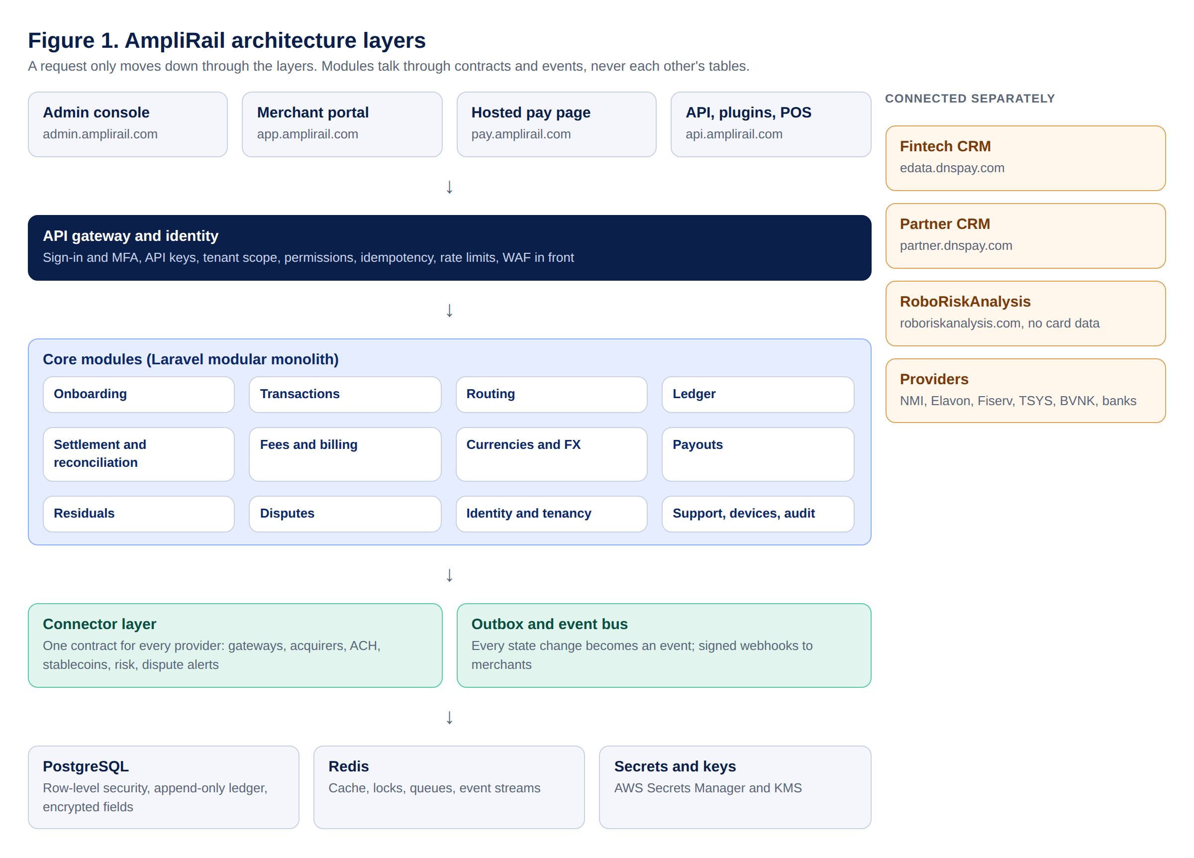
Figure 1. AmpliRail architecture layers

4.1 Architecture principles
Pattern | Applies to | Reason
Hexagonal (ports and adapters) | Every module | Domain logic never imports a provider SDK
Modular monolith first | Core services | One deployable; extract a service only under measured load
Canonical data model | All APIs and events | Providers are swappable
Strategy pattern | Routing, fees, residual plans | Configurable per tenant without code changes
State machine | Merchant, payment, payout, ticket lifecycles | Only legal transitions; each transition audited
Transactional outbox | Every write that emits an event | Commit and publish can never disagree
Idempotency keys | Every mutating call | No double charges on retry
Orchestrated saga | Onboarding, refunds, payouts | Compensating actions instead of distributed transactions
Append-only ledger | All money movement | Balances derived, never edited
CQRS for reporting | Dashboards and reports | Heavy reads never touch the payment path

4.2 Module boundary rules
- A module owns its tables. No other module reads or joins them.
- Modules talk through a published interface in their Contracts folder or through events, never through another module's models.
- IDs are prefixed ULIDs: org_, usr_, mer_, macc_, txn_, tat_, rf_, led_, stl_, po_, evt_, whk_, tkt_, dev_.
- Deptrac or Pest architecture tests fail CI if a module imports another module's internals.

4.3 Technology stack
Concern | Choice
Core application | Laravel 12, PHP 8.3+, Octane for the payment API
Database | PostgreSQL 16 (AWS RDS or Aurora), row-level security, pgaudit
Cache, locks, queues, bus | Redis 7 (ElastiCache), Laravel Horizon, Redis Streams
Admin and merchant portals | Laravel + Inertia with Vue 3 or React (Lead eDataPay PHP Developer to confirm in ADR-0003), Tailwind
Object storage | S3 with KMS encryption, private buckets only
Secrets and keys | AWS Secrets Manager and KMS
Infrastructure | Docker, ECS Fargate or EKS, Terraform, separate AWS accounts per environment
Observability | OpenTelemetry, Grafana or Datadog, Sentry, trace ID on every request and event
CI | GitHub Actions: PHPStan level 8+, Pest, contract tests, architecture tests, OpenAPI diff, dependency and secret scanning

4.4 Repository layout
amplirail-unified-commerce/
AGENTS.md CLAUDE.md SECURITY.md
app/ HTTP kernel, gateway middleware
modules/
Identity/ users, roles, permissions, SSO, sessions, sign-in log
Tenancy/ org nodes, TenantContext
Onboarding/ merchant saga, KYB
Payments/ intents, attempts, state machine
Routing/ routing strategies, eligibility
Ledger/ postings, entries, balances
Settlement/ ingestion, reconciliation, payouts
Residuals/ plans, statements
Pricing/ fee plans
Webhooks/ subscriptions, deliveries
Support/ tickets, SLAs, knowledge base
Devices/ terminals, orders, pairing
Audit/ immutable audit trail
MerchantProducts/ virtual terminal, invoices, links, subscriptions, customers, products
(each: Domain/ Application/ Infrastructure/ Http/ Contracts/ Tests/)
connectors/
Contracts/ ContractTests/ Simulator/ Nmi/ Elavon/ KybSimulator/
scs/ README only in Phase 1 (decision D2)
openapi/ API contract (source of truth)
infra/ Terraform, environments, backup policies
docs/ this document, ADRs, prompts, tickets
tests/

4.5 High-volume architecture (50 million transactions per month)
Targets
Measure | Target
Monthly volume | 50,000,000 transactions (authorizations, captures, refunds and ACH items)
Average and peak | About 20 per second average; designed for 1,000 per second peak (holiday and flash-sale spikes), scalable further by adding capacity
AmpliRail added latency | Under 150 ms at the 95th percentile, excluding provider time
Availability | 99.95% for the payment API; no single point of failure
Ledger postings | Up to about 200 million rows per month (2 to 4 postings per transaction)

Design rules
- Stateless API and worker containers (Laravel Octane on ECS Fargate) that scale out automatically on CPU and queue depth; no session state on servers.
- The payment hot path does only what is needed to authorize: key check, idempotency, screening, routing, connector call, write the attempt and outbox event. Everything else (webhooks, reports, fees, residuals, statements) runs asynchronously from events.
- PostgreSQL with monthly partitions for transactions, attempts, ledger postings, events and audit; PgBouncer connection pooling; read replicas for portals and reports; older partitions archived on schedule.
- Idempotency keys and rate limits in a Redis cluster; locks with short timeouts.
- Event bus behind the EventPublisher interface: Redis Streams at launch, with a planned move to a managed streaming service (for example Amazon MSK) before sustained volume passes the threshold set by load tests.
- Reporting reads from rollup tables and a separate analytics store, never from the live payment tables.
- Connectors use timeouts, retries only where safe, circuit breakers and per-provider concurrency limits, so one slow provider never slows the others.
- Multi-zone deployment in us-east-1 with the DR region; database failover tested; payment API behind a global load balancer and WAF.
- Observability: request tracing across connectors, dashboards for approval rate, latency and error rate per connector, alerts on SLO breach.
Load testing (gate before each volume step): scripted load tests in staging against the simulator at 2 times the next target (for example 200, 500, then 1,000 per second sustained for 1 hour), with no lost or duplicated transactions, ledger in balance, and latency within target. Results are kept as evidence.
Cost at volume. Per-transaction bridge fees grow with volume (a few cents per transaction at 50 million transactions a month is a large monthly cost), which is why processor-direct connectors and the AmpliRail Switch (Section 7.9) move up the plan as volume grows.

5. Roles, portals, tenancy and identity

5.1 Portals and roles
Portal | Who | Sign-in requirement
Super admin (ops.amplirail.com, Phase 2) | Platform owner staff; manages admin organizations, global connectors, platform audit | Security key (WebAuthn), IP allowlist, session 15 min idle
Admin console (admin.amplirail.com) | eDataPay staff: owner, operations, finance, underwriter, support agent, developer, read only | Email + password + authenticator app or security key, or company SSO with MFA; session 15 min idle
Merchant portal (app.amplirail.com) | Merchant owners and staff | Email + password + emailed 8-digit code; step-up code for refunds above threshold and bank account changes
Partner access | Agents, ISOs, resellers | Partner CRM for now; AmpliRail exposes read APIs scoped to their node

5.1.1 Sign-in flow (required)
- Sign-in page: portal, email, password, forgot password, SSO option, links to Terms of service and Privacy policy.
- Merchant portal: after a correct password, send an 8-digit numeric code by email. Admin console: ask for the authenticator code or security key instead (no emailed codes for admins). Store only a hash of the code. Expires in 10 minutes, single use, resend allowed after 45 seconds, maximum 5 codes per hour.
- Five wrong codes or passwords lock the account for 30 minutes and alert the user.
- New device or location sends an email alert and is flagged in the sign-in log.
- Every page of every portal shows a footer with Terms of service, Privacy policy, Security and System status. Legal text is supplied by counsel ([Terms], [Privacy]).

5.2 Tenancy
Tenancy follows the payments hierarchy: platform → organization (admin tenant) → ISO → sub-ISO/ISV → agent → merchant → location. Table org_nodes stores id, type, parent_id, materialized path (for example /plt_1/org_1/iso_7/agt_42/mer_901/) and status. Every domain row carries org_node_id. Visibility is a path-prefix match. Roles are granted at a node and inherit downward. Configuration (pricing, routing, residual splits) inherits downward unless overridden.

5.3 Permissions (minimum set)
merchants.view, merchants.create, merchants.edit, merchants.go_live.approve, payments.view, payments.refund, payments.void, routing.view, routing.draft, routing.publish, recon.view, recon.resolve, risk.view, risk.decide, residuals.view, residuals.approve_payout, users.manage, roles.manage, api_keys.manage, webhooks.manage, support.view, support.reply, devices.manage, audit.view, settings.security.manage, merchants.risk.edit, merchants.limits.edit, merchants.descriptors.edit, merchants.view_as (read only, logged), wallet.view, payouts.instant, rewards.manage, giftcards.manage, traffic.manage, apikeys.merchant.manage, reports.export, fees.view, fees.manage, fees.approve, billing.manage, fx.manage, fx.approve_markup, payouts.accounts.verify, currencies.manage.
Sensitive permissions (payments.refund above a threshold, routing.publish, risk.decide, residuals.approve_payout, roles.manage, agent attribution override) require step-up MFA, and those marked dual-control need a second approver.

5.4 Sign-in and session logging (required)
Every sign-in, sign-out, failed attempt, lockout, MFA challenge, password reset, new-device sign-in and session expiry writes an auth event: user, portal, IP, user agent, approximate location, method, result, timestamp and correlation ID. The Management screen shows this log with filters and CSV export. Lock after 5 failed attempts for 30 minutes. Alert the user by email on new device or location.

6. Canonical domain model and state machines
Entity | Key fields
OrgNode | id, type, parent_id, path, status
User | id, email, name, mfa methods, status; memberships (org_node_id, role)
Merchant | id, org_node_id, crm_deal_id (immutable), legal name, DBA, MCC, KYB status, risk tier, original agent (locked)
MerchantAccount | merchant_id, connector_id, provider MID/TID reference, environment, status, pricing plan
Location | merchant_id, address, devices
PaymentMethod | provider token reference, brand, last4, expiry, network token flag, customer_id
Transaction | amount_minor, currency, channel, capture mode, status, idempotency key, route list
TransactionAttempt | intent_id, merchant_account_id, provider reference, canonical status, decline category, AVS/CVV result
Refund | intent_id, amount_minor, reason, status, provider reference
LedgerAccount / Posting / Entry | see Section 9
SettlementBatch / SettlementRecord | provider, batch date, gross, fees, net, reconciliation status
Payout | merchant_id, amount_minor, bank account token, rail, status
Dispute | intent_id, amount, reason code, status, deadlines
SupportTicket | merchant_id, category, priority, channel, SLA due, assignee, status
Device | merchant_id, location_id, model, serial, connector, status
OtpChallenge | user_id, code hash, expires_at, attempts, consumed_at
ApiKey | org_node_id, type (publishable, secret, restricted), environment, scopes, IP allowlist, hash, last used
MerchantRiskProfile | merchant_id, MCC primary and secondary, tier, reserve type, percent, hold days, funding delay
VelocityLimit | merchant_id, metric, window, threshold, action (decline, hold, alert, approval)
BlockRule | org_node_id, type (BIN, ICA, issuing bank, country, US state, email domain, IP), value, scope, expires_at
Descriptor | merchant_id, default text, locked prefix, dynamic allowed, city or phone
TrafficSource | merchant_id, name, tracked link or subdomain, parameters, postback URL, spend entries
Plan / Subscription / Membership | plan price and cycle; subscription payment method and next run; member number, tier, dues, house account balance
Invoice / PaymentRequest | line items, tax, due date, allowed methods, channel (email, SMS, link), status
LoyaltyAccount / GiftCard | points balance and tier; gift card number (tokenized), balance, status
SettlementBatch integrity | gateway count, processor count, processor net, bank deposit, match status
FeeType | code, name, category, default basis (flat, percent, per item, per MID, per terminal, per user, tiered), payer types allowed
FeeSchedule / FeeRule | owner (merchant, ISO, PSP, bank), version, effective_from and effective_to, rules with conditions (rail, currency, card brand, MCC, channel, MID, volume tier), amount or rate, minimum and maximum, billing method
FeeAgreement | fee schedule version, document hash, signer, signed_at, e-signature reference, status (sent, signed, declined, superseded)
FeeAssessment | fee rule, source (transaction, batch, MID, terminal, month), amount and currency, billing method, ledger posting
BillingStatement / PlatformInvoice | period, lines, totals per currency, collection method (net from settlement, ACH debit, card, wallet), status
CurrencyConfig | code, decimals, enabled rails, enabled for processing, settlement and payout
FxRate / FxQuote / FxConversion | provider, pair, mid-rate, markup, client rate, quoted_at, expires_at; conversion links source and target amounts and the ledger posting
PayoutAccount | owner (merchant, ISO, affiliate), rail (ACH, wire, SEPA, SPEI, Pix, push to card, stablecoin), currency, tokenized details, verification status

Merchant states: draft → submitted → kyb_pending → underwriting → approved → boarding → test_mode → validation → active; side states needs_info, manual_review, declined, suspended, closed. On approved, the system automatically creates a sandbox MerchantAccount on the simulator, a test MID, a sandbox API key pair and a webhook secret.
Transaction states: created → pending_authentication → authorized → captured → settled; side states failed, voided, partially_refunded, refunded. Transitions live in one state-machine class. Any other transition throws and is logged.

7. Connector framework
Every provider is an adapter implementing capability interfaces. A manifest declares capabilities, currencies, card brands, channels and 3DS support. Routing reads the manifest so unsupported features are never sent.
interface CardProcessor {
public function authorize(AuthorizeRequest $r): ProviderResult;
public function sale(SaleRequest $r): ProviderResult;
public function capture(CaptureRequest $r): ProviderResult;
public function void(VoidRequest $r): ProviderResult;
public function refund(RefundRequest $r): ProviderResult;
public function chargeToken(TokenChargeRequest $r): ProviderResult;
public function getTransaction(string $providerRef): ProviderResult;
public function healthCheck(): HealthResult;
}
interface MerchantBoarding { submitApplication(); getBoardingStatus(); }
interface SettlementSource { fetchSettlements(DateRange $range): iterable; }
interface WebhookNormalizer { verify(Request $raw): bool; toDomainEvent(Request $raw): ?ProviderEvent; }
interface BankTransfer { sendCredit(); sendDebit(); }
interface RiskDecision { underwrite(); preAuthCheck(); }
interface KYBProvider { verifyBusiness(); verifyOwner(); }
ProviderResult carries canonical status (approved, declined, pending, error), canonical decline category (insufficient_funds, do_not_honor, fraud_suspected, invalid_card, authentication_required, provider_unavailable, timeout), the raw provider code and message, and a retryable flag. Each adapter owns its response-code mapping table.
Inside every adapter: per-connector timeouts, exponential backoff on network errors only, circuit breaker, masked request/response log keyed by attempt ID, credentials fetched from Secrets Manager by reference. Every adapter must pass the shared ContractTests suite.

7.1 Simulator connector (first connector, mandatory)
Test input | Result
Simulator token tok_sim_approved, any amount not listed below | approved
amount ending .02 (for example 10.02) | declined, do_not_honor
amount ending .51 | declined, insufficient_funds
amount ending .59 | declined, fraud_suspected
amount ending .65 | authentication_required
flag sim_timeout | timeout, unknown state, retryable
flag sim_outage | provider_unavailable, retryable
flag sim_avs_fail | approved with AVS mismatch
amount 1.23 | partial approval
repeated idempotency key | original result returned

The simulator also emits settlement, funding, refund, chargeback and reversal events using the same schemas and webhook engine as live connectors.

7.2 Connector roadmap
Connector | Category | Phase
Simulator, KYB simulator | Test | Sprint 1
NMI (cards, ACH and eCheck, Collect.js tokens, NMI stored-card tokens, settlement) | Gateway | Sprint 2
Elavon / U.S. Bank (product path from SE: P365, Lightbox or HPP for CNP; cSDK for POS) | Acquirer | Sprint 3, after SE
Fiserv (First Data), TSYS (Global Payments), other processors | Acquirers and processors | After NMI and Elavon, per contract
Verifi, Ethoca, Chargebacks911, other | Dispute alerts and resolution | Sprint 5
[BIN data provider] | Card brand and card type (credit, debit, prepaid) | Sprint 5
Gattera (Stream Payments) | Hidden gateway bridge (Level 1); use hosted fields or tokens only | Sprint 3, after API review
Elavon terminals, Talech POS | Card-present devices and optional POS plugin | Sprint 4
NMI cloud devices, Tap to Pay on iPhone (NMI) | Card-present through NMI bridge; Tap to Pay as paid add-on | Sprint 6
Apple Pay, Google Pay through processors | Wallets in phase 1 | Sprint 4
Account updater and network tokens (through processors) | Stored-card freshness and portability | Sprint 4
[Open banking provider] | Pay by bank | Expansion
[Global accounts provider] | Multi-currency receiving accounts (Model B) | After license
ACI Worldwide | Orchestration and acquiring | Evaluate
BVNK or equivalent (USDC, USDT) | Stablecoins | Sprint 6, after provider contract
Visa Direct | Push-to-card payouts | Sprint 6
[FX rate provider] | Currency rates | Sprint 6
[Brazil PSP] for Pix and BRL cards | Local rail | Expansion
[Dominican Republic acquirer] for DOP | Local acquiring (LATAM pilot) | Expansion
[Safeguarding bank] payouts: SEPA, Faster Payments, SPEI, Pix, wires | Payout rails (Model B) | After license
ACH direct (Nacha rules), RTP / FedNow | Account to account | Expansion
Apple Pay, Google Pay, PayPal | Wallets and APMs | Expansion
Avvance (U.S. Bank POS lending) | BNPL | Expansion
Inabit | Crypto POS | Expansion
IDem gateway | Gaming (MCC 7995), LATAM | Expansion
EU, UK and LATAM acquirers | Cross-border | Expansion

ELAVON RULE: Design the connector interface now, but do not code the production Elavon connector until the Solution Engineer confirms the product path, PCI boundary and certification plan. Converge XML requires a Level 1 PCI AOC and must not be chosen without Adam's written approval.

7.3 Payment rails and integration methods
Rail | How it works in AmpliRail | Key rules
Cards | Sale, authorize, capture, void, refund, credit, token charge | PCI boundary (Section 14.1); 3D Secure when required
ACH and eCheck | Debit and credit with SEC code (CCD, PPD, WEB, TEL), check conversion | Nacha authorization stored; returns (R codes) handled like chargebacks
Stablecoins | Payment request with QR, rate lock (15 minutes), confirmation after network confirmations, settle as USD or keep as stablecoin | Provider custody only (D17); sanctions screening by provider and RoboRiskAnalysis
Payouts | ACH next day; instant push to debit card (Visa Direct); RTP later | Dual control above threshold

Integration method | Who uses it | PCI effect for the merchant
Server-to-server API | Platforms and developers, with tokens | Tokens only: small scope. Raw card data server-to-server needs the merchant's own PCI validation and our written approval
Hosted payment page (pay.amplirail.com) | Any merchant | Lowest scope
Hosted card fields (JavaScript) | Merchant checkouts | Card data goes straight to the processor
Virtual terminal | Merchant staff | Processor-hosted fields
Payment requests and invoices | Merchant staff | Hosted page
Plugins: WooCommerce first; Shopify (needs Shopify approval), Adobe Commerce, BigCommerce | eCommerce merchants | Hosted fields or page
POS devices | In-store | Certified P2PE or semi-integrated only
3D Secure | Automatic when the card, rule or region requires it | Through [3DS provider] connector

7.4 Integration methods (AmpliRail names)
The gateway benchmark review confirmed the feature set merchants expect. AmpliRail provides each capability under its own design and names (rule 13).
Capability merchants expect | AmpliRail product | Notes
Server-to-server payments | Transactions API (REST, JSON, tokens) | Raw card data only for PCI-validated merchants with written approval
Tokenizing card fields on the merchant's page | Secure Fields (JavaScript) | Processor-hosted fields underneath
Fully hosted checkout | Hosted pay page (pay.amplirail.com) | Merchant branding and custom subdomain
Buy buttons and simple cart | Pay buttons and payment links | Signed button parameters so amounts cannot be altered; CAPTCHA option
Invoices, email and SMS pay requests | Payment requests and invoices | Section 12.2
Stored cards | Secure Card Storage (SCS) | Tokens only
Event notifications | Events and webhooks | Signed, retried, replayable
Transaction data pull | Reporting API (/v1/reports, /v1/transactions) | Section 9.1
Card-present cloud devices and device SDKs | Cloud POS and Device SDK (iOS, Android, Windows, Linux) | Built on certified device vendors' semi-integrated kits
Third-party carts | Plugins | WooCommerce first
Merchant boarding by partners | Boarding API (/v1/merchants, /v1/merchant_accounts, /v1/services, /v1/merchants/{id}/status) | Typed settings per connector (Section 7.7)
Fraud tools | Transaction screening rules and RoboRiskAnalysis | Optional third-party fraud connectors
3D Secure | 3D Secure connector | No legacy redirect API is needed

7.5 Transaction lifecycle
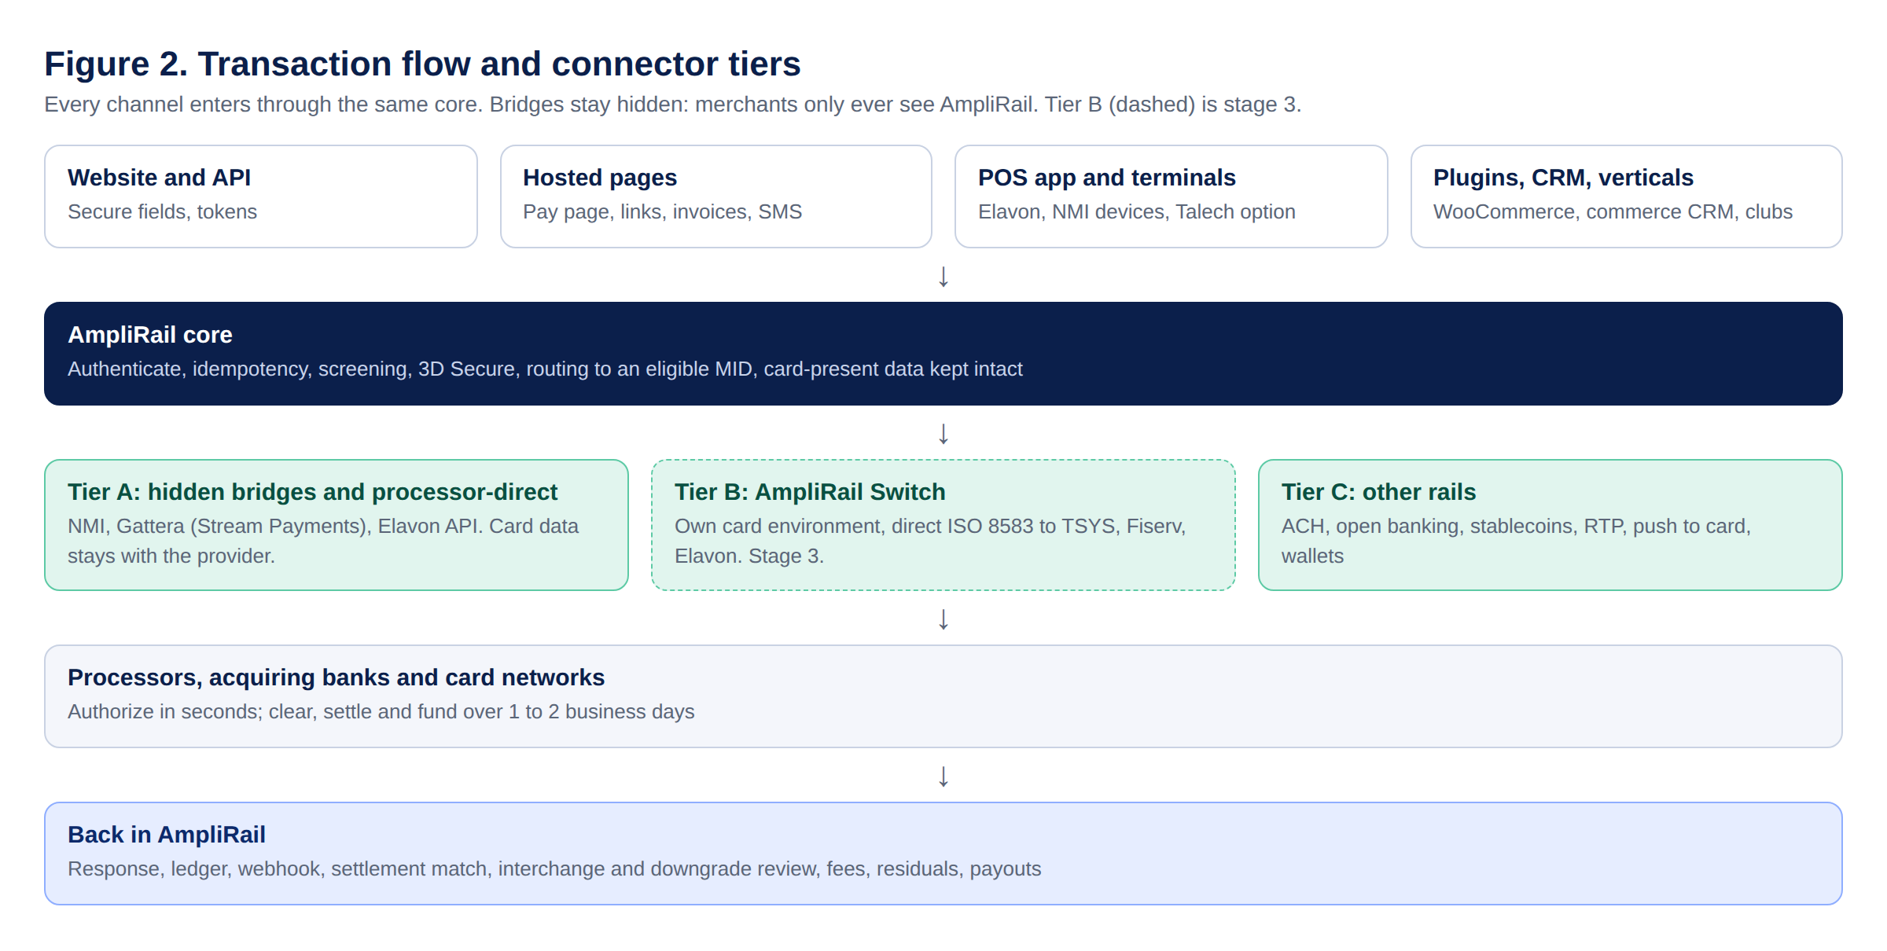
Figure 2. Transaction flow and connector tiers
Authorization (1 to 3 seconds). The customer pays through secure fields or a device and AmpliRail receives a token. AmpliRail checks the key and idempotency, runs screening, triggers 3D Secure when needed and routes to an eligible MID. The gateway passes the request to the processor, the processor routes it over the card network to the issuing bank, and the issuer checks funds, fraud, CVV and AVS. The issuer approves or declines with a response code and places a hold on approval. No money moves yet. AmpliRail records the attempt, updates the state and sends the webhook.
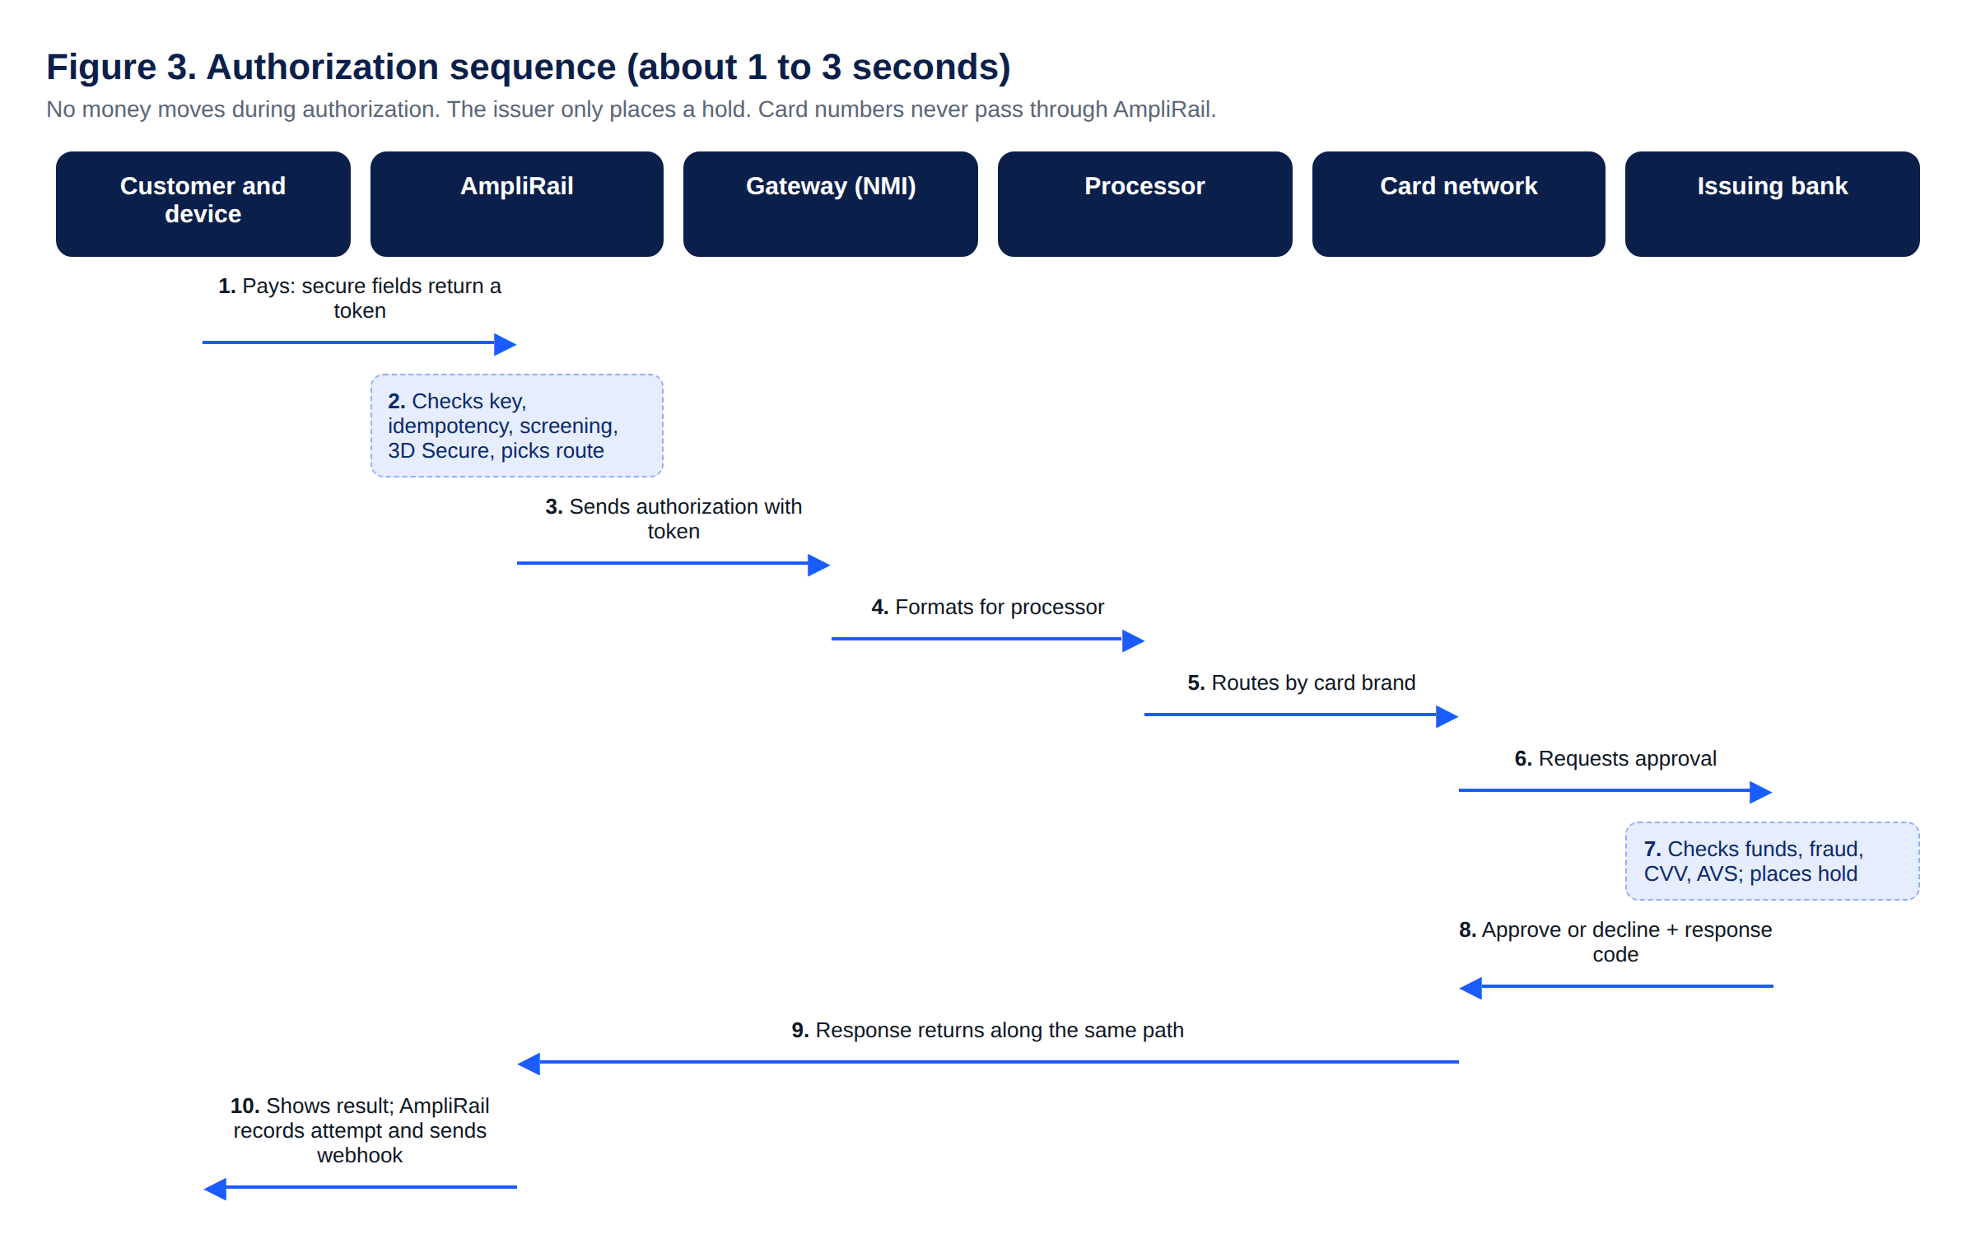
Figure 3. Authorization sequence
Capture, batch, clearing, settlement and funding (same day to 2 business days). Sales capture immediately; authorize-only transactions capture later. At the MID batch close time, captured transactions go to the processor as one batch. The processor clears them through the network; issuers post them and interchange is calculated. The network settles to the acquiring bank (total minus interchange and network fees), usually the next business day. The acquirer funds the merchant by ACH (Model A) or funds AmpliRail's safeguarded account (Model B). AmpliRail then imports settlement files and runs the three-way match, ledger, fees and residuals (Section 9).
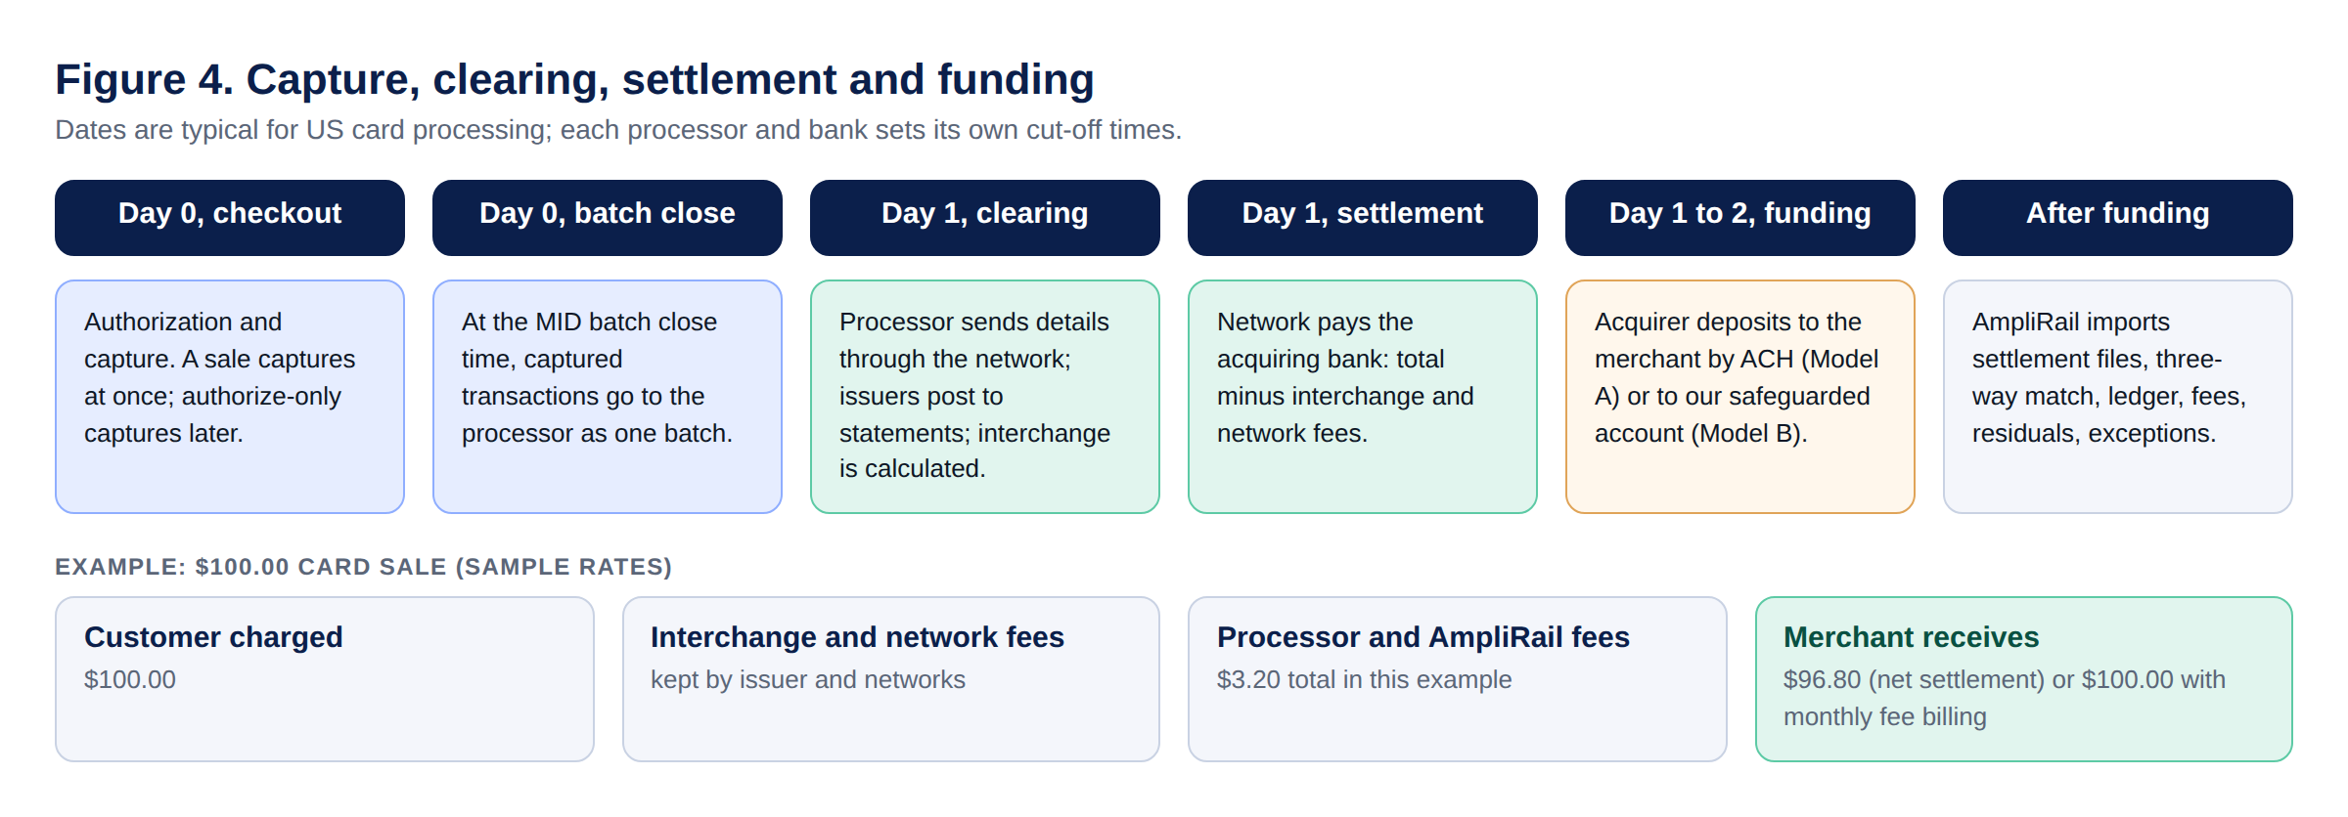
Figure 4. Capture, clearing, settlement and funding
Money flowing back. Refunds travel the same path as a credit and always go to the processor that authorized the sale (or the reroute target, Section 7.7). Chargebacks start at the issuer and arrive through the network and processor into the dispute module (Section 9.6).
Other rails. ACH and eCheck move through the ACH network in 1 to 2 business days, with returns (for example R01) usually within 2 business days and consumer unauthorized returns up to 60 days. Stablecoin payments settle on the blockchain after network confirmations; the provider pays out in stablecoin or converts to fiat; there is no interchange or chargeback, and refunds are new outgoing payments.

7.6 Connector tiers and the direct ISO 8583 plan
Tier | What it is | Card data in AmpliRail | When
A. Hidden bridges and processor-direct | Gateway bridges (NMI, Gattera) and processor-direct APIs with processor-hosted fields (Elavon API first, then Fiserv and TSYS) | No, tokens only (Gattera only with its hosted fields or tokens) | Phase 1
B. Direct host connectors | AmpliRail speaks ISO 8583 (or the host's message spec) directly to TSYS, Fiserv or Elavon hosts | Yes | Phase 3
C. Other rails | ACH, stablecoins, RTP and FedNow, push to card | No card data | As contracted

Phase 3 prerequisites (Tier B): sponsor-bank and host agreement; host message specification and certification for each host and each card brand; our own PCI DSS Level 1 card environment with hardware security modules, key management (including P2PE decryption keys) and segmented network; batch file creation and settlement handling that the processor did before; card-network registration through the sponsor bank. Direct connection to VisaNet or the Mastercard network is available only to members (acquirers) and their registered processors, so access comes through the sponsor bank.
Connector rule: Tier B code lives in a separate service ("AmpliRail Switch") inside its own card environment; the rest of AmpliRail keeps calling it through the same connector contract and still never sees card numbers.

7.7 Processing controls (from the gateway benchmark review)
Control | Requirement
Level III data | Line-item, tax and customer code data for B2B card transactions, sent when the connector supports it, so eligible merchants qualify for lower interchange
Split funding | Split a payment between the merchant and one or more partners by percent or fixed amount, for surcharges, platform fees or marketplace payouts (PayFac and Model B)
Duplicate transaction check | Per MID: on or off, look-back window in seconds, and whether the merchant may override for one transaction
Required fields per MID | Choose which fields every transaction must include: name, company, address, city, state, ZIP, country, phone, email, CVV, or CVV on first use of a card only
AVS and CVV pre-check method | Per MID: void on decline (authorize full amount, void if checks fail) or separate small pre-authorization before the full amount
Merchant status | Active, restricted (can sign in and report, cannot process), closed (cannot sign in; admins keep reporting and voids) and deleted (only after closed; history kept for reporting and residuals)
Refund reroute | When a MID or processor is disabled, its future refunds can be routed to a named active MID
Typed connector settings | Each connector defines named, validated settings instead of numbered generic slots. Examples: TSYS (merchant number, acquirer BIN, store number, terminal number, MCC, location number, V number, agent bank, agent chain, MVV, PayFac sub-merchant fields); Fiserv (merchant number, terminal ID, settlement merchant ID); Elavon (bank number, terminal ID, merchant ID)
Per-MID limits | Max transaction amount and max monthly volume, with a choice to apply them to all card brands
Industry classification | eCommerce, mail or telephone order, retail, restaurant or lodging per MID, limited to what the connector supports

7.8 Card-present processing, terminals and downgrade prevention
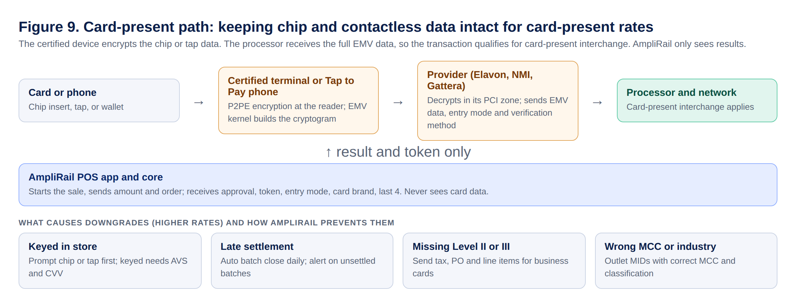
Figure 9. Card-present path
Why it matters. AmpliRail merchants get their own MID and interchange-plus pricing, so the lower card-present interchange flows to them. Flat-rate providers also process chip and tap transactions, but blend the rate, so the merchant does not see the saving. Card-present pricing only works if the full chip or contactless data reaches the processor.
Supported in-store options
Option | Connector | Notes
Elavon terminals | Elavon connector (semi-integrated or cloud) | Primary card-present path for Elavon MIDs
Talech POS (Elavon) | Optional plugin | For merchants who want Elavon's POS; payments reported into AmpliRail
NMI cloud devices | NMI bridge | Card-present through NMI where the MID is on NMI
Tap to Pay on iPhone | NMI bridge, paid add-on | Card-present contactless; Apple entitlement required
AmpliRail POS app | Any card-present connector above | Register, tabs, tips, member charge (Section 12.2)

Card-present rules (rule 14 in Section 1 applies):
- Send EMV data, POS entry mode, terminal capability, cardholder verification method and terminal ID exactly as the device produced them; never re-key or convert to e-commerce format.
- Prompt chip or tap first. A keyed in-store sale requires AVS ZIP and CVV and is flagged as keyed.
- Close batches automatically every day; alert on any batch not settled within 24 hours.
- Send Level II (tax, customer code) and Level III (line items) for business and purchasing cards when the connector supports it.
- Each outlet uses a MID with the correct MCC and industry classification (retail, restaurant, lodging).
- Tip adjust, incremental authorization and delayed charges follow card brand rules for restaurants and lodging.
Downgrade review. AmpliRail compares each settled transaction's qualification with what it should have been and shows the reasons (keyed, late settlement, missing Level II or III, AVS missing, wrong classification) on the Conversion and interchange insights screen.

7.9 Stage 3: AmpliRail card environment
Goal: AmpliRail processes without any third-party gateway. Components: a token service (Secure Card Storage operated by AmpliRail) inside a segmented card environment; hardware security modules and key management (including P2PE decryption key handling with a device key-injection partner); direct processor and host connections (ISO 8583 or host specifications) with certification per host and per card brand; EMV terminal certifications for supported devices; batch and settlement file handling; 3D Secure, network tokens and account updater contracts. Built as the separate AmpliRail Switch service (Section 7.6). Requires a full PCI DSS Level 1 assessment of the card environment. Gattera's licensed Level 1 gateway technology is an alternative that can shorten this stage; compare cost and control before building.

8. Orchestration and routing
Routing pipeline, in order: eligibility filter (capability, currency, brand, 3DS, merchant actually approved on that account, circuit breaker closed) → rule match (tenant rules inherited down the hierarchy) → scoring (cost, approval rate, latency, weights per ISO) → optional volume split. The ordered route list is stored on the intent so every decision is explainable.
Consistency rules:
- Check the idempotency key before anything else. A repeated key returns the stored response.
- Write the attempt row as pending before calling the adapter. A recovery job resolves stuck attempts by querying the provider.
- Captures, voids and refunds always go to the connector that authorized the payment.
- Only soft failures (timeout, provider_unavailable) move to the next route. Hard declines are never retried elsewhere.
- Routing chooses only among accounts the merchant is approved and configured for.
- Routing policies are versioned. AI may draft a policy; publishing needs routing.publish and a second approver.
- Phase 1 ships one route per merchant, but the pipeline exists from day one.

9. Ledger, settlement, reconciliation, payouts and residuals
Tables: ledger_accounts (owner type and id, account type such as merchant_pending, merchant_available, processor_receivable, fee_revenue, residual_payable, reserve; currency), ledger_postings (event type, source reference, effective_at, unique idempotency key), ledger_entries (posting_id, account_id, direction, amount_minor, currency).
Invariants enforced in code and database: debits equal credits per currency per posting; the application database user has no UPDATE or DELETE on entries; corrections are reversing postings; ledger_balances snapshot updated in the same transaction and recomputed nightly with an alert on any difference.
Example, $100.00 captured at 2.9% + $0.30: debit processor_receivable 100.00; credit merchant_pending 96.80; credit fee_revenue 3.20.
Settlement and reconciliation: each connector's SettlementSource ingests files or APIs; raw files archived unchanged in S3 with object lock; three-way match of attempts, settlement records and bank deposits; unmatched items go to an exceptions queue with reason codes (missing_in_rail, missing_in_provider, amount_mismatch, deposit_mismatch, fee_variance); every resolution needs a reason code and is audited.
Payouts: move merchant_available minus reserves and RoboRiskAnalysis holds to the merchant's bank on the plan schedule. Payout approval above a threshold is dual control.
Residuals: plans are strategy classes per hierarchy node (revenue share, basis points, per transaction, hybrid), effective-dated. A monthly job reads settled margin from the ledger only and posts residual_payable entries. The original agent from the CRM is locked; changes need a management workflow with a second approver. Agents never see another agent's merchants.

9.1 Reporting, search and batch integrity
Transaction search fields: merchant (admin), transaction ID, order ID, first and last name, email, card last 4, account last 4 or wallet, payment rail, status, transaction type, processor, source, batch ID, customer ID, company, phone, authorization code, PAR, platform ID, date range with quick ranges. 36 months searchable online, older in archive. Large searches run in the background and email the user when ready. Export to CSV and Excel.
Report tabs: transactions (all rails in one list); settled batches matched to bank deposits; chargebacks together with ACH and eCheck returns; snapshot grouped by merchant, batch, rail, processor, card brand, source or agent; transaction detail with full action history, print and email receipt, create subscription, create order template, save to SCS, refund.
Batch integrity (no lost transactions or batches):
- Every attempt must reach a final state within 24 hours; the recovery job queries the provider otherwise.
- Transaction IDs are checked for sequence gaps.
- Nightly pull of each processor's batches compared with the gateway count and amount.
- Batch net compared with the bank deposit (three-way match).
- Alert if a processor file or batch has not arrived by 06:00 Eastern.
- Raw settlement files archived unchanged with object lock.
Any mismatch opens a reconciliation exception with a reason code and appears on the Reports batch integrity tab.
Portfolios: a Global portfolio of all merchants, broken down by acquirer or processor, ISO or agent. For any portfolio, merchant or MID, and for any period: TPV, refund amount and refund %, chargeback count and chargeback % (by count and by amount), approval rate, and active MIDs. Every view can be split by card brand (Visa, Mastercard, American Express, Discover and others) with merchant totals. Each currency is reported separately.
Card brand and card type reports: volume, approval rate, refunds and chargebacks by card brand, and by card type (credit, debit, prepaid) using a BIN data provider connector. Merchants can block prepaid cards per merchant, MID or traffic source (common for affiliate traffic).
Decline reports: approval and decline ratios, decline counts by issuer reason and response code, soft versus hard declines, card type most affected, and retry advice. Merchants see the same reports for their own MIDs.

9.2 Fees, pricing and billing engine
AmpliRail bills its own fees separately from card-network pass-through costs (interchange and network assessments). Every fee is a configurable rule; the eDataPay PHP development team adds new fee types by configuration as the business needs them.
Who can be billed: merchants, ISOs and resellers, PSPs and banks that use AmpliRail, and partners. Each payer has its own fee schedule, inherited down the hierarchy (platform → ISO → merchant) unless overridden.
Starting fee catalog (extend as needed):
Category | Fee types
Transaction | Gateway per-transaction fee, percentage markup, authorization fee, AVS fee, batch fee, decline fee
Stored credentials | Every card-on-file charge is flagged as customer-initiated or merchant-initiated (recurring, installment, unscheduled) with the original transaction reference, as card brand rules require
Rails | ACH and eCheck per item, ACH return fee, stablecoin payment fee, Pix and other local-rail fees
Account | Setup fee, monthly fee, statement fee, monthly minimum, per MID monthly fee, per terminal monthly fee, per user fee
Services | Gateway fee, security fee, media fee, PCI program fee, Secure Card Storage (SCS) token fee, card updater fee, text-to-pay fee, wallet access fee, connector fees (bank, app, plugin)
Risk and disputes | Chargeback fee, retrieval fee, Rapid Dispute Resolution (RDR) fee, high-risk monitoring fee
Money movement | Currency conversion markup, crypto conversion fee, crypto payout fee, instant payout fee, wire fee
Partner payouts | Affiliate, ISO and agent payouts (residuals) are payables, not fees, and are calculated in the residuals module

Cost and sell: every fee line carries our cost (buy rate from the provider, bank or contract) and the sell rate charged to the client; the margin is calculated and feeds residuals. Each client schedule can override the sell rate; cost comes from the provider contract.
Fee rule bases: flat amount, percentage, per item, per MID, per terminal, per user, per month, volume tiers, with minimums, maximums and caps. Conditions can target rail, currency, card brand, MCC, channel, MID, terminal or connector.
Billing methods: deduct from settlement (net, Model B), daily or monthly; ACH debit from the merchant's bank (Model A); charge a card on file; deduct from the merchant wallet; or issue an invoice.
Rules:
- A fee schedule is versioned and effective-dated. Changes go through Approvals.
- A fee only applies after the payer signs the fee agreement for that version (electronic signature, document hash stored). Unsigned changes stay pending.
- Every assessed fee is a ledger posting (debit the payer, credit fee_revenue in that currency) linked to its source.
- Monthly statements show every fee line, the rule that produced it and the agreement version.
- Card-network pass-through costs are shown separately from AmpliRail fees.

9.3 Multi-currency processing and currency conversion
Processing currency: each MID has one processing and settlement currency. Transactions, settlement batches, payouts, fees and reports use that currency. Reports always show amounts in the original currency; an optional reporting-currency view converts at a stored daily reference rate and is labeled as an estimate.
Launch currencies: USD, EUR, JPY (0 decimals), MXN, GBP, INR, CAD, BRL (with Pix through a Brazilian provider connector) and DOP (through a Dominican Republic acquirer connector, supporting the LATAM pilot). New currencies are added by configuration once a connector supports them.
Currency conversion app (optional, per merchant): needed when the merchant prices in one currency and the MID settles in another (for example, selling in USD on a Mexican MID), or when a payout goes out in a different currency or in stablecoins.
- Rates come from a contracted FX rate provider through an FxRateProvider connector. Each conversion stores provider, pair, mid-rate, markup and client rate with full precision.
- Markup is a fee rule (default 1.5% above the provider rate), configurable per merchant and approved through Approvals.
- Quotes have an expiry (for example 15 minutes for payments, 60 seconds for payouts). Expired quotes are re-quoted, never reused.
- Refund policy is chosen per merchant and written into the fee agreement: refund at the original rate (merchant absorbs the difference) or at the current rate.
- Ledger: each currency has its own accounts. A conversion is one posting with legs in both currencies and the markup credited to fx_revenue. Balances are never summed across currencies.
- Rounding: half-up to the currency's minor unit, at the final step only.
- If a cardholder is ever offered a choice of currency at checkout, that is dynamic currency conversion and card-network rules apply; it needs a separate compliance review before it is offered.
Crypto payouts: a merchant may choose stablecoin payouts (USDC, USDT) through the stablecoin provider. Conversion rate, network fee and AmpliRail's crypto payout fee are shown before confirmation. Custody stays with the provider (D17).

9.4 Funds flow and merchant payouts
Model | Who holds funds | Who pays the merchant | How AmpliRail gets paid
A (default) | Processor or acquirer | Processor or acquirer | Monthly statement collected by ACH debit, card or invoice
B (licensed; only when AmpliRail is the PayFac or acquiring bank) | AmpliRail's safeguarded account under its money license | AmpliRail, from the ledger | Fees deducted from settlement before payout

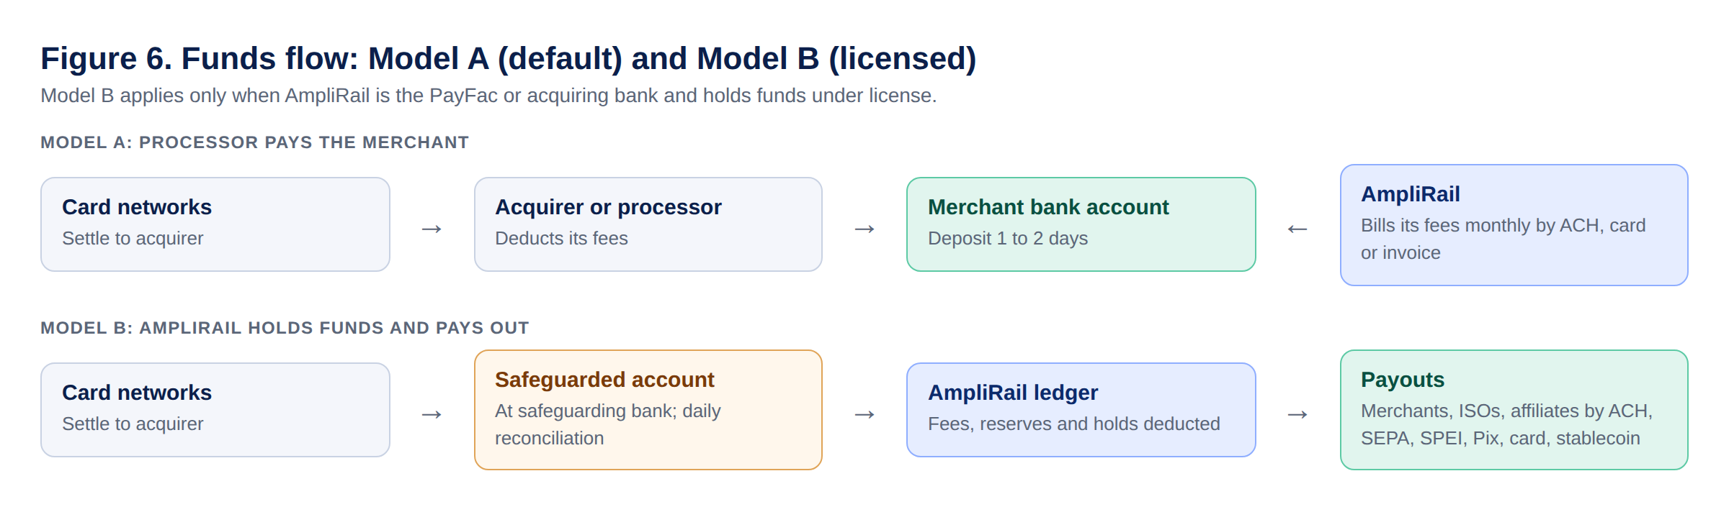
Figure 6. Funds flow, Model A and Model B
Model B requirements (built behind a feature flag, D16):
- Funds land in a safeguarded or for-benefit-of account at the safeguarding bank; daily three-way reconciliation of bank balance, ledger and processor settlement.
- Payout rails per currency: ACH and wire (USD), SEPA (EUR), Faster Payments (GBP), SPEI (MXN), Pix (BRL), local transfers (DOP, INR, CAD, JPY) through provider connectors, push to debit card, and stablecoin through the stablecoin provider.
- Payout = available balance minus reserves, holds and fees, in the payout account's currency; conversion only through the currency conversion app.
- Payout accounts are verified (bank verification connector) and screened against sanctions lists before first use and on change.
- ISO, agent and affiliate payouts come from residual statements and follow the same rails, verification and dual control.
- Payouts above a threshold, changes to payout accounts and manual payouts need dual control.
- Counsel confirms which license covers which country before Model B goes live in that country.

9.5 Residuals
Type | Source | How agent residuals are calculated
1a. Processing residuals from banks and processors | Residual files received from acquirers, processors and MSPs | Residual received per merchant, split to the original agent and hierarchy by plan percentage
1b. PayFac third-party billing | AmpliRail bills merchants at sell rates over buy rates (interchange plus or interchange plus plus) | Margin = sell minus buy minus pass-through costs, split by plan
2. Gateway technology residuals | AmpliRail platform fees (Section 9.2) | Agent share of platform fee revenue by fee type, per plan

Residual files from banks and processors are imported, matched to merchants and MIDs, and archived unchanged. Statements show each type separately. The original agent stays locked; changes need a second approver.

9.6 Disputes, alerts and chargeback prevention
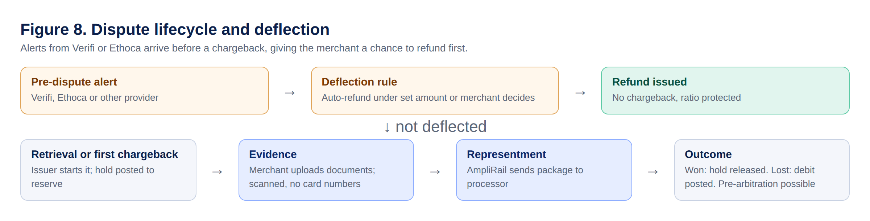
Figure 8. Dispute lifecycle and deflection
- Lifecycle stages: pre-dispute alert, retrieval request, first chargeback, representment, pre-arbitration, arbitration; ACH returns tracked alongside.
- Alert and resolution providers are DisputeProvider connectors: Verifi (Visa Order Insight and Rapid Dispute Resolution), Ethoca alerts (Mastercard), Chargebacks911, and any other provider added later.
- Deflection rules per merchant: automatically refund alerts under a set amount, refund when an order has not shipped, always ask the merchant above a set amount. A deflected alert becomes a refund instead of a chargeback.
- Evidence: merchants and admins upload documents (receipts, delivery proof, signed orders, messages, screenshots) to the case; AmpliRail packages them and sends the representment to the processor through the connector, recording the submission and the outcome.
- Uploads are scanned for malware and checked so no full card numbers are stored; stored encrypted.
- Ledger: chargebacks post a hold to reserve; wins release it; losses post the debit.

9.7 Commerce CRM
For subscription, direct-response and affiliate merchants (the same use cases served by dedicated commerce CRMs).
Area | Capability
Catalog and offers | Products, offers, bundles, trials, upsells and downsells, coupons
Orders | Order lifecycle, fulfillment status, returns, notes, customer service actions (refund, cancel, pause, change card)
Subscriptions and rebills | Rebill schedules, trial-to-paid, smart pause, dunning emails, automatic retries on soft declines only
Campaigns and affiliates | Campaign and traffic source tracking, postbacks, CPA and CPS (Section 12.4)
Decline recovery | Retry rules by reason code and timing; account updater; network tokens
Chargeback prevention | Alerts and deflection (Section 9.6), descriptor management, refund-before-chargeback rules
MID routing | Routing across the merchant's own approved MIDs by rules (currency, card brand, amount, approval rate)

MID routing compliance (rule 15): a merchant can route only to MIDs boarded for that same merchant, business name and descriptor, and approved for the product sold. Routing to spread volume to hide chargeback ratios, or processing one business's sales through another business's MID, is prohibited by card brand rules (transaction laundering) and blocked in code; attempts are logged and alerted.

9.8 Club, golf, hotel and resort payment capabilities
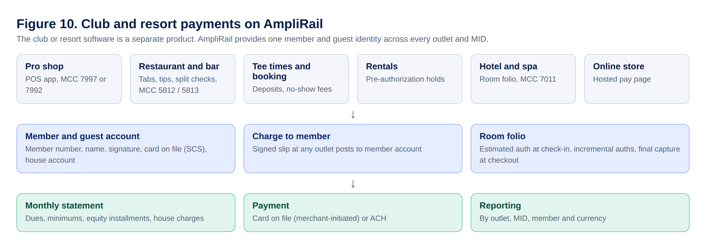
Figure 10. Club and resort payments
Need | AmpliRail capability
Member identity | Member and guest account across all outlets and MIDs: member number, name, card on file (SCS), house account balance
Charge to member | At any outlet, staff enter member number; member signs on the device; signature image and terminal ID stored with the charge; posts to the house account
Dues, minimums, equity and initiation | Recurring plans, installment plans, minimum spend tracking, monthly statements paid by card on file (merchant-initiated, flagged) or ACH
Outlets | One merchant, several outlets, each with its own MID and MCC (for example 7997 membership clubs, 7992 public golf courses, 5812 restaurants, 5813 bars, 7011 hotels and resorts)
Booking | Deposits, pre-authorizations and no-show fees for tee times, rooms, spa and rentals
Restaurants and bars | Tabs, tip adjust, split checks
Rentals | Pre-authorization holds, partial capture, damage charges with notice
Hotels and resorts | Room folio: estimated authorization at check-in, incremental authorizations, charges from every outlet posted to the folio, final capture at checkout, delayed charges under lodging rules
Reporting | By outlet, MID, member, folio and currency

9.9 Payout statements, reserves and reconciliation
Replaces manual payout spreadsheets. Every number on a statement comes from the ledger, the fees engine (Section 9.2) and the disputes module; nothing is typed in.
Cycle. Configurable per merchant from the signed agreement: daily, weekly or monthly; paid in arrears (for example 7 days). One statement per merchant per period, with sections per MID, provider (acquirer, PSP or bridge) and currency, and a merchant total per currency.
Statement lines (data-driven, from the fee schedule version the merchant signed):
Section | Lines
Activity | Approved count and gross sales, declined count (information), refunds count and amount, chargebacks count and amount, retrievals
Bank-card fees | Discount rate (MDR) or interchange plus pass-through and markup, per-transaction fee, credit and refund fees, chargeback fee by ratio tier, retrieval and re-presentment fees
Gateway and platform fees | Gateway transaction fee, fraud screening per item, monthly gateway fee (first statement of the month only), payout statement fee, verification fee, connector and add-on fees
Reserve | Security reserve percent of gross, rolling reserve tier by chargeback ratio (shown; deducted only if the agreement says this party holds it)
Payout method | ACH, wire (international wire fee), stablecoin (percent fee), push to card, local rails
Totals | Total fees (excluding reserve), reserve withheld, net payout, cost as a percent of gross
Margin (internal only) | Each fee line's cost (buy) and sell; margin feeds residuals; never shown to the merchant

Calculation rules:
- Monthly and one-time fees are charged once, on the first statement of the month or on the event, never on every weekly statement.
- Chargeback ratio = chargebacks in the measurement month divided by settled sales transactions, per each brand's program definition; thresholds for Visa (VAMP) and Mastercard programs are configuration, reviewed when brand rules change.
- Fee tiers that depend on the ratio use the ratio for the measurement period stated in the agreement.
- Amounts in integer minor units per currency; rounding half-up per line; totals equal the sum of lines.
- Statements are immutable once issued; corrections are adjustment lines on the next statement with a reason.
Who pays the merchant:
Payer | AmpliRail role
AmpliRail (Model B, Section 9.4) | Calculates, approves (dual control above threshold) and pays
Processor or acquirer | Produces the statement; imports the deposit for matching
PSP or bridge partner | Produces the expected payout; imports the PSP's payout report and bank deposit; shows expected versus received with variances to merchant and admin

Reserves. A reserve ledger per merchant and per holder (AmpliRail, acquiring bank or PSP): every withholding and release, balance, rolling-reserve tier, release schedule on closure (for example 60% at 6 months, 60% of the remainder at 12 months, balance at 18 months), and where the funds are held. Reserve terms come only from the signed agreement; changes need Approvals and a signed amendment.
Merchant tools. Statement list and detail; download as PDF, CSV and Excel; reserve balance and release schedule; reconciliation view with variance questions that open a support ticket; API (/v1/payout_statements) and webhook payout_statement.issued.
Compliance. Payouts only to the merchant's verified account in its own name (split funding only to approved parties, Section 7.7); sanctions screening of payout accounts; fees and reserves exactly as disclosed in the signed agreement; statements retained per the retention policy; PayFac and Model B funding follow sponsor-bank and card brand rules.

9.10 Rewards, vouchers, gift cards and offers
Merchants sell and promote offers for holidays, special occasions, events and memberships: hotels, travel packages, casinos, clubs, restaurants, golf and spas. Offers are sold on a hosted landing page (offers.amplirail.com/<merchant>), a website widget, QR codes in store, email and SMS campaigns, and the POS, and redeemed at the POS, online checkout, member charge screen and bookings.
Offer types
Type | Example | Notes
Gift card (stored value) | $100 holiday gift card | Paid value follows gift card rules (expiry and fee limits disclosed)
Package voucher | Golf plus lunch, $89 for $120 value | Paid value and promotional value tracked separately; promotional value can carry its own end date
Discount voucher | Members 20% off at the bar | No stored value; usage limits and eligibility rules
Prepaid reward card | Card given as a loyalty reward | Through an issuing partner and BIN sponsor (flagged)
Network voucher | Travel credit usable at partner merchants | Requires license or issuing partner (below)

Program levels (decision D33)
Level | Who can redeem | Regulatory position | Status
1. Closed loop | One merchant, or its affiliated outlets under common ownership (for example a resort's restaurants, spa and golf) | Gift card and consumer protection rules; unclaimed property | Build now
2. Network vouchers | Unrelated participating merchants | Generally treated as open-loop prepaid access or e-money; needs a money license (EMI or US prepaid access and state licensing) or an issuing partner | Flagged until license and counsel sign-off
3. Wallet with internal transfers | Users send value to each other or between merchants (wallet-style) | Money transmission or e-money licensing | Later phase, same license track as the consumer wallet (D16)

Ledger and money rules. Every sale of stored value posts a liability per merchant, program and currency; redemption reduces it; expiry and breakage follow the signed program terms and state unclaimed property rules. Voucher funds are never mixed with merchant settlement funds. For network vouchers, cross-merchant redemptions create amounts owed between merchants, settled on the payout statement (Section 9.9).
Vertical rules. Casino offers follow the gaming regulator's rules in each jurisdiction; travel packages follow seller-of-travel rules where required; alcohol offers follow local rules. Offers that need a vertical review are held in Approvals before publishing.
Controls. Per-buyer and per-day limits, code-guessing lockout, card screening on purchases, single-use codes with redemption audit, terms accepted at purchase, balance check page, Apple Wallet and Google Wallet passes.

10. Onboarding saga and RoboRiskAnalysis
Step | Owner | Compensation on failure
1. Application submitted | CRM → AmpliRail API (crm_deal_id preserved) | None
2. KYB and identity | AmpliRail via KYBProvider | needs_info
3. Risk underwriting | RoboRiskAnalysis via RiskDecision | declined or manual_review
4. Sandbox provisioned | AmpliRail (automatic) | Retry, then alert ops
5. Processor boarding | AmpliRail via MerchantBoarding | Retry, then boarding_failed
6. Pricing and routing attached | AmpliRail | None
7. Validation and go-live | Admin with merchants.go_live.approve | Stay in test_mode

AI may extract, compare and recommend. Deterministic rules score. Authorized humans make underwriting decisions, reserves and overrides. RoboRiskAnalysis pushes merchant.risk_changed, which can place a reserve or hold payouts.

10.1 Merchant setup, risk and limits
Add merchant: merchant type (Standard, Mobile, Test), then auto-board from a CRM deal or manual entry. Fields: legal name, DBA, tax ID (encrypted), MCC (searchable list with restricted MCC flags), website, time zone, address, company contact, settlement bank account (tokenized, last 4 shown), primary user (username 4 to 32 letters or numbers, email), processing services per rail, value-added services, pricing plan, parent ISO or agent (original agent locked). Sandbox created immediately.
Complete merchant setup fields (Add merchant and Merchant profile):
Group | Fields
Type | Merchant type (eCommerce online, POS and terminals, mobile, test); boarding mode (auto from CRM deal or manual)
Business | Legal name, DBA, tax ID (encrypted), entity type, years in business, website, time zone, address, phone, business description
Owners and contacts | Owners with ownership %, company contact, primary user (username, email)
Category | Primary MCC, secondary MCC, product or service description, average and highest ticket, expected monthly volume, card-present and card-not-present split
Processing setup | Processor or acquirer (NMI, Elavon, Fiserv, TSYS, other), acquirer MID (true MID from the bank), TIDs, settlement currency, descriptor and customer service phone, batch close time, funding schedule
Acceptance | Card brands accepted, card types accepted (credit, debit, prepaid), rails (card, ACH and eCheck, stablecoin), channels
Banking | Settlement bank account (tokenized, last 4 shown), billing account for fees
Risk | Velocity limits, reserve, transaction screening rules, blocking rules, descriptor rules (from Merchant risk and limits)
Commercial | Fee schedule and agreement, portfolio, parent ISO or agent (original agent locked), residual plan
Services | Secure Card Storage (SCS), card updater, invoicing, recurring, chargeback alerts, currency conversion
Compliance | RoboRiskAnalysis gate status, PCI validation type and expiry

Merchant risk and limits (admin, changes go to Approvals):
- MCC primary and secondary, category rules, allowed channels and rails.
- Reserve: rolling, up-front, capped or none; percent; hold days; funding delay; manual payout hold.
- Velocity limits with actions: max ticket, daily and monthly volume, transactions per card per day, per IP per hour, refunds per day, card-not-present share.
- Transaction screening rules (inside AmpliRail, results shared with RoboRiskAnalysis): card testing, refunds above sales, chargeback ratio watch, ticket spikes, after-hours volume.
- Blocking rules: BIN, Mastercard ICA, issuing bank, country (card and IP), US state allow-list, email domain, IP. Gaming state rules require a certified geolocation provider, not IP alone.
- Dynamic descriptors: default text, locked prefix, per-transaction dynamic text (PayFac only, D16), city or phone.
- Account security: two-factor for all merchant users, API key IP restriction, approval for bank account changes.

10.2 RoboRiskAnalysis integration
RoboRiskAnalysis (RRA) is a separate, evidence-first merchant-risk platform with its own development specification (RoboRiskAnalysis Complete Development Specification, v1.1). It runs on its own and is plugged into AmpliRail. This section defines only the boundary.
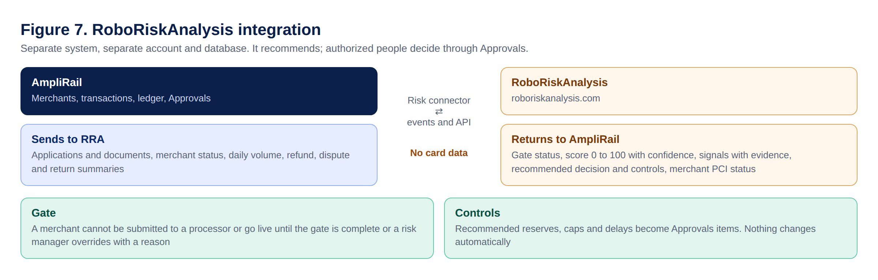
Figure 7. RoboRiskAnalysis integration
Topic | Rule
Deployment | Own repository (roboriskanalysis), own domain (roboriskanalysis.com), own AWS account, database and keys. Admin users reach it from Connected apps with single sign-on.
PCI scope | RRA never receives PAN, CVV or full bank numbers. It stays outside the card-data environment and outside AmpliRail's QSA scope.
AmpliRail to RRA | Merchant application and documents (from the CRM handoff), merchant status changes, and daily summaries of volume, refunds, disputes, returns and payouts per merchant.
RRA to AmpliRail | Pre-submission gate status, 0-100 score with band and confidence, signals with evidence references, recommended decision and recommended controls (reserve, caps, delayed funding, monitoring), merchant PCI status and expiry, card-brand screening status.
Gate | A merchant cannot be submitted to a processor or move to live in AmpliRail until RRA reports the gate as complete or an authorized risk manager records an override with reason.
Controls | RRA recommendations become AmpliRail Approvals items. Nothing changes a merchant's reserve, limits or funding automatically.
Interfaces | AmpliRail: RiskDecision connector (underwrite, preAuthContext, controlsRecommended). RRA side: its provider adapters (PCI validation, card-brand screening, bank verification, KYB, background, credit, monitoring). Processor risk inputs are provider-neutral adapters; no processor's product names are used.
Events | AmpliRail consumes risk.assessment.completed, risk.decision.recommended, risk.control.recommended, risk.pci.expiring, risk.monitoring.drift_detected. RRA consumes merchant.* , settlement.*, dispute.*, refund.* summary events.
Naming inside RRA | Rename RRA's "Vault" module to "Evidence Store", and remove the other-provider architecture section and provider-specific templates from the RRA specification before it goes to developers (see rule 11 and 12).

11. Events, outbox and webhooks
Every state change writes an outbox_events row in the same transaction. A relay publishes to Redis Streams. Consumers are idempotent and record processed event IDs.
{ "id": "evt_01J9ZK...", "type": "payment.captured", "version": 1,
"occurred_at": "2026-09-26T10:15:00Z", "environment": "sandbox",
"org_path": "/plt_1/org_1/iso_7/agt_42/mer_901/",
"actor": { "type": "user|system|agent", "id": "usr_..." },
"correlation_id": "corr_...", "policy_version": "routing-v3",
"subject": { "type": "payment_intent", "id": "txn_..." },
"data": { "amount_minor": 10000, "currency": "USD", "connector": "simulator" } }
Domain | Events (Phase 1)
Merchant | merchant.submitted, merchant.approved, merchant.sandbox_provisioned, merchant.activated, merchant.risk_changed
Payment | payment.created, payment.routed, payment.authorized, payment.declined, payment.captured, payment.voided, payment.failed, refund.created, refund.succeeded
Finance | settlement.received, settlement.reconciled, reconciliation.exception, payout.sent, payout.failed, dispute.opened
Identity and security | auth.signed_in, auth.failed, auth.locked, auth.mfa_challenged, user.invited, role.changed, permission.changed, api_key.created, api_key.rotated, production_access.granted
Support | ticket.created, ticket.replied, ticket.sla_breached, ticket.resolved
Risk and limits | limit.hit, block_rule.matched, reserve.changed, descriptor.changed, velocity.changed
Merchant products | invoice.sent, invoice.paid, payment_request.paid, subscription.renewed, subscription.failed, payout.instant_sent, giftcard.redeemed, loyalty.points_earned
Reporting | batch.mismatch_detected, batch.missing, report.export_ready
Fees and billing | fee_schedule.proposed, fee_schedule.approved, fee_agreement.sent, fee_agreement.signed, fee.assessed, statement.issued, statement.collected, statement.failed
Currency and payouts | fx.quote.created, fx.quote.expired, fx.converted, payout_account.verified, payout.scheduled, payout.sent, payout.failed, payout.returned

Outbound webhooks: HMAC-SHA256 signature over timestamp and body, 5-minute replay tolerance, exponential backoff retries for up to 72 hours, then endpoint disabled and owner alerted. Delivery log with replay button.

12. Product screens and acceptance
The AmpliRail Platform Screens V3 prototype (Claude canvas, 54 screens) is the visual reference. Each screen is a build unit with its own ticket in Appendix H.

12.1 Admin console (30 screens)
Screen | Must include
Overview | Volume by connector, connector health, onboarding pipeline, needs-attention queue
Approvals | Dual-control queue (routing publish, payout batches, refunds above threshold, agent overrides, go-live, risk changes); requester cannot approve own request; approve with step-up code and required note
Merchants | List with Merchant ID, CRM Deal ID, locked original agent, stage, routes, risk, volume
Add merchant | Type (Standard, Mobile, Test), auto from CRM or manual, fields in Section 10.1, sandbox now
Merchant 360 | CRM, onboarding, MIDs and routes, payments, settlement, disputes, risk, residuals, event timeline; links to profile and risk
Merchant profile | Information, contact, settlement bank (masked), processing services per rail, value-added services, fee schedule, users (reset password, view as merchant read-only and logged), advanced features
Merchant risk and limits | Section 10.1
Portfolios | Global portfolio and breakdowns by acquirer, processor, ISO and agent: TPV, refunds and refund %, chargeback count and %, approval rate, by MID and card brand with merchant totals (Section 9.1)
Reports and search | Section 9.1 including batch integrity, card brands and types, and decline reasons
Transactions | Detail with event timeline, refund, void, replay webhook
Disputes and chargebacks | Alerts and disputes by stage, deflection rules, alert and resolution providers, evidence upload and send to processor, ratio watch (Section 9.6)
Rails and connectors | Connector catalog with status, channels, optimization features, performance, token references
Routing | Versioned policy editor, dry run, submit for approval
Reconciliation | Match rate, exception queue, ledger view, imports
RoboRiskAnalysis | Risk cases from RRA: 0-100 score with band and confidence, pre-submission gate status, signals with evidence, recommendation, human decision or override with reason
Residuals | Processing residuals from banks and processors, PayFac billing margins, gateway technology residuals, agent statements, payout approval (dual control) (Section 9.5)
Management | Users, roles and permissions, sign-in log, audit trail, security policy
Support desk | Tickets with SLA, linked context, AI drafts never auto-sent, knowledge base, status
Devices | Deployed devices and status, orders, pairing, catalog; certified devices only
System and backups | Recovery targets vs measured, backup and lock status, restore tests, environments and deploy approvers, CI gates, secrets rotation, incidents
Connected apps | SSO launcher and event stream health
Developers | Platform API keys, webhooks, simulator scenarios
Payment flow map | Channels → AmpliRail → connectors → banks, with PCI boundary
Fees and billing | Fee catalog with our cost, default sell rate and margin, fee schedules per merchant, ISO, PSP or bank, versions and effective dates, agreement status, monthly statements and collections, revenue by fee type and currency
Currencies and FX | Enabled currencies and rails, MIDs by currency, conversion app settings and markups per merchant, rate provider status, quotes and conversions, FX revenue
Rewards network | Programs and outstanding value by merchant and currency, program levels and licensing status, controls and compliance
Payout statements | Weekly statement runs by merchant, MID, provider and currency; approve and issue; reserve rules; chargeback monitoring settings; PSP reconciliation queue
Payouts | Model B payout runs by currency and rail, payout accounts and verification, holds, failed and returned payouts, safeguarding reconciliation
Conversion and interchange insights | Approval rate by connector, card brand, card type and reason; card-present versus keyed share; downgrade reasons and estimated cost; retry and recovery results
PCI compliance | Our AOC status, open gaps, PAN scanner results, payment-page tamper alerts, status by PCI requirement, evidence calendar, payment-page script inventory, third-party AOCs, merchant PCI status from RRA (Section 14.5)

12.2 Merchant portal (21 screens)
Screen | Must include
Point of sale | Register with items and categories, tabs, tips, discounts, split checks, member charge, card reader status, offline queue; card-present via Section 7.8 options
Members and charges | Member accounts, house account balances, charge-to-member with signature, statements, dues and minimums
Hotel folios | Open folios, estimated and incremental authorizations, outlet charges, checkout capture, delayed charges
Commerce CRM | Orders, subscriptions and rebills, offers, campaigns, decline recovery, compliant MID routing
Dashboard | Go-live checklist, sales across rails, next deposit, pending ACH, chargebacks, quick actions (card, check or ACH, stablecoin, payment request, invoice, add customer, add subscription, batch upload)
Virtual terminal | Tabs for card (sale, authorize, capture, void, refund, credit), ACH and eCheck (SEC code, authorization), stablecoin (QR, rate lock); hosted card fields; text to pay, reader, batch upload
Payment requests and invoices | Pay link by email, SMS or copy with allowed methods and customer preview; manual invoice builder with line items and tax; list with status
Subscriptions and memberships | Plans, subscriptions with automatic retries, memberships (member number, tier, dues, house account, charge-to-account), Secure Card Storage (SCS)
Payout statements and reserve | Statement detail with every fee line, net payout, PDF, CSV and Excel downloads, reserve ledger and release schedule, reconciliation of expected versus received deposits
Wallet and payouts | Available, pending, reserve and stablecoin balances from the ledger; ACH and instant payouts; activity and statements. Merchant wallet only (D16)
Rewards, vouchers and gift cards | Loyalty points and tiers; gift card sell, reload, redeem; business and staff debit cards behind D16
Transactions and reports | Section 9.1, merchant scope
Transaction detail | Information, account (masked), billing, shipping, merchant-defined fields, action history, receipt, subscription, SCS, refund
Traffic and performance | Section 12.4
Apps and integrations | Gateway capabilities list and marketplace (plugins, QuickBooks, 3DS, fraud, card updater, text to pay, stablecoins, webhooks)
Developers and API keys | Scoped keys (publishable, secret, restricted), IP allowlist, integration methods, sandbox sample, webhooks, request logs without card data
Settings | General, transactions, security and fraud options (Section 12.5)
Fees and statements | Signed fee agreements, current fee schedule in plain language, monthly statements with every fee line, currency conversion and payout preferences
Disputes and chargebacks | Merchant's alerts and disputes, document upload, explanation, submit to processor or refund instead, alert settings
Public offers page (customer view) | Merchant-branded landing page selling gift cards and vouchers with instant delivery, wallet passes, clear terms and balance check
Help and support | Ticket form linked to a payment, my tickets, articles, contact, account security

12.3 Access (3 screens)
Sign in (portal selection, email, password, SSO, Terms and Privacy), emailed code verification (Section 5.1.1), super admin (Phase 2).

12.4 Traffic and performance
Each source (affiliate network, campaign or landing page) gets a tracked link or subdomain with parameters (source, sub_id, click_id) and an optional postback URL. Per source: visits, attempts, approvals, approval rate, declines and top reasons, spend (entered or imported), CPA (spend divided by approved customers), CPS (spend divided by approved sales including repeats) and chargeback rate. Alerts: pause a source when approval rate drops below a set level, alert on chargeback rate, block reused click IDs.

12.5 Merchant settings
General: account information, users and roles, two-factor, look and feel (logo, color, receipts), billing statement, custom subdomain. Transactions: settlement schedule, merchant-defined fields, test mode, webhooks, API configuration, report configuration, card updater, customer fees (surcharge and cash discount, subject to state rules), country and currency, SEC codes, dynamic descriptors. Security: keys, IP restrictions, AVS rules, CVV rules, fraud rules, blocking rules, state limits, velocity limits (view).

12.6 Design rules
AmpliPay blue #1A5CFF and navy #0B1F4B (logo blue #0456CA). Sentence case. No em-dashes in UI copy. WCAG 2.2 AA contrast, real buttons and labels, keyboard access. Sandbox or Live badge always visible. Footer with Terms, Privacy, Security and Status on every page. Placeholders in brackets until real content exists.

13. API standards and MVP endpoints
One versioned REST API, OpenAPI-first. CI fails on undocumented endpoints. SDKs for PHP and JavaScript are generated from the spec.
Conventions: /v1 paths; Idempotency-Key header required on every POST (stored 24 hours); integer minor units; UTC ISO 8601; cursor pagination; results automatically scoped to the caller's node; one error shape: error.type, error.code, error.message, error.decline_category, error.request_id.
Caller | Auth | Scope
Server integrations, partners | Secret API key per node, prefix arsec_sbx_ or arsec_live_ | Full API within node
Browser and mobile checkout | Publishable key, prefix arpub_ | Tokenize and confirm only
Portal users | OIDC, short-lived JWT, refresh rotation | User's role at node
Internal services (CRM, RoboRiskAnalysis) | OAuth2 client credentials | Service scopes

Resource | MVP operations
/v1/merchants | create, get, update, list, activate_sandbox, request_go_live
/v1/merchant_accounts, /v1/locations | create, configure, list, status
/v1/transactions | create, get, confirm, capture, cancel, list
/v1/refunds | create, get, list
/v1/payment_methods | create reference, list, revoke
/v1/webhook_endpoints | create, rotate secret, test, replay
/v1/routing_policies | get, dry_run, draft, submit, publish (approval)
/v1/transactions | search, timeline
/v1/settlements, /v1/reconciliation | imports, matches, exceptions, resolve
/v1/events, /v1/audit | query by resource or correlation ID
/v1/tickets | create, reply, list (merchant scope)
/v1/auth/otp | send, verify (rate limited)
/v1/api_keys | create, list, roll, revoke (secret shown once)
/v1/merchants/{id}/risk, /limits, /block_rules, /descriptors | get, propose change (goes to Approvals)
/v1/payment_requests, /v1/invoices | create, send, get, list, cancel
/v1/plans, /v1/subscriptions, /v1/memberships | create, update, list, cancel
/v1/wallet, /v1/payouts | balances, activity, create payout, instant payout
/v1/traffic_sources | create, list, stats, spend entries
/v1/loyalty, /v1/gift_cards | earn, redeem, balance, issue, reload
/v1/reports | search, snapshot, export (async)
/v1/approvals | list, approve, reject
/v1/fee_types, /v1/fee_schedules | list, create, version, propose change (goes to Approvals)
/v1/fee_agreements | send for signature, get status, download signed copy
/v1/statements | list, get, download, collect
/v1/currencies | list enabled currencies and rails
/v1/fx/quotes | create quote, get, convert (within expiry)
/v1/payout_accounts | create, verify, list, disable
/v1/payout_statements | list, get, download (pdf, csv, xlsx), reconcile
/v1/reserves | balance, ledger, release schedule

14. Security architecture

14.1 PCI boundary
Card data enters only through processor-hosted fields (NMI Collect.js; Elavon Lightbox or Hosted Payment Page once confirmed) and certified P2PE / semi-integrated POS devices (Elavon cSDK). AmpliRail stores only token references, brand, last4, BIN where permitted and expiry. CVV is never stored anywhere, ever. A PCI data-flow diagram (docs/PCI_DATA_FLOW.md) must exist before Sprint 2 production code and be reviewed at every connector change.
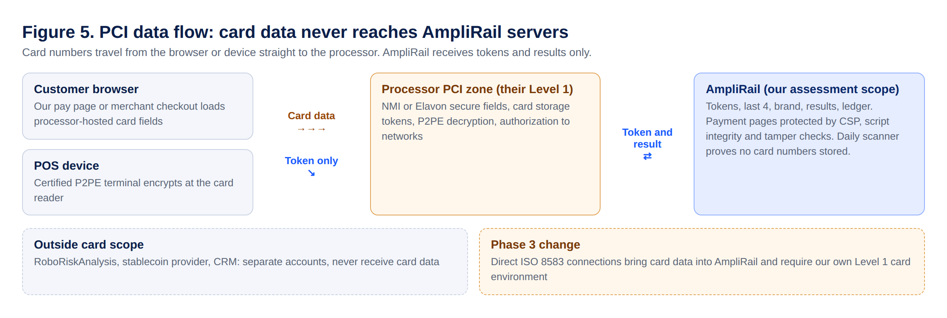
Figure 5. PCI data flow

14.2 Controls mapped to OWASP Top 10:2025
Category | Required control in AmpliRail
A01 Broken Access Control | Policy check on every route and query; tenant scope plus RLS; IDOR tests for every resource; admin, merchant, partner and service separation tested
A02 Security Misconfiguration | Debug off outside local; strict CORS allowlist; security headers (HSTS, CSP, X-Content-Type-Options, frame-ancestors); no directory listing; infra as code reviewed
A03 Software Supply Chain | composer.lock and package-lock committed; Dependabot; composer audit and npm audit in CI; pinned GitHub Actions by SHA; signed release artifacts
A04 Cryptographic Failures | TLS 1.2+ everywhere; Argon2id for passwords; KMS envelope encryption for SSN, tax ID and bank account numbers; no custom crypto
A05 Injection | Eloquent or bound parameters only; no raw SQL string building; output encoding; validated FormRequests on every input
A06 Insecure Design | Abuse cases per feature (card testing, refund abuse, account takeover); velocity limits; dual control on money-moving admin actions
A07 Authentication Failures | MFA; lockout; rate limits on login and reset; secure, HttpOnly, SameSite cookies; session rotation on login and privilege change; step-up MFA
A08 Integrity Failures | Webhook signature verification in and out; no unsafe deserialization; protected branches; required reviews; CI artifacts verified
A09 Logging and Alerting | Auth, admin, money and config events logged immutably; no PAN, CVV, secrets or full bank numbers in logs; alerts routed to a person
A10 Exceptional Conditions | Fail closed on auth, tenancy and money paths; timeouts everywhere; no stack traces to clients; unknown payment states go to recovery, never assumed

14.3 Secrets
All secrets in AWS Secrets Manager, injected at runtime. Rotation schedule: database credentials 90 days, provider credentials per provider rules, webhook secrets on demand. Gitleaks in pre-commit and CI. Any exposed secret is rotated immediately and logged as an incident.

14.4 Rate limits and abuse
Per API key and per IP limits on authorize, tokenize, login and password reset. Card-testing detection (many small declines, many cards per customer or IP) triggers RoboRiskAnalysis and automatic throttling.

14.5 PCI DSS v4.0.1 control map (what we build to pass)
AmpliRail is assessed as a service provider. Even with no card data on our servers, we host pages that load the payment fields (pay.amplirail.com, the virtual terminal, plugins), so we can affect card security and are in scope. The controls below are the extra code and evidence the QSA will test. Ticket numbers refer to Appendix H.
Req. | What the QSA checks | What AmpliRail builds or keeps | Evidence | Ticket
1 | Network security controls, documented and reviewed every 6 months | Security groups and network rules as Terraform; deny by default; separate accounts; review record | Diagrams, rule review log | AR-006, AR-072
2 | Secure configuration, no vendor defaults | Hardened base container images (CIS benchmark), configuration standards, image scanning | Config standard, scan reports | AR-073
3 | No stored sensitive authentication data; PAN protected or not stored; masking | No PAN or CVV anywhere; display at most BIN and last 4; automated PAN and CVV scanner over database, logs, files and tickets with alert and incident procedure (also 12.10.7) | Scanner reports, data retention policy | AR-074
4 | Strong cryptography in transit; inventory of keys and certificates | TLS 1.2+ only, HSTS, certificate and key inventory with expiry alerts | Inventory, TLS scan | AR-075
5 | Anti-malware; anti-phishing | Container and upload malware scanning; DMARC, SPF, DKIM on all sending domains | Scan logs, DNS records | AR-073
6.2 | Secure development, yearly developer training, code review before release | P6 independent review plus human review on every PR; yearly secure-coding training log | PR history, training records | AR-005, AR-076
6.3 | Vulnerabilities ranked; software inventory; critical patches within one month | SBOM generated in CI for our code and every library; Dependabot; patch due dates tracked | SBOM, patch log | AR-077
6.4.1-6.4.2 | Public web apps protected by an automated solution | Web application firewall in front of every public endpoint, blocking mode, logs kept | WAF config and logs | AR-078
6.4.3 | Every script on payment pages inventoried, authorized and integrity-checked | Content Security Policy with nonces, Subresource Integrity hashes, script registry with business justification, block unknown scripts | Script registry, CSP reports | AR-079
6.5 | Change control; separate environments; no live data in test | GitHub rulesets and CODEOWNERS; separate AWS accounts; synthetic data only, checked in CI | Change records | AR-005
7 | Least privilege; user and system account reviews every 6 months | Roles and permissions (Section 5.3); access review workflow in Management with sign-off | Review records | AR-080
8 | Unique IDs; MFA for all admin and remote access; strong passwords; lockout; 15-minute idle timeout; no hard-coded system passwords | Authenticator or security key for admins (D13); 12+ character passwords; lock after 5 attempts for 30 minutes; 15-minute idle timeout; system accounts in Secrets Manager with rotation | Config evidence, tests | AR-008, AR-081
9 | Physical security; POS device protection | Inherited from AWS AOC; device inventory and tamper inspection log in Devices for merchants | AWS AOC, device logs | AR-034
10 | Audit logs for all access; daily automated review; 12 months kept, 3 months searchable; time sync; critical control failures detected | Central immutable logging (CloudTrail, application audit, database audit); automated daily review with alerts; NTP; alert when a security control (logging, WAF, scanner, IDS) stops | Log samples, alert records | AR-082
11.3 | Quarterly internal authenticated scans and external ASV scans | Scheduled scans with results stored; fix and rescan until passing | ASV reports | AR-083
11.4 | Yearly and after-change penetration tests; segmentation tests every 6 months for service providers | Booked external, internal, web and API tests; segmentation test of the card-data boundary | Pentest reports | AR-083
11.5 | Intrusion detection, including covert malware channels for service providers; change detection on critical files | AWS GuardDuty and network monitoring; immutable signed container images; change detection on critical configuration | Alerts, config history | AR-084
11.6.1 | Detect unauthorized changes to payment pages and their HTTP headers | Tamper detection job compares payment pages, scripts and headers against approved baselines at least weekly (we run every 15 minutes) and alerts | Job logs, alerts | AR-079
12 | Policies, targeted risk analyses, yearly cipher review, scope confirmation every 6 months, executive responsibility, vendor AOCs, responsibility matrix for merchants, incident response tested yearly, security awareness with phishing | Policy set and evidence calendar in the PCI compliance screen; vendor AOC tracker; merchant-facing responsibility matrix; incident runbooks and yearly test | Policies, records | AR-085, AR-086

Notes for the build:
- The hosted payment page and every page that embeds payment fields are payment pages for 6.4.3 and 11.6.1, including the virtual terminal and payment request pages.
- Mastercard allows at most "first 8, any other 4" digits when a card number is truncated; AmpliRail displays BIN and last 4 only and stores no full number.
- Stablecoin rails and RoboRiskAnalysis run in separate accounts and networks so they stay outside the card-data scope.
- If the QSA decides multi-tenant service provider requirements (PCI DSS Appendix A1) apply, the tenant isolation tests in Section 5.2 are the evidence.

14.6 PCI fast-track plan
Week | Work | Owner
1 | Send fixed-fee requests to QSAs listed for the United States region; confirm in writing that Elavon and the sponsor bank accept the chosen QSA; lock scope decisions; start CRM card-data purge (AR-002) | Adam
1-2 | Production AWS account built clean: private subnets, no public database, SSO with MFA, central logs, Secrets Manager, WAF | Lead eDataPay PHP Developer
2 | Choose QSA, sign fixed fee, buy ASV scanning | Adam
2-3 | QSA scoping call and gap assessment against docs/PCI_DATA_FLOW.md | QSA, Lead eDataPay PHP Developer
3-6 | Close gaps (AR-072 to AR-086); write the policy set | Lead eDataPay PHP Developer, Adam
4 | First external ASV scan and internal scan; fix and rescan until clean | Lead eDataPay PHP Developer
5-6 | Penetration and segmentation tests; fix and retest | Test firm
6-7 | Payment-page script controls and tamper detection live; log review evidence | Lead eDataPay PHP Developer
7-10 | Remote QSA fieldwork | QSA
10-12 | Close findings; QSA issues ROC and Service Provider AOC | QSA
12+ | Send AOC to the acquirer for Visa and Mastercard service-provider registration; renew yearly; quarterly scans and 6-month segmentation tests on the calendar | Adam

For the first assessment, the most recent ASV scan must pass, with a documented plan for quarterly scans. A QSA firm should not assess controls it designed or built for us. Lean budget estimate: about $12,000 to $30,000 for year one (QSA, scans, testing, tooling), per the AmpliPay PCI Fast-Track Plan.

14.7 Merchant PCI management
As a gateway and future PayFac, AmpliRail helps acquirers track merchant compliance. RoboRiskAnalysis records each merchant's channel, card-data flow, validation type (for example SAQ A, SAQ A-EP, SAQ C-VT, SAQ P2PE, SAQ D, ROC), evidence and expiry. AmpliRail shows it in Merchant 360 and the PCI compliance screen, blocks card acceptance when RRA reports validation as required and missing (unless an authorized exception exists), and sends merchants reminders 60 and 30 days before expiry. AmpliRail gives each merchant a responsibility matrix showing which PCI requirements AmpliRail covers for each integration method.

14.8 Gateway and payment provider of record
Step | What it means | Owner
PCI DSS Level 1 Service Provider ROC and AOC | Section 14.6; the legal name on the AOC must exactly match the registration name | Adam, QSA
Sponsor acquirer registration | Acquirer registers AmpliPay with Visa as a third-party agent and with Mastercard as a service provider (merchant payment gateway); registration fees paid through the acquirer | Adam
Brand listings | Visa Global Registry of Service Providers; Mastercard registered service provider list (requires a QSA AOC submitted after registration) | Acquirer, Adam
PayFac registration | Separate application through the sponsor bank, with sub-merchant agreements and monitoring | Adam, Jeffrey Stein
Annual renewal | New ROC and AOC each year; quarterly scans; listing renewal | Adam

15. Database security
- Private subnets only; no public IP; security groups allow only application services.
- Admin access through SSO with MFA via a bastion or AWS Systems Manager session, with session recording.
- Separate database roles per module and a read-only reporting role. No superuser use in normal operation. Migrations run with a dedicated migration role in CI.
- Row-level security on every tenant table; the application role cannot bypass RLS.
- Ledger entries table: INSERT and SELECT only for the application role.
- Encryption at rest with KMS customer-managed keys; TLS required for connections.
- Field-level encryption for SSN, tax ID and bank account numbers; store fingerprints for matching.
- pgaudit on production with alerts for bulk exports, schema changes and off-hours admin sessions.
- No production data in development or AI sessions. Use synthetic seeds or masked copies.
- Migrations always backward compatible; reviewed by a human when they touch money, identity or RLS.

16. Backup, disaster recovery and incident response
Item | Requirement
Point-in-time recovery | Enabled on production PostgreSQL, 35-day window
Snapshots | Daily, copied to a separate AWS backup account in us-east-2
Immutability | AWS Backup lock (compliance mode) and S3 Object Lock in compliance mode; retention 1 year for daily, 7 years for month-end ledger snapshots (confirm with accountant)
Encryption | KMS keys owned by the backup account
Optional second provider | Google Cloud Storage bucket with retention lock. Never Dropbox or Google Drive for data
Restore test | Monthly into an isolated account; record duration, data checks and ledger balance check
Targets | RPO 5 minutes, RTO 4 hours (decision D12)
Redis | Treated as cache and transport; the outbox in PostgreSQL is the durable source
Documents | S3 versioning plus object lock for settlement files and KYB documents

Incident response: severity levels, on-call rotation, a runbook per scenario (connector outage, suspected breach, exposed secret, ledger mismatch, database loss), processor and card brand notification duties, and a post-incident review within 5 business days. Security incidents are reported to Adam immediately.

17. Environments and CI/CD gates
Environment | Purpose | Data
Local | Docker Compose with simulator connectors | Synthetic
Sandbox | Public, for merchants and partners to test | Synthetic, simulator connectors
Staging | Provider sandboxes (NMI, Elavon) | Synthetic
Production | Live | Real, restricted

CI gates on every pull request: PHPStan level 8+, Pest unit and feature tests, connector contract tests, architecture tests, OpenAPI diff, composer and npm audit, Gitleaks, SAST (Semgrep), migration check, and the AI security review report for security-relevant changes. Deploys are blue-green; production deploy requires a human approval in GitHub Environments.

18. AI agent operating model
AI agents write most of the code. Humans own decisions, approvals, certification and production.
Agent role | Does | Never does
Architect agent | Drafts ADRs, schemas, OpenAPI changes | Changes canonical schemas without an approved ADR
Builder agent | Implements one ticket per branch with tests | Touches files outside the ticket's allowed list
Test agent | Writes unit, feature, contract and abuse-case tests | Weakens or deletes a test to make it pass
Security reviewer agent | Runs prompt P5 and reports | Declares the system secure or compliant
Code reviewer agent (independent session) | Runs prompt P6 on every PR | Approves its own code
Docs agent | Updates README, runbooks, API docs | Documents features that don't exist

Workflow for every task:
- The assigned eDataPay PHP Developer creates a ticket using docs/TASK_TEMPLATE.md.
- Builder agent starts a fresh session with prompt P0, then P1 with the ticket.
- Agent posts its plan and the files it will change, then implements with tests.
- CI runs all gates.
- Independent reviewer session runs P6. Security-relevant changes also run P5.
- The Lead eDataPay PHP Developer reviews and merges. Production deploy needs Lead eDataPay PHP Developer approval; payment, identity, security and infrastructure changes also need a second human.
AI must never: push to main or production, read or request production secrets, use real card or customer data, create live processor credentials, publish routing policy, move money, issue refunds, change RLS or permissions without human review, or disable a CI check.

18.1 AI toolchain policy
Role | Tool | Rules
Primary builder | Claude Code | Reads AGENTS.md and CLAUDE.md; one ticket per session
Independent reviewer | A different model (OpenAI or GitHub Copilot review) | Runs prompt P6 on every pull request
Editor assistant | GitHub Copilot | Small edits only; same review gates
Other models (for example DeepSeek, Kimi, Grok) | Only open-weight versions self-hosted on AmpliPay infrastructure, or not at all | No AmpliRail code or data sent to hosted services that have not passed vendor review

All tools: business or enterprise plans that do not train on our code; no secrets, production data or card data in prompts; vendor list kept for the QSA (Requirement 12.8); every change still passes the human gates in Section 18.

19. Phased build plan
Phase | Target | Exit criteria
Sprint 0: Foundation | Weeks 1-2 | Repo, starter pack, CI gates, Terraform skeleton, Identity and Tenancy modules, audit and outbox, simulator spec, CRM card-data audit done
Sprint 1: Working rail | Weeks 2-4 | Milestone #1 (Section 20) passes in sandbox
Sprint 2: NMI | Weeks 4-6 | NMI behind the same contract; Collect.js tokens; settlement ingestion; reconciliation prototype; no merchant API changes
Sprint 3: Elavon | After SE path confirmed | Elavon connector per SE guidance; certification plan executed
Sprint 4: Orchestration | Weeks 6-10 | Eligibility, rules, scoring, failover, RoboRiskAnalysis context, multi-MID, recurring
Sprint 5: Operations | Weeks 8-12 | Ledger complete, payouts, residuals, disputes, support desk, devices, Merchant 360, reports and batch integrity
Sprint 6: Merchant products | Weeks 10-14 | Virtual terminal all rails, payment requests and invoices, subscriptions and memberships, wallet and payouts, traffic and performance, apps, merchant developers, settings
Sprint 6b: Fees, currencies and payouts | Weeks 12-16 | Fees engine and agreements, statements, multi-currency MIDs and reports, currency conversion app (flagged), Model B payouts (flagged)
Sprint 7: Risk and regulated features | Weeks 12-16 | Merchant risk and limits, blocking rules, descriptors; stablecoin connector, rewards, gift and debit cards behind D16 flags
Pre-launch gate | Before first live payment | Penetration test, restore test passed, PCI scope confirmed by QSA, incident runbooks, pilot merchant plan
Expansion | After controlled go-live | ACH, wallets, BNPL, crypto, gaming, cross-border, super admin

Sprint 0 tickets are in Appendix E. The full backlog for every screen is in Appendix H.

19.1 Two-week launch slice
Goal: real merchants processing on AmpliRail within two weeks, on the NMI bridge (US, with its existing processor connections) and the Gattera bridge (EU acquiring banks), operating under the providers' PCI Level 1 certificates (D19 Track A) until AmpliPay's own certificate is issued. More providers are added as soon as the Level 1 certificate is in hand.
Day | Deliverable | Tickets
1 | Repository, CI, staging environment, secrets manager | AR-001, AR-003 to AR-006
2 | Tenancy, identity with 2-factor, audit and outbox | AR-007 to AR-009
3 | Connector contract, simulator, contract tests; partitioned tables | AR-011, AR-012, AR-161
4 to 5 | NMI bridge connector with hosted card fields: sale, authorize, capture, refund, void; transaction sync and provider webhooks | AR-016 to AR-019 (NMI scope)
5 to 6 | Gattera bridge connector (hosted fields or tokens only), EUR and other EU currencies | AR-125
6 to 7 | Merchant setup (manual), MIDs per provider, virtual terminal, payment links and invoices | AR-020, AR-052, AR-053
8 to 9 | Payout statements: fee schedules, weekly statements, reserve ledger, PSP reconciliation, PDF, CSV and Excel | AR-146 to AR-150
9 | Merchant portal: dashboard, transactions, statements; admin: merchants, approvals, reports | AR-057 and screens
10 | Security review, load test at 200 per second on the simulator, backup restore test | AR-013, AR-165
11 to 12 | Pilot with test merchants, fixes | n/a
13 to 14 | Go-live for first merchants; daily reports | n/a

Not in the launch slice (next, in order): processor-direct and other providers after the Level 1 certificate; POS, members and folios; commerce CRM; rewards and vouchers; currency conversion; Model B payouts; AmpliRail Switch.
Prerequisites from Adam: NMI sandbox and production API access for the team; Gattera API documentation and sandbox; counsel-approved merchant and fee agreement wording; list of first pilot merchants.

20. Milestone #1 acceptance test
- A management user creates a merchant; sandbox Merchant ID, test MID, API key pair and webhook secret are provisioned automatically.
- A $100.00 Transaction via the API routes to the simulator and returns approved.
- Payment, attempt, events and balanced ledger postings are written; the admin Transactions screen shows the full timeline.
- A signed webhook is delivered; a forced failure can be retried and replayed, and is audited.
- Retrying with the same idempotency key does not create a second charge.
- Forced decline, timeout and outage scenarios behave as specified in Section 7.1.
- A user from another merchant cannot access the payment (tested by API and UI).
- No secret or card data appears in any log (tested by log scan).
- Every transition has a correlation ID and an immutable audit event.
- All CI gates pass.

21. Definition of done (every ticket)
- Acceptance criteria from the ticket are met and demonstrated.
- Tests added: unit, feature, and contract or abuse-case tests where relevant; all pass in CI.
- Tenant isolation and authorization tested for every new endpoint or query.
- No secrets, PAN, CVV or production data in code, fixtures, prompts or logs.
- OpenAPI updated for any API change; schema changes versioned and backward compatible.
- Structured logs with correlation ID; metrics for new critical paths.
- Migration and rollback notes when data or schema changes.
- Independent review report (P6) attached; security review (P5) for security-relevant changes, with statuses Verified fixed, Open or Not tested.
- Lead eDataPay PHP Developer approved the merge.

22. Elavon and NMI implementation rules
- NMI is the first live connector. Use Collect.js hosted fields and NMI stored-card tokens. Our servers never receive PAN.
- Elavon: prepare the SE meeting package (architecture diagram, use-case matrix, stack summary, PCI data-flow sketch, integration backlog, pilot plan) and ask the questions in the Elavon brief, Section 6.
- Elavon may use different products for CNP and card-present; AmpliRail presents one normalized contract.
- Capture transaction, settlement, funding, refund and dispute data from each provider into normalized models.

23. Product success metrics
Time from merchant creation to first sandbox payment; API availability and error rate; webhook success rate; approval rate by connector and reason; authorization latency; reconciliation match rate and exception age; open risk cases and review time; support first response and SLA breaches; active merchants, MIDs and volume; lead time, deployment frequency, escaped defects and security findings.

24. IP and ownership gate (before material coding)
- The GitHub organization and all repositories are owned by the correct company entity, with Adam as an organization owner. No personal accounts own repositories.
- Every developer and contractor has signed an IP assignment to that entity.
- AI-generated code follows the same repository, review and ownership process as human code.
- Keep a development ledger linking module, developer, invoice or time, and PR.
- Do not mix pre-existing eData, Gattera and APGP code or credentials without a written decision.

25. Open items for Adam
Item | Default the agents use until decided | Owner
D4 Hosting on AWS | AWS us-east-1 / us-east-2 | Adam
D6 KYB vendor | KYB simulator | Adam with RoboRiskAnalysis
D9 PCI validation type | Hosted fields + P2PE scope | QSA
D12 RPO 5 min / RTO 4 h | As stated | Adam and Lead eDataPay PHP Developer
Ledger retention period | 7 years month-end | Joel Friedman (CPA)
Support phone, email and hours | Placeholders | Adam
Portal front-end framework | the front-end ADR | Lead eDataPay PHP Developer
Partner features (affiliates, commissions, service prices) in Partner CRM or AmpliRail | Stay in Partner CRM | Adam
Stablecoin provider (BVNK or other) | Simulator stablecoin connector | Adam
3D Secure provider | Simulator 3DS | Lead eDataPay PHP Developer
Gift card provider and card issuing partner (BIN sponsor) | Features flagged off | Adam
Geolocation provider for gaming merchants | Gaming state rules flagged off | Adam
Terms of service and Privacy policy text | Placeholder pages | Jeffrey Stein (counsel)
Shopify payments app approval | WooCommerce first | Lead eDataPay PHP Developer
Email delivery provider for one-time codes | Amazon SES with DKIM, SPF and DMARC | Lead eDataPay PHP Developer
QSA selection and acquirer acceptance of that QSA | RFQs to listed US-region QSAs | Adam
Confirm RoboRiskAnalysis replaces the AmpliGuard name (D18) | RoboRiskAnalysis | Adam
Money license (EMI or other) jurisdictions and safeguarding bank for Model B | Model B flagged off | Adam, Jeffrey Stein
FX rate provider and markup policy | Simulator rates, 1.5% default | Adam
Fee agreement template and e-signature provider | Placeholder agreement | Jeffrey Stein
Card-network rules review for currency conversion offered to cardholders | Not offered | Jeffrey Stein
Gattera API documentation, hosted fields or token support, pricing and contract | Gattera bridge connector built against simulator | Adam
Elavon terminal and Talech integration path (semi-integrated or cloud) | Elavon card-present connector designed, not coded | Adam, Lead eDataPay PHP Developer
NMI device and Tap to Pay add-on pricing; Apple Developer organization account | Tap to Pay flagged off | Adam
Sponsor acquirer conversation for Visa and Mastercard registration | Started with Level 1 audit track | Adam
NMI partner agreement review (non-compete, white-label, reverse engineering) | Clean-room rule 13 applies | Jeffrey Stein
First direct host after NMI (TSYS, Fiserv or Elavon) and whether direct connection is allowed later | Tier A only | Adam
Clean the RoboRiskAnalysis specification (rename its Vault module, remove other-provider templates) | Done before RRA build starts | Adam, Lead eDataPay PHP Developer

26. Kickoff checklist (start of development)
# | Item | Owner | Done when
1 | Company-owned GitHub organization and repository | Adam, Lead eDataPay PHP Developer | AR-001 closed
2 | Starter pack committed (AGENTS.md, CLAUDE.md, SECURITY.md, this document, prompts, templates, backlog) | Lead eDataPay PHP Developer | AR-003 closed
3 | AWS accounts created (sandbox, staging, production, backups) | Adam (Systems Administrator / Platform Owner), Lead eDataPay PHP Developer | AR-006 plan approved
4 | CRM card-data audit started | Lead eDataPay PHP Developer | AR-002 report delivered
5 | Confirm D4, D6, D9, D12, D14 | Adam | Section 25 updated
6 | Elavon SE session requested | Adam | Date set
7 | QSA and penetration test firm shortlisted | Adam | Two quotes received
8 | Counsel asked for Terms, Privacy and regulated-feature review (wallet, issuing, descriptors, gaming) | Jeffrey Stein | Written guidance
9 | First Claude Code session run with prompt P0, then AR-004 | Lead eDataPay PHP Developer | Skeleton merged
10 | QSA fixed-fee requests sent; NMI and sponsor-bank AOCs on file (Track A) | Adam | Quotes received, AOCs filed

Appendix A: AGENTS.md (repo root)

AGENTS.md: operating rules for every AI agent in this repository
You are building AmpliRail 2.0, a processor-neutral payments orchestration platform for eDataPay / AmpliPay. Money and card data are involved. Correctness and security outrank speed.

Read first, every session
- This file.
- docs/MASTER_DEVELOPMENT_DOCUMENT_V3.md (the controlling document; it wins any conflict).
- SECURITY.md.
- The ticket you were given (docs/TASK_TEMPLATE.md format) and its row in docs/BACKLOG.md.
If the ticket conflicts with the master document, stop and report the conflict. Do not guess.

Hard rules (never break)
- Never store, log, print or pass raw card numbers (PAN) or CVV through AmpliRail. Card entry uses processor-hosted fields only.
- Never put secrets in code, config committed to git, tests, fixtures, logs, comments or your replies. Use Secrets Manager references.
- Never use real customer, merchant or card data. Use synthetic data and simulator test cards.
- Money is integer minor units plus ISO 4217 currency. No floats for amounts.
- The ledger is append-only. Never write UPDATE or DELETE against ledger entries.
- Every mutating endpoint requires an idempotency key.
- Every state change goes through the state machine and writes an outbox event in the same transaction.
- Every query is tenant-scoped. Code without a TenantContext must fail closed.
- A module never imports another module's internals. Use its Contracts or events.
- Provider-specific fields stay inside connectors/.
- Never retry a hard issuer decline on another route.
- Never weaken, skip or delete a test, lint rule or CI check to make something pass.
- Never push to main, deploy, create live credentials, publish routing policy, move money or change RLS or permissions without a human.
- Regulated features (consumer wallet, card issuing, dynamic descriptors, gaming geofencing, gift cards, stablecoins) are built behind feature flags that stay off in production until a human enables them. Never write code that holds crypto private keys.
- Call stored cards Secure Card Storage (SCS). Never use the word "vault" in UI text, API names, code, tables or docs (third-party trademark); use scs, card_storage or token storage instead.
- Use neutral AmpliRail terms only. Never use other payment companies' product or object names (for example Radar, Connect, PaymentIntent, Smart Retries) or their key prefixes (pk_, sk_, rk_, whsec_). Use Transaction, TransactionAttempt, transaction screening, automatic retries, and key prefixes arpub_, arsec_, arrst_, arwhk_.
- RoboRiskAnalysis is a separate system: never send it card numbers, CVV or full bank numbers, and never apply its recommendations without the Approvals service.
- Money in different currencies is never added together without a recorded conversion; use each currency's own decimals. Fees come only from versioned fee rules, and a fee rule never applies before the payer's agreement for that version is signed.
- Clean room: never copy third-party gateway documentation, endpoint names, field names, product names or screens into AmpliRail. Provider docs are used only inside that provider's connector folder (docs/providers/<provider>/).
- Card-present integrity: pass the device's EMV or contactless data to the processor unchanged; never convert card-present to keyed or e-commerce.
- MID routing: route only to MIDs boarded for the same merchant, business name and descriptor; block and log anything else.
- Use only approved AI tools (master document Section 18.1); never paste AmpliRail code or data into unapproved hosted AI services.
- Never claim something is secure, compliant or tested unless you ran the check and show the output.

How you work on a ticket
- Restate the goal, list the files you will create or change, and list anything unclear. Wait for approval if the ticket says plan-first.
- Work on a branch named ar-<ticket number>-<short-name>.
- Write or update tests first where practical.
- Implement the smallest change that meets the acceptance criteria.
- Run: composer test, composer stan, composer arch, composer contract, composer audit, and gitleaks. Paste the summarized results.
- Update openapi/ for any API change and docs/ where behavior changed.
- Open a pull request using .github/pull_request_template.md. Fill every section honestly.

Code conventions
- Laravel 12, PHP 8.3+, strict_types on every file, PHPStan level 8+.
- Module layout: Domain (no framework code), Application (use cases), Infrastructure (Eloquent, adapters), Http (controllers, requests, resources), Contracts (public interfaces), Tests.
- IDs: prefixed ULIDs (mer_, txn_, tat_, rf_, led_, stl_, po_, evt_, usr_, org_, tkt_, dev_, whk_).
- Validation in FormRequest classes. Authorization in Policies. No business logic in controllers.
- Structured logs with correlation_id. Mask PII.
- Errors return the single error shape with request_id. No stack traces to clients.

When you are unsure
Stop and ask. Write the question in your reply with the options you see and the one you recommend. Never invent provider API behavior; if documentation is not in the repo, say so.

Appendix B: CLAUDE.md (repo root)

CLAUDE.md
Claude Code: follow AGENTS.md in this repository root. It is mandatory and applies to every session.
Also load, in this order: docs/MASTER_DEVELOPMENT_DOCUMENT_V3.md, SECURITY.md, and the ticket you are given.
Useful commands:
- composer test (Pest)
- composer stan (PHPStan level 8)
- composer arch (architecture tests / Deptrac)
- composer contract (connector contract tests)
- composer audit and npm audit
- gitleaks detect --no-banner
Prompt library: docs/prompts/PROMPT_LIBRARY.md

Appendix C: SECURITY.md (repo root)

SECURITY.md: AmpliRail security requirements
Baseline: OWASP Top 10:2025, OWASP ASVS for deeper checks, PCI DSS for card data, Nacha for ACH. Full detail is in the master document, Sections 14 to 16.

Card data boundary
- Card entry only through processor-hosted fields (NMI Collect.js; Elavon Lightbox or Hosted Payment Page once the Solution Engineer confirms) and certified P2PE / semi-integrated devices.
- AmpliRail stores token references, brand, last4, BIN where permitted and expiry. Nothing else.
- CVV is never stored anywhere.
- docs/PCI_DATA_FLOW.md must be updated for any change to how payment data enters or moves.

Identity and access
- Merchant portal: email + password, then an emailed 8-digit one-time code (hash stored, 10 minutes, single use, 5 per hour).
- Admin console: authenticator app or security key required (no emailed codes); 15 minute idle timeout (PCI DSS 8.2.8). Super admin: security key and IP allowlist. Super admin: WebAuthn hardware key and IP allowlist.
- Passwords hashed with Argon2id. Lock after 5 failed attempts for 30 minutes.
- Step-up MFA and, where marked, a second approver for refunds above threshold, routing publish, risk decisions, payout approval, role changes and agent attribution overrides.
- Every sign-in event is logged (user, portal, IP, user agent, location, method, result).

Application controls
- Tenant scope in code plus PostgreSQL RLS. Fail closed without context.
- Parameterized queries only. FormRequest validation on every input. Output encoding.
- Security headers: HSTS, CSP, X-Content-Type-Options, frame-ancestors, Referrer-Policy.
- Strict CORS allowlist. CSRF protection on all session routes.
- Webhooks in and out: HMAC-SHA256 with timestamp, 5-minute tolerance.
- Rate limits on login, reset, tokenize and authorize. Card-testing detection.
- File uploads: type and size checks, content sniffing, random names, private S3, no execution.

Payment rails
- ACH and eCheck: store Nacha authorization evidence; account numbers field-encrypted; returns tracked.
- Stablecoins: provider holds custody; AmpliRail stores references only and never private keys.
- Blocking and velocity rules run before routing and are audited when matched.
- Terms of service and Privacy policy linked on every page.

Secrets
- AWS Secrets Manager and KMS only. Never in git, .env in production, prompts, tickets or logs.
- Gitleaks in pre-commit and CI. An exposed secret is rotated immediately and treated as an incident.

Database
- Private subnets, no public IP, TLS required, KMS encryption at rest.
- Separate roles per module; read-only reporting role; dedicated migration role.
- Ledger entries: INSERT and SELECT only.
- Field-level encryption for SSN, tax ID and bank account numbers.
- pgaudit with alerts on bulk export, schema change and off-hours admin sessions.
- No production data in development, tests or AI sessions.

Backups and recovery
- Point-in-time recovery (35 days) on production PostgreSQL.
- Daily snapshots copied to a separate AWS backup account and region, locked with AWS Backup lock and S3 Object Lock (compliance mode).
- Monthly restore test with recorded results and ledger balance check.
- Targets: RPO 5 minutes, RTO 4 hours.
- Never Dropbox or Google Drive for backups or data exports.

Logging
- Log auth, admin, money-moving and configuration events immutably with correlation IDs.
- Never log PAN, CVV, secrets, full bank account numbers or full SSNs.
- Retain security logs at least 12 months with 3 months immediately searchable.

PCI DSS v4.0.1 (service provider) essentials
- Target: Level 1 Service Provider ROC and AOC by a QSA. Control map: master document Section 14.5.
- Payment pages (hosted page, virtual terminal, payment requests, any page with payment fields): Content Security Policy with nonces, Subresource Integrity, script registry with justification, tamper detection every 15 minutes (6.4.3, 11.6.1).
- PAN and CVV scanner runs daily over database, logs, files and tickets; any finding is an incident (3, 12.10.7).
- WAF on all public endpoints (6.4.2). SBOM in CI; critical patches within one month (6.3).
- Access reviews every 6 months (7.2.4). Logs reviewed daily by automation; alert when a security control stops (10.4.1.1, 10.7.2).
- Quarterly internal and ASV scans; yearly penetration test; segmentation test every 6 months (11.3, 11.4).
- Yearly secure-coding training for developers and security awareness with phishing for all staff (6.2.2, 12.6).
- RoboRiskAnalysis and stablecoin services stay in separate accounts outside the card-data scope.

AI tools and vendors
- Approved AI tools and roles are listed in master document Section 18.1. Business or enterprise plans only; no training on our code.
- Open-weight models only when self-hosted on AmpliPay infrastructure.
- Keep the vendor list current for PCI DSS Requirement 12.8.

Reporting a vulnerability or incident
Tell Lead eDataPay PHP Developer and Adam immediately. Do not discuss details in public channels or AI tools outside the approved project workspace.

Appendix D: Prompt library (docs/prompts/PROMPT_LIBRARY.md)

AmpliRail prompt library
Copy these prompts into Claude Code (or another approved agent) inside the amplirail-unified-commerce repository. Replace anything in angle brackets. Start every new session with P0. Never paste secrets, production data or card data into any prompt.

P0: Session bootstrap (start of every session)
You are working in the AmpliRail repository. Before doing anything else:
1. Read AGENTS.md, docs/MASTER_DEVELOPMENT_DOCUMENT_V3.md and SECURITY.md in full.
2. Summarize in 10 bullets or fewer the hard rules you must follow.
3. List the modules and connectors that currently exist and the CI commands available.
4. Confirm you will not touch secrets, production data or card data, and will work only through a branch and pull request.
Do not write code yet. Wait for the ticket.

P1: Execute a ticket
Here is ticket <AR-number>:
<paste the full ticket from docs/TASK_TEMPLATE.md>

Work rules:
- Stay inside the files allowed in the ticket. If you need another file, stop and ask.
- First reply with: your understanding of the goal, the plan, the exact files you will create or change, the tests you will write, and any question or conflict with the master document.
- After I approve, create branch ar-<number>-<short-name>, write tests first where practical, then implement.
- Run composer test, composer stan, composer arch, composer contract, composer audit and gitleaks. Show the summarized output.
- Fix failures properly. Never weaken or skip a test or check.
- Open the pull request using .github/pull_request_template.md and fill every section truthfully.

P2: Scaffold a module
Scaffold the <ModuleName> module following master document Section 4.2 and 4.4.
Create Domain/, Application/, Infrastructure/, Http/, Contracts/ and Tests/ folders with:
- The entities and value objects listed in ticket <AR-number>, with prefixed ULID IDs.
- A state machine class if the entity has a lifecycle (Section 6), with a test for every legal and one illegal transition.
- Migrations that include org_node_id, RLS policies and the correct database role grants.
- A Contracts interface other modules may call, and nothing else public.
- An architecture test proving no other module imports this module's internals.
Do not add endpoints unless the ticket asks for them.

P3: Build a connector
Build the <Provider> connector in connectors/<Provider> as a Composer package.
Inputs: the provider documentation stored in docs/providers/<provider>/ (do not assume behavior that is not documented; list gaps as questions).
Requirements:
- Implement only the capability interfaces in connectors/Contracts that the provider supports, and write the capability manifest.
- Map every provider response code to a canonical status and decline category in a mapping table with tests.
- Timeouts, exponential backoff on network errors only, and a circuit breaker.
- Masked request/response logging keyed by attempt ID. Never log PAN, CVV or credentials.
- Credentials loaded by reference from Secrets Manager.
- Pass the shared ContractTests suite and add provider sandbox tests that run only in staging.
- Card data must never reach our servers: use the provider's hosted fields or token APIs only.
Stop and ask before implementing anything that would bring raw card data into scope.

P4: Write tests
For <file or feature>, write tests that prove the acceptance criteria in ticket <AR-number>.
Include: happy path, validation failures, authorization failures, cross-tenant access attempts (must fail), idempotency replay, and failure modes (timeouts, provider errors, unknown states).
For money: assert integer minor units and balanced ledger postings.
Use synthetic data and simulator test cards only. Do not change production code unless a test reveals a real bug; if so, report the bug separately.

P5: Security review (approved eDataPay standard prompt)
Act as a senior application-security reviewer for this eDataPay project. Perform a defensive security review of the code and configuration that are actually accessible to you. Do not claim to have tested anything you cannot access or execute.

1) INVENTORY & SCOPE FIRST
- Identify the application/framework, major components, authentication/authorization model, data stores, APIs, external services, deployment/config files, dependency manifests and tests that you can inspect.
- State clearly what is NOT accessible or NOT testable (for example production server configuration, cloud/IAM, database grants, firewall/WAF, DNS, CI/CD settings, third-party dashboards, secrets manager, live environment or external provider configuration).

2) REVIEW
Review for OWASP Top 10:2025: Broken Access Control; Security Misconfiguration; Software Supply Chain Failures; Cryptographic Failures; Injection; Insecure Design; Authentication Failures; Software or Data Integrity Failures; Security Logging & Alerting Failures; and Mishandling of Exceptional Conditions. Also inspect eDataPay-specific concerns: role/tenant isolation; secrets exposure; payment-data handling; API/webhook authentication and replay protection; input validation; file uploads; session/cookie security; CSRF/CORS/security headers; database least privilege assumptions; logging of sensitive data; dependency risk; CI/CD/deployment risks visible in the project; error handling; rate limiting; idempotency/retry behavior; and backup/rollback assumptions visible in configuration.

3) FINDINGS
For each finding provide: ID, severity (Critical/High/Medium/Low), affected file/component and location, security impact, evidence/reasoning, and a concrete remediation. Avoid speculative findings: label uncertainty explicitly.

4) REMEDIATION
Where safe and within the accessible project, implement the smallest secure fix that preserves intended behavior. Do not silently redesign payment, authentication, authorization, database, infrastructure, or third-party integration behavior. Flag high-impact architectural changes for human approval. Never insert real credentials or weaken a control to make a test pass.

5) VERIFY
For every implemented fix, run or add an appropriate test/validation when execution is available. Record the exact verification performed and whether it passed. Re-review the changed code for regressions. A code change without verification must remain "Open - Fix Applied, Verification Pending," not "Verified Fixed."

6) FINAL REPORT
Return a concise executive summary followed by a table with these statuses only:
- VERIFIED FIXED: remediation applied and verification passed.
- OPEN / ACTION REQUIRED: unresolved, partially resolved, requires approval, or verification failed/pending.
- NOT TESTED / ACCESS REQUIRED: cannot be validated with current access.
Columns: ID | Status | Severity | OWASP/Control | Component | Finding | Remediation/Current State | Verification Evidence | Owner/Next Step.
End with: (a) tests/scans executed and results, (b) files changed, (c) remaining Critical/High items, (d) access needed to complete untested areas, and (e) recommended pre-production security actions.

Do not state that the system is "secure," "fully compliant," or "OWASP compliant" based only on this review.

P6: Independent code review (run in a fresh session, never the builder's session)
You are an independent reviewer. You did not write this code. Review pull request <number> / branch <name> against AGENTS.md, SECURITY.md and master document sections <list>.
Check and report on:
1. Scope: any file outside the ticket's allowed list.
2. Architecture: module boundaries, hexagonal layering, provider fields leaking outside connectors.
3. Correctness: state machine transitions, idempotency, integer money, balanced ledger postings, outbox events in the same transaction.
4. Security: tenant isolation and RLS, authorization policies, input validation, secrets, logging of sensitive data, fail-closed behavior.
5. Tests: do they actually prove the acceptance criteria, including cross-tenant and failure cases? Are any tests weakened?
6. API: OpenAPI updated and backward compatible.
Output a table: ID | Severity (Blocker/Major/Minor) | File:line | Issue | Required fix. Then a verdict: Approve for human review / Changes required. Do not fix the code yourself.

P7: Database migration or schema change
Ticket <AR-number> requires a schema change: <describe>.
Produce: the migration (backward compatible, expand then contract), RLS policies for any new tenant table, role grants (ledger tables INSERT/SELECT only), indexes, a data backfill plan if needed, and a written rollback path.
Explain the effect on running code during a blue-green deploy.
Flag for human review if it touches money, identity, permissions or RLS.

P8: Bug fix or incident
Bug / incident: <description, error messages, correlation IDs; no secrets or card data>.
1. Reproduce with a failing test first.
2. Find the root cause and explain it.
3. Fix with the smallest change; show the test now passes.
4. Check for the same bug elsewhere.
5. If money, ledger or security is affected, stop after step 2 and report to the Lead eDataPay PHP Developer before changing code.

P9: ADR and documentation
Draft ADR-<number> for: <decision>.
Sections: Context, Options considered (at least two), Decision, Consequences, Security and PCI impact, Rollback or exit path.
Keep it under one page. Mark it Proposed; only a human can mark it Accepted.

P10: UI screen from the prototype
Build the <screen name> screen described in master document Section 12 and the AmpliRail Platform Screens V3 prototype (38 screens). Use the ticket row in docs/BACKLOG.md.
Rules: data only from existing AmpliRail API endpoints (never direct DB access from the UI), permission checks mirrored from the API, AmpliPay colors #1A5CFF and #0B1F4B, sentence case, no em-dashes, WCAG 2.2 AA, Sandbox or Live badge always visible, placeholders in brackets for unknown content.
Card fields must be processor-hosted fields only.
Include feature tests for access by each role that should and should not see the screen.
Every page includes the footer with Terms of service, Privacy policy, Security and System status.

P11: Risk rule, limit or blocking feature
Implement <velocity limit / block rule / reserve / descriptor> for ticket <AR-number> per master document Section 10.1.
- Evaluate rules before routing, in a deterministic order, and record which rule matched on the attempt.
- Changes to a merchant's rules go through the Approvals service; never apply them directly.
- Emit limit.hit or block_rule.matched events and audit every change with before and after values.
- Tests: rule hit, rule miss, rule expired, cross-tenant rule cannot apply, approval required.
- For US state rules on gaming merchants, depend on the GeolocationProvider interface; do not use IP geolocation as the only signal.

P12: Regulated or partner-dependent feature
Ticket <AR-number> is a regulated or partner-dependent feature (<wallet / card issuing / gift cards / stablecoins / dynamic descriptors>).
- Build it behind a feature flag named <flag> that defaults to off in every environment except local and sandbox.
- Put the partner behind a connector interface with a simulator implementation. Do not call a real partner.
- Never store crypto private keys, full card numbers or full bank numbers.
- List in the PR every legal or partner assumption you made so counsel can review.

P13: PCI control and evidence
Ticket <AR-number> implements PCI DSS v4.0.1 requirement <number> per master document Section 14.5.
- Build the control so it produces evidence automatically (a stored report, log entry or record with date, result and owner).
- Show the evidence on the PCI compliance screen and add the recurring task to the evidence calendar if it repeats.
- Never weaken an existing control to make a test pass. If the control cannot be automated, write the manual procedure in docs/policies/ and say so in the PR.
- In the PR, state which PCI requirement and testing procedure the change supports, and what a QSA should look at.

P14: Fees, currency or payout feature
Ticket <AR-number> touches fees, currencies or payouts (master document Sections 9.2 to 9.4).
- Fees: implement as data (fee types, schedules, rules), never as hard-coded amounts. Every assessment must reference its rule, schedule version and signed agreement, and post to the ledger.
- Currencies: use integer minor units with the currency's own decimals. Never add amounts in different currencies. Conversions only through an FxQuote within its expiry, storing provider, mid-rate, markup and client rate.
- Payouts: verify and sanctions-screen payout accounts first; dual control above threshold; Model B code stays behind its feature flag.
- Tests: JPY zero-decimal case, cross-currency refund under both refund policies, expired quote rejected, unsigned fee schedule not applied, ledger balanced in every currency.

P15: Card-present, POS or vertical feature
Ticket <AR-number> touches card-present, POS, member charge or hotel folio (master document Sections 7.8 and 9.8).
- Card-present: pass the device's EMV or contactless data, entry mode, terminal capability and cardholder verification method to the connector unchanged. Never key or convert to e-commerce.
- Keyed in-store sales require AVS ZIP and CVV and must be flagged as keyed.
- Lodging and restaurants: estimated and incremental authorizations, tip adjust and delayed charges must follow card brand rules; record the original authorization reference.
- Member charge: store signature image reference and terminal ID with the charge; post to the house account in the ledger.
- Tests: chip, tap, keyed, tip adjust, incremental authorization, checkout capture, offline queue replay without duplicates.

Appendix E: Sprint 0 tickets (docs/SPRINT_0_TICKETS.md)

Sprint 0 tickets (weeks 1 to 2)
Ticket | Title | Acceptance criteria (summary) | Security-relevant
AR-001 | Company-owned GitHub org and repo protections | Org owned by company entity; Adam is org owner; main protected; required reviews and status checks; secret scanning on | Yes
AR-002 | Audit current CRM for card data | Report of every table, log and file that may hold PAN, CVV or bank data; purge plan for anything found; no data copied out | Yes
AR-003 | Starter pack in repo | AGENTS.md, CLAUDE.md, SECURITY.md, master document, prompt library, task and PR templates committed | No
AR-004 | Laravel 12 skeleton and module layout | Modules folder per Section 4.4; strict_types; PHPStan level 8 passes; Pest runs | No
AR-005 | CI pipeline | GitHub Actions running test, stan, arch, contract, audit, gitleaks, Semgrep, OpenAPI diff; PR blocked on failure | Yes
AR-006 | Terraform skeleton | Separate AWS accounts for sandbox, staging, production, backups; private networking; RDS PostgreSQL with PITR; KMS; Secrets Manager; no resources public | Yes
AR-007 | Tenancy module | org_nodes with materialized path; TenantContext middleware; RLS policies; queries without context fail; cross-tenant tests | Yes
AR-008 | Identity module | Users, memberships, roles, permissions from Section 5.3; Argon2id; emailed 8-digit one-time code for merchants and authenticator or security key for admins (Section 5.1.1, AR-081); 15-minute admin idle timeout; lockout; session rules; sign-in event log | Yes
AR-009 | Audit and outbox | Immutable audit table; outbox_events; Redis Streams relay; idempotent consumer base class; event envelope per Section 11 | Yes
AR-010 | Canonical schemas and OpenAPI v1 skeleton | Merchant, MerchantAccount, Transaction, PaymentAttempt, Refund, Event schemas; error shape; idempotency header | No
AR-011 | Connector contracts and ContractTests suite | Interfaces from Section 7; ProviderResult; capability manifest; shared contract test suite | No
AR-012 | Simulator connector | All scenarios in Section 7.1 deterministic; passes ContractTests | No
AR-013 | Backup policy and first restore test | AWS Backup plan with backup lock (compliance mode) in the backup account; restore test documented with timings | Yes
AR-014 | PCI data-flow document | docs/PCI_DATA_FLOW.md showing every entry point for payment data and that none reaches AmpliRail servers | Yes
AR-015 | Elavon SE meeting package | Diagram, use-case matrix, stack summary, PCI sketch, backlog, pilot plan (Elavon brief Section 7) | No

Appendix F: Ticket template (docs/TASK_TEMPLATE.md)

Ticket AR-___: <title>
Sprint: <n> Owner: eDataPay PHP Developer Agent role: Builder / Test / Architect / Docs
Plan first: yes / no Security-relevant: yes / no (auth, tenancy, payments, ledger, secrets, infra, DB permissions)

Goal
One or two sentences on the outcome.

Context
Links to master document sections, ADRs and related tickets.

Scope: files allowed to change
- modules/<Module>/...
- tests/...
- openapi/...

Out of scope
What must not be touched.

Acceptance criteria
- ...
- ...

Tests required
- Unit: ...
- Feature / API: ...
- Contract / abuse case / tenant isolation: ...

Security considerations
Data classes touched, permissions, failure mode (fail closed?), logging redaction.

Rollback
How to revert safely (migration down path, feature flag).

Appendix G: Pull request template (.github/pull_request_template.md)

Ticket
AR-___

What changed
Short description.

Files changed
List, and confirm they are all inside the ticket's allowed scope: yes / no

Tests and checks run (paste summaries)
- composer test:
- composer stan:
- composer arch:
- composer contract:
- composer audit / npm audit:
- gitleaks:

Security checklist
- ☐ No PAN, CVV, secrets or production data in code, fixtures, logs or this PR
- ☐ Tenant isolation tested for new endpoints or queries
- ☐ Authorization via Policy for every new action
- ☐ Money as integer minor units; ledger append-only respected
- ☐ Idempotency on new mutating endpoints
- ☐ Events via outbox for new state changes
- ☐ OpenAPI updated (or no API change)

Reviews
- Independent review (P6) report: attached / link
- Security review (P5) report if security-relevant: attached / not required

Rollback plan

Human approval
Lead eDataPay PHP Developer: [ ] Second reviewer (payments, identity, security, infra): [ ]

Appendix H: Full backlog (docs/BACKLOG.md)

Full backlog (Sprints 0 to 7 and pre-launch)
Every ticket follows docs/TASK_TEMPLATE.md and the definition of done. Sprint 0 tickets AR-001 to AR-015 are in docs/SPRINT_0_TICKETS.md. Screen names match the AmpliRail Platform Screens V3 prototype.
Ticket | Sprint | Epic | Title | Screen | Key acceptance
AR-016 | 1 | Onboarding | Merchant create API and state machine | Add merchant | Draft to test_mode transitions; crm_deal_id immutable; audit events
AR-017 | 1 | Onboarding | Automatic sandbox provisioning | Add merchant | Test MID, API key pair and webhook secret created on approval
AR-018 | 1 | Payments | Transaction and PaymentAttempt with idempotency | Transactions | Repeat key returns stored response; pending attempt written first
AR-019 | 1 | Routing | Routing pipeline skeleton with single route | Routing | Route list stored on intent; eligibility filter tested
AR-020 | 1 | Ledger | Postings and entries with invariants | Reconciliation | Unbalanced posting rejected; no UPDATE or DELETE grant
AR-021 | 1 | Webhooks | Signed outbound webhooks with retry and replay | Developers | HMAC with timestamp; 72-hour retry; replay audited
AR-022 | 1 | Identity | Emailed 8-digit code sign-in | Sign in, Verify | Hash stored; 10 minute expiry; single use; lockout after 5
AR-023 | 1 | Portal | Admin shell, navigation, footer with Terms and Privacy | All admin | Role-based menu; Sandbox badge; footer on every page
AR-024 | 1 | Portal | Transactions screen with event timeline | Transactions | Milestone #1 visible end to end
AR-025 | 1 | Milestone | Milestone #1 acceptance test suite | n/a | All 10 checks in Section 20 automated in CI
AR-026 | 2 | Connectors | NMI card connector with Collect.js tokens | Rails and connectors | Passes ContractTests; no PAN reaches our servers
AR-027 | 2 | Connectors | NMI ACH and eCheck | Virtual terminal | SEC codes; authorization stored; R-code returns mapped
AR-028 | 2 | Settlement | NMI settlement ingestion and archive | Reconciliation | Raw files archived with object lock; records normalized
AR-029 | 2 | Reconciliation | Three-way match and exception queue | Reconciliation | Reason codes; resolution audited
AR-030 | 2 | Portal | Merchant portal shell and navigation | All merchant | 13-item menu; footer; role checks
AR-031 | 2 | Portal | Merchant developers and API keys | Developers and API keys | Scoped keys; secret shown once; IP allowlist; roll and revoke
AR-032 | 2 | Portal | Hosted payment page (pay.amplirail.com) | Payment flow map | Card and ACH; branding; 3DS hook; custom subdomain by CNAME
AR-033 | 3 | Connectors | Elavon connector per Solution Engineer path | Rails and connectors | Certification plan executed; no Converge XML without approval
AR-034 | 3 | Devices | Device registry, pairing and status | Devices | Certified devices only; pairing code 10 minutes
AR-035 | 4 | Routing | Eligibility, rules, scoring, failover | Routing | Hard declines never rerouted; policy versions
AR-036 | 4 | Approvals | Dual-control approvals service and screen | Approvals | Requester cannot approve; step-up code; required note
AR-037 | 4 | Routing | Routing policy editor, dry run and publish via approval | Routing | Publish only through Approvals
AR-038 | 4 | Risk | RoboRiskAnalysis risk connector: gate status, pre-authorization context, fail modes | RoboRiskAnalysis | D7 behavior configurable per ISO; gate blocks go-live
AR-039 | 4 | Payments | Recurring charges on tokens with stored-credential flags | Subscriptions and memberships | Initial and subsequent indicators set
AR-040 | 5 | Reporting | Transaction search with all fields in Section 9.1 | Reports and search | 36 months; background export; CSV and Excel
AR-041 | 5 | Reporting | Settled batches, chargebacks and returns, snapshot tabs | Reports and search | All rails in one list
AR-042 | 5 | Reporting | Batch integrity checks and alerts | Reports and search | Six checks in Section 9.1 running nightly
AR-043 | 5 | Reporting | Merchant transactions, reports and transaction detail | Transactions and reports, Transaction detail | Receipt, subscription, SCS and refund actions
AR-044 | 5 | Disputes | Dispute ingestion, evidence and ratio watch | Disputes | Deadlines; ledger hold posted
AR-045 | 5 | Residuals | Residual plans, statements and payout approval | Residuals | Reads ledger only; dual control
AR-046 | 5 | Merchants | Merchants list, Merchant 360 and merchant profile | Merchants, Merchant 360, Merchant profile | View as merchant is read only and logged
AR-047 | 5 | Management | Users, roles, sign-in log, audit trail, security policy | Management | CSV export; filters
AR-048 | 5 | Support | Support desk and merchant help | Support desk, Help and support | SLA timers; AI drafts never auto-sent
AR-049 | 5 | Platform | System and backups screen and restore drill | System and backups | Shows real backup and restore data
AR-050 | 5 | Platform | Connected apps SSO launcher and event health | Connected apps | SSO to CRM, Partner CRM, RoboRiskAnalysis
AR-051 | 5 | Onboarding | Add merchant screen (types, CRM import, manual) | Add merchant | Fields in Section 10.1
AR-052 | 6 | Merchant products | Virtual terminal: card, ACH and eCheck, stablecoin tabs | Virtual terminal | Hosted fields; all card actions
AR-053 | 6 | Merchant products | Payment requests and manual invoices | Payment requests and invoices | Email, SMS, link; allowed methods; reminders
AR-054 | 6 | Merchant products | Plans, subscriptions and memberships | Subscriptions and memberships | Automatic retries; member number charge-to-account
AR-055 | 6 | Merchant products | Merchant wallet and payouts | Wallet and payouts | Balances from ledger; ACH and instant payout
AR-056 | 6 | Connectors | Visa Direct instant payouts | Wallet and payouts | Dual control above threshold
AR-057 | 6 | Merchant products | Traffic sources, tracked links and performance | Traffic and performance | CPA and CPS per Section 12.4; alerts
AR-058 | 6 | Merchant products | Apps and integrations marketplace; WooCommerce plugin | Apps and integrations | Install flow; plugin uses hosted fields
AR-059 | 6 | Merchant products | Merchant settings | Settings | All options in Section 12.5
AR-060 | 6 | Merchant products | Merchant dashboard with quick actions | Dashboard | Figures across rails
AR-061 | 7 | Risk | Merchant risk profile, reserves and velocity limits | Merchant risk and limits | Changes via Approvals; limit.hit events
AR-062 | 7 | Risk | Blocking rules (BIN, ICA, bank, country, state, email, IP) | Merchant risk and limits | Evaluated before routing; audited
AR-063 | 7 | Risk | Dynamic descriptors | Merchant risk and limits | Locked prefix; flag D16
AR-064 | 7 | Connectors | Stablecoin connector (BVNK or equivalent) | Virtual terminal, Wallet and payouts | No custody (D17); rate lock; confirmations
AR-065 | 7 | Merchant products | Rewards and loyalty | Rewards, gift and debit cards | Earn and redeem at terminal
AR-066 | 7 | Merchant products | Gift cards and debit card program (flagged) | Rewards, gift and debit cards | Off until partner contract (D16)
AR-067 | 7 | Connectors | 3D Secure provider connector | Payment flow map | Automatic when required
AR-068 | 7 | Platform | Payment flow map and orchestration catalog screens | Payment flow map, Rails and connectors | Reflect live connector status
AR-069 | Pre-launch | Pre-launch | Penetration test and fixes | n/a | No open Critical or High
AR-070 | Pre-launch | Pre-launch | PCI scope confirmation with QSA | n/a | Written confirmation
AR-071 | Pre-launch | Pre-launch | Pilot merchant go-live | n/a | Pilot plan success criteria met
AR-072 | 1 | PCI | Network rules as code and 6-month review record | System and backups, PCI compliance | Req 1: deny by default; review logged
AR-073 | 1 | PCI | Hardened images, image and upload malware scanning, DMARC/SPF/DKIM | PCI compliance | Req 2 and 5 evidence produced
AR-074 | 1 | PCI | PAN and CVV scanner over database, logs, files and tickets | PCI compliance | Req 3 and 12.10.7: daily run; finding opens incident
AR-075 | 1 | PCI | TLS policy and certificate and key inventory | PCI compliance | Req 4: TLS 1.2+ only; expiry alerts
AR-076 | 0 | PCI | Secure-coding training log and code-review evidence | PCI compliance | Req 6.2: yearly training recorded per developer
AR-077 | 1 | PCI | SBOM in CI and patch due-date tracking | PCI compliance | Req 6.3: critical patches within one month
AR-078 | 1 | PCI | Web application firewall on all public endpoints | System and backups | Req 6.4.2: blocking mode, logs kept
AR-079 | 2 | PCI | Payment-page script controls and tamper detection | PCI compliance | Req 6.4.3 and 11.6.1: CSP, SRI, script registry, 15-minute checks
AR-080 | 5 | PCI | Six-monthly user and system account access reviews | Management | Req 7.2.4 and 7.2.5.1: sign-off recorded
AR-081 | 0 | PCI | Admin MFA by authenticator or security key, 15-minute idle timeout | Sign in, Verify, Management | Req 8: emailed code not accepted for admins
AR-082 | 1 | PCI | Central immutable logging, daily automated review, control-failure alerts | System and backups | Req 10: 12 months kept, 3 months searchable
AR-083 | 2 | PCI | Quarterly internal and ASV scans; pentest and segmentation test | PCI compliance | Req 11.3 and 11.4: passing reports stored
AR-084 | 1 | PCI | Intrusion detection and change detection on critical configuration | System and backups | Req 11.5 alerts routed to a person
AR-085 | 2 | PCI | PCI compliance screen and evidence calendar; vendor AOC tracker | PCI compliance | Req 12: every recurring task has owner and due date
AR-086 | 2 | PCI | Policy set, risk analyses, incident response test, responsibility matrix | PCI compliance | Req 12 documents reviewed by QSA
AR-087 | 5 | RRA | Merchant PCI status from RoboRiskAnalysis in Merchant 360; card acceptance block | Merchant 360, PCI compliance | Blocks card acceptance when validation missing, unless approved exception
AR-088 | 6b | Fees | Fee types catalog and fee schedule model with versions and inheritance | Fees and billing | New fee type added by configuration only
AR-089 | 6b | Fees | Fee rules engine (bases, conditions, tiers, minimums, caps) | Fees and billing | Deterministic; every fee links to its rule
AR-090 | 6b | Fees | Fee agreements with e-signature; fees inactive until signed | Fees and billing, Fees and statements | Signed copy and hash stored
AR-091 | 6b | Fees | Fee assessment postings and monthly statements | Fees and statements | Pass-through costs shown separately
AR-092 | 6b | Fees | Collection by net settlement, ACH debit, card or wallet | Fees and billing | Failed collection retried and alerted
AR-093 | 6b | Currency | Currency configuration and per-currency decimals | Currencies and FX | JPY 0 decimals; stablecoins 6
AR-094 | 6b | Currency | Multi-currency MIDs, ledger accounts and reports | Reports and search, Currencies and FX | Never sums across currencies
AR-095 | 6b | Currency | FX rate provider connector, quotes and conversions (flagged) | Currencies and FX | Quote expiry enforced; markup from fee rule
AR-096 | 6b | Currency | Refund conversion policy per merchant | Currencies and FX | Policy follows signed agreement
AR-097 | 6b | Payouts | Payout accounts, verification and sanctions screening | Payouts | Verified before first payout
AR-098 | 6b | Payouts | Model B payout runs by currency and rail (flagged) | Payouts | Dual control above threshold
AR-099 | 6b | Payouts | Safeguarding account daily reconciliation (flagged) | Payouts, Reconciliation | Bank, ledger and processor three-way match
AR-100 | 7 | Payouts | Stablecoin payouts with conversion and fees shown first | Payouts, Wallet and payouts | Provider custody only (D17)
AR-101 | 5 | Onboarding | Merchant types: eCommerce online, POS and terminals, mobile, test | Add merchant | Type drives allowed channels
AR-102 | 5 | Onboarding | Complete merchant setup fields and processing setup (acquirer MID, TIDs, MCC, descriptor, batch, funding) | Add merchant, Merchant profile | All fields in Section 10.1 stored and audited
AR-103 | 5 | Onboarding | Card brands and card types accepted; prepaid blocking per merchant, MID or source | Add merchant, Merchant risk and limits | Blocked card types declined before routing
AR-104 | 5 | Connectors | BIN data provider connector (brand, card type, issuer country) | Reports and search | Every transaction tagged
AR-105 | 5 | Reporting | Portfolios: global and by acquirer, ISO, agent; TPV, refund %, CB count and % by MID and brand | Portfolios | Per currency; matches ledger totals
AR-106 | 5 | Reporting | Card brand, card type and decline reason reports (admin and merchant) | Reports and search, Transactions and reports | Soft and hard declines separated
AR-107 | 5 | Disputes | DisputeProvider connectors: Verifi, Ethoca, Chargebacks911, other | Disputes and chargebacks | Alerts ingested and matched to transactions
AR-108 | 5 | Disputes | Deflection rules (alert to refund) | Disputes and chargebacks | Refund issued before chargeback; audited
AR-109 | 5 | Disputes | Evidence upload and representment to processor | Disputes and chargebacks | Submission and outcome recorded
AR-110 | 6b | Fees | Cost (buy) and sell rates with margin on every fee line | Fees and billing | Margin feeds residuals
AR-111 | 5 | Residuals | Processing residual file import, PayFac billing margins, gateway technology residuals | Residuals | Three residual types on agent statements
AR-112 | 3 | Connectors | Fiserv and TSYS connector interfaces and certification plans | Rails and connectors | Pass ContractTests in staging
AR-113 | 5 | Processing controls | Duplicate transaction check per MID | Merchant risk and limits | Window and override honored
AR-114 | 5 | Processing controls | Required fields per MID including CVV on first use | Merchant profile | Missing field rejected before routing
AR-115 | 5 | Processing controls | AVS and CVV pre-check method per MID | Merchant profile | Void on decline and pre-auth both tested
AR-116 | 5 | Merchants | Merchant status: active, restricted, closed, deleted | Merchant profile | Restricted cannot process; closed cannot sign in
AR-117 | 5 | Connectors | Refund reroute when a MID or processor is disabled | Rails and connectors | Refund goes to named active MID; audited
AR-118 | 3 | Connectors | Typed connector settings schemas (NMI, TSYS, Fiserv, Elavon) | Add merchant, Merchant profile | Validated per connector; no generic slots
AR-119 | 6 | Payments | Level III data on supported connectors | Virtual terminal | Line items and tax sent; tested in staging
AR-120 | 6b | Payouts | Split funding by percent or fixed amount | Payouts, Fees and billing | Splits post balanced ledger entries
AR-121 | 6 | Merchant products | Pay buttons with signed parameters and CAPTCHA option | Payment requests and invoices | Altered amount rejected
AR-122 | 7 | Devices | Device SDK and Cloud POS on certified semi-integrated kits | Devices | Pairing, sale, refund on test devices
AR-123 | 0 | Governance | Clean-room rule and provider docs folder (docs/providers/) | n/a | Rule 13 in AGENTS.md; NMI docs only in connector folder
AR-124 | Pre-launch | Phase 3 | AmpliRail Switch design for direct ISO 8583 (Tier B) | Payment flow map | Design approved; not built until prerequisites met
AR-125 | 3 | Connectors | Gattera bridge connector (hosted fields or tokens only) | Rails and connectors | Passes ContractTests; no raw card data to AmpliRail
AR-126 | 4 | Card-present | Elavon terminal connector (semi-integrated or cloud) with full EMV data | Point of sale, Devices | Card-present qualification confirmed in staging
AR-127 | 4 | Card-present | Talech POS optional plugin | Apps and integrations | Talech sales reported into AmpliRail
AR-128 | 6 | Card-present | NMI cloud devices through the bridge | Devices | Card-present data intact
AR-129 | 6 | Card-present | Tap to Pay on iPhone add-on (NMI SDK, iOS app) | Point of sale | Flagged; Apple entitlement in place
AR-130 | 5 | Card-present | Downgrade review and interchange qualification report | Conversion and interchange insights | Reasons and estimated cost per merchant
AR-131 | 4 | Payments | Apple Pay and Google Pay through processors | Virtual terminal, Hosted pay page | Wallet payments in sandbox
AR-132 | 4 | Payments | Stored credential flags (customer- and merchant-initiated) with original reference | Transactions | Every card-on-file charge flagged
AR-133 | 4 | Payments | Account updater and network tokens through processors | Subscriptions and memberships | Updated cards applied automatically
AR-134 | 6 | Merchant products | Point of sale app: register, tabs, tips, split checks, offline queue | Point of sale | Sale, tip adjust and refund on test devices
AR-135 | 6 | Verticals | Member accounts, charge to member with signature, house accounts, statements | Members and charges | Signature and terminal ID stored with charge
AR-136 | 6 | Verticals | Hotel folios: estimated and incremental authorization, checkout capture, delayed charges | Hotel folios | Lodging rules followed
AR-137 | 6 | Verticals | Outlets with own MIDs and MCCs under one merchant | Merchant profile | Reports by outlet
AR-138 | 7 | Commerce CRM | Orders, offers, subscriptions and rebills, dunning | Commerce CRM | Rebill retries soft declines only
AR-139 | 7 | Commerce CRM | Compliant MID routing rules with laundering block | Commerce CRM | Routing to another business's MID rejected and alerted
AR-140 | 5 | Reporting | Conversion and interchange insights screen | Conversion and interchange insights | Approval and downgrade views by connector
AR-141 | Pre-launch | Compliance | Sponsor acquirer registration with Visa and Mastercard; registry listings | PCI compliance | Listed after AOC
AR-142 | 0 | Governance | AI toolchain policy in AGENTS.md and SECURITY.md; vendor list | n/a | Vendors recorded for 12.8
AR-143 | Expansion | Rails | Open banking pay by bank connector | Rails and connectors | Simulator first
AR-144 | Expansion | Payouts | Global multi-currency receiving accounts (Model B) | Currencies and FX | Flagged until license
AR-145 | Stage 3 | Switch | AmpliRail card environment: token service, HSM, key management, first direct host | Payment flow map | Level 1 assessment of card environment
AR-146 | 6b | Payouts | Payout statement engine: cycle, arrears, sections per MID, provider and currency | Payout statements, Payout statements and reserve | Totals equal ledger; immutable once issued
AR-147 | 6b | Payouts | Monthly and one-time fee proration rules on statements | Payout statements | Monthly fee once per month
AR-148 | 6b | Payouts | Reserve ledger per holder with rolling tiers and closure release schedule | Payout statements and reserve | Release schedule from agreement
AR-149 | 6b | Payouts | PSP and processor payout import with expected versus received reconciliation | Payout statements and reserve, Reconciliation | Variances flagged and ticketed
AR-150 | 6b | Payouts | Statement downloads PDF, CSV, Excel and /v1/payout_statements API | Payout statements and reserve | Formats match on-screen totals
AR-151 | 5 | Risk | Chargeback ratio by brand program definition with configurable thresholds | Payout statements, Merchant risk and limits | Settled sales basis; not declines
AR-152 | 6b | Payouts | Statement adjustments with reason on next statement | Payout statements | No edits to issued statements
AR-153 | Expansion | Rewards | Prepaid reward cards through issuing partner (flagged) | Rewards, gift and debit cards | Partner contract and counsel review
AR-154 | 7 | Rewards | Digital vouchers with campaigns, limits and redemption audit | Rewards, gift and debit cards | Single-use codes cannot be reused
AR-155 | 7 | Rewards | Offer builder: gift cards, package and discount vouchers, occasions, limits, terms | Rewards, vouchers and gift cards | Paid and promotional value tracked separately
AR-156 | 7 | Rewards | Hosted offers landing page, widget, QR and wallet passes | Public offers page (customer view) | Purchase to delivery in sandbox
AR-157 | 7 | Rewards | Redemption at POS, checkout, member charge and booking | Point of sale, Members and charges | Single-use codes enforced
AR-158 | 7 | Rewards | Voucher liability ledger, expiry, breakage and unclaimed property reporting | Rewards network | Liability per merchant and currency
AR-159 | 7 | Rewards | Rewards network admin: programs, controls, vertical review in Approvals | Rewards network | Casino and travel offers held for review
AR-160 | Expansion | Rewards | Network vouchers across merchants with cross-merchant settlement (flagged) | Rewards network | License or issuing partner in place first
AR-161 | 1 | Scale | Partitioned tables (transactions, attempts, ledger, events, audit) and PgBouncer | n/a | Monthly partitions created automatically
AR-162 | 1 | Scale | Octane workers and autoscaling on CPU and queue depth | n/a | Scales out under load test
AR-163 | 2 | Scale | Connector timeouts, circuit breakers and per-provider concurrency limits | Rails and connectors | Slow provider does not affect others
AR-164 | 3 | Scale | Rollup tables and analytics store for reports | Reports and search | Reports never query live payment tables
AR-165 | 3 | Scale | Load test suite: 200, 500, 1,000 per second gates with evidence | System and backups | No lost or duplicated transactions; ledger balanced
AR-166 | Pre-launch | Scale | Event bus migration plan to managed streaming at threshold | n/a | Switch behind EventPublisher without code changes in modules
AR-167 | 1 | Observability | Tracing, SLO dashboards and alerts per connector | System and backups | Alert on SLO breach

Appendix I: GitHub files (CODEOWNERS)
Keep this file at .github/CODEOWNERS.
# Default owner for everything
* @amplirail/rail-owners
# Sensitive areas need an owner review (the Lead eDataPay PHP Developer plus Adam or a named second reviewer)
/modules/Identity/ @amplirail/rail-owners @amplirail/security-reviewers
/modules/Tenancy/ @amplirail/rail-owners @amplirail/security-reviewers
/modules/Ledger/ @amplirail/rail-owners @amplirail/security-reviewers
/modules/Payments/ @amplirail/rail-owners @amplirail/security-reviewers
/connectors/ @amplirail/rail-owners @amplirail/security-reviewers
/infra/ @amplirail/rail-owners @amplirail/security-reviewers
/database/migrations/ @amplirail/rail-owners @amplirail/security-reviewers
/.github/ @amplirail/rail-owners
AGENTS.md SECURITY.md CLAUDE.md @amplirail/rail-owners

Appendix J: CI workflow (.github/workflows/ci.yml)
Starter CI. Ticket AR-005 completes it.
name: ci
on:
pull_request:
push:
branches: [main]
permissions:
contents: read
jobs:
test:
runs-on: ubuntu-latest
services:
postgres:
image: postgres:16
env:
POSTGRES_PASSWORD: postgres
POSTGRES_DB: amplirail_test
ports: ["5432:5432"]
options: --health-cmd pg_isready --health-interval 5s --health-retries 10
redis:
image: redis:7
ports: ["6379:6379"]
steps:
# After the first green run, pin every action to its full commit SHA (Dependabot keeps them updated).
- uses: actions/checkout@v4
with:
fetch-depth: 0
- uses: shivammathur/setup-php@v2
with:
php-version: "8.3"
coverage: none
- run: composer install --no-interaction --prefer-dist
- run: composer audit
- run: vendor/bin/phpstan analyse --level=8
- run: vendor/bin/pest
env:
DB_CONNECTION: pgsql
DB_HOST: 127.0.0.1
DB_DATABASE: amplirail_test
DB_USERNAME: postgres
DB_PASSWORD: postgres
REDIS_HOST: 127.0.0.1
- run: vendor/bin/pest --group=architecture
- run: vendor/bin/pest --group=contract
secrets:
runs-on: ubuntu-latest
steps:
- uses: actions/checkout@v4
with:
fetch-depth: 0
- uses: gitleaks/gitleaks-action@v2
env:
GITHUB_TOKEN: ${{ secrets.GITHUB_TOKEN }}

Appendix K: Claude Code safety settings (.claude/settings.json)
Keep this file at .claude/settings.json in the repository.
{
"permissions": {
"deny": [
"Read(./.env)",
"Read(./.env.*)",
"Read(./secrets/**)",
"Read(./storage/keys/**)",
"Bash(git push --force:*)",
"Bash(terraform apply:*)",
"Bash(aws:*)",
"Bash(git push origin main:*)"
]
}
}

Appendix L: Ticket issue template (.github/ISSUE_TEMPLATE/ticket.md)
Sprint: Agent role: Builder / Test / Architect / Docs
Plan first: yes / no Security-relevant: yes / no
Screen (canvas): Backlog row: docs/BACKLOG.md

Goal

Context (master document sections, ADRs)

Files allowed to change

Out of scope

Acceptance criteria
1.

Tests required

Security considerations

Rollback

Appendix M: Daily report template (docs/DAILY_REPORT_TEMPLATE.md)

AmpliRail daily report: <date>
Merged today: AR-___, AR-___
In review: AR-___ (link)
In progress: AR-___ (expected merge date)
Blocked: what, who can unblock it, since when
CI and security: all green / failing check and plan
Decisions needed from Adam: item, options, recommendation
Tomorrow: tickets planned

Appendix N: Screen gallery (all 54 screens)
Static images of every screen in the AmpliRail Platform Screens canvas (https://claude.ai/artifact/UPPfFZYDBTuZzg7pKggYwM). The canvas stays the live, clickable version; these images are for reading and review. All data shown is sample data. Ticket numbers match Appendix H.

Admin console

Screen 1. Overview · AR-023
Volume by connector, connector health, onboarding pipeline, needs-attention queue
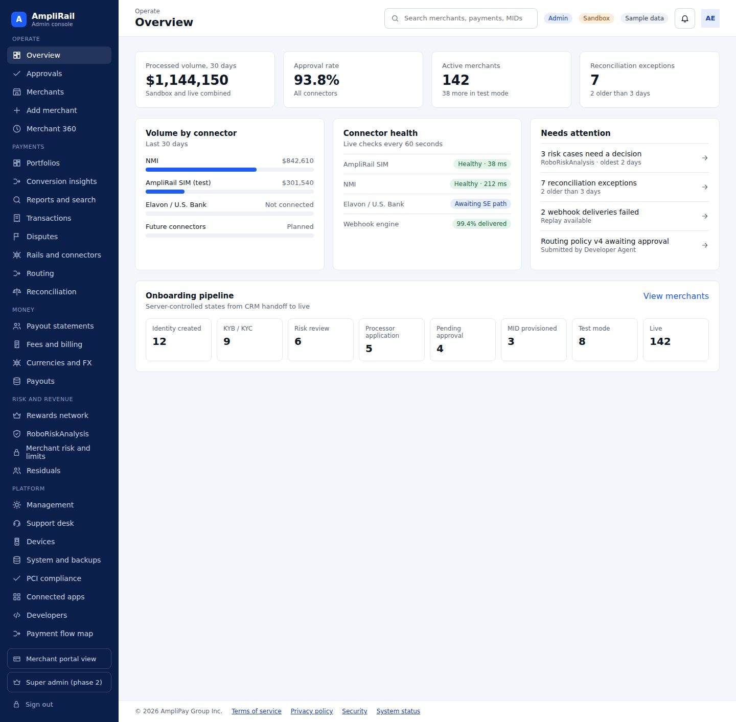

Screen 2. Approvals (dual control) · AR-036
Dual-control queue (routing publish, payout batches, refunds above threshold, agent overrides, go-live, risk changes); requester cannot approve own request; approve with step-up code and required note
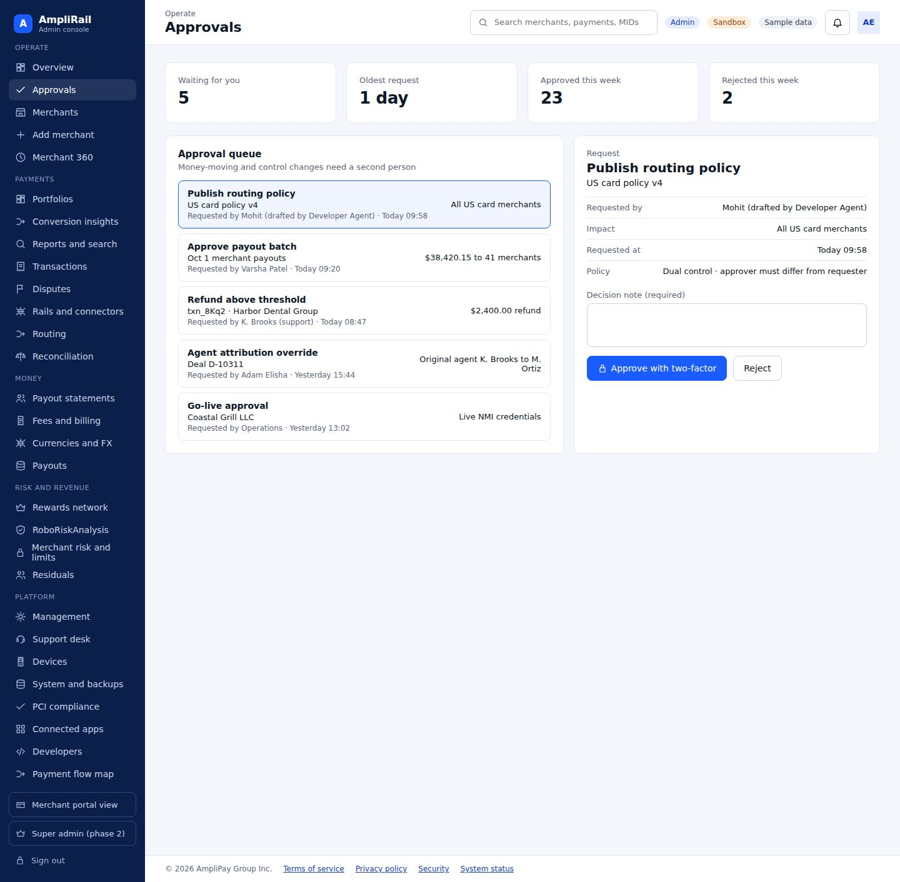

Screen 3. Merchants · AR-046
List with Merchant ID, CRM Deal ID, locked original agent, stage, routes, risk, volume
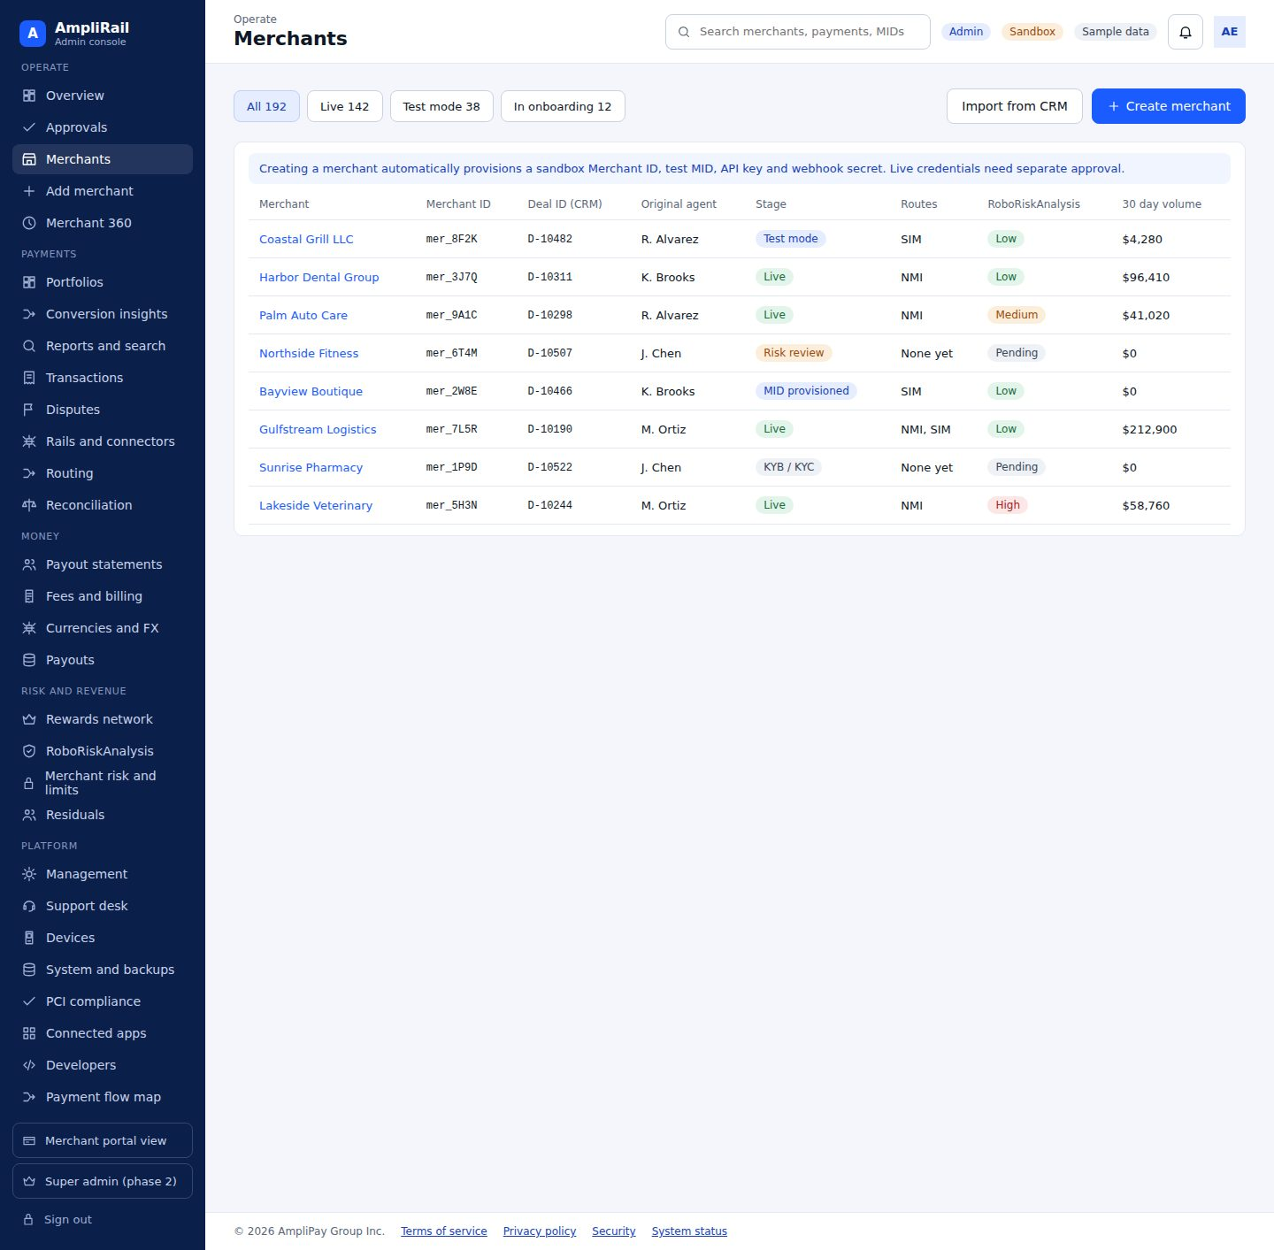

Screen 4. Add merchant (type, processor, processing setup) · AR-016, AR-017, AR-051, AR-101, AR-102, AR-103, AR-118
Type (Standard, Mobile, Test), auto from CRM or manual, fields in Section 10.1, sandbox now
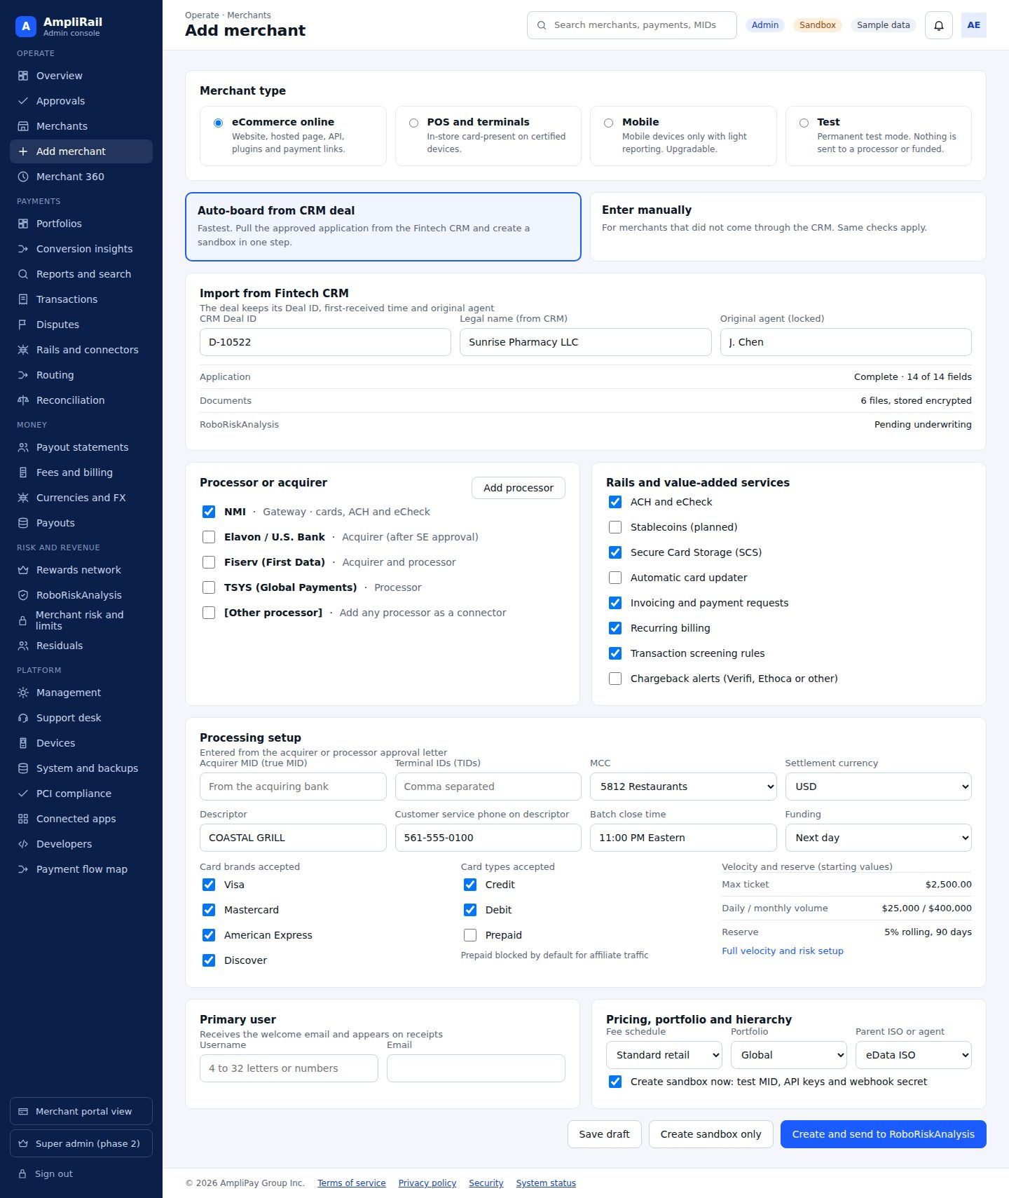

Screen 5. Merchant 360 · AR-046, AR-087
CRM, onboarding, MIDs and routes, payments, settlement, disputes, risk, residuals, event timeline; links to profile and risk
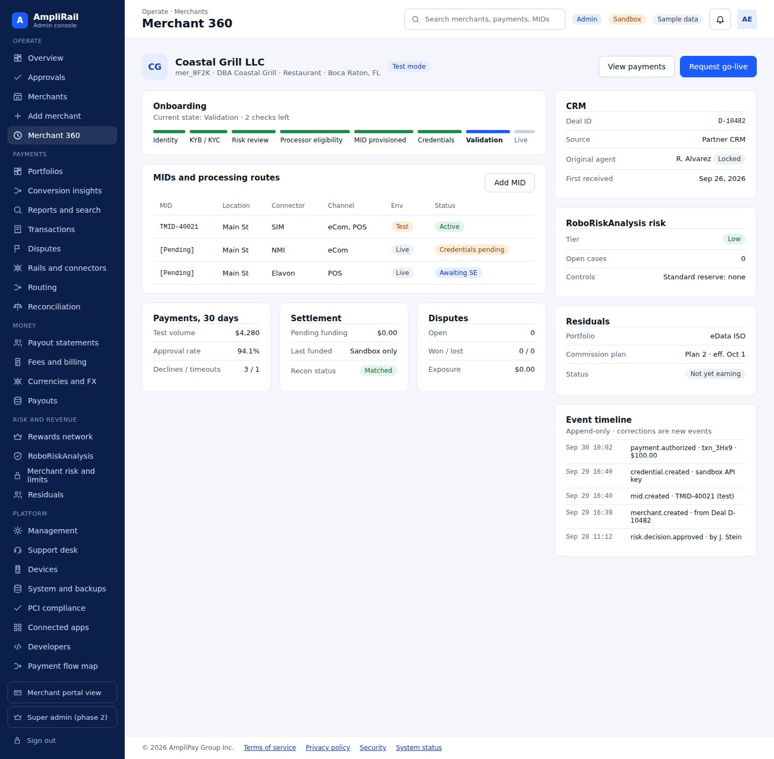

Screen 6. Merchant profile and services · AR-046, AR-102, AR-114, AR-115, AR-116, AR-118, AR-137
Information, contact, settlement bank (masked), processing services per rail, value-added services, fee schedule, users (reset password, view as merchant read-only and logged), advanced features
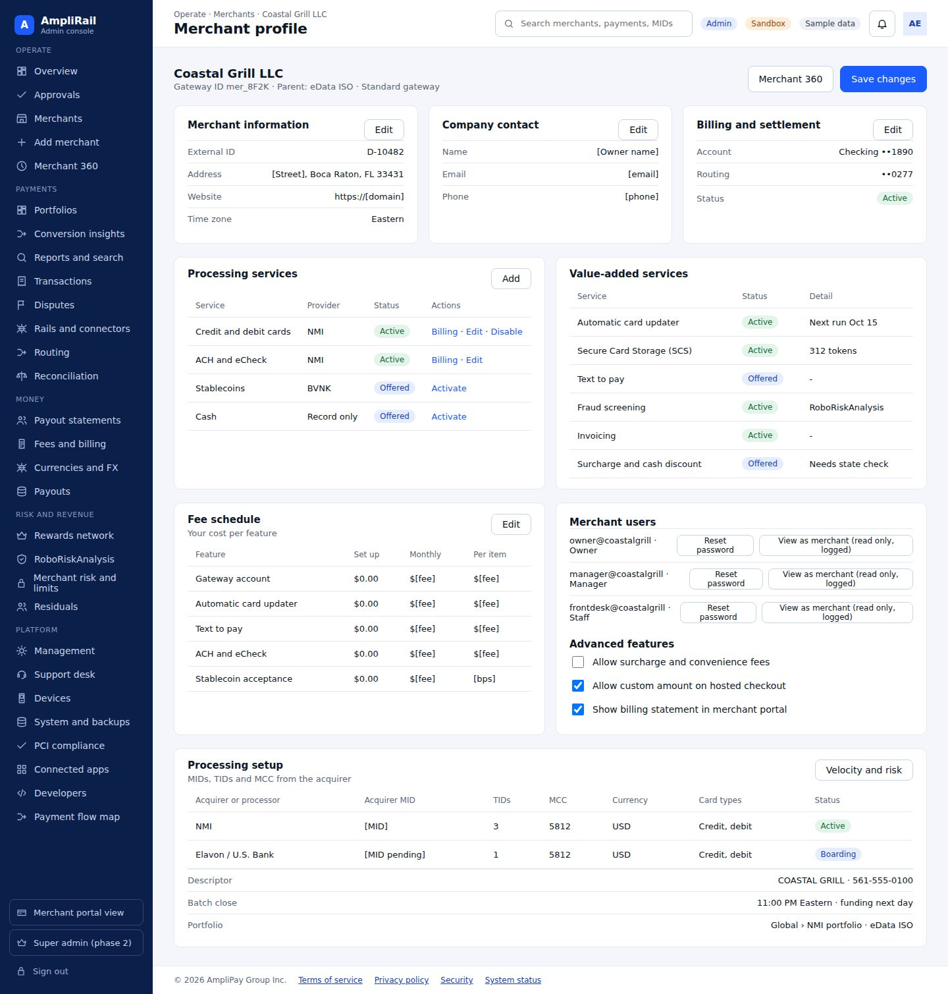

Screen 7. Merchant risk, limits and descriptors · AR-061, AR-062, AR-063, AR-103, AR-113
Section 10.1
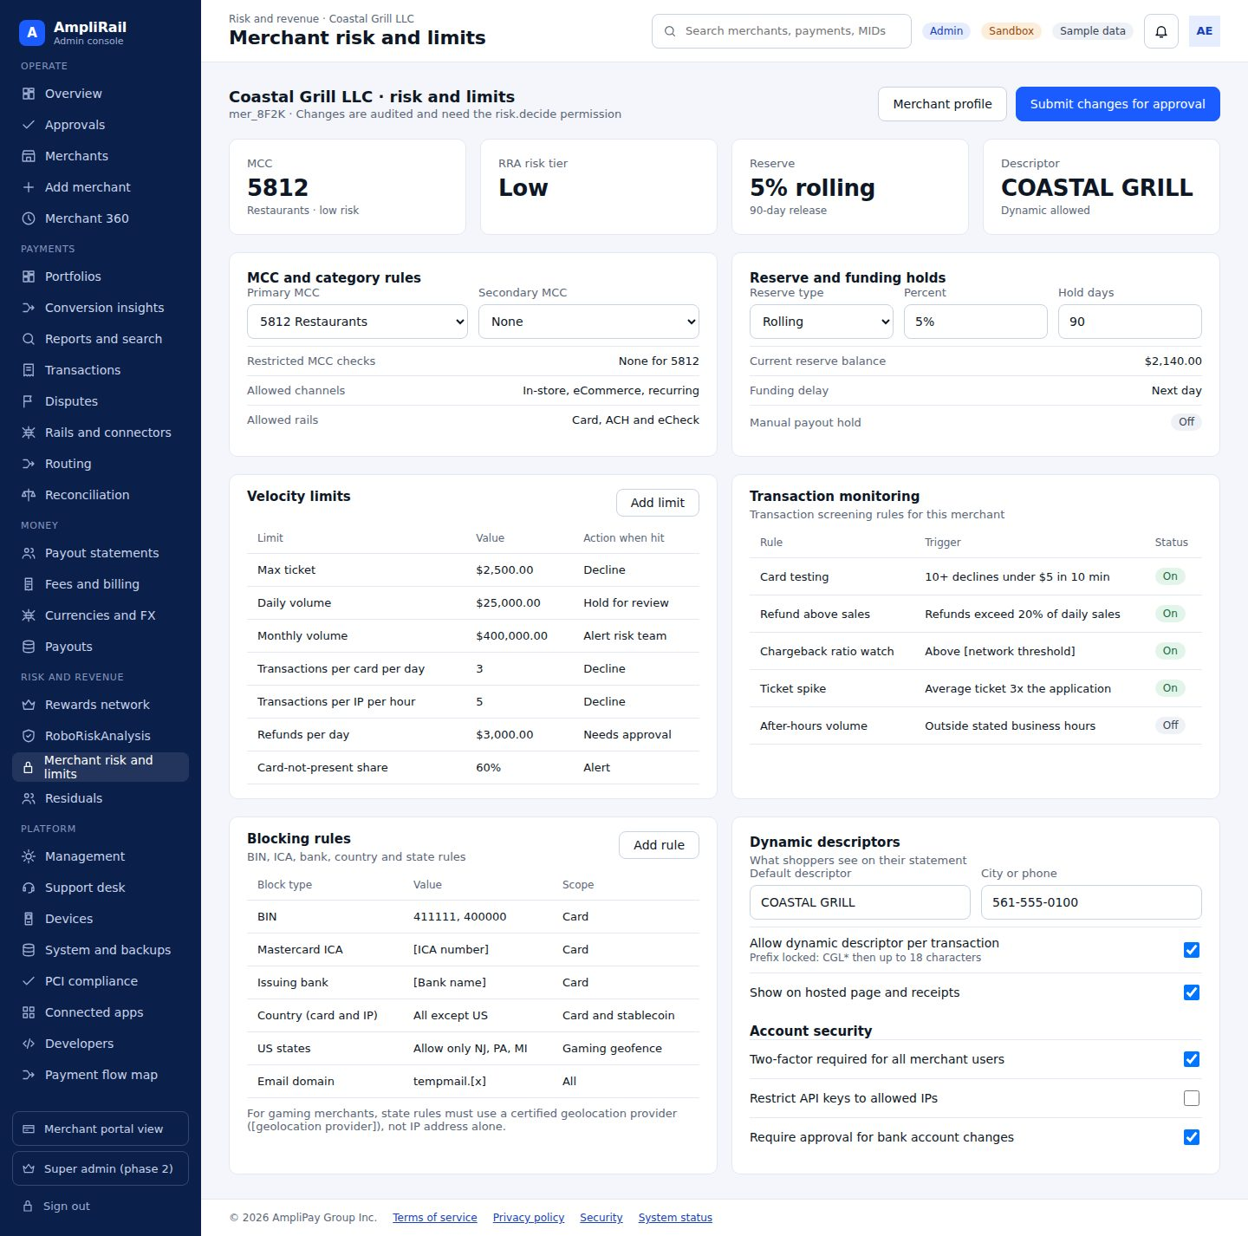

Screen 8. Portfolios · AR-105
Global portfolio and breakdowns by acquirer, processor, ISO and agent: TPV, refunds and refund %, chargeback count and %, approval rate, by MID and card brand with merchant totals (Section 9.1)
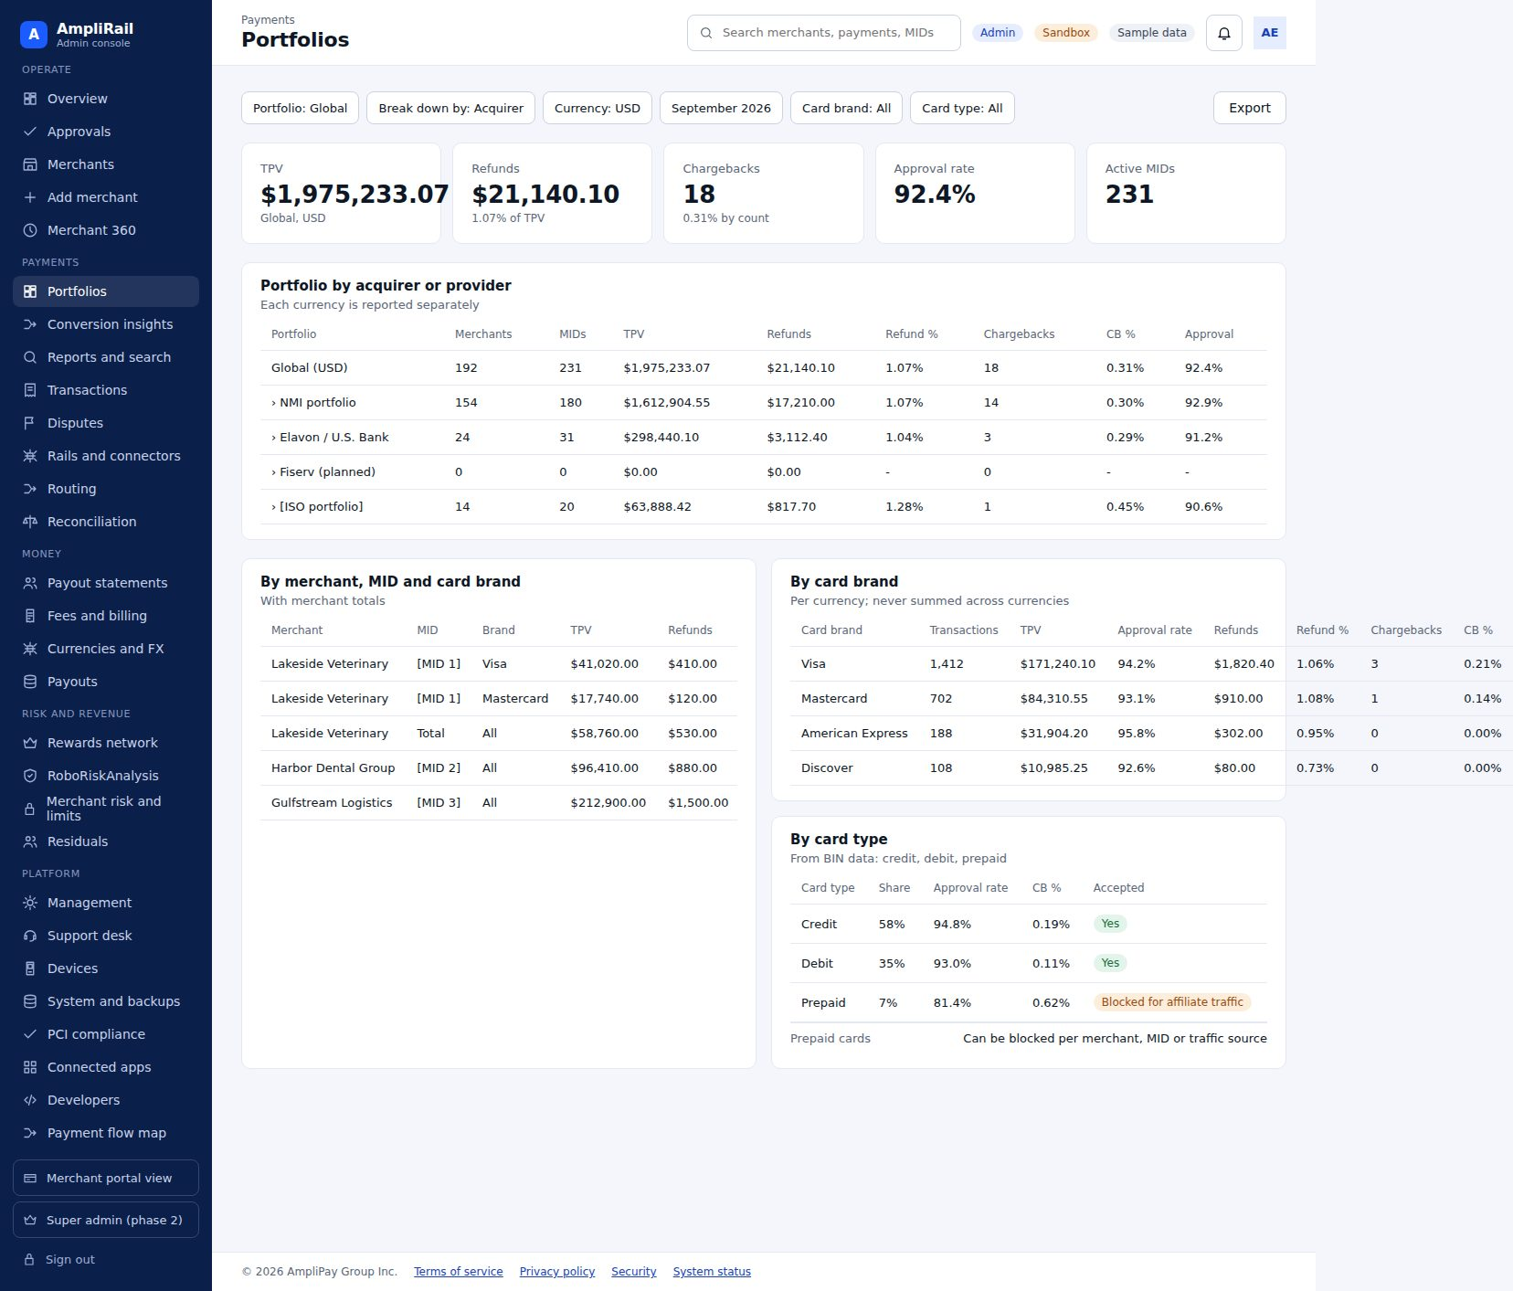

Screen 9. Conversion and interchange insights · AR-130, AR-140
Approval rate by connector, card brand, card type and reason; card-present versus keyed share; downgrade reasons and estimated cost; retry and recovery results
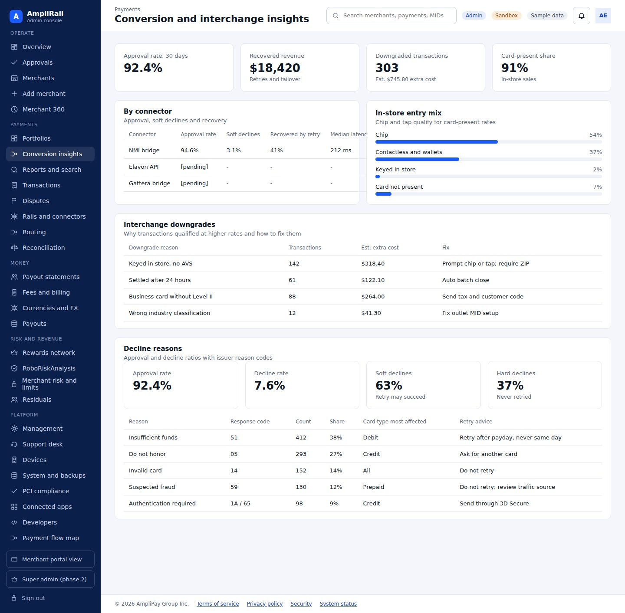

Screen 10. Reports and transaction search · AR-040, AR-041, AR-042, AR-094, AR-104, AR-106
Section 9.1 including batch integrity, card brands and types, and decline reasons
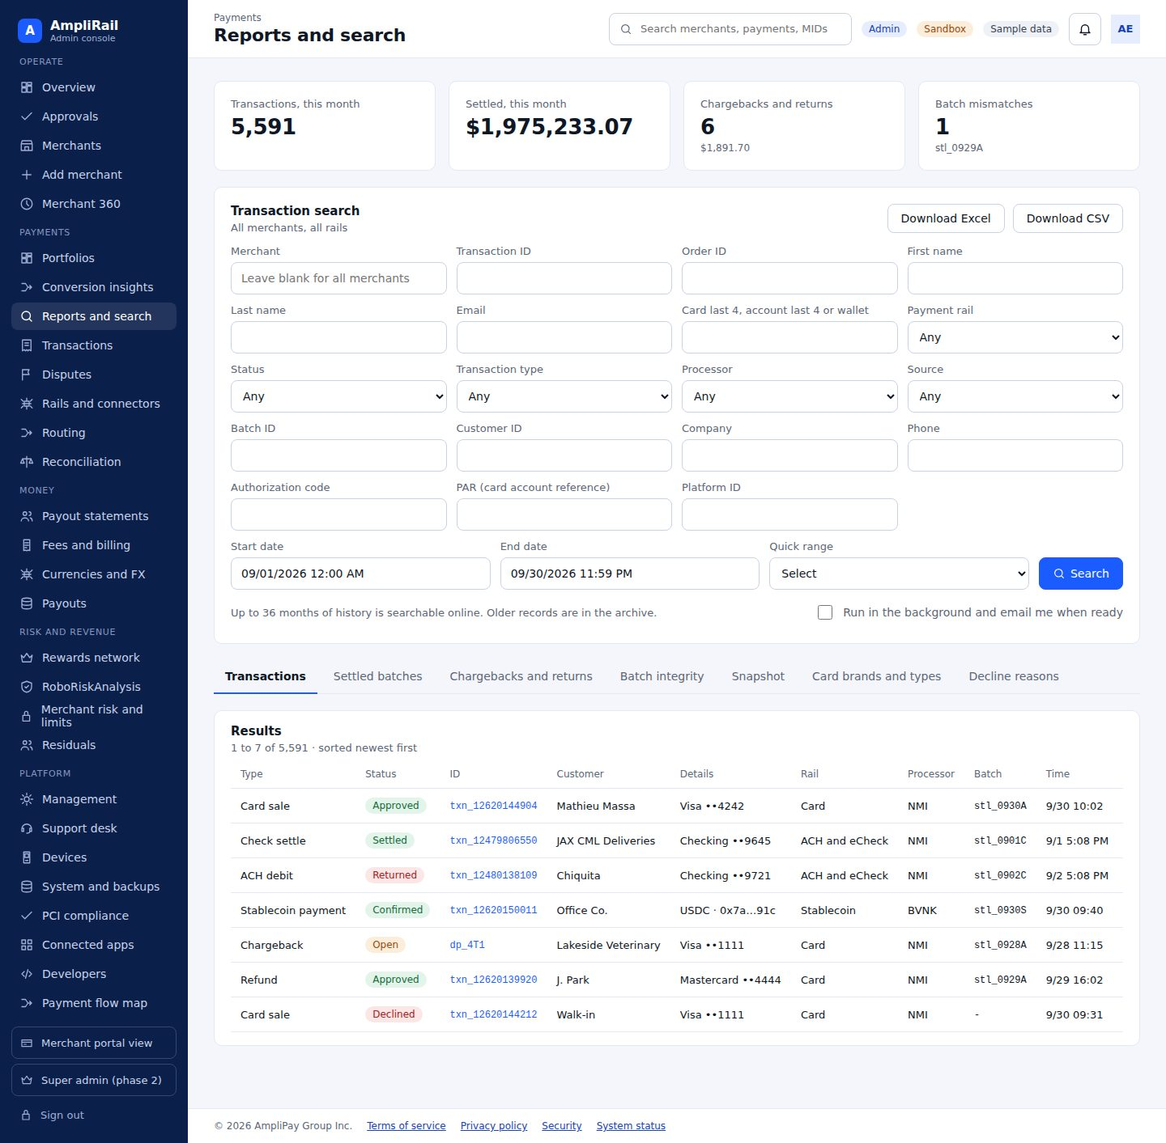

Screen 11. Transactions and timeline · AR-018, AR-024, AR-132
Detail with event timeline, refund, void, replay webhook
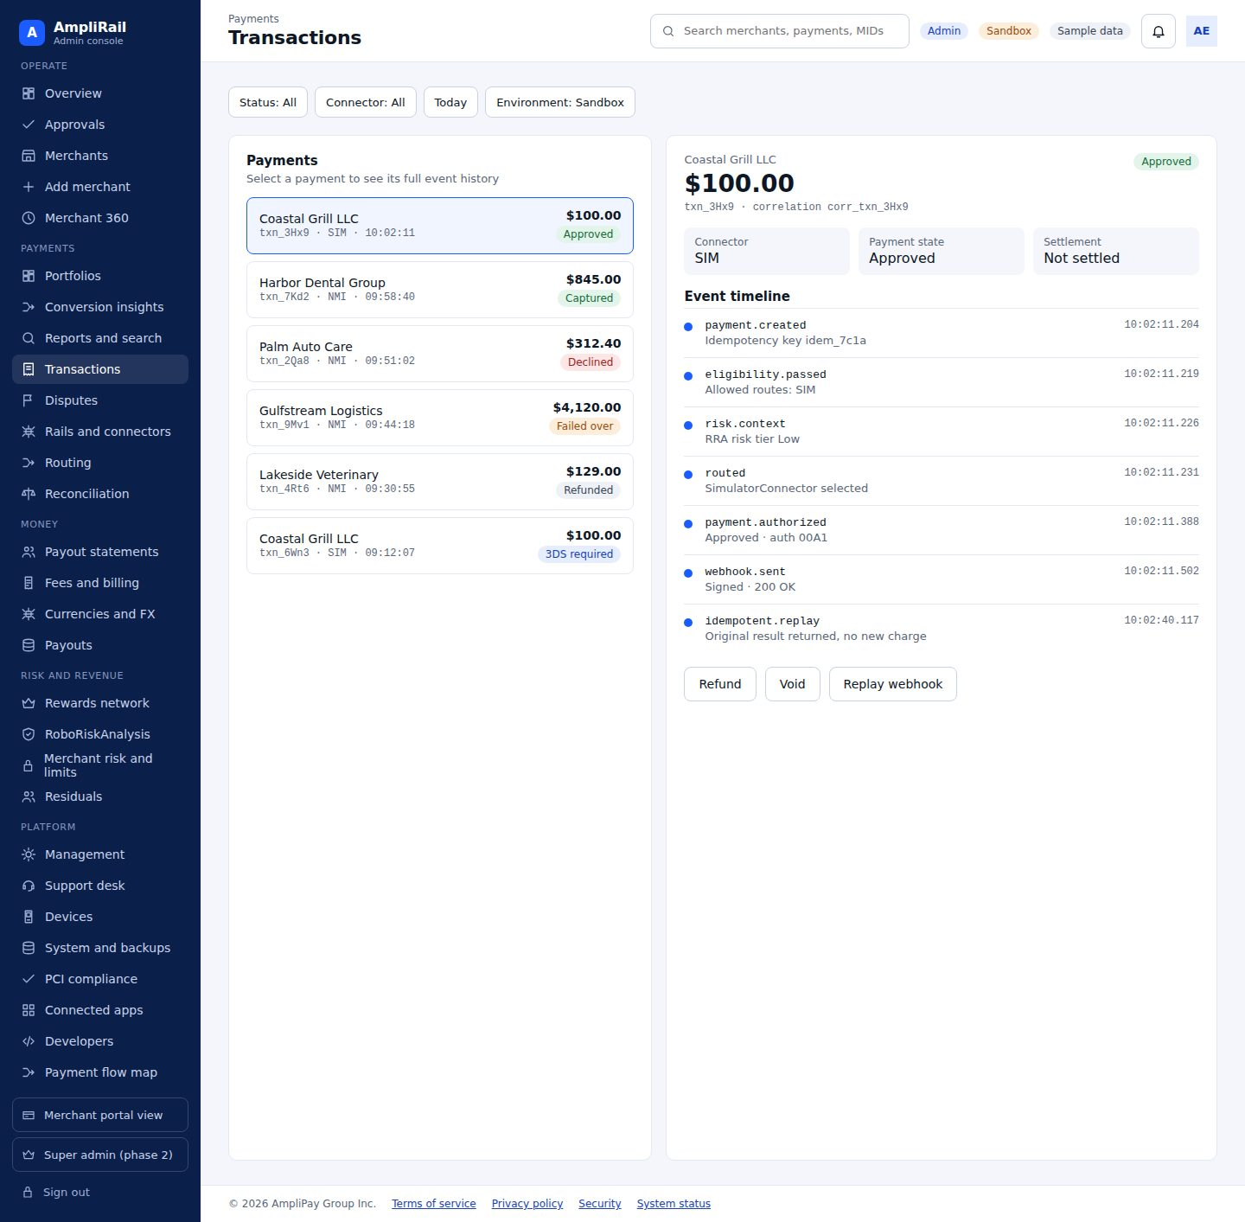

Screen 12. Disputes, alerts and chargebacks · AR-044, AR-107, AR-108, AR-109
Alerts and disputes by stage, deflection rules, alert and resolution providers, evidence upload and send to processor, ratio watch (Section 9.6)
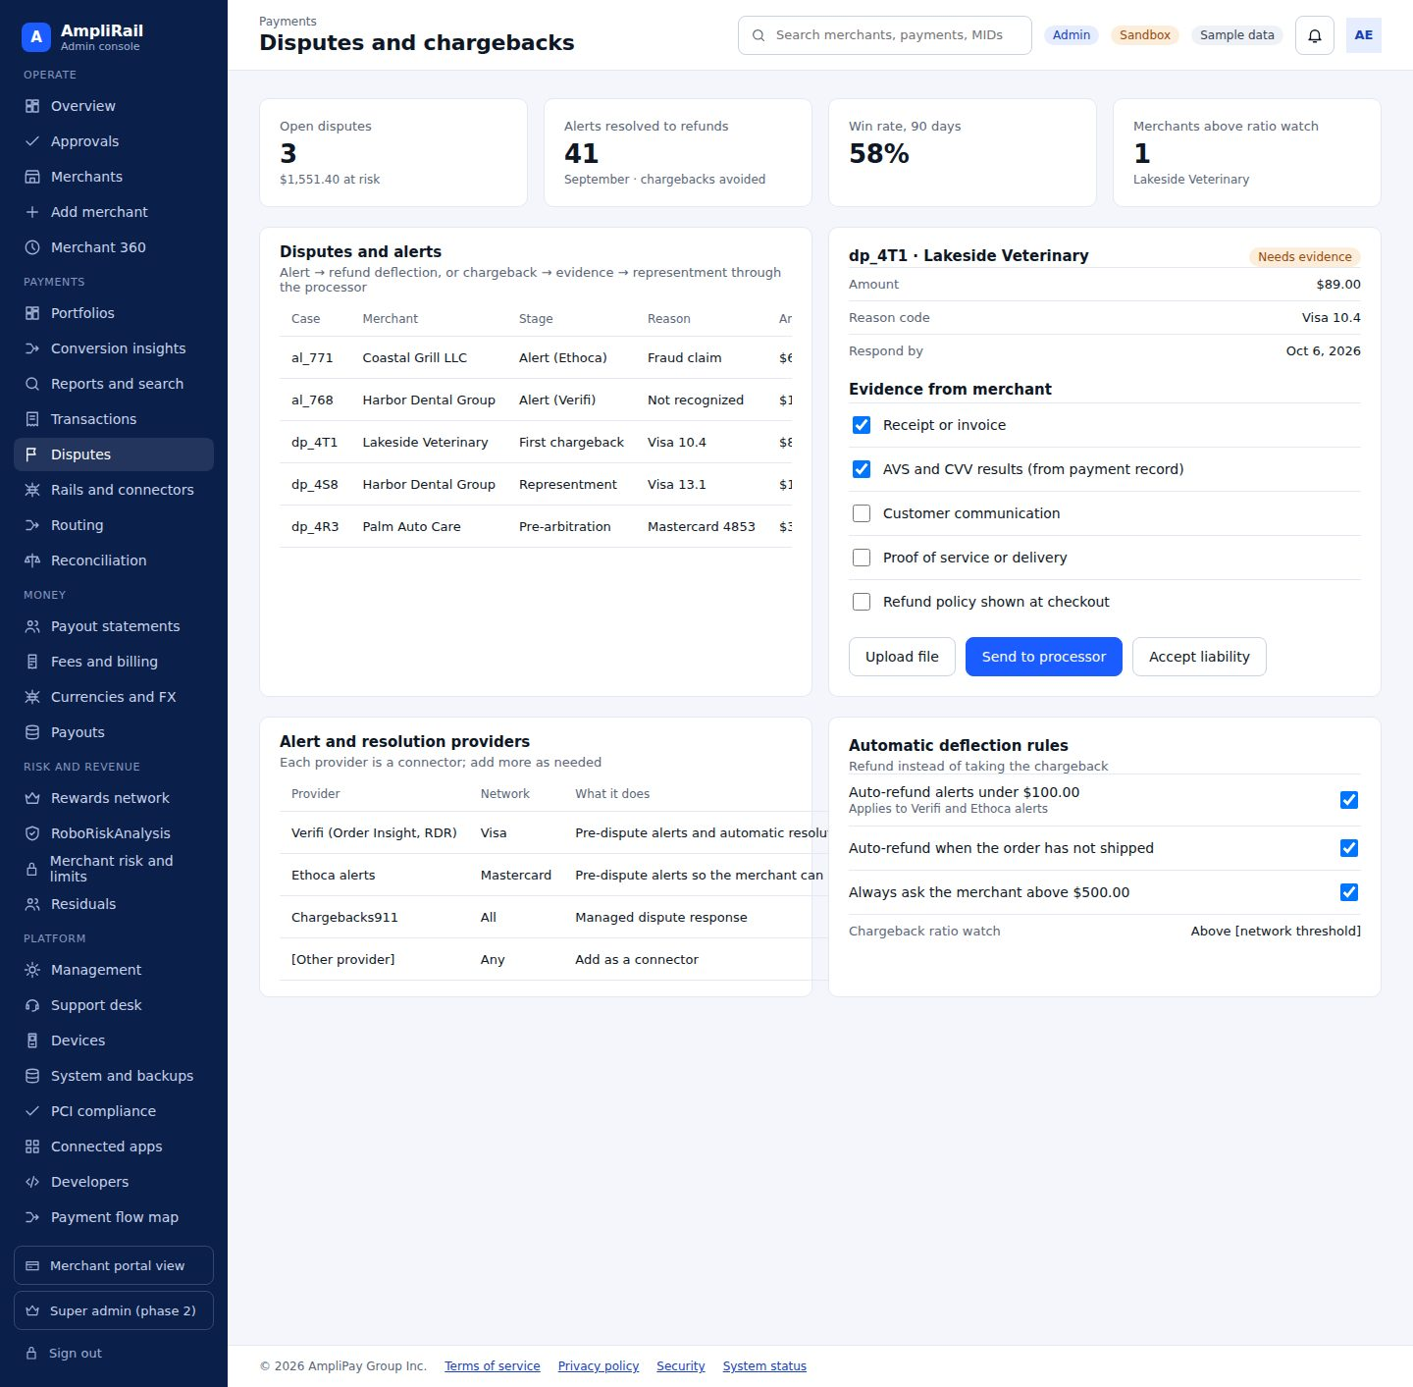

Screen 13. Rails and connectors · AR-026, AR-033, AR-068, AR-112, AR-117, AR-125, AR-143
Connector catalog with status, channels, optimization features, performance, token references
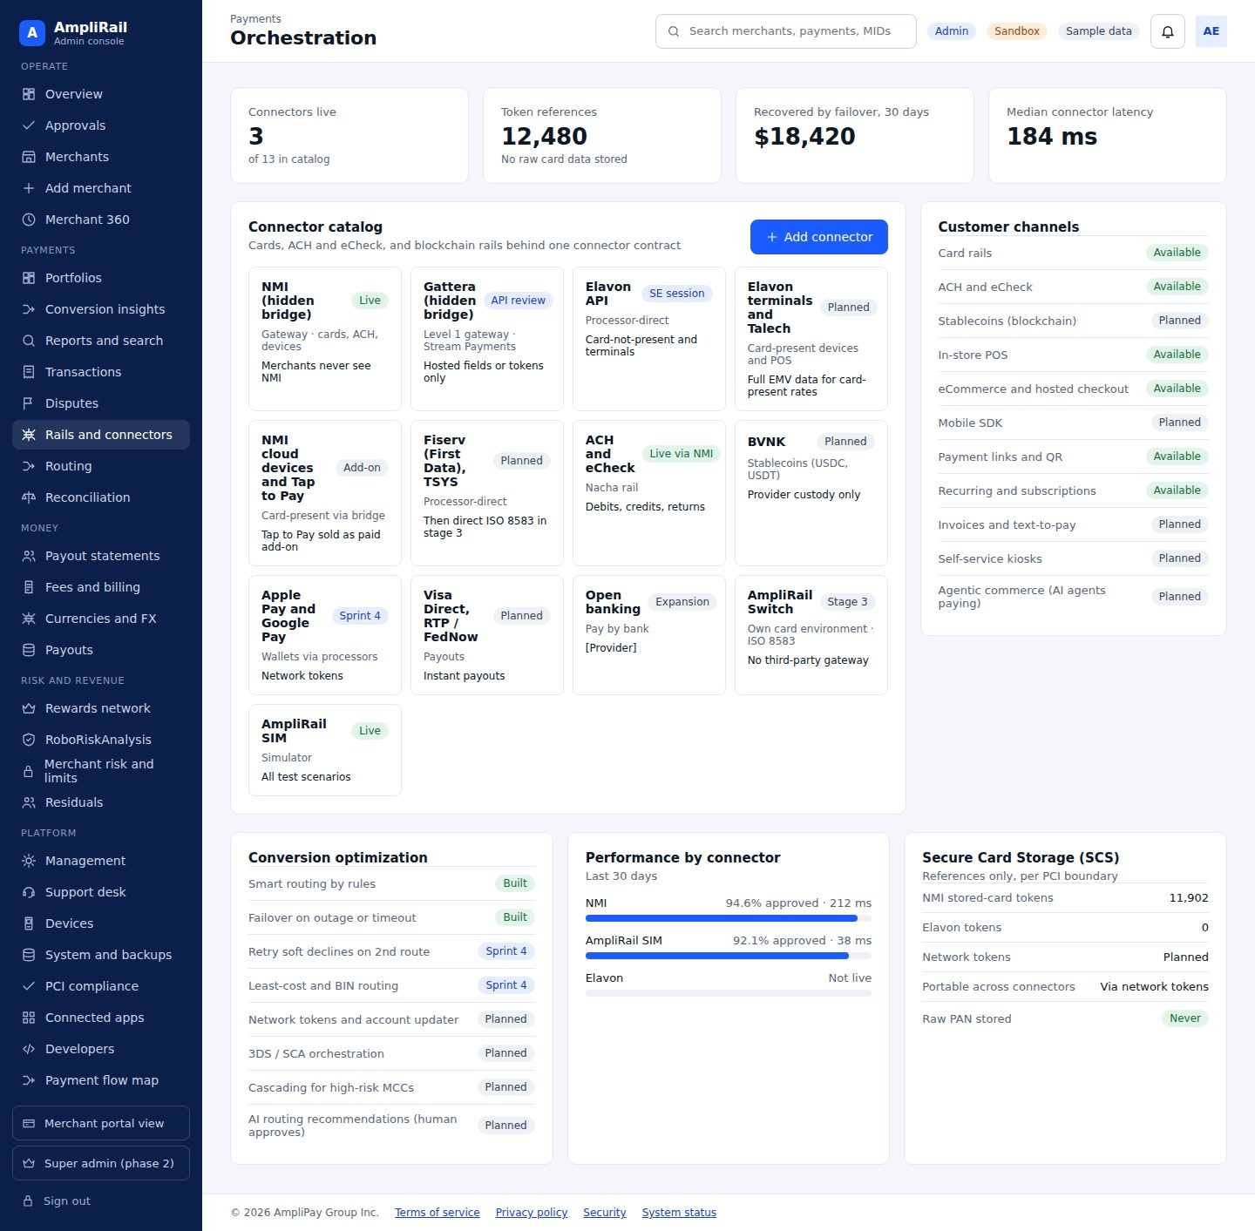

Screen 14. Routing policy · AR-019, AR-035, AR-037
Versioned policy editor, dry run, submit for approval
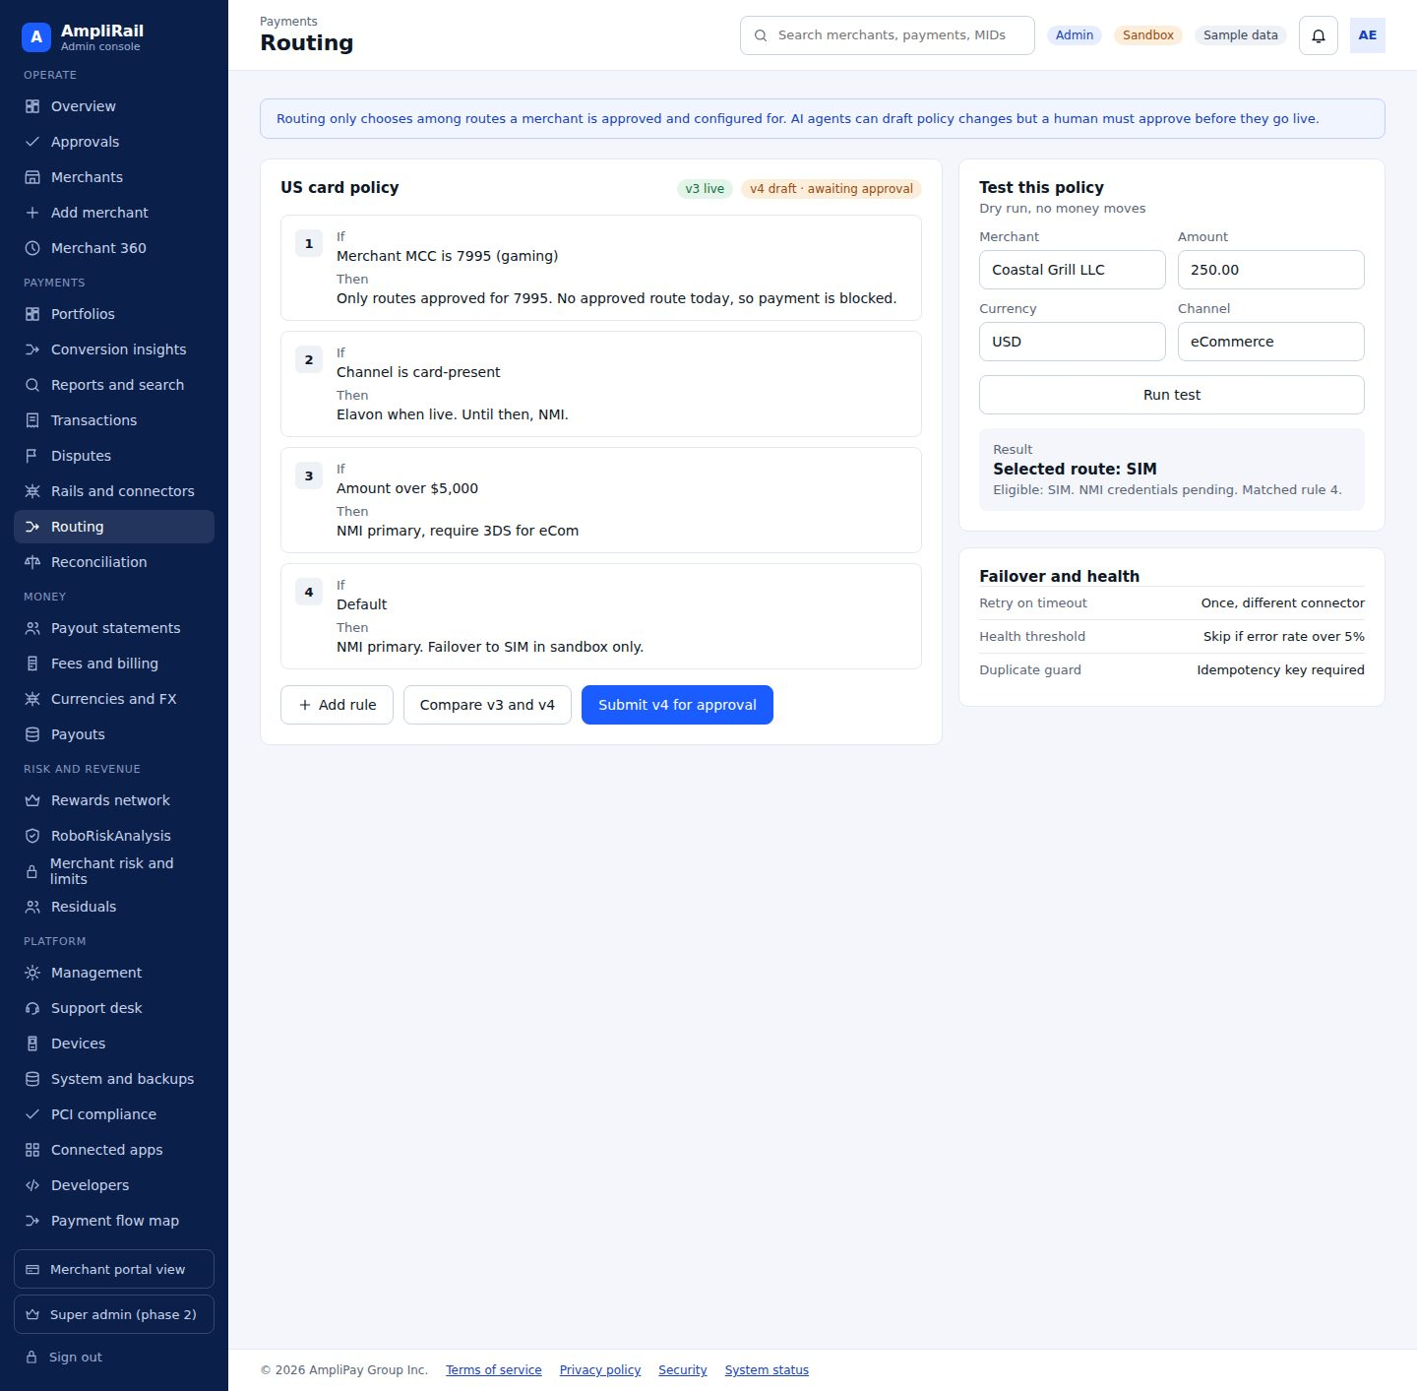

Screen 15. Reconciliation · AR-020, AR-028, AR-029, AR-099
Match rate, exception queue, ledger view, imports
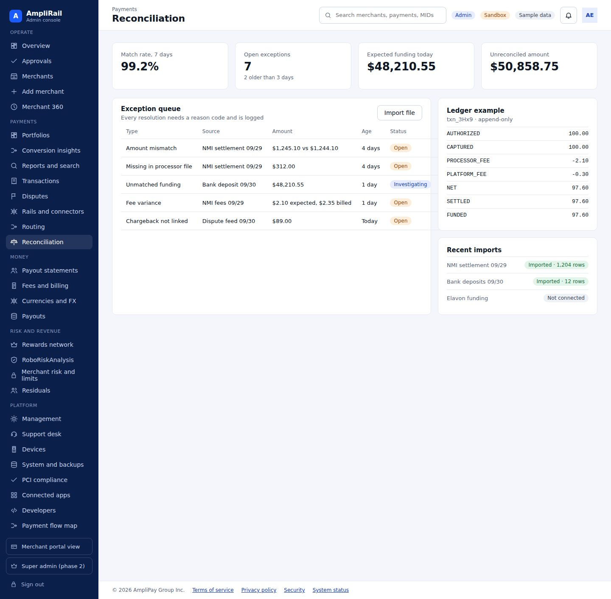

Screen 16. Payout statements · AR-146, AR-147, AR-148, AR-151, AR-152
Weekly statement runs by merchant, MID, provider and currency; approve and issue; reserve rules; chargeback monitoring settings; PSP reconciliation queue
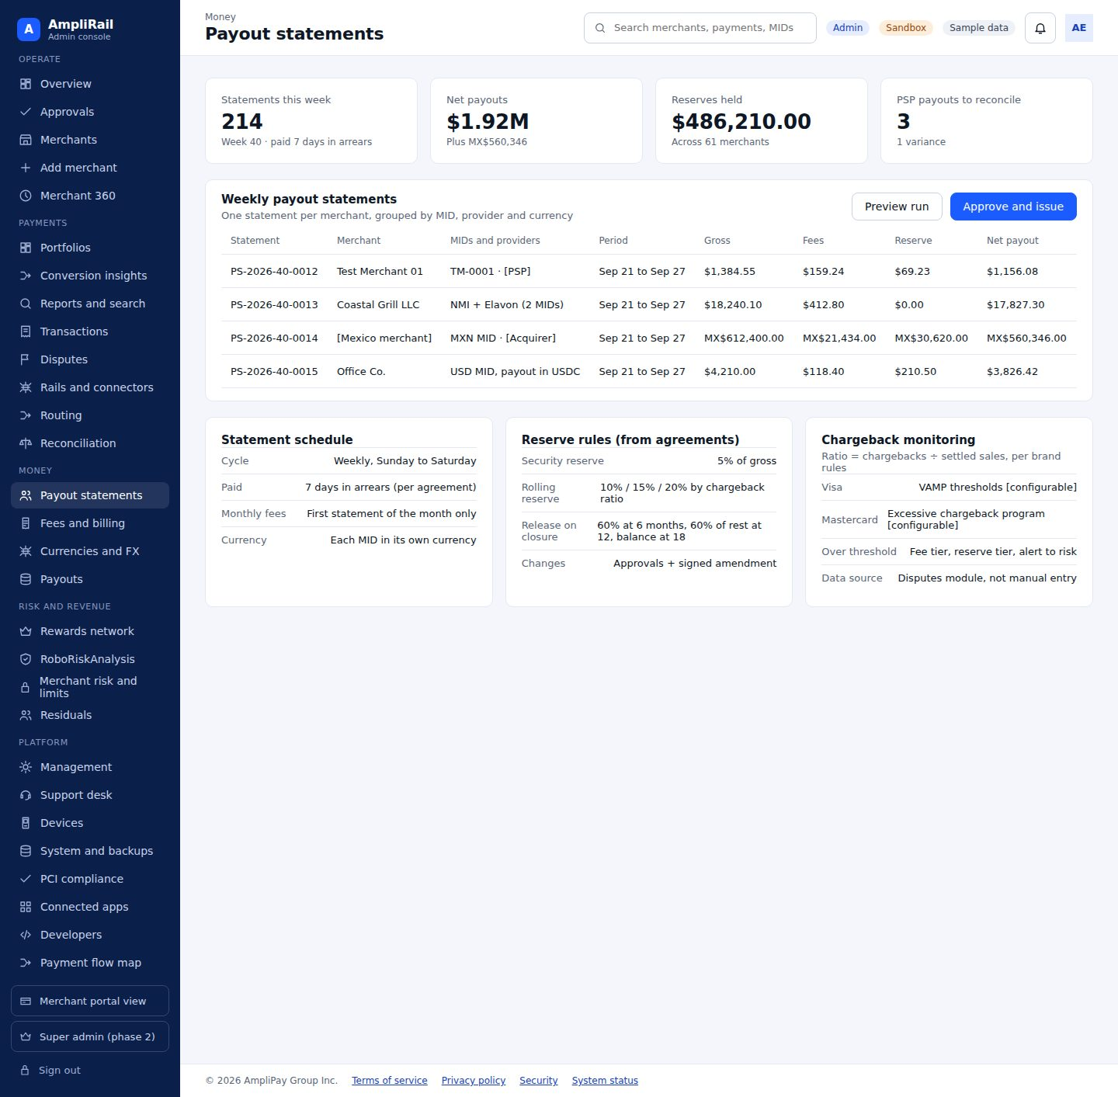

Screen 17. Fees and billing · AR-088, AR-089, AR-090, AR-092, AR-110, AR-120
Fee catalog with our cost, default sell rate and margin, fee schedules per merchant, ISO, PSP or bank, versions and effective dates, agreement status, monthly statements and collections, revenue by fee type and currency
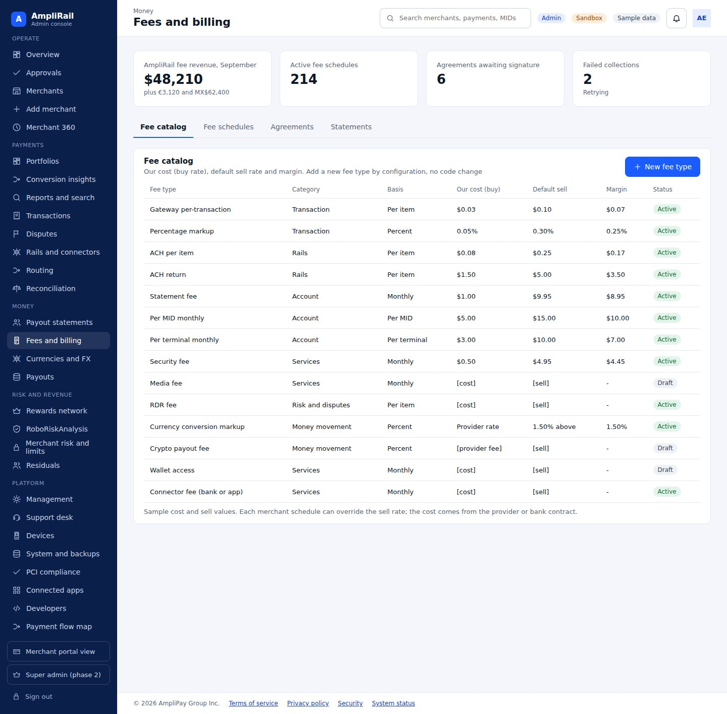

Screen 18. Currencies and FX · AR-093, AR-094, AR-095, AR-096, AR-144
Enabled currencies and rails, MIDs by currency, conversion app settings and markups per merchant, rate provider status, quotes and conversions, FX revenue
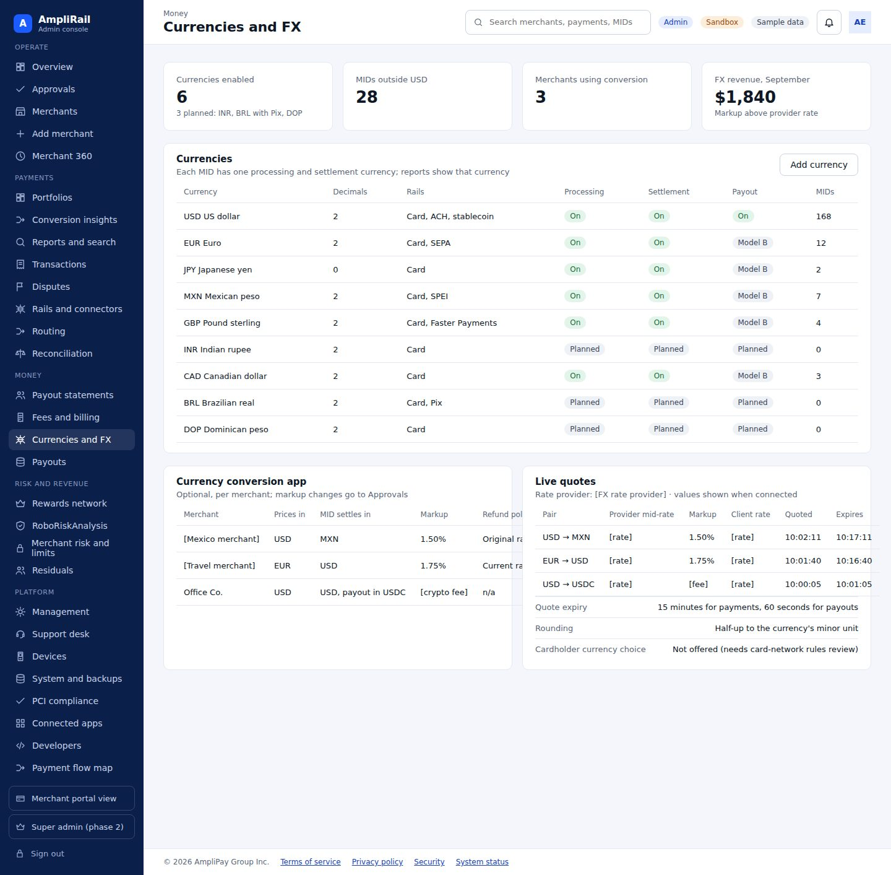

Screen 19. Payouts (Model B) · AR-097, AR-098, AR-099, AR-100, AR-120
Model B payout runs by currency and rail, payout accounts and verification, holds, failed and returned payouts, safeguarding reconciliation
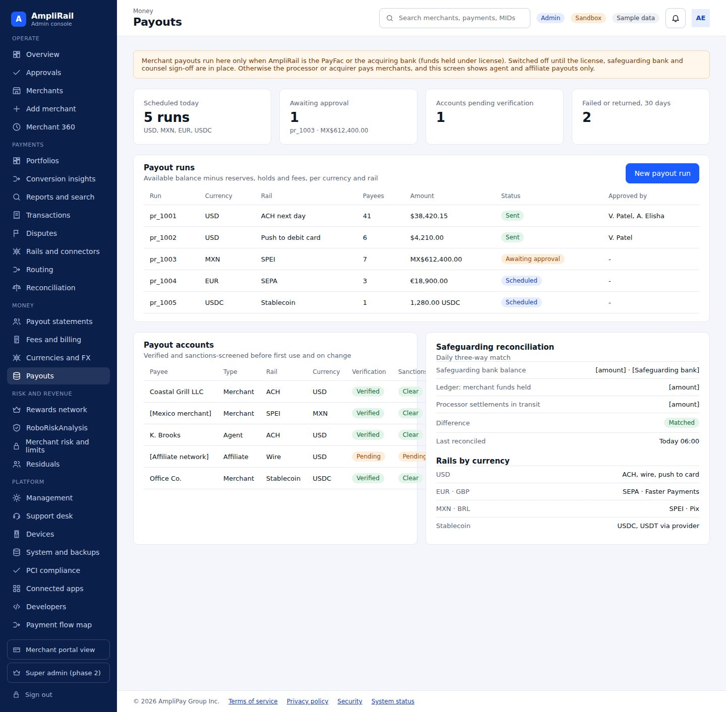

Screen 20. Rewards network · AR-158, AR-159, AR-160
Programs and outstanding value by merchant and currency, program levels and licensing status, controls and compliance
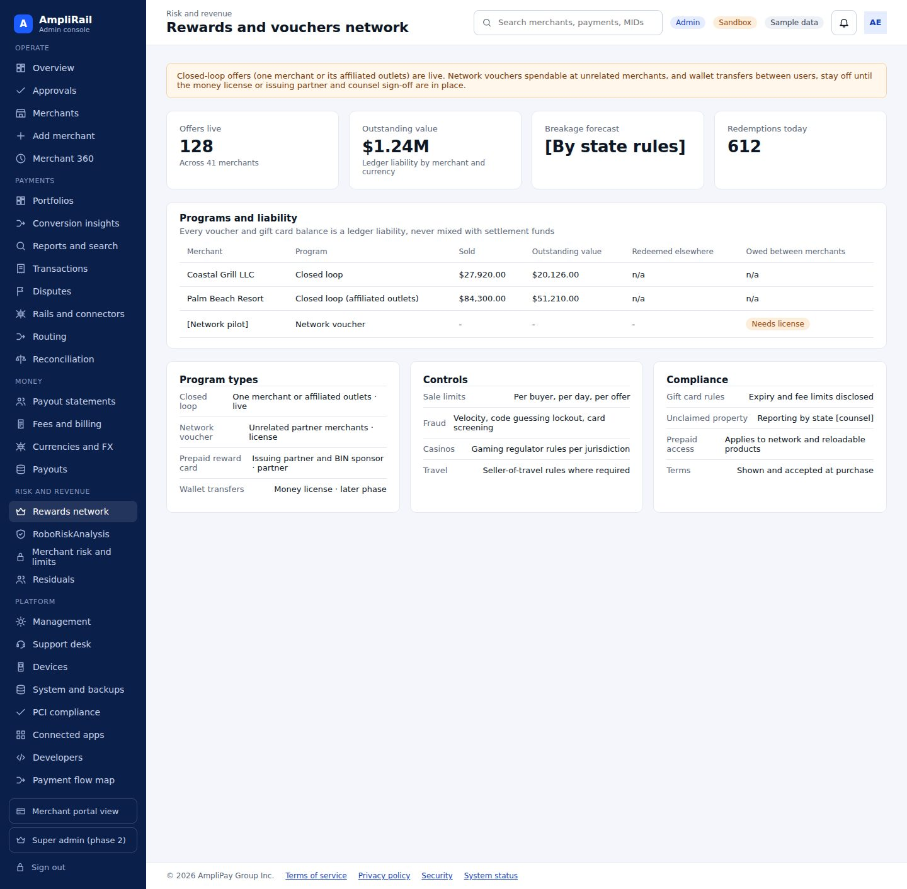

Screen 21. RoboRiskAnalysis (merchant risk) · AR-038
Risk cases from RRA: 0-100 score with band and confidence, pre-submission gate status, signals with evidence, recommendation, human decision or override with reason
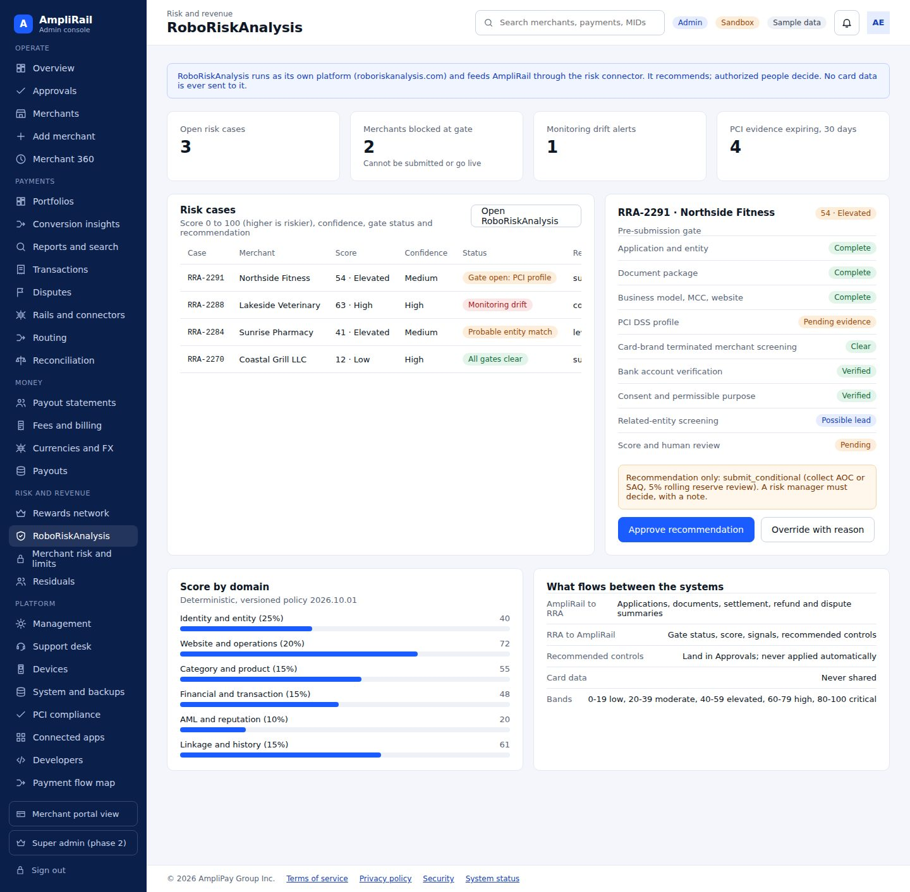

Screen 22. Residuals · AR-045, AR-111
Processing residuals from banks and processors, PayFac billing margins, gateway technology residuals, agent statements, payout approval (dual control) (Section 9.5)
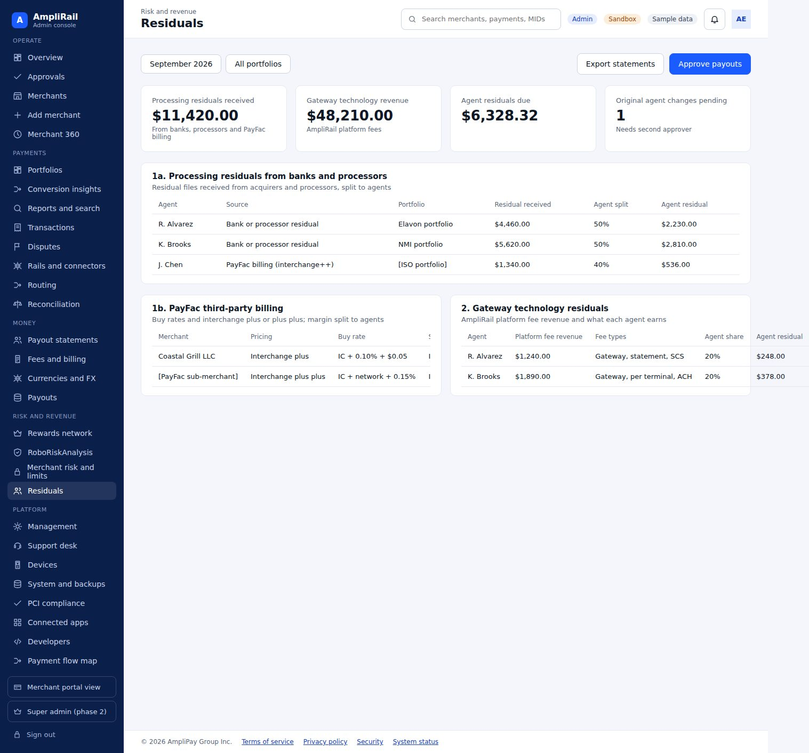

Screen 23. Management: users, roles, logs · AR-047, AR-080, AR-081
Users, roles and permissions, sign-in log, audit trail, security policy
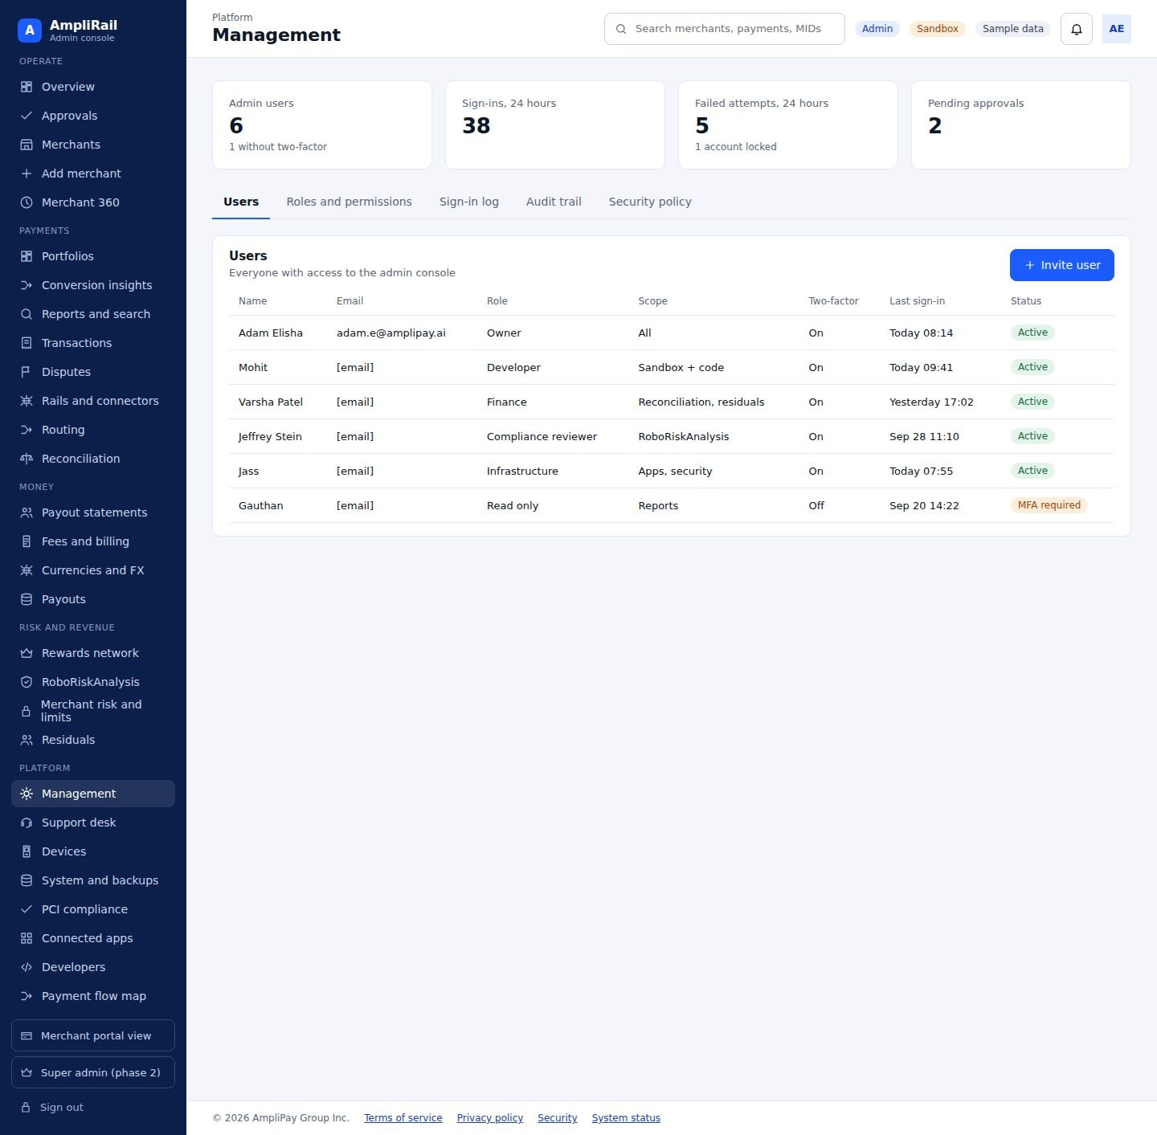

Screen 24. Support desk · AR-048
Tickets with SLA, linked context, AI drafts never auto-sent, knowledge base, status
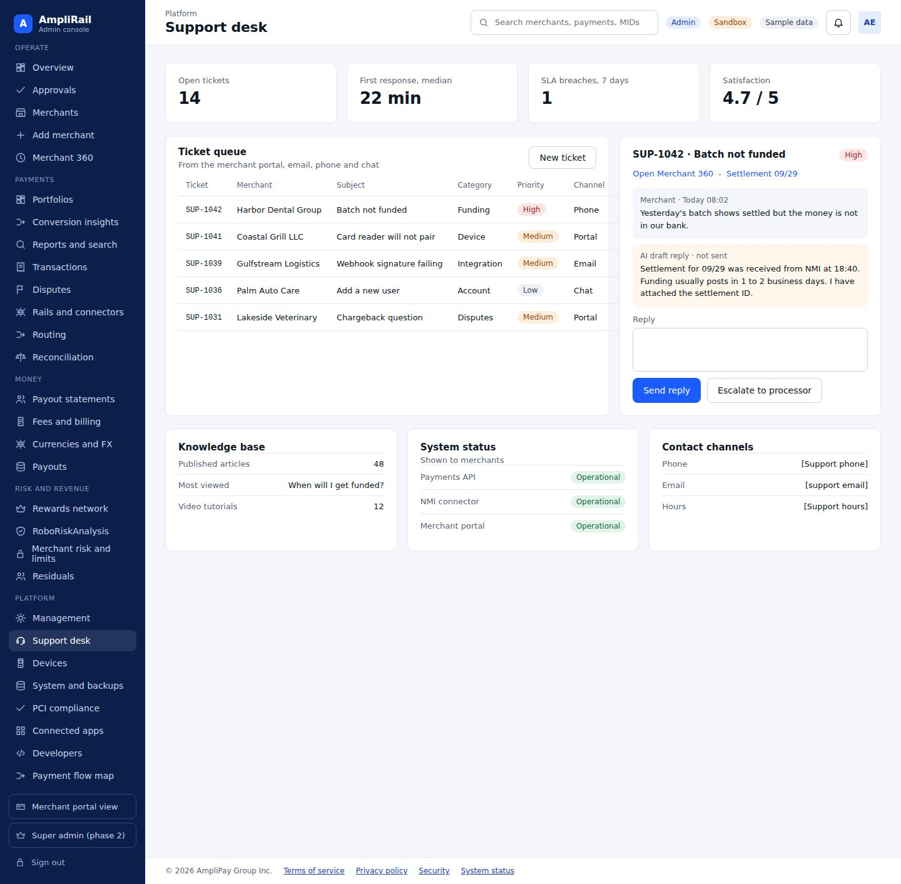

Screen 25. Devices · AR-034, AR-122, AR-126, AR-128
Deployed devices and status, orders, pairing, catalog; certified devices only
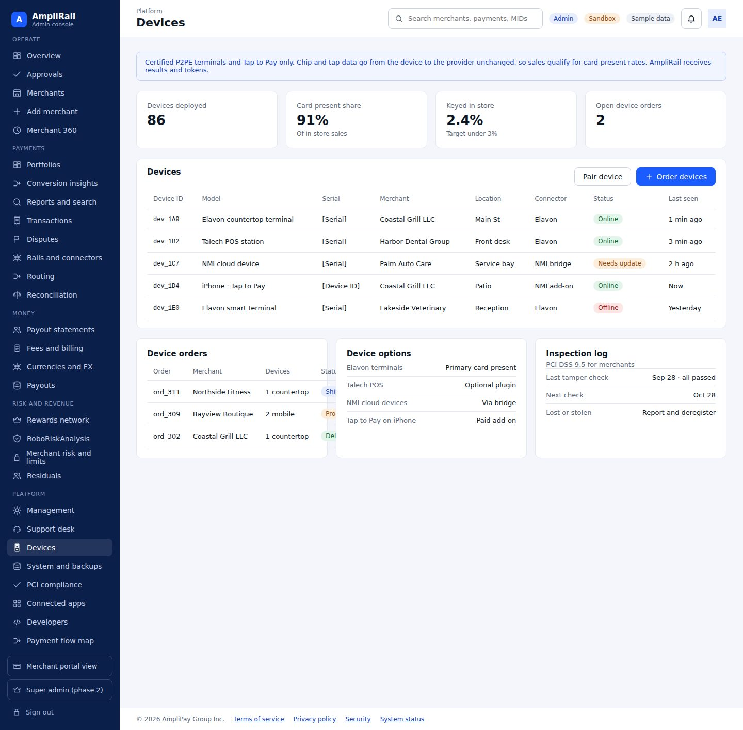

Screen 26. System and backups · AR-049, AR-072, AR-078, AR-082, AR-084
Recovery targets vs measured, backup and lock status, restore tests, environments and deploy approvers, CI gates, secrets rotation, incidents
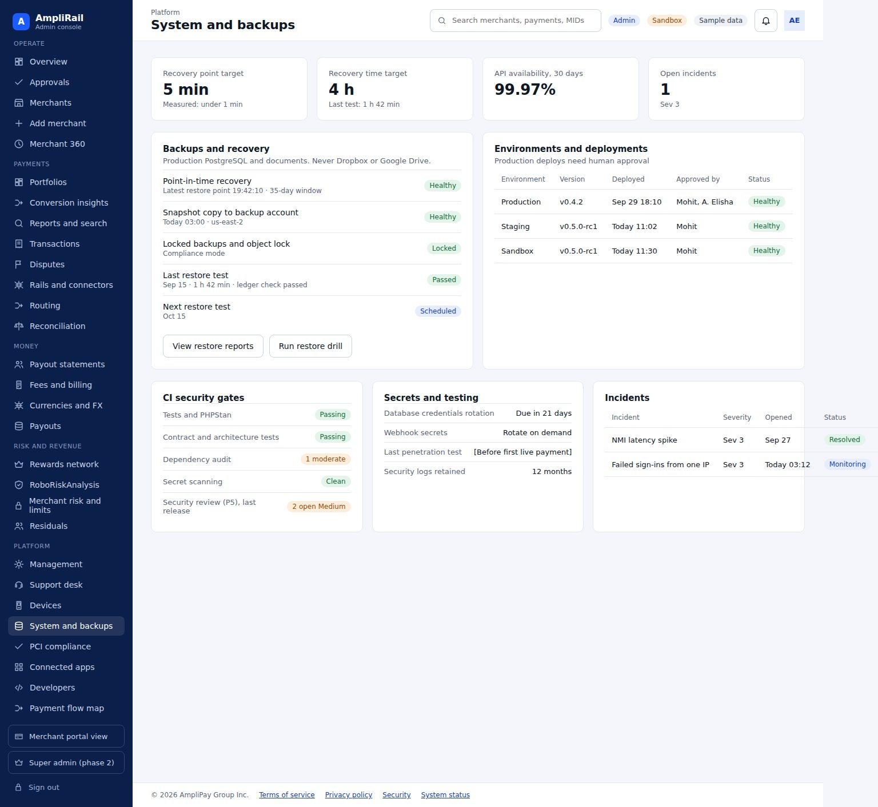

Screen 27. PCI compliance center · AR-072, AR-073, AR-074, AR-075, AR-076, AR-077, AR-079, AR-083, AR-085, AR-086, AR-087, AR-141
Our AOC status, open gaps, PAN scanner results, payment-page tamper alerts, status by PCI requirement, evidence calendar, payment-page script inventory, third-party AOCs, merchant PCI status from RRA (Section 14.5)
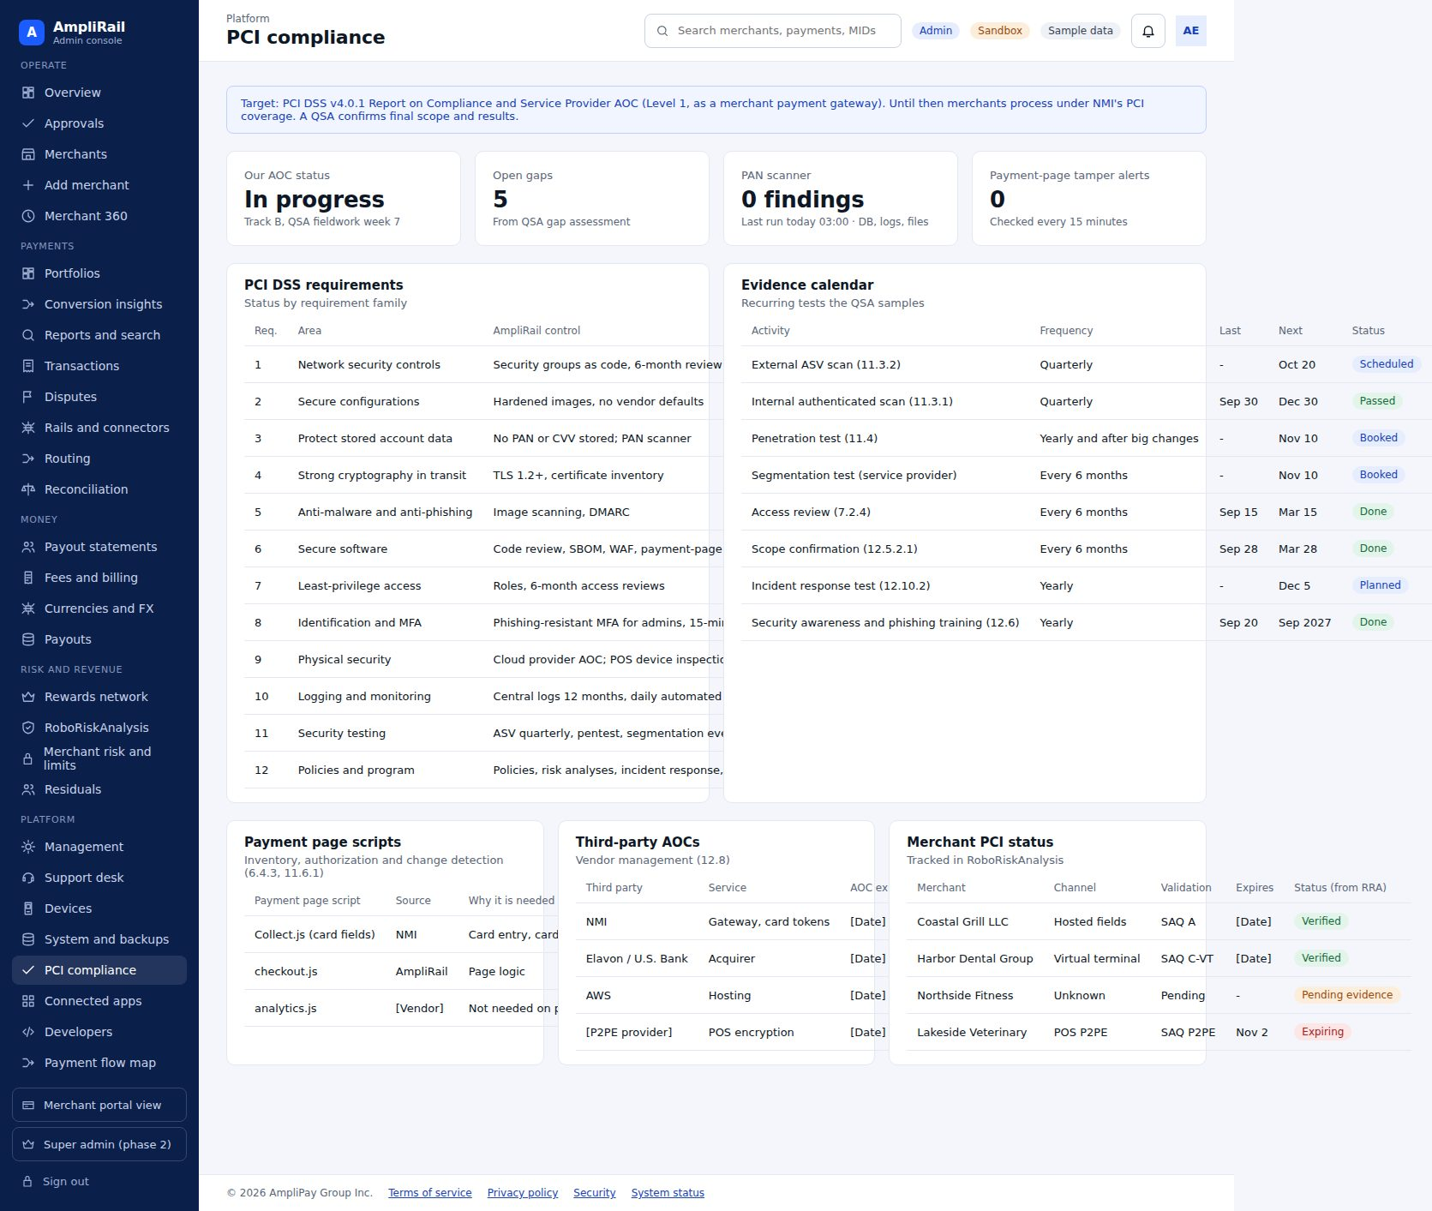

Screen 28. Connected apps and subdomains · AR-050
SSO launcher and event stream health
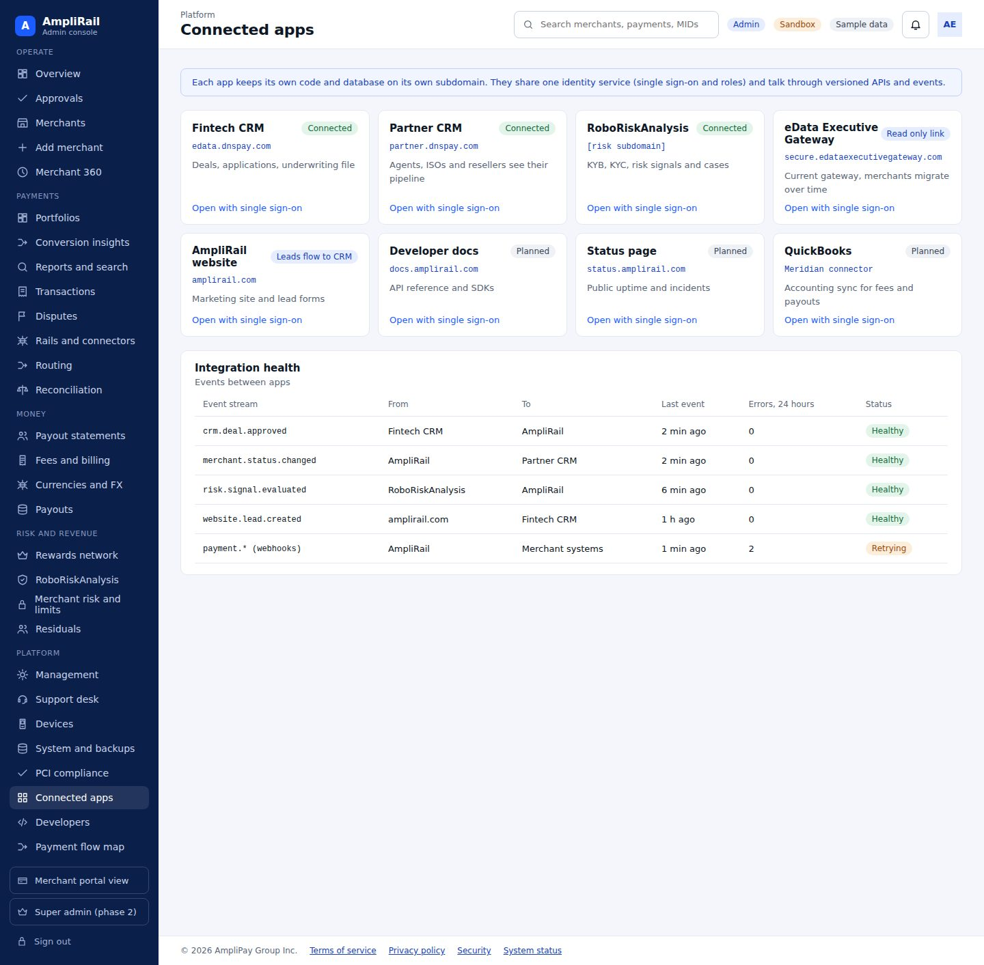

Screen 29. Developer console · AR-021
Platform API keys, webhooks, simulator scenarios
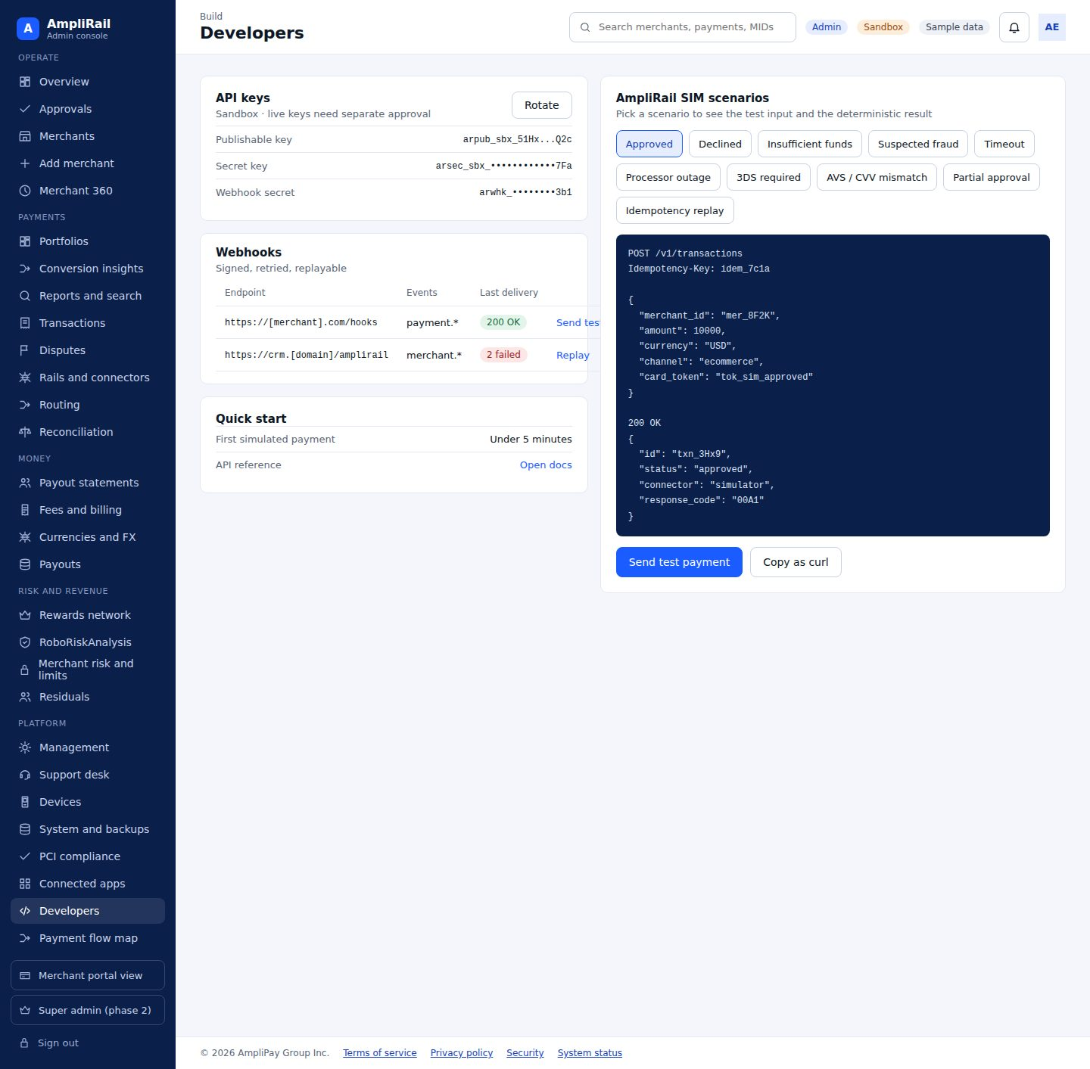

Screen 30. Payment flow map and PCI boundary · AR-032, AR-067, AR-068, AR-124, AR-145
Channels → AmpliRail → connectors → banks, with PCI boundary
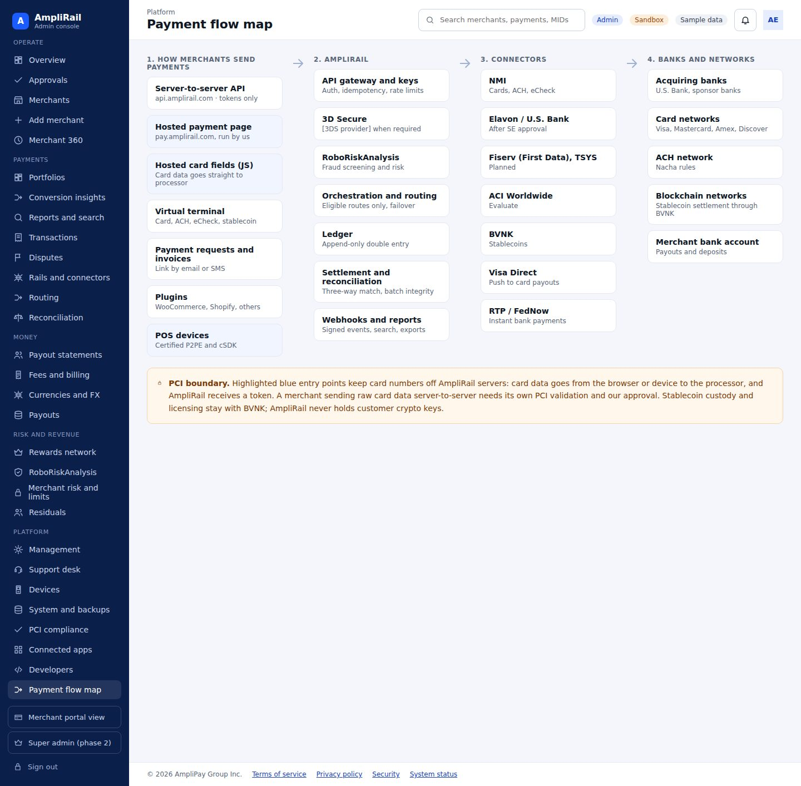

Merchant portal

Screen 31. Merchant: dashboard · AR-030, AR-060
Go-live checklist, sales across rails, next deposit, pending ACH, chargebacks, quick actions (card, check or ACH, stablecoin, payment request, invoice, add customer, add subscription, batch upload)
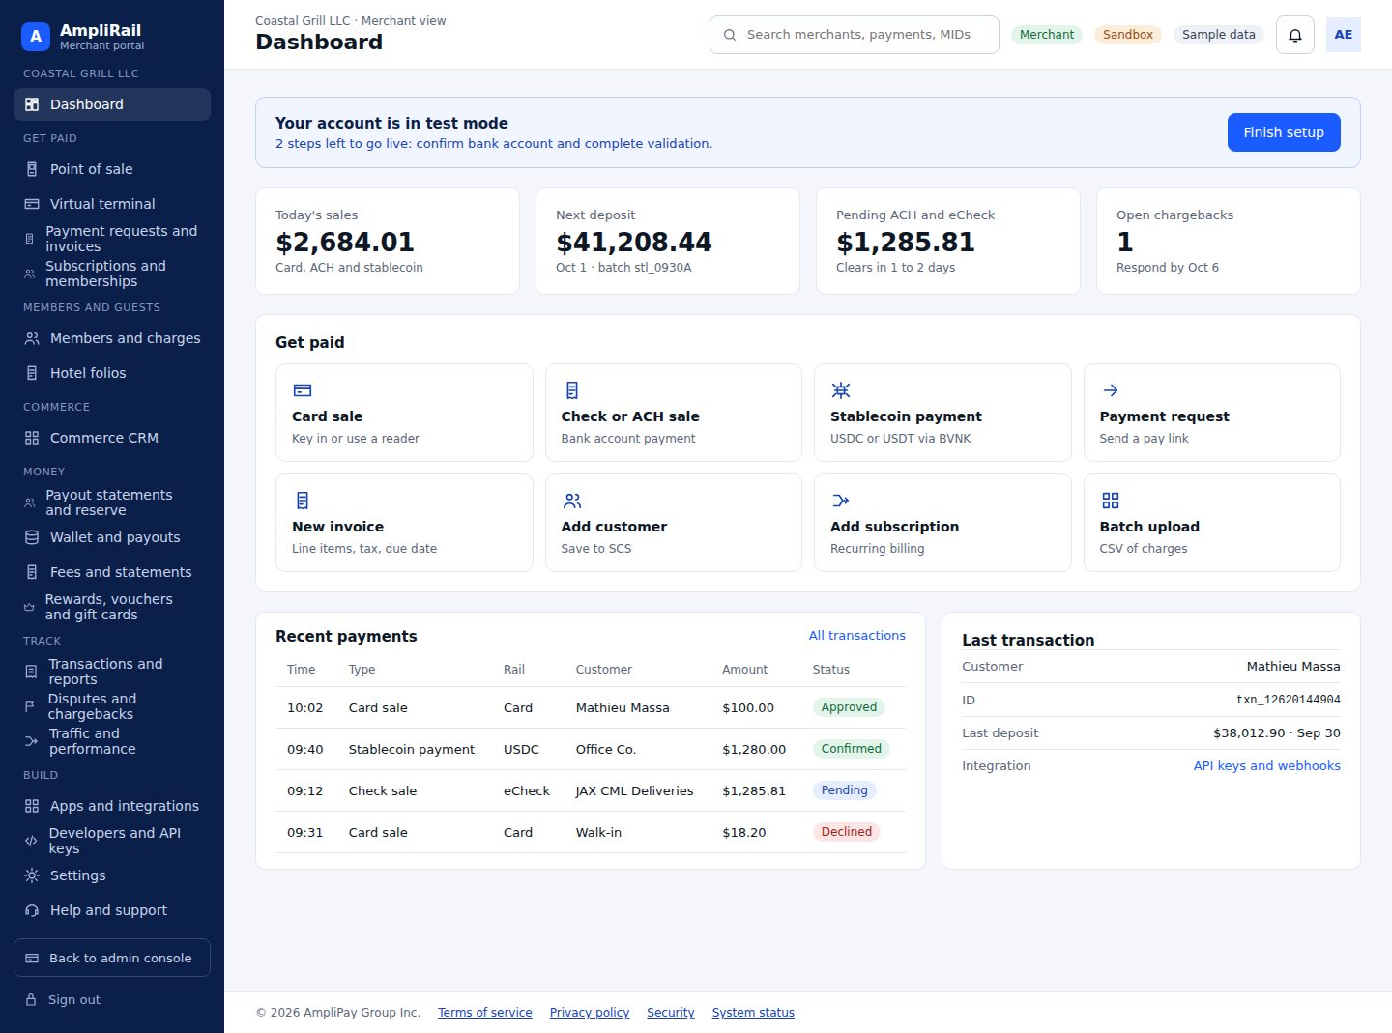

Screen 32. Merchant: point of sale · AR-126, AR-129, AR-134
Register with items and categories, tabs, tips, discounts, split checks, member charge, card reader status, offline queue; card-present via Section 7.8 options
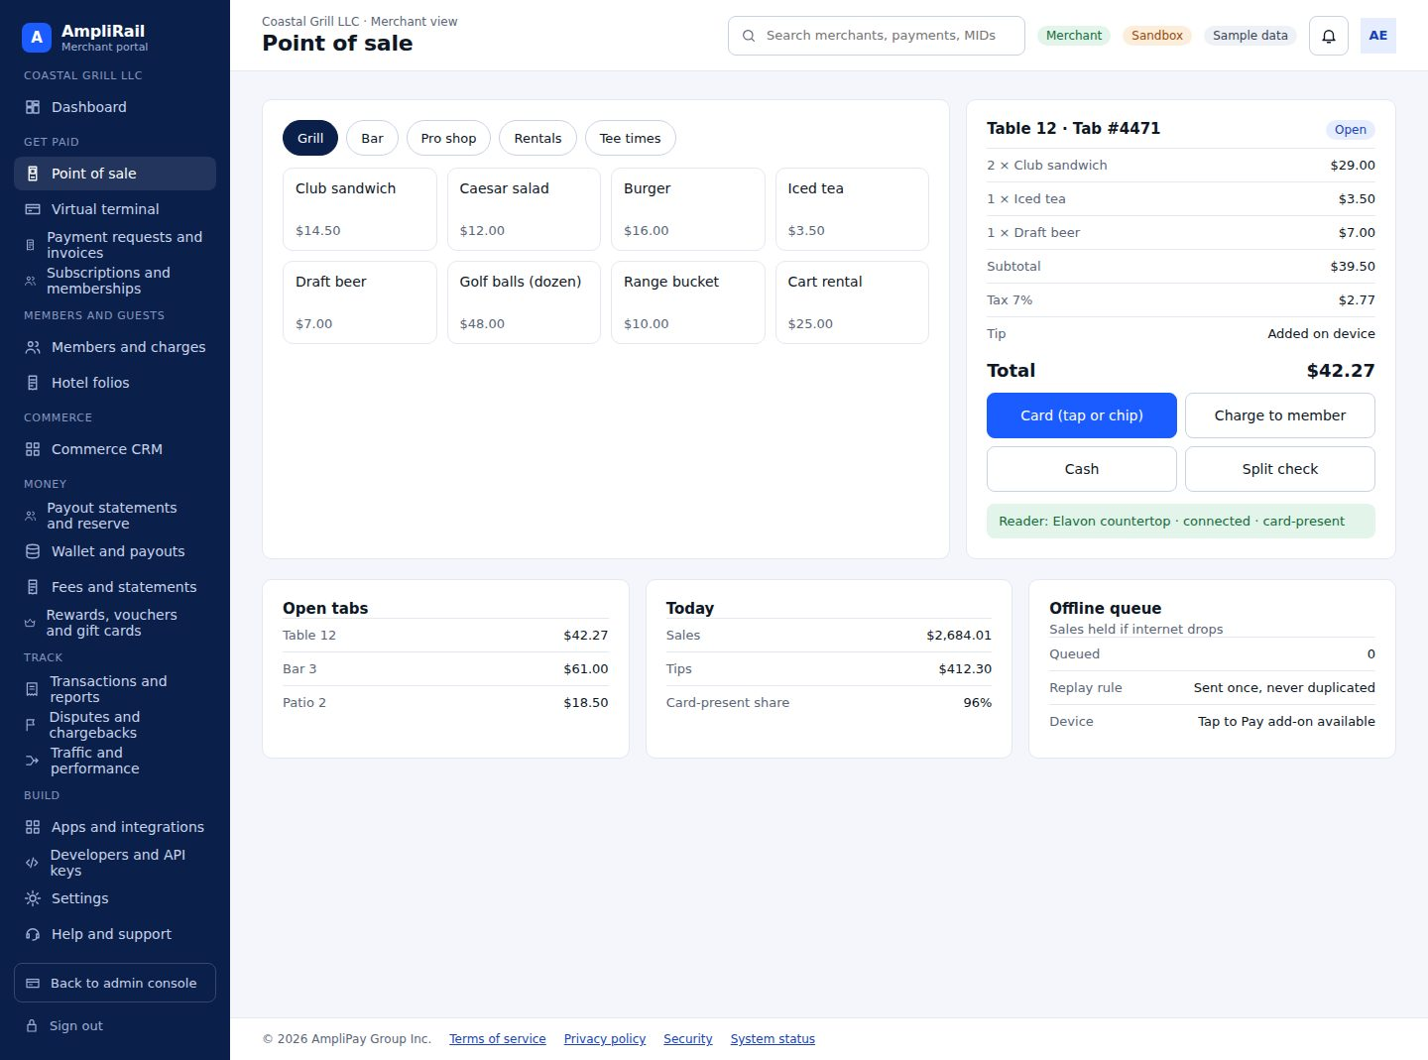

Screen 33. Merchant: virtual terminal · AR-027, AR-052, AR-064, AR-119, AR-131
Tabs for card (sale, authorize, capture, void, refund, credit), ACH and eCheck (SEC code, authorization), stablecoin (QR, rate lock); hosted card fields; text to pay, reader, batch upload
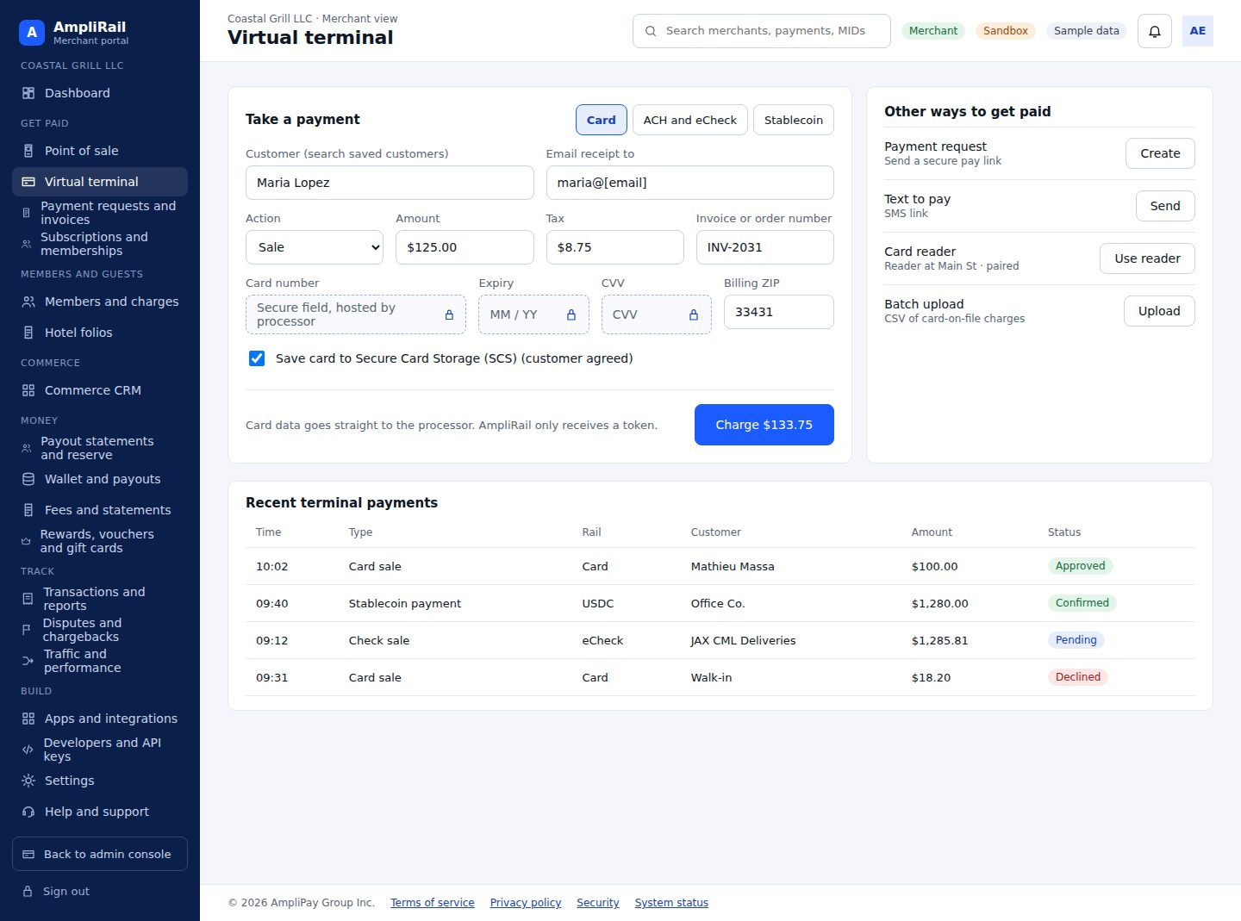

Screen 34. Merchant: payment requests and invoices · AR-053, AR-121
Pay link by email, SMS or copy with allowed methods and customer preview; manual invoice builder with line items and tax; list with status
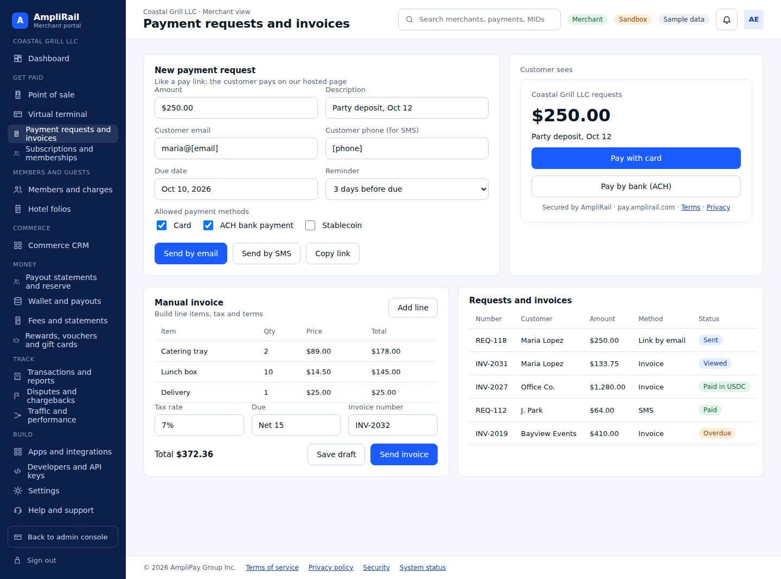

Screen 35. Merchant: subscriptions and memberships · AR-039, AR-054, AR-133
Plans, subscriptions with automatic retries, memberships (member number, tier, dues, house account, charge-to-account), Secure Card Storage (SCS)
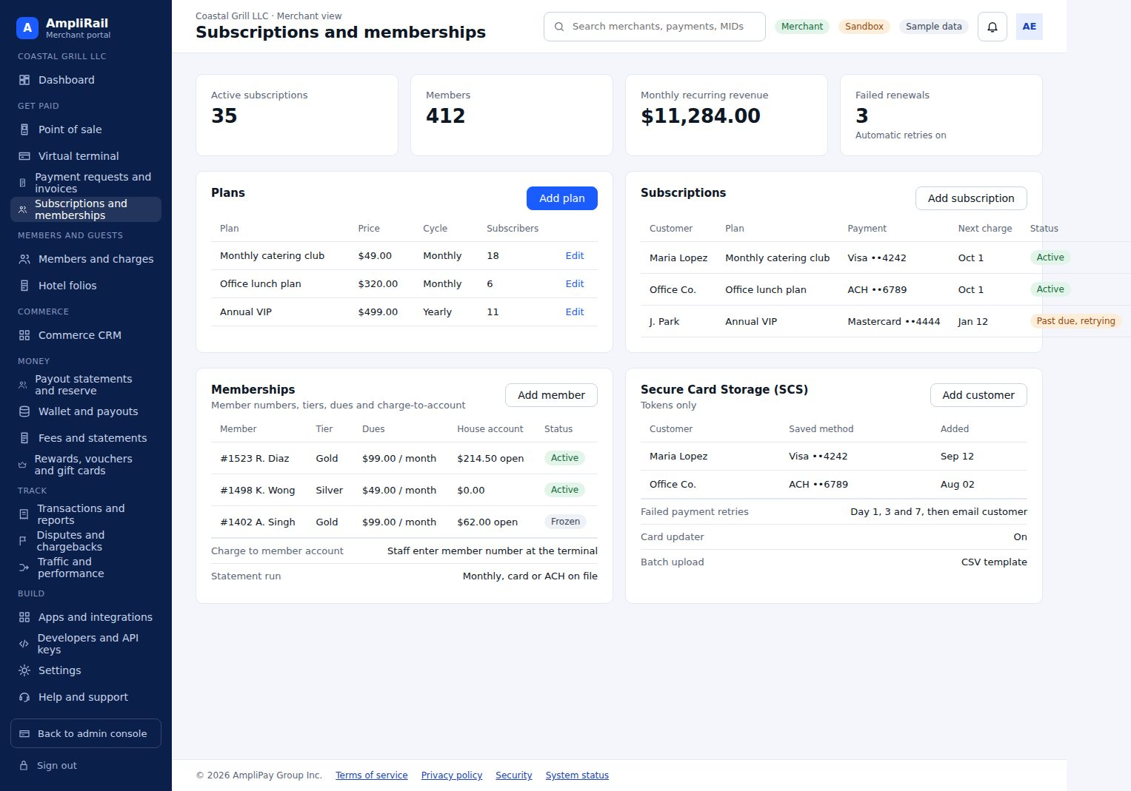

Screen 36. Merchant: members and charges · AR-135
Member accounts, house account balances, charge-to-member with signature, statements, dues and minimums
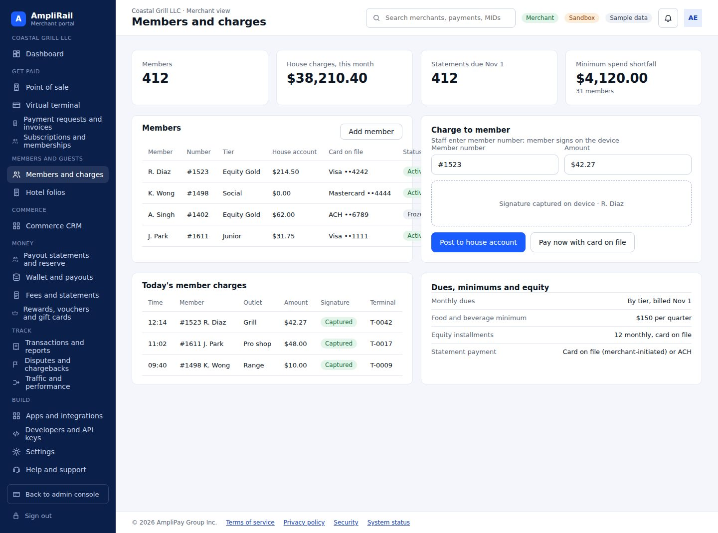

Screen 37. Merchant: hotel folios · AR-136
Open folios, estimated and incremental authorizations, outlet charges, checkout capture, delayed charges
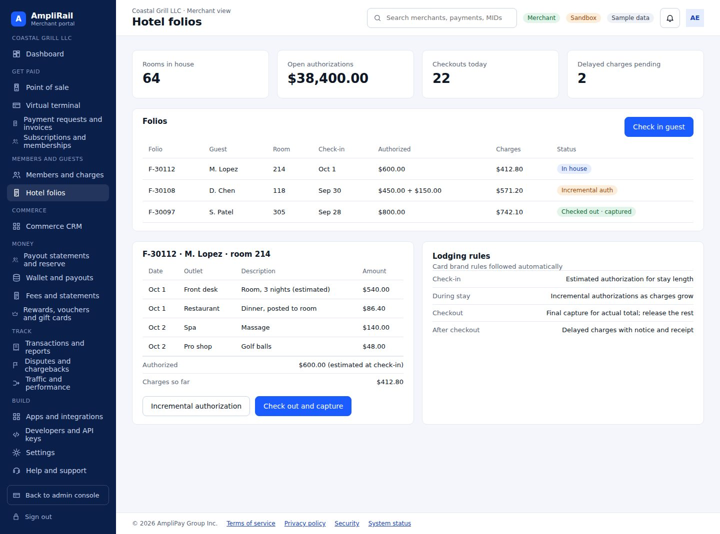

Screen 38. Merchant: commerce CRM · AR-138, AR-139
Orders, subscriptions and rebills, offers, campaigns, decline recovery, compliant MID routing
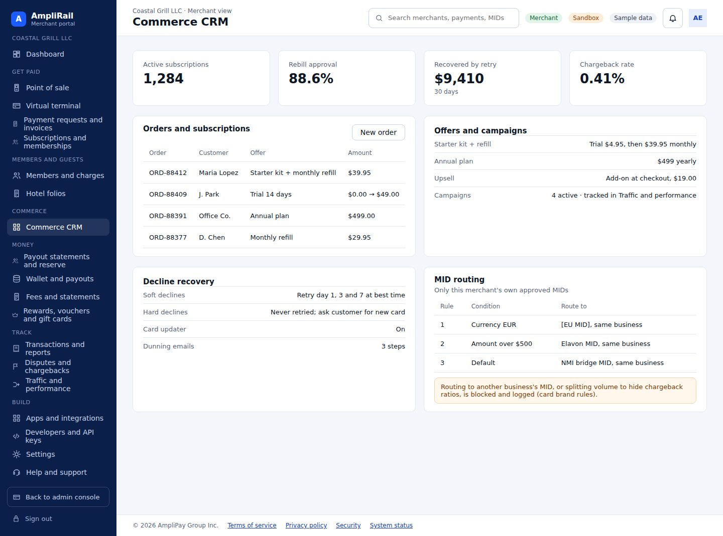

Screen 39. Merchant: payout statements and reserve · AR-146, AR-148, AR-149, AR-150
Statement detail with every fee line, net payout, PDF, CSV and Excel downloads, reserve ledger and release schedule, reconciliation of expected versus received deposits
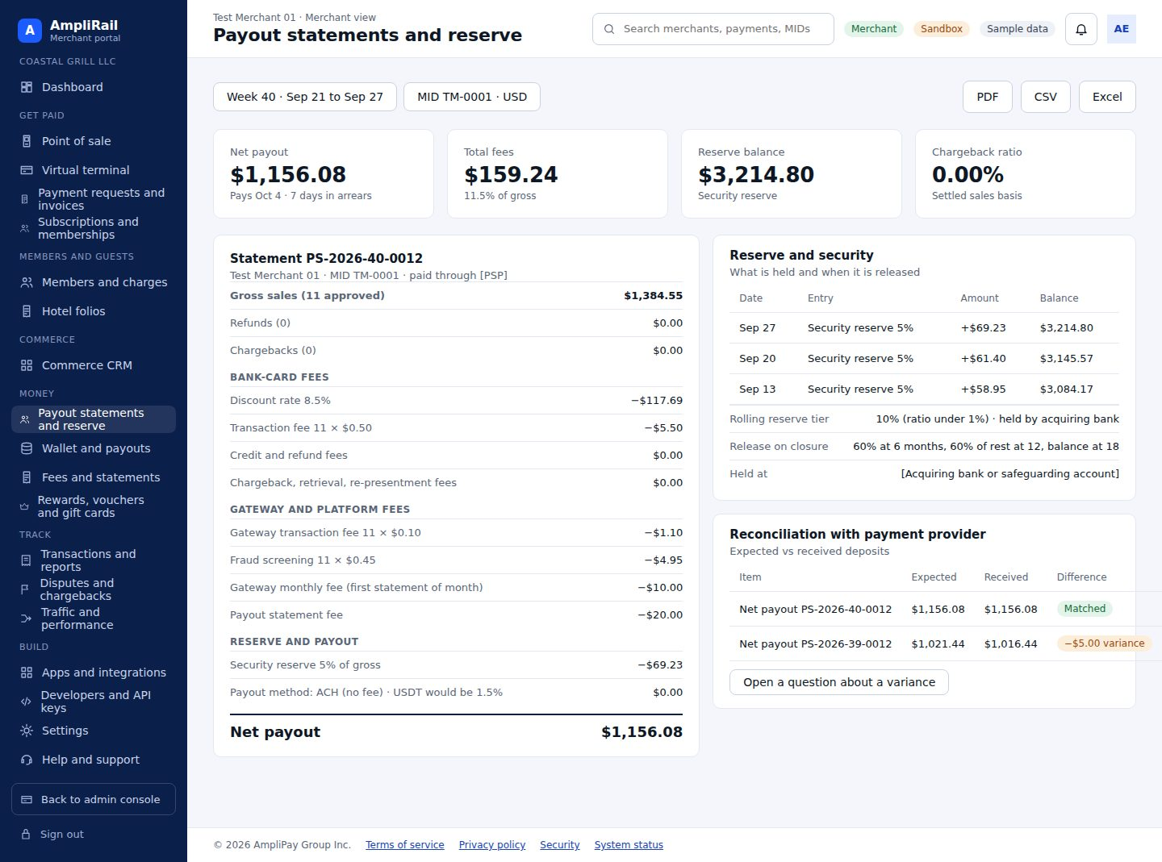

Screen 40. Merchant: wallet and payouts · AR-055, AR-056, AR-064, AR-100
Available, pending, reserve and stablecoin balances from the ledger; ACH and instant payouts; activity and statements. Merchant wallet only (D16)
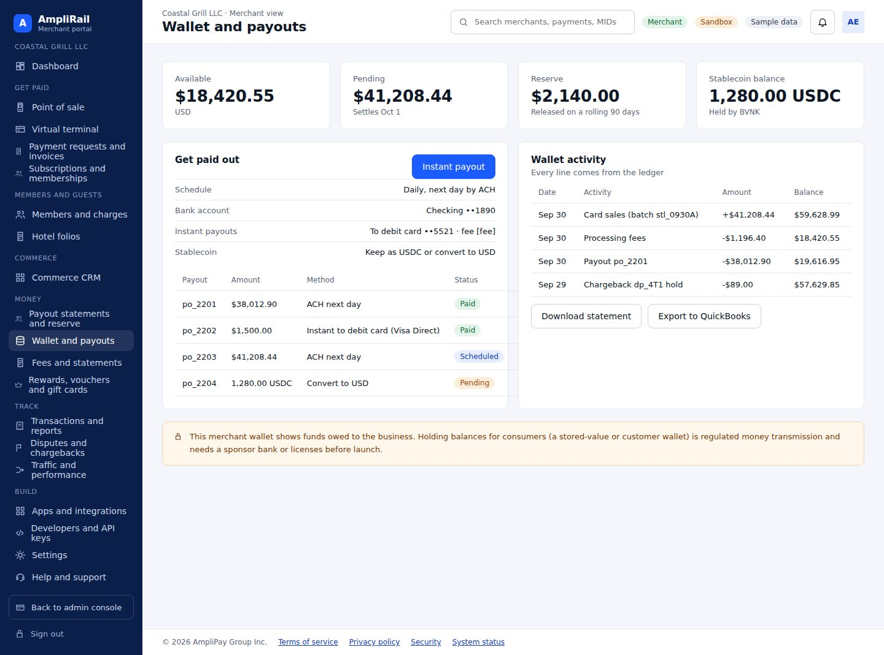

Screen 41. Merchant: fees and statements · AR-090, AR-091
Signed fee agreements, current fee schedule in plain language, monthly statements with every fee line, currency conversion and payout preferences
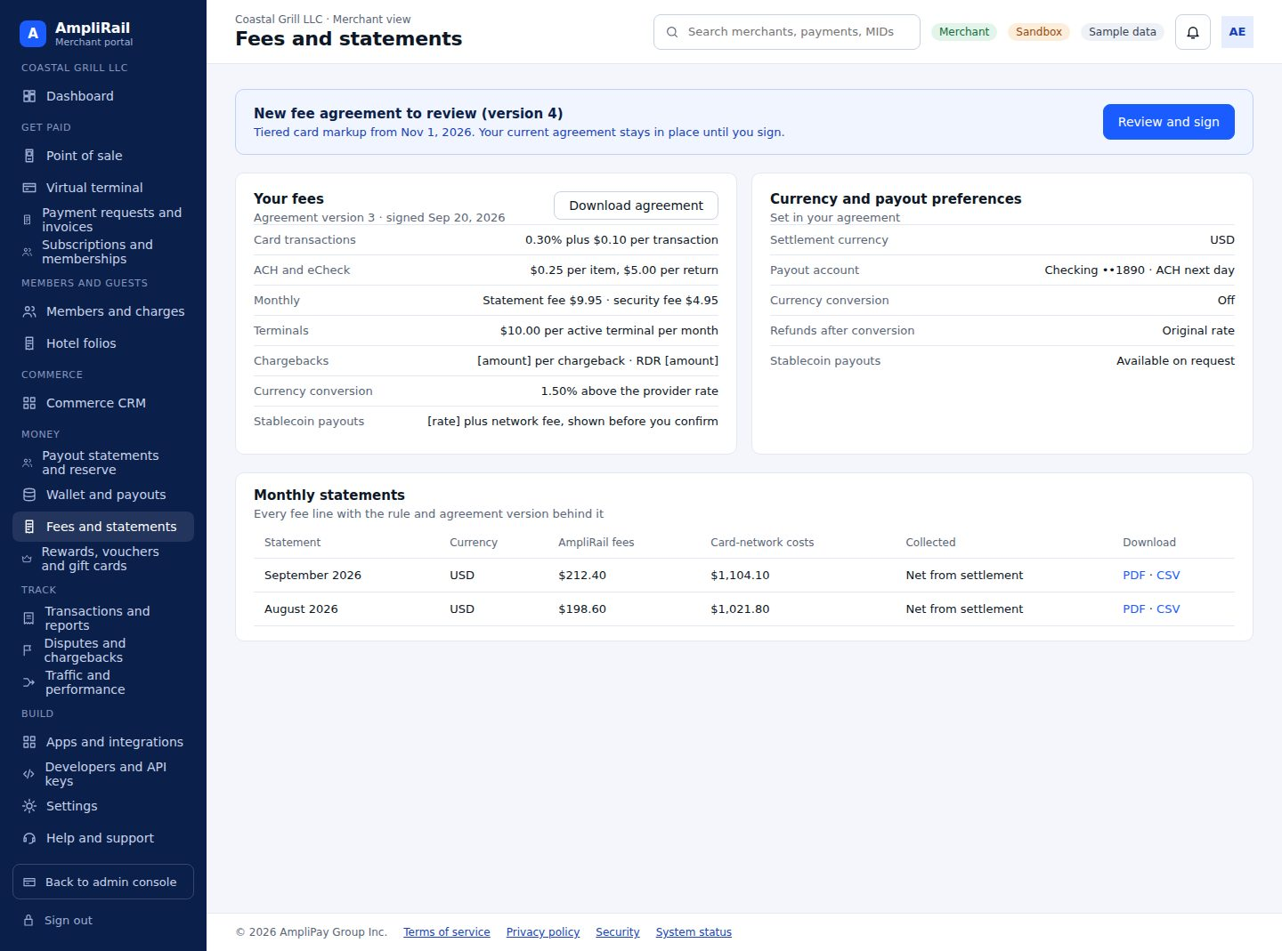

Screen 42. Merchant: rewards, vouchers and gift cards · AR-155, AR-157, AR-158
Loyalty points and tiers; gift card sell, reload, redeem; business and staff debit cards behind D16
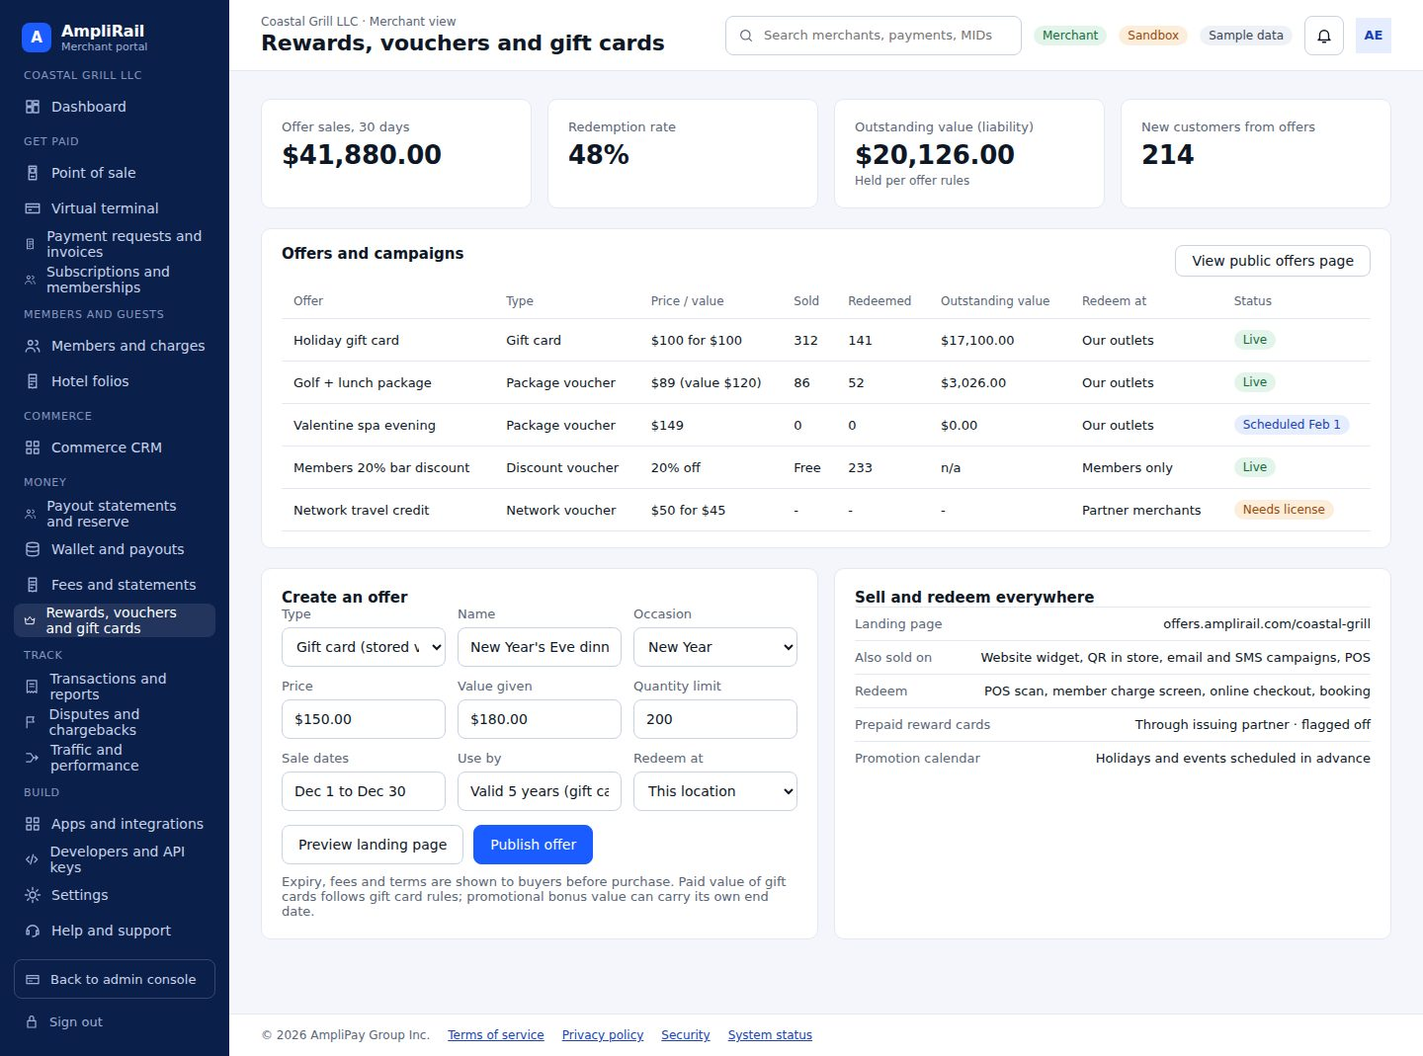

Screen 43. Customer view: public offers page · AR-156
Merchant-branded landing page selling gift cards and vouchers with instant delivery, wallet passes, clear terms and balance check
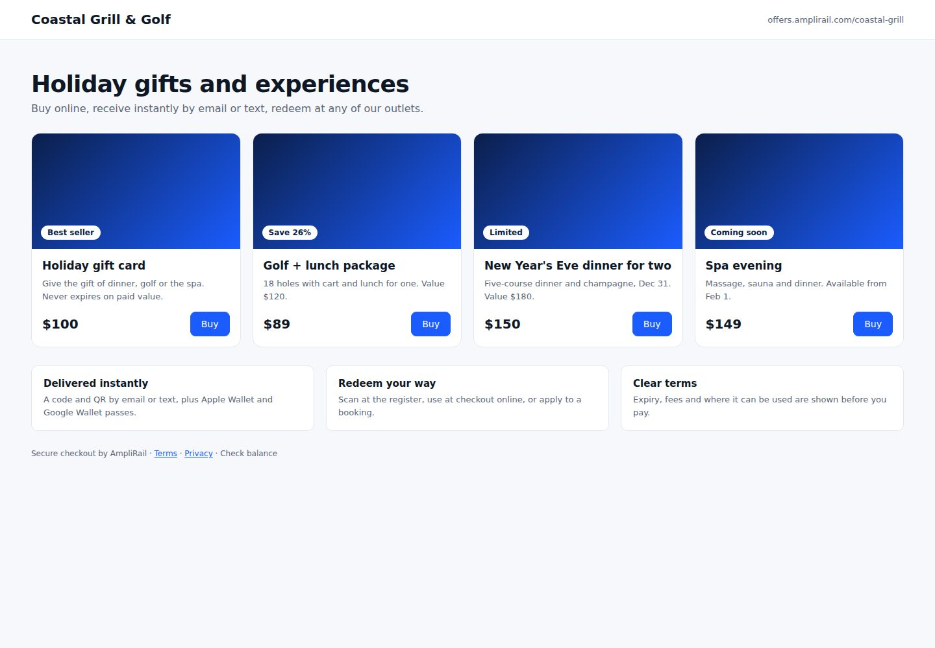

Screen 44. Merchant: transactions and reports · AR-043, AR-106
Section 9.1, merchant scope
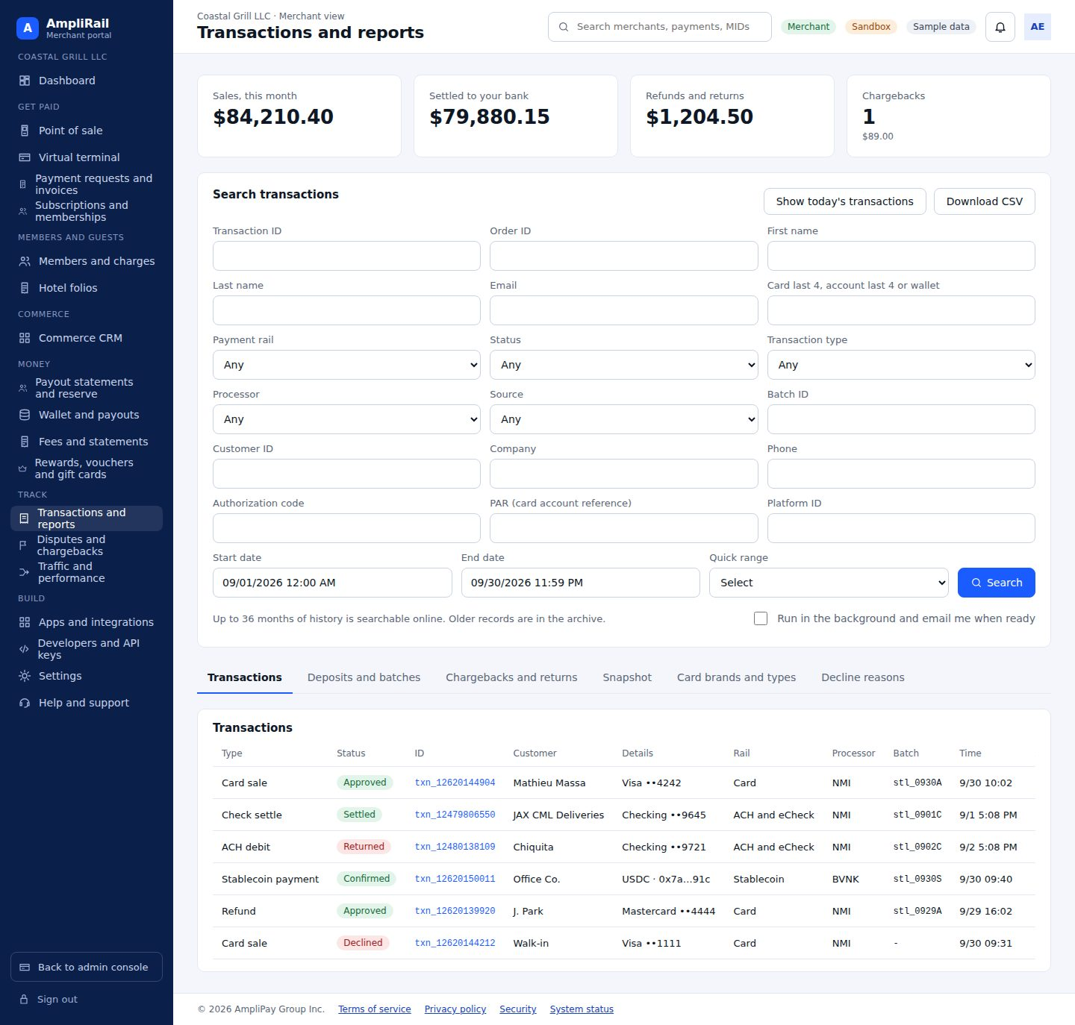

Screen 45. Merchant: transaction detail · AR-043
Information, account (masked), billing, shipping, merchant-defined fields, action history, receipt, subscription, SCS, refund
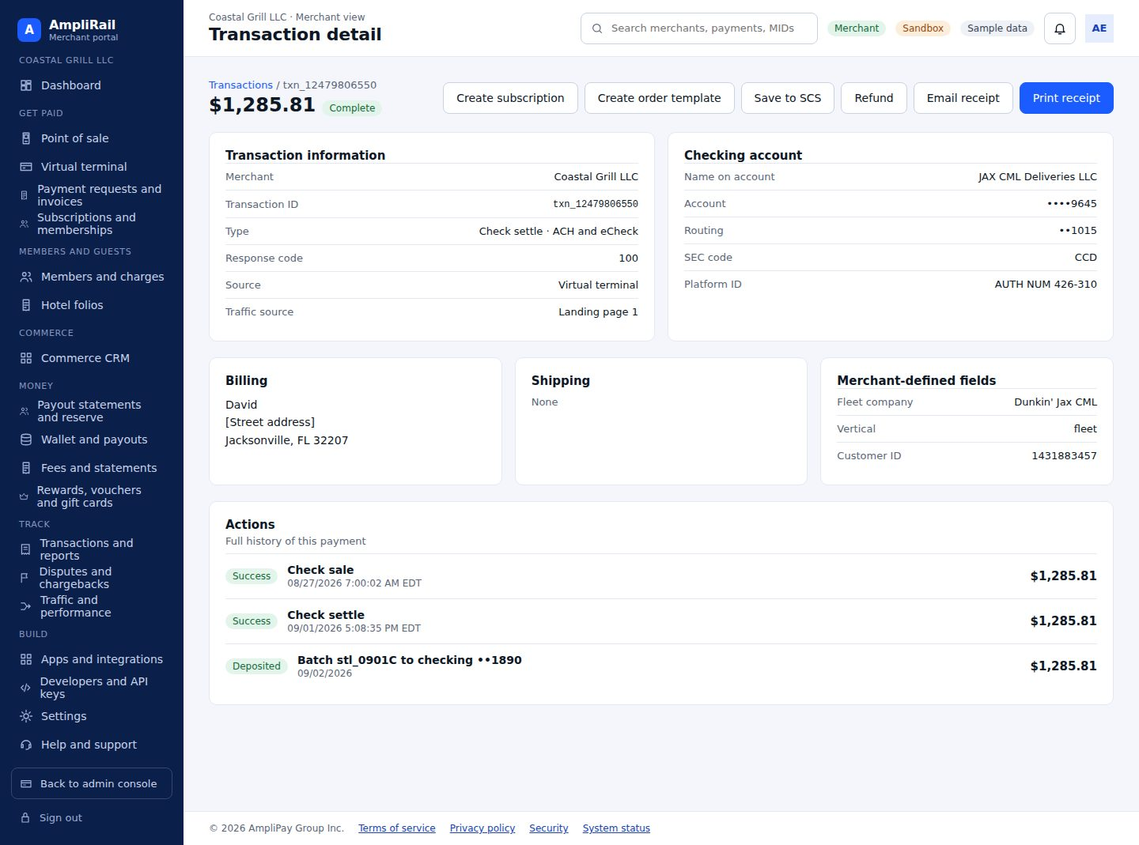

Screen 46. Merchant: disputes and chargebacks · AR-107, AR-108, AR-109
Merchant's alerts and disputes, document upload, explanation, submit to processor or refund instead, alert settings
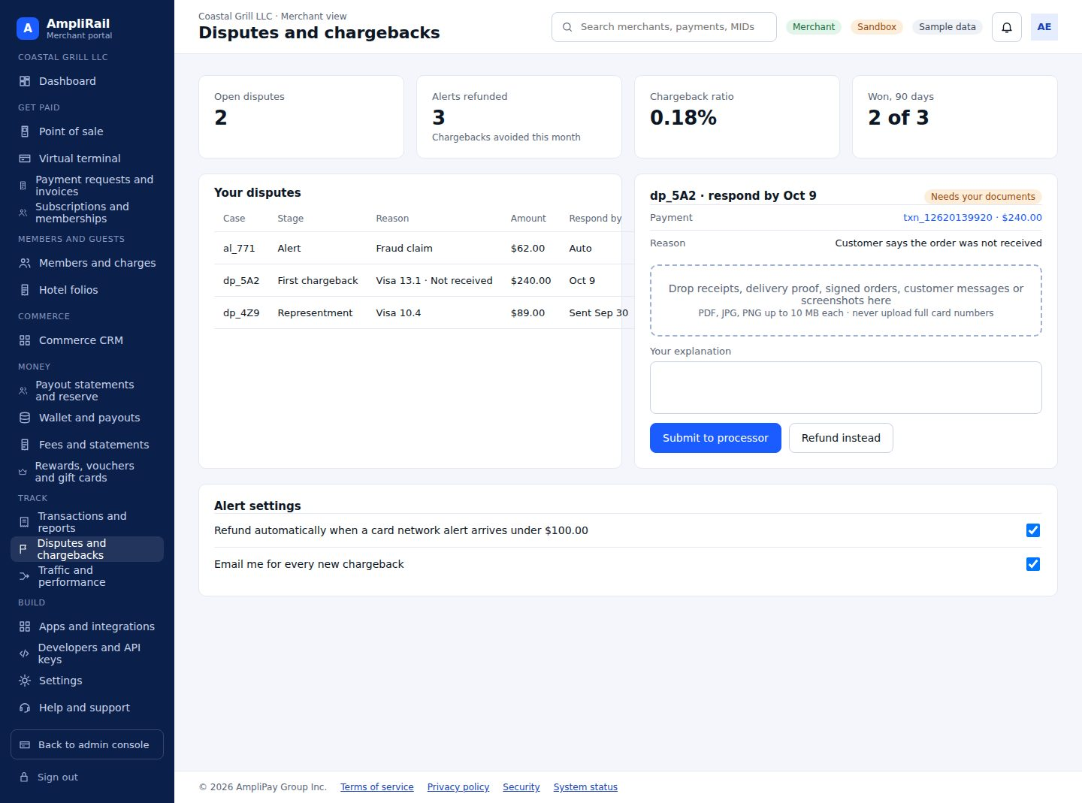

Screen 47. Merchant: traffic and performance · AR-057
Section 12.4
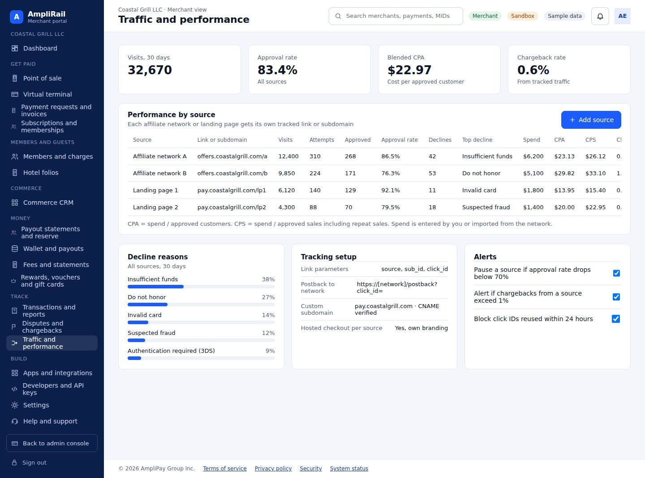

Screen 48. Merchant: apps and integrations · AR-058, AR-127
Gateway capabilities list and marketplace (plugins, QuickBooks, 3DS, fraud, card updater, text to pay, stablecoins, webhooks)
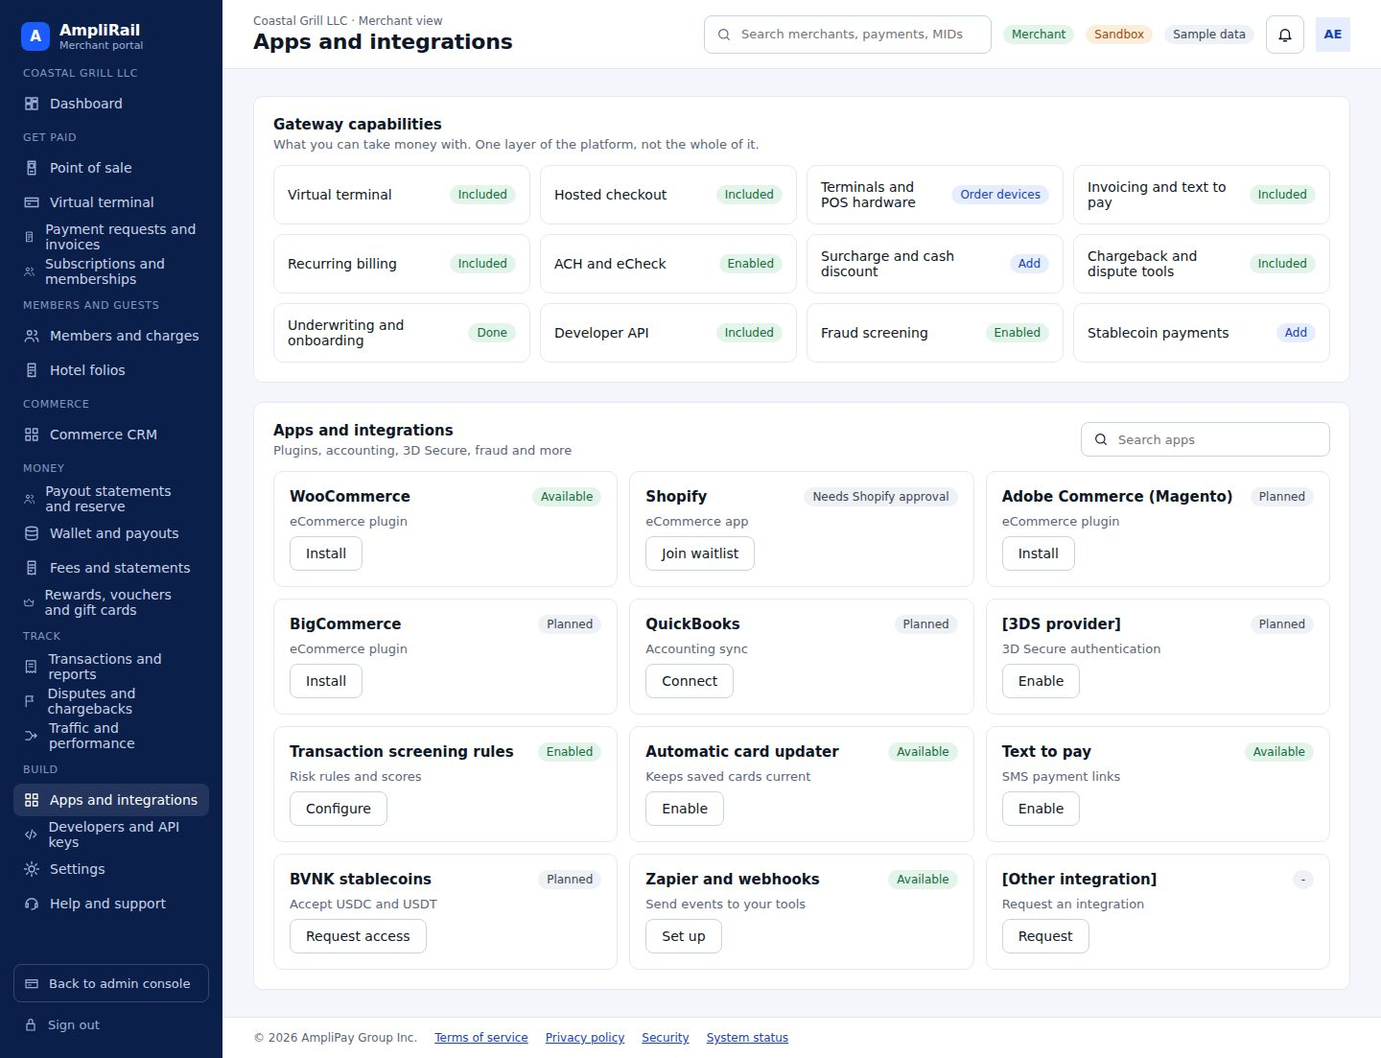

Screen 49. Merchant: developers and API keys · AR-031
Scoped keys (publishable, secret, restricted), IP allowlist, integration methods, sandbox sample, webhooks, request logs without card data
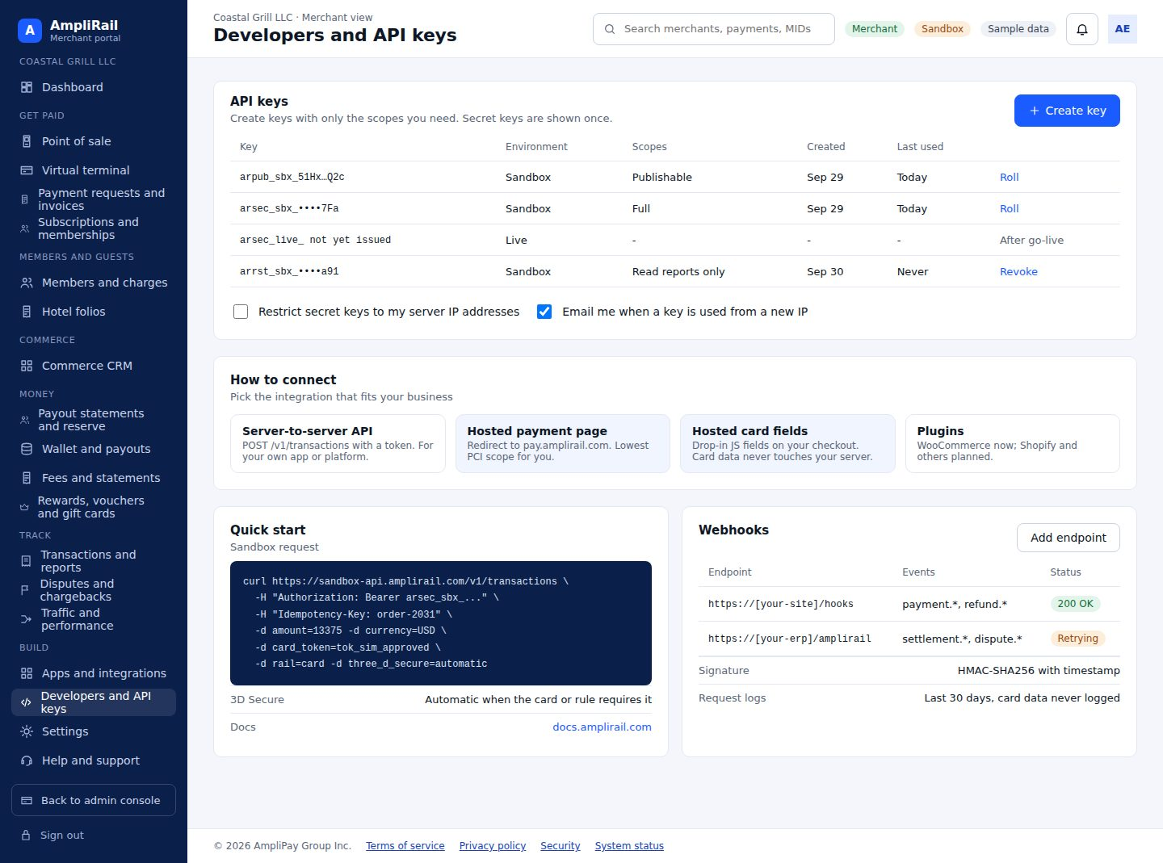

Screen 50. Merchant: settings · AR-059
General, transactions, security and fraud options (Section 12.5)
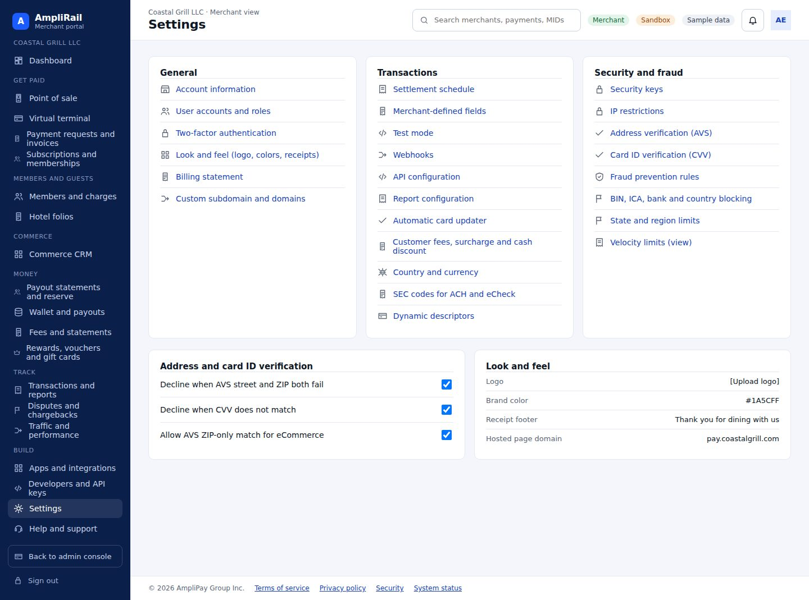

Screen 51. Merchant: help and support · AR-048
Ticket form linked to a payment, my tickets, articles, contact, account security
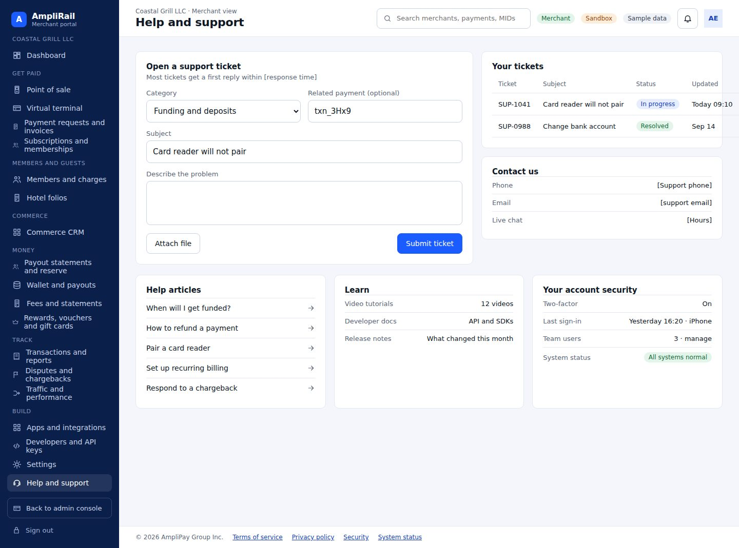

Sign in and super admin

Screen 52. Sign in with Terms and Privacy · AR-022, AR-081
Portal selection, email, password, SSO, forgot password, Terms of service and Privacy policy links. Admins use an authenticator app or security key; merchants get an emailed code.
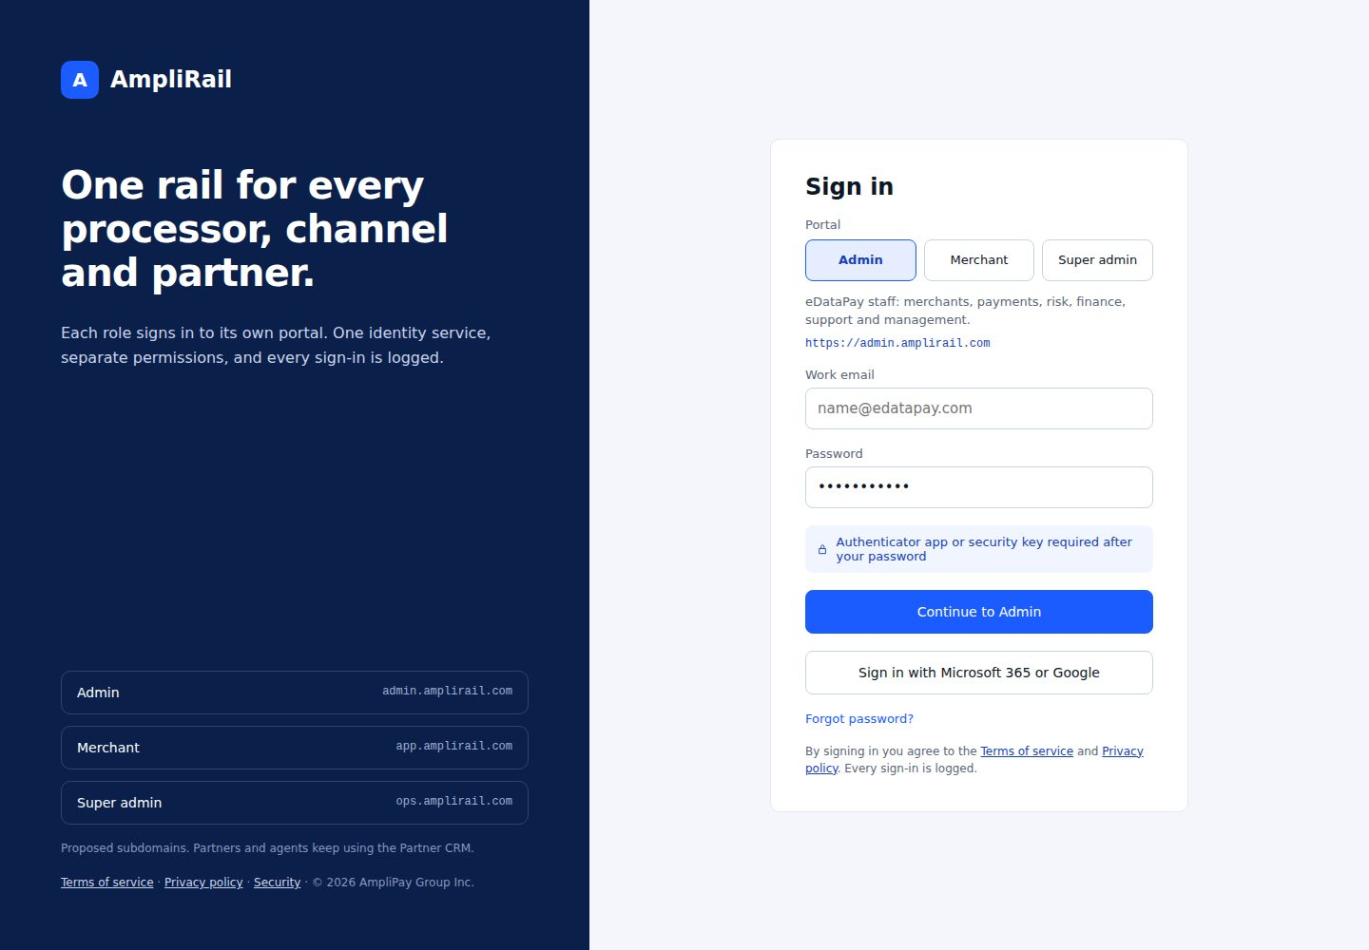

Screen 53. Emailed code verification · AR-022, AR-081
Emailed 8-digit one-time code for merchants, resend, lockout after 5 attempts, new-device alert; authenticator or security key option.
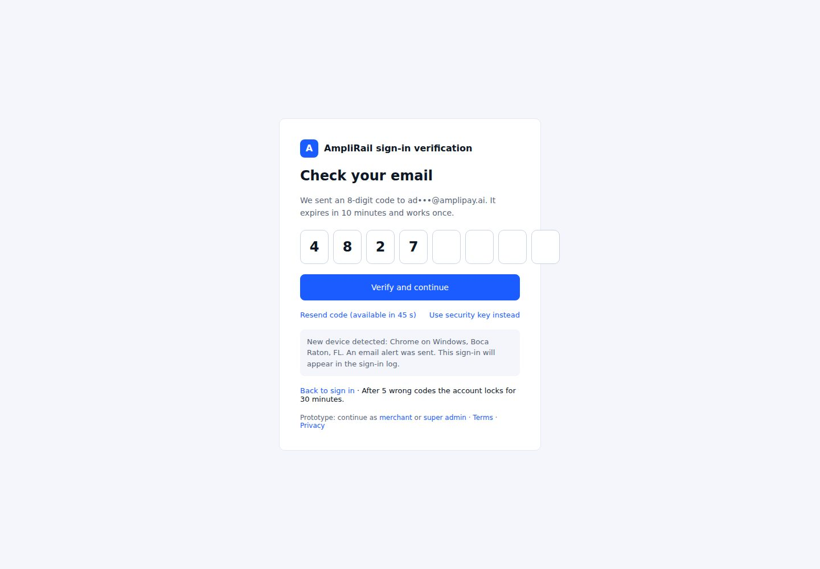

Screen 54. Super admin (phase 2) · Phase 2
Phase 2. Admin organizations, feature flags per organization, global connector credentials, platform billing.
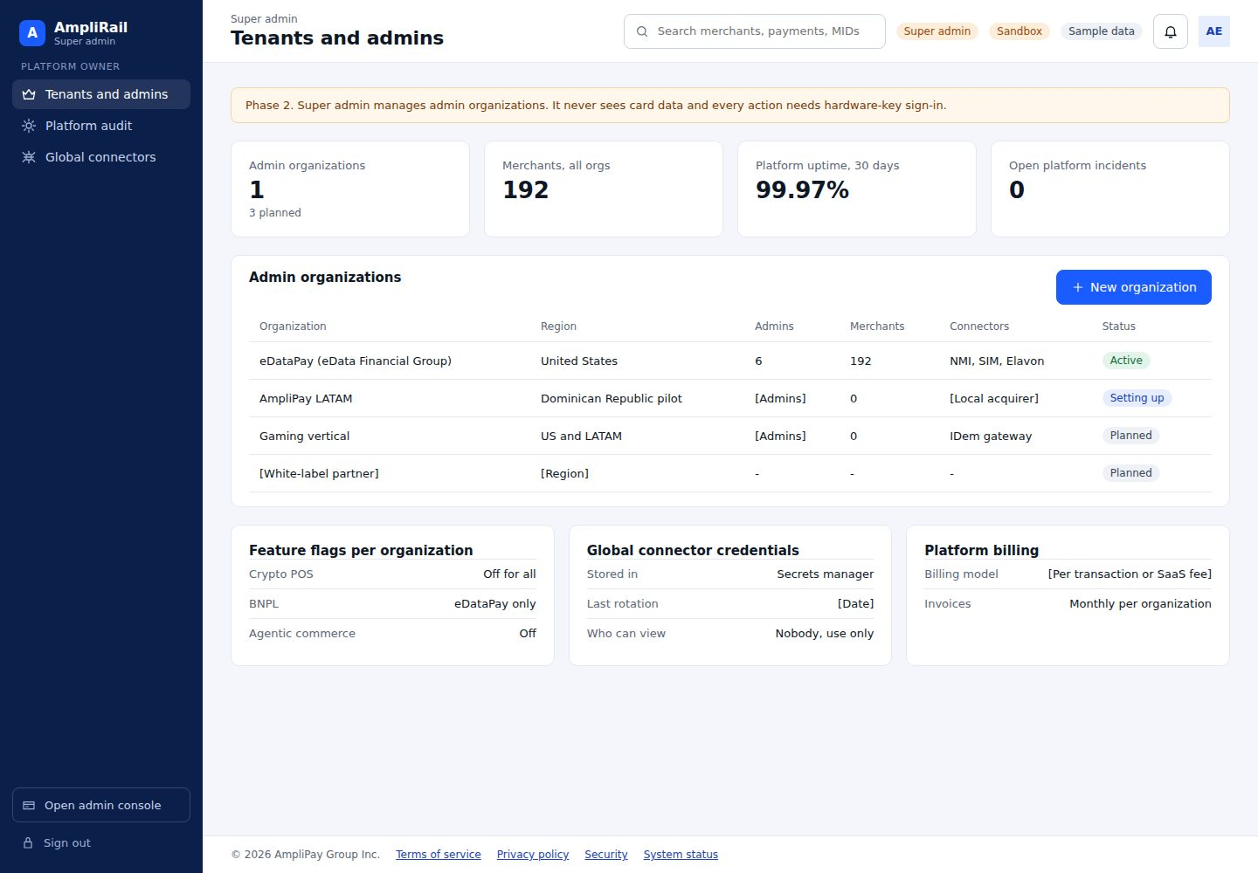

V3.7.1 Controlling Addendum - 4-Day Activation Engine
This addendum resolves the activation-specific V3.7 conflicts and adds Sprint 0.5. Where this addendum conflicts with earlier V3.7 wording on the items below, this addendum controls.
• RoboRiskAnalysis: separate PHP/Laravel product, separate repository/database/deployment boundary; AmpliRail integrates through RiskDecision only.
• Sandbox provisioning: occurs at merchant submitted state so technical integration can proceed in parallel with underwriting.
• CRM machine authentication: approved AmpliRail machine-auth mechanism; OAuth2 client credentials where supported by Identity.
• Go-live safety: fail-closed. Gate disabled/unavailable means no transition to active; emergency override requires Platform Owner + second authorized human + step-up + reason + immutable audit.
• Sprint 0.5 tickets: AR-168 through AR-174 are part of the controlling backlog. AR-174 runs first. Sprint 0 and Sprint 0.5 run in parallel.
Approval required: Lead eDataPay PHP Developer and Adam Elisha - Systems Administrator / Platform Owner.

