eDataPay / AmpliRail 2.0
V3.7.1 DEVELOPMENT PACKAGE
Sprint 0 + Sprint 0.5 • 4-Day Merchant Activation Engine
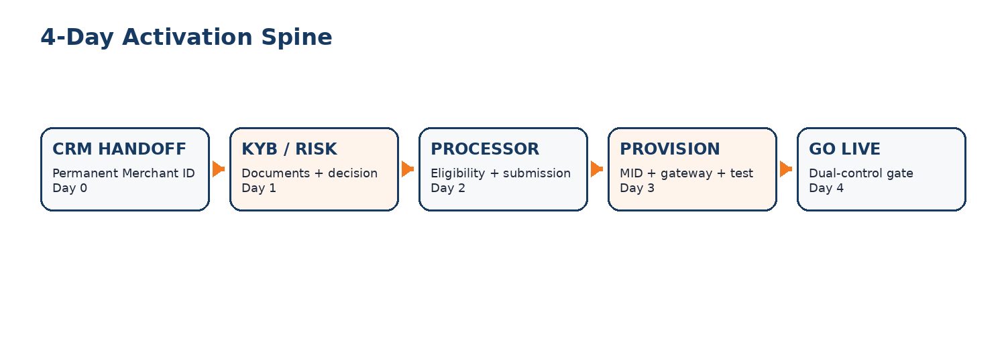
PURPOSE This is the developer handoff package. It turns the V3.7 architecture and the 4-Day Activation blueprint into executable PHP/Laravel work, with security gates, dependencies, tests, ownership and a controlled path to the first pilot merchant.

Role | V3.7.1 responsibility
Adam Elisha - Systems Administrator / Platform Owner | AWS/server infrastructure, production access, secrets/platform controls, monitoring/backups, production deployment authorization and architecture/governance approval.
Lead eDataPay PHP Developer | Technical owner for Laravel architecture, code quality, connector contracts, review, staging readiness and ADR technical approval.
eDataPay PHP Developer(s) | Implement assigned tickets, automated tests and documentation through branches and pull requests. No direct production changes.
AI coding agents | Assist inside bounded tickets. No production activation, secret handling or independent merge authority.

1. Executive Direction
V3.7.1 does not redesign AmpliRail. It aligns the activation workflow with the existing rail architecture and makes the work executable. PHP/Laravel remains the development standard for AmpliRail and RoboRiskAnalysis. Python/FastAPI is not a Phase 1 dependency.
- AmpliRail remains the payment orchestration and operational control plane.
- RoboRiskAnalysis remains a separate Laravel/PHP product, not a domain module inside AmpliRail.
- The eDataPay CRM is the application origin and hands a canonical merchant package to AmpliRail.
- Sandbox provisioning begins at submitted so integration can run in parallel with underwriting.
- Production activation is always controlled, dual-approved and fail-closed.
- Sprint 0 and Sprint 0.5 run in parallel to shorten the path to Milestone #1.
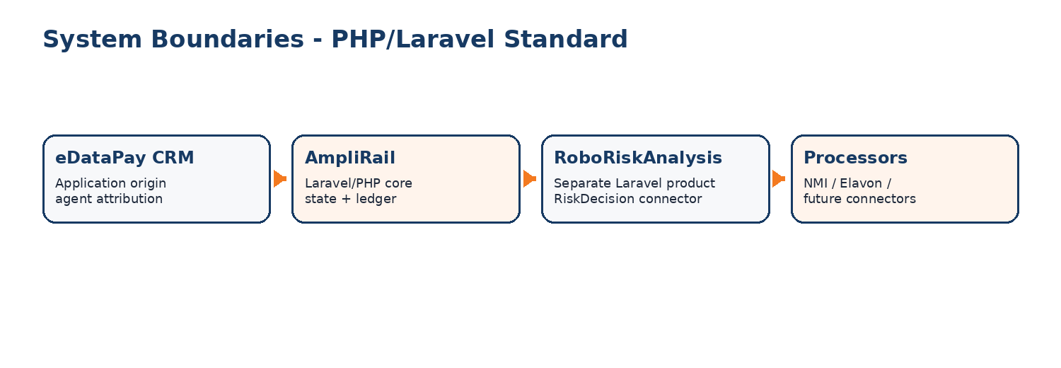

2. What Changed from V3.7
Area | V3.7.1 decision
RoboRisk | Separate Laravel/PHP product; own repo/database/deployment; AmpliRail integrates through RiskDecision only.
Sandbox timing | Provision sandbox MerchantAccount, test MID, API keys and webhook secret at submitted.
CRM machine authentication | Use approved AmpliRail machine-auth. OAuth2 client credentials only where Identity already supports it.
Go-live rollback | Fail closed. Disabling/unavailability of go-live gate does not expose a manual bypass.
Backlog | AR-168 through AR-174 added as Sprint 0.5.
Governance | Lead eDataPay PHP Developer + Platform Owner approve ADR-0004 before code tickets depend on it.

3. Build Order and Parallel Work
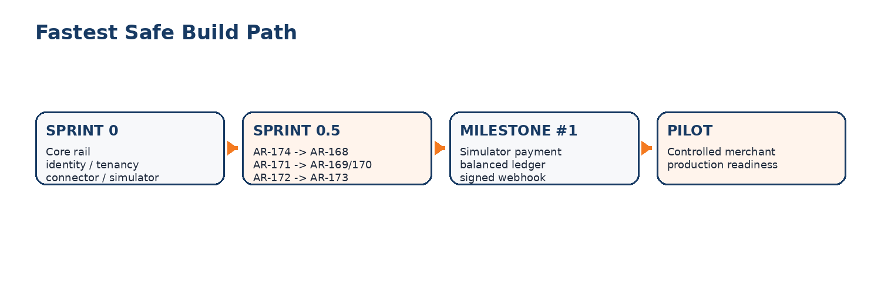
RUN ORDER AR-174 first -> AR-168 -> AR-171 -> AR-169 and AR-170 in parallel -> AR-172 -> AR-173. Sprint 0 core-rail work continues in parallel. Do not wait for all Sprint 0.5 work to finish before progressing the simulator/core rail.

4. Four-Day Operational Target
Day | System objective | Human control
Day 0 | CRM handoff; canonical merchant; sandbox/test credentials; document/risk cases opened. | Resolve incomplete application data.
Day 1 | KYB/KYC, document checklist, risk decision and processor eligibility. | Risk/Operations decides exceptions.
Day 2 | Build/submit processor package; status synchronization; more-info loop. | Operations handles processor exceptions.
Day 3 | MID/gateway/service provisioning and integration validation. | Technical review for non-standard integrations.
Day 4 | Test payment/refund/webhook/settlement checks; dual-control activation. | Second authorized approver activates production.

5. Ticket Series AR-168 to AR-174

AR-174 - ADR - RoboRisk boundary and sandbox state
Field | Developer instruction
Purpose | Architectural prerequisite
Goal | Resolve the two V3.7 conflicts before code.
Acceptance focus | Accepted ADR; RoboRisk separate Laravel product; sandbox at submitted.

AR-168 - CRM handoff API + Day 0 auto-provisioning
Field | Developer instruction
Purpose | Onboarding spine
Goal | One idempotent CRM call creates the canonical merchant and sandbox resources.
Acceptance focus | No duplicates by Idempotency-Key or crm_deal_id; tenant-safe; no raw bank/PAN data.

- Endpoint: POST /v1/merchants/handoff.
- Preserve immutable crm_deal_id and agent attribution.
- Provision sandbox MerchantAccount, test MID, arpub_sbx_/arsec_sbx_ keys and arwhk_sbx_ webhook secret at submitted.
- Authenticate through approved machine-auth; do not create a new OAuth subsystem solely for this ticket.
- No PAN/CVV/raw bank account numbers in payload; bank information is a token reference.

AR-171 - Onboarding event catalog wiring
Field | Developer instruction
Purpose | Audit/state spine
Goal | Wire lifecycle events to one strict state machine and transactional outbox.
Acceptance focus | Illegal jumps blocked; events immutable and idempotent.

- application.created
- merchant.sandbox_provisioned
- documents.complete
- kyb.passed
- risk.approved
- processor.submitted
- processor.more_info_required
- processor.approved
- mid.created
- credentials.created
- test.completed
- merchant.live

AR-169 - Document checklist engine
Field | Developer instruction
Purpose | Evidence workflow
Goal | Data-driven document requirements by merchant/processor profile.
Acceptance focus | Encrypted private storage; completeness/reopen events; audited access.

- Store documents encrypted in private object storage; metadata in PostgreSQL.
- Short-lived signed download URLs only.
- Every view/download is permission checked and audited.
- Processor more-info requests dynamically reopen the checklist.

AR-170 - Processor eligibility engine
Field | Developer instruction
Purpose | Routing pre-filter
Goal | Rank explainable eligible routes before submission work begins.
Acceptance focus | Versioned/effective-dated rules; specific failing rules returned.

- Rules cover geography, MCC/restricted category, channel, recurring, volume, ticket size, chargeback profile, currency, reserve and document requirements.
- Return ordered eligible routes and specific failed rules.
- Rules are versioned and effective-dated; publishing uses Approvals.

AR-172 - Go-live gate with dual control
Field | Developer instruction
Purpose | Production safety gate
Goal | No test_mode -> active transition until live checks and second-human approval pass.
Acceptance focus | Fail-closed; no manual bypass when gate disabled/unavailable.

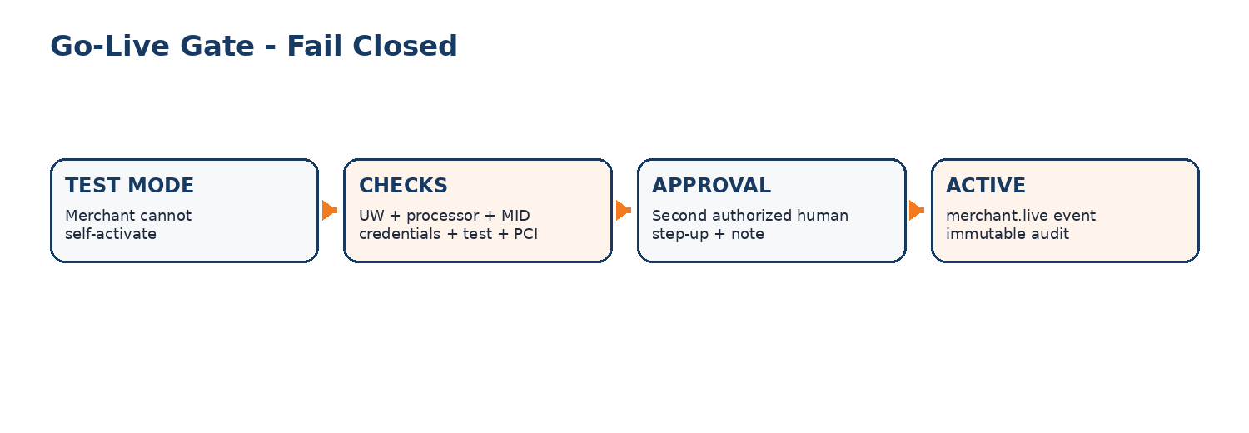
- Requester and approver must be different authorized humans.
- Approver requires merchants.go_live.approve, step-up authentication and a note.
- If any check cannot be evaluated, activation fails.
- If feature flag/gate is unavailable, merchant remains in test_mode.
- Emergency override requires Platform Owner + second authorized human + mandatory reason + immutable audit event.

AR-173 - Activation SLA command center
Field | Developer instruction
Purpose | Operations control
Goal | Show blocker, owner, next action, deadline, time-in-state and health.
Acceptance focus | Read-only dashboard; permission checked; figures match source data.

- Pipeline counts: New, KYB/KYC, Risk, Processor, Test, Live.
- Per merchant: state, days in state, blocker, owner, next action, deadline.
- Median/average time per state and total time-to-live for trailing 90 days.
- Connector and webhook health visible; screen remains read-only.

6. CRM Handoff Contract - Developer View
The handoff endpoint is a service-to-service contract between the Fintech CRM and AmpliRail. The CRM remains a separate system; AmpliRail owns the canonical merchant and activation state after handoff.
Payload area | Required behavior
Business | Legal name, DBA, EIN/entity reference, address and contacts.
Ownership | Owners/UBOs and required identity references; sensitive values encrypted.
Banking | Settlement bank token/reference only; never raw account/routing values in this handoff.
Commerce | Website, products/services, requested MCC, channels, volume and ticket estimates.
Evidence | Document references and checklist metadata.
Attribution | crm_deal_id and agent attribution preserved immutably.
Safety | Idempotency-Key required; tenant context required; validation is all-or-nothing.

7. State Machine and Event Rules
There must be one authoritative onboarding state machine. UI code, jobs and connectors may request transitions but may not bypass it. Every accepted transition writes its lifecycle event to the transactional outbox in the same database transaction.
NON-NEGOTIABLE A retry must never create a second merchant, MID, API key, event occurrence or processor submission. Idempotency is a business invariant, not just an HTTP convenience.

8. RoboRiskAnalysis Boundary
RoboRiskAnalysis is still part of the eDataPay platform family, but V3.7.1 keeps its risk-domain implementation separate from AmpliRail. Both may use Laravel/PHP; separation is about product/security boundaries, not programming language.
AmpliRail may contain | AmpliRail must not contain
RiskDecision connector interface/adapter | RoboRisk scoring domain logic
Risk DTOs and contract tests | RoboRisk private database tables
risk.* event consumers | RoboRisk secrets/vendor credentials
Health/retry/reconciliation logic | Card data passed to RoboRisk

9. Go-Live Gate - Production Rule
Required check | Gate behavior
Underwriting | Authorized decision recorded.
Processor | Approval and production MID/TID recorded.
Credentials | Stored through approved secrets process.
Payments | Test sale plus required refund/void validation passed.
Webhooks | Delivery validated.
Settlement | Funding/settlement configuration verified.
Risk/PCI | Limits, reserve, descriptor and PCI status recorded.
Approval | Second authorized human; requester cannot self-approve.

10. Roles, Access and Deployment
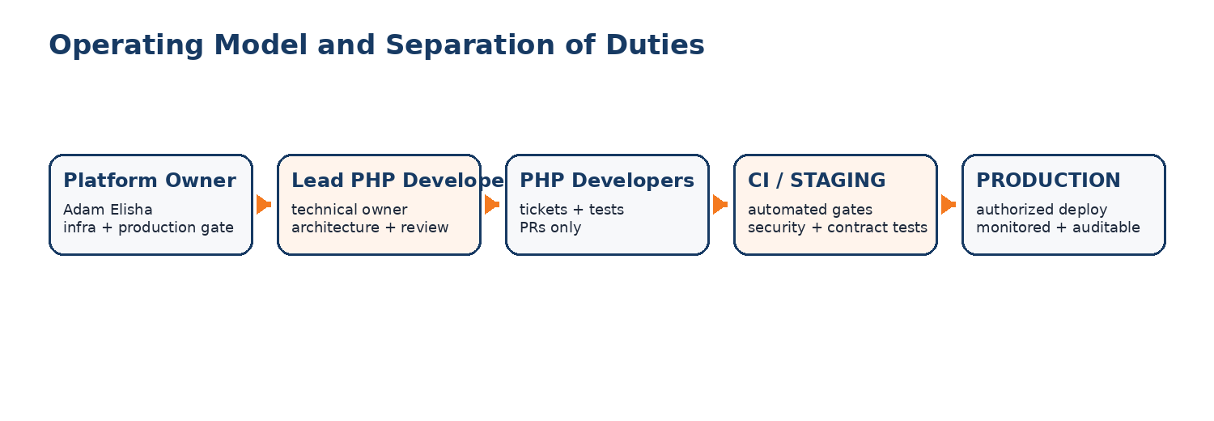
- Developers work through branches, pull requests and CI.
- No developer needs unrestricted standing production server access for ordinary development.
- Production secrets stay in approved secrets management and never in code, tickets, chat or logs.
- Adam, as Systems Administrator / Platform Owner, owns production infrastructure controls and deployment authorization.
- Lead PHP Developer owns technical readiness and code review; this is distinct from production authorization.

11. Definition of Done for Every Sprint 0.5 Ticket
- Acceptance criteria implemented and demonstrated.
- Unit/feature/contract/security tests required by ticket are green.
- Tenant-isolation tests added where data is tenant-scoped.
- OpenAPI/contracts updated where interfaces change.
- No secrets or sensitive data in logs/fixtures.
- Feature flag/rollback behavior implemented exactly as specified.
- Audit/event behavior verified.
- Pull request reviewed by a human; security-relevant tickets receive security review.
- Staging evidence attached before ticket is marked Done.

12. Milestone #1 Acceptance
MILESTONE #1 Create a merchant -> provision sandbox -> run a $100 simulator transaction -> write the transaction event -> post a balanced ledger journal -> produce a signed webhook -> show the complete event timeline in the admin console. No real card data is used.

13. First Pilot Readiness Checklist
- AR-174 Accepted.
- Sprint 0 core simulator/identity/tenancy/outbox prerequisites green.
- AR-168 and AR-171 green.
- Document checklist and eligibility engine available for the pilot route.
- Go-live gate tested fail-closed.
- Backups and restore procedure tested.
- Monitoring/alerts and connector health visible.
- NMI sandbox/production access confirmed for intended route.
- Pilot merchant and processor route approved by Operations/Risk.
- Production deployment authorized by Platform Owner.

14. Human Dependencies / External Unblocks
Dependency | Owner / action
NMI sandbox and production API access | Platform Owner / provider relationship
Gattera API documentation and sandbox | Platform Owner / provider relationship
Merchant and fee agreement wording | Counsel + management approval
Pilot merchant list | Management / Operations
Elavon Solution Engineer session | Management / Elavon relationship
Lead PHP Developer GitHub identity | Add actual username to CODEOWNERS/rail-owners before coding sessions

15. Developer Start Instruction
START HERE 1) Read AGENTS.md, SECURITY.md, ADR-0004 and the assigned ticket. 2) AR-174 is documentation/approval first. 3) One ticket per branch/session. 4) Simulator only until the ticket explicitly permits another environment. 5) No real card data or secrets in chat. 6) Human approval for every merge. 7) Production deployment requires Platform Owner authorization.

Package version: V3.7.1 • Prepared October 4, 2026

