|  |
| --- |
| University of Pittsburgh  Extra Credit #1 |
| CS 1632 – DELIVERABLE 3: Automated System Testing of a Web Application |
| https://github.com/adam-granieri/D3 |

|  |
| --- |
| Adam Granieri @adam-granieri  4-2-2019 |

Struggles creating this application:

While creating this project, the main difficulty I encountered was how embedded ruby actually worked in the document. I spent a significant portion of time thinking I had to hard-code in a lot of table elements because the html lines between embedded ruby lines, for example a loop and <% end %> would execute regardless if the conditions were met. When I realized that it lets you essentially generate html as the output of ruby functions my progress notably increased. After that my other major difficult was generating the table array in truth.rb. I was originally trying to put 1’s and 0’s in based on a set of more obscure rules because I didn’t know ruby had a built-in function to turn a number into a binary representation. Once I realized that and changed my generate_table method to make the beginning rows, it was very simple to create the logical function results as long as I was aware of how ruby does bitwise operations. The only hiccup in this part was that when ruby does a bitwise NOT and represents it as a number, it interprets it in 2’s compliment, so 1 becomes -2 and 0 becomes -1. Lastly the tests were straightforward to create with Katalon Recorder, though the target field could be tricky when clicking which exact box you want to target and the process is slow since you can only edit a single test at a time and can’t move about quickly like in a traditional editor like vim.

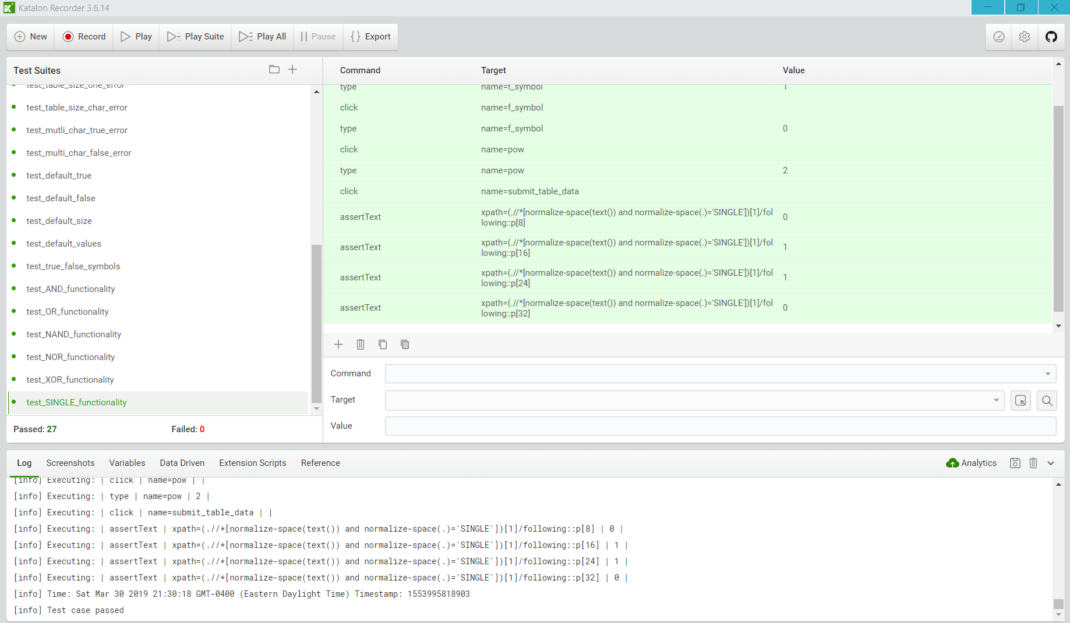

Traceability Matrix:

Requirement 1: test_landing_page

Requirement 2: test_reload_index_page, test_reload_table_page, test_reload_error_page

Requirement 3: test_error_address_link, test_error_param_link, test_invalid_param_h1_text, test_invalid_param_text,

Requirement 4: test_true_false_same_char_error, test_table_size_one_error, test_table_size_char_error, test_multi_char_true_error, test_multi_char_flase_error, test_true_false_symbols

Requirement 5: test_table_link, test_valid_table_titles,

Requirement 6: test_AND_functionality, test_OR_functionality, test_NAND_functionality, test_NOR_functionality, test_XOR_functionality, test_SINGLE_functionality

Requirement 7: test_default_true, test_default_false, test_default_size, test_default_values

Requirement 8: test_wrong_url