ESIS_report.R

Adam

Fri Oct 28 08:14:19 2016

# Rreports!

## An introduction to using R for reporting

Adam Gruer Oct 27 2016

Last updated: 2016-10-28 08:14:19

## Overview

This is a short demo on how R can be a very effective tool for producing reports.

## Operating system and R version

Below are the details of the operating system and version of R used to create this report.

version

## _   
## platform x86_64-apple-darwin13.4.0   
## arch x86_64   
## os darwin13.4.0   
## system x86_64, darwin13.4.0   
## status   
## major 3   
## minor 3.1   
## year 2016   
## month 06   
## day 21   
## svn rev 70800   
## language R   
## version.string R version 3.3.1 (2016-06-21)  
## nickname Bug in Your Hair

## Load packages

As always, the first step is to load all the necessary packages

suppressPackageStartupMessages({  
library(tidyverse)  
library(lubridate)  
})

## Conflicts with tidy packages ----------------------------------------------

## Create some random test data for elective surgery waitlist report

set.seed(198) #100  
waitlist <- tibble(  
 month = seq.Date(  
 from = ymd("2015 Oct 01"),  
 to = ymd("2016 Oct 01"),  
 by = "month" ),  
 patients_waiting = sample(  
 1900:2000,  
 size = 13,  
 replace = TRUE),  
 patients_admitted = sample(  
 600:900,  
 size = 13,  
 replace = TRUE)  
   
   
 )

Let's use the dplyr package to work out the patients added each month using the difference between the month and the previous month , **add back** the admissions in the month. We add this to out data table.

waitlist <- waitlist %>%  
 mutate( patients_waiting_change =  
 patients_waiting - lag(patients_waiting) ) %>%  
 mutate( patients_added =   
 patients_waiting_change + patients_admitted) %>%  
 replace_na(list(patients_added = 750L, patients_waiting_change = -12L))

We will create some variables for the hospital name and city so we don't have to type it everywhere - and when we get a new job we can bring this report with us

hospital_name <- "Imperial Little'uns Hospital"  
hospital_city <- "North Haverbrook"

## Imperial Little'uns Hospital, North Haverbrook

### Waitlist Report

|  |  |  |  |  |
| --- | --- | --- | --- | --- |
| month | patients_waiting | patients_admitted | patients_waiting_change | patients_added |
| 2016-10-01 | 1987 | 746 | 19 | 765 |
| 2016-09-01 | 1968 | 815 | 33 | 848 |
| 2016-08-01 | 1935 | 715 | -40 | 675 |
| 2016-07-01 | 1975 | 685 | 34 | 719 |
| 2016-06-01 | 1941 | 624 | 0 | 624 |
| 2016-05-01 | 1941 | 765 | 17 | 782 |
| 2016-04-01 | 1924 | 629 | -70 | 559 |
| 2016-03-01 | 1994 | 805 | 78 | 883 |
| 2016-02-01 | 1916 | 837 | -18 | 819 |
| 2016-01-01 | 1934 | 803 | -20 | 783 |
| 2015-12-01 | 1954 | 800 | 31 | 831 |
| 2015-11-01 | 1923 | 611 | -76 | 535 |
| 2015-10-01 | 1999 | 776 | -12 | 750 |

### Waitlist Trend

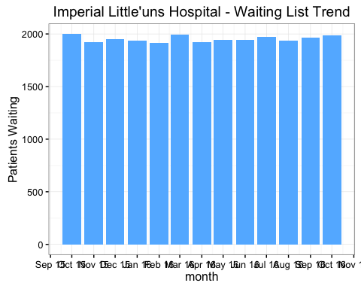

In October, the waiting list for elective surgery increased by 19 (1.0%) to 1987. There were 746 admissions from the waiting list and 765 children were added to the waiting list during the month.

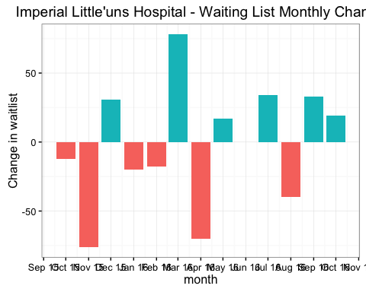

### Monthly Admissions and Additions

