* Sine Wave – 100Khz f1
  + At 400KHz Sampling Rate
    - t1 = 2.5us

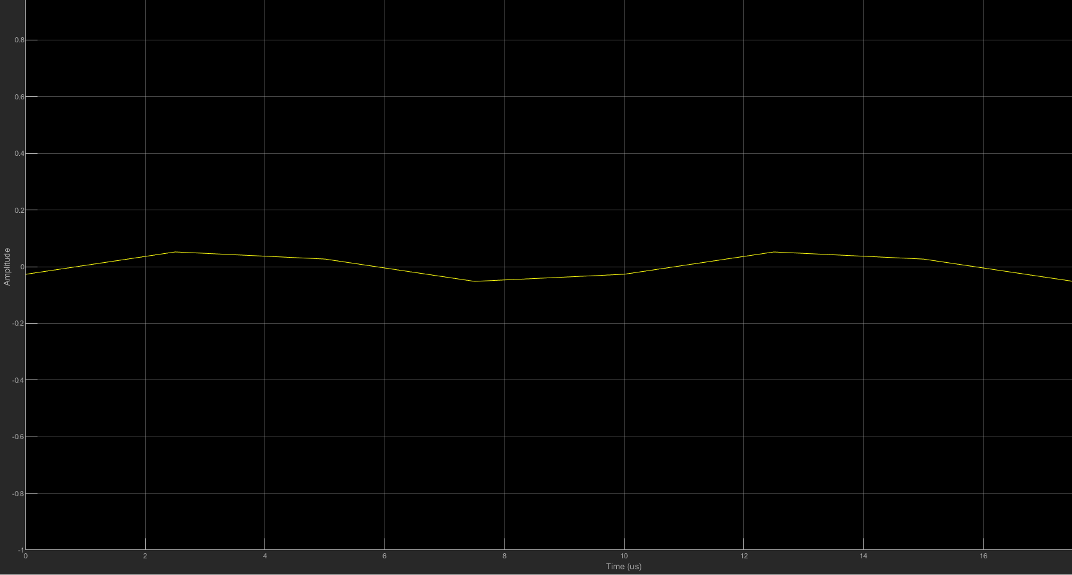

* At 800KHz Sampling rate
  + t1 = 1.25us

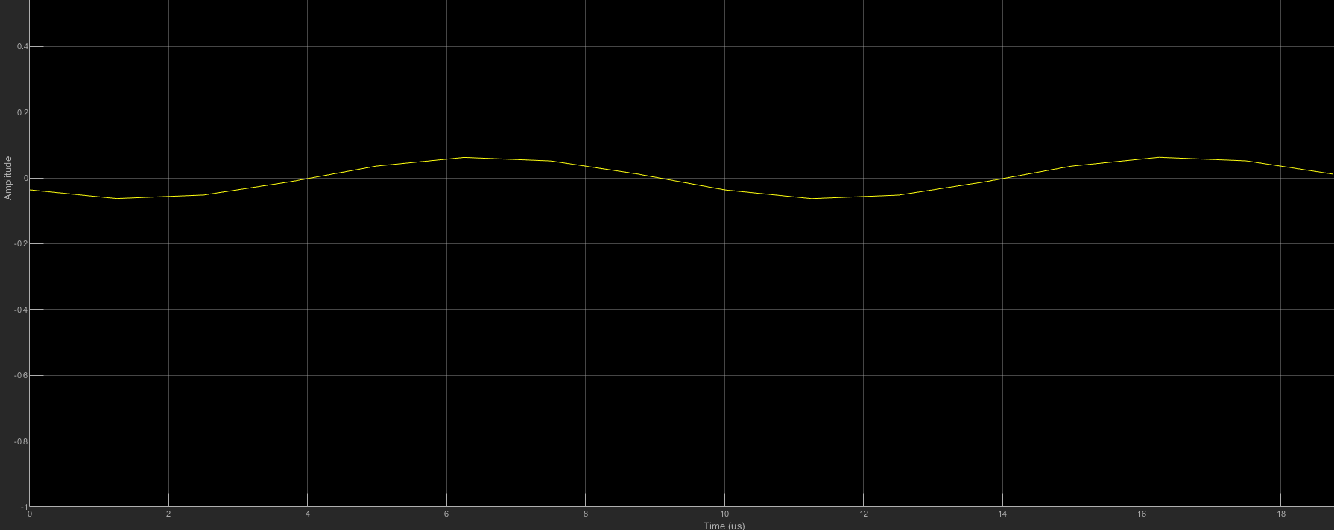

* At 1MHz Sampling Rate
  + t1 = 1 us

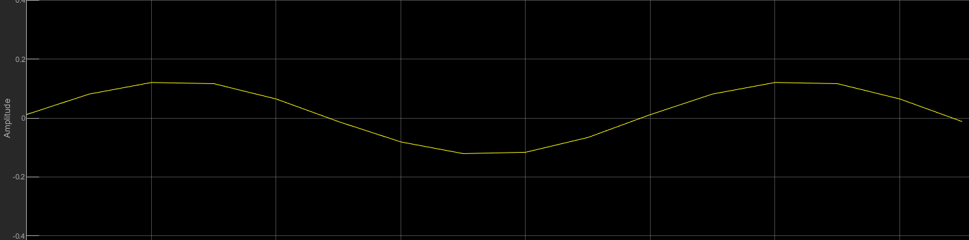

* Frequency Offset Calibration
  + [**https://www.mathworks.com/help/supportpkg/usrpradio/ug/frequency-offset-calibration-with-usrp-tm-hardware.html**](https://www.mathworks.com/help/supportpkg/usrpradio/ug/frequency-offset-calibration-with-usrp-tm-hardware.html)
  + Subtract 2.344 from receiver center frequency

**Reader Waveforms**

* Found out you need to have the antenna plugged into the reader for it to send out a signal (thought before the antenna was used to receive the signal)
* when the reader first gets turned on it is not sending out any signals
  + after sending out a command, the reader will continue to send out the RF field even if it not sending a command.
  + this RF field can be disabled by
    - unplugging and replugging in the reader
    - using the system reset command in ISOStart
    - or simply using the RF OnOff command in ISOStart
* For the inventory command under host commands in ISOStart.
  + the reader will continuously send out the inventory command by pressing start
  + this waveform will look like this:

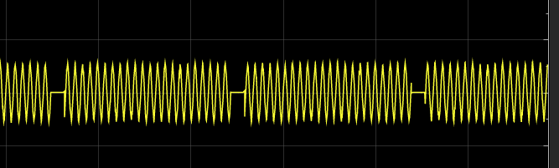

* If the RF-reset option is checked, then it will reset the RF field after every inventory command, the waveform looks like this

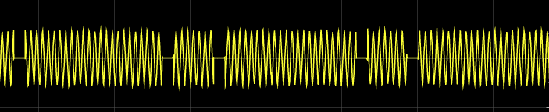

* Judging from these two waveforms, it leads me to believe that the parts with a lot of pulses are the inventory command and the small pulses are either the RF field either starting up or turning off (will look more into this Thursday)
* The reader uses 1 out of 4 coding method
* Example of decoding waveform

This kinds of waveform depicts a request

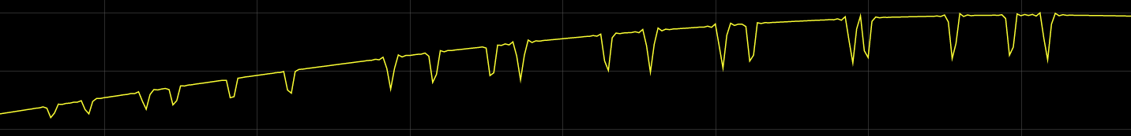

This is what it looks like zoomed in

You can see the first two dips indicate the Start of Frame. Which we know depicts the 1 of out 4 coding method

As you can see it starts with a low signal for 9.44 us. On the waveform the low signals start at the bottom (top) of the dip (peak).

Then the signal returns to normal for 37.76 us. then dips again

It is shown the timings are not always perfect, but they are pretty close

The signal then dips for another 9.44 us

Then is will be normal for 18.88 us

This is the whole start of frame from beginning to end

After this the same method can be applied to the get the binary values according to the 1 out of 4 coding

Test Card UID: E0040100876A3E5C