FYP Lifecycle processes 24/25.

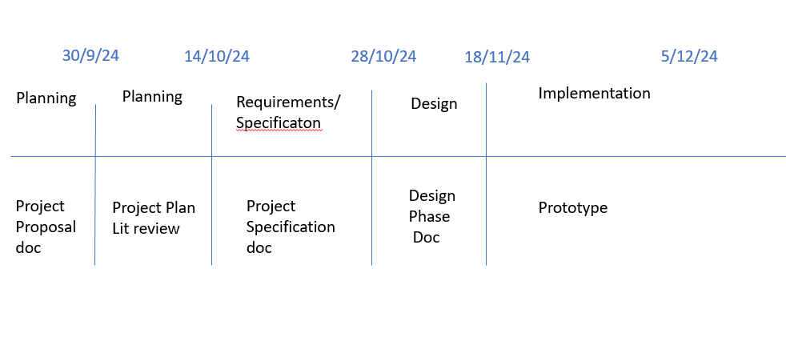

Planning Phase

INPUTS:
Idea
Supervisor

ACTIVITIES:

- Interim review. Research question and Research areas.
- Project Plan. Use template below and if necessary, include list software considerations.

Week | Activities & Estimate | Output | Status | Comments

- Lit Review started and headings identified.
- Risk Analysis.

Risk Description | Impact (High, med, low) | Likelihood (High, med, low) | Prevention activity | Action plan

OUTPUTS:
Research Question 3/10/24
Research Areas 3/10/24
Project Plan 14/10/24
Risk Analysis 14/10/24
Lit Review write up started. 14/10/24

Requirements Phase

INPUTS:
Outputs from planning phases (agreed and signed off with supervisor)

ACTIVITIES:

Project specification: Defines the scope, the functional and non-functional
Requirements.

Create a Product Backlog: Prioritised list of epics & some user stories (requirements)

User Story

Unique Number: US 001

Title:

Category: n/a
Owner

Dependency:

Estimate (story points or hours) (not more than 22hrs)

Priority: MoSCow method( Must have, should have, could have, won’t have)
(30:30:30:10)

Description : As a _____ I want ____so that ____.

Acceptance Criteria (Done criteria)
Success
Failure

Test your user stories against the INVEST model

Pick a tool for implementing the Backlog and share with your supervisor

OUTPUTS:
Project specification – Product backlog.

----------------------DONE ----------------------

Design Phase

INPUTS:
Backlog of prioritised epics/user stories

ACTIVITIES:

Design Documents : Should provide the development team with an overview of what to build and how.

Content
Use Cases
*Class Diagrams
System models
Data flow diagrams
*Sequence Diagrams
*Activity Diagrams
*Data Schemas
Story boards
Interface Designs
etc

Tested against Copelands Checklist

Methodologies

Sprint = 2 weeks – 22 hrs ( 1 week is 5hrs labs + 6hrs)

Activties
Monitoring time spent.
Sprint planning (Decide on items from backlog to implement , agreed with supervisor)
Review your user story, acceptance criteria and write your test cases.
Code – Design patterns , framework. Clean code, performance, adhere to language coding standards. Static Analyser.
https://peps.python.org/pep-0008/

Run your tests and review acceptance criteria.

Write up work completed during the sprint.
Demo to your supervisor
Review backlog and make adjustments accordingly.
Reprostictive – compare actual/estimate times.

OUTPUTS:

Design and methodology chapter 18/11/2024

Implementation Phase

INPUTS:
Backlog,
Design doc
Sprint plan

ACTIVITIES:

Implement your sprint plan

OUTPUTS:
5th of December 2024
FYP Document: (Work in progress)
Research Chapters, Methodology & Design Chapter
Some Increments (agreed with supervisor) implemented/tested.
Electronic submissions on Canvas.

