Appendix C: IEEE 830 Template
Software Requirements Specification
for
Simple Digital Thermometer
Version «#4»
Prepared by Adam Omieciński
«organisation»
«22/05/2026»
«Page Break»
Table of Contents
«Table of Contents»
Revision History
Name | Date | Reason for Changes | Version
«Adam Omieiciński» | «27/04/2026» | «Initial version» | «#1»
«Adam Omieiciński» | «08/05/2026» | «UML implemented» | «#2»
«Adam Omieiciński» | «15/05/2026» | «Added System Architecture diagram» | «#3»
«Adam Omieiciński» | «22/05/2026» | «Added Workflow diagram» | «#4»
«Page break»
1. Introduction
1.1. Purpose
This document identifies the software requirements and design for the Simple Digital Thermometer product. It covers the scope of the basic temperature monitoring system intended for home use.
1.2. Document Conventions
«Describe any standards or typographical conventions that were followed when writing this specification, such as fonts or highlighting that have special significance. For example, state whether priorities for higher-level requirements are assumed to be inherited by detailed requirements, or whether every requirement statement is to have its own priority.»
1.3. Intended Audience and Reading Suggestions
«Describe the different types of reader that the document is intended for, such as developers, project managers, marketing staff, users, testers, and documentation writers. Describe what the rest of this document contains and how it is organized. Suggest a sequence for reading the document, beginning with the overview sections and proceeding through the sections that are most pertinent to each reader type.»
1.4. Product Scope
The software will operate a simple digital thermometer. Its purpose is to read temperature data from a sensor and display it clearly to the user. The goal is to provide a reliable, easy-to-read, and fast temperature measurement tool.
1.5. References
«List any other documents or Web addresses to which this document refers or was based on. These may include user interface style guides, contracts, standards, system requirements specifications, use case documents, or a vision and scope document. Provide enough information so that the reader could access a copy of each reference, including title, author, version number, date, and source or location. Include the assignment document in the references.»
2. Overall Description
2.1. Product Perspective
The Simple Digital Thermometer is a new, self-contained system. It is an independent application running on a basic microcontroller or local environment. It does not replace any existing systems and operates completely offline, interfacing directly with a physical temperature sensor and a display module.
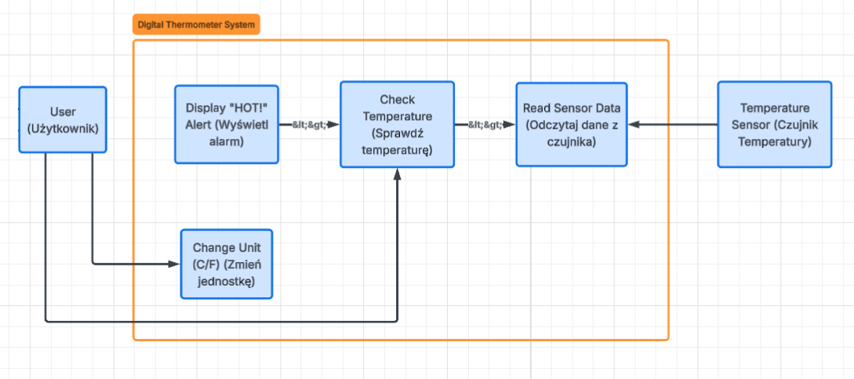
2.2. Product Features
Read temperature from a sensor.
Display temperature on a screen.
Alert the user if the temperature is too high.
2.3. User Classes and Characteristics
The main user class is a standard home user with no technical expertise. The system must be fully automated and require zero configuration.
2.4. Operating Environment
The software will operate on a basic microcontroller or local PC environment, interfacing with a standard digital temperature sensor.
2.5. Design and Implementation Constraints
«Describe any items or issues that will limit the options available to the developers. These might include: corporate or regulatory policies; hardware limitations (timing requirements, memory requirements); interfaces to other applications; specific technologies, tools, and databases to be used; parallel operations; language requirements; communications protocols; security considerations; design conventions or programming standards (for example, if the customer’s organization will be responsible for maintaining the delivered software).»
2.6. User Documentation
«List the user documentation components (such as user manuals, on-line help, and tutorials) that will be delivered along with the software. Identify any known user documentation delivery formats or standards.»
2.7. Assumptions and Dependencies
«List any assumed factors (as opposed to known facts) that could affect the requirements stated in the specification. These could include third-party or commercial components that you plan to use, issues around the development or operating environment, or constraints. The project could be affected if these assumptions are incorrect, are not shared, or change. Also identify any dependencies the project has on external factors, such as software components that you intend to reuse from another project, unless they are already documented elsewhere (for example, in the vision and scope document or the project plan).»
2.8. System Architecture (Class Diagram)
This diagram outlines the static software architecture for the Simple Digital Thermometer. It shows the main orchestrator class (ThermometerSystem) managing hardware abstraction layers, specifically the TemperatureSensor and DisplayModule. It also includes utility components, such as a UnitConverter for temperature scale adjustments and an AlertSystem to handle high-temperature warnings.
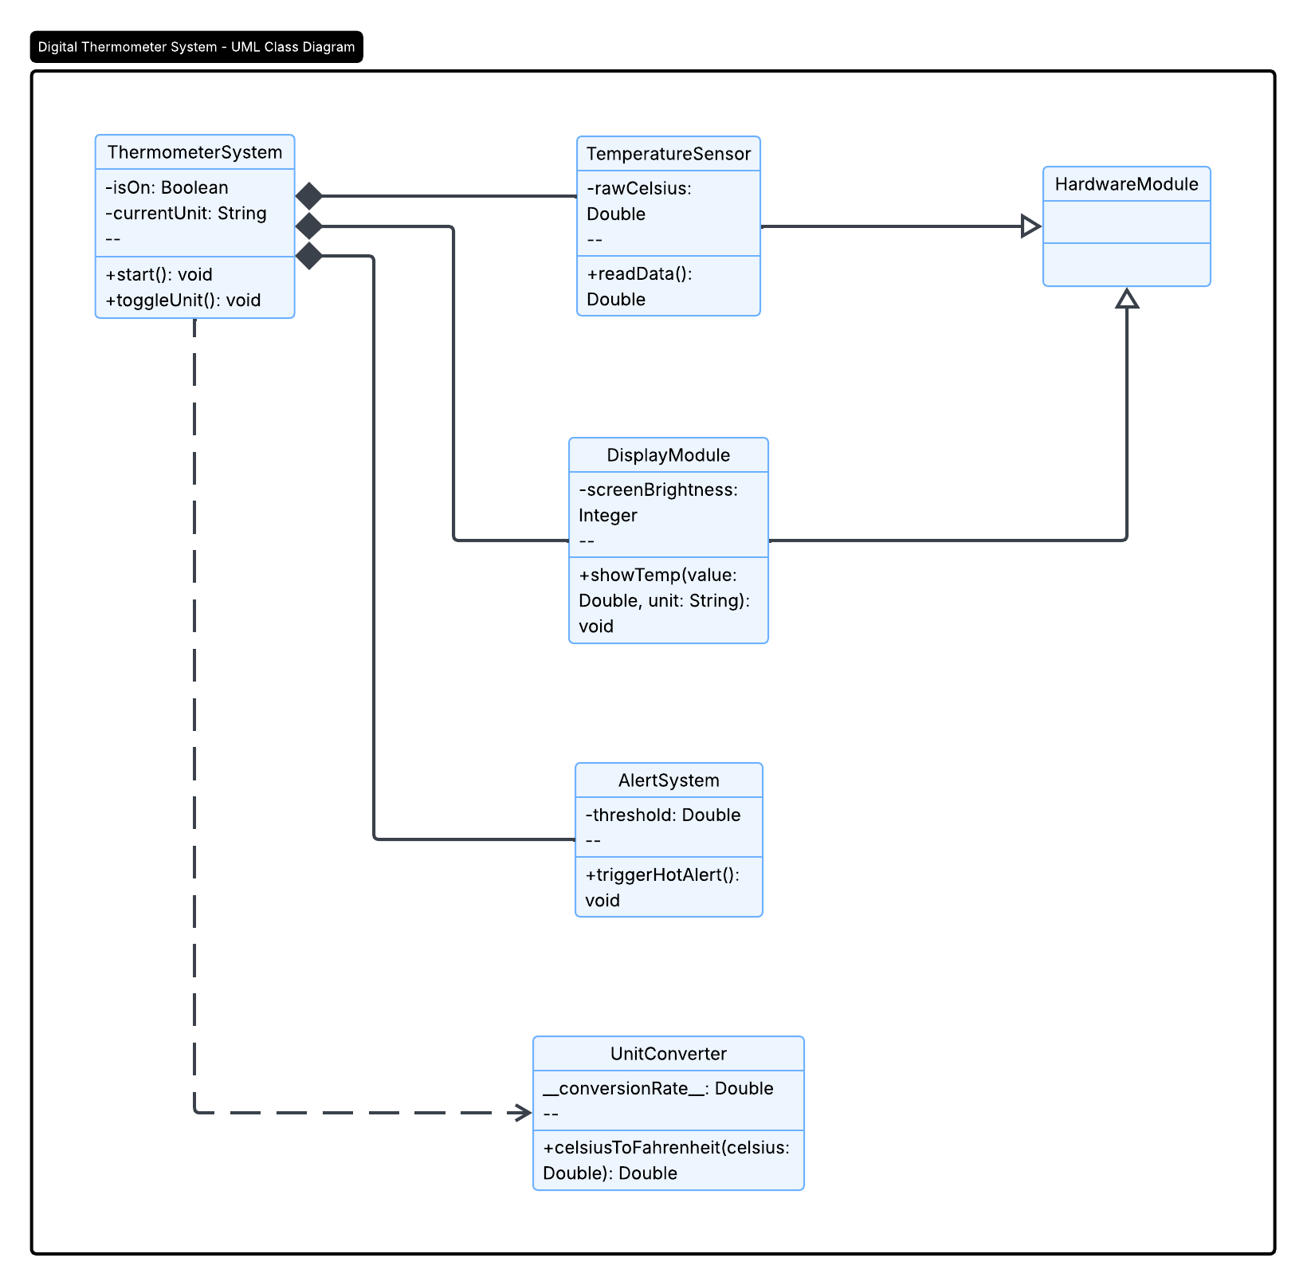
2.9. System Workflow (Activity Diagram)
This activity diagram models the continuous operational workflow of the Simple Digital Thermometer. It maps the main execution path from reading sensor data to updating the display. It highlights the decision logic for triggering the high-temperature alert and utilizes concurrent processing (Fork/Join) to handle screen updates while simultaneously listening for user input (unit toggle). An interruptible region is included to handle sudden power loss.
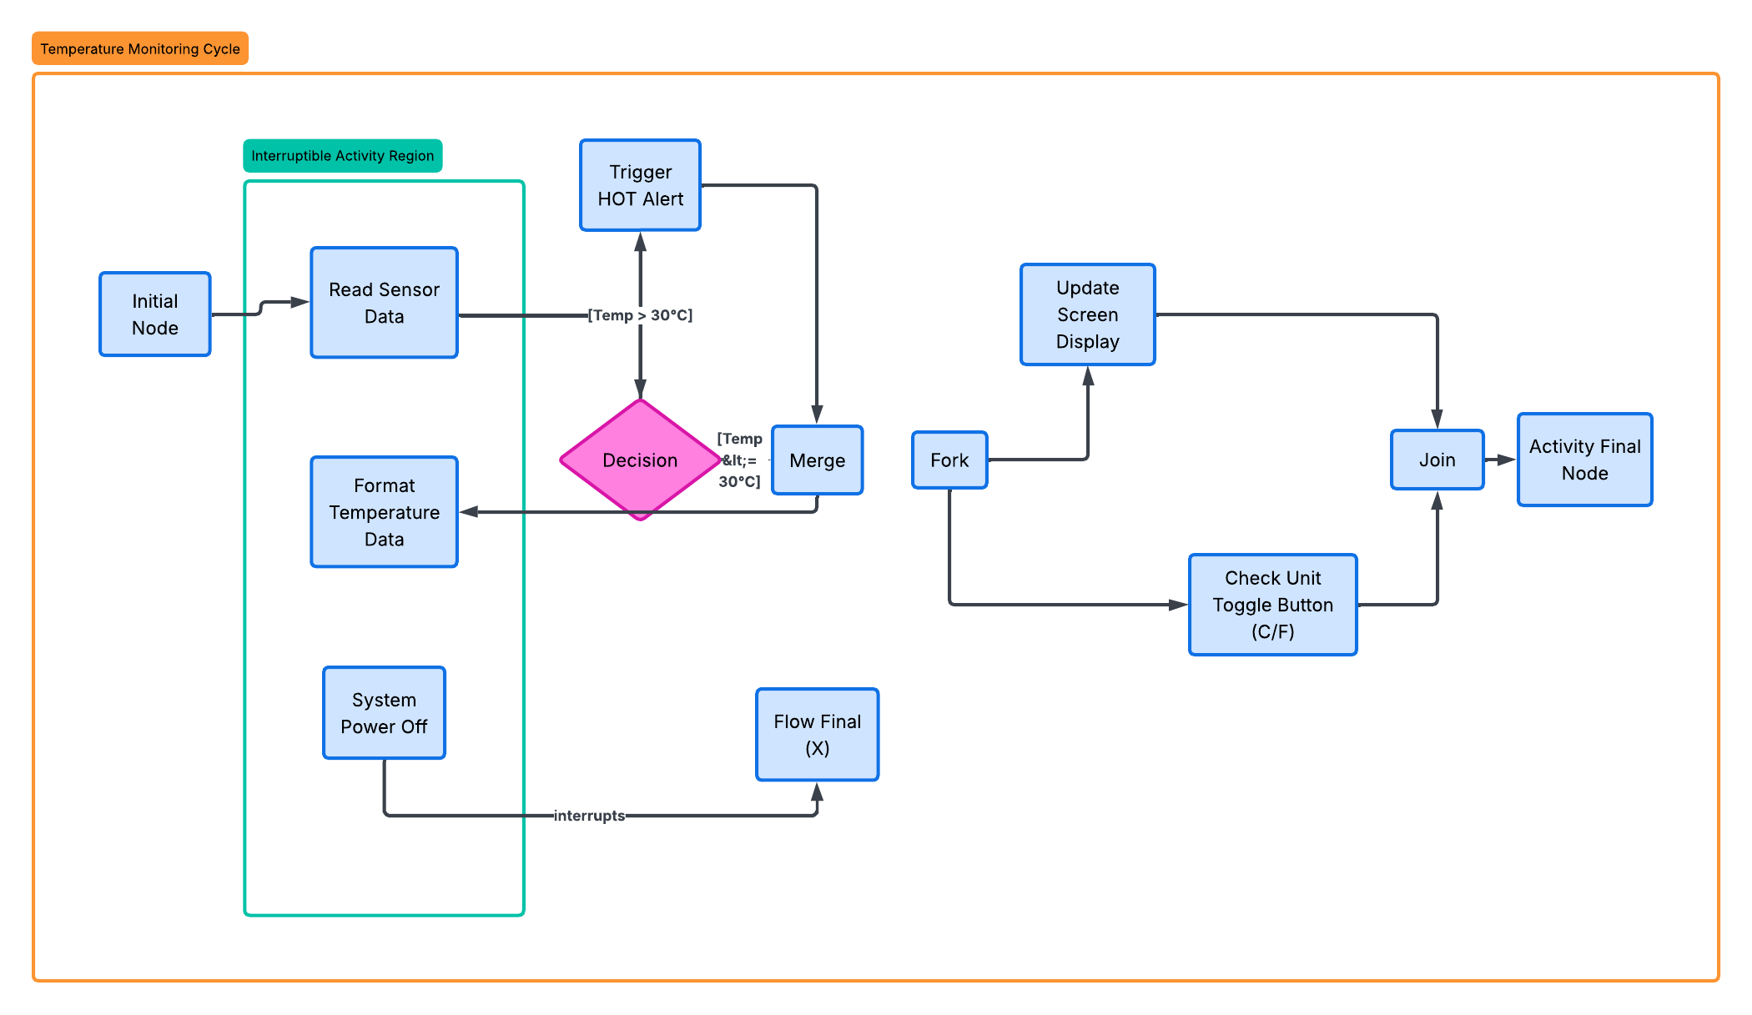

3. System Features
«The purpose here is to give a brief introduction to the system features, so that §4 has something to reference. Then, the full explanation of the system features is given in §5, likely referencing §4. The numbering in §3 and §5 should match.»
3.1. Temperature Measurement
The system constantly monitors the environment and extracts temperature data to keep the user informed.
3.«N». «Additional feature blocks as needed»
4. External Interface Requirements
4.1. User Interfaces Overview
The user interface consists of a simple digital display (either a physical LCD or a basic GUI window on a computer screen) that shows the current temperature as a number.
4.2. Hardware Interfaces
«Describe the logical and physical characteristics of each interface between the software product and the hardware components of the system. This may include the supported device types, the nature of the data and control interactions between the software and the hardware, and communication protocols to be used.»
4.3. Software Interfaces
«Describe the connections between this product and other specific software components (name and version), including databases, interpreters, operating systems, tools, libraries, and integrated commercial components. Identify the data items or messages coming into the system and going out and describe the purpose of each. Describe the services needed and the nature of communications. Identify data that will be shared across software components. If the data sharing mechanism must be implemented in a specific way (for example, use of a global data area in a multitasking operating system), specify this as an implementation constraint.»
5. System Features/Modules
5.1. Temperature Monitoring System
5.1.1 Description and Priority
This module is responsible for fetching, processing, and displaying the temperature. Priority: High.
5.1.2 Stimulus/Response Sequences
«”Stimulus” or “Condition”»: «Describe the stimulus or condition»
Response: «Describe the response»
«Additional Stimulus/Response pairs as needed»
5.1.3 Functional Requirements
REQ-1.1: The system shall read the current temperature data from the sensor..
REQ-1.2: The system shall display the measured temperature in degrees Celsius.
REQ-1.3: The system shall update the displayed temperature every 2 seconds.
REQ-1.4: The system shall display a warning message "HOT!" when the temperature exceeds 30°C.
REQ-1.5: The system shall allow the user to switch the display unit from Celsius to Fahrenheit using a designated button or key press.
5.«N». «Additional feature blocks»
6. Nonfunctional Requirements
6.1. Performance
NF-1.1: System shall respond to the user's unit-switch command in < 1 second.
NF-1.2: The system shall successfully boot up and display the first reading in < 5 seconds.
NF-1.3: The system shall maintain a temperature measurement accuracy of +/- 1°C.
6.2. Reliability & Environment
NF-2.1: The system shall maintain 99% uptime during continuous operation.
NF-2.2: The system shall operate stably on a standard 5V power supply.
6.«N». «Any additional “nonfunctional” blocks»

