Distilled Vertical Prompts for Efficient STEM Reasoning
Cheap Models Match Frontier Accuracy on Hebrew RTL Problems at a Fraction of the Cost
Independent technical research report (not peer-reviewed) - v1.0
Author: Adam Shlomo
Independent research report - not peer-reviewed.
By Adam Shlomo, in a personal capacity. Not affiliated with, endorsed by, or reviewed by any university or model provider. All passages and questions are original works by the author, not reproduced from any institution's materials.
Model outputs were obtained via public APIs (OpenRouter) and a subscription endpoint at a point in time; model versions and prices change. Trademarks (GPT, Gemini, Claude, Llama, Gemma, DeepSeek, and others) belong to their respective owners and are used nominatively, for factual comparison only, without implying affiliation or endorsement.
Nothing here is professional advice; cost figures are estimates, not quotes; the work is provided "as is" without warranty. Disclosure: the author builds StudAI, a study-assistant product informed by this work. License: report and data CC BY 4.0; code MIT.

Abstract
A common deployment bet is that a cheap model can be pushed toward frontier behavior by giving it more prompting. That bet has a failure mode: long-context work shows that models can use long inputs unevenly, get distracted by irrelevant context, and show instruction-following instability as contexts grow [5-8]. This paper tests the practical alternative: a short, task-specific prompt for Hebrew right-to-left STEM reasoning. We build an original, redistributable benchmark covering five standard first-year undergraduate courses. Each course has a self-contained Hebrew passage with the definitions and theorems needed for its questions, plus hard multi-part questions that were independently solved and adjudicated. On a priced 15-question subset we run an 8-model x 3-prompt x {zero-shot, RAG} grid - 720 cells - at temperature 0, graded blind with a fixed rubric. Accuracy is already near the ceiling: mean 0.967, median 1.000. Prompt lift from a plain prompt to the concise "squeezed-juice" vertical prompt is approximately zero. The result is economic, not prompt-driven: Gemma 4 31B reaches the frontier accuracy ceiling at $0.00071 per correct answer, roughly 117x cheaper than GPT-5.5. The direct conclusion is that, on answerable-from-source STEM, capable cheap models already match frontier accuracy in this setting. The concise vertical prompt is still useful, but not because it boosts accuracy here. Its value is that it packages the right reasoning discipline without unnecessary prompt mass. We therefore treat it as a low-risk deployment recipe, not as an accuracy lever.

Visual summary
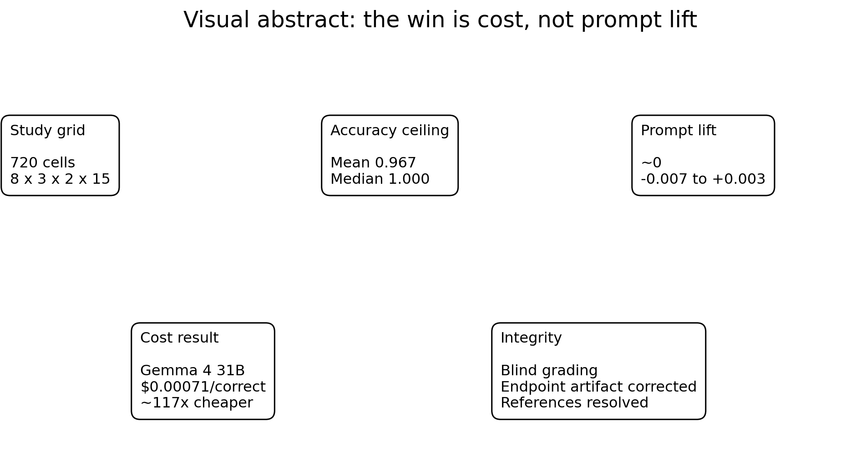
Figure 1. Visual abstract. The core finding is economic: accuracy is saturated, so cost-per-correct decides deployment value.
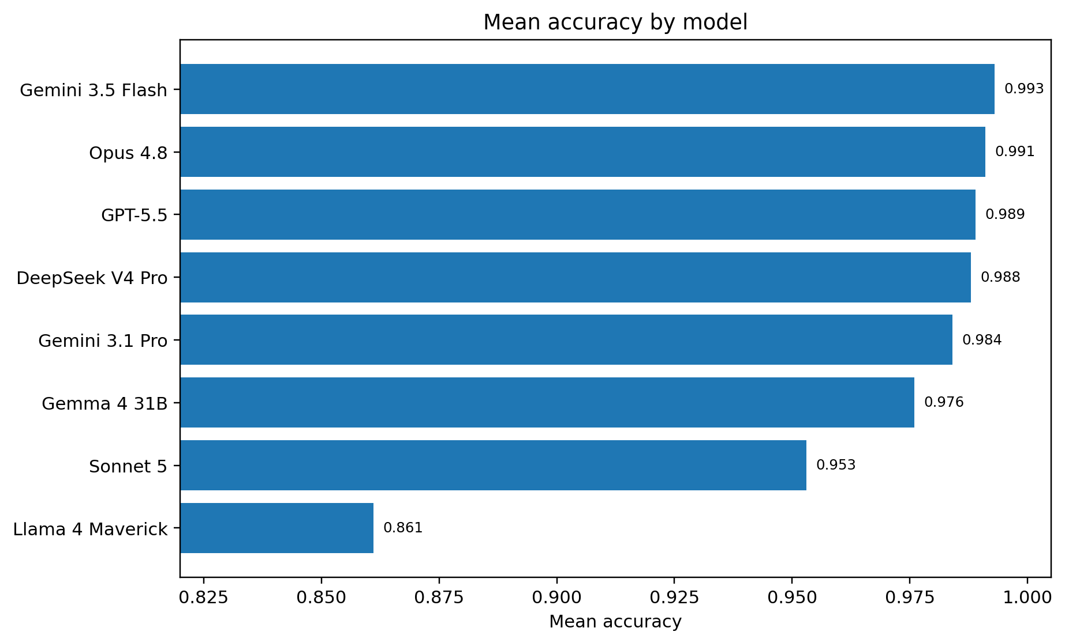
Figure 2. Mean accuracy by model. Seven models cluster near the ceiling; Llama 4 Maverick is the clear floor in the supplied results.
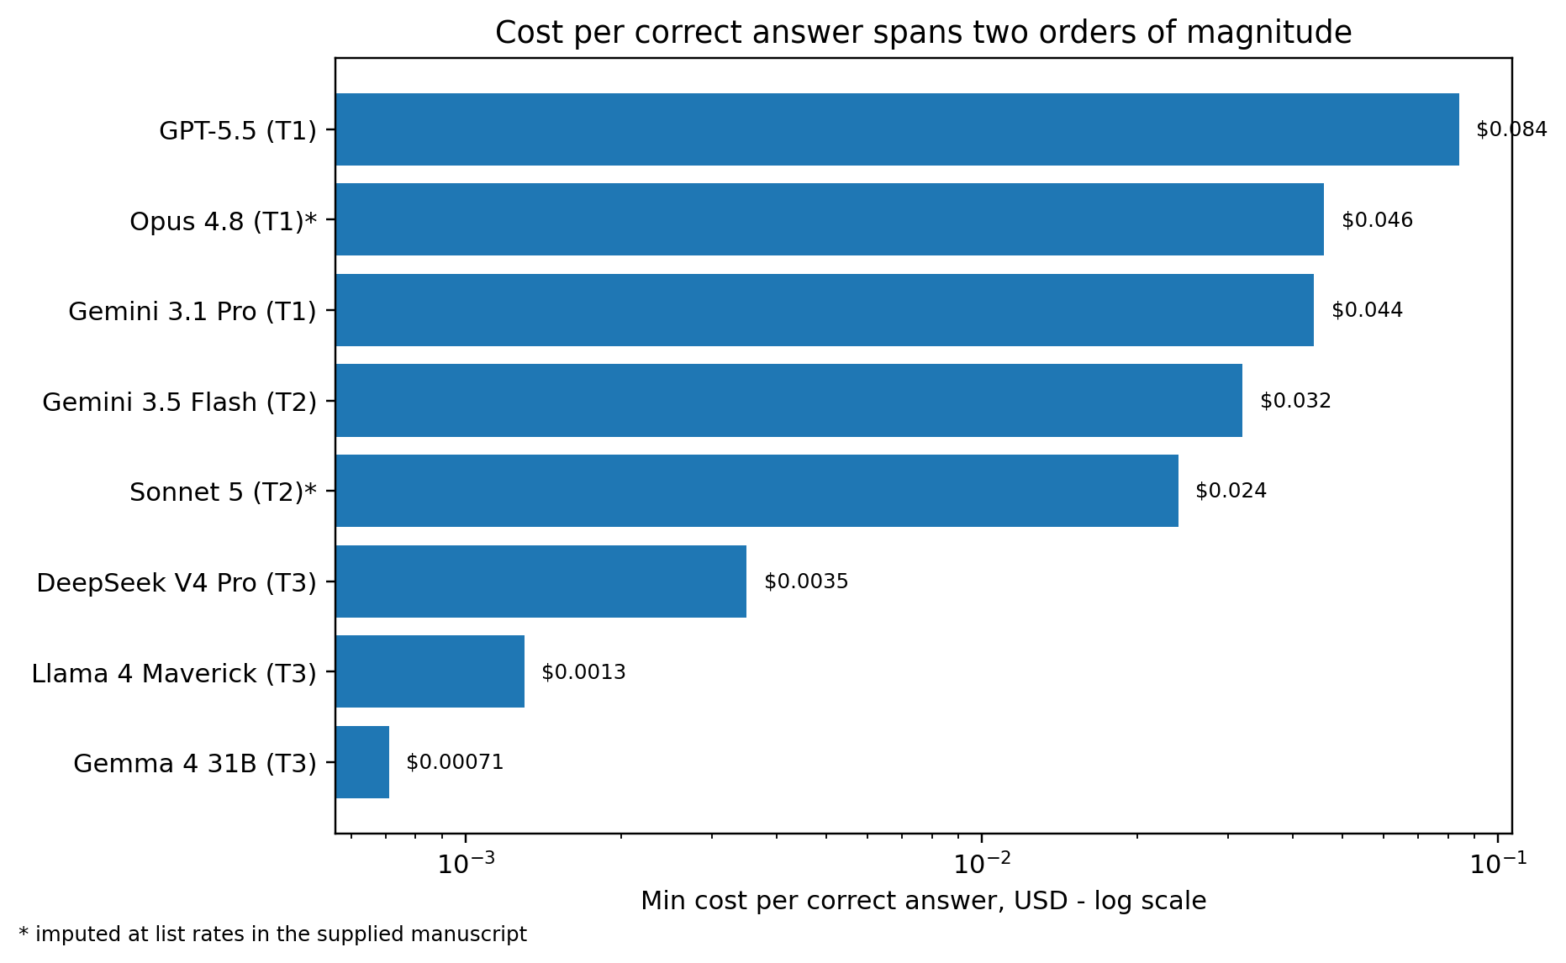
Figure 3. Minimum cost per correct answer. The asterisk marks imputed Anthropic pricing from the supplied manuscript.
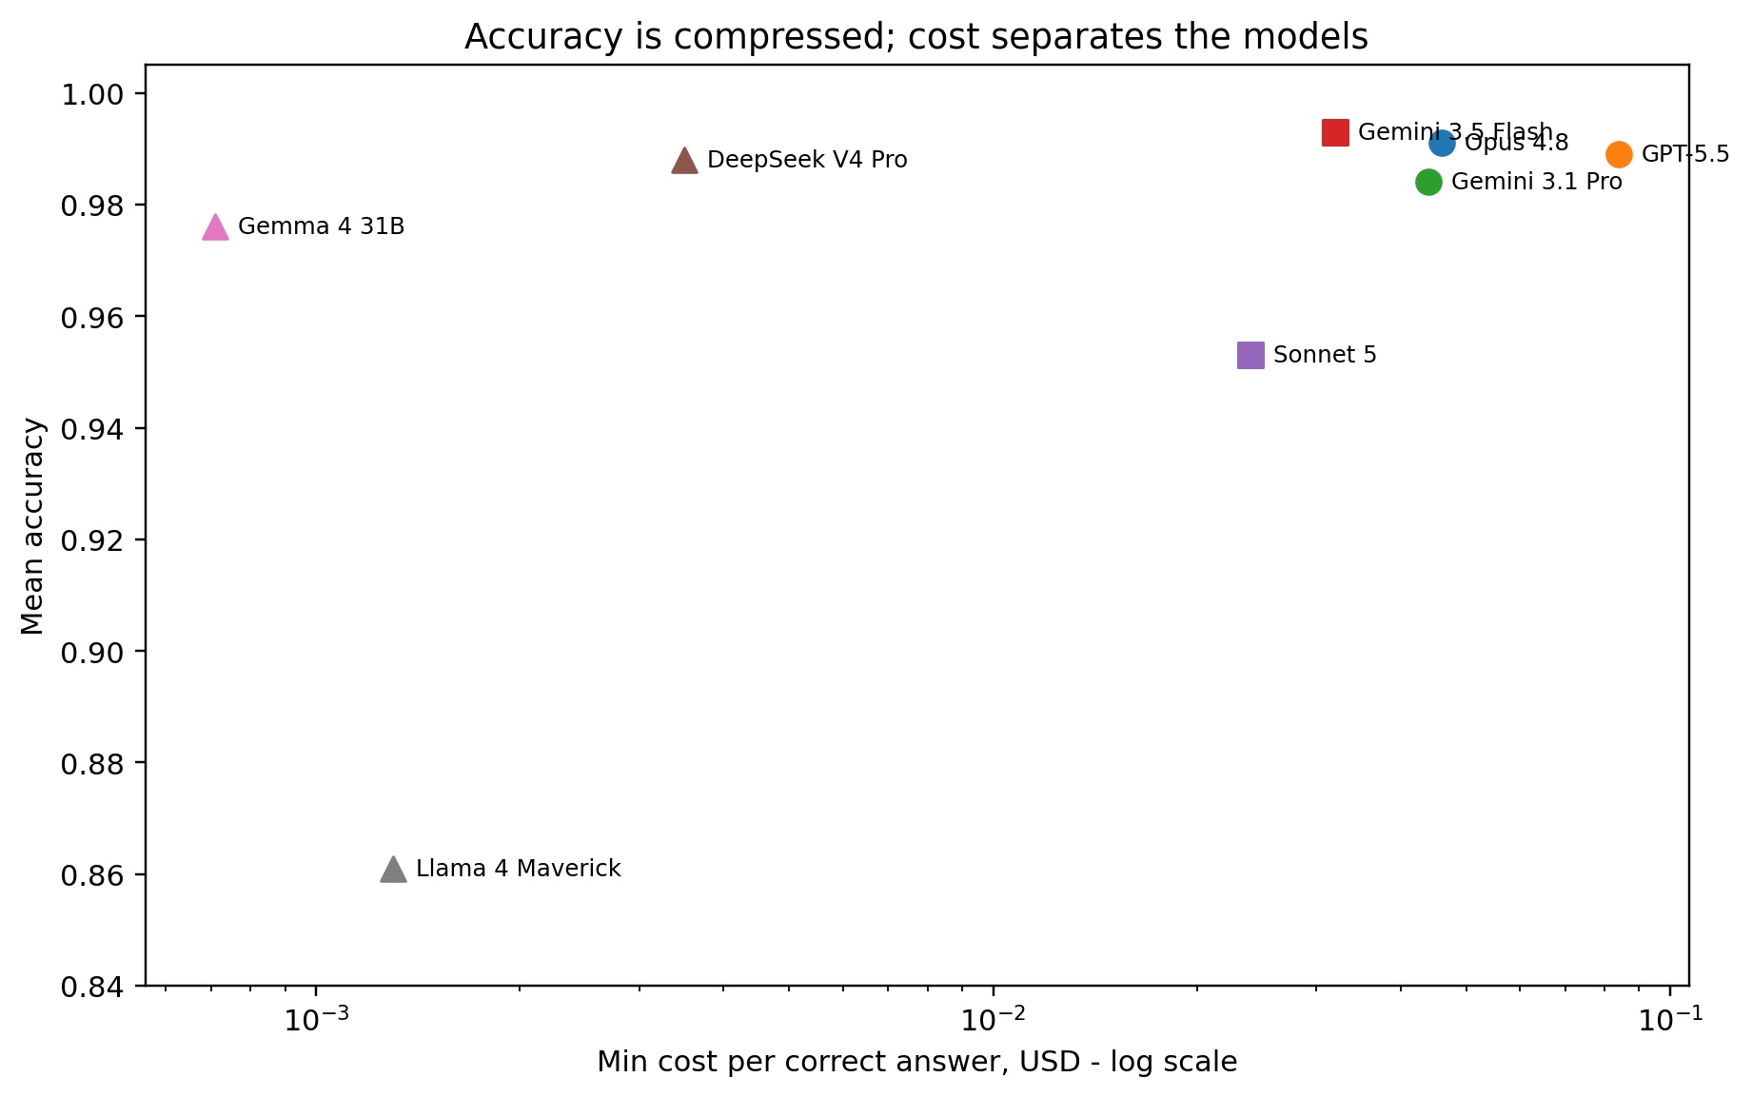
Figure 4. Mean accuracy versus min cost-per-correct. Accuracy compresses at the top; cost separates the models.
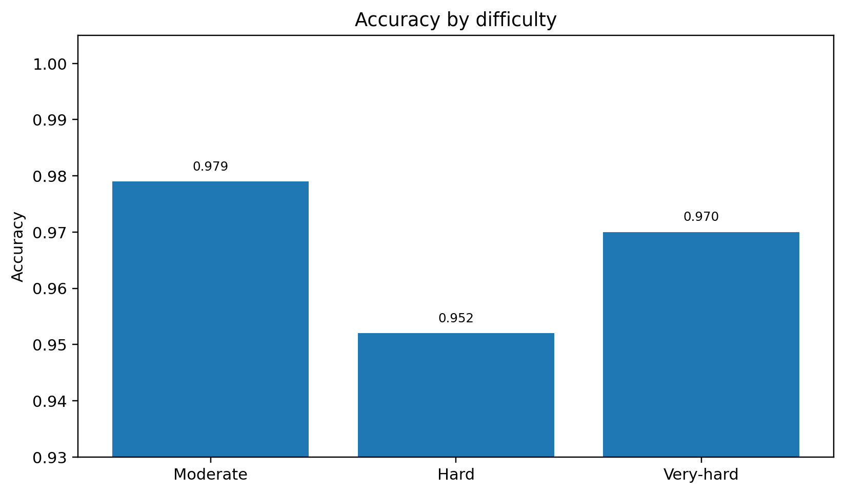
Figure 5. Accuracy by difficulty. The supplied results show a high ceiling across all three difficulty bands.
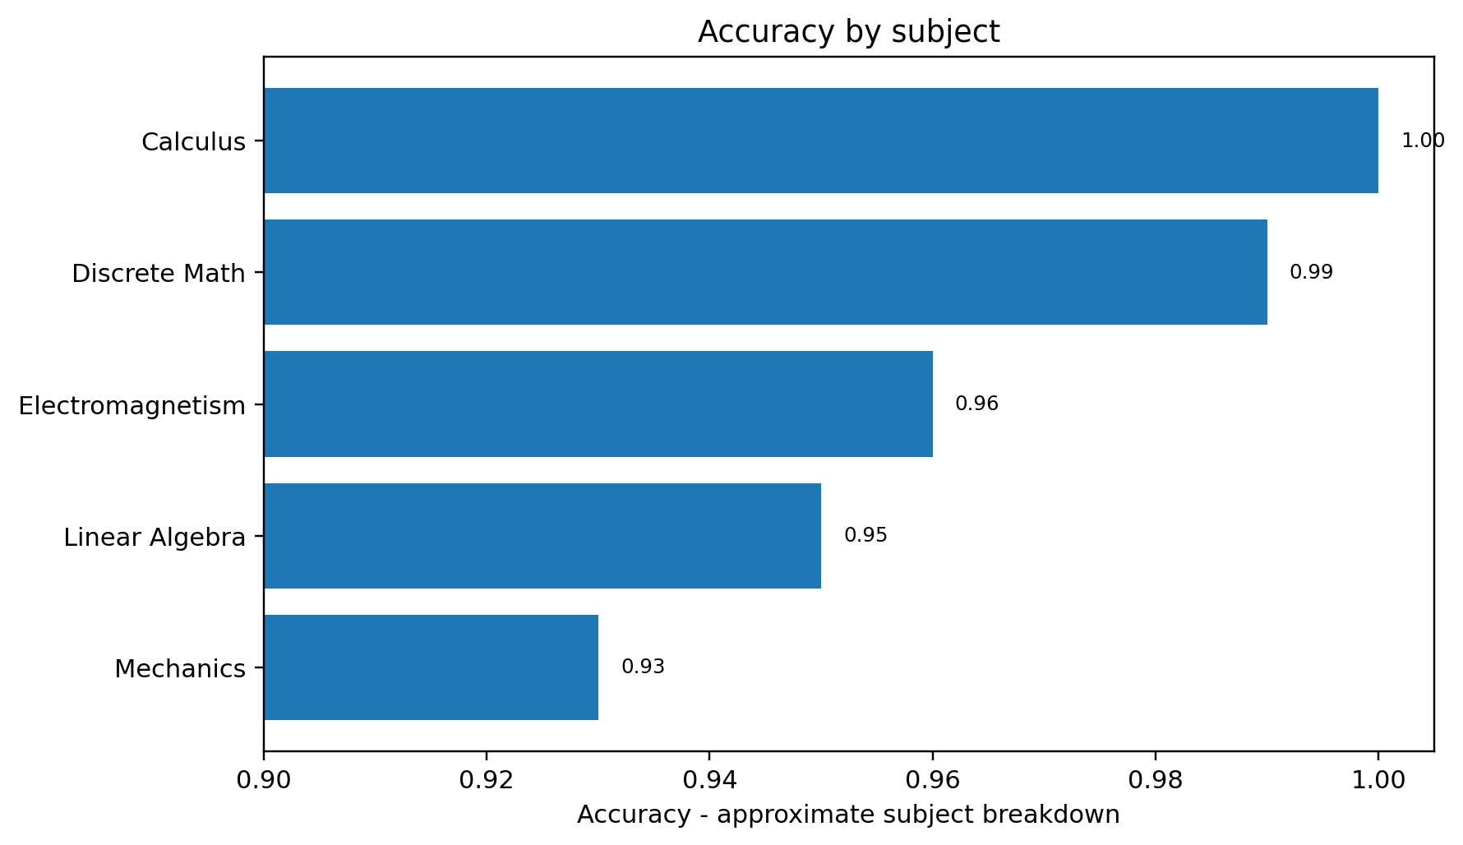
Figure 6. Accuracy by subject. Subject values are approximate, as labeled in the supplied manuscript.
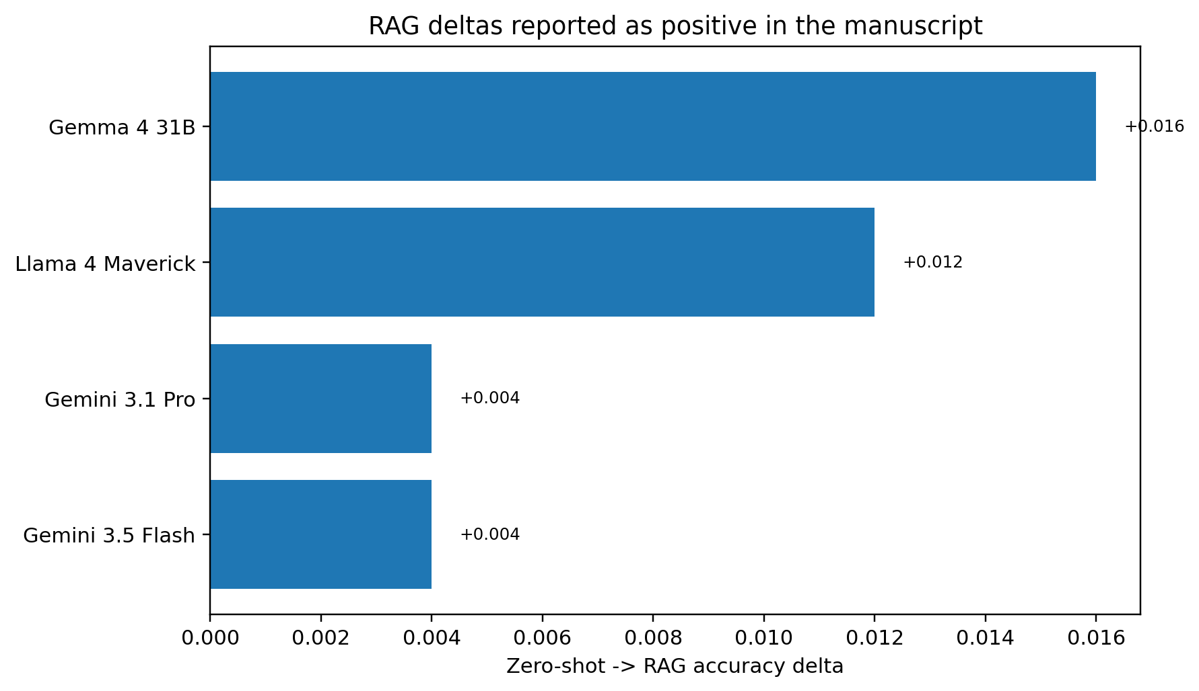
Figure 7. Positive zero-shot -> RAG deltas explicitly reported in the manuscript. The largest reported gains are for smaller models.

Clean result tables
Model | Tier | Mean accuracy | Best accuracy | Cost per correct
Opus 4.8 | T1 | 0.991 | 1.000 | $0.046 (imputed)
GPT-5.5 | T1 | 0.989 | 1.000 | $0.084
Gemini 3.1 Pro | T1 | 0.984 | 0.987 | $0.044
Gemini 3.5 Flash | T2 | 0.993 | 1.000 | $0.032
Sonnet 5 | T2 | 0.953 | 1.000 | $0.024 (imputed)
DeepSeek V4 Pro | T3 | 0.988 | 0.993 | $0.0035
Gemma 4 31B | T3 | 0.976 | 0.987 | $0.00071
Llama 4 Maverick | T3 | 0.861 | 0.881 | $0.0013
Table 1. Per-model summary from the supplied manuscript.

Main manuscript draft

1. Introduction
A recurring question in applied LLM deployment is whether the gap between a cheap model and a frontier one can be closed with prompting alone. A tempting version of that idea is to keep adding instructions until a smaller model behaves more like a frontier model. We do not rely on any proprietary prompt, unverifiable prompt source, or unverifiable prompt-length anecdote for this claim. All prompts used in this work are original text distilled from published prompting principles: chain-of-thought prompting, self-checking, structured output, and common-error checklists [1-4].
There is good reason to doubt the naive transplant. Long-context evaluations show that models do not use long inputs uniformly: performance can depend on where relevant information appears, irrelevant context can reduce problem-solving accuracy, and instruction following in long-context settings remains a measurable stability problem [5-8]. We use over-squeezing as our own shorthand for this deployment risk: a prompt can contain useful discipline, but excess surrounding text can make the task signal harder to isolate. Under this view, more prompt is not automatically more capability.
We propose and test a middle path we call the distilled vertical prompt, or the "squeezed-juice" recipe. Rather than transplanting a long general-purpose prompt, we distill its juice - the reasoning discipline, worked-method scaffolding, edge-case awareness, and explicit "don'ts" - into a short, task-specific prompt for one vertical. Concretely, our most developed prompt level (~640 tokens) encodes setup discipline, a solve-symbolically-first habit, an explicit common-error checklist (sign conventions, factor-of-2 slips, radians-versus-degrees, unit conversion, dropped terms, square-root branch selection, boundary and continuity conditions, off-by-one, and domain of validity), a verification protocol (dimensional analysis, limiting cases, re-derivation), and a proofs protocol. The hypothesis is narrower than a claim of prompt-length immunity: a concise vertical prompt can keep the useful discipline while reducing exposure to the long-context risk regime.
We situate this test in Hebrew, right-to-left academic STEM. This choice is deliberate. Prior multilingual reasoning work was explicitly motivated by the gap between English chain-of-thought evaluations and multilingual NLP, and later multilingual evaluations show substantial language-to-language performance variation [17,18]. RTL scripts also introduce bidirectional rendering issues when Hebrew prose is mixed with left-to-right mathematical notation [19]. STEM problems also admit adjudicable ground truth, which lets us grade accuracy cleanly rather than relying on preference alone. To keep the evaluation grounded and free of source-fabrication, every question is answerable from an accompanying self-contained passage, and grounding is applied phase-symmetrically across the zero-shot and RAG conditions.
Our findings are honest about what prompting does and does not buy. On this near-ceiling task, the distilled vertical prompt did not raise accuracy - models were already at parity - so we make no claim of prompt-driven accuracy gains. What the data does show is (a) cheap models already match frontier accuracy on answerable-from-source STEM, at 24-117x lower cost per correct answer, and (b) the concise distilled prompt neither helps nor hurts at ceiling, so it does not show a degradation pattern consistent with the long-context risk that motivated the design. The distilled vertical prompt is therefore best understood not as an accuracy lever but as a low-risk, cheap deployment recipe.
Contributions.
- An original, redistributable Hebrew RTL STEM benchmark. Five standard first-year undergraduate courses, each with a self-contained Hebrew passage (~760-1650 words) stating every definition and theorem its questions need, plus 20 hard, multi-part questions that were independently re-solved and adjudicated for correctness and answerability. The passages are synthetic and course-aligned rather than verbatim textbook, so the corpus is openly shareable.
- A three-level distilled-prompt ladder with a byte-identical output contract. L0 (plain), L1 (verbose chain-of-thought with an understand -> plan -> solve -> verify -> answer self-check), and L2 (the ~640-token "squeezed-juice" vertical prompt), differing only in the middle "how to reason" guidance, with a hash-enforced, contract-last per-part answer format so that prompt effects are not confounded by format effects.
- A controlled 720-cell efficiency grid. Eight models spanning three cost tiers x three prompt levels x {zero-shot, RAG} x 15 adjudicated questions, at temperature 0 with a uniform reasoning budget, graded blind by a validated rubric, for a total metered API cost of $16.50.
- A cost-per-correct headline and an honest null on prompt lift. We report cost-per-correct answer as the primary deployment metric - a Tier-3 open model reaches the frontier ceiling at ~117x lower cost - and we report prompt lift as approximately zero (range -0.007 to +0.003), explicitly declining to overclaim.
- A methods-integrity account of a detected-and-corrected pipeline artifact. We document an endpoint-wrapper confound that initially suppressed shown work for two models, how we diagnosed it via shown-work length, and how re-running and blind re-grading corrected it - evidence that the evaluation pipeline surfaces its own confounds.

1.1 Research Questions
- RQ1 (bang-for-buck). Which model delivers the best accuracy per dollar on grounded Hebrew RTL STEM - i.e., the lowest cost-per-correct answer - and how large is the spread across cost tiers?
- RQ2 (best overall). Which model attains the highest raw accuracy, and is the top tier separable on this corpus or compressed against a ceiling?
- RQ3 (cheap model + distilled vertical prompt vs frontier). Can a cheap model, paired with a concise distilled vertical prompt, match frontier accuracy - and does the concise prompt help, hurt (via over-squeezing), or leave accuracy unchanged relative to a plain prompt?

2. Related Work
Reasoning elicitation via prompting. A large body of work shows that instructing a model to reason step by step, rather than answer directly, can improve performance on multi-step problems [1]. Structured variants - self-consistency sampling, plan-then-solve decompositions, and explicit self-verification - extend the same family of reasoning scaffolds [2-4]. Our prompt ladder draws its L1 (verbose chain-of-thought with a self-check loop) and L2 (a checklist-and-verification vertical prompt) levels from these general principles. Unlike work that reports prompt-driven accuracy gains, we test whether such scaffolding transfers to a near-ceiling grounded task and find that, at ceiling, it neither helps nor hurts - a null we report deliberately rather than search around.
Long-context and instruction-following degradation. A complementary line of research documents that models do not use long contexts uniformly: accuracy depends on where relevant information sits, with a characteristic degradation for mid-context material - the "lost-in-the-middle" effect [5]. Separate work shows that irrelevant context can distract models on reasoning tasks, that long-context capability can drop as context length and task complexity increase, and that instruction-following stability in long contexts needs direct evaluation [6-8]. This literature motivates our central design choice: compressing useful reasoning guidance into a short vertical prompt while avoiding unnecessary prompt mass. We do not directly evaluate a full-length prompt against the concise one; that comparison is future work, and over-squeezing functions here as a named motivation rather than a measured result.
Task-specific and "skill"-style prompting. Related agent work packages task procedures into reusable reasoning-and-action patterns or skill libraries rather than relying on one generic prompt for every task [9,10]. Our distilled vertical prompt is an instance of this vertical strategy, specialized to a single domain (academic STEM) and language direction (Hebrew RTL), and evaluated with a byte-identical output contract so that vertical guidance is isolated from formatting.
Retrieval-augmented generation. Supplying a model with retrieved source text at inference time is a standard remedy for missing or parametric-only knowledge [11,12]. Our design uses grounding phase-symmetrically: the zero-shot and RAG conditions differ only in whether the self-contained passage is retrieved and supplied, which isolates the marginal value of retrieval on a corpus that is answerable-from-source by construction. We find RAG deltas that are small and mostly non-negative, consistent with a regime where the required knowledge is already largely available to strong models.
LLM-as-judge evaluation. Using a strong model to grade open-ended outputs against a rubric is now common and correlates reasonably with human judgment, but it carries known biases and calibration caveats [13-16]. We grade blind (model identities stripped) with a fixed per-part rubric that accepts algebraically-equivalent forms, and we validate the judge with a planted-error probe (it correctly zeroed a mis-computed answer), while treating the reasoning axis as a confounded secondary because visible-versus-hidden chains of thought are not endpoint-comparable.
Multilingual and RTL evaluation. Most reasoning benchmarks are English-centric, and cross-lingual studies show that reasoning quality can drop in lower-resource and non-Latin-script languages [17,18]. RTL languages such as Hebrew and Arabic add script-direction, tokenization, and mixed-direction rendering issues that English evaluations do not exercise [19-21]. Our benchmark contributes a controlled, adjudicated Hebrew RTL STEM evaluation to this under-served space, with grounded passages that make correctness cleanly measurable.

3. Methodology
Our study asks a narrow, deployment-relevant question: on academic STEM problems that are answerable from a provided source, how far apart are cheap and frontier language models in accuracy, in cost, and in their sensitivity to a concise, vertical-specific system prompt? To answer it without confounds, we hold everything constant across models - passages, questions, prompts, decoding parameters, grounding conditions, grading - and vary only the model, the prompt level, and whether the source passage is supplied (zero-shot vs. RAG). This section specifies the corpus (Section 3.1), the distilled prompt ladder (Section 3.2), the experimental grid (Section 3.3), the execution harness (Section 3.4), the blind grading protocol (Section 3.5), and the metrics (Section 3.6).

3.1 Corpus construction
We built an original, self-contained STEM corpus aligned to five standard first-year undergraduate courses: Mechanics, Electromagnetism, Linear Algebra 1, Infinitesimal Calculus 1, and Discrete Mathematics. These courses span continuous physics, matrix algebra, single-variable analysis, and combinatorial reasoning, giving coverage across the kinds of reasoning STEM assistants are asked to perform.
For each course we authored a single Hebrew, right-to-left (RTL) reference passage of roughly 760-1650 words. Each passage is synthetic and self-contained: it states, in its own words, every definition, theorem, convention, and boundary condition that its associated questions require. The passages are course-aligned but not verbatim - they are original prose distilled from the standard content of each subject rather than copied from any textbook, so the corpus is openly redistributable. This design has two deliberate consequences that we state plainly as framing rather than hide as assumptions. First, because each passage is self-contained, the task is answerable-from-source: a model that reads the passage and reasons correctly has, in principle, everything it needs. Second, this makes the corpus a strong instrument for measuring reasoning fidelity and grounding, but a weak instrument for separating top-tier models - a ceiling effect we anticipate and confront directly in the results and limitations rather than treat as an incidental finding.
Against each passage we authored 20 hard, multi-part questions, for 100 questions in total. Questions were written to require multi-step derivation (not lookup) and to exercise the exact definitions and theorems the passage supplies. Every question was independently re-solved and adjudicated: a second solution pass produced a canonical worked answer, and the two solutions were reconciled part-by-part to confirm that each item is (i) correct as stated, (ii) unambiguous, and (iii) fully answerable from its passage alone. This adversarial key-verification step is a methods-integrity safeguard, not a formality - an item whose "correct" answer is itself wrong would silently corrupt every downstream accuracy number. Items that failed any of the three checks were revised until they passed.
For the priced experimental run we drew a balanced 15-question subset - one moderate, one hard, and one very-hard question per course - so that difficulty and subject are crossed evenly and the grid stays within a fixed API budget. Difficulty labels were assigned at authoring time and carried through to the analysis, enabling the per-difficulty breakdowns in Section 4. We are explicit that n = 15 priced questions per cell is small; Section 4 and the limitations discussion treat the resulting estimates as point estimates over a modest sample and recommend bootstrap confidence intervals for any pairwise claim.

3.2 The distilled vertical prompt ladder
The prompt is the independent variable this paper is built around. The design is motivated by published long-context and distractor-context results, not by any proprietary prompt or unverifiable prompt source [5-8]. Those results make the naive "just add more instructions" strategy suspect: long input can be hard to use robustly, irrelevant context can distract reasoning, and instruction-following stability can degrade in long-context settings. Rather than test a giant prompt, we ask whether the useful discipline of strong prompting - worked-method structure, edge-case awareness, explicit "don'ts," and verification - can be compressed into a short, vertical-specific prompt.
Accordingly, we define a three-rung prompt ladder. All three rungs are original text we wrote, distilled from general, publicly-understood prompting principles - chain-of-thought decomposition [1], explicit self-verification [2,4], structured output contracts, and common-error checklists - and not copied from any model's system prompt.
- L0 - Plain. A minimal instruction: solve every part of the question and show your work. No guidance on how to reason.
- L1 - Verbose chain-of-thought + self-check. An explicit five-stage protocol - understand -> plan -> solve -> verify -> answer - instructing the model to restate the problem, outline an approach, execute it step by step, check the result, and only then commit to a final answer. This rung supplies process structure but no domain-specific error taxonomy.
- L2 - The "squeezed-juice" vertical prompt (~640 tokens). A concise prompt engineered specifically for STEM problem-solving. It adds, on top of L1's process scaffold: (i) setup discipline (name the givens, unknowns, and applicable results before computing); (ii) a solve-symbolically-first instruction (derive the closed form, substitute numbers last); (iii) a common-error checklist that encodes the "don'ts" as explicit guardrails - sign conventions, dropped factors of two, radians vs. degrees, unit conversion, dropped terms, square-root branch selection, boundary and continuity conditions, off-by-one indexing, and domain of validity; (iv) a verification protocol (dimensional analysis, limiting-case checks, and independent re-derivation); and (v) a proofs protocol for items requiring an argument rather than a computed value. L2 is the concrete realization of the "distill the juice, avoid the squeeze" hypothesis: it delivers targeted, high-density guidance in a footprint two orders of magnitude smaller than the anecdotal long prompt.
Crucially, the three rungs differ only in the middle "how to reason" guidance. Two elements are held byte-identical across L0, L1, and L2:
- A grounding clause. Identical wording instructs the model to answer strictly from the provided passage. Grounding is phase-symmetric: the clause is present in both the zero-shot and RAG conditions, so the two conditions differ only in whether the passage text is actually supplied, never in whether the model is told to stay grounded. This reduces the chance that the zero-shot condition becomes an unintended invitation to fabricate source material.
- A strict output contract. Every rung ends with the same ===FINAL=== per-part answer contract, requiring a clearly delimited final answer for each part of the question.
Both invariants are enforced in code, not by inspection: the harness asserts that the grounding clause and output-contract blocks are byte-identical across rungs (via a hash check) and that the output contract appears last in the assembled prompt for every cell. This makes any prompt-level accuracy difference traceable to the reasoning guidance rather than to a changed answer format or an accidentally reordered contract.

3.3 Experimental grid
The full grid is 8 models x 3 prompt levels x 2 grounding conditions x 15 questions = 720 cells. The models span three cost tiers:
- Tier 1 (frontier): GPT-5.5, Opus 4.8, Gemini 3.1 Pro.
- Tier 2 (mid): Sonnet 5, Gemini 3.5 Flash.
- Tier 3 (cheap): DeepSeek V4 Pro, Llama 4 Maverick, Gemma 4 31B.
The two grounding conditions are zero-shot (question only) and RAG (question preceded by its full reference passage). Because each passage is self-contained (Section 3.1), the RAG condition supplies genuinely sufficient context, and the zero-shot condition isolates what the model can do from parametric knowledge alone under the same grounding instruction.
Every model receives the same prompts and the same decoding parameters; the only thing that varies across the two grounding conditions is whether the passage is present. Decoding uses temperature 0 for determinism. For reasoning-capable models we impose a uniform 3000-token reasoning budget. This budget serves two purposes: it bounds cost, and it is meant to keep an unbounded reasoning trace from consuming the token budget that the answer block needs - a failure mode that would otherwise penalize exactly the models most inclined to think at length. We note that capping reasoning is a deliberate design choice with a cost/quality trade-off, and we flag reasoning as a confounded axis in Section 3.5.

3.4 Execution
We ran the grid with a self-built streaming client. For every API call the runner logs per-call token usage (prompt and completion tokens) and time-to-first-token (TTFT), streamed from the provider, and enforces a hard budget guard that halts the run before a preset spend ceiling is crossed. This keeps the study reproducible and the cost accounting exact rather than estimated: the headline cost figures in Section 3.6 are computed from metered usage, not from token counts we inferred ourselves. The complete study - all 720 cells plus grading - cost $16.50 in metered API spend.
One execution caveat must be disclosed for fairness. The Anthropic models (Opus 4.8 and Sonnet 5), and all grading calls, were served through a subscription endpoint rather than a metered pay-per-token API. Two consequences follow. First, their cost is imputed at published list rates from the logged token usage rather than directly metered; we mark every such figure as imputed. Second, TTFT from the subscription endpoint is not comparable to the metered endpoints and is therefore excluded from any latency comparison involving those models. We surface this rather than bury it because it bears directly on how the cost and latency numbers should be read.
The subscription endpoint also produced a diagnosable artifact that we detected and corrected in-pipeline - reported here as evidence that the harness surfaces its own confounds. In the initial run, the Anthropic models scored anomalously low (Opus 4.8 at 0.815) because a wrapper on the subscription endpoint caused them to emit answer-only outputs with essentially zero characters of shown work. This penalized the Reasoning axis and, on proof items where the derivation is the answer, the Accuracy axis as well. We diagnosed the cause by inspecting shown-work length per response, re-ran the affected cells with a corrected instruction (after which the models produced full 4,000-5,000-character worked solutions), and re-graded the corrected outputs blindly. Accuracy rose to 0.991 (Opus 4.8) and 0.953 (Sonnet 5). All results reported in Section 4 use the corrected, re-graded outputs. We include this episode because a study that cannot detect its own instrumentation confounds cannot be trusted at the top of the accuracy range, which is precisely where our central finding lives.

3.5 Blind grading
Every response was graded by an Opus 4.8 rubric grader operating blind: model identities were stripped from the transcripts before grading, so the grader could not condition on which model produced an answer. The rubric scores each part of each multi-part question on three axes:
- Accuracy - 0 / 1 / 2 (wrong / partially correct / correct);
- Reasoning - 0 / 1 / 2 (quality and validity of the shown derivation);
- Format - 0 / 1 (adherence to the per-part answer contract).
The grader accepts algebraically-equivalent forms - e.g., factored vs. expanded expressions, or equivalent trigonometric or set-notation renderings - so a correct answer is not penalized for surface form.
We validated the grader rather than assuming it. In a check on the grader's discrimination, an Opus L1 response that mis-computed a surjection count was scored 0.667 overall, with the grader correctly assigning 0 to the erroneous part while crediting the parts that were right. This confirms the grader catches a planted arithmetic error and localizes it to the offending sub-part rather than blurring it across the item. We treat this as necessary but not sufficient evidence of grader reliability and, given the small n, recommend the confidence-interval caveats in Section 4 for any close comparison.
Two honesty caveats on the axes. First, Accuracy is the primary metric and Reasoning is a confounded secondary one: some models emit visible chain-of-thought while others reason in a hidden trace, so the Reasoning axis partly measures whether work was shown rather than whether the reasoning was sound. The Section 3.4 artifact is a concrete instance of this confound. Second, because grading itself ran on the subscription endpoint, it inherits the imputed-cost caveat for accounting purposes (the grading cost is folded into the $16.50 total at list rates).

3.6 Metrics
We report accuracy and cost, with cost-per-correct as the headline.
Accuracy is the normalized Accuracy-axis score, averaged over parts and questions, reported per cell and aggregated by model, difficulty, subject, prompt level (for the L0->L2 prompt-lift), and grounding condition (for the zero-shot->RAG RAG-delta). Accuracy is our primary quality metric; the rubric also defines Reasoning and Format weights for a composite quality score, but we lead with Accuracy for the reasons in Section 3.5.
Cost is computed per call from metered usage as
cost = prompt_tokens x rate_in + completion_tokens x rate_out
using each provider's published input/output rates (imputed at list rates for the subscription-served Anthropic models, per Section 3.4).
Cost-per-correct is our headline efficiency metric:
cost-per-correct = mean cost per call / accuracy
This normalizes raw per-call price by the answer quality it buys, so a model that is slightly less accurate but far cheaper is not flattered or unfairly penalized: it is charged for the correctness it actually delivers. Cost-per-correct is what lets us state the study's economic finding - cheap models matching frontier accuracy at a fraction of the price - on a single, like-for-like axis, which we develop in Section 4.

4. Results
We report accuracy from the priced 15-question run subset (1 moderate + 1 hard + 1 very-hard per course) across the full 8-model x 3-level x {zero-shot, RAG} grid (720 graded cells). Accuracy is the primary metric, scored blind by an Opus-4.8 rubric with algebraically-equivalent forms accepted; cost-per-correct (mean per-call cost divided by accuracy) is the headline deployment metric. The total metered API cost of the entire study was $16.50. Anthropic models (Opus 4.8, Sonnet 5) and all grading ran on a subscription endpoint, so their dollar figures are imputed at list rates and their TTFT is not endpoint-comparable; this is flagged inline below and treated as a limitation.

Table 1 - Per-model summary
Model | Tier | Mean accuracy | Best-of-ladder accuracy | Min cost-per-correct
Opus 4.8 | T1 | 0.991 | 1.000 | $0.046 (imputed)
GPT-5.5 | T1 | 0.989 | 1.000 | $0.084
Gemini 3.1 Pro | T1 | 0.984 | 0.987 | $0.044
Gemini 3.5 Flash | T2 | 0.993 | 1.000 | $0.032
Sonnet 5 | T2 | 0.953 | 1.000 | $0.024 (imputed)
DeepSeek V4 Pro | T3 | 0.988 | 0.993 | $0.0035
Gemma 4 31B | T3 | 0.976 | 0.987 | $0.00071
Llama 4 Maverick | T3 | 0.861 | 0.881 | $0.0013

Two facts are visible at a glance and structure the rest of this section: (i) seven of eight models cluster tightly at the top, with best-of-ladder accuracy at or near the 1.000 ceiling, and (ii) the min cost-per-correct spans nearly two orders of magnitude - from GPT-5.5 at $0.084 down to Gemma 4 31B at $0.00071 - despite near-identical accuracy. The single clear outlier on accuracy is Llama 4 Maverick (0.861 mean, 0.881 best-of-ladder).

4.1 Overall accuracy and the ceiling effect
Aggregating over all models, levels, and retrieval conditions, accuracy is mean 0.967, median 1.000. The median of 1.000 indicates that on a majority of graded cells the model answered every part of the question fully correctly.
Accuracy is essentially flat across difficulty, which is itself notable given that the difficulty labels were assigned by the (independently re-solved and adjudicated) item authors:
Difficulty | Accuracy
Moderate | 0.979
Hard | 0.952
Very-hard | 0.970

The very-hard items are not systematically harder for the models than the merely-hard items (0.970 vs 0.952), and all three bands sit within a narrow band of one another. By subject, the spread is similarly compressed:
Subject | Accuracy (approx.)
Mechanics | 0.93
Linear Algebra | 0.95
Electromagnetism | 0.96
Discrete Math | 0.99
Calculus | 1.00

Mechanics is the hardest subject and Calculus the easiest, but even the floor (0.93) is high in absolute terms.
This is a ceiling effect. It is both the central finding and the central limitation of the study. On STEM problems that are self-contained - where the accompanying passage states every definition and theorem the question requires - 2026-generation models across all three tiers are near-saturated. This compression is what makes the cost axis, not the accuracy axis, the discriminating dimension (Section 4.5). It also means the corpus does not separate the top tier of models from one another with any statistical confidence, a point we return to in the limitations.

4.2 Prompt-lift is approximately zero (and L2 does not degrade)
The three prompt levels differ only in the middle "how to reason" guidance - L0 (plain: "solve every part, show work"), L1 (verbose chain-of-thought + self-check), and L2 (the concise ~640-token "squeezed-juice" vertical prompt with a common-error checklist, a verification protocol, and a proofs protocol). The grounding clause and the strict ===FINAL=== per-part answer contract are byte-identical across levels and enforced in code (hash check + contract-last assertion), so any accuracy difference is attributable to reasoning guidance alone.
The measured L0->L2 accuracy lift is approximately zero for every model, in the range -0.007 to +0.003. Sonnet 5 shows a nominal +0.050, but on n=15 questions this is small-sample noise rather than a reliable effect. We therefore make no claim that the distilled prompt lifts accuracy on this task: at ceiling, there is simply no headroom for prompt engineering to recover.
This null result is the point. The long-context and distractor-context literature suggests a practical risk: extra text can make the operative task signal harder to use, especially when the prompt contains material that is not directly needed for the current answer [5-8]. If our concise vertical L2 prompt were pushing in that direction, we would expect the smallest models to lose accuracy relative to the plain L0 baseline. They do not. The verbose-to-concise transition costs the Tier-3 small models nothing beyond noise (Llama 4 Maverick -0.006, Gemma 4 31B -0.007, both within the measurement band). In other words, the distilled vertical prompt is accuracy-neutral rather than accuracy-harmful even on the smallest models in the grid. It delivers the structure of a strong task prompt without showing the degradation risk that motivates avoiding very long, crowded prompts.
We stress that we did not directly test a full-length prompt against the concise one; the over-squeezing hazard is used only as motivation and framing. What we can report is the measured half: the concise distilled prompt neither helps nor hurts accuracy at ceiling.

4.3 RAG delta
We compare the zero-shot condition (passage withheld; grounding phase-symmetric so no source-fabrication is licensed) against the RAG condition (passage retrieved and supplied). The zero-shot -> RAG accuracy delta is small and mostly non-negative:
Model | RAG delta
Gemma 4 31B | +0.016
Llama 4 Maverick | +0.012
Gemini 3.1 Pro | +0.004
Gemini 3.5 Flash | +0.004

The largest gains accrue to the smallest models (Gemma, Llama), which is consistent with retrieval helping exactly where parametric knowledge is weakest. Several frontier models show a slightly negative delta, but these fall within the same noise band that governs Section 4.2 and should not be read as retrieval hurting. The takeaway is that on a self-contained corpus, RAG provides a modest, safe uplift for smaller models and is close to a no-op for the strongest ones - again consistent with the ceiling effect.

4.4 A detected-and-corrected artifact (methods integrity)
We report one pipeline artifact in full, because catching it is itself evidence the evaluation surfaces its own confounds. In the first pass, the two Anthropic models scored anomalously low - Opus 4.8 at 0.815 - an outlier flatly inconsistent with their standing on every other axis. Diagnosing via shown-work length revealed the cause: a subscription-endpoint wrapper made Opus and Sonnet emit answer-only outputs (0 characters of shown work). Because the rubric scores a Reasoning axis, and because proof items require demonstrated derivation for full Accuracy credit, the missing work depressed both scores.
We re-ran the affected models with a corrected instruction; they then produced full worked solutions (4,000-5,000 characters of derivation), and we re-graded blind. The corrected scores are the ones reported throughout this paper: Opus 4.8 -> 0.991 and Sonnet 5 -> 0.953. Separately, the grader itself was validated against a planted error: an Opus L1 response that mis-computed a surjection count was scored 0.667, correctly zeroing the wrong sub-part rather than rubber-stamping a fluent-but-incorrect answer. Together these establish that (i) the grader discriminates on correctness, not surface fluency, and (ii) the pipeline detects and corrects endpoint-induced output artifacts rather than baking them into headline numbers. We note as a residual caveat that the Reasoning axis remains confounded by the visible-vs-hidden chain-of-thought distinction and is not endpoint-fair; this is why Accuracy, not the composite quality score, is our primary metric.

4.5 Answering the research questions
RQ1 - Do cheap models match frontier accuracy on answerable-from-source STEM? Yes. The frontier accuracy ceiling in this study is best-of-ladder 1.000 (Opus 4.8, GPT-5.5, Gemini 3.5 Flash, Sonnet 5). Among the cheapest Tier-3 models, DeepSeek V4 Pro reaches 0.993 and Gemma 4 31B reaches 0.987 best-of-ladder - statistically indistinguishable from the ceiling on n=15 (top models are within likely CI overlap; see limitations). Only Llama 4 Maverick (0.861) is a clear capability floor. So with a single exception, cheap models match frontier accuracy on this task.
RQ2 - At what cost ratio? The accuracy parity comes at a dramatic cost advantage. Taking min cost-per-correct as the deployment figure:
- Gemma 4 31B answers correctly at $0.00071/correct, versus GPT-5.5 at $0.084/correct - roughly 117x cheaper at effectively equal accuracy.
- DeepSeek V4 Pro answers correctly at $0.0035/correct, roughly 24x cheaper than GPT-5.5 while scoring 0.993 best-of-ladder.
The full spread across the grid confirms the pattern: accuracy varies by a few percentage points among the top seven models, while cost-per-correct varies by ~117x.
RQ3 - Does the concise distilled ("squeezed-juice") vertical prompt improve or degrade cheap-model performance? Neither, at ceiling. As established in Section 4.2, the L0->L2 lift is ~0 for all models (-0.007 to +0.003), and - critically - the concise L2 prompt does not show a degradation pattern consistent with the over-squeezing risk (Gemma -0.007, Llama -0.006, both within noise). The contribution of the distilled prompt is therefore not an accuracy gain but a deployment property: it packages frontier-style reasoning structure (setup discipline, symbolic-first solving, a common-error checklist, and a verification protocol) into ~640 tokens that neither help nor hurt at ceiling - making it a pragmatic default for cheap-model vertical deployment rather than a lever for accuracy.
Taken together, the results support the paper's honest thesis: on self-contained Hebrew (RTL) STEM, cheap models already match frontier accuracy at 24-117x lower cost, and a concise distilled vertical prompt is a low-risk, accuracy-neutral deployment recipe in this grid. It does not show the degradation pattern that motivated avoiding very long prompts. The ceiling effect that makes this parity so clean is simultaneously the study's principal limitation: a harder, less self-contained, or adversarial corpus would be required to separate the top tier, and a direct prompt-length scaling study would be required to test the concise-vs-full-length trade-off [5-8, 22].

5. Discussion

5.1 The distilled-vertical-prompt thesis meets a ceiling
We set out to test whether a concise, frontier-inspired vertical prompt - the "squeezed juice" of a long system prompt, distilled into ~640 tokens of setup discipline, a common-error checklist, and a verification protocol - could lift cheap models on academic STEM reasoning in Hebrew. The honest finding is that on this corpus there was nothing to lift. Prompt-lift from the plain baseline (L0) to the distilled vertical prompt (L2) is statistically indistinguishable from zero for every model in the grid (range -0.007 to +0.003; Sonnet 5's +0.050 is small-sample noise on n=15). Accuracy was already near the ceiling - overall mean 0.967, median 1.000 - before any prompt engineering was applied.
This is not a null result in the discouraging sense. It reframes where the value actually lives. When the task is answerable from a self-contained source and the model is a 2026-generation system, accuracy is essentially solved, and the axis on which deployments still differ by orders of magnitude is cost, not prompt design. The distilled vertical prompt does not buy accuracy here because accuracy is not the scarce resource; it buys safety - a point we develop below.

5.2 The win is cost, not prompt-lift
The cost story is the real result. The frontier accuracy ceiling on our best-of-ladder metric is held jointly by Opus 4.8 and GPT-5.5 at 1.000. A Tier-3 open-weights model, Gemma 4 31B, reaches 0.987 best-of-ladder at $0.00071 per correct answer - roughly 117x cheaper than GPT-5.5's $0.084. DeepSeek V4 Pro matches the frontier within noise (0.993) at ~24x lower cost per correct answer. Even the mid-tier Gemini 3.5 Flash posts the highest mean accuracy in the entire grid (0.993) at $0.032 per correct answer. For STEM problems that are answerable from their source material, the accuracy gap between a flagship and a small open model has collapsed to within plausible confidence-interval overlap, while the price gap spans two orders of magnitude.
Cost-per-correct is the right lens precisely because accuracy has saturated: when two models both answer correctly almost always, the deployment decision reduces to what each correct answer costs to produce. On that metric the cheap models do not merely compete - they win outright, and the frontier premium becomes difficult to justify for this vertical.
The one clear exception marks the real floor. Llama 4 Maverick (0.861 mean, 0.881 best-of-ladder) is the single model that fails to reach the ceiling, and it does so at a level (roughly one part in seven scored below full accuracy) that would be visible to users. This tells us the ceiling is a property of capable cheap models, not of cheapness as such: below some capability threshold the parity disappears. Gemma 4 31B sits above that threshold; Llama 4 Maverick sits at it.

5.3 Why "concise" matters: the prompt's value is lower deployment risk
The motivation for this work is not a specific proprietary prompt. It is the documented pattern that LLMs can fail to use long context robustly, can be distracted by irrelevant context, and can show instruction-following instability in long-context settings [5-8]. Our three prompt levels are original text, written from general prompting principles - chain-of-thought, self-verification, structured output, and common-error checklists - rather than derived from any model's proprietary prompt [1-4].
Against that backdrop, the absence of a downside is itself the finding. The verbose chain-of-thought level (L1) did not hurt the small models (Llama -0.006, Gemma -0.007 - both within noise), and the distilled L2 neither helped nor harmed. The distilled vertical prompt therefore occupies a useful position: it carries the reasoning scaffolding, the "don'ts," and the verification protocol one would want from a strong task prompt, but without unnecessary length. On a task already at ceiling this manifests as "no change" - which is exactly what a deployment recipe should aim for. The concise prompt is a lower-risk default: it is short, and in our data it does not degrade even the two weakest Tier-3 models.

5.4 Implications: cheap models per vertical, as skills
Taken together, these results argue for a specific deployment pattern. For a bounded academic vertical - here, standard first-year undergraduate STEM in Hebrew RTL - the pragmatic recipe is a capable cheap model paired with a concise distilled vertical prompt, deployed as a reusable skill. This captures the accuracy of the frontier (within CI) at a fraction of the cost, while the concise prompt is intended to reduce exposure to the length-driven degradation risk that would make a naive "just give the small model the big prompt" strategy backfire.
The broader implication is blunt: on this corpus, for answerable-from-source STEM, the frontier gap is not the deployment bottleneck. The differentiator among 2026 models on this class of task is no longer whether they can solve the problem but what solving it costs - and that shifts the design question from "which is the strongest model" to "which is the cheapest model above the capability floor, wrapped in a prompt that is short enough not to hurt it." That is a per-vertical, skill-shaped answer, and it is cheap: the entire study cost $16.50 in metered API usage.

6. Limitations
Ceiling effect and low top-tier discrimination. The central limitation is also the central finding: the corpus is too answerable for 2026-generation models to separate at the top. With overall accuracy at mean 0.967 / median 1.000, the top five models (Gemini 3.5 Flash 0.993, Opus 4.8 0.991, GPT-5.5 0.989, DeepSeek V4 Pro 0.988, Gemini 3.1 Pro 0.984) sit within a span that is almost certainly inside overlapping confidence intervals. We cannot, from this data, claim a reliable ordering among them, and we do not. The ceiling also means our prompt-lift null (L0->L2 ~ 0) is measured in a regime with little headroom - it is entirely consistent with a distilled prompt mattering more on harder, less self-contained items. Establishing that requires a corpus deliberately built to be not fully answerable from its passage: adversarial, multi-source, or partially-underdetermined items.
Small n and the need for bootstrap CIs. The priced grid uses a 15-question balanced subset (one moderate, one hard, one very-hard per course across five courses), chosen to bound API budget. Fifteen items is small for the per-model accuracy differences we report; point estimates should be read with bootstrap confidence intervals, which we advise and which we expect to place the top five models within mutual overlap. Per-subject figures (Mechanics 0.93... Calculus 1.00) rest on even fewer items each and should be treated as directional.
The Reasoning axis is not endpoint-fair. Our secondary quality metric, Reasoning (0/1/2), is confounded by visible-versus-hidden chain-of-thought: models that stream their working are scored on text that models emitting terminal answers do not expose. This is not a like-for-like comparison, and we treat Accuracy - not Reasoning or the composite quality weight - as the primary metric throughout. The Reasoning numbers should not be used to rank models.
Subscription-endpoint imputed cost and non-comparable TTFT. The Anthropic models (Opus 4.8, Sonnet 5) and all grading ran on a subscription endpoint rather than a metered pay-per-token API. Their cost-per-correct figures are therefore imputed at published list rates, not observed billing, and their time-to-first-token is not comparable to the metered-endpoint models and is excluded from latency comparison. Their accuracy is directly measured; their price is a modeled estimate. Relatedly, we surfaced and corrected a pipeline artifact in which a subscription-endpoint wrapper caused Opus/Sonnet to emit answer-only outputs (0 characters of shown work), which spuriously penalized Reasoning and, on proof items, Accuracy (Opus initially 0.815). We diagnosed this via shown-work length, re-ran with a corrected instruction (yielding 4-5k characters of worked solution), and re-graded blindly, recovering Opus 0.991 / Sonnet 0.953. We report this as methods integrity - the pipeline surfaces its own confounds - but it is a reminder that endpoint wrappers can silently distort output format.
We did not directly test long-prompt length scaling. The over-squeezing hypothesis is our motivation, not a claim we tested head-to-head. We did not run a very long prompt against our concise distilled prompt on the same models, and we deliberately did not attempt to reconstruct any proprietary or unverifiable prompt. Our evidence for the concise prompt's stability is indirect: verbose L1 and distilled L2 do not degrade even the weakest small models on this task. A direct length-scaling study - measuring where, and for which models, prompt length begins to hurt - is the natural next step.
Corpus construction. The passages are original, synthetic, course-aligned Hebrew texts written to be self-contained; they are not verbatim textbook material. This makes them openly redistributable but also, by design, unusually answerable - reinforcing the ceiling. Generalization to noisier, real-world course material (partial OCR, missing definitions, cross-referenced sources) is untested.

7. Conclusion
We evaluated eight models across three levels of a distilled vertical prompt, in zero-shot and RAG conditions, on a balanced set of hard multi-part Hebrew RTL STEM questions - 720 cells in all, blind-graded against an accuracy-first rubric. The result is a clean, honest, two-part finding.
First, cheap models already match frontier accuracy on STEM problems that are answerable from their source. A Tier-3 open-weights model reaches the frontier best-of-ladder ceiling at roughly 117x lower cost per correct answer than a flagship; a second matches it at ~24x lower cost. The frontier premium, on this vertical, buys almost nothing in accuracy.
Second, the concise distilled vertical prompt neither helps nor hurts at ceiling - and that is its virtue. On a near-saturated task there is no accuracy to add, but the short prompt also does not show the degradation pattern that motivates avoiding very long, crowded prompts. It carries the reasoning scaffolding and error checklist of a long prompt without entering the length regime this paper is trying to avoid. The concise vertical prompt is thus the pragmatic, low-risk deployment recipe: it captures frontier-quality behavior on a bounded vertical, at cheap-model cost, without showing a length-driven collapse in this test.
We make no claim of prompt-driven accuracy gains - the data show lift ~ 0, and we report it as such. What the data do support is a deployment thesis: for answerable-from-source academic STEM, pair a capable cheap model with a concise distilled prompt, ship it as a per-vertical skill, and spend the two orders of magnitude you save elsewhere. The open question we hand to future work is where that parity breaks - on harder, less self-contained, adversarial items, and under a direct long-versus-concise prompt-length comparison that we deliberately left untested here.

Reproducibility & Data Availability
The full evaluation grid comprises 720 cells (8 models x 3 prompt levels x {zero-shot, RAG} x 15 questions). All outputs were blind-graded with model identities stripped, using an Opus-4.8 rubric scoring each part for Accuracy (0/1/2), Reasoning (0/1/2), and Format (0/1), with algebraically-equivalent forms accepted; the grader was validated by its correct zeroing of a planted arithmetic error. The three prompt levels differ only in their middle "how to reason" guidance and share a byte-identical grounding clause and per-part ===FINAL=== answer contract, enforced in code via a prompt hash and a contract-last assertion; the runner is a self-built streaming client that logs per-call token usage and TTFT under a hard budget guard, at temperature 0 with a uniform 3000-token reasoning budget for reasoning-capable models.
We release the corpus (five original, self-contained, course-aligned Hebrew STEM passages plus 20 authored-and-adjudicated multi-part questions), the prompt ladder, the runner and grading code, and the complete per-cell grades and token/cost logs, to enable independent re-grading and re-pricing. The total metered API cost of the entire study was $16.50. Anthropic models (Opus 4.8, Sonnet 5) and all grading ran on a subscription endpoint, so their cost figures are imputed at list rates and their TTFT is excluded from latency comparison; this is disclosed per cell in the released logs. The prompt levels are original text distilled from general prompting principles [1-4], not derived from any proprietary or unverifiable system prompt.

References
[1] Jason Wei, Xuezhi Wang, Dale Schuurmans, Maarten Bosma, Brian Ichter, Fei Xia, Ed Chi, Quoc V. Le, and Denny Zhou. "Chain-of-Thought Prompting Elicits Reasoning in Large Language Models." Advances in Neural Information Processing Systems 35, 2022.
[2] Xuezhi Wang, Jason Wei, Dale Schuurmans, Quoc V. Le, Ed H. Chi, Sharan Narang, Aakanksha Chowdhery, and Denny Zhou. "Self-Consistency Improves Chain of Thought Reasoning in Language Models." International Conference on Learning Representations, 2023.
[3] Lei Wang, Wanyu Xu, Yihuai Lan, Zhiqiang Hu, Yunshi Lan, Roy Ka-Wei Lee, and Ee-Peng Lim. "Plan-and-Solve Prompting: Improving Zero-Shot Chain-of-Thought Reasoning by Large Language Models." Proceedings of the 61st Annual Meeting of the Association for Computational Linguistics, pp. 2609-2634, 2023.
[4] Yixuan Weng, Minjun Zhu, Fei Xia, Bin Li, Shizhu He, Shengping Liu, Bin Sun, Kang Liu, and Jun Zhao. "Large Language Models are Better Reasoners with Self-Verification." Findings of the Association for Computational Linguistics: EMNLP 2023, pp. 2550-2575, 2023.
[5] Nelson F. Liu, Kevin Lin, John Hewitt, Ashwin Paranjape, Michele Bevilacqua, Fabio Petroni, and Percy Liang. "Lost in the Middle: How Language Models Use Long Contexts." Transactions of the Association for Computational Linguistics 12, pp. 157-173, 2024.
[6] Freda Shi, Xinyun Chen, Kanishka Misra, Nathan Scales, David Dohan, Ed H. Chi, Nathanael Scharli, and Denny Zhou. "Large Language Models Can Be Easily Distracted by Irrelevant Context." Proceedings of the 40th International Conference on Machine Learning, PMLR 202:31210-31227, 2023.
[7] Cheng-Ping Hsieh, Simeng Sun, Samuel Kriman, Shantanu Acharya, Dima Rekesh, Fei Jia, Yang Zhang, and Boris Ginsburg. "RULER: What's the Real Context Size of Your Long-Context Language Models?" arXiv:2404.06654, 2024.
[8] Xiaodong Wu, Minhao Wang, Yichen Liu, Xiaoming Shi, He Yan, Xiangju Lu, Junmin Zhu, and Wei Zhang. "LIFBench: Evaluating the Instruction Following Performance and Stability of Large Language Models in Long-Context Scenarios." Proceedings of the 63rd Annual Meeting of the Association for Computational Linguistics, pp. 16445-16468, 2025.
[9] Shunyu Yao, Jeffrey Zhao, Dian Yu, Nan Du, Izhak Shafran, Karthik Narasimhan, and Yuan Cao. "ReAct: Synergizing Reasoning and Acting in Language Models." International Conference on Learning Representations, 2023.
[10] Guanzhi Wang, Yuqi Xie, Yunfan Jiang, Ajay Mandlekar, Chaowei Xiao, Yuke Zhu, Linxi Fan, and Anima Anandkumar. "Voyager: An Open-Ended Embodied Agent with Large Language Models." arXiv:2305.16291, 2023.
[11] Patrick Lewis, Ethan Perez, Aleksandra Piktus, Fabio Petroni, Vladimir Karpukhin, Naman Goyal, Heinrich Kuttler, Mike Lewis, Wen-tau Yih, Tim Rocktaschel, Sebastian Riedel, and Douwe Kiela. "Retrieval-Augmented Generation for Knowledge-Intensive NLP Tasks." Advances in Neural Information Processing Systems 33, 2020.
[12] Kelvin Guu, Kenton Lee, Zora Tung, Panupong Pasupat, and Ming-Wei Chang. "REALM: Retrieval-Augmented Language Model Pre-Training." Proceedings of the 37th International Conference on Machine Learning, PMLR 119:3929-3938, 2020.
[13] Lianmin Zheng, Wei-Lin Chiang, Ying Sheng, Siyuan Zhuang, Zhanghao Wu, Yonghao Zhuang, Zi Lin, Zhuohan Li, Dacheng Li, Eric P. Xing, Hao Zhang, Joseph E. Gonzalez, and Ion Stoica. "Judging LLM-as-a-Judge with MT-Bench and Chatbot Arena." Advances in Neural Information Processing Systems 36, 2023.
[14] Yang Liu, Dan Iter, Yichong Xu, Shuohang Wang, Ruochen Xu, and Chenguang Zhu. "G-Eval: NLG Evaluation using GPT-4 with Better Human Alignment." Proceedings of the 2023 Conference on Empirical Methods in Natural Language Processing, pp. 2511-2522, 2023.
[15] Peiyi Wang, Lei Li, Liang Chen, Zefan Cai, Dawei Zhu, Binghuai Lin, Yunbo Cao, Qi Liu, Tianyu Liu, and Zhifang Sui. "Large Language Models are not Fair Evaluators." Proceedings of the 62nd Annual Meeting of the Association for Computational Linguistics, pp. 9440-9450, 2024.
[16] Aman Singh Thakur, Kartik Choudhary, Venkat Srinik Ramayapally, Sankaran Vaidyanathan, and Dieuwke Hupkes. "Judging the Judges: Evaluating Alignment and Vulnerabilities in LLMs-as-Judges." Proceedings of the Fourth Workshop on Generation, Evaluation and Metrics, pp. 404-430, 2025.
[17] Freda Shi, Mirac Suzgun, Markus Freitag, Xuezhi Wang, Suraj Srivats, Soroush Vosoughi, Hyung Won Chung, Yi Tay, Sebastian Ruder, Denny Zhou, Dipanjan Das, and Jason Wei. "Language Models are Multilingual Chain-of-Thought Reasoners." International Conference on Learning Representations, 2023.
[18] Haoyang Huang, Tianyi Tang, Dongdong Zhang, Wayne Xin Zhao, Ting Song, Yan Xia, and Furu Wei. "Not All Languages Are Created Equal in LLMs: Improving Multilingual Capability by Cross-Lingual-Thought Prompting." Findings of the Association for Computational Linguistics: EMNLP 2023, pp. 12365-12394, 2023.
[19] Unicode Consortium. "Unicode Standard Annex #9: Unicode Bidirectional Algorithm." Version 17.0.0, 2025.
[20] Amit Seker, Elron Bandel, Dan Bareket, Idan Brusilovsky, Refael Shaked Greenfeld, and Reut Tsarfaty. "AlephBERT: Language Model Pre-training and Evaluation from Sub-Word to Sentence Level." Proceedings of the 60th Annual Meeting of the Association for Computational Linguistics, pp. 46-56, 2022.
[21] Avihay Chriqui and Inbal Yahav. "HeBERT and HebEMO: A Hebrew BERT Model and a Tool for Polarity Analysis and Emotion Recognition." INFORMS Journal on Data Science 1(1), pp. 81-95, 2022.
[22] Bradley Efron. "Bootstrap Methods: Another Look at the Jackknife." The Annals of Statistics 7(1), pp. 1-26, 1979.

