Adam Smoulder

BIOENG 1580

Computer Vision Homework

FEEDBACK:

1. At what level does the Mach band illusion arise? Photoreceptors? Retinal ganglion cells? V1?

-Roger, bolded my answer to this in the last paragraph of the q - RGCs

2. Please include a colorbar for your Gabor filter (and also make it grayscale).

-Done, see #2

3. Your answer here is good. State explicitly how receptive field size varies from foveal to peripheral vision, and how this gives rise to the gray dot illusion.

-Got it, see #3

Part 1.

Mach Band Illusion:

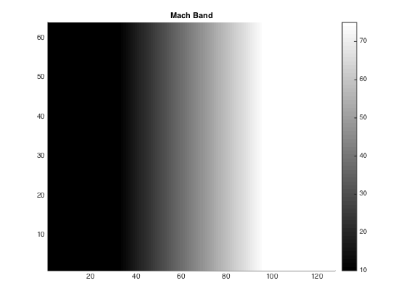

Brightness level of Mach Band Illusion horizontal slice

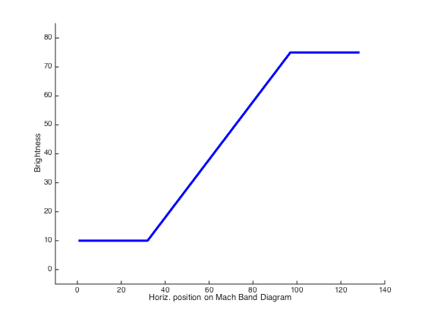

Receptive Field generated from Gaussian:

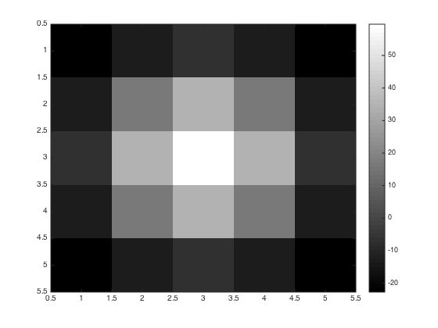

Mach Band Illusion filtered with receptive field

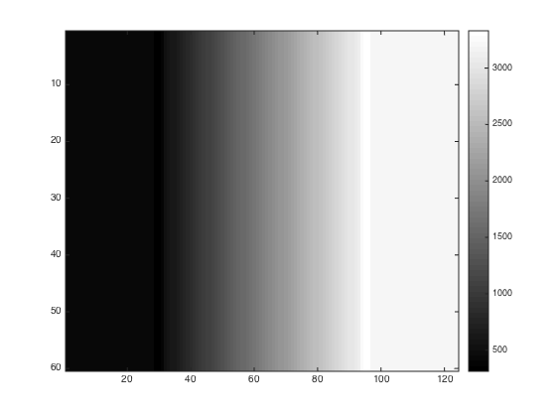

Brightness of filtered Mach Band Illusion:

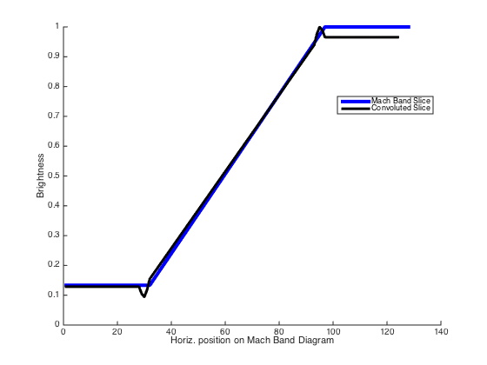

The original Mach Band Illusion and brightness plot below it show that while the increase in brightness is gradual, the human eye tends to perceive a more striking distinction of shade difference where the brightness derivative flatlines.

To simulate this, a 2D receptive field was generated as shown, based on a Gaussian distribution with the parameters provided in the instructions. This receptive field represents the “eye” as a filter, meaning convolution with the receptive field produces a result similar to what the “eye” sees. This yields the last two figures – the Mach Band illusion with truly (quantitatively) more distinct brightness peaks/valleys at the points where the brightness level flatlines.

I do think that this is showing a true property of the receptive fields (**at the retinal ganglion cell level**) and is not merely coincidence. Biologically, it would make sense that the eyes establish distinction when one reaches the end of a gradient for things such as edge detection. An interesting question would be how well the Mach Band illusion works for a darker gray to a lighter gray as opposed from black to white. Playing around with this myself, it appears that it holds true, though it’s a little bit less noticeable. Part 2.

Gabor Function:

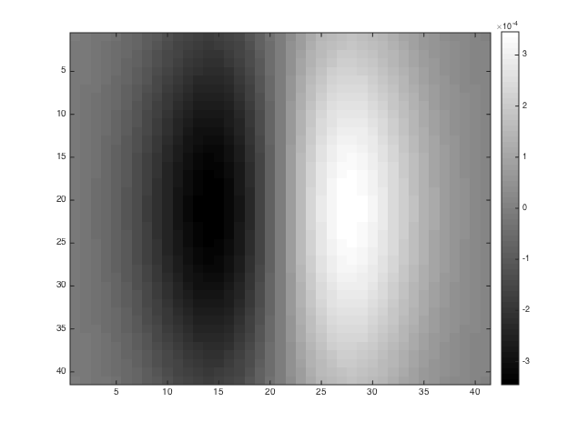

Rose convolved with different Gabor functions:

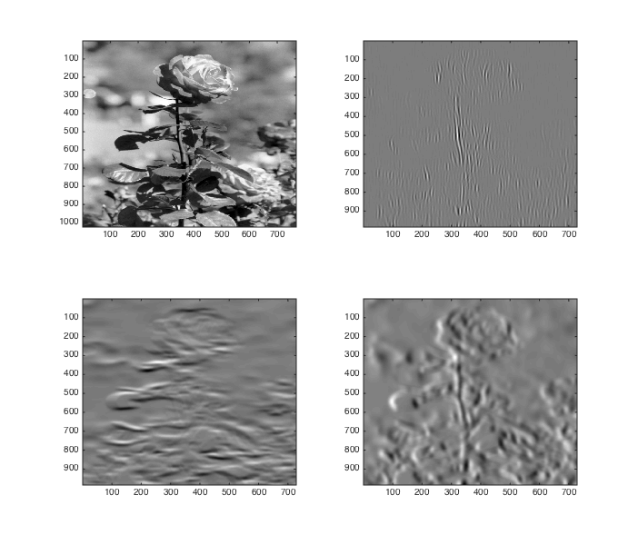

SF = 0.01, OR = pi/2

SF = 0.01, OR = 0

SF = 0.1, OR = 0

Original

Lower SF yields greater edge detection (though little noticeable difference from 0.001 under, not shown), and non-zero OR seems to distort the image. Interestingly, if you put the OR to pi, you see the exact same result as the OR of 0 but with the “3D orientation” flipped – what previously appeared to be going into the page is now coming out of the page:

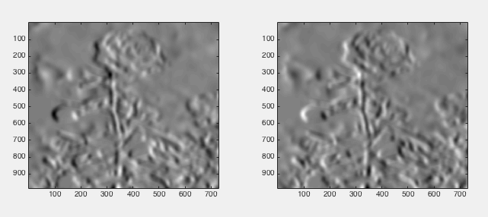

OR = 0

OR = pi

I believe what this is trying to show is that a diversity of neurons is needed in V1 to reproduce images properly. SF seems important for edge detection, while OR pertains to depth perception. Filtering through neurons with different combinations of these in V1 may be what allows us to perceive the details in images we process.

Part 3.

Quick notes: size = receptive field size, next page has figures

Holding size constant (0.25):

-lower SD ( < 0.15, SD = 0.1 in figure) causes the squares to appear somewhat crisper and gray to appear at the points of intersection [fig A]

-higher SD ( > 0.15, SD = 0.25 in figure) blurs it more, smaller squares, no gray at intersections [fig B]

Holding SD constant (0.15):

-lower size ( < 0.1) causes the squares centers to dim a bit, but gray shading appears at the point where normally the illusion occurs [fig C]

-higher size ( > 0.3) makes the squares become blurry circles; no illusion effect, no gray at the usual points [fig D]

Trying a lower SD for greater crispness (SD = 0.01):

-very high size (~.95) causes the gray to appear very evidently [fig E]

As I understand it, this model is explaining the illusion via lateral inhibition. We see the gray spots when we’re seeing them peripherally, which corresponds to a larger neural receptive field size. The field size determines how much of the image is being integrated into each “calculation” – photoreceptors would be *activated* by the white part of the image, but *deactivated* by the black, meaning if your size is large enough to integrate over both of these areas, some gray may emerge. This is what we see at the intersections, where the greatest black/white juxtaposition occurs.

For why they disappear: whenever you look directly at the gray spots, vision focuses, meaning that the receptive fields that are being activated have smaller areas of integration. This no longer integrates the black part of the image that the more peripheral view saw, meaning there’s no blend to produce the gray that we saw before.

**Comparing foveal and peripheral vision, peripheral vision uses larger receptive fields based on the figure. We integrate larger areas of photoreceptors with these, which allow the illusion to occur in our periphery. Because our foveal receptive fields are smaller, the illusion goes away upon focus to a point of intersection.**

Figures of what I described above are on the next page.

A: Size = 0.25, SD = 0.10 B: Size = 0.25, SD = 0.25

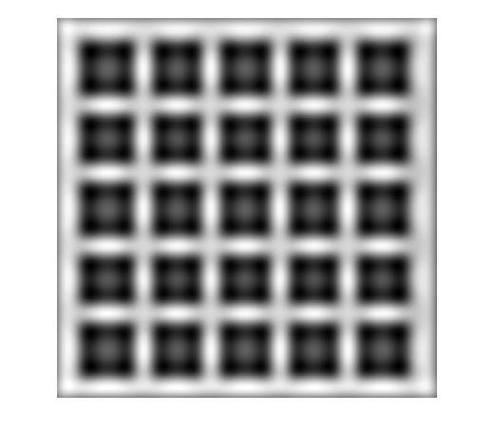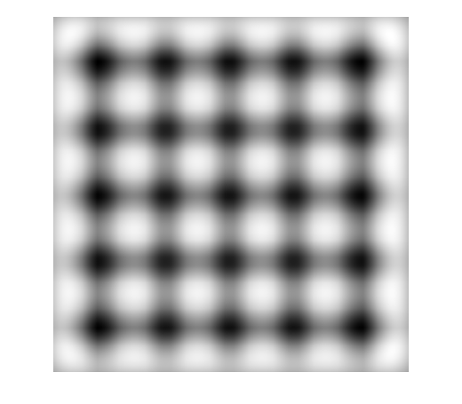

C: Size = 0.1, SD = 0.15 D: Size = 0.3, SD = 0.15

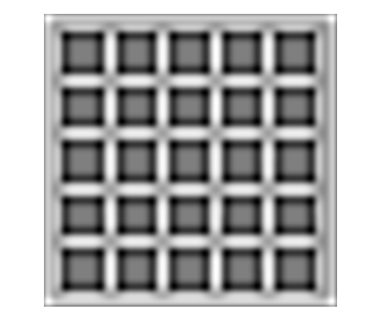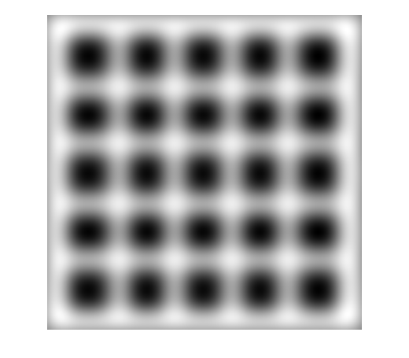

E: Size = 0.95, SD = 0.01

