Adam Smoulder

BIOENG 1580

MT Homework

1. Psychometric curve. I used cftool and got alpha = 0.119, beta = 3.266:

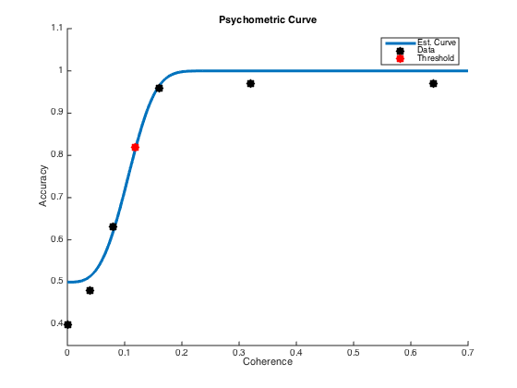

2. Neurometric curve. Once again, used cftool after ROC analysis,

alpha = 0.175, beta = 1.086:

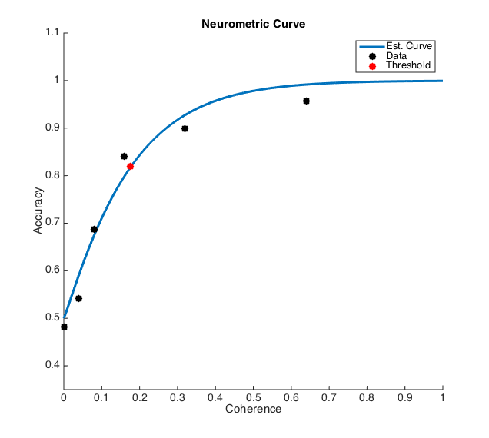

While I don’t think the question explicitly asks for it, I want to talk about what this shows for a second. Alpha value corresponds to threshold, and beta corresponds to the slope of the curve (sensitivity). What we see from these results is that the individual neurons appear to be, in this case, both less sensitive (lower beta) and worse at stimulus recognition (higher alpha).

3. I pretty much followed the method you suggested; I split the two neuron’s data up between left and right and created separate variables for each neuron’s choices. I iterated over the MT data for each coherence value and wrote FRs for right decisions to the Right-Neuron Right-Choice (RN_RC) and Left-Neuron Right-Choice (LN_RC) variables; if a left decision was made, it was saved to left choice variables (RN_LC, LN_LC). FR values in each were sorted based on the quantity of left or right decisions for the given coherence value. From here, it was ROC analysis for the left and right choice separately.

One point of some confusion was whether or not this analysis should have left decision ROC curves flipped with parameters with respect to right decision ones. For right decisions, like in #2, the ROC curve uses the left-neuron FR as the null-distribution (x-axis) and the right-neuron FR as the preferred distribution (y-axis). Since the left decision is what is being looked for, the left distribution would be “preferred”, so I used it as my y-axis. Result was:

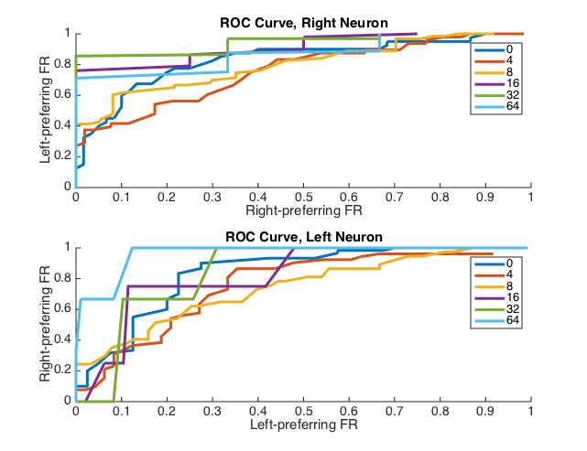

While the curves themselves for the left choice look pretty normal, it’s interesting to notice how higher coherence values actually yield worse prediction results for that. The right choice curve (correct decision) follows the opposite trend, as seen both above and in #2; this makes sense, as certainty about correctness increases with higher coherence, yielding higher FR. This difference in trend can be explained by the fact that, as coherence increases (towards the right side, as all of these trials only had rightward coherence), certainty towards the right probably increases, meaning leftward prediction would go down. The (rather trial limited) probability distribution looks like so:

8 bin histogram

Mean = 0.73

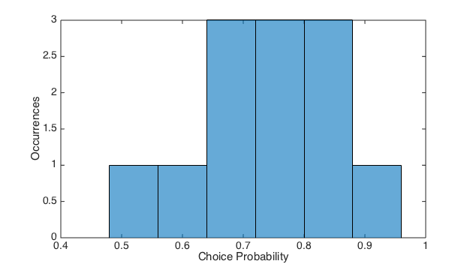

This would imply that the monkey’s neurons that we measured only predict his response 73% of the time.

4. To quantify bias, we would have to look at which direction the monkey prefers under no directional stimulus. 60 out of 100 of the trials with 0% Coherence showed a choice to the left, so I would say there is some **leftward bias!**