Adam Smoulder

BIOENG 1586

Reaching Homework

Part 1: Movement stuff

1. Loaded the data successfully. Woo!

2. By inspection (loaded data then displayed variable), coordinates are given as (x,y) in mm:

targets = [-98 -17; -86 50; -64 -76; -34 93; 34 93; 64 -76; 86 50; 98 -17];

3. Took a bit of data finagling but I think I got it to work. Points are the targets:

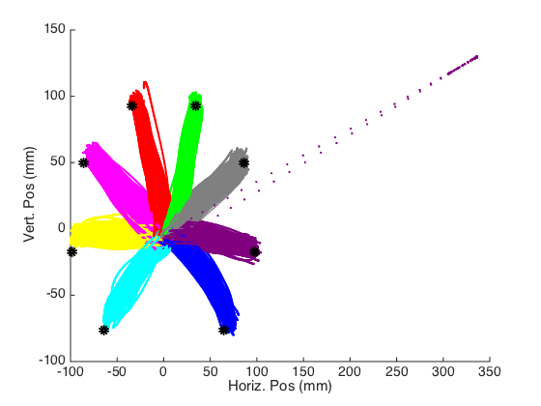

The one trial with the crazy far out point is #1739. Not sure what happened there.

5. (No number 4?) Done; reaction time (RT) was calculated to be 289.7±22.45 ms.

6. Let’s use α=0.05. Here is a table summarizing the means and stds of each to start:

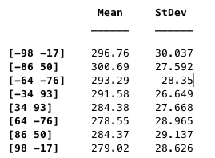 With the target location being the far left column.

I used one-way ANOVA to analyze significance in difference between RTs among targets; the result was an overall p-value of 1.50x10-46, which is a pretty strong indicator that these means are not equal if the analysis was done correctly. Full ANOVA table is below:

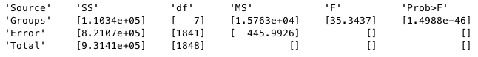

Using the “multicompare” command in MATLAB (default α=0.05), we can look at which individual trials are different than others. Here are the confidence intervals (CIs) of each target, where target number (y-axis) corresponds to the following targets and x-axis is reaction time:

[-98 -17; -86 50; -64 -76; -34 93; 34 93; 64 -76; 86 50; 98 -17]; See below

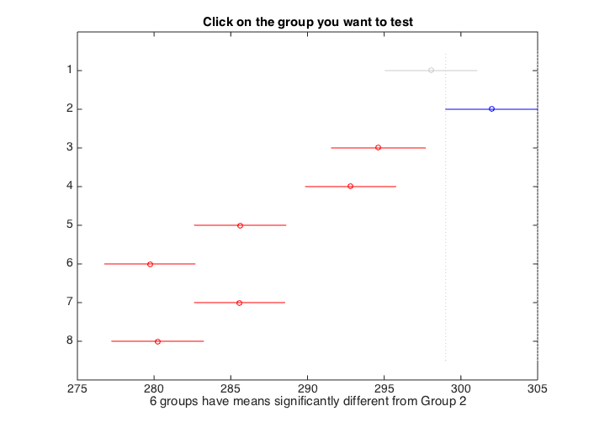

**8**

**7**

**6**

**5**

**4**

**31**

**2**

**1**

Shown here is an example of how the tool works, along with a picture of the labeled targets for reference; you can select one CI (blue), and the figure will show which groups are significantly different (red) based on the decided significance value and which are not (gray).

Significant differences are observed between the following groups:

Target 1: 5,6,7,8

Target 2: 3,4,5,6,7,8

Target 3: 2,5,6,7,8

Target 4: 2,5,6,7,8

Target 5: 1,2,3,4

Target 6: 1,2,3,4

Target 7: 1,2,3,4

Target 8: 1,2,3,4

Recall that target order is oriented based on horizontal position, meaning targets numbered 1-4 are leftward saccades while 5-8 are to the right. Each target from one side is significantly different from all on the other side. All rightward saccades (targets 5-8) are deemed equal by this analysis. The same applies on the leftward saccades for targets 1, 3, and 4. Target 2 has a greater reaction time, leading it be significantly different from targets 3 and 4 by this analysis. By this, we would say that the monkey has significantly lower reaction time for rightward saccades.

7. I calculated monitor latency to be timeGoCuePHOTO – timeGoCue, and got 18.9±4.89 ms. By this, refresh rate would be ~53Hz.

8. This looks really ugly but it gets the point across:

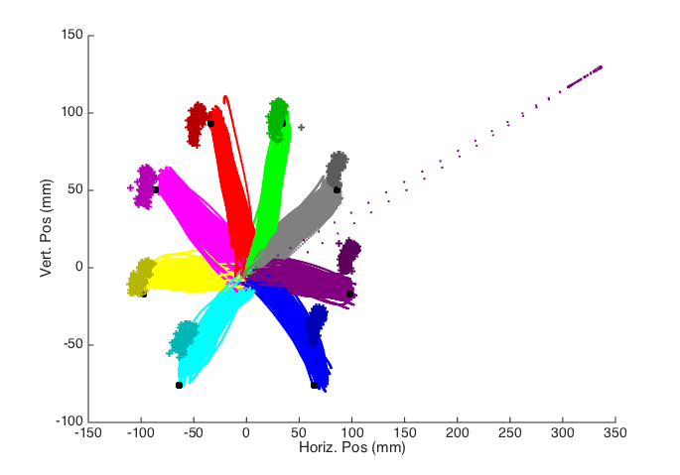

Where the slightly darker colored + marks are average eye locations for each trial. In general, he appears to look towards the target, though for the lower/right targets he seems to look a little higher.

Part 2: Neural Stuff

1. Rasters and all that jazz:

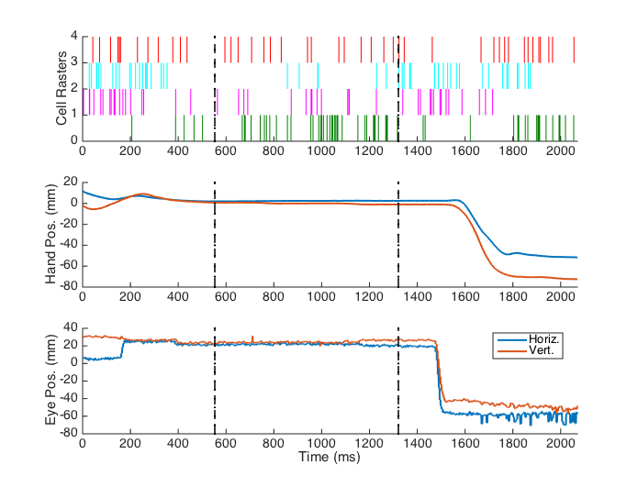

Where the first dotted line is the appearance of the instruction cue and the second is when the monitor displays the go cue. The eye position can be seen to be a great deal more noisy than the hand position, probably because the eyes move a lot faster and require small amounts of motion to maintain fixation.

Just looking at the eye and hand positions, we see that (after RT has passed) the eyes move to the target area first (in this case, target 1) followed by the hand with some delay. From just the rasters, it’s hard to tell the relationship between neural activity and the movements. Activity sporadic but comparable across the board when looking between neurons, which isn’t really what I’m expecting… let’s try some PSTHs.

2. See next page for PSTHs

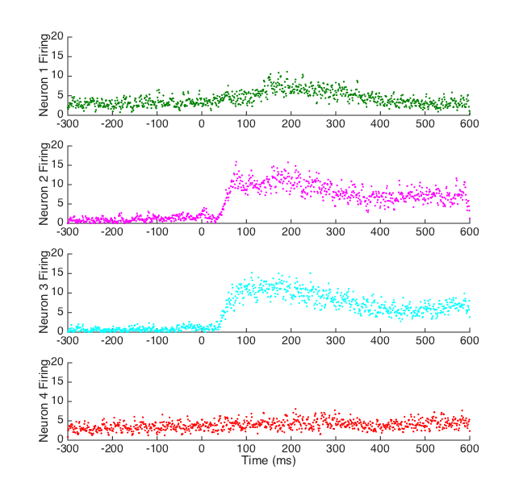

(y-axis should say firing rate ) Looking at the two that showed strong responses (2 and 3), latency looks to be ~50ms. Neural signal processing requires chemical reactions to occur based on stimuli that occur. In this task, the eye needs to perceive that the target has appeared before anything else. The neurons shown here are located in the brain (unspecified where? Presumably M1?), meaning there is at least some processing time for the chain of signal transduction to occur before these specific neurons get activated.

3)

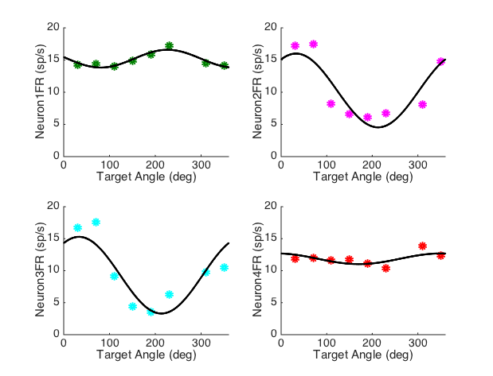

So by the looks of it, the peaks for each neuron are around:

Neuron 1: ~230 degrees

Neuron 2: ~70 degrees

Neuron 3: ~70 degrees

Neuron 4: ~330 degrees

Meaning these are the preferred angle stimuli!