Adam Smoulder

BIOENG 1586

Spike Sorting Homework

1. So here’s what we got to look at:

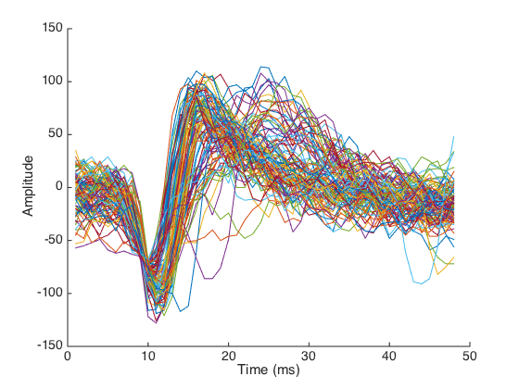

If I had to stab at a guess of how many neurons there are here, I think I’d argue for maybe two? Definitely the one that we see going low around 10ms and high around 17ms is viable, but there also looks like one with a higher end peak around 25ms.

2. Looks like 3ish now! The yellow, one above, and one kinda inbetween to the left:

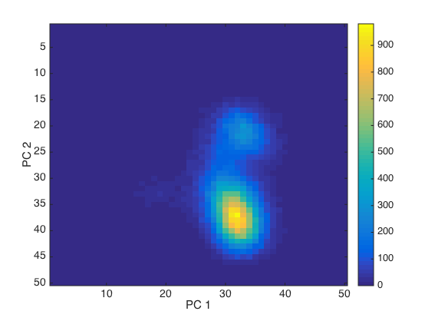

Let’s look in 3D:

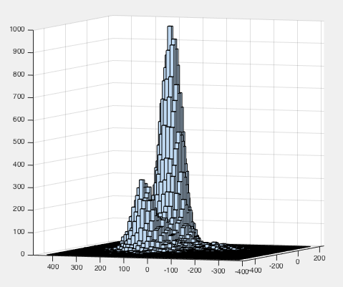

So we can justttt see that third neuron popping up on the left side! So **k = 3!**

3. and 4.

k = 3

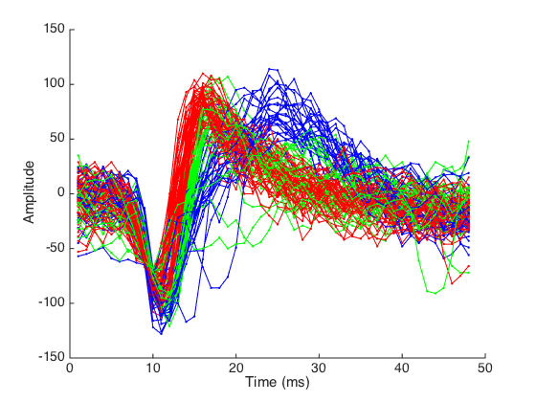

K = 3 seems pretty legit!

5. The coefficients we got from PCA are the principal components and already have a magnitude of 1 (so they are unit vectors). The only step then would be to plot the values of each PC along the same 48-point axis as the original:

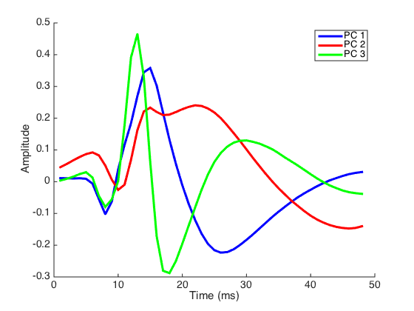

The PCs look almost like the shape that the neurons’ readings were but a bit stretched. The first and third PCs also have a more similar shape than the second does, though all are generally the same (dip down around 10ms, go up aver, dip down again later)

6. So here’s the percent of variance explained as a function of the dimension #:

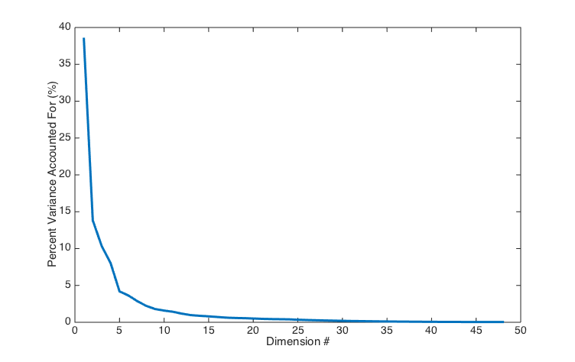

From a quick look, I’d say the “elbow” that you speak of looks like it’s around 5 or so.

To get a measure of where that 90%-accounted-for point is, I have a plot of the cumulative sum of this previous figure:

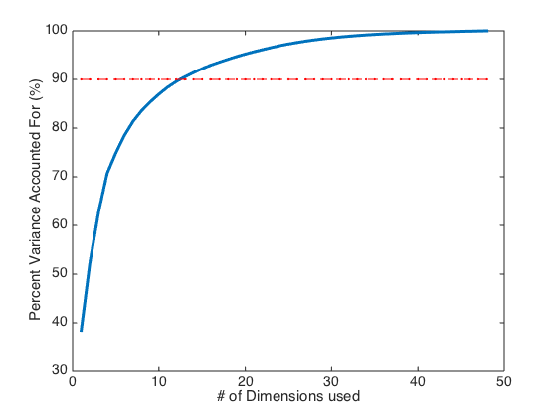

It takes **13 dimensions** to get over 90% variance accounted for. Though that’s a lot of dimensions

7. So I did it with both k = 2 and 3; not sure if this was exactly what you were looking for, let me know if something should be done differently. For k = 2

k = 3

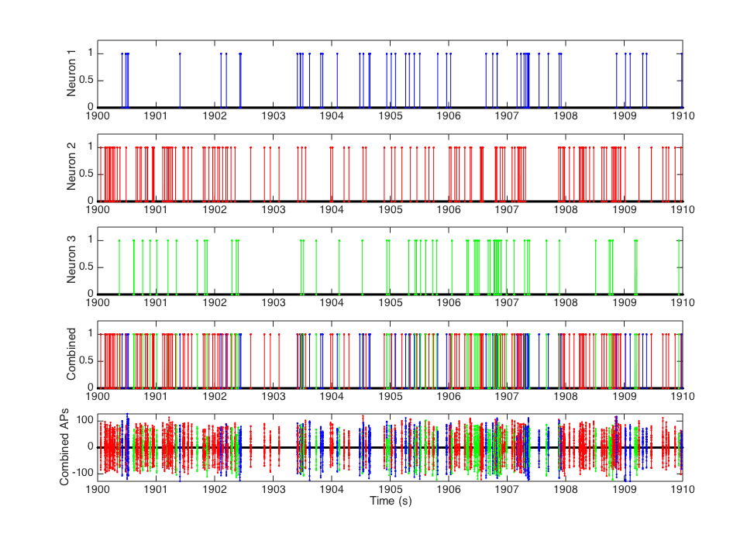

The top graphs in the subplot are just short rectangular pulses at each of the timestamps for the given neuron selected. The bottom actually shows the overlaid waveforms.

8. ISI histograms: First, I used a 1000 bin histogram on each ISI for k = 3

k = 3:

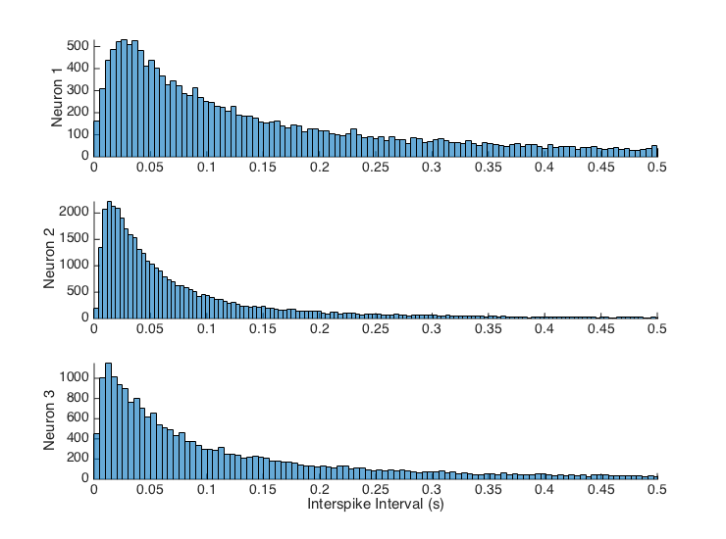

Then, I tried a 10000 bin histogram on k = 3 (note the x-axis is zoomed in)

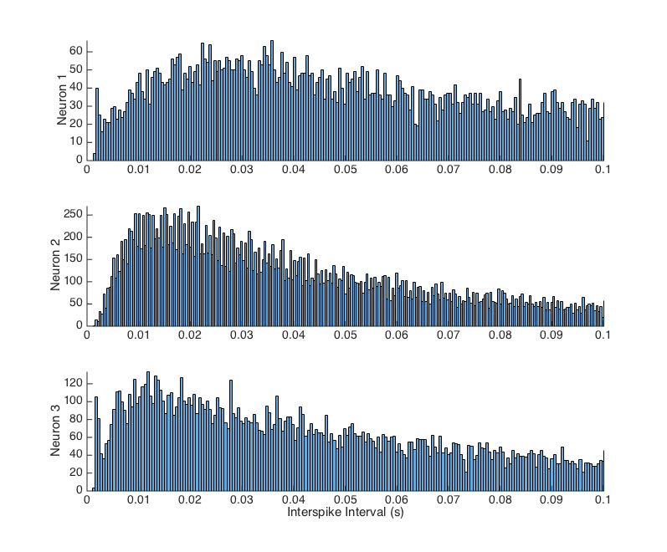

The minimum ISI for each neuron was 0.015, which about lines up with the refractory period of neurons (1-2ms). The leftward-leaning center of the histograms for all is also encouraging, as the neurons in use are probably firing many times in a row, meaning the refractory period (or time around it) would be what is limiting the ISI. If we did see ISIs under the refractory period, we would know that there must be another neuron at play that we are not taking into account. Mean neuron ISIs were 0.179, 0.102, and 0.231s.