**Game Design Document**  
  
**Bit**

Adam Spice

Overview

# INTRODUCTION

This 2D side scrolling platform game chronicles the adventures of Bit, a simple Bit like character, as he tries to get through the levels by collecting bytes and squishing enemies to unlock the portal.

DESIGNER’S STATEMENT  
Bit utilizes elements from many successful games in the platformer genre to create a fun puzzle game with high replay value. The character is simple and easy to control. The goal is to complete the tree levels with the highest score possible before the timer on each level runs out.

About

GENRE  
Puzzle platformer – In this game, you navigate levels using a side-scrolling view. The entire level is built with each object in place, but players only see a portion of the level. This is done by having the camera view follow the character’s movements. Players will not be able to move the camera on their own.

TARGET AUDIENCE  
This game is for everybody. It will appeal to both seasoned gamers and those new to the hobby. The target age is 5+ and is not specific to any gender.

ART DIRECTION  
Bit will contain a simple art style with cute characters and simple environments. The main goal of this game is to make it playable and appealing to all manner of people, so our focus will be on the sprites (characters) and actual level layout (vs. artistic merit). Our main character doesn’t have much in the way of a body, so we must rely on visuals to make the player care about their fate.

  
The main character

SIMILAR GAMES  
Bit is similar to Super Mario Brothers in that the main character squashes his enemies and collects bytes. It is It is also a platformer, which is the same genre of these titles.

Game Elements

STORY  
Our man character Bit lives inside a PC’s CPU. He carries out his day to day life following the instructions given to him by central command. On this day though, Bit notices that something is different, and blobs have begun to appear, and this is a sign of a virus taking over the system. Bit must squish all blobs and do his part to help save central command. He also knows he has to save enough bytes from corruption by picking them up.

CHARACTERS

Our main protagonist is Bit. He is a simple Bit like character that can move, and jump. He can collect bytes that will unlock the level portal.

ENEMIES

|  |  |
| --- | --- |
| The main enemy of the game is the Blob. As far as Bit is concerned, they are dumb stupid things that need to be squashed by jumping on their head. The truth is that Blobs are a bit smarter than Bit thinks. They will move in one direction until they hit a wall and then turn and go the other way. If Bit touches them in anyway except from above its instant death for him. |  |

INANIMATE OBJECTS

In addition to Artificial Intelligence (AI)-controlled creatures and objects, there are also inanimate objects in the environment with which to interact. These objects will appear in the levels unobtrusively and in some circumstances need to be collected to advance.

|  |  |
| --- | --- |
| Bytes |  |
| Portals |  |

Game Structure  
CONTROL  
Bit only moves left, right, or up by jumping off the ground. Players input the left and right arrow or the ‘A’ or ‘<--’ and ‘D’ or ‘-->’ keys to move left or right, respectively. Jumping is done by pressing the ‘space bar'. To pick up a byte Bit just needs to touch it. To kill an enemy Bit needs to jump on top of it, this will give Bit a jump boost to get hard to reach bytes.

MECHANICS

Bit needs to kill an enemy to get some of the higher placed bytes in the levels. Portals won’t unlock if the levels byte target has not been reached. If the timer runs out, you fail the level.

HEALTH/RESPAWNS

You don’t really have any health, as such one touch = death. When you die, you can choose to retry the level and you will respawn at the beginning. There is no limit to the number of respawns your character has, so you could try multiple ways to defeat a level.

LEVELS

The game takes place inside a CPU at the atomic level. Players progress through the levels by collecting bytes to unlock portals. As you navigate the levels, you eventually make your way to the third level. This is the boss level and here you must squish enough enemies to unlock the portal while surviving wave after wave of enemies.

LEVEL 1 – THE BEGINNING

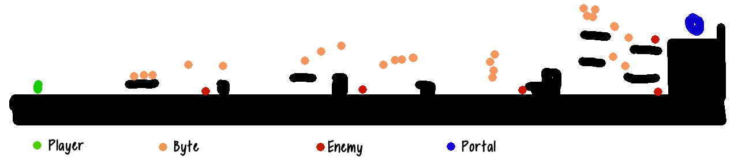

The above is a design sketch of level 1. Bit starts on the far left of the level and must get to the portal on the far right. There are five enemies in the level, and they will not begin to move until they’re displayed on screen. This makes for some interesting effects like enemies falling on your head etc. This is the simplest level, and any player should be able to complete it.

LEVEL 2 – A BIT HARDER

Level 2 differs from level 1 slightly as the portal is located on a platform in the middle of the level. There are 6 enemies this time and more bytes than you need to collect. This level is also simple, albeit slightly harder than level 1.

LEVEL 3 – THE FUN BEGINS

Level 3 is very different from the other two. It’s by far the hardest level. Enemies enter the level in waves and will go left or right on spawning. They also vary their speed to make the harder to squish. Bit will need to squish a significant number of the them to complete the level.