

SCHOOL OF INFORMATICS & IT

CIA2E01 Text & Social Media Analytics
Project Solution (Individual)
AY2024/2025 Oct Semester

Student Name (Matric Number) : Adam Haizad (2302276G)

Practical Group : PC02
Jenny LING (TP)
Tutor : Mr Surojit Dutta

Submission Date : 16/02/2025

Declaration of Originality

I am the originator of this work and I have appropriately acknowledged all other original sources used as my references for this work.

I understand that Plagiarism is the act of taking and using the whole or any part of another person’s work, including work generated by AI, and presenting it as my own.

I understand that Plagiarism is an academic offence
and if I am found to have committed or abetted the offence of plagiarism in relation to this submitted work, disciplinary action will be enforced.

Declaration on the use of Generative AI tools for assignments

Describe how you have used Generative AI tools such as ChatGPT or Dall.E- in this project.

Share the link to the conversations you had with the AI tool (i.e., the prompts you used and the responses you get from the AI tool).

Please refer to this PDF on “How to share the conversations made with ChatGPT?”
OpenAI. (2024). ChatGPT (Feb 13 version) [Large language model]. [Determining threshold for occurrences].
https://chatgpt.com/share/67afee0d-6004-8001-ac12-0e2bbaa6f9a6

How do you indicate the reference?
The content generated by AI tools are not retrievable except by the user who generated them, so they are considered non-recoverable sources. Although non-recoverable data or quotations in APA Style papers are usually cited as personal communications, with ChatGPT-generated text there is no person communicating. Quoting text from ChatGPT chat is therefore more like sharing the output of an algorithm, with a reference list entry and the corresponding in-text citation.
According to the official APA Style site, ChatGPT references should be cited as:
E.g. OpenAI. (2024). ChatGPT (Feb 13 version) [Large language model].
https://chat.openai.com/chat

Note: The information in parentheses refers to the update or revision date of the model used. Refer to the release notes in the ChatGPT application.

Important Note:

- Do not copy answers produced by the AI tool in totality as it is considered as plagiarism.

- Do not rely on any information produced by the AI tool blindly. You should always verify the answer with other sources. Do not assume that these answers provided by the AI tool are correct.

- To achieve quality outputs from the AI tool, you should provide good prompt that is clear and specific. Be precise and provide context. Avoid asking open-ended questions.

Reiteration of problem statement and background (from proposal)
To comprehend audience sentiment and interaction with the Christmas movie Red One, this research examines Reddit comments. Through an analysis of user discussion, we hope to ascertain how audiences perceive the movie, whether their responses are positive, neutral or negative, and which elements—like the storyline, characters, action scenes, or holiday themes—are most often brought up. By examining the connection between sentiment and upvotes, we also aim to gauge engagement. Sentiment analysis will shed light on how the movie was received overall, important conversation topics will assist determine what appeals to audiences the most, and engagement analysis will show how audience interaction differs depending on the sentiment. A better grasp of audience perception and Red One's level of viewer connection will be provided by this study.
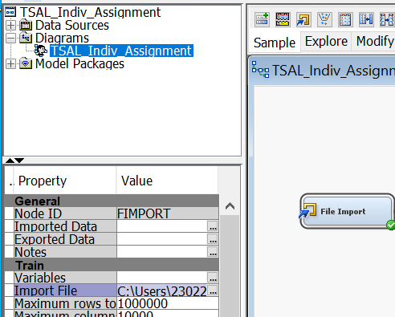
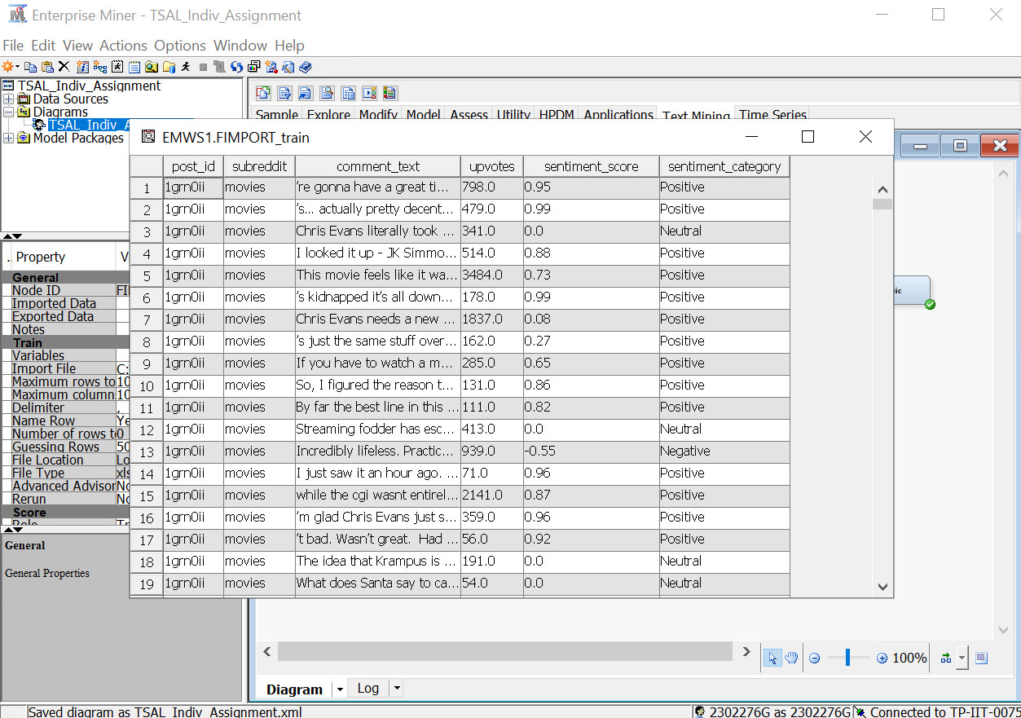
Create Project and File Import Node

I created a project named TSAL_Indiv_Assignment and created a new diagram and then added a file import and load the dataset in.

Text Parsing Node
I then added a text parsing node and ran the node with default settings to check if any terms should be added to the stop words list.
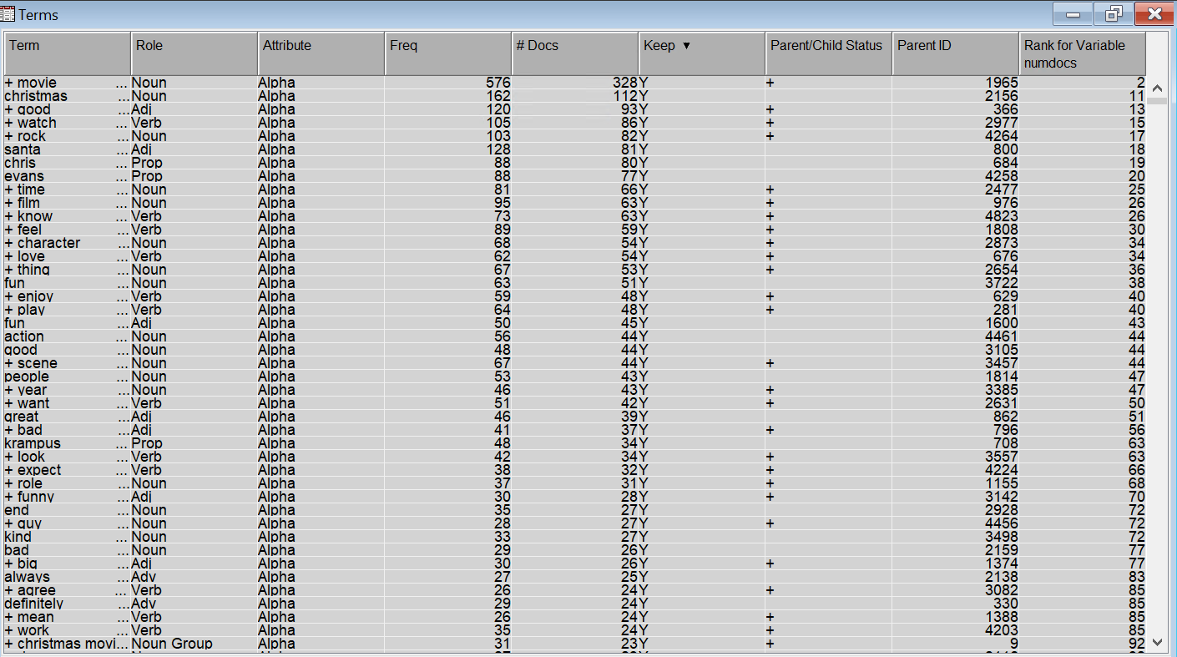
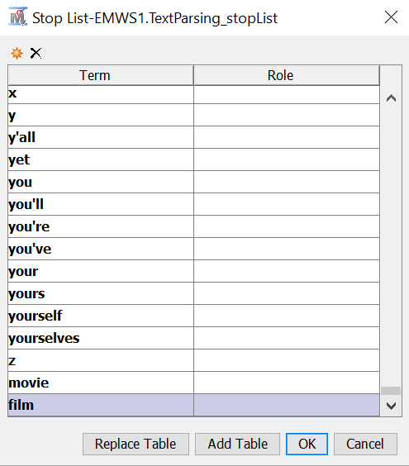
This is the raw data from the text parsing results using the default settings.

I found after looking over the raw data that several words, such as movie and film, don't add anything significant to the analysis. The understanding of sentiment, themes, or trends is not enhanced by these overly general phrases that are used frequently in various comments. I added movie and film to the list of stop words to improve the quality of the text analysis. This ensures that the analysis concentrates on keywords that are more relevant and informative.
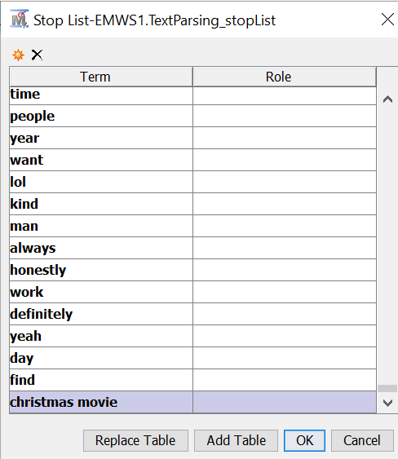
Backed by ChatGPT https://chatgpt.com/share/67afee0d-6004-8001-ac12-0e2bbaa6f9a6
I noticed that stop words were still present in the analysis while going over the data such as people and day. It was not practical to individually review each word for relevance due to the enormous number of words. As such, I used a 30-occurrence threshold as a filtering criterion to expedite the process, which was ChatGPT's recommendation. By removing excessively common but useless phrases, this approach guarantees that only significant terms stay in the analysis.
Stop words I added: Thing, know, time, people, year, want, lol, kind, man, always, honestly, work, definitely, yeah, day, find, Christmas movie
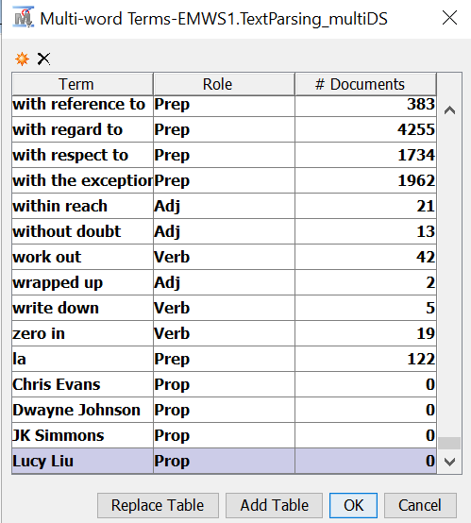
I combined the names of the main actors, including Chris Evans, Dwayne Johnson, JK Simmons, and Lucy Liu, into a single word to increase the text analysis's accuracy. This prevents their names from being broken up into separate words, which can cause context to be lost. The analysis can more effectively capture interactions and discussions between the actors if they are treated as distinct entities.

Text Filter Node
To improve the text preprocessing even more, I included a Text Filter node. By identifying and managing synonyms inside the dataset, I was able to make sure that terms with similar meanings were handled consistently.
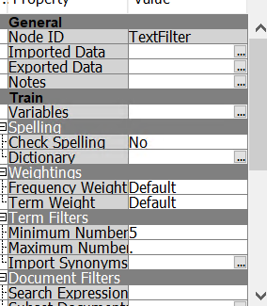
I modified the Minimum Number filter on the Text Filter node from 4 to 5. By making sure that only keywords that occur in the dataset at least five times are retained, the modification aids in the removal of extremely infrequent terms that might not offer useful information. By reducing noise from uncommon or outlier terms and focus on more often occurring important phrases by changing the threshold, I hoped to enhance the overall quality of text analysis.

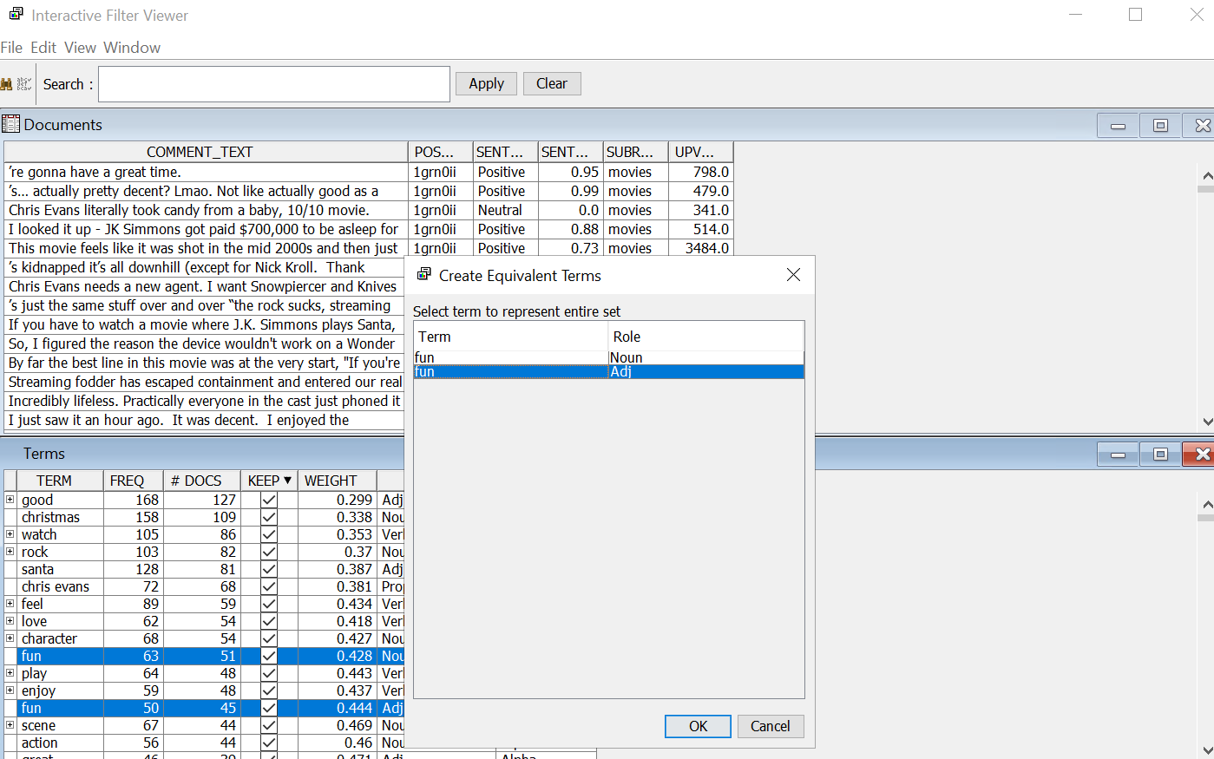
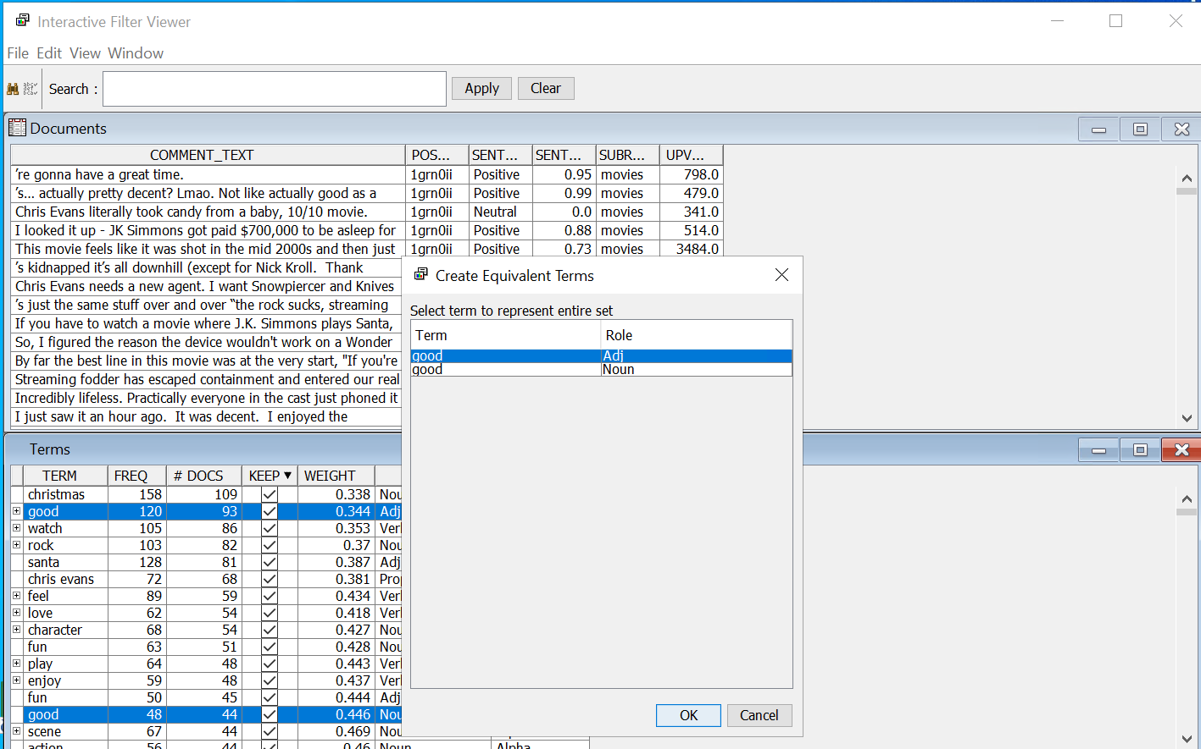
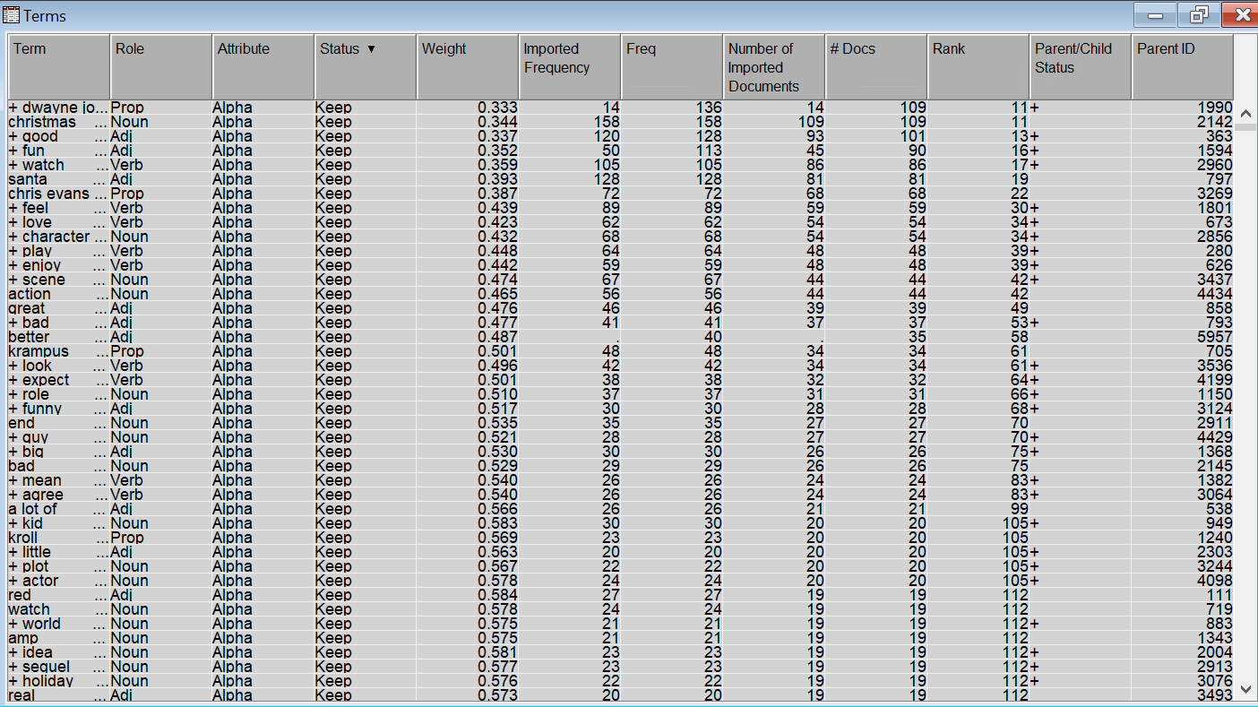
To improve consistency, I grouped synonyms in the Text Filter node using the Filter Viewer setting. Since "good (Adj)" is more frequently used to discuss films and performances, I chose it as the representative term and made "good (Noun)" and "good (Adj)" synonyms. I merged the words "fun (Noun)" and "fun (Adj)" to describe "fun," selecting "fun (Adj)" since it more accurately captures the descriptive aspect of experiences. To guarantee consistency when referring to the actor, I also combined the terms "Dwayne Johnson," "Rock (Prop)," and "Rock (Noun)" into a single synonym set and chose "Dwayne Johnson" as the representative term to ensure no confusion between rock and the actual rock. By making these changes, term fragmentation is avoided, and text processing is enhanced.

These are the results of the Text Filter once synonyms have been added. I identified common phrases using TF-IDF weights to further narrow down the selection. Because they were too common to offer significant distinction, words with weights less than 0.3 were eliminated. I went over each term with a weight between 0.3 and 0.5 by myself to see if it belonged on the list of stop words. However, following review, no further terms were required to be eliminated because every word was either over 0.3 or relevant to the analysis.
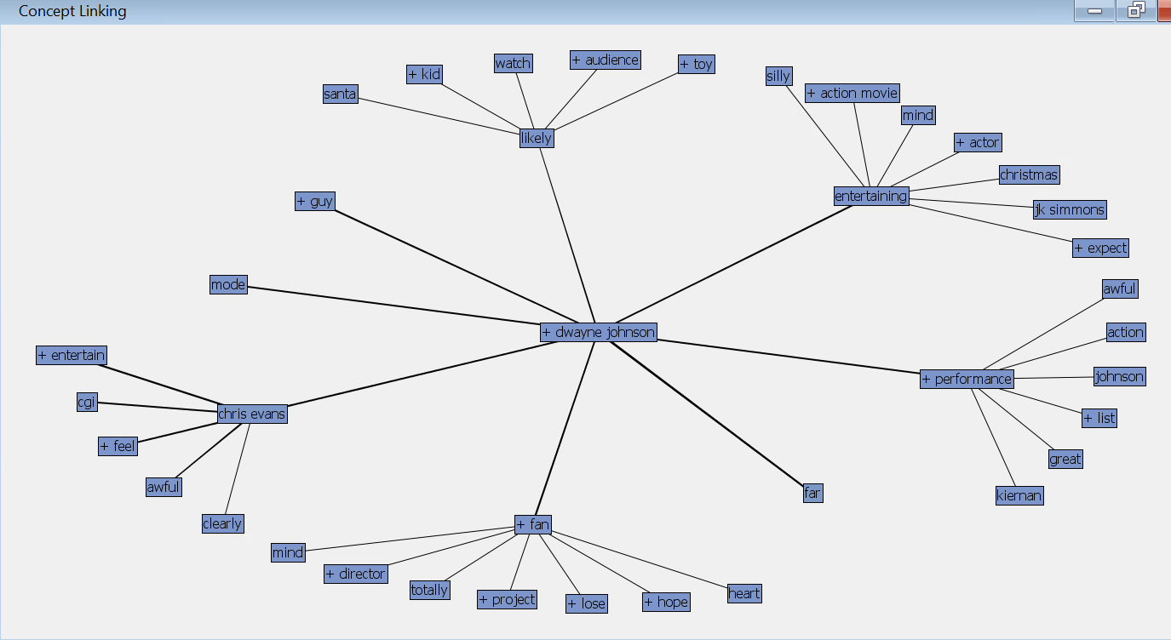
After that, I made a concept link for Dwayne Johnson because the term appears a lot in the data. I can recognise important phrases and ideas related to him in the movie as a result

The concept link diagram displays the connections between "Dwayne Johnson" and other terms that commonly occur with him in the text. All the nodes—such as "Chris Evans," "entertaining," "fan" etc.—are topics that people frequently bring up in conversation with Dwayne Johnson. In comments or evaluations, a stronger or thicker relationship signifies a higher co-occurrence. For example, "performance" and "entertaining" imply that people frequently discuss Dwayne Johnson's acting, and "Chris Evans" and "Dwayne Johnson" are connected because they are co-stars. Overall, the concept link highlights the main topics that people directly relate to Dwayne Johnson in their comments, ranging from co-stars and the festive setting of the movie to both positive and negative adjectives.

Text Cluster Node
After that, I included a Text Cluster node to find trends and organise related comments according to their content. This stage groups terms that appear together frequently to assist find underlying themes in the data. By examining these clusters, I can learn more about the text's prevailing debates, recurrent viewpoints, and connections between various ideas.
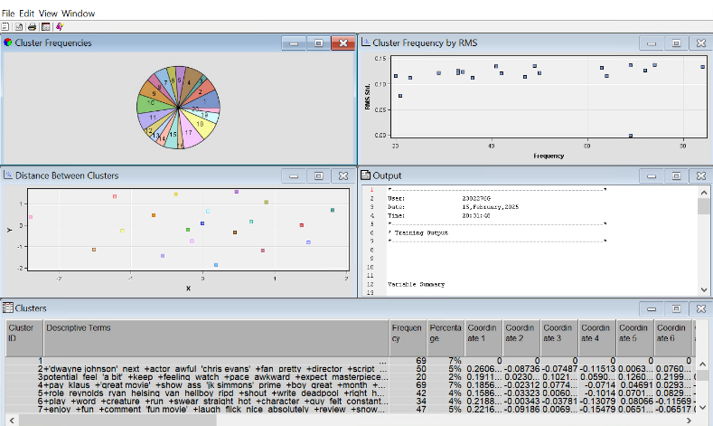
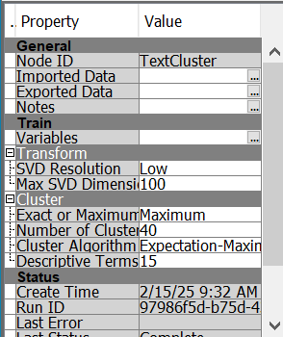

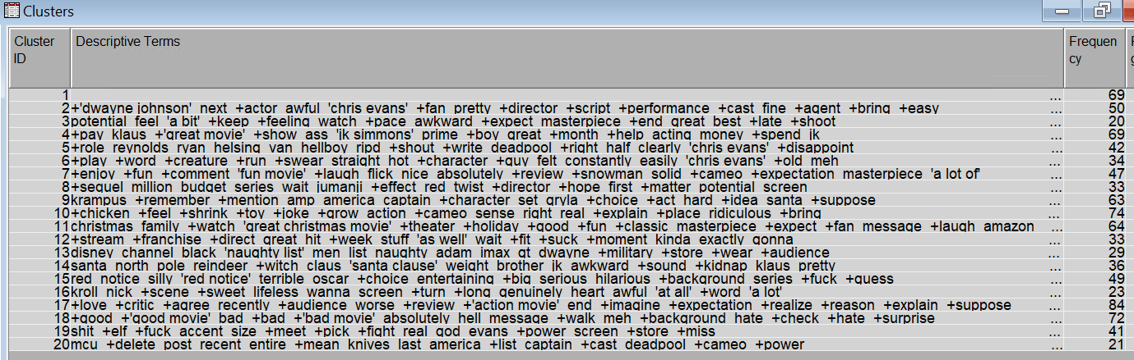
When the Text Cluster node was run with its default settings, the results ended up overlapping—many clusters concentrated on almost the same ideas—and one cluster seemed "empty" since there were no distinct words that could adequately describe it. When too many clusters are allowed, small, repetitive groupings naturally emerge, and when documents are too brief or lack common keywords, the algorithm is unable to assign meaningful descriptors. For example, Clusters 9 and 14 focused on the Christmas theme, essentially expressing the same conversation from somewhat different perspectives.

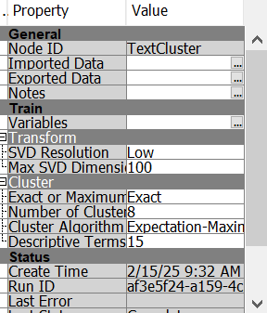
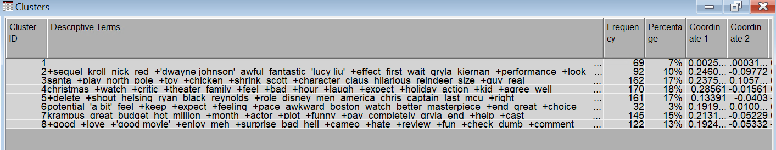

The Text Cluster node still produced one empty cluster and some overlapping clusters even after changing the number of clusters to 8 instead of 40 and to exact instead of maximum. Holiday references, for example, were central to both Clusters 3 and 4
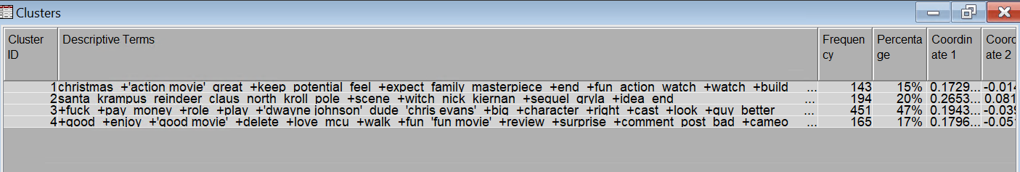
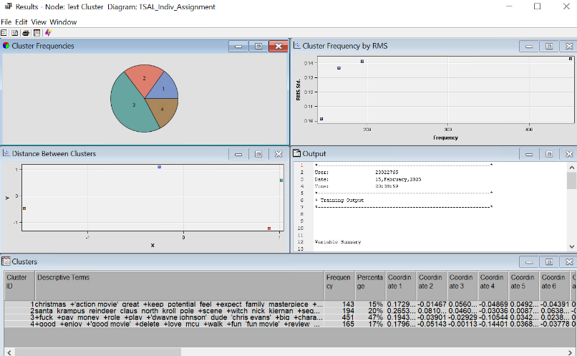

Four unique groupings—none of which are empty—are now formed by lowering the cluster count to four, and there is significantly less overlap between them. You no longer observe an empty cluster or several clusters repeating the same theme since each cluster contains a distinct set of descriptive phrases (such as "Christmas," "Santa/Krampus," "Dwayne Johnson/Chris Evans," and "Good Movie/MCU") that concentrate on distinct topics. Without losing significant distinctions, this more straightforward structure facilitates the interpretation of the topics that people discuss most frequently.
Text Topic Node
I placed the Text Topic node after the Text Cluster node to refine the analysis even more. While the Text Cluster node arranges documents based on similarity, the Text Topic node finds frequently occurring terms in the dataset to extract significant topics. This allows for a more in-depth examination of the subjects being discussed and goes beyond merely grouping comparable texts. By using both to analyse how comments are grouped and the topics that show up inside those clusters, it will be possible to have a better understanding of the dominant themes in the data.
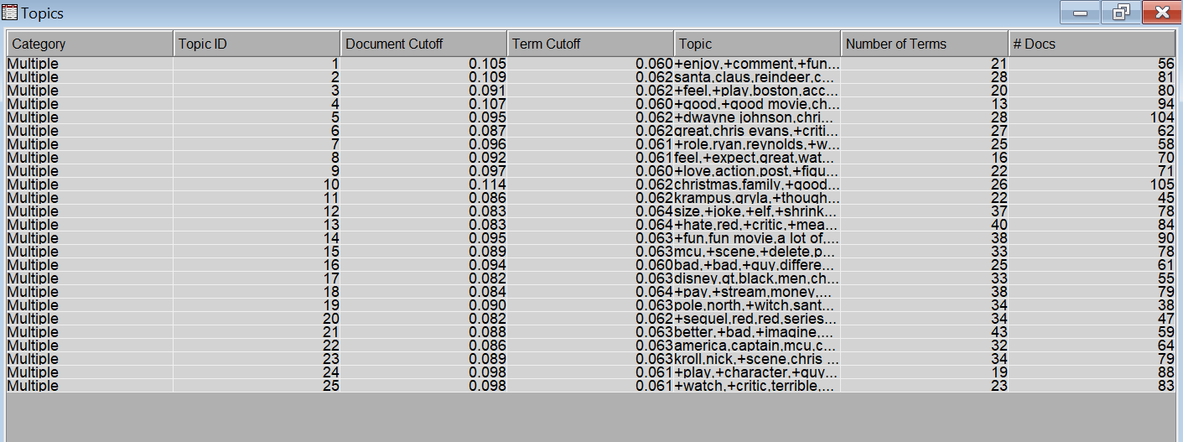
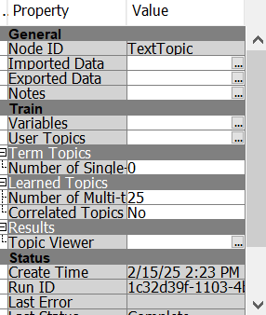
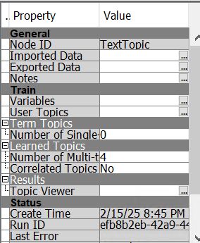
The Text Topic node had 25 multi-term topics when I ran it with the default settings. As a result, there was an extensive amount of overlap among the subjects, which weakened their uniqueness. For instance, Topic 2 (which uses terms like "santa," "claus," "reindeer,”) and Topic 19 (which uses phrases like "pole," "north,") both centre on comparable holiday references, which makes them seem redundant. Similar sentiment or enjoyment terms are shared by Topic 1 (which includes the words "enjoy," "fun," "comment," and "fun movie") and Topic 4 (which includes the words "good," "good movie," "enjoy," and "love"). The high number of topics likely contributed to this redundancy, making it necessary to adjust the settings for clearer topic separation.

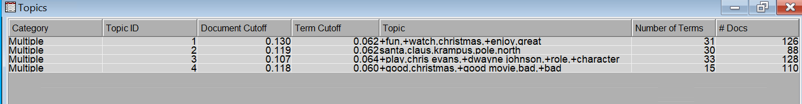

To align with the topics, I lowered the number of multi-term topics to four, which simplified comparisons and decreased overlap. With 25 themes in the past, several of them used terms that were similar, which made insights unclear. Text Topic finds themes that appear repeatedly in different sources. For instance, Topic 1 is about the enjoyment and fun (fun, watch, enjoy, amazing), Topic 2 discusses Christmas (Santa Claus, Krampus), Topic 3 is about actors (Dwayne Johnson, Chris Evans), and Topic 4 is about reviews (good, bad, good movie). Although helpful for identifying trends, some overlap still exists.
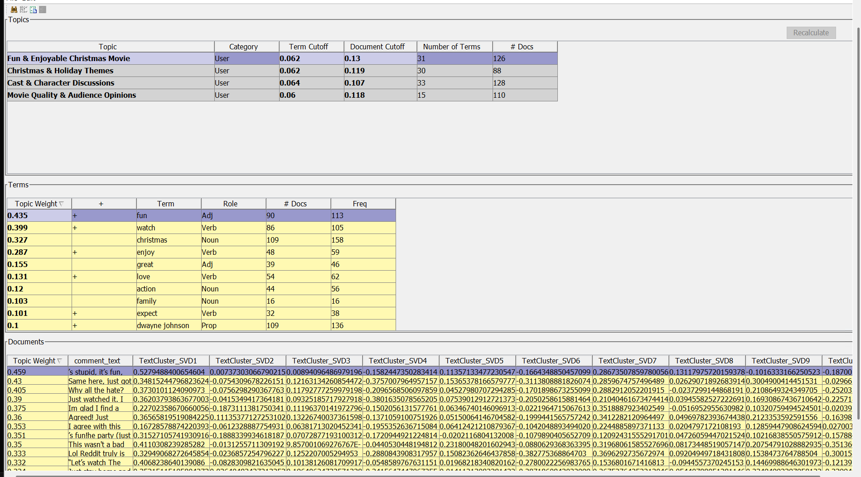
In contrast, Text Cluster does not extract themes; instead, it organises documents according to similarities. similar subjects are also reflected in the clusters; for example, like Topic 1, Cluster 1 captures broad conversations regarding the film's entertainment value. Cluster 2 contains Christmas themes, which is like Topic 2, while Cluster 3 and Topic 3 both centre on actors. Topic 4 and Cluster 4 also have to do with sentiment and reviews. There is no absolute superiority between the two approaches because they both pinpoint the same main issues. Both approaches are equally valid for analysis; the main distinction is that Text Topic emphasises on word correlations throughout the dataset, whereas Text Cluster combines documents with similar content.

Using the most relevant terms, I renamed the topics to more accurately represent their main ideas. "Fun & Enjoyable Christmas Movie" relates with words like "fun," "watch," "enjoy," and "great" to capture conversations about entertainment. "Christmas & Holiday Themes" refers to seasonal conversations about Santa Claus and Krampus. The topic of "Cast & Character Discussions" involves actors and their roles, such as Dwayne Johnson, Chris Evans, and character. Lastly, the evaluations in "Movie Quality & Audience Opinions" use terms like "good," "bad," and "good movie". By bringing issues into line with their main themes, this renaming enhances clarity.
These topics reflect the main ideas that come out of the comments, offering information about the features of Red One that the public finds most appealing, such as its entertainment value, cast, holiday elements, and general reception.
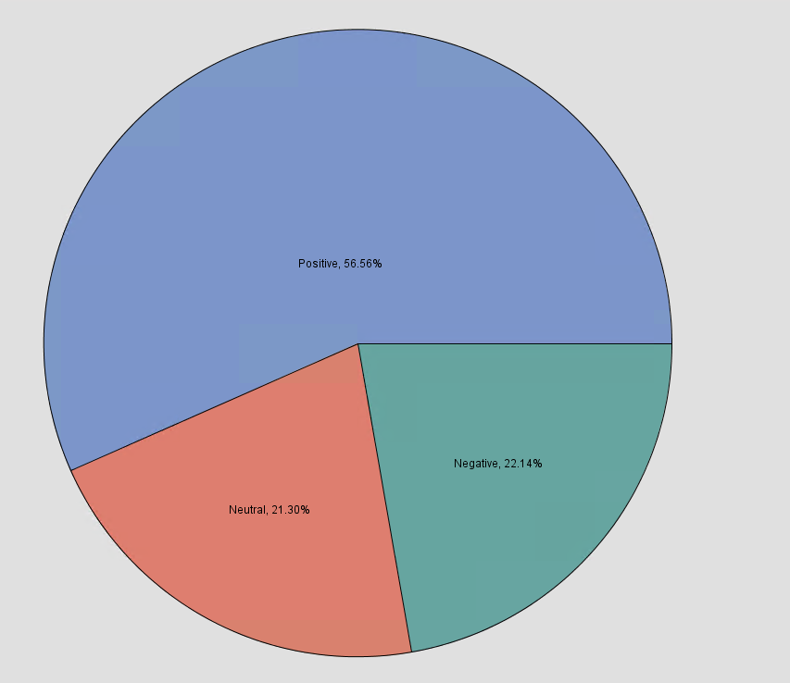

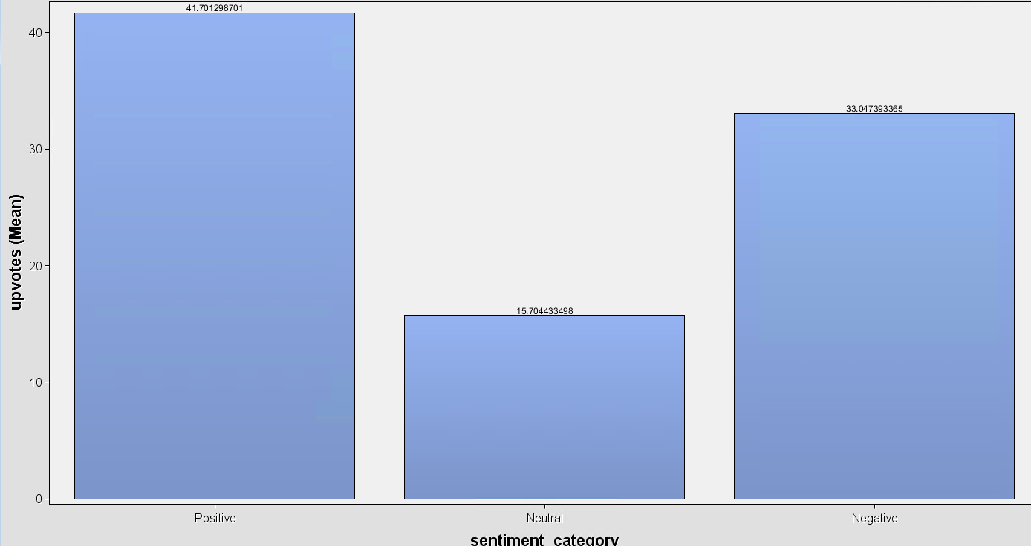
The sentiment distribution of comments for the film Red One is shown in the pie chart. Most comments are positive with 56.56%, suggesting that most viewers think the movie is good. 21.30% of responses are neutral, indicating that some audience members gave conflicting or unconcerned feedback. In contrast, 22.14% of comments are negative and represent criticisms or unfavourable responses. With over half of the audience expressing positive opinions, this split indicates that Red One has been well received overall.
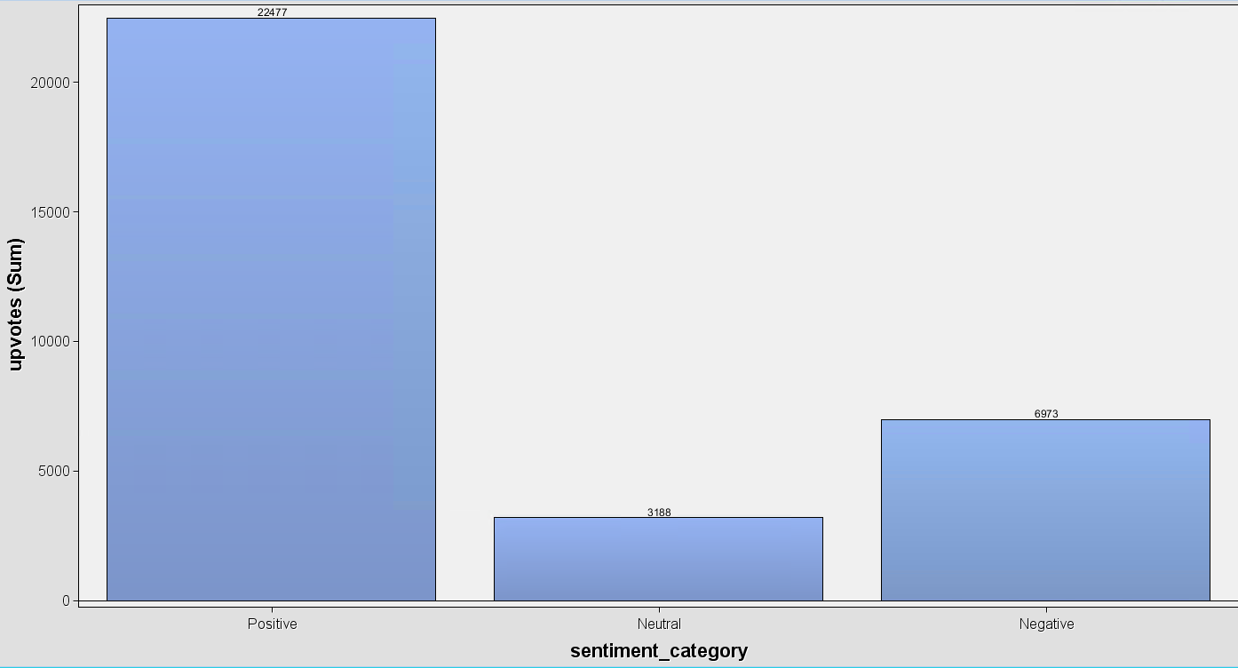
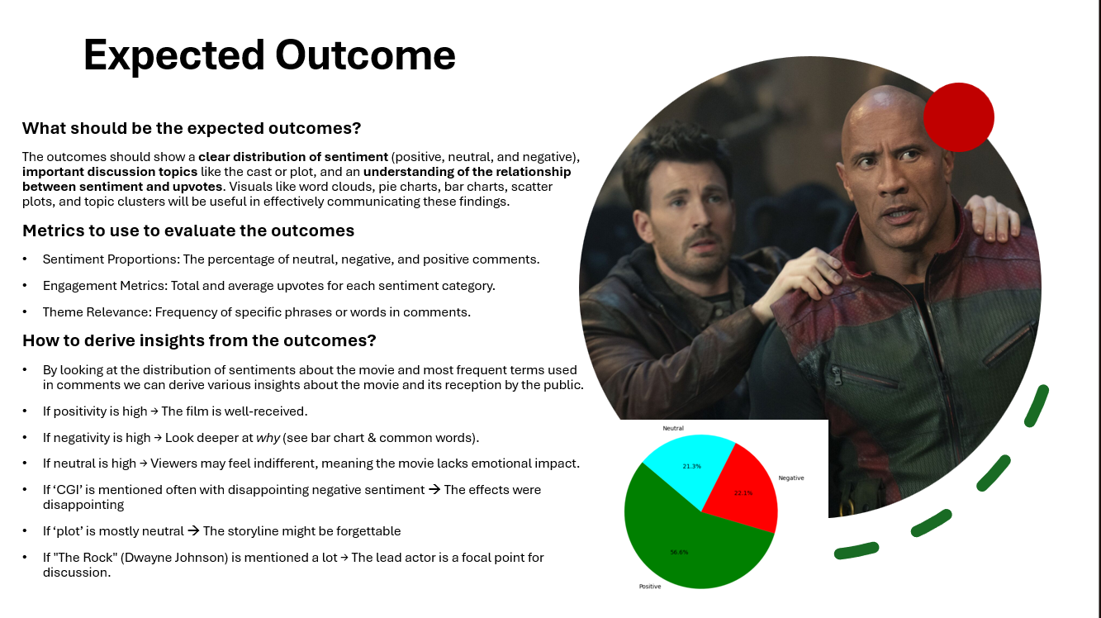
The total number of upvotes obtained by each sentiment category is shown in the first graph. Neutral comments had the lowest engagement (3,188), while positive comments had the maximum total upvotes (22,477), followed by negative comments (6,973). The average number of upvotes for each sentiment per comment is displayed in the second graph. Average upvotes were highest for positive comments (41.7), moderate for negative comments (33.0), and lowest for neutral comments (15.7). This shows that, on average, negative comments also generate a lot of engagement, even if positive comments are the most engaged overall. This suggests that while Red One is generally well-received by its viewers, it also attracts a lot of critical attention.

A clear sentiment distribution, important discussion subjects (cast, plot, and CGI), and a correlation between sentiment and upvotes were all predicted by the hypothesised outcome. While negative comments would draw attention to issues like CGI, a high positive sentiment would suggest a well-received film. Dwayne Johnson's position as a focal point would be confirmed with frequent references to him.
The real outcomes are quite similar. A mainly good response is confirmed by the pie chart, which displays 56.6% positive sentiment. Nonetheless, as evidenced by the average and total upvotes, negative comments (22.1%) attracted a considerable amount of interaction. Expectations were also met by the discussion subjects, which included cast, movie quality, and holiday themes. Additionally, the data supports the hypothesis that Dwayne Johnson was discussed a lot.
Although there is a large proportion of positive sentiment overall, the significant level of engagement with negative comments indicates a mixed yet active audience.

Recommendations
Red One's positive review (56.6%) emphasises the advantages of having a well-known cast, holiday themes, and high entertainment value—all of which must be included in future movies. However, the large percentage of negative responses (22.1%) indicates that audience satisfaction might be raised by addressing frequent complaints, like CGI or plot depth. Using star power in marketing and casting choices will draw attention, as seen by the high demand for stars like Chris Evans and Dwayne Johnson. Producing additional seasonal films or carefully scheduling releases around festive seasons may improve engagement, as the holiday subject generated a lot of conversation. Going ahead, the business may improve storyline, production quality, and promotional tactics for upcoming projects by keeping an eye on customer reaction and feedback.

