THE EMBODIED AGENT
IN INTERACTIVE ENVIRONMENTS
A Preliminary Design and Evaluation of Observation, Episodic Memory, and Event-Triggered Reasoning
━━━━━━━━━━━━━━━━━━━━━━━━━━━━━━━━
Researcher
Adam Mohamed Hassan Emam
October 2026
Preliminary research paper and reproducible simulation experiment
SCOPE AND EVIDENCE NOTE
This study evaluates a synthetic grid-world, not the official ARC-AGI-3 benchmark. The current reasoning module is a manually encoded symbolic routine, not a real VLM or LLM. The results therefore test a software loop, not AGI-level generalization.

Scope note: The results in this paper come from a synthetic grid-world implemented in the accompanying Python script. They are not results on the official ARC-AGI-3 benchmark. The current reasoning module is a hand-coded symbolic routine, not a real vision-language model (VLM) or large language model (LLM). The experiment tests the engineering loop of observation, memory, event-triggered reasoning, and action; it does not establish AGI.

Abstract
The central idea of this work is that an interactive agent should not rely on a single screenshot or make isolated guesses at every step. It should observe the environment, try an action, record the outcome, and use that experience to choose what to do next. In the proposed design, lightweight routines handle predictable operations, while a reasoning component is activated only when a meaningful event occurs, such as encountering a locked door.
To examine this idea, we implemented a synthetic 10×10 grid-world containing an agent, a key, a locked door, a goal, and a moving hazard. The observation does not expose the agent’s internal key-possession or door-unlocked flags; the agent must infer progress from interaction outcomes. Four agents were evaluated over 250 generated episodes using five random seeds. The locations of objects vary, while the underlying key-and-door rule remains the same.
The proposed agent, which combines an SQLite event log with event-triggered symbolic reasoning and route planning, succeeded in 250 of 250 episodes, with a mean of 21.89 steps and one reasoning-module call per episode. The random reactive baseline succeeded once, the memory-only baseline succeeded once, and the stateless goal heuristic solved no episodes. This is an encouraging result within this particular simulation, but it is not evidence of VLM performance or equivalent performance on ARC-AGI-3: the rule and plan are explicitly encoded, and the baselines are intentionally simple. The next step is to replace the symbolic module with a real model, run the agent in official benchmark environments, and perform stronger comparisons and ablation studies.
Keywords: embodied agent; episodic memory; SQLite; active exploration; event-triggered reasoning; route planning; ARC-AGI-3.

1. Introduction: Is Seeing the Image Enough?
In an interactive game, detecting the visible objects is not enough. An agent may recognize a door, a goal, and a key without yet knowing how they relate to one another. It must test the environment, observe the consequences of its actions, and turn experience into a practical decision.
This is related to the motivation behind ARC-AGI-3, an interactive benchmark built around game-like environments in which an agent must explore, infer rules and goals, and plan from interaction rather than rely only on static input [1, 2]. However, an agent designed for interactive tasks does not necessarily need to run a large vision-language model on every frame. Some changes can be detected using lightweight routines; only ambiguous or strategically important situations may require deeper reasoning.
Rather than making the model reason about everything all the time, build an agent that observes and records, then requests deeper reasoning when there is a clear reason to do so.

2. Hypothesis and Research Questions
The engineering hypothesis is that combining episodic memory with event-triggered reasoning and an explicit planning algorithm can help an agent solve this class of puzzle more reliably than random movement or event recording without a plan.
The prototype examines three questions:
1. Can an event log by itself solve the puzzle, or does the log need a mechanism that turns observations into an actionable rule?
2. Can reasoning be triggered by a meaningful event instead of being invoked at every step?
3. Does translating an inference into an executable route reduce the number of steps needed to reach the goal?
These questions apply to the synthetic environment used here. The results should not be generalized to all games or treated as a direct test of general intelligence.

3. Architecture of the Embodied Agent
The agent operates in a closed loop:
Observation → event logging → detection of a stall or novel event → reasoning when needed → action selection → observation of the outcome.

3.1. Observation Layer
The current implementation receives a symbolic grid describing floor, walls, a key, a door, a goal, a moving hazard, and the agent’s position. This is a deliberate simplification. The current experiment does not process raw video, extract Canny edges, or calculate a Laplacian measurement from an actual image. It therefore should not be described as a completed computer-vision experiment. A later implementation could connect to an image stream or an official game interface and use OpenCV to extract visual features from real screenshots.

3.2. Episodic Memory
The script uses SQLite to record each important event, including the previous state, the action taken, the resulting event, and a synthetic surface indicator. The purpose of the log is to keep previous failures available when the agent chooses its next action, rather than letting it repeat the same unsuccessful action without using the outcome.
For this experiment, SQLite is used as a small in-memory store rather than as a persistent production database. It could later be changed to a file-backed database to retain experience across separate runs.

3.3. Event-Triggered Reasoning
When the agent encounters the door or receives an event indicating that the door is locked, it records the event and invokes the reasoning module once. The module is not a VLM: it is a symbolic Python routine that maps the event “locked door” to the rule “obtain the key first,” then changes the agent’s current subgoal to finding the key.
The agent then uses breadth-first search (BFS) to find a route to the key, returns to the door, interacts with it, and proceeds to the goal. BFS is appropriate for this small grid because movement costs are effectively uniform. Larger or more complex environments may require A*, risk-aware planning, or planning that considers time and moving hazards.
Although the broader research idea mentions chain-of-thought (CoT), this experiment does not use a language model’s internal reasoning trace. It uses a structured event log and an inspectable symbolic rule. If a VLM is added in the future, it should receive a compact summary of events, unresolved questions, and candidate actions rather than necessarily receiving a long, unstructured history.

4. Experimental Design

4.1. Environment
The synthetic game is a 10×10 grid with outer walls, a horizontal dividing wall, and a single opening represented by a door. The agent starts in the upper region; the key is in the upper region, the goal is in the lower region, and a hazard moves along a short patrol path that can be avoided.
The key, door, goal, and initial hazard direction vary across generated episodes. The underlying puzzle rule remains the same: the agent must obtain the key, unlock the door, and then reach the goal. The episodes are therefore spatial variations of one puzzle mechanic, not entirely new games with independently changing rules.
The observation exposes object locations but does not directly expose the internal flags indicating whether the key has been collected or the door has been unlocked. Progress is inferred from the events returned after actions. The “roughness” values assigned to the door and key are synthetic constants, not sensor measurements or values calculated by a live Laplacian filter.

4.2. Agents Compared
- Random reactive agent: selects movements and interactions randomly, without using memory to guide its actions.
- Stateless goal heuristic: moves according to a simple goal-directed rule but does not build a causal interpretation from repeated collisions with the door.
- SQLite memory-only agent: records events but does not convert the log into a strategic rule and executable plan.
- Proposed agent: records experience, activates symbolic reasoning after detecting the locked door, then uses route planning to reach the key, return to the door, and reach the goal.
These are intentionally simple baselines intended to illustrate the difference between recording events and combining event records with reasoning and planning. They are not a comprehensive comparison against strong agents. Because the proposed agent uses a manually encoded rule, the result must not be interpreted as demonstrated superiority over real VLMs.

4.3. Evaluation Protocol
The benchmark runs 50 episodes for each of five seeds: 11, 123, 2026, 9001, and 424242. Each agent is therefore evaluated on 250 episodes. The maximum length of an episode is 80 steps. The script records success rate, mean number of steps, number of reasoning-module calls, and approximate local simulation runtime.
Runtime values depend strongly on the machine and process, and the task is small enough that these timings should not be treated as evidence about VLM latency or GPU deployment. This version does not run a vision-language model at all.

5. The Agent’s Decision Algorithm: A Step-by-Step Walkthrough
One representative episode can be described as the following sequence:
1. Observe the current state: read the symbolic map and locate the agent, door, and goal without direct access to the internal key-possession flag.
2. Test a route: move toward the door because it appears to be a possible passage to the goal.
3. Detect the failure: attempt to cross the door; the environment returns `HIT_LOCKED_DOOR`, and the agent’s position does not change.
4. Record the experience: save the action and outcome in SQLite, including the synthetic surface value associated with the door.
5. Trigger reasoning: because the event signals a meaningful obstacle, call the symbolic reasoning routine once. The routine applies the programmed rule that the key is required.
6. Change the subgoal: stop repeating the failed move and make the key the next subgoal; use BFS to plan a route toward it.
7. Act and verify: reach and interact with the key. The environment returns `OBTAINED_KEY`, which confirms progress within this simulation.
8. Return to the obstacle: plan back to the door and interact. The event `UNLOCKED_DOOR` indicates that the programmed hypothesis worked in this environment.
9. Complete the task: plan a route to the goal, execute actions, and check each outcome until `REACHED_GOAL` appears or the step limit is reached.
10. Retain the history: preserve the event records during the episode for diagnosis and post-run analysis.

Pseudocode
Begin the interaction loop
Read the current observation
Write the previous action and outcome to SQLite
If a locked-door event occurs and the rule has not been inferred:
Invoke the reasoning module once
Apply the rule that the key is required
Set the key as the current subgoal
If the key has been collected:
Plan a route back to the door
If the door has been unlocked:
Plan a route to the final goal
Choose the first action on the relevant BFS path
Execute the action and observe the new outcome
Repeat until success or the step limit is reached

This is not a claim that the agent has consciousness or human-like thought. It is an explicit description of the program’s decision process that can be inspected, modified, and tested.

6. Images from the Gameplay Experiment
The following images were generated directly from game states produced by the accompanying script. They are not screenshots from official ARC-AGI-3 games. The example shown used seed 11 and level ID 3; it finished in 25 steps with one call to the symbolic reasoning module.
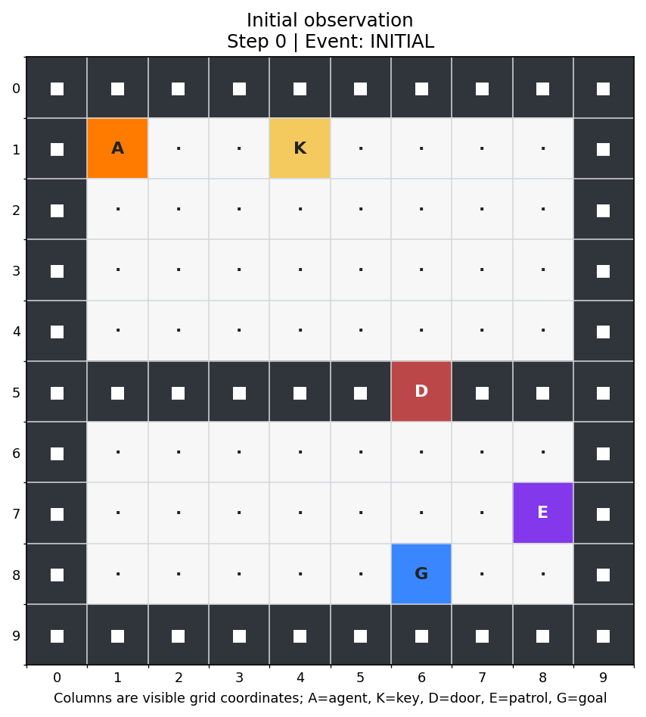
Figure 1. Initial observation. The map is shown before the agent interacts with the door. A = agent, K = key, D = door, E = moving hazard, G = goal.
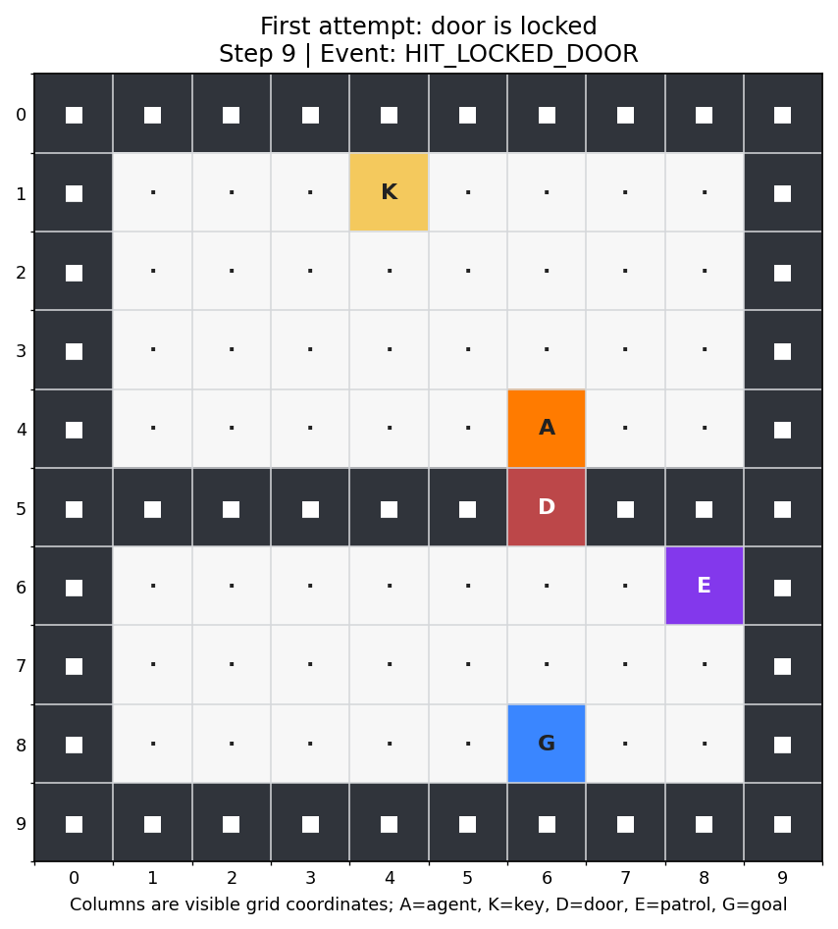
Figure 2. Encountering the locked door. At step 9, the agent attempts to move down through the door but remains in place; the environment returns `HIT_LOCKED_DOOR`.
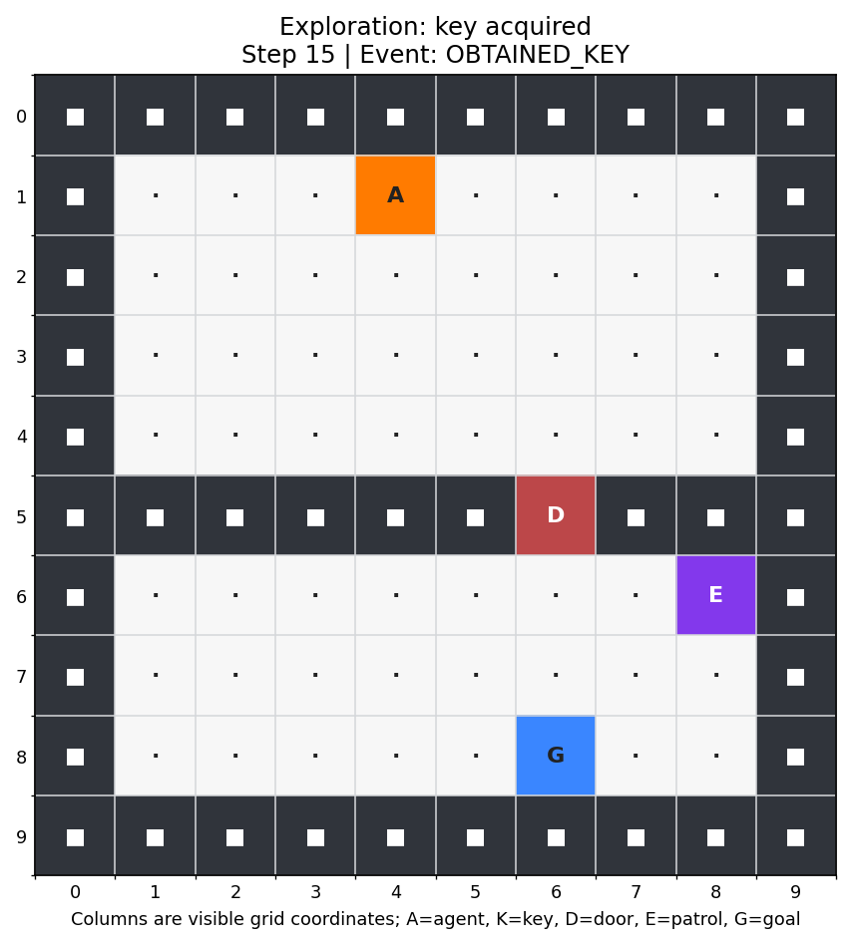
Figure 3. Key obtained. After reasoning, the agent changes its subgoal and reaches the key. At step 15, the event log records `OBTAINED_KEY`.
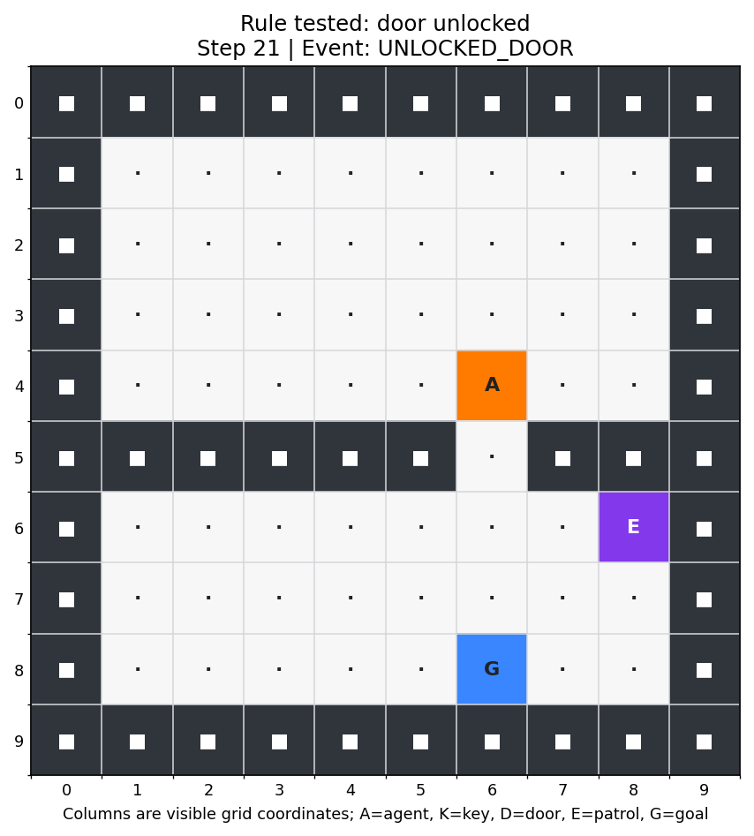
Figure 4. Door unlocked. After returning to the door, the agent interacts at step 21 and receives `UNLOCKED_DOOR`; this confirms the programmed rule within the simulator.
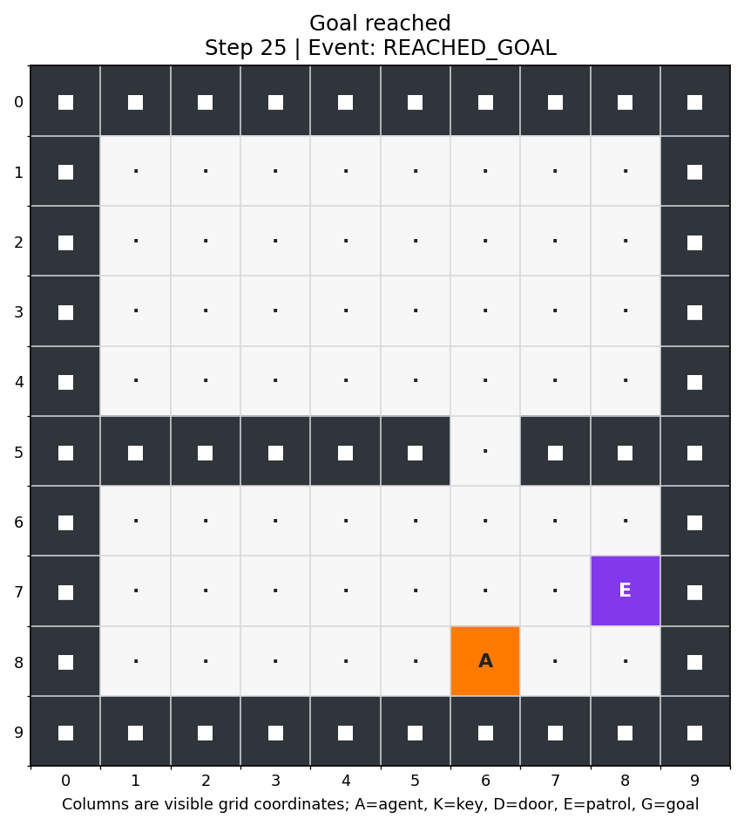
Figure 5. Goal reached. The agent reaches the goal at step 25, and the episode ends successfully.

7. Results
The table below aggregates the five random-seed settings, with 50 episodes per seed. Each row summarizes 250 episodes for the corresponding agent.
Results across 250 episodes
Agent | Successes | Success rate | Mean steps | Reasoner calls / episode
Random reactive | 1 / 250 | 0.4% | 79.92 | 0.00
Stateless goal heuristic | 0 / 250 | 0.0% | 80.00 | 0.00
SQLite memory only | 1 / 250 | 0.4% | 78.75 | 0.00
Memory + event-triggered reasoning + BFS | 250 / 250 | 100.0% | 21.89 | 1.00

What Does the Result Mean?
Within this small world, storing events alone was not enough. The agent also needed to convert an event into a rule and then into an executable plan. Triggering reasoning when the locked door was encountered reduced the number of reasoning calls: the proposed system made one symbolic call per episode, after which the path-planning routine handled the movements.
There is an important difference between succeeding at a programmed puzzle and discovering a genuinely new rule. The “key opens door” rule is explicitly encoded in `infer_rule_and_plan()`, and route planning uses BFS. The agent receives a symbolic map with object types already identified, and the baseline agents are intentionally simple. Therefore, the 100% result shows that the current code reliably executes the designed scenario; it does not show that a VLM independently inferred the rule or that the architecture will succeed on games with genuinely unknown mechanics.

8. Review of the Prototype and Limits of the Conclusions
The earlier prototype included a function named `mock_vlm_inference`, but it did not call a real model; it chose actions from rules written in code. The planning function also effectively fixed the key-door mechanism and coordinates. Moreover, in that earlier version, the level identifier did not affect layout generation, so the placements did not genuinely vary across the 50 episodes. That version should not be described as testing 50 independent games or as evidence of VLM success.
The updated script in this package improves reproducibility by varying object locations, writing metrics to JSON, and saving both images and an event trace. It still deliberately uses a symbolic reasoning module so the decision sequence remains transparent and repeatable. No real VLM was loaded, and OpenCV was not used to measure properties from the game images.

Key Limitations
- The puzzle rule remains the same across episodes; object positions vary, but the underlying mechanics do not.
- The proposed agent uses hand-coded symbolic reasoning, not a model that learns an unseen rule without prior programming.
- The agent receives a symbolic grid rather than raw images, so visual perception is not evaluated.
- The “roughness” values are synthetic constants, not measured texture values.
- The baselines are not strong enough to establish general superiority; stronger comparisons and ablation studies are needed.
- No score was obtained on the official ARC-AGI-3 leaderboard, and no official benchmark metric was measured.

9. The Next Experiment
A stronger follow-up study should make the next step genuinely test the proposed architecture rather than confirm a rule already placed in the code. A practical plan is:
1. Connect the agent to a documented official ARC-AGI-3 environment and record observations, actions, and outcomes returned by the environment.
2. Replace the symbolic stand-in with a real VLM or LLM; log actual prompts, model calls, latencies, and outputs.
3. Keep the rule hidden and vary the mechanics across tasks, not only object coordinates. Include puzzles in which an initial hypothesis is wrong and must be revised.
4. Compare against stronger baselines, including a planner with access to the same observations, a model called at every step, and an agent with memory but no event-triggered reasoning.
5. Run ablations: remove episodic memory, disable event-triggering, and replace the planner. Report confidence intervals over multiple seeds.
6. Measure success, steps, model calls, wall-clock latency, token use, memory use, and robustness to visual ambiguity.
These tests would allow the central hypothesis—whether event-triggered reasoning plus memory is more efficient than continuous heavyweight inference—to be evaluated empirically instead of assumed.

10. Conclusion
The main idea of this paper is that an interactive AI system needs more than a powerful model that can interpret an image. It needs a process for observing, experimenting, recording outcomes, and using prior experience when choosing the next action. It should know when a lightweight routine is enough and when an unfamiliar situation calls for deeper reasoning.
The proposed architecture combines traditional computer-vision ideas, episodic memory through SQLite, event-triggered reasoning, and route planning. The current experiment isolates the memory–reasoning–planning loop in a small synthetic environment. Its 100% success rate is a repeatable simulation result, not proof of AGI and not evidence of performance by a real VLM.
The agent does not merely see the environment; it uses what happens when it acts in the environment to guide its next decision.

The key research question remains open: can structured memory, active exploration, and reasoning invoked at the right time help an agent deal with environments whose rules it has not been programmed to know? Answering that question requires real models, genuinely novel tasks, and rigorous benchmark evaluation.

References
[1] ARC Prize Foundation. “Announcing ARC-AGI-3: A New Challenge for Frontier Agentic Intelligence.” 25 March 2026. https://arcprize.org/blog/arc-agi-3-launch
[2] ARC Prize Foundation. “ARC-AGI-3: A New Challenge for Frontier Agentic Intelligence.” Technical Report, April 2026. https://arcprize.org/media/ARC_AGI_3_Technical_Report.pdf

Appendix A. Running the Experiment
Requirements: Python 3.10 or later, NumPy, and Matplotlib. SQLite is included with Python. Install the third-party dependencies if needed:
pip install numpy matplotlib

From the directory containing `arc_embodied_experiment.py`, run:
python arc_embodied_experiment.py --episodes 50 --seeds 11 123 2026 9001 424242 --render-demo --outdir arc_experiment_output

The program prints aggregate results, writes `experiment_results.json`, and—when `--render-demo` is enabled—saves five gameplay figures and `demo_trace.json` under the output directory.
Reproducibility note: this is a synthetic grid-world, not the official ARC-AGI-3 benchmark. The reasoner is a hand-coded symbolic stand-in; no actual VLM/LLM API or model weights are loaded. The texture values are synthetic proxies; no live OpenCV Laplacian measurement is performed.

Appendix B. Full Python Source Code
The following listing is the same source file provided separately as arc_embodied_experiment.py. It is included to support inspection and reproducibility.
#!/usr/bin/env python3
"""Reproducible toy experiment for an embodied interactive agent.

Important scope note:
- This is a small synthetic grid-world, NOT the official ARC-AGI-3 benchmark.
- The "selective reasoner" is a transparent symbolic rule-inference stand-in,
not a live LLM/VLM call. Replace infer_rule_and_plan() with a real VLM adapter
to test a neural model.
- Texture values are synthetic environment properties, not measurements from
OpenCV/Laplacian on real screenshots.

Run:
python arc_embodied_experiment.py --episodes 50 --render-demo
"""
from __future__ import annotations

import argparse
import json
import random
import sqlite3
import time
from collections import deque
from dataclasses import dataclass
from pathlib import Path
from typing import Dict, List, Optional, Tuple

import numpy as np

Pos = Tuple[int, int]
UP, DOWN, LEFT, RIGHT, INTERACT = range(5)
ACTION_NAMES = {UP: "UP", DOWN: "DOWN", LEFT: "LEFT", RIGHT: "RIGHT", INTERACT: "INTERACT"}
DELTAS = {UP: (-1, 0), DOWN: (1, 0), LEFT: (0, -1), RIGHT: (0, 1)}

class GridWorld:
"""Small generated puzzle with hidden key-door dependency and moving hazard."""

def __init__(self, level_id: int, seed: int = 2026, max_steps: int = 80):
self.level_id = level_id
self.rng = random.Random(seed + 7919 * level_id)
self.n = 10
self.max_steps = max_steps
self.reset()

def reset(self):
self.steps = 0
self.done = False
self.success = False
self.has_key = False
self.door_unlocked = False
self.grid = np.zeros((self.n, self.n), dtype=np.int8)
self.grid[0, :] = self.grid[-1, :] = 1
self.grid[:, 0] = self.grid[:, -1] = 1
self.player: Pos = (1, 1)
self.grid[5, :] = 1
self.door: Pos = (5, self.rng.randint(3, 6))
self.grid[self.door] = 3
key_candidates = [(r, c) for r in range(1, 5) for c in range(2, 9)
if (r, c) != self.player and (r, c) != self.door]
self.key: Pos = self.rng.choice(key_candidates)
self.grid[self.key] = 2
self.goal: Pos = (8, self.rng.randint(3, 6))
self.grid[self.goal] = 4
# A short patrol in the lower-right lane; it is visible and avoidable.
self.enemy_col = 8
self.enemy_row = self.rng.choice([6, 7])
self.enemy_dir = 1 if self.enemy_row == 6 else -1
self.grid[self.enemy_row, self.enemy_col] = 5
self.textures = {"door": 85.5, "key": 12.3, "floor": 2.1, "wall": 98.0}
self.history: List[dict] = []
return self.observe()

def observe(self) -> dict:
visible = self.grid.copy()
visible[self.player] = 9
return {
"grid": visible,
"player_pos": self.player,
"step": self.steps,
# Deliberately do not expose has_key / door_unlocked to the agent.
}

def step(self, action: int):
if self.done:
return self.observe(), 0, True, {"event": "ALREADY_DONE", "action": ACTION_NAMES[action]}
self.steps += 1
prev_pos = self.player
event = "NONE"
texture = self.textures["floor"]

if action == INTERACT:
adjacent = [
(self.player[0] - 1, self.player[1]),
(self.player[0] + 1, self.player[1]),
(self.player[0], self.player[1] - 1),
(self.player[0], self.player[1] + 1),
self.player,
]
valid_adjacent = [p for p in adjacent if 0 <= p[0] < self.n and 0 <= p[1] < self.n]
# Prioritize collecting a key under the agent before interacting with a neighboring door.
key_target = next((p for p in valid_adjacent if int(self.grid[p]) == 2), None)
door_target = next((p for p in valid_adjacent if int(self.grid[p]) == 3), None)
if key_target is not None:
self.has_key = True
self.grid[key_target] = 0
event, texture = "OBTAINED_KEY", self.textures["key"]
elif door_target is not None:
texture = self.textures["door"]
if self.has_key:
self.door_unlocked = True
self.grid[door_target] = 0
event = "UNLOCKED_DOOR"
else:
event = "DOOR_LOCKED_NEED_KEY"
else:
dr, dc = DELTAS[action]
target = (self.player[0] + dr, self.player[1] + dc)
cell = int(self.grid[target])
if cell == 1:
event, texture = "HIT_WALL", self.textures["wall"]
elif cell == 3 and not self.door_unlocked:
event, texture = "HIT_LOCKED_DOOR", self.textures["door"]
elif cell == 5:
event = "HIT_ENEMY_TRAP"
self.done = True
self.success = False
else:
self.player = target
if self.player == self.goal:
self.done = self.success = True
event = "REACHED_GOAL"
elif cell == 2:
event = "STEP_ON_KEY"
else:
event = "MOVED"

# Move the enemy after the player. The demonstrated planner routes away
# from its short patrol lane; entering an occupied enemy tile is fatal.
if not self.done:
self.grid[self.enemy_row, self.enemy_col] = 0
if self.enemy_row == 6:
self.enemy_dir = 1
elif self.enemy_row == 7:
self.enemy_dir = -1
self.enemy_row += self.enemy_dir
self.grid[self.enemy_row, self.enemy_col] = 5

if self.steps >= self.max_steps and not self.success:
self.done = True
if event not in ("HIT_ENEMY_TRAP", "REACHED_GOAL"):
event = "TIMEOUT"

info = {
"step": self.steps,
"prev_pos": prev_pos,
"curr_pos": self.player,
"action": ACTION_NAMES[action],
"event": event,
"texture_variance": texture,
"enemy_pos": (self.enemy_row, self.enemy_col),
}
self.history.append(info.copy())
reward = 100 if self.success else (-10 if event == "HIT_ENEMY_TRAP" else -1)
return self.observe(), reward, self.done, info

def find_path(grid: np.ndarray, start: Pos, goal: Pos, allow_door: bool = False,
block_enemy: bool = True) -> Optional[List[int]]:
"""BFS over currently observed tiles; returns actions or None if unreachable."""
q = deque([start])
came_from: Dict[Pos, Tuple[Optional[Pos], Optional[int]]] = {start: (None, None)}
while q:
p = q.popleft()
if p == goal:
break
for action, (dr, dc) in DELTAS.items():
nxt = (p[0] + dr, p[1] + dc)
if not (0 <= nxt[0] < grid.shape[0] and 0 <= nxt[1] < grid.shape[1]):
continue
cell = int(grid[nxt])
if cell == 1 or (cell == 3 and not allow_door):
continue
if cell == 5 and block_enemy:
continue
if nxt not in came_from:
came_from[nxt] = (p, action)
q.append(nxt)
if goal not in came_from:
return None
path: List[int] = []
cur = goal
while cur != start:
prev, action = came_from[cur]
assert prev is not None and action is not None
path.append(action)
cur = prev
path.reverse()
return path

def locate(grid: np.ndarray, symbol: int) -> Optional[Pos]:
found = np.argwhere(grid == symbol)
if len(found) == 0:
return None
return tuple(int(x) for x in found[0])

class BaseAgent:
def __init__(self):
self.reasoner_calls = 0
self.db = sqlite3.connect(":memory:")
self.db.execute("CREATE TABLE events(step INTEGER, prev TEXT, action TEXT, event TEXT, texture REAL)")
self.last_info: Optional[dict] = None

def record(self, info: Optional[dict]):
if not info:
return
self.last_info = info
self.db.execute("INSERT INTO events VALUES (?, ?, ?, ?, ?)",
(info["step"], str(info["prev_pos"]), info["action"], info["event"], info["texture_variance"]))
self.db.commit()

def get_action(self, obs: dict, info: Optional[dict] = None) -> int:
raise NotImplementedError

class RandomReactiveAgent(BaseAgent):
"""Random actions; no use of memory for decisions."""
def __init__(self, seed: int = 1):
super().__init__()
self.rng = random.Random(seed)

def get_action(self, obs, info=None):
# deliberately do not save/use episodic history
return self.rng.choice([UP, DOWN, LEFT, RIGHT, INTERACT])

class StatelessGoalAgent(BaseAgent):
"""A stateless greedy agent that heads toward the goal and repeats on obstacles."""
def get_action(self, obs, info=None):
grid, pos = obs["grid"], obs["player_pos"]
goal = locate(grid, 4)
door = locate(grid, 3)
if goal is None:
return INTERACT
# It tries to reduce Manhattan distance, preferring vertical movement.
candidates = []
if pos[0] < goal[0]: candidates.append(DOWN)
elif pos[0] > goal[0]: candidates.append(UP)
if pos[1] < goal[1]: candidates.append(RIGHT)
elif pos[1] > goal[1]: candidates.append(LEFT)
if door and abs(pos[0]-door[0]) + abs(pos[1]-door[1]) == 1:
# no episodic history: repeatedly interacts with the locked door
return INTERACT
return candidates[0] if candidates else INTERACT

class MemoryOnlyAgent(BaseAgent):
"""Records experience and avoids repeating the exact last move, but does not infer a key-door rule."""
def __init__(self):
super().__init__()
self.last_action = None

def get_action(self, obs, info=None):
# Memory is written but not converted into a high-level causal plan.
self.record(info)
grid, pos = obs["grid"], obs["player_pos"]
goal = locate(grid, 4)
door = locate(grid, 3)
if goal is not None and door is not None and abs(pos[0]-door[0])+abs(pos[1]-door[1]) == 1:
return INTERACT
actions = [DOWN, RIGHT, UP, LEFT]
# avoid repeating precisely the previous action; this is not strategic planning
if self.last_action in actions and len(actions) > 1:
actions.remove(self.last_action)
action = actions[0]
self.last_action = action
return action

class ProposedEmbodiedAgent(BaseAgent):
"""SQLite episodic memory + event-triggered symbolic reasoning + BFS planning.

infer_rule_and_plan() is a transparent rule-based stand-in, not an actual VLM.
"""
def __init__(self):
super().__init__()
self.stage = "explore_door"
self.has_key_belief = False
self.door_open_belief = False
self.planned_rule = None
self.trigger_reason = None

def infer_rule_and_plan(self, obs: dict, triggering_event: str):
# This is the point where a real VLM could be called. Current experiment
# uses explicit symbolic logic so it remains offline/reproducible.
self.reasoner_calls += 1
recent = self.db.execute("SELECT event, texture FROM events ORDER BY step DESC LIMIT 10").fetchall()
if triggering_event in ("HIT_LOCKED_DOOR", "DOOR_LOCKED_NEED_KEY"):
self.planned_rule = "A key is required before the door can be crossed."
self.trigger_reason = {"event": triggering_event, "recent_memory_rows": len(recent)}
self.stage = "get_key"

def get_action(self, obs: dict, info: Optional[dict] = None) -> int:
self.record(info)
if info:
event = info.get("event")
if event == "OBTAINED_KEY":
self.has_key_belief = True
self.stage = "return_to_door"
elif event == "UNLOCKED_DOOR":
self.door_open_belief = True
self.stage = "reach_goal"
elif event in ("HIT_LOCKED_DOOR", "DOOR_LOCKED_NEED_KEY") and self.planned_rule is None:
self.infer_rule_and_plan(obs, event)

grid, pos = obs["grid"], obs["player_pos"]
key = locate(grid, 2)
door = locate(grid, 3)
goal = locate(grid, 4)

if self.stage == "explore_door":
if door is None:
self.stage = "reach_goal"
else:
path = find_path(grid, pos, door, allow_door=True)
if path:
return path[0]
# If already adjacent to door, try crossing to test its rule.
if abs(pos[0]-door[0]) + abs(pos[1]-door[1]) == 1:
return DOWN if pos[0] < door[0] else (UP if pos[0] > door[0] else (RIGHT if pos[1] < door[1] else LEFT))
return INTERACT

if self.stage == "get_key":
if key is not None:
if pos == key:
return INTERACT
path = find_path(grid, pos, key, allow_door=False)
if path:
return path[0]
# Grid changes are not expected to make the upper key unreachable.
return INTERACT
if self.has_key_belief:
self.stage = "return_to_door"

if self.stage == "return_to_door":
if door is None:
self.stage = "reach_goal"
else:
if abs(pos[0]-door[0]) + abs(pos[1]-door[1]) == 1:
return INTERACT
# Reach the upper neighbor of the door; the divider blocks other routes.
target = (door[0] - 1, door[1])
path = find_path(grid, pos, target, allow_door=False)
if path:
return path[0]
return INTERACT

if self.stage == "reach_goal":
if goal is None:
return INTERACT
path = find_path(grid, pos, goal, allow_door=False)
if path:
return path[0]
# The door should now be open; reattempt if perception is momentarily ambiguous.
return INTERACT

return INTERACT

def run_episode(agent: BaseAgent, level_id: int, seed: int, keep_trace: bool = False):
env = GridWorld(level_id, seed)
obs = env.reset()
info = None
snapshots = []
if keep_trace:
snapshots.append({"grid": obs["grid"].copy(), "player_pos": obs["player_pos"],
"step": 0, "event": "INITIAL", "action": "NONE",
"has_key": env.has_key, "door_unlocked": env.door_unlocked,
"door": env.door, "key": env.key, "goal": env.goal,
"enemy_pos": (env.enemy_row, env.enemy_col)})
while not env.done:
action = agent.get_action(obs, info)
obs, _, _, info = env.step(action)
if keep_trace:
snapshots.append({"grid": obs["grid"].copy(), "player_pos": obs["player_pos"],
"step": env.steps, "event": info["event"], "action": info["action"],
"has_key": env.has_key, "door_unlocked": env.door_unlocked,
"door": env.door, "key": env.key, "goal": env.goal,
"enemy_pos": (env.enemy_row, env.enemy_col)})
return {"success": env.success, "steps": env.steps, "reasoner_calls": agent.reasoner_calls,
"trace": snapshots, "event_log": env.history, "agent": agent,
"environment": env}

def benchmark(episodes: int = 50, seed: int = 2026):
factories = {
"Random reactive": lambda ep: RandomReactiveAgent(seed + ep),
"Stateless goal heuristic": lambda ep: StatelessGoalAgent(),
"SQLite memory only": lambda ep: MemoryOnlyAgent(),
"Proposed: memory + event-triggered planner": lambda ep: ProposedEmbodiedAgent(),
}
results = {}
for name, factory in factories.items():
outcomes = []
start = time.perf_counter()
for ep in range(episodes):
agent = factory(ep)
result = run_episode(agent, ep, seed)
outcomes.append(result)
elapsed = time.perf_counter() - start
results[name] = {
"episodes": episodes,
"successes": sum(x["success"] for x in outcomes),
"success_rate_pct": round(100 * sum(x["success"] for x in outcomes) / episodes, 2),
"mean_steps": round(sum(x["steps"] for x in outcomes) / episodes, 2),
"mean_reasoner_calls": round(sum(x["reasoner_calls"] for x in outcomes) / episodes, 2),
"total_reasoner_calls": sum(x["reasoner_calls"] for x in outcomes),
"runtime_sec": round(elapsed, 4),
}
return results

def render_demo(outdir: Path, seed: int = 2026, level_id: int = 3):
import matplotlib.pyplot as plt
from matplotlib.colors import ListedColormap
outdir.mkdir(parents=True, exist_ok=True)
result = run_episode(ProposedEmbodiedAgent(), level_id, seed, keep_trace=True)
trace = result["trace"]
env = result["environment"]
# Select authentic states around meaningful transitions from the recorded episode.
chosen = []
chosen.append(("01_initial", "Initial observation", trace[0] if trace else {
"grid": env.observe()["grid"], "step": 0, "event": "INITIAL"}))
for target_event, filename, title in [
("HIT_LOCKED_DOOR", "02_locked_door", "First attempt: door is locked"),
("OBTAINED_KEY", "03_key_obtained", "Exploration: key acquired"),
("UNLOCKED_DOOR", "04_door_unlocked", "Rule tested: door unlocked"),
("REACHED_GOAL", "05_goal_reached", "Goal reached"),
]:
state = next((s for s in trace if s["event"] == target_event), None)
if state is not None:
chosen.append((filename, title, state))
if len(chosen) < 5 and trace:
chosen.append(("05_final_state", "Final state", trace[-1]))

cmap = ListedColormap(["#f7f7f7", "#30343b", "#f4c95d", "#bc4749", "#3a86ff", "#8338ec", "#1b998b", "#f7f7f7", "#adb5bd", "#ff7b00"])
labels = {0: "Floor", 1: "Wall", 2: "Key", 3: "Locked door", 4: "Goal", 5: "Patrol", 9: "Agent"}
for filename, title, state in chosen:
grid = state["grid"]
fig, ax = plt.subplots(figsize=(6, 6))
ax.imshow(grid, cmap=cmap, vmin=0, vmax=9)
ax.set_xticks(np.arange(-.5, grid.shape[1], 1), minor=True)
ax.set_yticks(np.arange(-.5, grid.shape[0], 1), minor=True)
ax.grid(which="minor", color="#d5d7da", linewidth=0.7)
ax.set_xticks(range(grid.shape[1]))
ax.set_yticks(range(grid.shape[0]))
ax.tick_params(length=0, labelsize=8)
ax.set_title(f"{title}\nStep {state.get('step', '?')} | Event: {state.get('event', '?')}", fontsize=11)
for r in range(grid.shape[0]):
for c in range(grid.shape[1]):
value = int(grid[r, c])
char = {0: "·", 1: "■", 2: "K", 3: "D", 4: "G", 5: "E", 9: "A"}.get(value, "")
if char:
ax.text(c, r, char, ha="center", va="center", fontsize=10,
color="white" if value in (1, 3, 5) else "#222222", fontweight="bold")
ax.set_xlabel("Columns are visible grid coordinates; A=agent, K=key, D=door, E=patrol, G=goal", fontsize=8)
fig.tight_layout()
fig.savefig(outdir / f"{filename}.png", dpi=160, bbox_inches="tight")
plt.close(fig)
# Write trace and per-step reasoning timeline for auditability.
timeline = []
for step in result["event_log"]:
timeline.append({k: (list(v) if isinstance(v, tuple) else v) for k, v in step.items()})
with open(outdir / "demo_trace.json", "w", encoding="utf-8") as f:
json.dump({"level_id": level_id, "seed": seed, "success": result["success"],
"steps": result["steps"], "reasoner_calls": result["reasoner_calls"],
"door": list(env.door), "key": list(env.key), "goal": list(env.goal),
"timeline": timeline}, f, ensure_ascii=False, indent=2)
return {"success": result["success"], "steps": result["steps"],
"reasoner_calls": result["reasoner_calls"], "images": [x[0] + ".png" for x in chosen]}

def main():
ap = argparse.ArgumentParser()
ap.add_argument("--episodes", type=int, default=50, help="episodes per seed")
ap.add_argument("--seed", type=int, default=2026, help="single seed when --seeds is omitted")
ap.add_argument("--seeds", type=int, nargs="*", default=None, help="optional list of seeds for repeated runs")
ap.add_argument("--outdir", type=Path, default=Path("arc_experiment_output"))
ap.add_argument("--render-demo", action="store_true")
args = ap.parse_args()
if args.episodes < 1:
raise SystemExit("--episodes must be >= 1")
seeds = args.seeds if args.seeds else [args.seed]
if not seeds:
seeds = [args.seed]
args.outdir.mkdir(parents=True, exist_ok=True)
started = time.perf_counter()
seed_runs = {str(seed): benchmark(args.episodes, seed) for seed in seeds}
model_names = [name for name in next(iter(seed_runs.values())).keys()]
results = {}
total_eps = args.episodes * len(seeds)
for name in model_names:
per_seed = [run[name] for run in seed_runs.values()]
successes = sum(v["successes"] for v in per_seed)
weighted_steps = sum(v["mean_steps"] * v["episodes"] for v in per_seed)
total_reasoner_calls = sum(v["total_reasoner_calls"] for v in per_seed)
results[name] = {
"episodes": total_eps,
"seeds": seeds,
"successes": successes,
"success_rate_pct": round(100 * successes / total_eps, 2),
"mean_steps": round(weighted_steps / total_eps, 2),
"mean_reasoner_calls": round(total_reasoner_calls / total_eps, 2),
"total_reasoner_calls": total_reasoner_calls,
"runtime_sec_all_runs": round(sum(v["runtime_sec"] for v in per_seed), 4),
}
results["per_seed_results"] = seed_runs
results["metadata"] = {
"experiment": "synthetic interactive grid-world, not official ARC-AGI-3",
"reasoner": "rule-based symbolic stand-in; no actual VLM/LLM API or weights loaded",
"texture": "synthetic numeric proxy; no live OpenCV Laplacian measurement",
"seeds": seeds,
"episodes_per_seed": args.episodes,
"total_benchmark_runtime_sec": round(time.perf_counter() - started, 4),
}
out_json = args.outdir / "experiment_results.json"
out_json.write_text(json.dumps(results, ensure_ascii=False, indent=2), encoding="utf-8")
print("=== Synthetic embodied-agent experiment ===")
for name, vals in results.items():
if name in ("metadata", "per_seed_results"):
continue
print(f"{name}: success={vals['successes']}/{vals['episodes']} ({vals['success_rate_pct']}%), "
f"mean_steps={vals['mean_steps']}, mean_reasoner_calls={vals['mean_reasoner_calls']}, "
f"runtime_all_runs={vals['runtime_sec_all_runs']}s")
print(f"Saved: {out_json}")
if args.render_demo:
demo = render_demo(args.outdir / "figures", seeds[0], level_id=min(3, args.episodes - 1))
print("Demo episode:", json.dumps(demo, ensure_ascii=False))

if __name__ == "__main__":
main()

