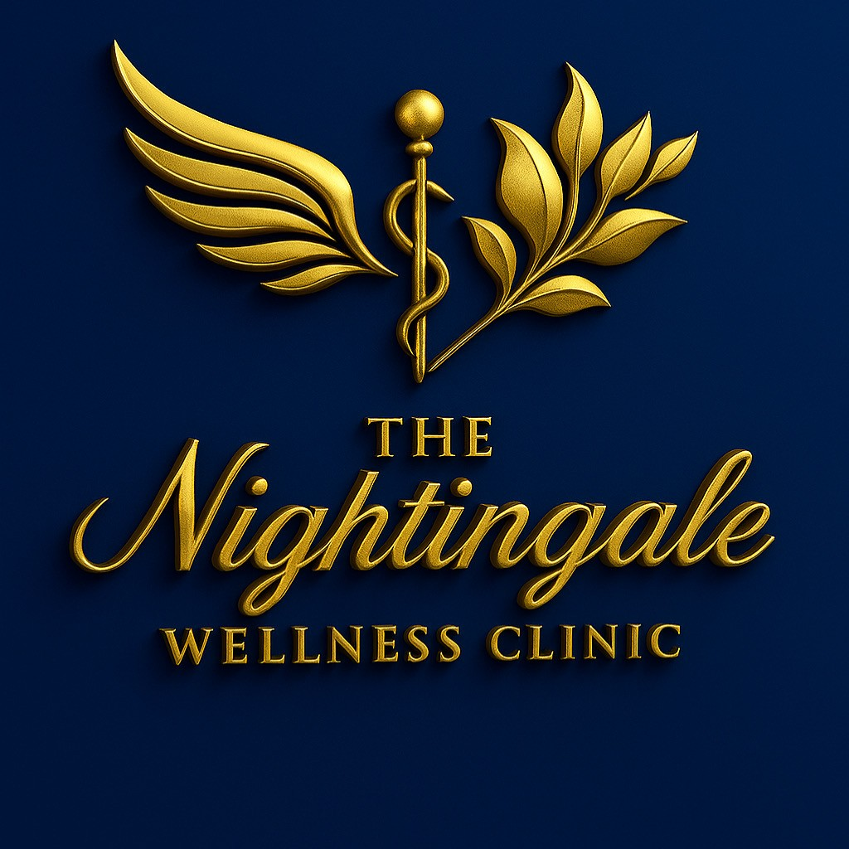
STRATEGIC BUSINESS PLAN 2025
The Nightingale Wellness Clinic

Prepared: December 2024
Version 1.0

TABLE OF CONTENTS
Executive Summary ................................. 3
Company Overview .................................. 4
Market analysis ................................... 5
Services & programmes ............................... 6
Marketing Strategy ................................ 7
Operations Plan ................................... 8
Management Team ................................... 9
Financial Projections ............................. 10
Risk analysis ..................................... 12
Implementation Timeline ........................... 13
Appendices ........................................ 14

EXECUTIVE SUMMARY
The Nightingale Wellness Clinic represents a premier healthcare destination committed to providing comprehensive, patient-centred wellness services. Our strategic business plan for 2025 outlines ambitious yet achievable growth targets, positioning us as a leader in integrative healthcare delivery.
Key highlights of our 2025 strategy include: expanding our service portfolio to include specialised wellness programmes, implementing cutting-edge technology solutions, growing our patient base by 35%, and achieving a projected revenue of $1.65 million with a 25% profit margin.
COMPANY OVERVIEW
Mission Statement
To provide exceptional, personalised healthcare services that promote healing, wellness, and optimal quality of life for every patient we serve.
Vision Statement
To be the premier wellness clinic in our region, recognised for clinical excellence, innovative treatments, and compassionate care that transforms lives.
Core Values
• Excellence in patient care and clinical outcomes
• Integrity in all business practices and patient relationships
• Innovation in treatment approaches and service delivery
• Compassion in every patient interaction
• Collaboration with patients, families, and healthcare partners
MARKET analysis
Industry Overview
The wellness and integrative healthcare market continues to experience robust growth, driven by increasing consumer awareness of preventive care, aging demographics, and growing demand for personalised healthcare solutions. Market research indicates a compound annual growth rate of 8-12% in our target segments.
Target Demographics
Our primary target market includes health-conscious adults aged 35-65, families seeking comprehensive wellness solutions, and individuals with chronic conditions requiring specialised care. Secondary markets include corporate wellness programmes and preventive care seekers.
SERVICES & programmes
Core Services
• Primary Care and Family Medicine
• Preventive Health Screenings
• Chronic Disease Management
• Wellness Coaching and Nutrition Counseling
• Mental Health and Stress Management
• Physical Therapy and Rehabilitation
• specialised Women's Health Services
Innovative programmes
• Integrative Medicine Approaches
• Telemedicine and Remote Monitoring
• Corporate Wellness Partnerships
• Health Education Workshops
• personalised Treatment Plans
• Advanced Diagnostic Services
FINANCIAL PROJECTIONS
The Nightingale Wellness Clinic projects strong financial growth over the next five years, driven by expanding service offerings, increased patient volume, and strategic market positioning. Our conservative projections show consistent revenue growth and improving profitability.
Revenue and Profit Projections
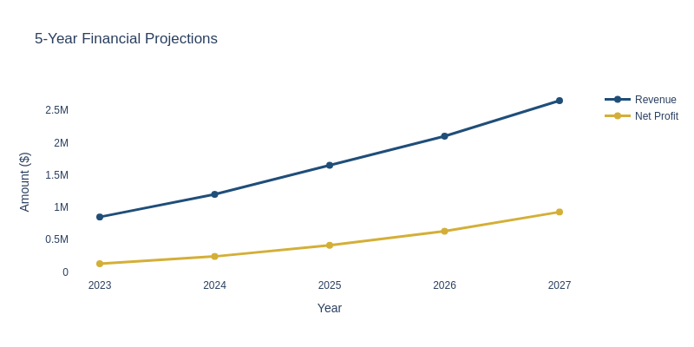
Metric | 2023 | 2024 | 2025 | 2026 | 2027
Revenue ($) | $850,000 | $1,200,000 | $1,650,000 | $2,100,000 | $2,650,000
Net Profit ($) | $127,500 | $240,000 | $412,500 | $630,000 | $927,500
Profit Margin (%) | 15% | 20% | 25% | 30% | 35%
Patient Count | 2,500 | 3,500 | 4,800 | 6,200 | 7,800
Growth Rate (%) | 15% | 25% | 35% | 28% | 26%
Patient Growth analysis
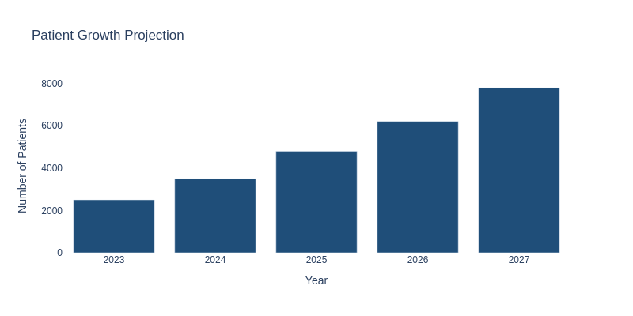
Annual Growth Rate Trends
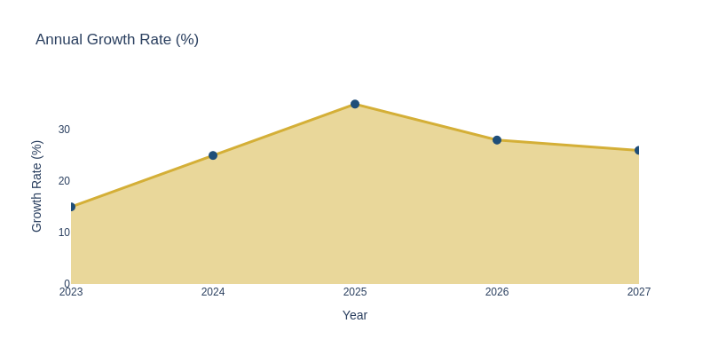
IMPLEMENTATION TIMELINE
Quarter | Key Initiatives | Expected Outcomes
Q1 2025 | Launch new wellness programmes  Implement technology upgrades | Increase patient satisfaction  15% revenue growth
Q2 2025 | Expand marketing initiatives  Hire additional staff | Grow patient base by 20%  Improve service capacity
Q3 2025 | Open satellite location  Launch corporate partnerships | Market expansion  Diversified revenue streams
Q4 2025 | Evaluate performance  Plan 2026 expansion | Achieve annual targets  Strategic planning complete
ADDITIONAL STRATEGIC DETAILS
The Nightingale Wellness Clinic represents the strategic evolution of Auty Medical Aesthetics Ltd, transforming from a successful Salon-based injectable practice into a comprehensive wellness destination in Ipswich. Building on our exceptional growth trajectory—262% revenue increase over three years culminating in £39,314 profit in FY2025—we are positioned to capitalise on the expanding aesthetic medicine market through strategic expansion.
This proven track record demonstrates our ability to build client relationships, deliver exceptional results, and operate profitably whilst working within established salon environments.
Dedicated Clinical Facility: Transition from salon-based operation to a professional 364 Nacton Road clinic (5-year lease commencing August 2025)
Advanced Technology Integration: Implementation of five cutting-edge 3D Aesthetics devices, positioning us as the regional leader in non-surgical aesthetic treatments
Service Diversification: Evolution from injectables-only to comprehensive wellness offerings including device treatments, premium packages, and membership programmes
Investment Requirements: Total expansion investment of £75,000 for equipment and clinc setup, generating:

