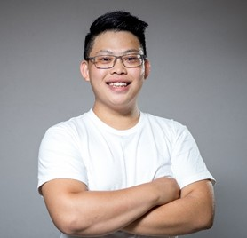

 **ABOUT ME**

* Dedicated to employing my expertise to build a resilient, robust, and reliable system
* Enthusiasm for utilizing software to analyze the physical response of a system and further to build easy-to-read as well as attractive data visualizations
* Being a multi-cultural background, communicative, independent, optimistic and active team member

 **WORK EXPERIENCE**

05/2020 - Present **Research Assistant** / Fraunhofer EMI  Freiburg im Breisgau, Germany

* Project - Modeling the impact failure (delamination) of different configurations of CFRP under various scenarios with LS-DYNA
* Project - Modeling the failure of a single-lap hybrid joint (Al-CFRP) under tensile loading with LS-DYNA
* Designed components geometry in Autodesk Inventor
* Established a meshed model in HyperMesh
* Optimized numerical parameters, analyzed results and built data visualization with Python

12/2019 - 03/2020 **Research Assistant** / INATECH, Uni Freiburg  Freiburg im Breisgau, Germany

**Simulation:**

* Built a numerical model of small-scale pivot specimen for torsion test with LS-Dyna
* Analyzed simulated results and built data visualization with Python

**Experiment:**

* Implementation of cyclic stress (fatigue) loading for small-scale material characterization
* Controlled the stepper motor with python to implement cycling loading (low-cycle fatigue)
* Optimized the sleeping time of stepper motor by considering the signal frequency, rotation speed and gear ratio
* Analyzed the signal and made data visualization with Python

09/2012 – 09/2018 **Teacher** / Freelancer  Taipei, Taiwan

* Taught junior high and high school students in mathematics, physics and chemistry
* Participated in teaching material editing and learned various techniques to enhance teaching efficiency and leadership
* Instructed group learning, managed team and center operation
* Facilitated junior high school student involvement in quantitative calculation and critical thinking, and also in educational counseling
* Supported students on oral examination and personal statement writing
* Provided special education support (e.g. ADHD)

07/2015 – 08/2015 **Manufacturing Intern** / Yiming Corporation  New Taipei, Taiwan

* Followed up on clients’ request of switchboard parts crafting (ex. drilling, stamping, plating, bending, welding, leveling, etc.)
* Conducted repeated product testing and revision prior to supervisor’s final evaluation

 **EDUCATION**

10/2018 – 02/2021 **MSc. Sustainable Systems Engineering (Master’s Thesis: 1.0, Overall: 1.7)**

Albert-Ludwigs-Universität Freiburg, Freiburg im Breisgau, Germany

02/2018 – 09/2018 **Graduate Institute of Automation and Control (Finished courses, no thesis)**

National Taiwan University of Science and Technology, Taipei, Taiwan

09/2012 – 06/2016 **BSc. Mechanical Engineering (Overall: 1.8)**

Chang Gung University, Taoyuan, Taiwan

** PROJECT**

10/2019 – 02/2020 **Implementation of cyclic stress loading for small-scale material characterization**

04/2019 – 07/2019 **Analyzing the market value of wind and solar power for different electricity markets**

09/2015 – 06/2015 **Injection molding design and manufacturing**

03/2015 – 06/2015 **Automatic flight control for a quadcopter**

**Yu-Sheng Tang**

MSc Sustainable Systems Engineering seeking for Research Engineer

***Motto* - “*You must do the thing you think you cannot do.*”**

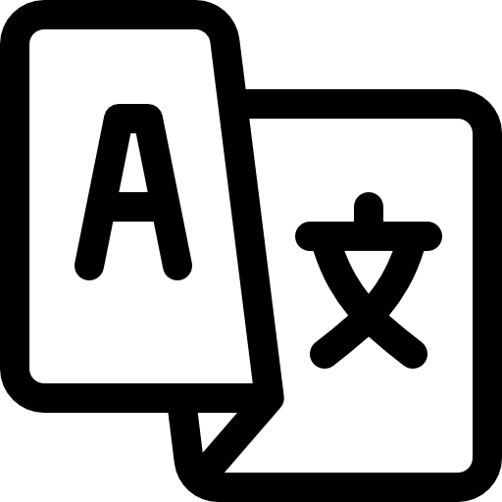 LANGUAGES

* Chinese (Native)
* Taiwanese (Native)
* English (C1)
* German (A2)

 SKILLS

Programming:

* Python (Expert)
* MATLAB (Advanced)

Finite Element Analysis:

* LS-DYNA (Expert)
* HyperMesh (Expert)
* Ansys (Intermediate)

Computer-Aided Design:

* SolidWorks (Advanced)
* Inventor (Advanced)
* PTC Creo (Intermediate)
* AutoCAD (Intermediate)

Applications:

* MS Office (Expert)
* LaTeX (Expert)
* Origin (Expert)
* Unix/Linux (Intermediate)

Hobbies and interests:

In my spare time, I enjoy preparing various cultural foods. Making Taiwanese cuisine, in particular, to introduce Taiwanese culture to my friends. My favorite way to relieve stress is to engage in hobbies like basketball, working out, and mountain climbing.

Heckerstrße 37, D-79114, Freiburg

+49 178 3012 373

[adam9515@gmail.com](mailto:adam9515@gmail.com)

20.09.1993 in Taipei

Taiwan

Single, no child

[www.linkedin.com/in/yu-sheng-tang](http://www.linkedin.com/in/yu-sheng-tang)

