



Script - Data protection

project no: **BOE858**

reply to: [**andybp@brightwavegroup.co**](mailto:andybp@brightwavegroup.co)**m**

responsiveRevision history

International House  
Queens Road  
Brighton, BN1 3XE  
United Kingdom  
Tel: +44 (0)1273 827676

[brightwavegroup.com](http://www.brightwavegroup.com)

|  |  |  |  |  |
| --- | --- | --- | --- | --- |
| Version | Date | Initials | Team | Summary of Revisions Made / Comments |
| 0.1 | 19.09.2016 | ABP | BW | First draft |
| 0.2 | 22.09.2016 | Sam Dorrell | BW | Edited quiz score screen to be a single screen |
| 0.3 | 22.09.2016 | EC | BW | QA |
| 0.4 | 22.09.2016 | ABP | BW | Amends after QA |
| 1.0 | 22.09.2016 | ABP | BW | Released for client review |
| 1,1 | 27.09.2016 | JL | BW | Client review |
| 1.2 | 28.09.2016 | ABP | BW | Amends after client review |
| 1.3 | 29/09/2016 | ABP | BW | Addition of client's assessment questions and editing of same |
| 2.0 | 30/09/2016 | ABP | BW | Released to client |
| 2.1 | 05/10/2016 | JL | UNI | Client review |
| 2.2 | 05/10/2016 | ABP | BW | Amends after client review |
| 3.0 | 06/10/2016 | LL | BW | Released for client sign off |
|  |  |  |  |  |
|  |  |  |  |  |
|  |  |  |  |  |
|  |  |  |  |  |
|  |  |  |  |  |
|  |  |  |  |  |
|  |  |  |  |  |
|  |  |  |  |  |
|  |  |  |  |  |
|  |  |  |  |  |
|  |  |  |  |  |
|  |  |  |  |  |
|  |  |  |  |  |

Purpose of this document

This script details the exact text that will appear on each screen of the course, together with the interactions and any buttons that appear. It also indicates the kind of graphics or images that will be used, although these are not final at this stage.

It's important that you check everything appears as you want it within the script, so that there are minimal changes once the course is built.

**As you read through this document, please use the Review tab to track any changes you would like made. You can also use comment boxes for more general points.**

**NB.** Gfx/Dev notes are for internal use only and directed to our design team.

Course overview

The aim of this course is to provide a fast-paced, lighter-touch version of the Data Protection training, making it appropriate for a 'refresher audience'. It brings the main points of the deep-dive training to life by relating the content back to its practical application. There is also an increased emphasis on the 'What's in it for me?' factor for the learner. Currently, data protection is commonly perceived as a blocker or a barrier to work, but this training aims to take away the fear of handling personal data.

Learning objectives

By completing this course, learners should be able to:

* identify different types of personal data and explain that handling it is central to the Bank's function
* explain what the Data Protection Act is and what it covers
* describe how to process personal data correctly
* identify the consequences of not complying with the legislation (e.g. fines, unwanted publicity etc.)
* describe the roles and responsibilities of Bank employees and the Information Commissioner in ensuring personal data is handled correctly.

Scope

|  |  |  |
| --- | --- | --- |
| Module | Topic title | Duration |
| Data Protection | Introduction | 3 mins |
| Data matters | 7 mins |
| Subject access requests | 8 mins |
| Working with personal data | 7 mins |
| Quiz | 10 mins |
| Total | | 35 mins |

# Menu

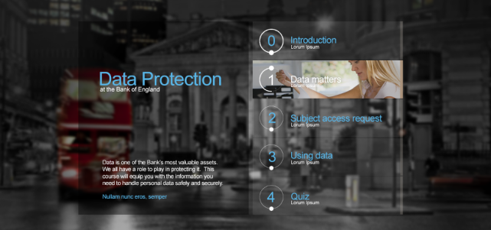

TITLE

Data protection

at the Bank of England

OPENING TEXT

The Bank deals with an increasing volume of information about individuals and we are all responsible for taking care of it. Data protection is all about ensuring we handle information in a manner which respects individuals’ rights and freedoms. This course will equip you with the knowledge you need to handle personal data safely and securely.

PROMPT

Select the topics in any order and then try the quiz.

TOPICS

1. Introduction
2. Data matters
3. Subject access requests
4. Working with personal data
5. Quiz

# Resources

DESCRIPTION

Pop-up screen with Close button.

TEXT

Resources

Explore the links below to take your data protection learning further.

|  |  |
| --- | --- |
| **Target** | **Link** |
| Records Management Course | To be supplied - link to eLearning course on Bank intranet |
| Cyber Seven IS Refresher | To be supplied - link to eLearning course on Bank intranet |
| Data Protection Liaison Representatives | http://intranet/HowDoI/Data-Protection/Pages/Data-Protection-Liaison-R.aspx?linkid=Search |
| Information Commissioner’s Office (ICO) | https://ico.org.uk/ |
| Data protection | http://intranet/Bank/Chief-Data-Office/Data-Compliance/Data-Protection/Pages/default.aspx?linkid=Navigate |
|  |  |

# Topic 1: Introduction

By the end of this topic the learner should be able to:

* identify different types of personal data and explain that handling it is central to the Bank's function.

## SCREEN 01_100

**SCREEN TYPE**: Text and graphic

DESCRIPTION

Data protection headlines animate onto the screen in the form of billboards on the wall of an escalator:

ANIMATED IMAGE



BILLBOARD TEXTS

|  |  |  |  |  |
| --- | --- | --- | --- | --- |
| TalkTalk attack estimated to cost between £30 and £35 million | 177 million emails and passwords for sale on the dark web after LinkedIn breach | Sony pays employees $8 million over theft of their personal information | Over 500 million Yahoo customers have their details hacked in cyber-attack. | $81 million stolen from the Bank of Bangladesh in cyber-attack |

PROMPT at bottom of screen

Scroll down or select the down arrow to continue.

TEXT - appears after scroll or click onwards

Personal data has become integral to how businesses operate, but what happens when things go wrong?

In September 2016, Yahoo revealed that it had suffered a significant attack that affected over half a billion of its customers – it’s still too soon to estimate how much this will cost the organisation – while earlier this year, the Information Commissioner’s Office issued its biggest ever fine of £350,000 to Prodial Ltd after receiving over 1,000 complaints related to the automated nuisance calls it generated.

And they aren't the only companies who have been making the headlines.

## SCREEN 01_110

**SCREEN TYPE**: Text and graphic

DESCRIPTION

A large background graphic of the Bank of England transitions onto the screen.

IMAGE

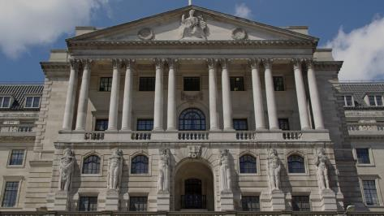

L:\Projects\BOE858_Data_Protection\development\visuals\originals\Bank_front.jpg

TEXT

Think about all the different types of personal data you handle. Whether it relates to staff you manage, business contacts, members of the public or customers and employees of firms we regulate, it's all personal data and we handle it every day.

We rely on you to take care of this data appropriately and keep us out of the headlines. Personal data appears in all parts of the Bank, so everyone needs to understand what their responsibilities are.

## SCREEN 01_120

**SCREEN TYPE**: Multiple choice question

DESCRIPTION

The learner answers the question by choosing options from the list and receives different feedback for correct, incorrect and partially correct answers.

**IMAGE**

L:\Projects\BOE858_Data_Protection\development\visuals\originals\Bank_inside.jpg

**QUESTION TEXT (30 words max)**

Which of the following does the DPA apply to?

**PROMPT**

Select your answers, then Confirm.

**OPTIONS (15 words max. per option)**

|  |  |  |
| --- | --- | --- |
| **1** | The name of an employee of a firm regulated by the Bank | **Correct** |
| **2** | A business contact’s email address | **Correct** |
| **3** | A recorded phone call with a member of the public | **Correct** |
| **4** | A colleague's mobile number on a call cascade list | **Correct** |
| **5** | A manager’s handwritten note from an interview | **Correct** |

**CORRECT TEXT FEEDBACK (50 words max)**

That’s right. These are all examples of personal data. The DPA regulates how organisations handle information related to individuals, no matter how it is presented. This information does not have to include a name or be particularly sensitive to be covered by the Act. You should always bear in mind that mishandling such data could have serious consequences for you, the person whose data it is, and the Bank.

Successfully completing this course will help you to handle personal information appropriately and confidently.

**PARTIALLY CORRECT TEXT FEEDBACK (50 words max)**

That’s not quite right. In fact, these are all examples of personal data. The DPA regulates how organisations handle information related to individuals, no matter how it is presented. This information does not have to include a name or be particularly sensitive to be covered by the Act. and you should always bear in mind that mishandling such data could have serious consequences for you, the person whose data it is, and the Bank.

But don't worry, successfully completing this course will help you to handle personal information appropriately and confidently.

## SCREEN 01_122

**SCREEN TYPE**: Text and graphic

DESCRIPTION

A large background graphic of another shot of the Bank of England transitions onto the screen.

IMAGE

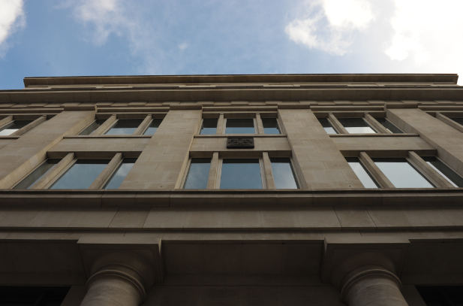

L:\Projects\BOE858_Data_Protection\development\visuals\originals\ SBO_8185.jpg

TEXT

We all have a role to play in ensuring the safeguard of all the personal data that comes in and out of the Bank and we are bound by eight data protection principles to handle this information in an appropriate way.

## SCREEN 01_123

**SCREEN TYPE**: Text reveals

DESCRIPTION

A large background graphic with intro text and text items in boxes. Learner selects text items to reveal more information.

IMAGE

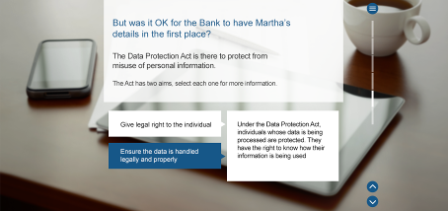

Shutterstock Image ID:104938577

INTRO TEXT

Take a minute here to go over the principles. Personal data shall be:

**TEXT ITEMS**

1. Fairly and lawfully processed
2. Processed for one or more specified purposes
3. Adequate, relevant and not excessive
4. Accurate and up to date
5. Not kept longer than necessary
6. Processed in accordance with the individual's rights
7. Secure
8. Not transferred to countries outside the EEA without adequate protection

**PROMPT**

Select each principle for more.

**TEXT REVEAL 1 -** Fairly and lawfully processed

You should have legitimate reasons for collecting and using the personal data you hold, and use it only in ways which would be reasonably expected. You should not use personal data unlawfully or in a way that could have an adverse effect on the data subjects.

**TEXT REVEAL 2 -** Processed for one or more specified purposes

You should provide individuals with appropriate privacy notices (also referred to as fair collection notices) when collecting their personal data. These let individuals know how their personal data will be used in a clear and transparent manner.

**TEXT REVEAL 3 -** Adequate, relevant and not excessive

Always consider whether you need to collect or use personal data. If you do, then make sure it is adequate and relevant to the business function you are conducting and that you don’t use or record more than is necessary.

**TEXT REVEAL 4 -** Accurate and up to date

Personal data should be accurate and up to date when it is being used as a basis for business decisions.

**TEXT REVEAL 5 -** Not kept longer than necessary

If you no longer need the personal data or its retention period has expired, ensure you delete it appropriately and, if necessary, inform your Data Protection Liaison Representative that you have done so. The Bank’s Records Classification Scheme has further guidance on the retention periods of classes of information.

**TEXT REVEAL 6 -** Processed in accordance with the individual's rights

Individuals have the right to make a subject access request (SAR) for a copy of their personal data. These must be dealt with within 40 calendar days. If you receive a request for personal information you should notify the Information Access Manager in the Information Access Team immediately.

**TEXT REVEAL 7 -** Secure

You should take appropriate security measures when dealing with personal data. Where personal data is stored in the Bank’s EDM system or transferred outside the Bank, it should be marked as Bank Confidential. Ensure that your screen is locked when you leave your desk and don’t leave personal information unattended on your desk.

**TEXT REVEAL 8 -** Not transferred to countries outside the EEA without adequate protection

If you need to transfer personal data outside the EEA, please contact the Data Protection Officer at [dataprotection@bankofengland.co.uk](mailto:dataprotection@bankofengland.co.uk)

## SCREEN 01_125

**SCREEN TYPE**: Text reveals

DESCRIPTION

A large background graphic with intro text and text items in boxes. Learner selects text items to reveal more information.

IMAGE



L:\Projects\BOE858_Data_Protection\development\visuals\originals\Bank_inside.jpg

INTRO TEXT

And let's have a quick look at who is responsible for what at the Bank in terms of data protection.

**TEXT ITEMS**

1. Everyone at the Bank
2. Data Protection Liaison Representative (DPLR)
3. Information Access Team (IAT)
4. Data Protection Officer (DPO)

**PROMPT**

Select each group for more.

**TEXT REVEAL 1 – Everyone at the Bank**

We all have a personal responsibility to make sure we don't breach any of the data protection principles. This means successfully completing your data protection training, being familiar with the data protection intranet pages and getting in touch with your business area’s DPLR or the Data Protection Team (DPT) if you have questions about personal data.

**TEXT REVEAL 2 – Data Protection Liaison Representative (DPLR)**

The DPLR is your business area’s data protection expert and is also responsible for coordinating SARs at the business area level.

**TEXT REVEAL 3 – Information Access Team (IAT)**

The IAT are responsible for co-ordinating the Bankwide search for the personal information asked for in a SAR and providing a response.

**TEXT REVEAL 4- Data Protection Officer (DPO)**

The DPO, who is supported by the Data Protection Team, is responsible for the co-ordination of all data protection matters in the Bank which includes formulating Bank policy on data protection, providing advice and submitting the Bank’s notification to the Information Commissioner.

## SCREEN 01_130

**SCREEN TYPE**: Topic selector

DESCRIPTION

A background image of various items that could hold personal data with two large overlaid buttons entitled 'LEARN MORE' and 'QUIZ' for the learner to choose between taking the course or going straight to the assessment.

IMAGE

.

TITLE

Where next?

TEXT

This course will provide you with an overview of the Data Protection Act 1998 (DPA), showing you how to process personal data correctly and what can happen if you don't comply with the legislation.

It should take you about 25 minutes and is followed by a quiz to check your understanding.

If, however, you feel you already know about data protection, you can try the quiz immediately.

**PROMPT**

Select an option.

BUTTONS

**LEARN** - takes the learner to the menu

**QUIZ** - takes the learner to Topic 5: Quiz

# Topic 2: Data matters

By the end of this topic the learner should be able to:

* identify different types of personal data and explain that handling it is central to the Bank's function
* explain what the Data Protection Act is and what it covers
* identify the consequences of not complying with the legislation (fines, unwanted publicity etc.)

## SCREEN 02_100

**SCREEN TYPE**: Title text and graphic

DESCRIPTION

The topic opens with a bold title, question and prompt over a full bleed image of our character called Martha at a desk reading a letter.

IMAGE

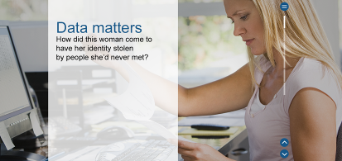

Shutterstock Image ID: 15328660

TITLE

Data matters

TEXT

How did careless management of personal data result in a criminal prosecution?

PROMPT at bottom of screen

Scroll down or select the down arrow to find out more.

## SCREEN 02_110

**SCREEN TYPE**: Chapter text and graphic

DESCRIPTION

A chapter heading over a full bleed image.

IMAGE



Shutterstock Image ID: 46928596

With an illegible address in the envelope's window.

TITLE

The discovery

## SCREEN 02_120

**SCREEN TYPE**: Text and graphic

DESCRIPTION

A large background graphic with text in a scrolling vertical band.

IMAGE

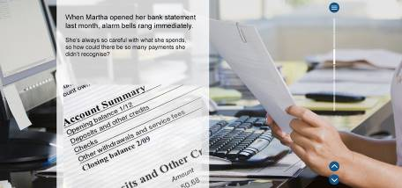

Shutterstock Image ID:15328657

TEXT

It's Monday morning and Martha, a self-employed architect, settles down to look at her mail. She opens a letter from a company she doesn't recognise.

**SMALL IMAGE**

A close-up of the letter (displayed at an angle) that reads:

|  |
| --- |
| Tibor Associates  235 Kyngs Road  Norwich NR2 9XV |
| Good news Martha!  Did you know that with a salary of £136,500 you could claim back up to £15,000 from HMRC?  As professional tax advisers, we can help you claim a substantial rebate on your earnings.  What have got to lose? Call us now to find out more. |

Just ring 0345 6 (the rest of the number is cut off in the picture)

**TEXT**

Alarm bells begin to ring for Martha. She's never heard of Tibor Associates, let alone asked them for any advice. How did they get her name and address? More importantly, how do they know her salary? And what else do they know about her?

She decides she can't just throw away the letter and gets in touch with her friend who works on the local paper…

## SCREEN 02_130

**SCREEN TYPE**: Text and graphic

DESCRIPTION

A large background graphic with text in a scrolling vertical band.

IMAGE

Screen style:



Background image:



TEXT

Martha's friend runs the story in both the print and online versions of the paper, and soon other people are coming forward from all around the country with the same complaint.

**SMALL IMAGE**

Newspaper column that reads:

|  |
| --- |
| Local tax firm alleged to be using people's personal data to promote business |
| Many people across the country are claiming that Tibor Associates have been using their personal data in mailshots aimed at ….  *(cut off image)* |

**TEXT**

The news coverage prompts Tibor Associates to release a statement saying they believe they obtained all the contact details legitimately. But by the time this statement is released, Martha has already reported the case to the Information Commissioner's Office (ICO), the UK’s independent authority responsible for overseeing the enforcement of the Data Protection Act.

## SCREEN 02_140

**SCREEN TYPE**: Multiple choice question

DESCRIPTION

The learner answers the question by choosing options from the list and receives different feedback for correct, incorrect and partially correct answers.

Style:

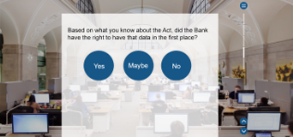

**IMAGE**

Screenshot of the **ico.** website on a computer.

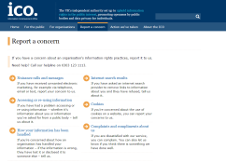

<https://ico.org.uk/concerns/>



Shutterstock Image ID: 139876522

**QUESTION TEXT (30 words max)**

Do you think Martha has grounds to report her case to the Information Commissioner?

**OPTIONS (15 words max. per option)**

|  |  |  |
| --- | --- | --- |
| **1** | Yes | **Correct** |
| **2** | No | **Incorrect** |

**CORRECT TEXT FEEDBACK**

That’s right, it looks like Martha does have grounds for complaint. Organisations are required to handle information relating to individuals in a way outlined by the DPA. Consequences for non-compliance could result in a fine of up to £500,000.

In addition, there are certain situations where a breach of the DPA is a criminal offence and for which the Information Commissioner can investigate and prosecute offenders. They include:

* Failure to notify the Commissioner of changes to the notification register entry
* Failure to comply with an enforcement or similar notice
* Knowingly or recklessly obtaining or disclosing personal information without the consent of the data controller (unless an exemption applies)
* Selling or offering to sell personal information (unless the data subject has consented and a privacy notice has clearly described this as a possibility)

Martha's case clearly concerns the third point and she is right to report it. After looking at the evidence, the Information Commissioner decides to investigate.

**INCORRECT TEXT FEEDBACK**

Actually, it looks like Martha does have grounds for complaint. Organisations are required to handle information relating to individuals in a way outlined by the DPA. Consequences for non-compliance could result in a fine of up to £500,000.

In addition, there are certain situations where a breach of the DPA is a criminal offence and for which the Information Commissioner can investigate and prosecute offenders. They include:

* Failure to notify the Commissioner of changes to the notification register entry
* Failure to comply with an enforcement or similar notice
* Knowingly or recklessly obtaining or disclosing personal information without the consent of the data controller (unless an exemption applies)
* Selling or offering to sell personal information (unless the data subject has consented and a privacy notice has clearly described this as a possibility)

Martha's case clearly concerns the third point and she is right to report it. After looking at the evidence, the Information Commissioner decides to investigate.

## SCREEN 02_150

**SCREEN TYPE**: Chapter text and graphic

DESCRIPTION

A chapter heading over a full bleed image.

Style:



IMAGE



TITLE

The investigation

## SCREEN 02_160

**SCREEN TYPE**: Text reveals

DESCRIPTION

A large background graphic with intro text and text items in boxes. Learner selects text items to reveal more information.

IMAGE



Shutterstock Image ID:104938577

INTRO TEXT

It's up to the Information Commissioner to decide whether the DPA has been breached.

The Act has been put in place to protect the privacy rights of individuals and prevent the misuse of personal information. It contains a framework of rights and duties, and prescribes the consequences of not adhering to them.

**TEXT ITEMS**

Rights

Duties

Consequences

**PROMPT**

Select each aim for more.

**TEXT REVEAL 1 Rights**

Individuals whose data is being processed are protected under the DPA. They have the right to know and understand how their information is being used and processed.

**TEXT REVEAL 2 Duties**

The eight data protection principles in the DPA outline how an organisation is expected to handle personal data.

**TEXT REVEAL 3 Consequences**

The Information Commissioner can take appropriate technical and organisational measures against unauthorised or unlawful processing of personal data and against accidental loss or destruction of, or damage to, personal data. This includes notices outlining the actions an organisation must take to comply with the DPA, fines of up to £500,000 following breaches of the DPA and, in certain circumstances, criminal prosecution.

## SCREEN 02_170

**SCREEN TYPE**: Text and graphic

DESCRIPTION

A large background graphic with text in a scrolling vertical band.

IMAGE

Screen style:



Background image:



TEXT

During the investigation, the Information Commissioner interviews the Managing Director of Tibor Associates, Stan Maloney.

Stan explains that until recently he worked for the Bank of England as a Technology Manager, but left to start a firm of tax advisers.

Prior to leaving the Bank, he discovered a document marked Unclassified View (UV), which contained information related to a substantial number of mortgages. The information included property addresses, postcodes and salaries but nobody's names.

He sent a copy of the document to his personal email address and then cross-referenced the information with the Land Registry. By doing this, he was easily able to determine the names of the property owners. He then contacted those individuals with salaries of over £100,000 to offer his new service.

Stan makes it clear to the Information Commissioner that this information was unclassified and that there were no names included in the list when he took it. So has he done anything wrong?

## SCREEN 02_180

**SCREEN TYPE**: Multiple choice question

DESCRIPTION

The learner answers the question by choosing options from the list and receives different feedback for correct, incorrect and partially correct answers.

Style:

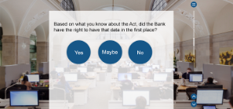

**IMAGE**



Shutterstock Image ID: 363839243

**QUESTION TEXT (30 words max)**

Three months later, the Information Commissioner is about to publish her decision. Based on what you've seen, do you think Tibor Associates are in breach of the DPA?

**OPTIONS (15 words max. per option)**

|  |  |  |
| --- | --- | --- |
| **1** | Yes | **Correct** |
| **2** | No | **Incorrect** |

**CORRECT TEXT FEEDBACK**

That’s right. The Information Commissioner prosecutes Stan Maloney for unlawfully obtaining and disclosing personal information. A fine of £40,000 is imposed on Tibor Associates for not verifying that the personal information was to be used in a way which Martha and all the others affected would have reasonably expected.

Finally, the Information Commissioner issues an enforcement notice to the Bank which orders the Bank to take measures to secure its personal data. This is published on the ICO website.

**INCORRECT TEXT FEEDBACK**

Actually, the Information Commissioner prosecutes Stan Maloney for unlawfully obtaining and disclosing personal information. A fine of £40,000 is imposed on Tibor Associates for not verifying that the personal information was to be used in a way which Martha and all the others affected would have reasonably expected.

Finally, the Information Commissioner issues an enforcement notice to the Bank which orders the Bank to take measures to secure its personal data. This is published on the ICO website.

## SCREEN 02_190

**SCREEN TYPE**: Photostory

DESCRIPTION

This screen consists of several frames, controlled by the learner, which summarise the scenario and relate it back to the learning objectives.

Visual style:



.

|  |  |  |
| --- | --- | --- |
| **Frame** | **Picture** | **Text** |
| **1** | Image of newspaper report:  Tibor or not Tibor?  Local tax advisers Tibor Associates were today fined £40,000 by the ICO for misusing personal data. Furthermore, Stan Maloney, CEO of Tibor Associates, has been found guilty of unlawfully obtaining personal data. Mr Maloney has stated that this could bankrupt his firm.  Last year Mr Maloney obtained data from a file he had chanced upon while working at the Bank of England. This data was…  (cut off) | **Title:** Case file  **Text:** Stan's improper and illegal handling of personal data has cost him his business and probably much more.  **Prompt:** Select the **+** for a summary of the data protection issues that affected his case. |
| **2** | files on the desk. | **Title:** Personal information  **Text:** The DPA defines personal data as data which relates to a living individual who can be identified:   1. from that alone   or   1. from the data along with other information which is in the possession of, or is likely to come into the possession of, the data controller.   -------------------------------------------  *(Separate column)*  Stan may well have thought the data he obtained from the UV file at the Bank was not personal because it did not include names. But the fact that he was able to connect it to other information and establish the identities of the people whose data it was, clearly demonstrates the second provision of the definition. |
| **4** | From website | **Title:** The Information Commissioner  **Text:** The Information Commissioner upholds information rights in the public interest. This includes making sure organisations meet the requirements of the Data Protection Act 1998 when handling personal information.  The ICO has a duty to investigate and even prosecute people and businesses who misuse personal data.  Actions they can take:  Criminal prosecution  Non-criminal enforcement  Audit  Serving monetary policy notices (fines) |
| **3** | From website | **Title:** The aims  **Text:** The Act has been put in place to protect the privacy rights of individuals and prevent the misuse of personal information. It creates a framework of rights and duties and prescribes the consequences of not doing that.  It defines the rights, duties and consequences of handling personal data. |
| **5** | Judge hitting gavel with paper at wooden table closeup | **Title:** The consequences  Text: The Information Commissioner issued Tibor Associates with a fine for £40,000. Their reputation was seriously damaged by the media coverage of the case, as was the reputation of the Bank by association.  There was also the possibility of criminal sanctions against the individual, Stanley Maloney, as well as action taken by the Information Commissioner against the Bank for not doing more to protect this personal information. |
| **6** | Silhouette of male hand pressing black keys on the laptop keyboard | **Title:** Classifying personal data  **Text:** Most documents containing personal data should be saved as BCP (Bank Confidential: Private).  You can find out more about classification in the Records Management Course as well as the Cyber Seven IS Refresher on the Bank’s eLearning portal (select Resources for links).  The IS Refresher also explains why sending Bank documents to your private email is forbidden. |
| **7** | blurred office working background | *(Note to developer: If you can fit all the content from frames 7 and 8 onto one screen under one 'Remember', then please do so.)*  **Title:** Remember:  **Text:**   * Legislation exists to guide the way we work with personal data to help protect the information and the rights of the individuals that the information concerns – it also defines the consequences of not respecting the legislation.   Consequences enforced by the ICO include requiring data controllers to stop processing personal data, requesting more information about how they process personal data, pursuing criminal prosecution and issuing fines.   * There are lots of different types of personal data – it's central to what the Bank does. Personal data might not look personal – just because a name isn’t included, doesn’t mean it’s not personal data. |
| **8** |  | **Title:** Remember:    **Text:**   * Incorrectly handling personal data can have far-reaching consequences. You need to make sure you're handling data correctly to protect yourself and protect the Bank against reputational damage and fines. Just because a document has been misclassified, does not release you from your responsibilities. * By attesting to Our Code, you are saying that you understand the importance of handling personal data appropriately and, more broadly, are acknowledging what is expected of you as a Bank employee.   **Prompt:** Select the Menu button to choose another topic. |