## SCREEN 05_150

SCREEN TYPE: Column sort

DESCRIPTION

There will be two columns – Do's and Don'ts and 5 options.

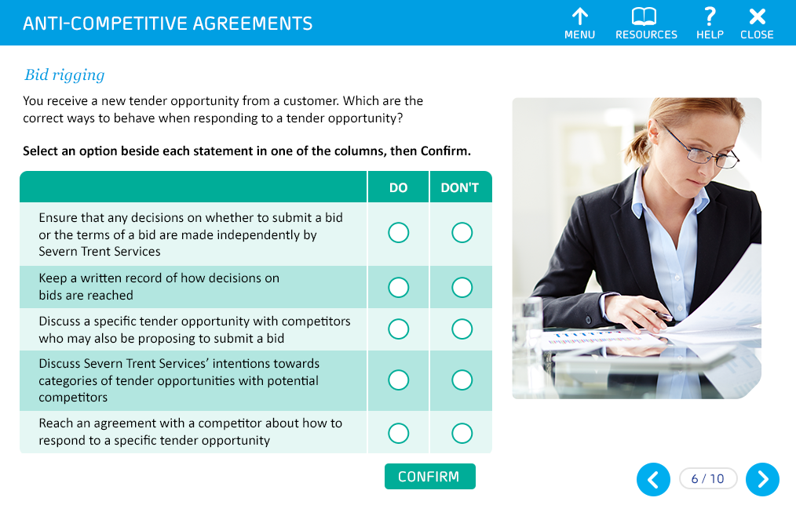

Same as the mock-up

SCREEN TITLE

Bid rigging

QUESTION TEXT (30 words max)

You receive a new tender opportunity from a customer.

Which of these are the correct ways to behave when responding to a tender opportunity?

PROMPT

Select an option beside each statement in one of the columns, then Confirm.

OPTIONS (15 words max. per option)

|  |  |  |  |
| --- | --- | --- | --- |
|  | | **Do** | **Don't** |
| **1** | Ensure that any decisions on whether to submit a bid or the terms of a bid are made independently by Severn Trent Services | ✓ |  |
| **2** | Keep a written record of how decisions on bids are reached | ✓ |  |
| **3** | Discuss a specific tender opportunity with competitors who may also be proposing to submit a bid |  | ✓ |
| **4** | Discuss Severn Trent Services' intentions towards categories of tender opportunities with potential competitors |  | ✓ |
| **5** | Reach an agreement with a competitor about how to respond to a specific tender opportunity |  | ✓ |

CORRECT TEXT FEEDBACK (50 words max)

That's right!

You must ensure that any decisions on whether to submit a bid or the terms of a bid are made independently by Severn Trent Services. Make sure you keep a written record of how decisions on bids are reached too.

Never discuss a specific tender opportunity or categories of tender opportunity with competitors who may also be proposing to submit a bid. You also should not reach any kind of agreement with a competitor about how to respond to a specific tender opportunity.

PARTIAL TEXT FEEDBACK (50 words max)

Not quite.

You must ensure that any decisions on whether to submit a bid or the terms of a bid are made independently by Severn Trent Services. Make sure you keep a written record of how decisions on bids are reached too.

Never discuss a specific tender opportunity or categories of tender opportunity with competitors who may also be proposing to submit a bid. You also should not reach any kind of agreement with a competitor about how to respond to a specific tender opportunity.

FAIL TEXT FEEDBACK (50 words max)

Sorry, that's not right.

You must ensure that any decisions on whether to submit a bid or the terms of a bid are made independently by Severn Trent Services. Make sure you keep a written record of how decisions on bids are reached too.

Never discuss a specific tender opportunity or categories of tender opportunity with competitors who may also be proposing to submit a bid. You also should not reach any kind of agreement with a competitor about how to respond to a specific tender opportunity.