## SCREEN 01_120

**SCREEN TYPE**: Graphic reveal

DESCRIPTION

Photos, illustrations or diagrams can be selected to reveal further information, usually in text form.

Example mock-up:

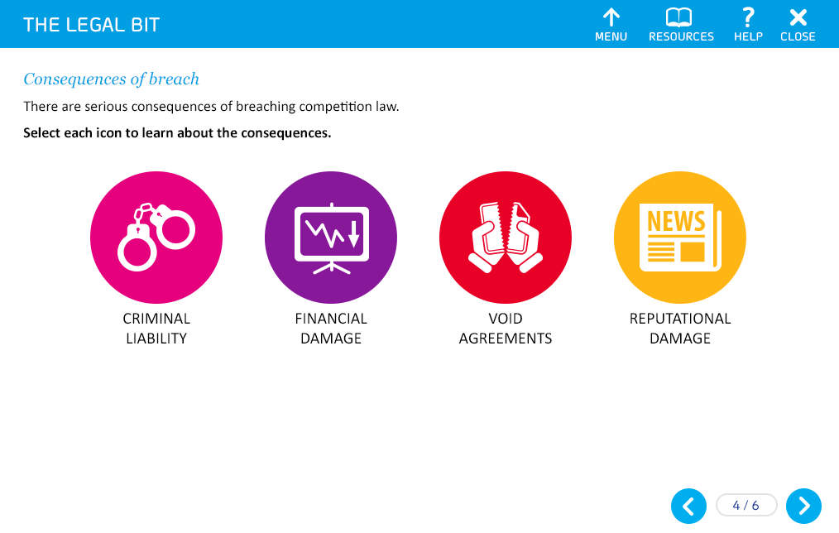

Use images instead of icons.

SCREEN TITLE

Your responsibilities

GRAPHIC 1

Image of a policy / an open book. Text should not be legible

GRAPHIC 2

Show someone talking on a phone

GRAPHIC 3

Two people in a discussion in a meeting room

GRAPHIC 4

Two people in a conversation around a computer in the office

OPENING TEXT (30 words max)

You have a role to play in avoiding and reporting any anti-competitive practices. It is important that you:

PROMPT

Select each image to find out more.

TEXT FOR REVEAL 1 (50 words max)

Understand and act in accordance with the Group Competition and Competitive Information Policy.

TEXT FOR REVEAL 2 (50 words max)

Report any known or suspected instances of anti-competitive behaviour.

TEXT FOR REVEAL 3 (50 words max)

Co-operate with any investigation into any concern.

TEXT FOR REVEAL 4 (50 words max)

Seek help from the Legal Team or your Line Manager if you have any queries or would like any further guidance.

END OF TOPIC PROMPT(*\*Dev note - this should only appear once each reveal has been selected)*

You have now completed this topic. Go to the menu and select another topic.