



MDLZ_LOGO_REV.png

Script

Big Purple Bus Tour: Landmarks

02 Research, Design & Quality (RDQ)

project no: MDL851

reply to: Elizabeth Hughes[**elizabeth.hughes@brightwavegroup.co**](mailto:elizabeth.hughes@brightwavegroup.co)**m**

Revision history

International House  
Queens Road  
Brighton, BN1 3XE  
United Kingdom  
Tel: +44 (0)1273 827676

[brightwavegroup.com](http://www.brightwavegroup.com)

|  |  |  |  |  |  |
| --- | --- | --- | --- | --- | --- |
| Version | Date | Initials |  | Team | Summary of Revisions Made / Comments |
| 0.1 | 03/10/16 | EH |  | BW | Initial draft |
| 0.2 | 04/10/16 | EH |  | BW | Initial draft following clarification with LS |
| 0.3 | 06/10/16 | EH |  | BW | Next draft following feedback from TF & client |
| 0.4 | 12/10/16 | LS |  | BW | Review and game scripting |
| 0.5 | 14/10/16 | TF |  | BW | Review and amends made |
| 0.6 | 14/10/16 | JAD |  | BW | Formatting |
| 0.7 | 14/10/16 | JAD |  | BW | QA |
| 1.0 | 14/10/16 | TF |  | BW | Amends made and released to client |
| 1.1 | 17/10/16 | TG |  |  | Client review 1 |
| 1.4 | 27/10/16 | EH |  | BW | Amends following client review/Solutions Call |
| 1.5 | 27/10/16 | ABP |  | BW | Proofread of amends |
| 2.0 | 27/10/16 | LL |  | BW | Released for sign off |
| 2.1 | 28/10/16 | TF |  | BW | Game screen amended to included feedback |
| 2.2 | 01/11/16 | TG |  |  | Client feedback |
| 2.3 | 01/11/16 | EH |  | BW | Amends. Check images. Make ready for Build |
| 2.4 | 02/11/16 | JAD |  | BW | Partial QA |
| 2.5 | 02/11/16 | EH |  | BW | QA, style guide & client amends |
| 2.6 | 09/11/16 | AB |  | BW | Script tidied for automation |
| 2.7 | 16/11/16 | EH |  | BW | Additional text from client added to Screens 02\_110 & 02\_140 + URL added to 'Additional Resources' section in Resources Room. |
| 2.8 | 18/11/16 | EH |  | BW | Amends to Titles of Resources in Resources Room. |
| 2.9 | 21/11/16 | EH |  | BW | Meta data page added. +  Topic titles amended to Sentence case.  + numerous small Script amends made as requested via BIT  + Pop-up text added to Photostory screens 01\_100 & 03\_110. |
| 2.10 | 22/11/16 | AB |  | BW | Alpha amends |
| 2.11 | 22/11/16 | EH |  | BW | Script amends as reviewing Alpha build. |
| 3.0 | 23/11/16 | NW |  | BW | Alpha release |
| 3.1 | 23/11/16 | EH |  | BW | URLs to resources 12 & 13 in Resource Room added. |
| 4.0 | 24/11/16 | LL |  | BW | Released with Alpha course |

Purpose of this document

This script details the exact text that will appear on each screen of the course, together with the interactions and any buttons that appear. It also indicates the kind of graphics or images that will be used, although these are not final at this stage.

It's important that you check everything appears as you want it within the script, so that there are minimal changes once the course is built.

**As you read through this document, please use the Review tab to track any changes you would like made. You can also use comment boxes for more general points.**

Contents

[Purpose of this document 2](#_Toc465417681)

[Contents 3](#_Toc465417682)

[Splash Screen 4](#_Toc465417683)

[Help 5](#_Toc465417684)

[Welcome 6](#_Toc465417685)

[Menu 7](#_Toc465417686)

[Topic 1: The Role of RDQ 8](#_Toc465417687)

[01\_100 8](#_Toc465417688)

[01\_110 10](#_Toc465417689)

[01\_120 11](#_Toc465417690)

[Topic 2: Global Collaboration 12](#_Toc465417691)

[02\_100 12](#_Toc465417692)

[02\_110 13](#_Toc465417693)

[02\_120 16](#_Toc465417694)

[02\_130 18](#_Toc465417695)

[02\_140 21](#_Toc465417696)

[02\_150 26](#_Toc465417697)

[02\_160 28](#_Toc465417698)

[Topic 3: Seeking Solutions 29](#_Toc465417699)

[03\_100 29](#_Toc465417700)

[03\_110 30](#_Toc465417701)

[03\_120 32](#_Toc465417702)

[03\_130 33](#_Toc465417703)

[03\_140 36](#_Toc465417704)

[03\_150 46](#_Toc465417705)

[Topic 4: Resources Room 47](#_Toc465417706)

# Meta data (used in LMS)

Course title

Research, Design & Quality (RDQ)

Course description

Research, Development and Quality (RDQ).

Visit time = 30 minutes.

Find out how the global RDQ teams discover the science and technology to meet our consumers' needs. See how this function develops delicious new products and deploys them into markets across the world.

RDQ teams don't just create our tasty snacks, they also design the processes to make them. Colleagues here develop and create all the packaging too.

Most importantly, RDQ make sure our products are safe, comply with local regulations, and meet the high quality consumers expect.

Keywords

Research, Development & Quality, research, development, quality, RDQ, science, technology, product, products, process, processes, packaging, snacks, compliance, compliant, regulations, global, collaboration, RSSL, must-win, markets, scientists, engineers, experts, SARA, Scientific and Regulatory Affairs, joy, safety, ingredient, well-being, Legal, heat resistant chocolate, chocolate, discover, deploy, develop, Advantaged Center, East Hanover, Curitiba, Bournville, Reading, Thane, Suzhou, Wroclaw, Singapore, product development, process development, nutrition, Research & Nutrition, Breakthrough Innovation, innovation, Strategy & Productivity, food safety, specifications, improved, HRC, consumers,

# Splash Screen

DESCRIPTION

The splash screen appears when the module is launched. It provides a summary of the module content and a note on audio. There is a button for learners to select when they are ready to start the module. This will open the module in a new window.

While the module is open, the module open text will be shown.

When the module has been closed, the module closed text will be shown.

TEXT

Welcome to the Research, Design & Quality (RDQ) landmark.

At this landmark you'll see:

* what the RDQ function does
* how RDQ teams work together and with other functions across the world
* how the delicious snacks that bring joy to our customers are created
* how new products, processes and packaging are discovered, developed and deployed.

This landmark contains optional sound. If you want to listen, please connect speakers or headphones. Use the audio controls on your device to adjust the volume or to mute the sound. You'll see this symbol on all screens with optional sound:



Your tour of this landmark is expected to last about 25 minutes. You can come back another time and complete your tour over several visits, if you want. Each time you come back to this landmark, we'll return you to the last point you visited.

BUTTON

Begin the tour

MODULE OPEN TEXT

The landmark tour has opened in a new window. Please leave this window open while you go on your visit.

MODULE CLOSED TEXT

You may now close this window.

FOOTER

Copyright Mondelēz International 2016

Produced by [Brightwave](http://www.brightwavegroup.com/).

# Help

DESCRIPTION

The help popover appears above the current content whenever the help button is selected. It has two tabs – one explaining the menu, the other explaining how to navigate within topics. The popover has a close button that removes the popover and restores the content the learner was viewing.

TAB TITLE

Getting around the menu

IMAGE

Show a segment of the menu from this module including a topic hotspot.

TEXT

You'll need to scroll left and right to see all areas in the menu.

**[Topic icon]** Select a burst to open a new area of the tour.

**[Help icon]** Select this icon to open this screen.

**[Exit]** Select this to return to the map.

TAB TITLE

Going on the tour

IMAGE

Show a screen from this module.

TEXT

When you're on the tour there are other buttons you'll use to move around.

**[Menu icon]** Takes you back to the menu.

**[Back and Next]** Use these buttons to move between screens.

**[Progress Icons]** Shows your progress in a topic.

# Welcome

SCREEN TYPE Video

DESCRIPTION

**NOTE**: This screen may become part of the Super Menu, pending a technical investigation into the capabilities of the MDLZ LMS. Failing that, it will be the first screen of the module, prior to the menu.

The tour guide provides an overview of the content for this landmark before the learner enters the tour for this landmark. The button will either launch the module (if this screen is in the Super Menu) or take the learner to the menu (if it is the first screen in the module)

VIDEO

Character animation (lip-synched) of tour guide in front of the RDQ landmark.

TRANSCRIPT

Welcome to the high-tech Research, Development and Quality building. We call this function RDQ for short.

Our visit here will take about half an hour. During that time you'll see how the global RDQ teams **discover** the science and technology to meet our consumers' needs. You'll find out how they **develop** delicious new products and then **deploy** them into markets across the world.

Here at RDQ our teams don't just create our tasty snacks, they also design the processes to make them. We develop and create all the packaging too.

Most importantly, we make sure our products are safe, comply with local regulations, and meet the high quality consumers expect.

You can leave the tour at any time and come back whenever you like. You'll start at the same point you left.

Let's go in!

BUTTON

Enter RDQ

# Menu

DESCRIPTION

The menu is a horizontally scrolling stylized interpretation of the work environment. It has several areas representing each of the topics in this module. Each area has an icon that the learner selects to access the relevant topic. Topic titles and durations are shown next to the icon as it passes through the central areas of the screen. No duration is shown for the Resources Room as it contains multiple items of discretionary content of variable length. The menu has audio, so it shows the audio icon. The first topic icon should be in view and showing its title at the opening position of the menu.

[**NOTE TO BW GRAPHIC DESIGN TEAM:** Images of **single individuals** should be kept to minimum level within the RDQ module. Collaboration is key to this department so pics and photos must ALWAYS **show people working as a team, 2 people minimum.]**

TOPIC 1 TITLE

The role of RDQ

TOPIC 1 DURATION

5 MINS

TOPIC 2 TITLE

Global collaboration

TOPIC 2 DURATION

10 MINS

TOPIC 3 TITLE

Seeking solutions

TOPIC 3 DURATION

7 MINS

RESOURCES ROOM

Resources room

GUIDE AUDIO

Now that you're inside the RDQ landmark, you can scroll to the right to see different areas. To enter an area, select the icon next to its title, like the one you can see here. When you want to leave this landmark, select the exit icon at the top of the screen. I'll remember where you were, so we can continue your tour when you return. Now, please select an area to begin your tour of RDQ.

INSTRUCTION TEXT

Scroll to the right to see all the areas. Select a burst to enter an area.

# Topic 1: The role of RDQ

## SCREEN 01\_100

SCREEN TYPE: Photostory

DESCRIPTION

A series of images with text that the learner explores in a fixed sequence that provides a linear narrative.

**NOTES TO BW GRAPHIC DESIGN TEAM:**

1. Images of **single individuals in the workplace are not allowed** within the RDQ module. Collaboration is key to this department so pics and photos **should show people working as a team, 2 people minimum, whenever possible**.

If a specific image is not provided… Whenever we show people with products, please make sure we show **smallish, healthy portions**.

Latest & greatest key source document is this one, saved on BW network on 1st November. Source: L:\Projects\MDL851\_BPBT\_Landmarks\from\_client\content\Module content\02\_RDQMLDZ Landmark Tour RDQ Outline 20161031

Show MDLZ diversity as well as collaboration. i.e. not just white males and not just chocolate.

|  |  |  |
| --- | --- | --- |
| **Frame** | **Picture** | **Text (Max 15 words per speech/caption)** |
| **1** | Use OREO cookie background shot, or OREO cookie packaging image. | **HEADLINE**  RDQ teams work together to solve different kinds of problems, such as:  **TEXT**   * How do we make more consumer-friendly packaging that prevents our cookies from breaking and keeps them fresh? * How can we create delicious, wholesome, healthy snacks which also deliver moments of joy? * How can our chocolate be more competitive in must-win markets in Africa and India?   **PROMPT**  Select the numbers below to discover what kind of people and teams we need, to come up with answers to these questions. |
| **2** | Photo of people working together, preferably MDLZ people, e.g. 2 men in the Innovation Kitchen shot  Source: L:\Projects\MDL851\_BPBT\_Landmarks\from\_client\content\Module content\02\_RDQMLDZ Landmark Tour RDQ Outline 20161031 Slide 41. | **HEADLINE**  Our people and knowledge are our most valuable assets; we treasure and develop them.  **TEXT**  Science and technology are essential to creating products and packaging that bring joy to our consumers every day.  We have teams of experts across the globe: many are scientists and engineers – other colleagues work in Quality Assurance, Regulatory Affairs or Consumer Science.  **Did you know…?** RDQ has 350 employees worldwide who develop different kinds of packaging. |
| **3** | Develop RDQ Structure Chart – see Slide 9 of Client Outline ppt.  Source: L:\Projects\MDL851\_BPBT\_Landmarks\from\_client\content\Module content\02\_RDQMLDZ Landmark Tour RDQ Outline 20161031 Use MDLZ icons as well as words for the Categories in the orange boxes at the top. Colors are up to design team. Source: L:\Projects\MDL851\_BPBT\_Landmarks\from\_client\content\Module content\02\_RDQMLDZ Landmark Tour RDQ Outline 20161031 Slide 11  BW make 1 change; Show **S**cientific **A**nd **R**egulatory **A**ffairs (SARA) < like this. I've explained this acronym in the script, – EH. | **HEADLINE**  The RDQ function is made of many different teams.  **TEXT**  Our Product and Process Development teams are category specific.  The other RDQ teams of experts support all categories.  SARA = **S**cientific **A**nd **R**egulatory **A**ffairs.  We always try to avoid jargon and acronyms but thought we needed a shorter name for this team! |
| **4** | http://image.shutterstock.com/z/stock-photo-young-daughter-is-feeding-her-father-with-chocolate-cookies-157286444.jpg  This Shutterstock image has been approved by client. (TG email 12.01pm Mon 1 November.) | **HEADLINE**  RDQ – our purpose and beliefs  **TEXT**  In RDQ we invent moments of joy to feed the body and nourish the soul.  We believe:   * the safety of our products and trust of our consumers comes first * science and technology are essential to creating products and packaging that bring joy to our consumers every day * collaboration is very important in RDQ – it drives our success * our colleagues are the special ingredient in our success, we care about their engagement, safety and well-being. |

**WARNING POP-UP TEXT**

If learner does not select ALL screens within a Photostory a pop-up appears to tell them there's content they haven't seen yet. Learner is directed back and must select all frames before being allowed to select 'Next'.

There's more information for you here. Select each of the numbers to see everything about this subject.

## SCREEN 01\_110

SCREEN TYPE Text reveal

DESCRIPTION

The learner selects text headings to reveal further information.

OPENING TEXT (30 words max)

RDQ has over 2,500 colleagues working either in category teams, or in global teams that support the categories. We help grow the business in lots of different ways.

PROMPT

Select each activity to learn more about how we do it and which teams (or sub-functions) are involved.

HEADING 1 TEXT (5 words max)

Understanding consumers' needs

TEXT FOR HEADING 1 (50 words max)

What do consumers want? It's the job of our Consumer Science & Statistics team to find out!

They work closely with the Strategy, Insight & Analytics, and Marketing functions to gather and analyze feedback from consumers across the globe.

When we know what people want, we can develop products and packaging to meet their needs.

HEADING 2 TEXT (5 words max)

Discovering the fundamental science and technology

TEXT FOR HEADING 2 (50 words max)

Our scientists and engineers have both technical expertise and business experience. Our researchers work externally and internally alongside product and process developers to design and develop new products, formulations and processes. They also find ways to make those we already have even better.

They create the tastier, healthier, fresher snacks our consumers prefer.

HEADING 3 TEXT (5 words max)

Making products safe and compliant

TEXT FOR HEADING 3 (50 words max)

It's top priority that all our products are safe for consumers to enjoy and it's a key objective for our **S**cientific **A**nd **R**egulatory **A**ffairs team (SARA). They are also aware of the different food industry regulations in individual countries and ensure our products comply with local standards, codes of practice and requirements.

## SCREEN 01\_120

SCREEN TYPE Text and graphic

DESCRIPTION

This screen presents information, sometimes with an illustrative graphic/image, and sometimes with typography, such as a pull-quote. There are no learning instructions or interactions. The layout of text and image will vary based on the requirements of the content.

Brief from Content Map: Wrap up the introduction of the RDQ function by recapping on the overview of RDQ, and make specific reference to their contribution to the overall organizational goals, and the pillars of Ambition2020.

PULL-QUOTE TEXT (Max 10 words)

Top-tier financial performance **and** a great place to work

BODY TEXT (Max 100 words)

Here in RDQ we:

* **discover** the science and technology to meet our consumers' wants and needs
* **develop** products, processes and packaging
* **deploy** them into local markets.

We unleash the power of our people with our collaborative, knowledge-sharing community. We offer careers and capabilities to develop products our consumers crave. We always put colleague safety at the center of everything we do.

We drive efficiency and fuel growth by being cost-conscious and over-achieving on our productivity targets.

We 'fill white spaces' with innovative products and great packaging which consumers love.

We 'accelerate our core' by driving food safety and providing quality in every bite so customers and consumers trust our brands.

PROMPT

Select the Home icon to return to the menu.

# Topic 2: Global collaboration

## SCREEN 02\_100

SCREEN TYPE Text and graphic

DESCRIPTION

This screen presents information, sometimes with an illustrative graphic/image, and sometimes with typography, such as a pull-quote. There are no learning instructions or interactions. The layout of text and image will vary based on the requirements of the content.

IMAGE

Close-up photo of chocolate being poured or melted during the manufacturing process.



BODY TEXT (Max 100 words)

Over 10 years ago, RDQ were asked to develop a Heat Resistant Chocolate (HRC).

The challenge was to create chocolate which would remain solid above 32oC, and still taste great

Such a chocolate would help us move into must-win markets in hot climates, where refrigeration isn't always available.

It sounded like an impossible task!

Like any challenge, teamwork was key to solving this sticky problem.

## SCREEN 02\_110

SCREEN TYPE Hotspot reveal

DESCRIPTION

The learner selects icons on an image to reveal further information, images or media.

Mondelēz red for Discover, blue for Develop and Mondelēz purple for Deploy.

Also, please make each of these colored words **bold**

+ Use relevant MDLZ Category icons to match the ones listed in the Reveal Text. Source: \\brightfs1\company\Projects\MDL851\_BPBT\_Landmarks\from\_client\content\Module content\RDQ\MLDZ Landmark Tour RDQ Outline 20160926.pptx Slide 11

MAIN IMAGE

MDLZ RDQ global sites map. Source: L:\Projects\MDL851\_BPBT\_Landmarks\from\_client\content\Module content\02\_RDQMLDZ Landmark Tour RDQ Outline 20161031 Slide 7

BW Build team: Remove all text & devices except Map, ADVANTAGED Sites list & location markers. (Change list from 'Strategic' Sites to Advantaged Sites.)

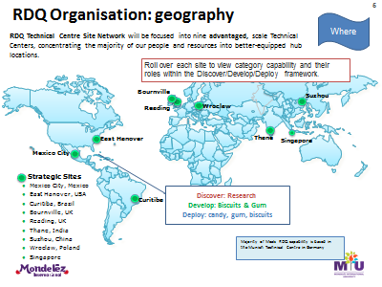

OPENING TEXT (30 words max)

Luckily RDQ has teams of experts all over the world.

PROMPT

Select each Advantaged Technical Center to find out more.

REVEAL 1 ICON PLACEMENT

Mexico City, Mexico

REVEAL 1 TEXT (50 words max)

¡Hola! The teams in the busy Mexican capital city work in the Gum, Candy Powdered Beverages and Meals categories.

They **deploy** all four categories and they've got the skills to **develop** Candy and Meals here. RDQ in Mexico also work hard to **discover** new Candy products.

REVEAL 1 IMAGE/VIDEO

Use relevant MDLZ Category icons to match the ones listed in the Reveal Text. Source:

Source: L:\Projects\MDL851\_BPBT\_Landmarks\from\_client\content\Module content\02\_RDQMLDZ Landmark Tour RDQ Outline 20161031 Slide 11

REVEAL 2 ICON PLACEMENT

East Hanover, USA.

REVEAL 2 TEXT (50 words max)

Hi there! In the township of East Hanover in New Jersey, USA, the RDQ teams **deploy** our Biscuits, Gum and Candy.

They also **discover** and **develop** great new Biscuits and Gum products.

REVEAL 2 IMAGE/VIDEO

Use relevant MDLZ Category icons to match the ones listed in the Reveal Text. Source: Source: L:\Projects\MDL851\_BPBT\_Landmarks\from\_client\content\Module content\02\_RDQMLDZ Landmark Tour RDQ Outline 20161031 Slide 11

REVEAL 3 ICON PLACEMENT

Curitiba, Brazil.

REVEAL 3 TEXT (50 words max)

Olá! Here in Curitiba, the capital city of Parana state in Brazil, our teams are busy **discovering** and **developing** new kinds of Powdered Beverages. Other RDQ teams here **deploy** our Powdered Beverages along with Biscuits, Chocolate and Meals.

REVEAL 3 IMAGE/VIDEO

Use relevant MDLZ Category icons to match the ones listed in the Reveal Text. Source:

Source: L:\Projects\MDL851\_BPBT\_Landmarks\from\_client\content\Module content\02\_RDQMLDZ Landmark Tour RDQ Outline 20161031 "

Slide 11

REVEAL 4 ICON PLACEMENT

Bournville, UK

REVEAL 4 TEXT (50 words max)

Hello. Bournville is a historic village, south of Birmingham, right in the middle of England. We have been making Cadbury chocolate here since 1879 and Chocolate is the only category we specialize in at this center. We **discover, develop** and **deploy** delicious chocolate treats our consumers love.

REVEAL 4 IMAGE/VIDEO

Use relevant MDLZ Category icons to match the ones listed in the Reveal Text. Source:

Source: L:\Projects\MDL851\_BPBT\_Landmarks\from\_client\content\Module content\02\_RDQMLDZ Landmark Tour RDQ Outline 20161031 Slide 11

REVEAL 5 ICON PLACEMENT

Reading, UK.

REVEAL 5 TEXT (50 words max)

Welcome to Reading, 42 miles from London. There's a university here and many scientific companies nearby, so we've got lots of talented people working in our teams. We use all that scientific knowledge to discover new ingredients and support the development of products across all our categories: Biscuits, Chocolate, Gum, Candy and Powdered Beverages. Reading is also the home of RSSL, a scientific business that provides analytical and consultancy services to Mondelēz International and other food and pharmaceutical companies.

REVEAL 5 IMAGE/VIDEO

Use relevant MDLZ Category icons to match the ones listed in the Reveal Text. Source:

Source: L:\Projects\MDL851\_BPBT\_Landmarks\from\_client\content\Module content\02\_RDQMLDZ Landmark Tour RDQ Outline 20161031

Slide 11

REVEAL 6 ICON PLACEMENT

Thane, India.

REVEAL 6 TEXT (50 words max)

Namaste! Thane is a suburb of Mumbai, known for its many beautiful lakes. At the RDQ Technical Center here we **develop** and **deploy** both Chocolate and Powdered Beverages.

REVEAL 6 IMAGE/VIDEO

Use relevant MDLZ Category icons to match the ones listed in the Reveal Text. Source:

Source: L:\Projects\MDL851\_BPBT\_Landmarks\from\_client\content\Module content\02\_RDQMLDZ Landmark Tour RDQ Outline 20161031

Slide 11

REVEAL 7 ICON PLACEMENT

Suzhou, China.

REVEAL 7 TEXT (50 words max)

Nǐ hǎo! Suzhou is a major city on the Yangtze river, famous for its canals, bridges and beautiful gardens. The RDQ Technical Center here focuses just on our Biscuits category, **developing** and **deploying** delicious cookies and snacks.

REVEAL 7 IMAGE/VIDEO

Use relevant MDLZ Category icons to match the ones listed in the Reveal Text. Source:

Source: L:\Projects\MDL851\_BPBT\_Landmarks\from\_client\content\Module content\02\_RDQMLDZ Landmark Tour RDQ Outline 20161031

Slide 11

REVEAL 8 ICON PLACEMENT

Wroclaw, Poland

REVEAL 8 TEXT (50 words max)

Cześć! Welcome to Wroclaw, Poland's fourth-largest city, known for its beautiful medieval architecture. The RDQ teams here **deploy** Biscuits and Chocolate.

REVEAL 8 IMAGE/VIDEO

Use relevant MDLZ Category icons to match the ones listed in the Reveal Text.

Source: L:\Projects\MDL851\_BPBT\_Landmarks\from\_client\content\Module content\02\_RDQMLDZ Landmark Tour RDQ Outline 20161031 Slide 11

REVEAL 9 ICON PLACEMENT

Singapore

REVEAL 9 TEXT (50 words max)

Hello! Singapore is an island city-state off southern Malaysia. The climate is tropical, it has a large multicultural population, and English is one of the national languages spoken. Our colleagues here **deploy** Candy and Gum. Yes, gum!

**Did you know…?** Contrary to popular belief, selling chewing gum **has** been allowed here since 2004, as long as it's for "therapeutic purposes", such as nicotine replacement or teeth whitening. Importing gum is still illegal though and you'll get a big fine if you drop gum or litter in Singapore.

REVEAL 9 IMAGE/VIDEO

Use relevant MDLZ Category icons to match the ones listed in the Reveal Text.

Source: L:\Projects\MDL851\_BPBT\_Landmarks\from\_client\content\Module content\02\_RDQMLDZ Landmark Tour RDQ Outline 20161031 Slide 11

## SCREEN 02\_120

SCREEN TYPE Hotspot reveal

DESCRIPTION

The learner selects icons on an image to reveal further information, images or media.

RDQ structure chart. Selecting different teams (blue boxes) gives description of what that team does.

MAIN IMAGE

Build team: Please develop / edit this RDQ Organization: structure slide. Cut all text on left & blue 'flag' at top right. Grab the main image – orange & blue 'blocks'.

***Source content:***

L:\Projects\MDL851\_BPBT\_Landmarks\from\_client\content\Module content\02\_RDQMLDZ Landmark Tour RDQ Outline 20161031 Slide 9

**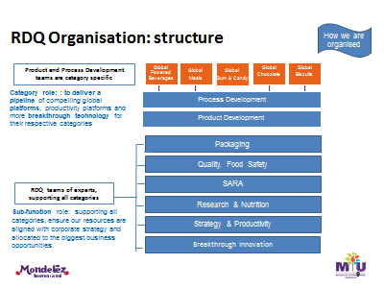**

OPENING TEXT (30 words max)

RDQ is a **global** function.

Both Process Development and Product Development are category specific. For example, teams within these sub-functions may concentrate just on Beverages or only on Biscuits.

PROMPT

Select each RDQ team to find out more.

REVEAL 1 ICON PLACEMENT

Process Development

REVEAL 1 TEXT (50 words max)

Colleagues here run pilot plant trials, improve our existing processes and generally create new and better ways of doing things. They make us more commercial by extending our range or manufacturing products more efficiently. The Process Development teams working in the Chocolate category played a big part in developing that new Heat Resistant Chocolate we talked about earlier.

REVEAL 1 IMAGE/VIDEO

Factory shot?

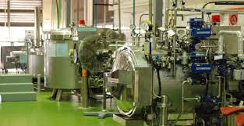

REVEAL 2 ICON PLACEMENT

Product Development

REVEAL 2 TEXT (50 words max)

Scientists, engineers and technologists create new snacks, or take our bestselling foods and think of fresh ideas to expand our product lines. Those working in our Biscuit category took our popular OREO cookies and created new flavors to appeal to consumers in must-win markets in the Asia Pacific region.

REVEAL 2 IMAGE/VIDEO

Green tea OREO

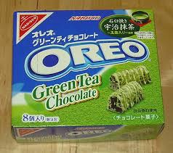]

## SCREEN 02\_130

SCREEN TYPE Text reveal

DESCRIPTION

The learner selects text headings to reveal further information, images or media.

Screen shows same structure diagram as previous screen 02\_120,

Source: L:\Projects\MDL851\_BPBT\_Landmarks\from\_client\content\Module content\02\_RDQMLDZ Landmark Tour RDQ Outline 20161031 Slide 9

But… the reveals will be linked to the final 6 boxes / departments.

OPENING TEXT (30 words max)

The other RDQ teams of experts support **all** categories. They make sure our resources and activities support corporate strategy and allow us to respond to the biggest business opportunities.

PROMPT

Select each heading to find out more.

HEADING 1 TEXT (5 words max)

Packaging

TEXT FOR HEADING 1 (50 words max)

Packaging is our first connection with consumers.

It attracts people, keeps products fresh and protects them from damage and contamination.

If there's an issue that consumers are having, our packaging experts solve problems too.

When consumers were frustrated by broken cookies and hard-to-open packets, we invented the Snack 'n Seal solution for OREO and CHIPS AHOY! cookies.

HEADING 2 TEXT (5 words max)

Quality & Food Safety

TEXT FOR HEADING 2 (50 words max)

We collaborate with RDQ colleagues and other functions to promote a consumer-focused quality culture.

We partner with Supply Chain to ensure our products are manufactured safely and consistently.

If there are any issues or concerns about food safety and quality, we'll provide expertise to manage the situation and find out the cause of the problem.

Source: \\brightfs1\company\Projects\MDL851\_BPBT\_Landmarks\from\_client\content\Module content\RDQ\MLDZ Landmark Tour RDQ Outline 20160926.pptx

**Slide 20**

HEADING 3 TEXT (5 words max)

SARA

TEXT FOR HEADING 3 (50 words max)

Scientific And Regulatory Affairs (SARA) is always busy behind the scenes.

We build collaborative relationships with local and international government and Trade Associations.

We ensure our products meet local regulations and are safe for consumers.

We ensure packaging has the correct ingredients, nutritional and allergens information for consumers' information.

HEADING 4 TEXT (5 words max)

Research & Nutrition

TEXT FOR HEADING 4 (50 words max)

25% of RDQ colleagues work in Research & Nutrition. It's such a large sub-function it's split into four different areas:

* Ingredient & Nutrition Research
* Consumer Science
* Innovation Accelerators
* Analytical Science

We'll take a closer look at these experts in the next screen.

HEADING 5 TEXT (5 words max)

Strategy & Productivity

TEXT FOR HEADING 5 (50 words max)

Strategy means long-term business planning. This area ensures that our resources are used to drive the biggest opportunities and that we continue to develop the capability of RDQ teams.

The Productivity team makes sure our products are produced as cost-effectively as possible, providing the fuel to focus more RDQ funds on developing products that hit our growth targets.

HEADING 6 TEXT (5 words max)

Breakthrough Innovation

TEXT FOR HEADING 6 (50 words max)

Our small, dedicated innovation team has an entrepreneurial mindset and a real sense of urgency. They use all the expertise we have internally and partner with external organizations to invent new processes and products. This creates even more moments of joy for our consumers.

## SCREEN 02\_140

SCREEN TYPE Hotspot reveal

**Research & Nutrition**

DESCRIPTION

The learner selects department names on an image to reveal further information, images or media.

MAIN IMAGE

Peanuts or blueberries. Choice up to Art Director / design team. Depending on whether a light or dark background is best for this screen.

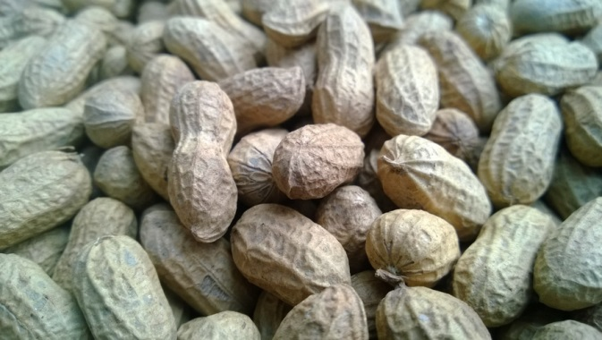

[**https://www.pexels.com/photo/brown-peanuts-61374/**](https://www.pexels.com/photo/brown-peanuts-61374/)

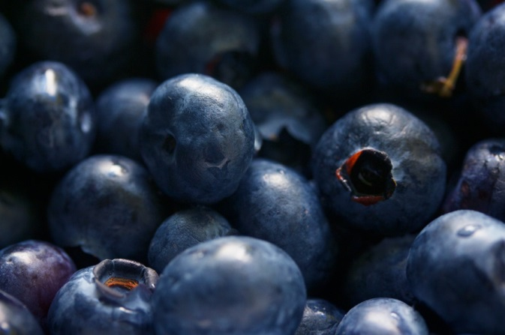

[**https://www.pexels.com/photo/close-up-photography-of-grey-round-fruits-139749/**](https://www.pexels.com/photo/close-up-photography-of-grey-round-fruits-139749/)

OPENING TEXT (30 words max)

Welcome to Research & Nutrition, where a quarter of RDQ colleagues work.

They **discover**, **develop** and **deploy** in four areas:

PROMPT

Select each area of expertise to find out more.

REVEAL 1 ICON PLACEMENT

Ingredient & Nutrition Research

REVEAL 1 TEXT (50 words max)

This is where we develop cross-category ingredient technologies using the fundamental building blocks of food: proteins, fats and carbohydrates. We find out how to make healthier snacks and generate the science behind our Well-being objective. Our work offers consumers balanced snack choices so they can be mindful of the treats they choose.

REVEAL 1 IMAGE

Image options below or something from MDLZ image library.

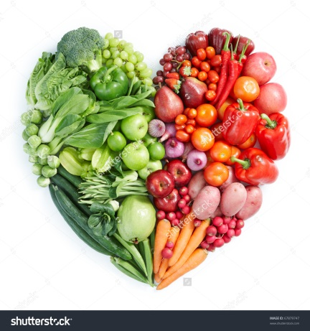

REVEAL 2 ICON PLACEMENT

Consumer Science

REVEAL 2 TEXT (50 words max)

In Consumer Science we find out more about what consumers enjoy and want. We run focus groups and test prototypes of snacks and packaging to discover what people prefer. We give this information to colleagues developing new products so they can make the best decisions for both consumers and our business.

REVEAL 2 IMAGE

Consumer Focus Group from MDLZ image library, if available.

Or something similar to this from Pexels; <https://www.pexels.com/photo/people-coffee-meeting-team-7096/>



REVEAL 3 ICON PLACEMENT

Innovation Accelerators

PLACEMENT

<Placement is up to graphic designer. Where does it look best on chosen image?>

REVEAL 3 TEXT (50 words max)

Our role is to foster a culture that promotes reapplication over reinvention, basically: "What can we learn and re-use from previous successes?" This helps us reach solutions faster – or literally accelerate innovation.

For example, we invented a unique foaming agent to improve cappuccino mixes in the early 2000s and have since used the same technology in our popular TANG fruity drinks, in mints and in candy products.

**Did you know…?** Astronaut John Glenn took TANG on the Friendship 7 spacecraft in 1962 and on later Gemini missions. Powdered drink mixes are still used on the International Space Station (ISS).

REVEAL 3 IMAGES

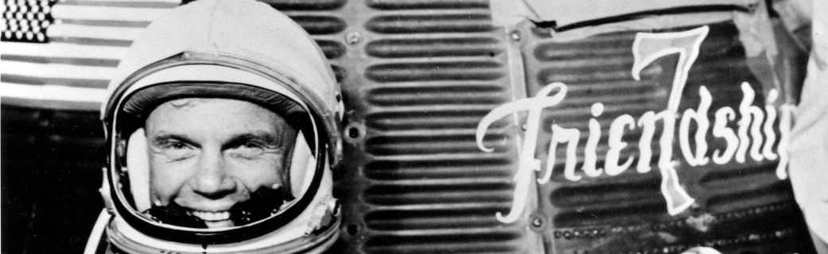

**Photo credit: NASA**

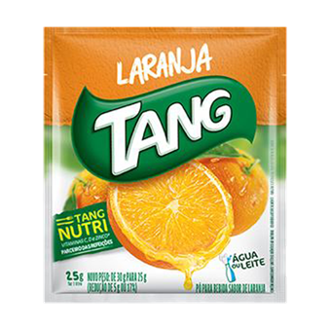

**BW Build team:** Use TANG sachet pic within the Reveal text screen, Keep the astronaut on the Hotspot screen please.

REVEAL 4 ICON PLACEMENT

Analytical Science

REVEAL 4 TEXT (50 words max)

Working in a laboratory environment, we analyze products and ingredients at a chemical and microbiological level. When new science is required, we create analytical methods then analyze and interpret the results. Our capabilities include: customized flavor development, food microstructure and a wide range of techniques to analyze oils, proteins and carbohydrates.

Analytical Science also incorporates **RSSL,** a wholly-owned company that provides scientific services to Mondelēz International and other food and pharmaceutical companies. This 200-strong team deliver deep and broad scientific expertise along with exceptional customer service.

REVEAL 4 IMAGE

BW Build team: Your choice of these or similar images.

Maybe place text over the 1st image? To the right of the female scientist?

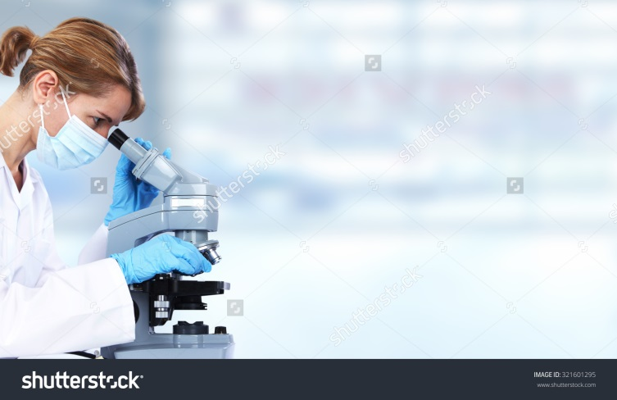

## SCREEN 02\_150

SCREEN TYPE: Drag and drop (many to many)

DESCRIPTION

The learner categorizes items by dragging them into two or three boxes. The learner selects a Confirm button once their answer is complete. Feedback is then provided. If the learner answers incorrectly they are able to compare their own answers to a model answer.

On this screen we'll challenge the learners on their understanding of how RDQ works with other functions. We'll first explain that in order to get the job done, RDQ will look for help from, or indeed support, some of the other functions.

We'll then provide a list of tasks in the process, and ask learners to attribute that task to a particular function.

OPENING TEXT (30 words max)

We regularly collaborate with other functions and our colleagues across RDQ. Here are some tasks where we work as a team.

OPENING AUDIO

RDQ teams collaborate with each other every day and often work with other functions too. Here are some tasks and objectives they regularly work on. What functions do you think RDQ collaborate with to get each job done?

PROMPT

Drag each function to the task you think it would be responsible for. When you're happy with all your choices select Confirm.

OPTIONS

|  |  |  |  |  |  |
| --- | --- | --- | --- | --- | --- |
|  | **OBJECT TO DRAG** | **Work with nutritionists to make our biscuits healthier and contribute to our Well-being strategy** | **Understand what consumers want and need** | **Make sure our factories can make our cookies to the specifications and quality standards consumers expect** | **Protect the recipe and the process we use to make our new Heat Resistant Chocolate** |
| **1** | Strategy Insights Analytics & Marketing |  | ✓ |  |  |
| **2** | Integrated Supply Chain |  |  | ✓ |  |
| **3** | Legal |  |  |  | ✓ |
| **4** | RDQ | ✓ |  |  |  |
|  |  |  |  |  |  |

CORRECT AUDIO FEEDBACK

Good job! You're right! Sometimes RDQ works with more than one other function. Both Marketing and SIA will have valuable data about what consumers want and need. We also frequently work with other sub-functions within RDQ, like Research and Nutrition, who can advise on making our products healthier.

CORRECT TEXT FEEDBACK (50 words max)

That's right! Sometimes RDQ works with more than one other function. Both Marketing and SIA will have valuable data about what consumers want and need. We also frequently work with other sub-functions within RDQ, like Research and Nutrition, who can advise on making our products healthier.

PARTIAL AUDIO FEEDBACK

You're nearly right. Sometimes RDQ works with more than one other function. Both Marketing and SIA will have valuable data about what consumers want and need. We also frequently work with other sub-functions **within** RDQ, like Research and Nutrition, who can advise on making our products healthier. You can use the 'Show answers' button to compare your answers with the correct ones.

PARTIAL TEXT FEEDBACK (50 words max)

That's nearly right. Sometimes RDQ works with more than one other function. Both Marketing and SIA will have valuable data about what consumers want and need. We also frequently work with other sub-functions **within** RDQ, like Research and Nutrition, who can advise on making our products healthier. Use the 'Show answers' button to compare your answers with the correct ones.

INCORRECT AUDIO FEEDBACK

Not quite. Sometimes RDQ works with more than one other function. Both Marketing and SIA will have valuable data about what consumers want and need. We also frequently work with other sub-functions **within** RDQ, like Research and Nutrition, who can advise on making our products healthier. You can use the See correct answers button to compare your answers with the correct ones. Use the 'Show answers' button to compare your answers with the correct ones.

INCORRECT TEXT FEEDBACK (50 words max)

That's not quite right. Sometimes RDQ works with more than one other function. Both Marketing and SIA will have valuable data about what consumers want and need. We also frequently work with other sub-functions **within** RDQ, like Research and Nutrition, who can advise on making our products healthier. Use the 'Show answers' button to compare your answers with the correct ones.

## SCREEN 02\_160

SCREEN TYPE: Multiple choice question (correct & partial feedback)

DESCRIPTION

A question and several answer options. The learner selects the option or options that they believe are correct, then they select a Confirm button. The correct answer(s) are then indicated and feedback once the user submits their chosen answer. The guide provides narration for these screens, so the audio icon will be present.

Now that the learner has seen who makes up the RDQ function, we'll refer them back to the Heat Resistant Chocolate challenge, and ask them to select which of the team of experts they think would be integral to the team that could solve this challenge.

QUESTION AUDIO

Well you've seen and learnt a lot about the RDQ function. Do you remember that new Heat Resistant Chocolate RDQ developed? Let's take a look at how many different teams within RDQ itself were involved in that challenge.

QUESTION TEXT (30 words max)

Which teams of experts do you think helped take our new Heat Resistant Chocolate to market?

PROMPT

Select your answers, then Confirm.

OPTIONS (15 words max. per option)

|  |  |  |
| --- | --- | --- |
| **1** | Consumer Science and Statistics | **Correct** |
| **2** | Chocolate Product Development | **Correct** |
| **3** | SARA | **Correct** |
| **4** | Packaging | **Correct** |
| **5** | Quality | **Correct** |

CORRECT AUDIO FEEDBACK

That's right! This project took several years, and all these RDQ teams, plus Ingredient Research, Analytical Science and Process Development, were involved along the way. Collaboration and teamwork are **so** important here in RDQ!

You've reached the end of this area; go back to menu to choose a new part of RDQ to explore.

CORRECT TEXT FEEDBACK (50 words max)

That's right! This project took several years, and all these RDQ teams, plus Ingredient Research, Analytical Science and Process Development, were involved. Collaboration and teamwork are key to RDQ.

Select the Home icon to return to the menu.

PARTIAL AUDIO FEEDBACK

That's not quite right… It's not a trick question but ALL these sub-functions, plus Ingredient Research, Analytical Science and Process Development, played a part in this exciting project. You can see how important collaboration and teamwork are to RDQ.

You've reached the end of this area; go back to menu to choose a new part of RDQ to explore.

PARTIAL TEXT FEEDBACK (50 words max)

That's not quite right. All these sub-functions, plus Ingredient Research, Analytical Science and Process Development, played a part in this exciting project. You can see how important collaboration and teamwork are to RDQ.

Select the Home icon to return to the menu.

# Topic 3: Seeking solutions

## SCREEN 03\_100

SCREEN TYPE Text and graphic

DESCRIPTION

This screen presents information, sometimes with an illustrative graphic/image, and sometimes with typography, such as a pull-quote. There are no learning instructions or interactions. The layout of text and image will vary based on the requirements of the content.

Here we'll link back to the conclusion of the previous topic, and explain that even though the best team is working on a challenge, that results aren't always immediate.

In some cases it could be that research takes a number of years before proper results are yielded. However, there are opportunities where a quicker solution can be found.

PULL-QUOTE TEXT (Max 10 words)

Turning great ideas into brilliant brands

BODY TEXT (Max 100 words)

Now you've seen how RDQ creates moments of joy.

They turn great ideas into products consumers love.

With our teams of experts working together and collaborating with other functions, we can find solutions quickly.

However, sometimes results can take a little longer. Large projects and complex challenges can take years before a successful new product reaches the market.

## SCREEN 03\_110

SCREEN TYPE: Photostory

DESCRIPTION

A series of images with text that the learner explores in a fixed sequence that provides a linear narrative.The text in each

We'll use this screen to provide a walkthrough of the solution to the Heat Resistant Chocolate (HRC) challenge set at the start of the course.

We'll give an overview of the teams that were involved in the process, and the work that was done.

Each stage will have a different visual representation. For example, when talking about process development involving consumer feedback, we could use an image of a blind taste-test situation.

|  |  |  |
| --- | --- | --- |
| **Frame** | **Picture** | **Text (Max 15 words per speech/caption)** |
| **1** | Envelope with a  "Mission Impossible" stamp. | **TEXT**  Over 10 years ago a challenge was delivered to RDQ.  **PROMPT**  Select the numbers below to find out more. |
| **2** | Melting, sticky chocolate bar | **TEXT**  How can consumers in hot climates enjoy our chocolate when temperatures rise and there's no refrigeration? |
| **3** | Technology | **TEXT**  **Ingredient Research** developed a patented technology so chocolate stays solid, even at high temperatures |
| **4** | Manufacturing chocolate, cooking, ingredients… | **TEXT**  **Product Development** created a recipe with a Cadbury taste.  **Packaging** protects the tablet and looks great. |
| **5** | Consumer Science Panel & analytical lab  ? From MDLZ library? | **TEXT**  **Consumer Science** helped understand consumer needs and **Analytical** developed measurement methods so the product met those needs. |
| **6** | Chocolate factory photo. | **TEXT**  **Process Development** found ways to make the new Heat Resistant Chocolate on a large scale. |
| **7** | Pic of wrapper showing ingredients list & nutritional info.  ? From MDLZ library?  Or this pic | **TEXT**  **SARA** supported the approval of the chocolate in new markets, collaborated with Legal and helped develop artwork. |
| **8** | Or this Shutterstock image shows couple in green & white; the colors of the Nigerian flag.  http://image.shutterstock.com/z/stock-photo-african-american-couple-showing-thumb-in-the-city-402548521.jpg | **TEXT**  In tests, 100% of consumers in Nigeria said that they would definitely or probably buy it!  We plan to roll heat resistant chocolate out around the world, bringing chocolate to millions of new consumers. |
| **WARNING POP-UP TEXT**  If learner does not select ALL screens within a Photostory a pop-up appears to tell them there's content they haven't seen yet. Learner is directed back and must select all frames before being allowed to select 'Next'.  There's more information for you here. Select each of the numbers to see everything about this subject. | | |

## SCREEN 03\_120

SCREEN TYPE Text reveal

DESCRIPTION

The learner selects text headings to reveal further information, images or media.

On this screen we'll go into more detail about the outcomes and the benefits of the work that went into the HRC project.

We'll split the information up into two headings. The first will focus on what the benefit was to the consumer, and how the results led to a surge in popularity of the product. The second will focus on the benefits for the company, this has growth rather than margin/cost benefits

OPENING TEXT (30 words max)

Our Heat Resistant Chocolate is a very recent technology breakthrough and we're expecting lots of benefits for customers, consumers and us.

PROMPT

Select each heading to find out more.

HEADING 1 TEXT (5 words max)

Customer and consumer benefits

TEXT FOR HEADING 1 (50 words max)

* Easy for our retail customers, distributors and wholesalers to store and transport.
* It won't melt, even if warehouses and vans aren't refrigerated.
* Delicious chocolate treats for consumers in hot countries.
* Melts in the mouth, not in the wrapper.

HEADING 2 TEXT (5 words max)

Benefits for us

TEXT FOR HEADING 2 (50 words max)

* An exciting new product generating interest and positive press coverage.
* Opens up opportunities in huge markets in Africa and south east Asia where chocolate has not previously been available.
* New technologies and expertise to help with future inventions.

## SCREEN 03\_130

SCREEN TYPE Hotspot reveal

**Title: Hall of Fame**

DESCRIPTION

The learner selects icons on an image to reveal further information, images or media.

We'll present this screen as a mini hall of fame the presents the success stories from RDQ.

In each case, when the learner clicks an image, we'll provide an overview of the challenge or aim, and then what happened as a result.

MAIN IMAGE

A trophy case with the featured product images on the 5 trophies.

e.g. 

OPENING TEXT (30 words max)

Heat Resistant Chocolate is just one example of a recent achievement. Here are some of our other success stories.

PROMPT

Select each trophy to find out more.

REVEAL 1 ICON PLACEMENT

Brazil goes nuts for 5 Star chocolate bars!

REVEAL 1 TEXT (50 words max)

When consumer insights showed that Latin America wanted smaller individual bars, rather than large chocolate blocks, we saw a way to get into the must-win Brazilian market. Our product and process teams in India, UK, Brazil, Australia and Ireland worked together to adapt our winning BOOST bar. The project introduced new processes and technology to the Brazilian Curitiba Plant. They made and launched the product,

branded as "5 STAR".

REVEAL 1 IMAGE

Source: \\brightfs1\company\Projects\MDL851\_BPBT\_Landmarks\from\_client\content\Module content\RDQ\MLDZ Landmark Tour RDQ Outline 20160926.pptx. Slide 12

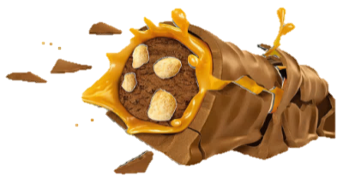

Source: \\brightfs1\company\Projects\MDL851\_BPBT\_Landmarks\from\_client\content\Module content\RDQ\MLDZ Landmark Tour RDQ Outline 20160926.pptx. Slide 20

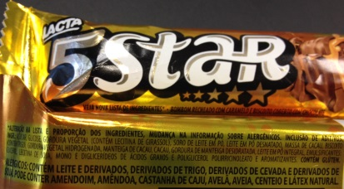

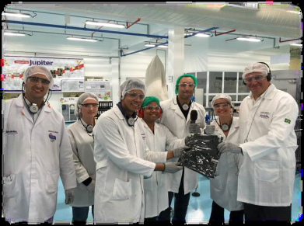

<CAPTION> Colleagues in Curitiba give **Claudio Parrotta**, ISC VP, a 5 STAR T-shirt after the first production run.

REVEAL 2 ICON PLACEMENT

Winning in cheese and dairy

REVEAL 2 TEXT (50 words max)

To be competitive in the cheese and dairy marketplace, we needed to reduce the cost of ingredients and processing.

Seven years ago, the Dairy Researchteam in Munich developed a technology that enhanced the creamy texture of our PHILADELPHIA products. This saved millions of Euros by reducing the amount of cream we used. This meant the fat content dropped by 10%, delighting consumers and putting a big, fat tick against our corporate Well-being goals.

REVEAL 2 IMAGE/VIDEO

Source: \\brightfs1\company\Projects\MDL851\_BPBT\_Landmarks\from\_client\content\Module content\RDQ\MLDZ Landmark Tour RDQ Outline 20160926.pptx. Slide 30

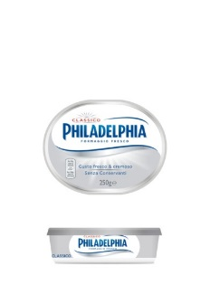

REVEAL 3 ICON PLACEMENT

Revolution in wheat production

REVEAL 3 TEXT (50 words max)

Most wheat grown across the world is hard wheat, great for bread, not good for cookies. Soft Wheat flour absorbs less water and takes less energy to bake (so it's more environmentally friendly). It also makes a softer biscuit, which consumers prefer.

We worked with government and research institutes to influence farmers, and finally Mondelēz International successfully increased production of soft wheat varieties in the USA and Canada.

Now there's a good supply of soft wheat flour, so we can guarantee consistent high quality in our products.

REVEAL 3 IMAGE/VIDEO

Source: \\brightfs1\company\Projects\MDL851\_BPBT\_Landmarks\from\_client\content\Module content\RDQ\MLDZ Landmark Tour RDQ Outline 20160926.pptx. Slide 26



REVEAL 4 ICON PLACEMENT

Peel & Seal packaging delivers our cookies in one piece

REVEAL 4 TEXT (50 words max)

Consumers complained that the packaging around OREO and CHIPS AHOY! cookies didn't work as well as they would have liked. It was difficult to open and literally "self-destructed" after opening. It was impossible to keep the tray in the package for future consumption.

Our solution was an innovative snack and seal packaging concept. It delivers freshness, re-sealability, and convenience.

REVEAL 4 IMAGE/VIDEO

Source: \\brightfs1\company\Projects\MDL851\_BPBT\_Landmarks\from\_client\content\Module content\RDQ\MLDZ Landmark Tour RDQ Outline 20160926.pptx. Slide 16

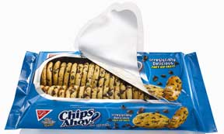

REVEAL 5 ICON PLACEMENT

Breakfast on the go

REVEAL 5 TEXT (50 words max)

One of the biggest game changers in the food industry! Our consumer insight showed that more and more people were eating breakfast on the go. It was our Product Development team in France who created belVita Breakfast. Consumers love them and they're now in 54 countries. Competitors liked them too and other breakfast products soon appeared on the market. Well, they say imitation is the best form of flattery!

REVEAL 5 IMAGE/VIDEO

belVita Breakfast biscuits packet / logo on final trophy.

## SCREEN 03\_140

SCREEN TYPE Text questions game

DESCRIPTION

Here we'll give learners the opportunity to follow the RDQ process from start to finish by creating their own product.

Using a text-only branching game, learners will be asked a series of questions as they move through the Discover/Develop/Deploy process, and meet different teams within RDQ along the way.

The game will use a repeating sequence of three screens: a question screen in which they get to make important choices, a feedback screen in which they find out how they did, and a success screen which moves them on to the next stage.

DEVELOPMENT NOTES

Retry button on feedback take the learner back to the previous question screen. Any correct answers the learner gave on the previous attempt should be marked as correct and locked, so that only incorrect answers can be changed.

LAUNCH SCREEN IMAGE

Snack development materials – drawings, prototypes etc.

LAUNCH SCREEN TEXT (Max 15 words)

It's your turn to develop a new product. In this game you'll get advice from colleagues and make a series of choices to create a great new snack.

LAUNCH SCREEN BUTTON

I'm ready!

LAUNCH SCREEN AUDIO

You're almost at the end of your journey through RDQ. Before you go, it's your turn to try developing a new product. In this game you'll have to listen to the advice of your colleagues and make the right choices to create a great new snack.

QUESTION SCREEN 1

QUESTION 1 TEXT

Welcome. You're about to begin the development of a tasty new snack.

As you go through the process you'll move through the **Discover, Develop, Deploy** framework RDQ use. It's worth noting the stages don't always happen in that order. In a busy project more than one thing is happening at the same time and the phases often overlap.

Before you begin, you need to decide on some objectives. Set yourself all of the goals that apply to creating a new product.

QUESTION 1 AUDIO

Before you start work on your new snack, set yourself some goals.

OPTIONS FOR QUESTION 1 (15 words max. per option)

CHECKBOX GROUP

Product development goals

|  |  |  |
| --- | --- | --- |
| **1** | Find out what consumers need | **Correct** |
| **2** | Make a snack that fits into a healthy lifestyle | **Correct** |
| **3** | Make a snack that's safe to eat and meets local regulations | **Correct** |
| **4** | Follow RDQ processes | **Correct** |

FEEDBACK SCREEN 1

CORRECT FEEDBACK TEXT

That's right.

Everything we do starts and ends with the consumer, so it's important we understand their needs.

Well-being is not an optional extra for our products – it's always a consideration.

Making food that's safe to eat and compliant with local regulations is something we're committed to in RDQ and across Mondelēz International.

CORRECT FEEDBACK AUDIO

You got it. Consumer needs, well-being and making food safe and legal are all important in product development.

CORRECT BUTTON

Move on to the next step

INCORRECT FEEDBACK TEXT STEM

It looks like you're not ready to move forward just yet. Here's some feedback from your colleagues to help you out:

INCORRECT FEEDBACK OPTION 1

SIA and Marketing: We've got some consumer insight for you. We think you'll find it useful.

INCORRECT FEEDBACK OPTION 2

Research and Nutrition: Don't forget that well-being is an important goal for Mondelēz International.

INCORRECT FEEDBACK OPTION 3

Quality and Food Safety: Sorry. We can't launch a product unless we're sure it's safe & legal.

INCORRECT FEEDBACK OPTION 4

Your manager: It's great you're so keen to get started, but our processes are there to make sure we don't miss any important steps.

INCORRECT FEEDBACK AUDIO

Sorry. You're not ready to move on yet. Look at what your colleagues have to say and try again.

INCORRECT BUTTON

Try again

SUCCESS SCREEN 1

SUCCESS SCREEN TEXT

Nice work so far. Now there's some consumer insight for you to consider:

SIA and Marketing:

" Consumers are looking for convenient, long-life, re-sealable snacks they can carry around to fill those gaps between meals. They need to be both tasty and healthy. Consumers will pay a premium price for the right product."

Consumer Science:

"The information we have for this type of snack says consumers like distinctive, fruity flavors. A pack with two or three portions, which they could eat on the go and store in the packaging was the favorite option.

A chewy texture and a product that doesn't break or crumble easily are best."

SUCCESS SCREEN AUDIO

It looks like you've received new briefings from SIA, Marketing and Consumer Science. Pay close attention – this information will help you create a successful product.

SUCCESS SCREEN BUTTON

Move on to the next step

QUESTION SCREEN 2

QUESTION 2 TEXT

**Develop**

Let's start by developing a prototype for Consumer Science to test with consumers. Based on the research you've seen, you decide to develop a fruity cereal bar and start to select some product characteristics.

QUESTION 2 AUDIO

OK, you're ready to test some prototypes with consumers. Remembering what your colleagues told you, select the product characteristics you'd like to try out. .

OPTIONS FOR QUESTION 2 (15 words max. per option)

RADIO BUTTON GROUP

Texture

|  |  |  |
| --- | --- | --- |
| **1** | Soft | **Incorrect** |
| **2** | Chewy | **Correct** |
| **3** | Crunchy | **Incorrect** |

RADIO BUTTON GROUP

Shape

|  |  |  |
| --- | --- | --- |
| **4** | One round snack | **Incorrect** |
| **5** | One large, square snack | **Incorrect** |
| **6** | Two or three long, thin sticks | **Correct** |

RADIO BUTTON GROUP

Flavor

|  |  |  |
| --- | --- | --- |
| **7** | Orange and Mango | **Correct** |
| **8** | Apple | **Incorrect** |
| **9** | Jalapeno | **Incorrect** |

FEEDBACK SCREEN 2

CORRECT FEEDBACK TEXT

Perfect. The consumers who took part in our tests loved the texture, shape and flavor of your prototype. It's time to move on to the next step.

CORRECT FEEDBACK AUDIO

Impressive! You've developed a product that our test groups loved. Let's move on.

CORRECT BUTTON

Move on to the next step

INCORRECT FEEDBACK TEXT STEM

Sorry. The results from the tests weren't entirely positive. Here's what Consumer Science has to say:

INCORRECT FEEDBACK OPTION 1

The texture is not firm enough.

INCORRECT FEEDBACK OPTION 2

The texture is just right.

INCORRECT FEEDBACK OPTION 3

The texture is firm but the snack breaks too easily and makes a mess.

INCORRECT FEEDBACK OPTION 4

The round shape is OK but they were looking for multiple portions.

INCORRECT FEEDBACK OPTION 5

It's too big, not very convenient to carry around and consumers prefer to eat a little at a time.

INCORRECT FEEDBACK OPTION 6

The shape is great! Consumers like having two or three smaller pieces to enjoy throughout the day.

INCORRECT FEEDBACK OPTION 7

Correct. Consumers say the flavor is delicious. However they would like it even better if it tasted fresher

INCORRECT FEEDBACK OPTION 8

The flavor is too ordinary – consumers want something more distinctive.

INCORRECT FEEDBACK OPTION 9

The flavor is too strong – consumers want something fruity.

INCORRECT FEEDBACK AUDIO

OK, you didn't quite get it right this time. Don't worry though; you can try again with different characteristics.

INCORRECT BUTTON

Try again

SUCCESS SCREEN 2

SUCCESS SCREEN TEXT

**Develop**

You did a great job developing a prototype that people liked. It usually takes several attempts to get it right.

The Ingredients Research team helped to make your snack healthier by “discovering” some great new fruit ingredients which retain all of the goodness of oranges and mangoes.

But don't forget, the consumers told us that there is still some work to do on freshness. Let's ask the Ingredients Research team to see what they can “discover” to solve this.

Remember we're developing a whole product – not just the bit you eat! Right now it's time to work on some packaging.

SUCCESS SCREEN AUDIO

Good work. You've got the right edible prototype for your snack. Now you need to think about the packaging.

SUCCESS SCREEN BUTTON

Move on to the next step

QUESTION SCREEN 3

QUESTION 3 TEXT

**Develop**

You need to decide what sort of packaging is best for this product.

QUESTION 3 AUDIO

You have a few choices for the type of packaging. Which one looks best to you?

OPTIONS FOR QUESTION 3 (15 words max. per option)

RADIO BUTTON GROUP

Packaging

|  |  |  |
| --- | --- | --- |
| **1** | Low-cost material – re-sealable (overall cost: $$) | **Incorrect** |
| **2** | High-cost material – not re-sealable (overall cost: $$) | **Incorrect** |
| **3** | High-cost material – re-sealable (overall cost: $$$) | **Correct** |

FEEDBACK SCREEN 2

CORRECT FEEDBACK TEXT

We ran some more tests and the packaging you selected scored highly with our test groups. Well done, it's the right choice but it's more expensive than the other materials, which is a concern. We'll see if our colleagues working in the 'discover' groups can think of any ways around that when we move into the 'scale up' phase.

CORRECT FEEDBACK AUDIO

Great news! We did more consumer testing and they love the new packaging. However it's more expensive than the other materials, which is a concern. We'll see if our colleagues working in the 'discover' groups can think of any ways around that when we move into the 'scale up' phase. Let's move on to the next step.

CORRECT BUTTON

Move on to the next step

INCORRECT FEEDBACK TEXT STEM

We tested more consumers and they weren't happy with the packaging. Here's what the Consumer Science team found:

INCORRECT FEEDBACK OPTION 1

Consumers find the re-seal option very useful, but the low-cost packaging doesn't protect the product enough.

INCORRECT FEEDBACK OPTION 2

The packaging protects the product well, but the product has to be used too quickly once the package is opened. Consumers prefer to eat a little at a time.

INCORRECT FEEDBACK AUDIO

Oh dear. It looks like our packaging wasn't a hit with consumers. Let's try again and make some changes.

INCORRECT BUTTON

Try again

SUCCESS SCREEN 3

SUCCESS SCREEN TEXT

**Develop**

The Product and Pack Development teams now understand what design characteristics are critical to success. This time you tested the product and the packaging separately, but sometimes we'll test them together, depending on what we're trying to discover.

You've developed a good working prototype, now we need to work out how to scale it up for full production.

SUCCESS SCREEN AUDIO

Wow! You've got product and pack prototypes which seems be working well with consumers. Now let's see how to scale it up.

SUCCESS SCREEN BUTTON

Move on to the next step

QUESTION SCREEN 4

QUESTION 4 TEXT

Develop

Now we need to think about producing this snack on a large scale, a phase we call 'scale up'.

Do we have the right processes to make this product?

Do we have the right raw materials and packaging?

Who would you ask to get the answers?

Select the right teams of experts to help with each challenge.

QUESTION 4 AUDIO

Great! You're ready to think about scale up. There are two questions we need to answer.

OPTIONS FOR QUESTION 4 (15 words max. per option)

COLUMN SORT (Requires one or two selections per row)

|  |  |  |  |  |  |
| --- | --- | --- | --- | --- | --- |
| **#** | **Question** | **Ingredient Research** | **ISC Procurement** | **Process teams** | **Packaging** |
| 1 | **Do we need new forming or packing processes?**  (Select two teams) |  |  | ✓ | ✓ |
| 2 | **Do we need new or novel ingredients or packaging?**  (Select three teams) | ✓ | ✓ |  | ✓ |

FEEDBACK SCREEN 4

CORRECT FEEDBACK TEXT

That's right. Our Process and Packaging teams can help us decide if we need new technology or processes. Ingredient Research, ISC Procurement and Packaging can help us source raw materials and the packaging we need.

Packaging have been working with suppliers on how to reduce the cost of the re-seal feature, they think they may have a solution.

CORRECT FEEDBACK AUDIO

That's great. You've identified all the right people to help us with some important production questions.

CORRECT BUTTON

Move on to the next step

INCORRECT FEEDBACK TEXT STEM

You haven't got quite the right help for this step. Here's what the teams had to say:

INCORRECT FEEDBACK INGREDIENT RESEARCH

Ingredient Research:

QUESTION 1 SELECTION

Sorry. Processes are not something we can help with.

QUESTION 2 SELECTION

Yes. We can give you lots of help with raw materials. We're working on a fresher tasting fruit ingredient which sounds like it would fit your needs.

INCORRECT FEEDBACK ISC PROCUREMENT

ISC Procurement:

QUESTION 1 SELECTION

Sorry, you'll have to look elsewhere for help on processes.

QUESTION 2 SELECTION

Yes. We're happy to advise you about the best suppliers to work with

INCORRECT FEEDBACK PROCESS TEAMS

Process teams:

QUESTION 1 SELECTION

We're definitely the right teams to advise you on processes.

QUESTION 2 SELECTION

We're not really the right people to ask about ingredients or packaging.

INCORRECT FEEDBACK PACKAGING

Packaging:

QUESTION 1 SELECTION

Correct! We can advise you on both existing and new packaging solutions.

QUESTION 2 SELECTION

Yes. We're experts on packaging development. We've been working with suppliers on how to reduce the cost of the re-seal feature, and we think we have some good options!

INCORRECT FEEDBACK AUDIO

It looks like you might need to change which teams you ask for advice on different things. Try again.

INCORRECT BUTTON

Try again

SUCCESS SCREEN 4

SUCCESS SCREEN TEXT

Now you've got answers to some important scale up questions. By investing the time to ask questions early on, RDQ can save time and money later in the project. We'll be more confident that we'll be able to make the product correctly when we run the trial in our factory. It will also meet the goals you set at the beginning. Sometimes we need to go slow, so we can go fast!

Now we're ready to set up that production trial.

SUCCESS SCREEN AUDIO

That's great – you've asked all the right questions and got answers from the right people. Now you're ready for that important first production trial.

SUCCESS SCREEN BUTTON

Move on to the next step

QUESTION SCREEN 5

QUESTION 5 TEXT

**Develop**

The factory needs to know what form the product ingredients will be manufactured in. Select the best form to use.

QUESTION 5 AUDIO

Right, it's time to decide the best form to use when we manufacture the product.

OPTIONS FOR QUESTION 5 (15 words max. per option)

RADIO BUTTON GROUP

Product form:

|  |  |  |
| --- | --- | --- |
| **1** | Sheet and Cut (Cost: $) | **Correct** |
| **2** | Tube (Cost: $$) | **Incorrect** |
| **3** | Moulded Pieces (Cost: $$$) | **Incorrect** |

FEEDBACK SCREEN 5

CORRECT FEEDBACK TEXT

That's right. Because of the thin, rectangular shape of our end product, sheet and cut is the most economical choice.

CORRECT FEEDBACK AUDIO

Good job. The factory can now be set up for the production trial.

CORRECT BUTTON

Move on to the next step

INCORRECT FEEDBACK TEXT STEM

The process team isn't entirely happy with your choice. Here's what they had to say:

INCORRECT FEEDBACK OPTION 2

A tube form will give us a stick format which appeals to the consumer, but it isn't the most cost effective route.

INCORRECT FEEDBACK OPTION 3

Moulded pieces are easy to work with, but the cost is high. We have invested in the packaging cost is high on this product, so we need to look for savings elsewhere.

INCORRECT FEEDBACK AUDIO

The process team would like you to think again about the product form. Try again when you're ready.

INCORRECT BUTTON

Try again

SUCCESS SCREEN 5

SUCCESS SCREEN TEXT

**Develop**

Your production trial is a success. You've demonstrated that the product can be produced correctly. Your trial production run has also generated samples that our sales team can use to get the retailers excited about the launch of this product.

The other great news is that the teams working in the 'discover' areas of Ingredients Research and Packaging have found an orange and mango ingredient that tastes fresher, and a cheaper, re-sealable pack. We’re good to go!

You've now reached the end of the **Discover** and **Develop** phases. It's time to move on to the **Deploy** stage.

SUCCESS SCREEN AUDIO

This is an exciting moment. The first few examples of the manufactured product are ready. It's time to scale things up now as you enter the Deploy phase.

SUCCESS SCREEN BUTTON

Move on to the next step

QUESTION SCREEN 6

QUESTION 6 TEXT

**Deploy**

We've completed a successful first trial, but we're not quite finished yet. There are some things we need to check before we start our first full production run.

Which expert team will you use for each of these checks?

QUESTION 6 AUDIO

Great. We're ready to think about production. Time to ask the right teams of experts your final questions.

OPTIONS FOR QUESTION 6 (15 words max. per option)

COLUMN SORT (Requires one selection per row)

|  |  |  |  |  |
| --- | --- | --- | --- | --- |
| **#** | **Question** | **Product, Process, Pack and Quality teams** | **SARA/ Legal** | **Consumer Science** |
| 1 | Have we invented new technology we need to protect? Do we comply with Local regulations? |  | ✓ |  |
| 2 | Does the final product delight the consumer? |  |  | ✓ |
| 3 | Are the right specifications in place so we can consistently make a high quality product? | ✓ |  |  |

FEEDBACK SCREEN 6

CORRECT FEEDBACK TEXT

That's right. SARA and Legal make sure we've protected any new inventions and that we're legally free to market and sell our products in the countries we've targeted.

Product, Process and Pack Development plus the Quality teams will make sure we can maintain quality standards when we scale up our production.

Product and Pack Category Development teams will work with the Consumer Science team to test the fully developed prototypes with consumers so we know they meet their quality expectations.

CORRECT FEEDBACK AUDIO

Well done – you've contacted the right RDQ teams and put all the final business, regulatory and quality checks in place, so we're ready to enter full production.

CORRECT BUTTON

Move on to the next step

INCORRECT FEEDBACK TEXT STEM

You haven't quite got the right help for this step. The RDQ teams have this feedback for you:

INCORRECT FEEDBACK PRODUCT, PROCESS, PACK AND QUALITY TEAMS

Product, Process, Pack and Quality teams:

QUESTION 1 SELECTION

Sorry. We can't help with legal questions.

QUESTION 2 SELECTION

Consumer tests? You're almost right, but try our Category Development colleagues.

QUESTION 3 SELECTION

Yes. We'll conduct production tests to make sure we can scale up production and hit our quality targets.

INCORRECT FEEDBACK SARA/LEGAL

SARA/Legal:

QUESTION 1 SELECTION

Correct. We'll check that we have protected inventions and that we've covered any legal requirements.

QUESTION 2 SELECTION

Sorry. Consumer testing is not really our thing.

QUESTION 3 SELECTION

I'm afraid you'll have to look elsewhere for help with scaling up production.

INCORRECT FEEDBACK CONSUMER SCIENCE

Consumer Science:

QUESTION 1 SELECTION

Sorry. We don't deal with the legal side of things.

QUESTION 2 SELECTION

Yes. We'll carry out further consumer tests, but we'll use the fully developed prototype this time.

QUESTION 3SELECTION

Try some of our other colleagues for help with the production process.

INCORRECT FEEDBACK AUDIO

You haven't selected quite the right teams for each task. Try again.

INCORRECT BUTTON

Try again

SUCCESS SCREEN 6

SUCCESS SCREEN TEXT

**Deploy**

You've done it!

Starting with a consumer need, you've developed and tested a product and got everything ready for the first full production run.

Your colleagues in Integrated Supply Chain are now working hard so that the product can be made for sale. Soon consumers will be enjoying this tasty new snack.

SUCCESS SCREEN AUDIO

Congratulations! You've done it. Your new product will soon be available in shops for consumers to enjoy.

SUCCESS SCREEN BUTTONS

End game

Play again

## SCREEN 03\_150

SCREEN TYPE Text and graphic

DESCRIPTION

This screen presents information, sometimes with an illustrative graphic/image, and sometimes with typography, such as a pull-quote. There are no learning instructions or interactions. The layout of text and image will vary based on the requirements of the content.

Here we'll conclude the module and signpost the resources available in the resources wall.

PULL-QUOTE TEXT (Max 10 words)

Turning great ideas into brilliant brands

BODY TEXT (Max 100 words)

We hope you've enjoyed your visit to RDQ.

If you'd like to know more about what we do, please go back to the menu and open the Resources Room. You'll find lots of fun ways to increase your knowledge of RDQ and how we create the products consumers love.

# Topic 4: Resources room

DESCRIPTION

The Resources Room is a visual catalogue of useful resources related to the function described in this module. Resources can be filtered by type:

* Watch (videos)
* Learn (e-learning)
* Read (PDFs)
* Visit (Intranet pages and external websites)

Up to four most recently visited resources will be collected in a personal section (My list) so they can be found again easily.

RESOURCE 1 TYPE

Visit

RESOURCE 1 TITLE

RDQ Intranet (News, Information and Resources)

RESOURCE 1 THUMBNAIL

Use first page of site

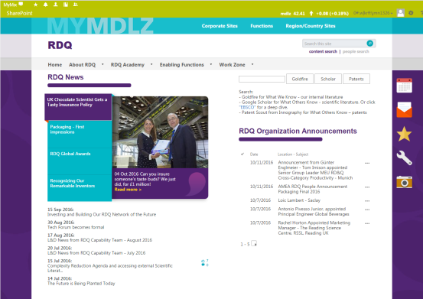

RESOURCE 1 SOURCE

<https://intranet.mdlz.com/sites/RDQ/>

RESOURCE 2 TYPE

Watch

RESOURCE 2 TITLE

The RDQ Movie

RESOURCE 2 THUMBNAIL

Use frame grab from video



RESOURCE 2 SOURCE

\\brightfs1\Company\Projects\MDL851\_BPBT\_Landmarks\development\visuals\audio\_video\Video\module2

RESOURCE 3 TYPE

Visit

RESOURCE 3 TITLE

I2M/IIM Processes

RESOURCE 3THUMBNAIL

Use first page of site

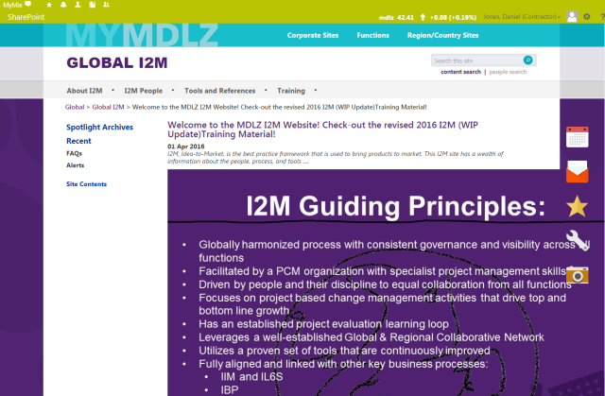

RESOURCE 3SOURCE

<https://intranet.mdlz.com/sites/i2m/Pages/Welcome-to-the-Mondelez-International-I2M-Website!.aspx>

RESOURCE 4 TYPE

Visit

RESOURCE 4TITLE

RDQ Ways of working site

RESOURCE 4 THUMBNAIL

Use first page of site

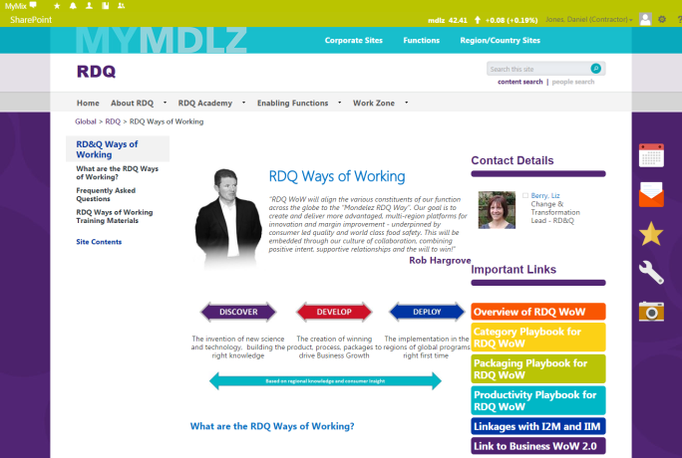

RESOURCE 4 SOURCE

<https://intranet.mdlz.com/sites/RDQ/wow/>

RESOURCE 5 TYPE

Visit

RESOURCE 5 TITLE

Director of RDQ Packaging on his role within this function

RESOURCE 5 THUMBNAIL

Opening image of Video or any other stunning visual from it you prefer

RESOURCE 5 SOURCE

<https://collaboration.mdlz.com/sites/MIU/Pages/RDQCareerEvents.aspx>

RESOURCE 6 TYPE

Visit

RESOURCE 6 TITLE

Develop & Grow in RDQ

<sub head> RDQ Career stories

RESOURCE 6 THUMBNAIL

Use first page of site

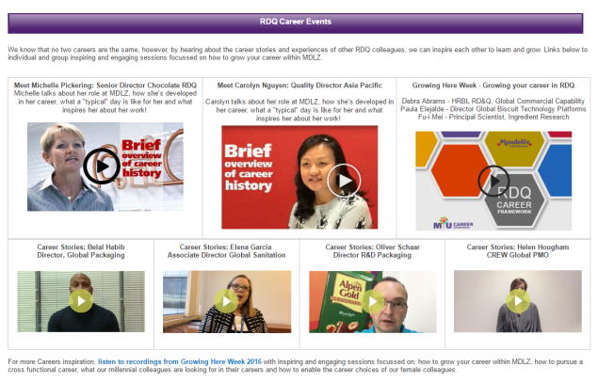

RESOURCE 6 SOURCE

<https://collaboration.mdlz.com/sites/MIU/Pages/RDQCareerEvents.aspx>

RESOURCE 7 TYPE

Visit

RESOURCE 7 TITLE

Develop & Grow in RDQ

<sub head> RDQ Academy

RESOURCE 7 THUMBNAIL



RESOURCE 7 SOURCES

**RDQ Academy:** <https://intranet.mdlz.com/sites/RDQ/academy/>

RESOURCE 8 TYPE

Visit

RESOURCE 8 TITLE

**RSSL website**

<sub head> Experts in Food and Pharmaceutical Analysis. Reading, UK.

RESOURCE 8 THUMBNAIL

Use first page of site

RESOURCE 8 SOURCE

<https://www.rssl.com/>

RESOURCE 9 TYPE

Visit

RESOURCE 9 TITLE

**Recognising our Inventors**

RESOURCE 9 THUMBNAIL

Use first page of site

RESOURCE 9 SOURCE

<https://intranet.mdlz.com/sites/news/en-us/Pages/092216ni-3.aspx>

RESOURCE 10 TYPE

Visit

RESOURCE 10 TITLE

**Super-tasters: Choc Scientist Gets a Tasty Insurance Policy**

RESOURCE 10 THUMBNAIL

Use first page of site

RESOURCE 10 SOURCE

<https://intranet.mdlz.com/sites/news/en-us/Pages/092216ni-1.aspx>

RESOURCE 11 TYPE

Visit

RESOURCE 11 TITLE

**One engineer's journey in the food sector**

RESOURCE 11 THUMBNAIL

Use first page of site

RESOURCE 11 SOURCE

<http://www.fponthenet.net/article/124181/One-engineer-s-journey-in-the-food-sector.aspx>

RESOURCE 12 TYPE

Visit

RESOURCE 12 TITLE

**Keeping us ahead of the game**

RESOURCE 12 THUMBNAIL

Use first page of site

RESOURCE 12 SOURCE

<http://careers.mondelezinternational.com/our-stories/research-development-quality-todd-abraham-keeping-us-ahead-of-game?bg=-purple>

RESOURCE 13 TYPE

Visit

RESOURCE 13 TITLE

**Meet an expert Moment Maker**

RESOURCE 13 THUMBNAIL

Use first page of site

RESOURCE 13 SOURCE

<http://careers.mondelezinternational.com/our-stories/meet-michelle-expert-moment-maker?bg=-purple>