

Script

Big Purple Bus Tour: Landmarks

IS&BPE [ITS]

project no: **MDL851_BPBT**

reply to: **Ben Pester** [**ben.pester@brightwavegroup.co**](mailto:email.address@brightwavegroup.co)**m**



International House  
Queens Road  
Brighton, BN1 3XE  
United Kingdom  
Tel: +44 (0)1273 827676

Revision history

[brightwavegroup.com](http://www.brightwavegroup.com)



|  |  |  |  |  |
| --- | --- | --- | --- | --- |
| Version | Date | Initials | Team | Summary of Revisions Made / Comments |
| 0.1 | 28/10/2016 | BP | BW | Initial draft |
| 0.2 | 28/10/2016 | EC | EC | QA |
| 0.3 | 28/10/2016 | BP | BW | Amends after QA |
| 0.4 | 28/10/2016 | TF | BW | Internal review |
| 1.0 | 28/10/2016 | NW | BW | Released to client |
| 2.0 | 10/11/2016 | BP | BW | Amends following client feedback |
| 2.1 | 11/11/2016 | AB | BW | Script tidied for automation |
|  |  |  |  |  |
|  |  |  |  |  |
|  |  |  |  |  |
|  |  |  |  |  |
|  |  |  |  |  |

Purpose of this document

This script details the exact text that will appear on each screen of the course, together with the interactions and any buttons that appear. It also indicates the kind of graphics or images that will be used, although these are not final at this stage.

It's important that you check everything appears as you want it within the script, so that there are minimal changes once the course is built.

**As you read through this document, please use the Review tab to track any changes you would like made. You can also use comment boxes for more general points.**

Contents

Purpose of this document 2

Contents 3

Splash Screen 4

Help 5

Welcome 6

Menu 7

Topic 1: Introduction to ITS 8

01_100 9

01_110 10

01_120 11

01_130 12

01_140 13

Topic 2: Our mission 14

02_100 15

02_110 17

02_120 19

02_130 20

Topic 3: How we work 21

03_100 22

03_110 23

03_120 26

03_130 27

03_140 28

03_150 30

03_160 31

03_170 32

03_180 33

Topic: Resources room 34

# Splash Screen

**DESCRIPTION**

The splash screen appears when the module is launched. It provides a summary of the module content and a note on audio. There is a button for learners to select when they are ready to start the module. This will open the module in a new window.

While the module is open, the module open text will be shown.

When the module has been closed, the module closed text will be shown.

**TEXT**

Welcome to the ITS landmark.

At this landmark you'll see:

* an introduction to ITS
* what our mission is
* how we work
* and the Resource room.

This landmark contains optional sound. Please connect speakers or headphones if you want to listen. Use the audio controls on your device to adjust the volume or to mute the sound. You'll see this symbol on all screens with optional sound:



Your tour of this landmark is expected to last about 25 minutes. You can come back another time and complete your tour over several visits, if you want. Each time you come back to this landmark, we'll return you to the last point you visited.

**BUTTON**

Begin the tour

**MODULE OPEN TEXT**

The landmark tour has opened in a new window. Please leave this window open while you go on your visit.

**MODULE CLOSED TEXT**

You may now close this window.

**FOOTER**

Copyright Mondelēz International 2016

Produced by [Brightwave](http://www.brightwavegroup.com/).

# Help

**DESCRIPTION**

The help popover appears above the current content whenever the help button is selected. It has two tabs - one explaining the menu, the other explaining how to navigate within topics. The popover has a close button that removes the popover and restores the content the learner was viewing.

**TAB TITLE**

Getting around the menu

**IMAGE**

Show a segment of the menu from this module including a topic hotspot.

**TEXT**

You'll need to scroll left and right to see all areas in the menu.

**[Topic icon]** These Mondelēz International 'bursts' link to different parts of the tour. Select a burst to open a new area of the tour.

**[Help icon]** Help is always available. Select this icon if you need us to point the way.

**[Exit]** Select this when you're ready to end your visit to this landmark and return to the map.

**TAB TITLE**

Going on the tour

**IMAGE**

Show a screen from this module.

**TEXT**

When you're on the tour there are other buttons you'll use to move around.

**[Menu icon]** Takes you back to the menu.

**[Back]** Takes you to the previous screen.

**[Next]** Takes you to the next screen.

# Welcome

|  |
| --- |
| **SCREEN TYPE** Video |

**DESCRIPTION**

**NOTE**: This screen may become part of the Super Menu, pending a technical investigation into the capabilities of the MDLZ LMS. Failing that, it will be the first screen of the module, prior to the menu.

The tour guide provides an overview of the content for this landmark before the learner enters the tour for this landmark. The button will either launch the module (if this screen is in the Super Menu) or take the learner to the menu (if it is the first screen in the module)

**VIDEO**

Character animation (lip-synched) of tour guide in front of the ITS landmark.

**TRANSCRIPT**

Welcome to the ITS landmark. Here you will discover the mission and practices of one of the most diverse, collaborative functions in MDLZ.

You will see how ITS works as partners across the organization, providing technology and process-based solutions that empower sustainable growth.

Feel free to explore at your own pace – any time you want to stop, you can leave the landmark and come back to the same place.

**BUTTON**

Enter ITS

# Menu

**DESCRIPTION**

The menu is a horizontally scrolling stylized interpretation of the work environment. It has several areas representing each of the topics in this module. Each area has an icon that the learner selects to access the relevant topic. Topic titles and durations are shown next to the icon as it passes through the central areas of the screen. No duration is shown for the Resources Room is this is contains multiple items of discretionary content of variable length. The menu has audio, so it shows the audio icon. The first topic icon should be in view and showing its title at the opening position of the menu.

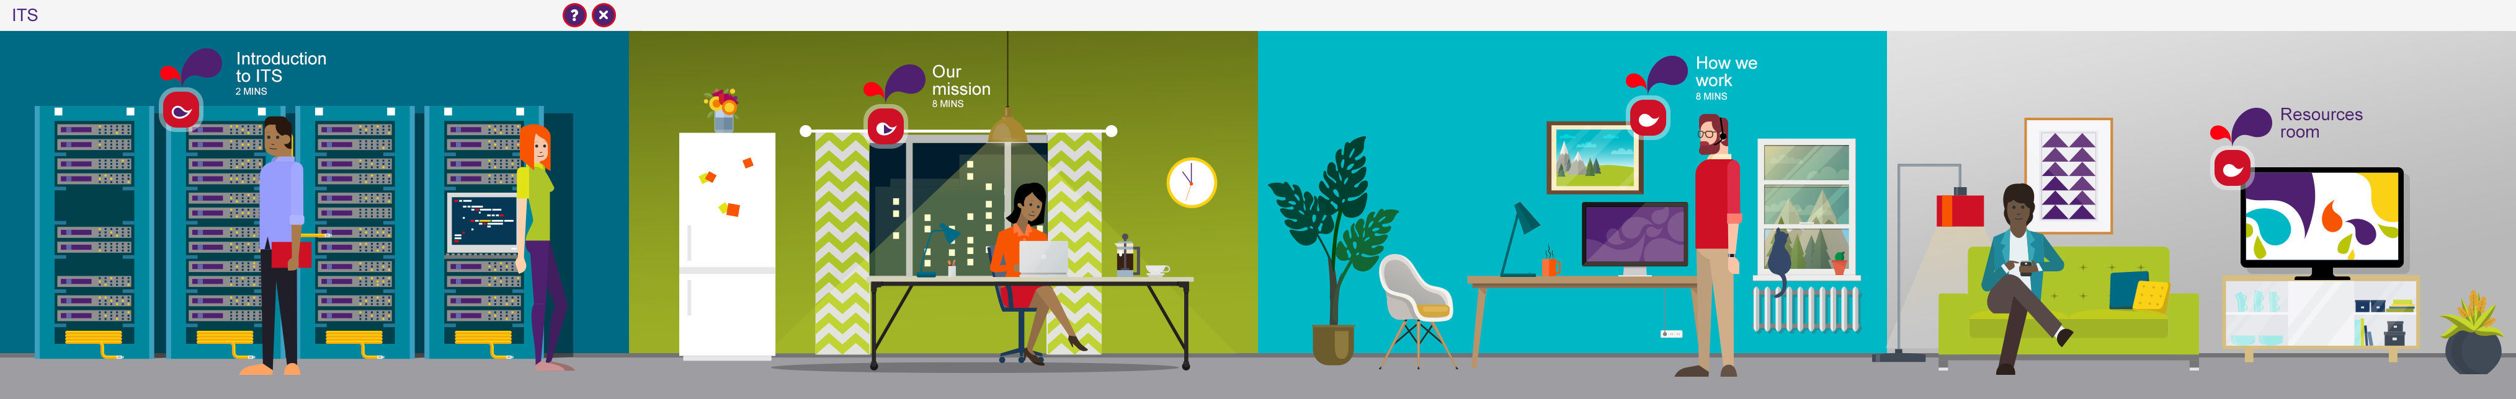

**TOPIC 1 TITLE**

Introduction to ITS

**TOPIC 1 DURATION**

5 MINS

**TOPIC 2 TITLE**

Our Mission

**TOPIC 2 DURATION**

5 MINS

**TOPIC 3 TITLE**

How we Work

**TOPIC 3 DURATION**

11 MINS

**RESOURCES TOPIC TITLE**

Resources Room

**GUIDE AUDIO**

Now that you're inside the ITS landmark, you can scroll to the right to see different areas. To enter an area, select the icon next to its title, like the one you can see here. Whenever you want to leave this landmark, select the exit icon at the top of the screen. It’ll remember where you were, so we can continue your tour when you return. Now please select an area to begin your tour of ITS.

**INSTRUCTION TEXT**

Scroll to the right to see all the areas. Select an icon to enter an area.

# Topic 1: Introduction to ITS

## SCREEN 01_100

SCREEN TYPE Text and Graphic

**DESCRIPTION**

This screen presents information, sometimes with an illustrative graphic/image, and sometimes with typography, such as a pull-quote. There are no learning instructions or interactions. The layout of text and image will vary based on the requirements of the content.

We will challenge learners to think about how MDLZ relies on Information Technology and Solutions.

**IMAGE**

Image echoing the menu screens across this and other Landmarks. People working in different locations in MDLZ, all using technology solutions.

**BODY TEXT (Max 100 words)**

Hi there! You probably already know that technology is ingrained in every part of our business – from the humble day-to-day work to our greatest strategic ambitions.

ITS stands for Information Technology and Solutions. All of these three words describe what we provide for the company to run the business and attain its goals– it is about providing information, engagement and innovation. It is about technology that enables business capabilities and connects our Mondelez world, and it is all about solutions either for data, systems or process excellence.

Let’s try a quick exercise – you don’t need to write anything down. Just think about your own role in Mondelēz International (MDLZ). Think about what you know about the rest of the organization. Can you think of any area that isn’t supported by a technology or process-based solution? Sometimes these solutions work so well, you hardly notice they’re even there.

Take a moment to reflect. When you’re ready, we can start to explore the exciting ways that ITS connects the whole MDLZ world.

## SCREEN 01_110

*SCREEN TYPE****:*** Multiple choice question (correct, partial & incorrect feedback)

**DESCRIPTION**

A question and several answer options. The learner selects the option or options that they believe are correct, then they select a Confirm button. The correct answer(s) are then indicated and feedback once the user submits their chosen answer. The guide provides narration for these screens, so the audio icon will be present.

**QUESTION AUDIO**

That was probably a tricky thing to do. That’s because ITS solutions reach into just about every part of our work. Let’s think some more about your contact with ITS today.

**QUESTION TEXT** (30 words max)

When would be a good time to make contact with ITS?

**PROMPT**

Select your answers, then Confirm.

**OPTIONS** (15 words max. per option)

|  |  |  |
| --- | --- | --- |
| 1 | When your new project requires a technology or process solution | Correct |
| 2 | When your existing project requires a technology or process solution | Correct |
| 3 | When you have a great idea for a new project, and need to make sure it can work | Correct |
| 4 | When you want to know if your | Correct |

**CORRECT AUDIO FEEDBACK**

Great! You’re already thinking along the right lines. You can see that ITS is all about Solutions.

**CORRECT TEXT FEEDBACK** (50 words max)

That’s right! All of these are good reasons to get in touch with ITS – that’s because they are all about solutions.

**PARTIAL AUDIO FEEDBACK**

Almost – you’re definitely getting close to understanding what ITS is all about.

**PARTIAL TEXT FEEDBACK** (50 words max)

Not quite. In fact all of these are excellent reasons to get in touch with ITS – that’s because they are all about finding a solution using processes or technology to support MDLZ.

**INCORRECT AUDIO FEEDBACK**

NA

**INCORRECT TEXT FEEDBACK** (50 words max)

NA

## SCREEN 01_120

SCREEN TYPE Hotspot reveal

**DESCRIPTION**

The learner selects icons on an image to reveal further information, images or media.

We’re going to pick apart the ITS value proposition, pulling out the meanings

**MAIN IMAGE**

Using strong typography, the ITS value proposition dominates the screen. The phrases themselves are the hotspots:

ITS: Connecting the MDLZ world to drive sustainable growth through competitive solutions.

**OPENING TEXT (30 words max)**

As we have thought about it already, the work of ITS is huge, and stretches throughout the entire organization. So, let’s make things simple for a minute – here is ITS in a single sentence.

**PROMPT**

Select each part of our value proposition to find out more.

**REVEAL 1 ICON PLACEMENT**

ITS

**REVEAL 1 TEXT (50 words max)**

Information Technology Solutions

**REVEAL 2 ICON PLACEMENT**

Connecting our MDLZ world

**REVEAL 2 TEXT (50 words max)**

We strive to partner with our eco-system which makes MDLZ thrive. That means consumers, customers, stakeholders and functions. People across the world of MDLZ have us on their side.

**REVEAL 3 ICON PLACEMENT**

To drive sustainable growth

**REVEAL 3 TEXT (50 words max)**

Technology and process-based solutions are at the heart of Ambition 2020’s objectives for growth. Through our enterprise strategy solutions, we help meet the needs of our organization .

**REVEAL 4 ICON PLACEMENT**

Through competitive solutions

**REVEAL 4 TEXT (50 words max)**

Competitive represents speedy and agile delivery of both technology and process solutions. This is where our impact is felt most.

## SCREEN 01_130

SCREEN TYPE Hotspot reveal

**DESCRIPTION**

The learner selects icons on an image to reveal further information, images or media.

Images from across the different functions represent concrete examples of the work of ITS in people’s everyday lives. Reveal text gives more information on each individual project.

**MAIN IMAGE**

Similar to a menu screen, but using examples that are specific to each function:

RDQ – the image of an ideas lab

Sales – field sales agent in a store

HR – recruitment interview

**OPENING TEXT (30 words max)**

So, how does our mission come into the lives of people at MDLZ? To get an idea, we can take a look at just a few examples of how we help each function achieve their goals.

**PROMPT**

Select each function pictured to find out more.

**REVEAL 1 ICON PLACEMENT**

Research Development and Quality (RDQ)

**REVEAL 1 TEXT (50 words max)**

We are making it possible for RDQto move faster from concept to market. The impact of this is that we drive growth and become more competitive.

**REVEAL 2 ICON PLACEMENT**

Sales

**REVEAL 2 TEXT (50 words max)**

We help sales by focusing on efficient retail execution, including distributor management and competitive revenue management capability. In practice, this means our sales agents on the ground are supported every step of the way. Solutions like WiSE and Perfect Store mean more sales and increased growth.

**REVEAL 3 ICON PLACEMENT**

Human Resources (HR)

**REVEAL 3 TEXT (50 words max)**

Our solutions have improved talent management (getting the best out of the people of MDLZ) through automated global processes and tools, as well as integrated employee data. You may already have experienced some of the technical solutions integrated into our Mondelez International University (MIU. If so, you will know that our solutions bring all your learning under one roof, meaning consistent ways to build learning plans and access global learning opportunities. Using these solutions, we can connect your work and ambitions to help you realize your potential.

**REVEAL 4 ICON PLACEMENT**

ISC

**REVEAL 4 TEXT**

Colleagues in manufacturing have benefitted from IDF - technology solutions that help develop the Factory of the Future. With IDF provides real-time efficiency data, supporting strategic goals and empowering growth across MDLZ.

## SCREEN 01_140

SCREEN TYPE Text reveal

**DESCRIPTION**

The learner selects text headings to reveal further information, images or media.

This is a positive message about why ITS love what they do, and why every solution matters. Each brief statement is expanded in more detail when selected by the learner.

**OPENING TEXT (30 words max)**

Now you have a better idea of what ITS is. Here’s what our function means to us. Our mission is to empower growth, this is what drives us to do what we do for the MDLZ world.

**PROMPT**

Select each heading to find out more.

**HEADING 1 TEXT (5 words max)**

ITS means creativity

**TEXT FOR HEADING** **1 (50 words max)**

We champion smart, simple and cost-effective solutions that build our capability.

**HEADING 2 TEXT (5 words max)**

ITS means being proactive

**TEXT FOR HEADING** **2 (50 words max)**

We get involved early and help to set the direction.

**HEADING 3 TEXT (5 words max)**

ITS means forward thinking

**TEXT FOR HEADING** **3 (50 words max)**

We think long term and invest in sustainable solutions.

**HEADING 4 TEXT (5 words max)**

ITS means agility

**TEXT FOR HEADING** **4 (50 words max)**

We are quick to respond to changing needs and priorities.

**HEADING 5 TEXT (5 words max)**

ITS means global reach

**TEXT FOR HEADING** **5 (50 words max)**

We provide a consistent service to everyone, everywhere.

FINAL PROMPT

Select the Home icon to return to the menu.

# Topic 2: Empowering growth

## SCREEN 02_100

SCREEN TYPE Hotspot reveal

**DESCRIPTION**

The learner selects icons on an image to reveal further information, images or media.

Breaking down the reasons for the ITS work , this screen will use the three strategic pillars to look at the mission that drives this function. This screen will use the three strategic pillars to further understand the mission that drives this function.

**MAIN IMAGE**

A simplified diagram representing the three strategic pillars connected by ITS. The Pillars shown are: Accelerate Growth, Future-proof the Foundation, Strengthen the Core. At the centre is ITS Empowering Growth

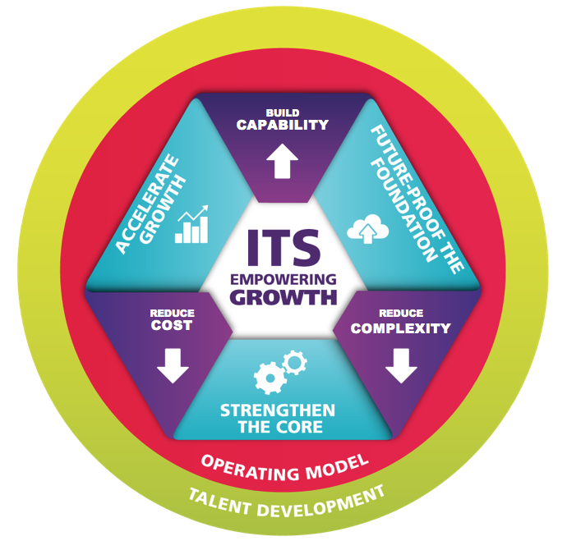

**OPENING TEXT (30 words max)**

You’ve seen what ITS does, and how we are dedicated to empowering growth. You have also been able to think about where our solutions support you in your role. Now let’s look at the strategy that guides us. All of our work is driven by three strategic pillars. Achieving these objectives helps us achieve our goals and meet our targets. .

**PROMPT**

Select each of the strategic pillars to find out more.

**REVEAL 1 ICON PLACEMENT**

Accelerate growth.

**REVEAL 1 TEXT (50 words max)**

During our strategic planning process we work with key leaders across MDLZ to identify the right capabilities to achieve our Ambition 2020 goals.

**REVEAL 2 ICON PLACEMENT**

Strengthen the Core

**REVEAL 2 TEXT (50 words max)**

We create solutions that help MDLZ achieve operating excellence. This means solutions that are efficient, reliable and cost effective. They must also be sustainable, adding value for the short and long term.

**REVEAL 3 ICON PLACEMENT**

Future-Proof the Foundation

**REVEAL 3 TEXT (50 words max)**

The main technology architecture of MDLZ is evolving all the time. We look to enable flexibility for MDLZ as a whole, increase our speed in getting products to market and improve consumer engagement, and digital enterprise. All of these things allow MDLZ to maintain its place as a leading global organization today, tomorrow and beyond.

## SCREEN 02_110

SCREEN TYPE Hotspot reveal

**DESCRIPTION**

The learner selects icons on an image to reveal further information, images or media.

**MAIN IMAGE**

The same image as screen 02_100 is displayed, but this time we only see the text:

Build Capability, reduce Cost and Reduce Complexity



**OPENING TEXT (30 words max)**

When you work hard, you want to make sure you have achieved what you set out to do, right? Like you, we are clear that our success is connected to the success of the whole MDLZ world. We measure our achievements against three guiding objectives.

**PROMPT**

Select each measure of success to find out more.

**REVEAL 1 ICON PLACEMENT**

Build Capability

**REVEAL 1 TEXT (50 words max)**

Building capability means that our work will result in visible top and bottom line growth. This is achieved when we increase organizational excellence and efficiency.

**REVEAL 2 ICON PLACEMENT**

Reduce Complexity

**REVEAL 2 TEXT (50 words max)**

World class technology and process solutions make life simpler. With each project, we aim to make MDLZ a faster, more agile organization. We ask ourselves, have we moved towards having MDLZ data in one source? Have we made the processes and technology across MDLZ work together? When we can answer yes, then we are succeeding.

**REVEAL 3 ICON PLACEMENT**

Reduce Cost

**REVEAL 3 TEXT (50 words max)**

Reducing cost is something we all strive for, but in ITS it means making our own processes more efficient, and reducing cost for MDLZ on a global level. We ask ourselves: Have we moved towards more engaging user experiences? Are we making people more self-sufficient? Are we being ruthless in the technology choices we make and ensuring anything outside of our portfolio is quickly retired? Are we keeping our costs within a competitive range?

## SCREEN 02_120

SCREEN TYPE Photostory

**DESCRIPTION**

A series of images with text that the learner explores in a fixed sequence that provides a linear narrative.The text in each

Key people from MDLZ functions – represented as images or illustrations - will describe how ITS solutions have been successfully delivered, and how they work now.

|  |  |  |
| --- | --- | --- |
| **Frame** | **Picture** | **Text (Max 15 words per speech/caption)** |
| **1** | A field sales agent in a store doing a WISE photo audit on a Smartphone | **Speech Andy Tosney:** We use WiSE to make sure our products sell the way they should in every store  **Caption**: In field sales, the retail platform WiSE has helped Build Capacity  **Prompt**: Select the green strip to the right of the image to find out more. |
| **2** | Close up of Sales Agent shaking hands with a happy Consumer | **Speech Andy Tosney:** This means I can work faster and have a better relationship with my customers.  **Caption**: WiSE will continue to support sales with new functionality in the future. |
| **3** | An MDLZ professional relaxing, working on top of a cloud | **Speech Joher Akolawala**:Transferring to a Cloud-based way of working has given me more freedom to work more flexibly and access information I need anywhere and any time.  **Caption**: A cloud-based way of working improves the working lives of all MDLZ people. |
| **4** | The cloud connects the MDLZ professional to the world | **Speech Joher Akolawala**:I am more connected than ever – relationships are simpler, and I can focus much more on my strategic objectives.  **Caption**: Cloud Transformation has reduced cost around the MDLZ world. |
| **5** | An HR professional is looking at the globe on a monitor. We see people standing-out on the map | **Speech Karen May:** Global HR makes talent management and recruitment simpler, and faster  **Caption**: Thinking globally about HR is transforming talent management, and making life easier for all of us. |
| **6** | Close up of the globe on the HR professional’s screen. One of the figures raised from the map has statistic listed:  Role: Talent  Happiness: 100%  Productivity: Rising | **Speech Karen May:** I can manage talent around the world from one location. Our people can develop and achieve their full potential.  **Caption**: We have reduced complexity, and liberated talent on a global level. |

## SCREEN 02_130

SCREEN TYPE Text and Graphic

**DESCRIPTION**

This screen presents information, sometimes with an illustrative graphic/image, and sometimes with typography, such as a pull-quote. There are no learning instructions or interactions. The layout of text and image will vary based on the requirements of the content.

A quick review of where we are now.

**PULL-QUOTE TEXT**

ITS – We are connected

**BODY TEXT (Max 100 words)**

We’ve come a long way, and you’ve seen who we are, what we do, and why we do it. Next we’re going to look at how we work.

Remember, everything we do is about connecting the MDLZ world – and that includes you. If you haven’t already, take a look at the resources room, and discover more about the ITS solutions at work in your function, and across the organization.

FINAL PROMPT

Select the Home icon to return to the menu.

# Topic 3: How we work

## SCREEN 03_100

SCREEN TYPE Text and Graphic

**DESCRIPTION**

This screen presents information, sometimes with an illustrative graphic/image, and sometimes with typography, such as a pull-quote. There are no learning instructions or interactions. The layout of text and image will vary based on the requirements of the content.

This screen introduces the learner to the ins and outs of ITS. How the function works, and who its people are.

**IMAGE**

Use menu imagery to show the whole ITS team together

**BODY TEXT (Max 100 words)**

Now that you know what we do, it’s time to get to know us even better. In this part of the tour, you’re going to meet some ITS people and find out how we partner across MDLZ .

You will discover that there are ITS colleagues all over the world, and how you can work with them.

## SCREEN 03_110

SCREEN TYPE Hotspot reveal

**DESCRIPTION**

The learner selects icons on an image to reveal further information, images or media.

The image shows the three operational layers of ITS, when the learner selects each area, they will discover more about how this function works

**MAIN IMAGE**

A simplified version of this diagram – keeping:

Mission, Strategy, Engagement, Execution areas, plus each of the headlines:

Empowering growth

Strategy & markets

Technology & architecture

Business Engagement

Project Services

Service Operations.

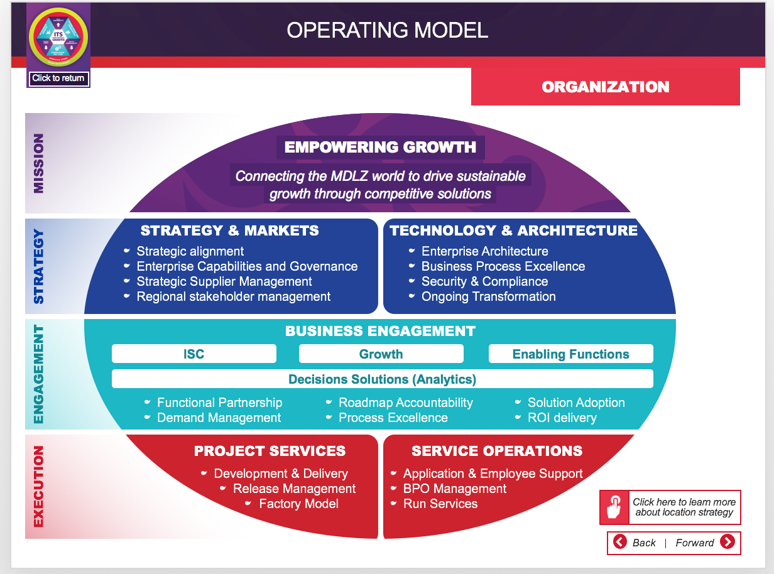

But separated out into areas on a table. Some examples of MDLZ snacks lie on the table too.



**OPENING TEXT (30 words max)**

Just like some of the tastiest snacks of MDLZ, ITS is textured and works on many levels. Our operations are split between 3 delicious areas .

**PROMPT**

Select each layer to find out more.

**REVEAL 1 ICON PLACEMENT**

Strategy

**REVEAL 1 TEXT (50 words max)**

We ensure the execution of every aspect of ITS is in line with our strategic focus. This means taking a global view of projects.

**REVEAL 2 ICON PLACEMENT**

Engagement

**REVEAL 2 TEXT (50 words max)**

Engagement is at the heart of all we do in ITS. We know it’s the best way to support the whole organization. By working as a partner to each of the main functions, we are able to deliver real value for MDLZ.

**REVEAL 3 ICON PLACEMENT**

Execution

**REVEAL 3 TEXT (50 words max)**

The execution layer is all about keeping us competitive in our work. Our projects are delivered using a ‘factory model’ approach. This means delivering each piece of work quickly, reliably and at the lowest possible cost.

## SCREEN 03_120

SCREEN TYPE Text and Graphic

**DESCRIPTION**

This screen presents information, sometimes with an illustrative graphic/image, and sometimes with typography, such as a pull-quote. There are no learning instructions or interactions. The layout of text and image will vary based on the requirements of the content.

**IMAGE**

An illustrated word cloud represents the different roles with ITS:

|  |
| --- |
| Tower BPE Lead |
| Change Control |
| Tower BPE Implementation |
| Market Lead |
| Data Modeler |
| Enterprise Architect |
| Tower Lead |
| Change Manager |
| Region Implementation |
| Tower Planning & Delivery Lead |
| Technical Analyst |
| Project Manager |
| Solution Architect |
| Support Analyst |
| Capability Lead |
| Capability Implementation |
| Region Engagement |
| Solution Process Expert |
| Global Solution Owner |
| Solution Delivery Expert |
| On Site Services |

**BODY TEXT (Max 100 words)**

ITS is a partner for every function of the MDLZ world. We collaborate within ITS, and across the organization to find the best possible solutions.

Each role is structured to maximize the possibilities that open up when we collaborate, share ideas, and think creatively about each solution.

## SCREEN 03_130

*SCREEN TYPE****:*** Multiple choice question (correct & incorrect feedback)

**DESCRIPTION**

A question and several answer options. The learner selects the option or options that they believe are correct, then they select a Confirm button. The correct answer(s) are then indicated and feedback once the user submits their chosen answer. The guide provides narration for these screens, so the audio icon will be present.

**QUESTION AUDIO**

Let’s think again about the projects at MDLZ that need ITS partnership

**QUESTION TEXT** (30 words max)

When do you think ITS come in to partner on a new project? Remember, we work as partners throughout the organization, so we need to join projects that are definitely going ahead.

**PROMPT**

Select your answer, then Confirm.

**OPTIONS** (15 words max. per option)

|  |  |  |
| --- | --- | --- |
| 1 | During quarterly rolling portfolio review | Correct |
| 2 | As soon as the business need has been identified | Incorrect |
| 3 | At the project definition phase | Incorrect |
| 4 | Later than that | Incorrect |

**CORRECT AUDIO FEEDBACK**

That’s right. You can see where the project becomes a reality, and that’s where we join.

**CORRECT TEXT FEEDBACK** (50 words max)

That’s right, we join at the moment a project becomes part of the quarterly rolling portfolio review.

**INCORRECT AUDIO FEEDBACK**

Ah, not quite. We join at the strategic planning process because that’s the moment we can be the most effective.

**INCORRECT TEXT FEEDBACK** (50 words max)

Sorry, that’s wrong. We join at the moment a project becomes part of the annual strategic planning process.

## SCREEN 03_140

SCREEN TYPE Text reveal

**DESCRIPTION**

The learner selects text headings to reveal further information, images or media.

The screen shows a list of 10 capabilities of ITS, each one can be selected, and the learner will discover more about that capability.

**OPENING TEXT (30 words max)**

The world of MDLZ is changing, and it’s an exciting time for all of us. We are constantly discovering new ITS solutions to make our shoppers happy and our consumers’ lives easier. We become more competitive with each new innovation, but we have to prioritize to maintain our strategy and focus.

**PROMPT**

Select each priority capability to find out more.

**HEADING 1 TEXT (5 words max)**

Analytics

**TEXT FOR HEADING** **1 (50 words max)**

Look across the MDLZ world, and you will see that each function relies on analytics to succeed. At ITS, we are creating an internal and external data market place. This means there is one single source of truth that all of us can learn from.

**HEADING 2 TEXT (5 words max)**

End-to-end IBP

**TEXT FOR HEADING** **2 (50 words max)**

IBP means Integrated Business Planning. ITS are using technology and process solutions to connect all MDLZ operations, strategy and financial performance. Our integrated planning tower is improving planning efficiency and accuracy.

**HEADING 3 TEXT (5 words max)**

Digital innovation

**TEXT FOR HEADING** **3 (50 words max)**

Our digital platforms are set to transform the way we work together, and connect to our shoppers and consumers.

**HEADING 4 TEXT (5 words max)**

E-commerce

**TEXT FOR HEADING** **4 (50 words max)**

Getting ahead in e-commerce means connecting our shoppers with delicious MDLZ snacks and driving growth. We are developing new platforms and new ways for them to integrate with consumers and partners.

**HEADING 5 TEXT (5 words max)**

Revenue management

**TEXT FOR HEADING** **5 (50 words max)**

Our new TPM tool makes it possible to optimize spending and improve margins across selected markets.

**HEADING 6 TEXT (5 words max)**

Retail execution

**TEXT FOR HEADING** **6 (50 words max)**

Thanks to DMS and WiSE, our work with retailers improves day by day. We have already seen how WiSE is empowering partners in Sales to improve execution in retail environments.

**HEADING 7 TEXT (5 words max)**

Digital supply chain

**TEXT FOR HEADING** **7 (50 words max)**

It’s thrilling when we connect solutions to real practical results. Improving our digital supply chain is about getting our products onto shelves, and into shoppers’ hands. This is why our IDF and warehouse management solutions are making it easier for our partners in logistics.

**HEADING 8 TEXT (5 words max)**

Human capital management and automation

**TEXT FOR HEADING** **8 (50 words max)**

You’re probably already experiencing some of the ways we help develop talent at MDLZ. Our MIU Learning Catalogue is an IT solution which integrates learning management with performance and goal setting processes as part of our HR strategy. If you’re looking forward to a long and varied career with MDLZ, our solutions will help you seize the opportunity.

**HEADING 9 TEXT (5 words max)**

Finance MBS and other functional transformation

**TEXT FOR HEADING** **9 (50 words max)**

As we work to drive and support transformation across the MDLZ world, we are partners in many projects. By implementing one finance and one procurement solution, we are making our processes more efficient. We are also rolling out D-I-A-L Process Excellence across the organization – more on D-I-A-L later.

**HEADING 10 TEXT (5 words max)**

Enterprise collaboration and productivity

**TEXT FOR HEADING** **10 (50 words max)**

As you have probably noticed, at MDLZ communicating and collaborating with each other is how we work best. ITS projects to improve collaboration and productivity are making a difference to all our working lives – from Lync and mobile technology to video enablement.

## SCREEN 03_150

SCREEN TYPE Hotspot reveal

**DESCRIPTION**

The learner selects icons on an image to reveal further information, images or media.

The screen shows a strategy meeting – all around are different considerations of the ITS strategic operational layer

**MAIN IMAGE**

The screen is dominated by menu-art style image of a strategy meeting. There are three hotspots:

Two people high-fiving

A map of the world which is pinned to a board

The closed door

**OPENING TEXT (30 words max)**

Our strategic area works in partnership across MDLZ. Our role is to support and focus MDLZ strategy using technology and process solutions.

**PROMPT**

Select each area of this strategy meeting to find out more.

**REVEAL 1 ICON PLACEMENT**

Two people high-fiving

**REVEAL 1 TEXT (50 words max)**

We focus on maintaining MDLZ’s strategic alignment. We ensure that solutions are in place to help us all work together, with the same strategic goals

**REVEAL 2 ICON PLACEMENT**

A map of the world

**REVEAL 2 TEXT (50 words max)**

We know that regional and national differences do matter – which is why we create global solutions that are sensitive to local needs. The key to this is creating solutions that empower our partners, wherever they are working.

**REVEAL 3 ICON PLACEMENT**

The closed door

**REVEAL 3 TEXT (50 words max)**

We are improving enterprise architecture – the underlying structure of all ITS solutions, allowing smoother access across the MDLZ world, while focusing properly on security.

## SCREEN 03_160

SCREEN TYPE Text and Graphic

**DESCRIPTION**

This screen presents information, sometimes with an illustrative graphic/image, and sometimes with typography, such as a pull-quote. There are no learning instructions or interactions. The layout of text and image will vary based on the requirements of the content.

This is the Engagement layer of the ITS operating model

**IMAGE**

ITS professional is giving a talk to another function – they are presenting using plasma screen. The ‘slide’ they are showing says ‘ITS about Engagement’

**BODY TEXT (Max 100 words)**

The engagement layer of our operation is essential to the way we work. You’ve already seen how we partner all functions in MDLZ – imagine how this would work without a dedicated engagement team. This is where we build the partnerships that make our work possible.

Our BE (Business Engagement) team are the front line of partnerships across MDLZ. We are actively engaged with Global Regional function teams.

Collaborating with business process owners, our engagement structure allows us to effectively prioritize each project requirement.

We also engage with other key players to throughout the process, so our solutions always meet the end business need.

## SCREEN 03_170

SCREEN TYPE Text reveal

**DESCRIPTION**

The learner selects text headings to reveal further information, images or media.

We will split the D-I-A-L acronym into 2 parts. We’re doing this to emphasize the importance of the A-L part of the process. By keeping to 2 parts, rather than 4, we’re giving the learner more time to think about these elements as an essential process.

**OPENING TEXT (30 words max)**

Project delivery within the execution layer is where we make proposed solutions a reality. Our operating framework for delivery is called D-I-A-L. You might recognize this way of working in your own function. Let’s take a look at what D-I-A-L means to us.

**PROMPT**

Select each letter to find out about how we D-I-A-L it up.

**HEADING 1 TEXT (5 words max)**

D-I

**TEXT FOR HEADING** **1 (50 words max)**

Define and Implement. This part of the process is probably something you are already familiar with. We design solutions that fit with our strategic goals. Before putting them into practice, we check to make sure they will enable growth, reduce cost, and drive down complexity.

Then, in partnership with our colleagues in each function, we implement the solution.

**HEADING 2 TEXT (5 words max)**

A-L

**TEXT FOR HEADING** **2 (50 words max)**

Now, this is where our value really matters. Once the solution/process has been implemented, we do not walk away. We Apply and sustain the solution – which means making it work and keep working for the future.

Then we Leverage and improve. A solution should always work hard for MDLZ – which is why we strive to leverage the best from everything we do, and continue to improve as the world changes.

## SCREEN 03_180

SCREEN TYPE Text and graphic

**DESCRIPTION**

This screen presents information, sometimes with an illustrative graphic/image, and sometimes with typography, such as a pull-quote. There are no learning instructions or interactions. The layout of text and image will vary based on the requirements of the content.

A long line of MDLZ professionals and partners from a variety of backgrounds – wearing high-vis, suits, retail uniforms, logistics uniforms, lab coats – the full range of the MDLZ working world – they thank you for learning about ITS.

**IMAGE [Delete if using typography]**

A long line of MDLZ professionals and partners from a variety of backgrounds – wearing high-vis, suits, retail uniforms, logistics uniforms, lab coats – the full range of the MDLZ working world – they thank you for learning about ITS.

**BODY TEXT (Max 100 words)**

Thank you for learning about ITS and how we work. We hope you enjoyed discovering how we work around the world, and around the clock, to connect our MDLZ world and drive sustainable growth.

Remember that wherever you are working, and whatever you do, we are striving to provide solutions that help you.

Don’t be a stranger – talk to us about your ideas. Find your ITS partner and discover what new solutions are coming your way.

FINAL PROMPT

Select the Home icon to return to the menu.

# Topic: Resources room

**DESCRIPTION**

The Resources room is a visual catalogue of useful resources related to the function described in this module. Resources can be filtered by type:

* Watch (videos)
* Learn (e-learning)
* Read (PDFs)
* Visit (Intranet pages and external websites)

Up to four most recently visited resources will be collected in a personal section (My list) so they can be found again easily.

**RESOURCE 1 TYPE**

Watch | Learn | Read | Visit (delete as applicable)

Intranet: https://intranet.mdlz.com/sites/informationsystems

MIU ITS Academy:

Interactive PDF:

DIAL Overview Training (Will need link from LMS team)

**RESOURCE 1 TITLE**

[Insert Resource 1 title]

**RESOURCE 1 THUMBNAIL**

[Describe thumbnail image used to illustrate this resource]

**RESOURCE 1 SOURCE**

[Insert the URL or file reference for the linked document]