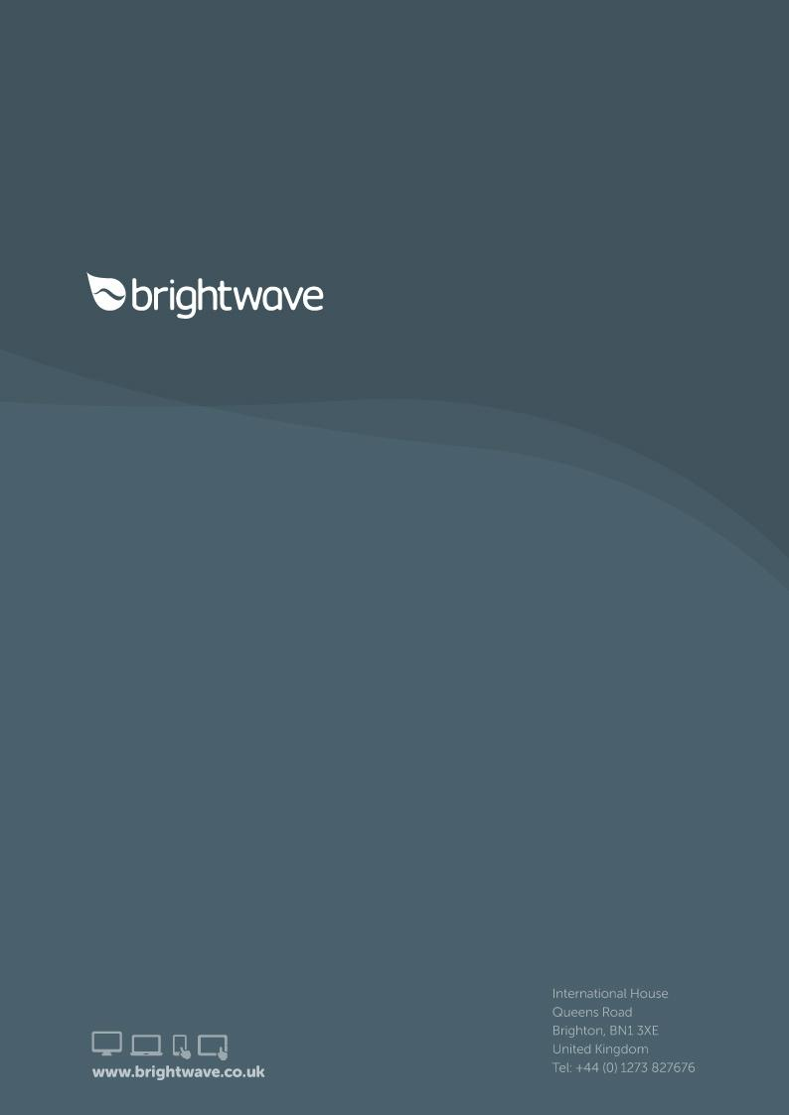

****

**Script**

**PWC G Suite**

project no: **PWC847**

reply to: **Rob Keywood** [**rob.keywood@brightwavegroup.com**](mailto:rob.keywood@brightwavegroup.comuk)

**Revision history**

|  |  |  |  |  |
| --- | --- | --- | --- | --- |
| **Version** | **Date** | **Initials** | **Team** | **Summary of Revisions Made / Comments** |
| 0.1 | 01/08/16 | RK | BW | First draft |
| 0.2 | 01/08/16 | SP | BW | QA |
| 0.3 | 03/08/16 | RK | BW | Amends from QA |
| 1.0 | 03/08/16 | NW | BW | Client release |
| 1.1 |  |  | PWC | Feedback |
| 1.2 | 09/08/16 | CF | BW | Amends after client call |
| 1.3 | 09/08/16 | LS | BW | Internal review |
| 1.4 | 10/08/16 | SH | QA | QA |
| 1.5 | 11/08/16 | LS | BW | Script tidy |
| 2.0 | 11/08/16 | NW | PWC | Client release |
| 2.1 | 15/08/16 | LS | BW | Amendments after alpha QA |
| 2.2 | 16/08/16 | LS | BW | Further amendments after alpha QA |
| 2.3 | 16/08/16 | AB | BW | Final video added (4\_110) |
| 3.0 | 16/08/16 | LL | BW | Released with EBR course |
| 3.1 | 22/08/16 | TF | BW | Amends made to include 'Scriptv2.1textonly.doc' feedback |
| 3.2 | 23/08/16 | EC | BW | QA |
| 3.3 | 24/08/16 | TF | BW | Amends made following QA |
| 3.4 | 24/08/16 | SP | BW | QA |
| 3.5 | 24/08/16 | TF | BW | Amends made following QA and to include 'Google eLearn Script\_BW final.docx' feedback |
| 3.6 | 26/08/16 | DJ | BW | Updates |
| 4.0 | 26/08/16 | DJ | BW | RELEASE with Alpha |
| 4.1 | 30/08/16 | DJ | BW | Updates |
| 4.2 | 30/08/16 | TF | BW | Updated script comparison |
| 5.0 | 30/08/16 | DJ | BW | Release |
| 5.1 | 05/09/16 | AV | PWC | Client fbk |
| 5.2 | 05/09/16 | TF | BW | Updates |
| 5.3 | 05/09/16 | SH/SP | BW | QA |
| 5.4 | 07/09/16 | AB | BW | New videos in course |
| 5.5 | 08/09/16 | ABP | BW | Added resources text |
| 6.0 | 09/09/16 | DJ | BW | Release |
| 6.1 | 15/09/16 | AB | BW | Client amends |
| 7.0 | 19/09/16 | LL | BW | Released with GOLD version |
| 8.0 | 03/10/16 | NW | BW | Updates |
| 8.1 | 05/10/16 | AB | BW | Client amends |
| 9.0 | 06/10/16 | LL | BW | Released with GOLD2 version |
| 9.1 | 07/10/16 | AB | BW | Client amends |
| 10.0 | 10/10/16 | LL | BW | Released with final course |
| 10.1 | 12/10/16 | DJ | BW | Clean version |
| 10.2 | 19/10/16 | DJ | BW | Client tracked changes |

**Purpose of this document**

This script details the exact text that will appear on each screen of the course, together with the interactions and any buttons that appear. It also indicates the kind of graphics or images that will be used, although these are not final at this stage.

It's important that you check everything appears as you want it within the script, so that there are minimal changes once the course is built.

**As you read through this document, please use the Review tab to track any changes you would like made. You can also use comment boxes for more general points.**

**Learning objectives**

By the end of the course learners will be able to:

* Explain the benefits that the introduction of this technology will bring in terms of collaboration and efficiency.
* Explain why this new technology is being introduced
* Identify the new tools being introduced
* Explain what they need to do on Day One of the switchover
* Understand where to access information about the business rules
* Know where to go for more help and guidance

**Contents**

[SCREEN Resources 6](#_Toc464655890)

[SCREEN Splash screen 7](#_Toc464655892)

[SCREEN Menu 8](#_Toc464655893)

[Topic 1: Why are we changing? 9](#_Toc464655894)

[SCREEN 01\_101 10](#_Toc464655895)

[Topic 2: What is changing? 11](#_Toc464655896)

[SCREEN 02\_100 12](#_Toc464655897)

[SCREEN 02\_110 14](#_Toc464655898)

[SCREEN 02\_120 16](#_Toc464655899)

[SCREEN 02\_130 18](#_Toc464655900)

[SCREEN 02\_140 19](#_Toc464655901)

[Topic 3: Google and Clients 21](#_Toc464655902)

[SCREEN 03\_100 22](#_Toc464655903)

[Topic 4: What can you expect? 24](#_Toc464655904)

[SCREEN 04\_100 25](#_Toc464655905)

[SCREEN 04\_110 26](#_Toc464655906)

[Topic 5: How do I get help? 28](#_Toc464655907)

[SCREEN 05\_100 29](#_Toc464655908)

[SCREEN 05\_110 31](#_Toc464655909)

## SCREEN Resources

**DESKTOP/MOBILE SCREEN TYPE**: Dialogue window

**TITLE:**

Resources

**TEXT (50 words max)**

Here are some useful links below:

|  |  |
| --- | --- |
|  |  |
| [Learning materials and resources](https://pwc.csod.com/LMS/LoDetails/DetailsLo.aspx?loid=9af3be9c-aa8e-465c-8a14-11a93a594fcc&query=?q=ME%20Going%20Google" \l "t=1) | On My Development in the Google Curriculum you will find access to various learning materials and resources that provide more detailed assistance on specific apps. |
| [FAQs and guidance](https://pwc-spark.com/groups/going-google-middle-east/pages/welcome) | You can find FAQs and guidance with tips and answers to common problems on the G Suite - Going Google: Middle East Spark group. If you can't find your answer, we recommend you post it as a question. |
| [Google with clients](https://pwc-spark.com/groups/going-google-middle-east/pages/business-rules" \t "_blank)  For the Global Google Exception Client Registry select here – [http://exceptionregistry](http://exceptionregistry" \t "_blank) |  |
| For the latest business rules select here – <https://pwc-spark.com/groups/going-google-middle-east/pages/business-rules> |  |

## SCREEN Splash screen

**TEXT**

Excited?

We are.

Technology is changing, and we are transitioning to G Suite to take advantage of the opportunities these changes provide us. Google will change the way we work together and with our clients, helping us to be more efficient at connecting, collaborating and sharing.

This online learning experience will show you what is coming and how you can make the most of it. It will show you the essentials and will help you prepare for when we switch over. This module is only one part of the support available to you but will serve as a great starting point for your transition to G Suite.

It's time we started to think together, think differently and think ahead.

**IMAGE**

CLIENT NOTE: Please make this visual and please ensure the "think" tags are all on brand

Suggest we use something that represents that something is coming, [a bit like this](http://www.shutterstock.com/pic-239776279/stock-photo-let-me-in.html?src=OQynJ7QDNdKiLsWpXXkCMg-1-31) where a new experience is about to begin. Could be a box with a lid slightly ajar, but needs to be atmospheric.

Ideally the image should be full screen, and the text appears to the right/left of the door (if we use the image above).

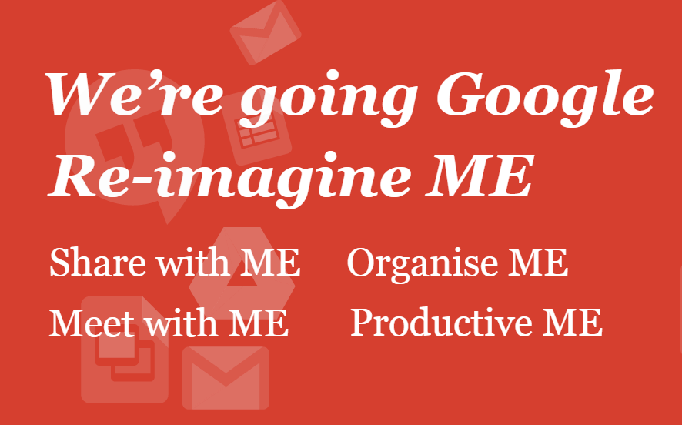

## SCREEN Menu

**DESCRIPTION**

Main menu

**TEXT**

We are introducing new technology via Google to help improve the way we work. To help us connect, share and collaborate. Here we'll cover the tools that will soon be available to all of us, and how we'll use them to our own benefit and to help our clients.

**PROMPT**

Select a topic from the tiles below.

**MOBILE PROMPT**

Select a topic from the list below.

**TOPIC TITLES**

1. Why are we changing?
2. What is changing?
3. Google and Clients
4. What can you expect?
5. How do I get help?

# Topic 1: Why are we changing?

## SCREEN 01\_101

**DESKTOP/MOBILE SCREEN TYPE**: Text and graphic

**DESCRIPTION**

Here we'll prepare the learner for the first day of Google.

**GRAPHIC**

Show a [busy city landscape](http://www.shutterstock.com/pic-224757718/stock-photo-city-life.html?src=5RBfleXk7zXe9mU43oFB5w-2-70) with people rushing around the scene.

**TITLE:**

**Why change now?**

**TEXT (50 words max)**

Think about it. Technology is changing our world in exciting ways. We're moving to Google to embrace these new opportunities, which include:

* making ***working together easier*** and better for us all***,*** dramatically improving efficiency and productivity
* delivering a ***faster, richer service to our clients*** – in time, we will also be able to collaborate with them using Google tools
* ***supporting more flexible working*** both with clients and each other, and increasing opportunities for different ways of working
* ***showcasing to the market*** that we are re-imagining the future of work through innovative technologies
* helping to meet the challenge to ***reduce meetings*** by 25%.

**FINAL PROMPT**

You've completed this topic. Select Home and choose the next topic.

**FINAL MOBILE PROMPT**

You've completed this topic. Select Main Menu from the dropdown and choose the next topic.

# Topic 2: What is changing?

## SCREEN 02\_100

**DESKTOP SCREEN TYPE**: Graphic Reveal Text

**MOBILE SCREEN TYPE**: Photostory

**DESCRIPTION**

Here we'll take a look at what is changing. Topic title appears above first frame on mobile.

**TITLE:**

**What will change?**

**OPENING TEXT (30 words max)**

The way you work and the technology you use every day will change. You'll get lots of help and support to enable you to get started using G Suite. Here's an overview of what you need to know **now**.

**PROMPT**

Select each icon to find out more.

**MOBILE PROMPT**

Scroll down to find out more.

**ICON GRAPHIC 1**

Google Calendar Icon

**DISPLAY GRAPHIC 1**

Google Calendar Screenshot

**TEXT FOR GRAPHIC 1 (50 words max)**

**Less in your seat, more on the move.**

With Google Calendar, you can quickly schedule meetings and events, and get reminders about upcoming activities so you always know what's next. Calendar is designed for teams, so it's easy to share your schedule with others and create multiple calendars that you and your team can use together.

**ICON GRAPHIC 2**

Google Mail Icon

**DISPLAY GRAPHIC 2**

Google Mail Screenshot

**TEXT FOR GRAPHIC 2 (50 words max)**

**Less searching, more finding.**

With Gmail, your emails are stored safely in the cloud where you can get to them from your PwC-managed devices. You can also quickly search and find important emails, and read and draft emails even when you don't have an internet connection.

**ICON GRAPHIC 3**

Google Drive Icon

**DISPLAY GRAPHIC 3**

Google Drive Screenshot

**TEXT FOR GRAPHIC 3 (50 words max)**

**Less sending files, more sharing space.**

With Google Drive, you've got unlimited storage space so you can upload and store all of your files online. You can then share these files with your team and access them from any PwC-managed devices.

Google is not going to be our office 'system of record'. All official final documentation should be stored in your LoS system of record.

**ICON GRAPHIC4 - Include Docs and Slides here too**

Google Sheets/Docs /Slides Icon

**DISPLAY GRAPHIC4**

Google Sheets Screenshot

**TEXT FOR GRAPHIC 4 (50 words max)**

**Less back and forth, more real time.**

Docs, Sheets and Slides are Google's equivalent of Microsoft Word, Excel and PowerPoint. They're hosted in the cloud, so files can be accessed and edited by multiple users simultaneously (including by PwC colleagues in other territories that have already gone Google, like USA, Canada, Australia and the Middle East). You can also access these files offline and on your PwC-managed mobile devices.

Don't forget to take a look at Forms. It's a great tool to gather and analyse data.

**ICON GRAPHIC 5**

Google Hangouts Icon

**DISPLAY GRAPHIC 5**

Google Hangouts Screenshot

**TEXT FOR GRAPHIC 5 (50 words max)**

**Less hold time, more hang time.**

Google Hangouts Video allows you to make video and audio calls, either one-to-one or in a group. You can use Hangouts from your PwC-managed devices, making it easier to connect with colleagues and clients.

Google Hangouts Chat, like Sametime, gives you the opportunity for instant messaging either one-to-one or in a group.

## SCREEN 02\_110

**DESKTOP/MOBILE SCREEN TYPE**: Tabs

**TITLE:**

**Google Calendar**

**DESCRIPTION**

* TAB 1 TITLE: Always in touch
* TAB 2 TITLE: The benefits
* TAB 3 TITLE: Ready for change

**PROMPT**

Select each tab to find out more.

**MOBILE PROMPT**

Select the text headings to find out more.

**TABS**

**Tab 1 image:**

A person using a laptop at a desk and incorporate the checklist text per graphic below. Can you design the graphic to make it look better please and on brand? Delete points 3,5 and 6. So it will only be a 4 point checklist.

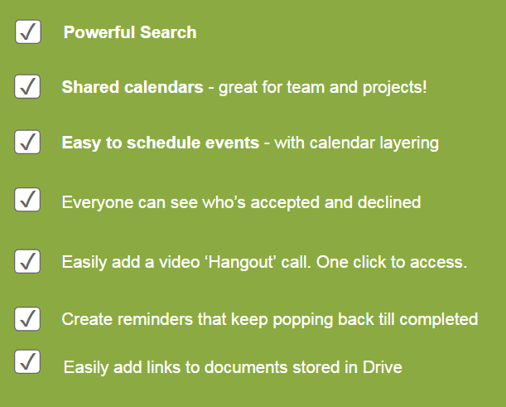

**Tab 1 text** **(50 words max):**

You can access your Google Calendar from your PwC-managed devices, helping you stay organised wherever you are. Google Calendar also allows you to manage your time with multiple integrated calendars, making it easier for you to stay connected with your colleagues across different projects or teams. It also has great search capabilities saving you more time, all of which combines to provide a significant improvement over Notes.

**Tab 2 image:**

A screen shot showing the Google Calendar log in.

**Tab 2 text** **(50 words max):**

Here's what else you can do.

* **Keep track of important events**, share your schedule and create multiple calendars.
* Spend **less time planning** and **more time doing** with shareable calendars that integrate seamlessly with [Gmail](https://apps.google.co.uk/intx/en_uk/products/gmail/), [Drive](https://apps.google.co.uk/intx/en_uk/products/drive/), Contacts and [Hangouts](https://apps.google.co.uk/intx/en_uk/products/hangouts/), so you always know what's next and have everything to hand.
* **Reminders and Tasks** help you to stay organised.
* **Join a Hangout** with one click straight from your calendar on your PwC laptop.
* Schedule events quickly by **checking availability** or **layering** multiple calendars in a single view.
* **Sync** with your PwC-managed mobile devices.
* Add and **customise calendars** to track team events or specific project deadlines.

**Tab 3 image:**

A screen shot of some Google Calendar appointments

**Tab 3 text** **(50 words max):**

Shortly after we make G Suite available, we'll migrate your calendar from Notes to Google, moving across a month of calendar entries in the past and all entries in the future.

It's important to spend some time after the calendar switchover setting up your preferences and taking action to make sure you don't miss any important meetings. Following migration, you'll need to adopt new calendar habits going forward. You can find out more on Spark.

We've got some more handy tips later on to help you get started, including links to where you can get additional support to help make the transition easier.

## SCREEN 02\_120

**DESKTOP SCREEN TYPE**: Graphic Reveal Text

**MOBILE SCREEN TYPE**: Photostory Topic title appears above all above first frame on mobile.

**DESCRIPTION**

Here we'll look at Google Mail.

**TITLE:**

**Gmail**

**PROMPT**

Select each icon to find out more.

**MOBILE PROMPT**

Scroll down to find out more.

**ICON GRAPHIC 1**

Gmail Icon

**DISPLAY GRAPHIC 1**

A screen grab of Gmail

**TEXT FOR GRAPHIC 1 (50 words max)**

With G Suite you'll receive a new email address which will be your primary email account (@pwc.com). Using it will allow you to maximise all the flexible benefits of Google you saw earlier with far more ease. You will retain your Notes account, allowing access to email and calendar entries received before the calendar switch and potentially, for exceptional situations, where it may be appropriate to continue to use Notes mail rather than Gmail.

We will cover more on managing engagements in the Google and Clients section.

**ICON GRAPHIC 2**

Warning triangle icon

**DISPLAY GRAPHIC 2**

An image of a business person looking at their iPhone.

**TEXT FOR GRAPHIC 2 (50 words max)**

In addition to Gmail, you'll continue to have your Notes email address and access to your archives. To minimise confusion caused by this, we will soon enable forwarding of email from Notes to Google.   
  
However, in accordance with the PwC Google business rules, Partners and staff who work with clients listed in the [Global Google Client Exception Registry](http://exceptionregistry/) must continue to use Notes to communicate. Check with your engagement team and the Registry to determine how to proceed.  
  
Please visit G Suite - Going Google: Middle East on Spark for additional guidance on the use of mail.

**ICON GRAPHIC 3**

Gmail open email icon

**DISPLAY GRAPHIC 3**

An image of Gmail as it appears on a mobile and on a laptop screen

**TEXT FOR GRAPHIC 3 (50 words max)**

Here are seven great features of Gmail:

1. Gmail messages are **grouped** into single thread conversations making it easier to stay organised.
2. **Labels** are folders with a twist. You can apply multiple labels, making it easier to find messages and stay organised.
3. Mark important emails with **Stars and Importance Markers**, helping you keep track and prioritise. The more you use it, the quicker it will train your Gmail about what's important to you.
4. Create **to-do lists** to keep track of key activities, and add them to your emails and tasks, with dates synced up seamlessly with your Google Calendar.
5. **View attachments instantly** or save attachments directly to Drive, making it easier to find things quickly.
6. **Chat** with your colleagues or join a Hangout straight from your inbox.
7. Set up **pre-written templates** for quick, easy responses to save time.

## SCREEN 02\_130

**DESKTOP/MOBILE SCREEN TYPE**: Text and graphic

**DESCRIPTION**

Here we'll describe Google Apps

**GRAPHIC**

**TITLE:**

**Google Docs, Sheets and Slides**

**TEXT (50 words max)**

Google offers a suite of apps called Sheets, Docs and Slides which are the equivalent to the existing Microsoft Office suite of products: Excel, Word and PowerPoint. The functionality is slightly different though and further learning materials will be available to help you use each app better.

Here are the top six reasons to move over to Google Apps.

1. **Collaborate** with your team, work on the same file, at the same time and see everyone's edits live.
2. **Control** who can access a document and what type of contribution they can make by asking them to comment, edit or simply view. This enables you to prevent further changes to final documents.
3. **Version control is easier** – the latest edits will be saved instantly as the current document. Don't worry, you can still return to any earlier version whenever you like!
4. No more forgetting to hit save with the **auto save** function online.
5. **Access** any files shared on Google Drive anywhere, anytime from your PwC-managed mobile devices.
6. **Share** links to documents online through Google Drive.

## SCREEN 02\_140

**DESKTOP/MOBILE SCREEN TYPE**: Photostory

**DESCRIPTION**

Here we'll take a look at Google Hangouts. Topic title appears above all frames on desktop and above first frame on mobile.

**TITLE:**

**Google Hangouts**

|  |  |  |  |
| --- | --- | --- | --- |
| **Frame** | **Picture** | **Text** | **Suggested image** |
| **1** | Shot from a Google Hangout | **Caption:** Google Hangouts is an easy and useful way to connect with colleagues and clients (video only). It's an instant messaging and video chat platform.  It comes jam-packed with lots of easy-to-use features.  **Prompt:**  Select the numbered buttons below to find out more.  **MOBILE PROMPT**  Scroll down to find out more. |  |
| **2** | A Google Hangout with lots of people. | **Caption:** Hangouts allows you to start a video call from Gmail, Calendar, the Hangouts app within Chrome, your desktop and your PwC-managed mobile devices.  It allows you to connect with up to 25 people at a time using HD video, screen share and Hangout text chat internally with up to 150 people. |  |
| **3** | Someone on a Google Hangout. | **Caption:** Video Hangouts can be used internally or with clients, letting you put a face to the name and have better virtual meetings.  You can instantly collaborate by sharing your screen and letting other people see what you're working on, allowing faster, easier collaboration. |  |
| **4** | Someone using a Smartphone, they should be talking into it while looking at the screen | **Caption:** You can set up a custom Hangout link for your meetings. It's just like the 'Meet Now' feature in WebEx – it's an 'always on' Hangouts link that you can send to someone to have them join you. No more wasting time setting up and renewing meeting links. |  |
| **5** | Someone using an iPad, they should be talking into it while looking at the screen. | **Caption:** Why not set up some future meetings through Google Hangouts? When creating an event in Google Calendar, select 'video call' to add a Hangout. You can use your PwC-managed devices (download Hangouts from Apps@Work) so no matter where you are, as long as you can get online, you can get connected. |  |

**FINAL PROMPT**

You've completed this topic. Select Home and choose the next topic.

**FINAL MOBILE PROMPT**

You've completed this topic. Select Main Menu from the dropdown and choose the next topic.

# Topic 3: Google and Clients

## SCREEN 03\_100

**DESKTOP/MOBILE SCREEN TYPE**: Tabs

**DESCRIPTION**

* TAB 1 TITLE: Client work
* TAB 2 TITLE: Global Google Exception Client Registry
* TAB 3 TITLE: Sharing content

**PROMPT**

Select each tab to find out more.

**MOBILE PROMPT**

Select the text headings to find out more.

**TABS**

**Tab 1 image:**

A business meeting taking place in a meeting room

**Tab 1 text** **(50 words max):**

**Before using Google for client work, read this.**  
  
In most cases, you can use G Suite on client engagements. As mentioned earlier, if a client is listed on the Registry, you'll need to continue to use Notes for email, and not use Drive (and associated apps) for client-confidential work.   
  
Please visit on Spark for specific guidance on the Google [business rules](https://pwc-spark.com/groups/going-google-middle-east/pages/business-rules) and how they apply.

**Tab 2 image:**

[An image of a world map](http://www.shutterstock.com/pic-194744945/stock-vector-blue-world-map-vector.html?src=G9aE-hAWU4D10f9AU5CPVQ-1-1)

**Tab 2 text** **(50 words max):**

Generally, we may use Google for all internal and external communications.   
  
There are some exceptions to this. The Global Google Exception Client Registry is a list of clients that, for a variety of reasons, cannot use cloud services. Clients are listed on the Registry by ultimate holding company.  
  
When working with clients on the Registry, we must use Notes email and not use Drive (and associated apps) for client-confidential work. Note that using Google Calendar is permissible for all clients. Check with your engagement team to determine current protocols.   
  
You can view the Global Google Exception Client Registry at <http://exceptionregistry>.

''

**Tab 3 image:**

The Google Drive icon

**Tab 3 text** **(50 words max):**

For now, we won't be able to share and collaborate with others outside the PwC network (e.g. clients and vendors) through Google Drive, even if they use Google. We will continue to evaluate this and provide further information in the future.   
  
To share Google files, you can export to popular file formats like Microsoft Office or PDF. You should check these exports carefully to make sure that all the content is in place and formatted accurately.   
  
Before using Google with clients, please refer to the **latest guidance on Spark:** **https://pwc-spark.com/groups/going-google-middle-east**

**FINAL PROMPT**

You've completed this topic. Select Home and choose the next topic.

**FINAL MOBILE PROMPT**

You've completed this topic. Select Main Menu from the dropdown and choose the next topic.

# Topic 4: What can you expect?

## SCREEN 04\_100

**DESKTOP/MOBILE SCREEN TYPE**: Text and graphic

**DESCRIPTION**

Screen explaining what happens when the switch is made

**GRAPHIC**

Close up image of hands typing on a computer keyboard

**TITLE:**

**What can you expect?**

**TEXT (50 words max)**

Before your Google account is activated, you will have everything you need to know to make the transition as smooth as possible.

We'll be making the changes necessary for you to start making the most of Google straight away, but there are a few things we need you to do.

You will be emailed a checklist for the actions you need to take in the coming days. Before then, let's look at some things you will need to do.

## SCREEN 04\_110

**DESKTOP/MOBILE SCREEN TYPE**: Photostory

**DESCRIPTION**

Here we'll take a look at the first steps that users should take when first making the move to Google.

**TITLE:**

**How can you be ready?**

|  |  |  |  |
| --- | --- | --- | --- |
| **Frame** | **Picture** | **Text** | **Suggested image** |
| **1** | Someone working at their laptop computer in an office. | **Caption:** Ideally, give yourself some time when G Suite launches to set up your tools.  To get started on your Google journey you must first log in to the Chrome browser, which is already installed on your PC. Your new email address will be communicated to you over the next few days – that's all you need to log in.  You will be able to use G Suite on the move. Just download the apps to your PwC-managed mobile device from the Apps@Work app.  **Prompt:**  Select the numbered buttons below to find out more.  **MOBILE PROMPT**  Scroll down to find out more. |  |
| **2** | The Google Calendar icon | **Caption:** Once your calendar has switched, you must review it at your earliest opportunity, as all calendars will now be on Google only.  Here are the things you need to do to get your **Google Calendar** up and running:   1. Select the Google Calendar icon to open the Calendar. 2. Your meetings and appointments will have migrated over from Notes. You can compare what you have in your Google Calendar to your Notes calendar from your archive, however you will also get specific errors reports to review, so you will know exactly what might not have migrated. 3. Any new meetings will need to be booked through Google Calendar. 4. Your calendar will automatically sync to your PwC-managed mobile device. |  |
| **3** | Someone looking at their mobile handset as if they were reading emails. | **Caption:** Gmail will be your primary email account and using it will allow you to maximise all the flexible benefits of Google. |  |
| **4** | The Gmail icon | **Caption:** When you switch to Gmail:  1. You will keep your Notes email and archives.  2. We will soon enable forwarding of email from Notes to Google.  3. Using the Registry, your engagement team may determine that client-related email must remain in Notes. If that is the case, email related to clients on the Registry will remain in Notes.  4. On PwC-managed mobile devices, email from both accounts will be shown in the "All Inboxes" view of Mail.  You will receive further guidance on what you need to complete before your Google account is activated. Make sure you work through all of the required actions to ensure a smooth transition. |  |

**FINAL PROMPT**

You've completed this topic. Select Home and choose the next topic.

**FINAL MOBILE PROMPT**

You've completed this topic. Select Main Menu from the dropdown and choose the next topic.

# Topic 5: How do I get help?

## SCREEN 05\_100

**DESKTOP/MOBILE SCREEN TYPE**: Tabs

**DESCRIPTION**

* TAB 1 TITLE: Google it
* TAB 2 TITLE: My Development
* TAB 3 TITLE: Spark
* TAB 4 TITLE: Google Guides

**PROMPT**

Select each tab to find out more.

**MOBILE PROMPT**

Select the text headings to find out more.

**TABS**

**Tab 1 image:**

Google Home screen with search bar

**Tab 1 text** **(50 words max):**

The great thing about the G Suite is that if you get stuck, a simple Google search will normally find the answer for you. There is also a built-in help tool for step-by-step guidance, or you can find help on the Google Apps Learning Centre.

ME IT are also available to help by using one of the methods below.  
  
**Chat** by clicking on ME IT Service Desk Chat  
**Phone** speed dial #4357  
**Online** via the ME IT Service Desk - Self Service  
**Mobile** via the IT Support App available from Apps@Work

**Tab 2 image:**

Screen shot of the MyDevelopment page

**Tab 2 text** **(50 words max):**

On Cornerstone you will find access to various learning materials and resources providing more detailed assistance on specific apps.

**Tab 3 image:**

Screenshot of Spark Page

**Tab 3 text** **(50 words max):**

You can also find FAQs and guidance with tips and answers to common problems on the '**G Suite - Going Google: Middle East’'** Spark group. If you can't find your answer, we recommend you post it as a question.

**Tab 4 image**:

Image of two people working together

**Tab 4 text** (50 words max):

We have Google Guides across the business and they will be around to help you where they can.

A list of Google Guides will be available on Spark, listing Guides by LoS, Business Unit and location.

**PROMPT**

You've completed this online learning. You may now close the learning or select Home to return to the menu.

## SCREEN 05\_110

**DESKTOP/MOBILE SCREEN TYPE**: Video

**VIDEO FILE:** pwc847\_05\_110.mp4

**DESCRIPTION**

Here we'll have the final attention grabbing video.

**TITLE:**

**Where next?**

**TEXT (50 words max)**

This is just the beginning… think ahead, think differently, think together.

**PROMPT**

Select Play to watch the video.

**FINAL PROMPT**

You've completed this online learning. You may now close the learning or select Home to return to the menu.

**TRANSCRIPT**

PwC is rethinking how we work. Here are just a few examples of how Google can transform and improve the way we connect, collaborate and share. Google offers us the opportunity to work together in new, more efficient and more meaningful ways.

Using Google Hangouts connecting with PwC people or clients can be face-to-face, anywhere, anytime and from any device resulting in quicker, more efficient meetings. Hangouts increase the quality of our connections, and can reduce travel and meeting times.

With Google you can create content more quickly with the quality that comes through effortless collaboration with team members and experts from across the firm. When you combine the native shared workspace functionality within the Google Apps suite, and the simple communication channels Hangouts provides, you have the recipe for simple and effective collaboration.

Struggling to get access to the right information for a client? Simply share a document with your team and crowdsource ideas inside some data for rich, meaningful content. Google empowers you to share in new, more efficient ways giving you access to the insights and knowledge you need. Sharing in Google is seamlessly integrated from any device, anywhere, anytime.

Google provides a powerful search engine, so you can find content easily and be confident that you always have access to the latest version of the document. Gain access to the organisation's knowledge to build quality content quickly. Reduce time tracking documents down on colleague's hard drives, minimising time recreating content that's already available.

PwC is rethinking how it can connect, collaborate and share using Google. What would you do differently?