## SCREEN 01_110

**SCREEN TYPE**: Text and graphic

DESCRIPTION

Text and graphic screen

IMAGE

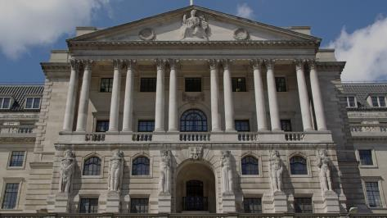

L:\Projects\BOE858_Data_Protection\development\visuals\originals\Bank_front.jpg

BODY TEXT

[This is a link](http://www.google.com)

This is replacement text. Whether it relates to staff you manage, business contacts, members of the public or customers and employees of firms we regulate, it's all personal data and we handle it every day.

We rely on you to take care of this data appropriately and keep us out of the headlines. Personal data appears in all parts of the Bank, so everyone needs to understand what their responsibilities are.

* This
* Is an unordered
* List

**This is bold text**

*This is emphasised text*

1. Numbered lists
2. Number 2