## SCREEN 03_130

SCREEN TYPE: Text reveal

DESCRIPTION

Photos, illustrations or diagrams can be selected to reveal further information, usually in text form.

Example mock-up

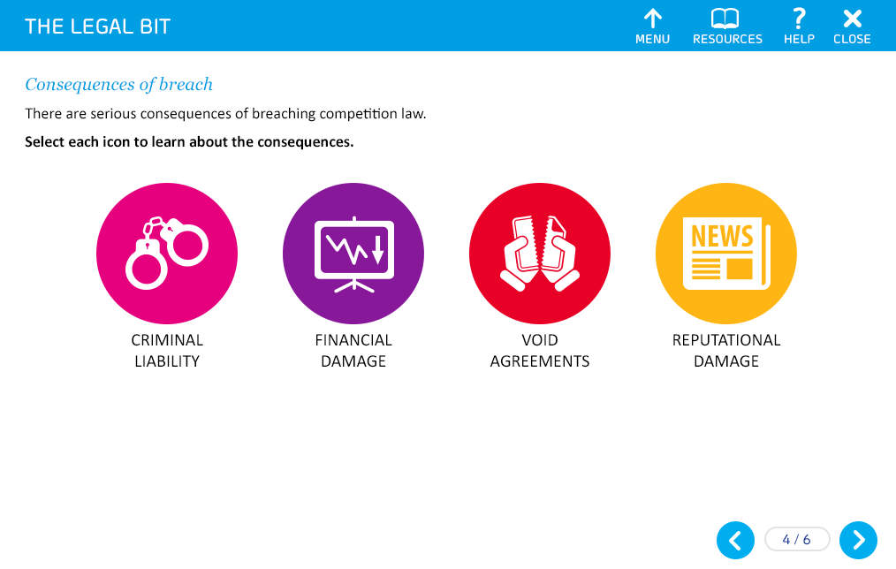

Use text labels instead of icons. Present the labels in a stylised manner to be consistent with the current STW courses.

SCREEN TITLE

Abuse of dominance – pricing

REVEAL BUTTON 1

Excessive pricing

REVEAL BUTTON 2

Predatory pricing

REVEAL BUTTON 3

Discriminatory pricing

REVEAL BUTTON 4

Margin squeeze

REVEAL BUTTON 5

Margin squeeze

OPENING TEXT (30 words max)

There are several ways a company may use pricing to abuse its dominant position.

PROMPT

Select each heading to find out more.

TEXT FOR REVEAL 1 (50 words max)

Excessive pricing can occur when a dominant company abuses its position by charging unfairly high prices for its products and services.

TEXT FOR REVEAL 2 (50 words max)

Predatory pricing is when a dominant company is prepared to suffer losses by charging very low prices in order to eliminate or substantially weaken a competitor's market position.

TEXT FOR REVEAL 3 (50 words max)

Discriminatory pricing occurs when a dominant company charges different customers or different classes of customer different prices for goods or services which cost the same – without any valid justification for doing so.

TEXT FOR REVEAL 4 (50 words max)

A margin squeeze happens when a dominant company for a particular product or service at a wholesale level of the supply chain (i.e. the upstream market) also trades at the retail level of the supply chain (i.e. the downstream market), but charges higher prices to third-party retailers than it does to its own integrated or associated retailer.

These higher costs create a reduction or 'squeeze' on the margin of the third-party retailer – even though they may be just as efficient in the downstream market as the wholesale supplier's integrated or associate retailer.

TEXT FOR REVEAL 5 (50 words max)

This is reveal 5!