## SCREEN 01_110

**SCREEN TYPE**: Text and graphic

DESCRIPTION

Text and graphic screen

IMAGE

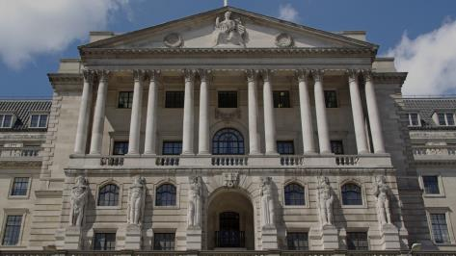

L:\Projects\BOE858_Data_Protection\development\visuals\originals\Bank_front.jpg

TITLE

Title Text

TEXT

This is replacement text. Whether it relates to staff you manage, business contacts, members of the public or customers and employees of firms we regulate, it's all personal data and we handle it every day.

* This
* Is an unordered
* List

**This is bold text**

*This is emphasised text*

1. Numbered lists
2. Number 2!

PROMPT

Select the next arrow to continue.

## SCREEN 01_120

**SCREEN TYPE**: Multiple choice question

DESCRIPTION

The learner answers the question by choosing options from the list and receives different feedback for correct, incorrect and partially correct answers.

**IMAGE**

L:\Projects\BOE858_Data_Protection\development\visuals\originals\Bank_inside.jpg

**TEXT**

Which of the following does the DPA apply to?

**PROMPT**

Select your answers, then Confirm.

**OPTIONS**

|  |  |  |
| --- | --- | --- |
| **1** | The name of an employee of a firm regulated by the Bank | **Correct** |
| **2** | A business contact’s email address | **Correct** |
| **3** | A recorded phone call with a member of the public | **Incorrect** |
| **4** | A colleague's mobile number on a call cascade list | **Correct** |
| **5** | A manager's handwritten note from an interview | **Incorrect** |

**CORRECT FEEDBACK**

That’s right. These are all examples of personal data. The DPA regulates how organisations handle information related to individuals, no matter how it is presented. This information does not have to include a name or be particularly sensitive to be covered by the Act. You should always bear in mind that mishandling such data could have serious consequences for you, the person whose data it is, and the Bank.

Successfully completing this course will help you to handle personal information appropriately and confidently.

**PARTIALLY CORRECT FEEDBACK**

That’s not quite right. In fact, these are all examples of personal data. The DPA regulates how organisations handle information related to individuals, no matter how it is presented. This information does not have to include a name or be particularly sensitive to be covered by the Act. and you should always bear in mind that mishandling such data could have serious consequences for you, the person whose data it is, and the Bank.

But don't worry, successfully completing this course will help you to handle personal information appropriately and confidently.

## SCREEN 01_125

**SCREEN TYPE**: Text reveal

DESCRIPTION

A large background graphic with intro text and text items in boxes. Learner selects text items to reveal more information.

IMAGE



L:\Projects\BOE858_Data_Protection\development\visuals\originals\Bank_inside.jpg

TEXT

And let's have a quick look at who is responsible for what at the Bank in terms of data protection.

**PROMPT**

Select each group for more.

**TEXT ITEMS**

1. Everyone at the Bank
2. Data Protection Liaison Representative (DPLR)
3. Information Access Team (IAT)
4. Data Protection Officer (DPO)

**TEXT REVEAL 1**

We all have a personal responsibility to make sure we don't breach any of the data protection principles. This means successfully completing your data protection training, being familiar with the data protection intranet pages and getting in touch with your business area’s DPLR or the Data Protection Team (DPT) if you have questions about personal data.

**TEXT REVEAL 2**

The DPLR is your business area’s data protection expert and is also responsible for coordinating SARs at the business area level.

**TEXT REVEAL 3**

The IAT are responsible for co-ordinating the Bankwide search for the personal information asked for in a SAR and providing a response.

**TEXT REVEAL 4**

The DPO, who is supported by the Data Protection Team, is responsible for the co-ordination of all data protection matters in the Bank which includes formulating Bank policy on data protection, providing advice and submitting the Bank’s notification to the Information Commissioner.

## SCREEN 02_140

**SCREEN TYPE**: Multiple choice question

DESCRIPTION

The learner answers the question by choosing options from the list and receives different feedback for correct, incorrect and partially correct answers.

Style:

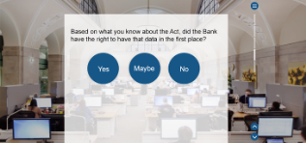

**IMAGE**

Screenshot of the **ico.** website on a computer.

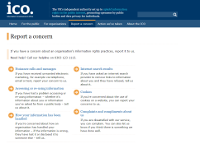

<https://ico.org.uk/concerns/>



Shutterstock Image ID: 139876522

**TEXT**

Do you think Martha has grounds to report her case to the Information Commissioner?

**OPTIONS**

|  |  |  |
| --- | --- | --- |
| **1** | Yes | **Correct** |
| **2** | No | **Incorrect** |

**CORRECT FEEDBACK**

That's right, it looks like Martha does have grounds for complaint. Organisations are required to handle information relating to individuals in a way outlined by the DPA. Consequences for non-compliance could result in a fine of up to £500,000.

In addition, there are certain situations where a breach of the DPA is a criminal offence and for which the Information Commissioner can investigate and prosecute offenders. They include:

* Failure to notify the Commissioner of changes to the notification register entry
* Failure to comply with an enforcement or similar notice
* Knowingly or recklessly obtaining or disclosing personal information without the consent of the data controller (unless an exemption applies)
* Selling or offering to sell personal information (unless the data subject has consented and a privacy notice has clearly described this as a possibility)

Martha's case clearly concerns the third point and she is right to report it. After looking at the evidence, the Information Commissioner decides to investigate.

**INCORRECT FEEDBACK**

Actually, it looks like Martha does have grounds for complaint. Organisations are required to handle information relating to individuals in a way outlined by the DPA. Consequences for non-compliance could result in a fine of up to £500,000.

In addition, there are certain situations where a breach of the DPA is a criminal offence and for which the Information Commissioner can investigate and prosecute offenders. They include:

* Failure to notify the Commissioner of changes to the notification register entry
* Failure to comply with an enforcement or similar notice
* Knowingly or recklessly obtaining or disclosing personal information without the consent of the data controller (unless an exemption applies)
* Selling or offering to sell personal information (unless the data subject has consented and a privacy notice has clearly described this as a possibility)

Martha's case clearly concerns the third point and she is right to report it. After looking at the evidence, the Information Commissioner decides to investigate.

## SCREEN 02_190

**SCREEN TYPE**: Photostory

DESCRIPTION

This screen consists of several frames, controlled by the learner, which summarise the scenario and relate it back to the learning objectives.

Visual style:

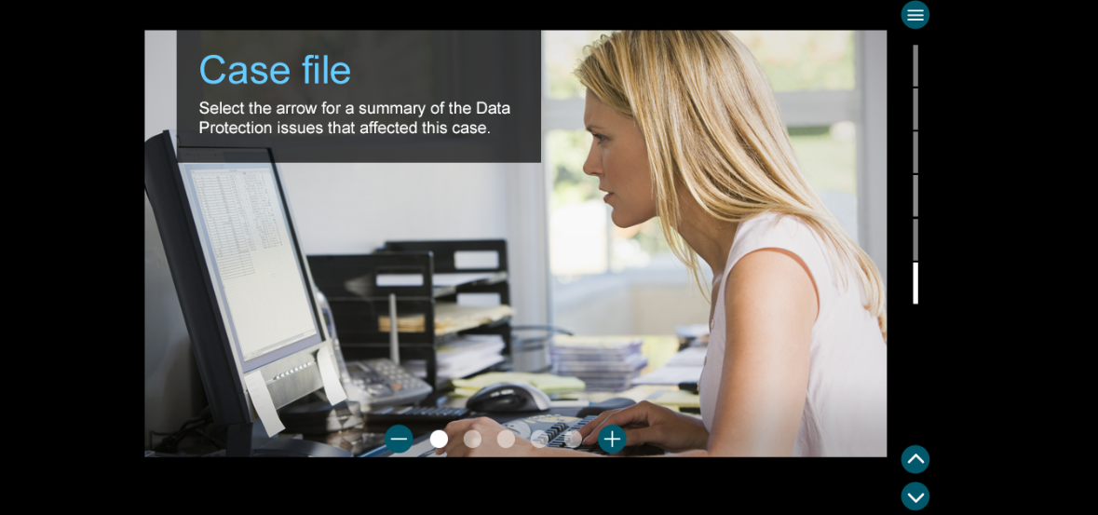

.

|  |  |  |
| --- | --- | --- |
| **Frame** | **Picture** | **Text** |
| **1** | Image of newspaper report:  Tibor or not Tibor?  Local tax advisers Tibor Associates were today fined £40,000 by the ICO for misusing personal data. Furthermore, Stan Maloney, CEO of Tibor Associates, has been found guilty of unlawfully obtaining personal data. Mr Maloney has stated that this could bankrupt his firm.  Last year Mr Maloney obtained data from a file he had chanced upon while working at the Bank of England. This data was…  (cut off) | **TITLE**  Case file  **TEXT**  Stan's improper and illegal handling of personal data has cost him his business and probably much more.  **PROMPT**  Select the **+** for a summary of the data protection issues that affected his case. |
| **2** | files on the desk. | **TITLE**  Personal information  **TEXT**  The DPA defines personal data as data which relates to a living individual who can be identified:   1. from that alone   or   1. from the data along with other information which is in the possession of, or is likely to come into the possession of, the data controller. |
| **3** | From website | **TITLE**  The Information Commissioner  **TEXT**  The Information Commissioner upholds information rights in the public interest. This includes making sure organisations meet the requirements of the Data Protection Act 1998 when handling personal information.  The ICO has a duty to investigate and even prosecute people and businesses who misuse personal data.  Actions they can take:  Criminal prosecution  Non-criminal enforcement  Audit  Serving monetary policy notices (fines) |
| **4** | From website | **TITLE**  The aims  **TEXT**  The Act has been put in place to protect the privacy rights of individuals and prevent the misuse of personal information. It creates a framework of rights and duties and prescribes the consequences of not doing that.  It defines the rights, duties and consequences of handling personal data. |
| **5** |  | **TITLE**  Remember:    **TEXT**   * Incorrectly handling personal data can have far-reaching consequences. You need to make sure you're handling data correctly to protect yourself and protect the Bank against reputational damage and fines. Just because a document has been misclassified, does not release you from your responsibilities. * By attesting to Our Code, you are saying that you understand the importance of handling personal data appropriately and, more broadly, are acknowledging what is expected of you as a Bank employee.   **PROMPT**  Select the Menu button to choose another topic. |