## SCREEN 01_110

**SCREEN TYPE**: Text and graphic

DESCRIPTION

A large background graphic of the Bank of England transitions onto the screen.

IMAGE

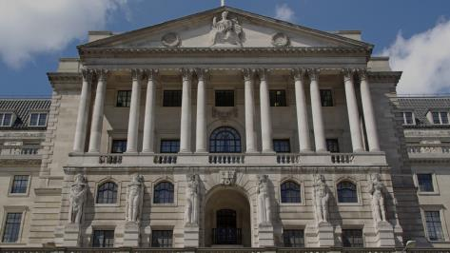

L:\Projects\BOE858_Data_Protection\development\visuals\originals\Bank_front.jpg

TEXT

Think about all the different types of **personal data you handle**. Whether it relates to staff you manage, business contacts, members of the public or customers and employees of firms we regulate, it's all personal data and we handle it every day.

We rely on you to take care of this data appropriately and keep us out of the headlines. Personal data appears in all parts of the Bank, so everyone needs to understand what their responsibilities are.

* This
* Is an unordered
* List

**This is bold text**

*This is emphasised text*

1. Numbered lists
2. Number 2!

## SCREEN 01_120

**SCREEN TYPE**: Multiple choice question

DESCRIPTION

The learner answers the question by choosing options from the list and receives different feedback for correct, incorrect and partially correct answers.

**IMAGE**

L:\Projects\BOE858_Data_Protection\development\visuals\originals\Bank_inside.jpg

**QUESTION TEXT (30 words max)**

Which of the following does the DPA apply to?

**PROMPT**

Select your answers, then Confirm.

**OPTIONS (15 words max. per option)**

|  |  |  |
| --- | --- | --- |
| **1** | The name of an employee of a firm regulated by the Bank | **Correct** |
| **2** | A business contact’s email address | **Correct** |
| **3** | A recorded phone call with a member of the public | **Correct** |
| **4** | A colleague's mobile number on a call cascade list | **Correct** |
| **5** | A manager’s handwritten note from an interview | **Correct** |

**CORRECT TEXT FEEDBACK (50 words max)**

That’s right. These are all examples of personal data. The DPA regulates how organisations handle information related to individuals, no matter how it is presented. This information does not have to include a name or be particularly sensitive to be covered by the Act. You should always bear in mind that mishandling such data could have serious consequences for you, the person whose data it is, and the Bank.

Successfully completing this course will help you to handle personal information appropriately and confidently.

**PARTIALLY CORRECT TEXT FEEDBACK (50 words max)**

That’s not quite right. In fact, these are all examples of personal data. The DPA regulates how organisations handle information related to individuals, no matter how it is presented. This information does not have to include a name or be particularly sensitive to be covered by the Act. and you should always bear in mind that mishandling such data could have serious consequences for you, the person whose data it is, and the Bank.

But don't worry, successfully completing this course will help you to handle personal information appropriately and confidently.