**EU SUPPORT FOR PRIVATE SECTOR IN RWANDA**

1. **EU projects**

**Area No 1**: *Support to Private Sector Development and Job creation in Rwanda*

This support is expected to harness the growth and decent job creation potential of the sustainable Tourism and Digital Economy, as well as ensure equal access to opportunities in these sectors for all. The programme will make a meaningful contribution to the Government's objective to create 214,000 new jobs per year up to 2024, whilst also being a first effort by the EU in terms of supporting private sector development as a crucial driver of economic development in Rwanda.

The programme focuses on two projects:

1. *Deployment of innovation hubs and start-up incubators in 4 secondary cities (Rubavu, Rusizi, Nyagatare and Ruhanga)*

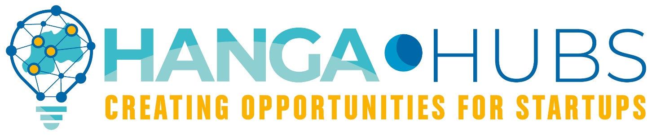

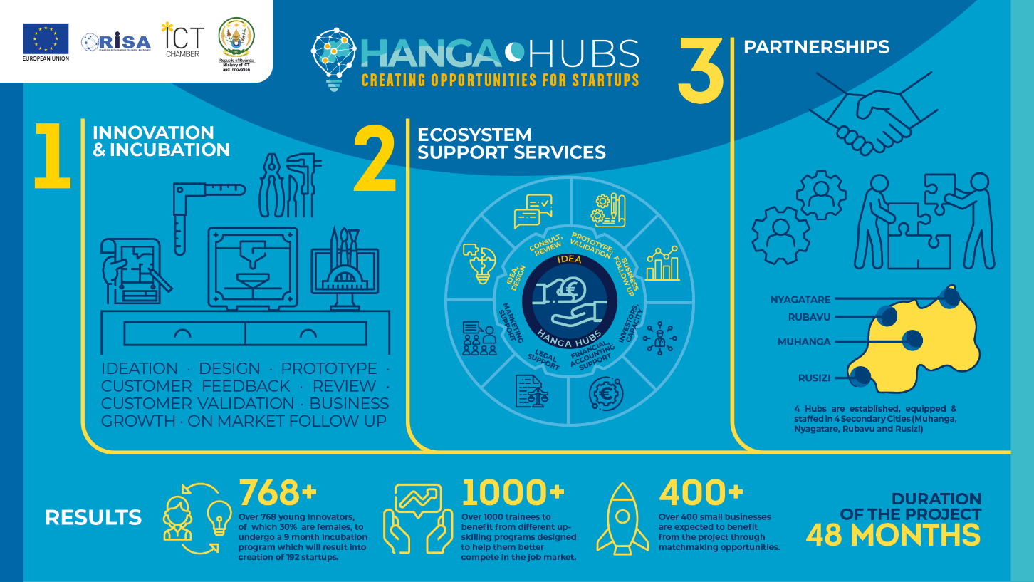

The project has been launched on 2nd March 2021.

1. *Job creation in the tourism sector via improvement of TVET*

The project to be launched in spring/summer 2021.

----

**Area No 2**: *Support to the production of reliable and policy oriented statistics and investment promotion in Rwanda*

The overall objective is to improve the availability, accessibility and integration of reliable statistics and business-oriented data into policies promoting investment and trade across potential economic sectors. Activities will focus on supporting the implementation of two projects supporting the Rwanda Development Board and the National Institute of Statistics of Rwanda.

**The first objective of the Action** is to enhance the production of reliable policy-oriented statistics. The production of national statistics in Rwanda has been supported by the European Union since 2007, through capacity building as well as funding surveys produced by the National Institute for Statistics of Rwanda, which has gradually developed into a well-established national institute that produces a broad range of reliable statistics. But a lot still remains to be done to enhance the capacity of the institute and make it a self-sustaining institution. There is also increasing demand for variety of data to track Sustainable Development Goals (SDGs), hence the production and dissemination of surveys in specific sectors such as health, agriculture and living conditions needs to be enhanced in order to support other sectoral development priorities and to ensure that the benefits of economic expansion are well spread around the country. The programme will also support the preparation of the 2022 census as the population is changing rapidly.

**The second objective of the Action** is to promote trade and investment across sectors, which would provide support to households and boost employment and growth towards recovery of COVID-19 impact to Rwanda. This action will further crowd in private investment in key economic sectors such services, infrastructure, agriculture, energy, information and communication technologies.

Projects will be launched in spring/summer 2021.

1. **Rwanda MIP 2021-2027**

The 2021-27 Multiannual indicative programme (MIP) for Rwanda aims to stimulate pro-poor, sustainable and inclusive growth. Progress in the proposed sectors will reduce poverty and unlock critical bottlenecks in Rwanda’s ambitious objective of reaching upper-middle income status by 2035 and high-income status by 2050. The MIP is in line with the Government’s Vision 2050 and the National Strategy for Transformation (NST1), whilst also contributing to progress toward the Sustainable Development Goals. In the field of private sector, the EU will engage in the following activities:

In terms of **economic governance**, the EU supports Rwanda’s NST1 commitment of developing the private sector as the main engine of economic growth. As Rwanda’s economy matures, and given the debt increase triggered by the COVID crisis, the country needs to accelerate the shift from the current public investment-led growth model to a stronger role for private sector as the main driver of investment and employment creation.

The EU will support transforming **agriculture** from a public sector-led growth model into a more private and market-driven sector, with better linkages to urban market areas.

With regard to **TVET sector**, the EU will support the improvement of the quality of learning outcomes and their alignment with the needs of private sector. The creation of more effective linkages with private sector will increase the involvement of private sector in both policy-making and actual training, including through workplace learning schemes, within public or private sector, (see also specific objective on *Inclusive* *entrepreneurship*).

Concerning **access to finance**, the EU will support investments in climate-resilient municipal infrastructure and green financial instruments for private sector investments. The focus will mainly be on secondary and satellite cities, to foster a more balanced system of cities within the country.

1. **The private sector development and youth employment sector-working group**

Since 2020, the EU acts as co-chair of the Private Sector Development and Youth Employment (PSDYE) Sector Working Group, creating an opportunity to instil a new dynamic in public-private dialogue. The creation of the EBCR in 2020 has already opened avenues for further engagement between Government and the European private sector.



1. **European Investment Bank in Rwanda**

The European Investment Bank (EIB) has been providing around RWF 80 billion to the local banking sector in the form of credit lines to boost credit to the private sector.

The EIB has also been providing direct credit and funding to the private sector for the last years, notably a EUR 9 million loan to Skoll Breweries to support a new packaging line and a EUR 15 million loan to Master Steel to increase the production of quality bars for infrastructure.

The EIB also provided a EUR 45 million sovereign loan to finance the Kigali Central Sewerage project (total cost EUR 96 million, co-funded by African Development Bank), a public sector project undertaken by the Government of Rwanda and the Water and Sanitation Corporation of Rwanda (WASAC).

|  |  |  |
| --- | --- | --- |
| **Year** | **Amount** | **Support type** |
| **2019** | RWF 30 billion | The EIB and Bank of Kigali announced a joint RWF 60 billion for the Rwandan private sector. EIB provided 30M euros credit line to Bank of Kigali, while the latter committed to add 30M euros from its own funds to increase this fund. In the framework of that cooperation, the two banks will co-fund agriculture, transport, education, health, manufacturing and tourism sectors. |
| **2018** | EUR 14 million | EIB provided a EUR 14 million credit line with the Development Bank of Rwanda and a USD 10 million lending programme managed locally by I&M Bank and accompanying technical assistance. |
| **2016** | EUR 28 million | EIB supported a new lending initiative by Bank of Kigali to back private sector investment across Rwanda. EIB provided EUR 28 million, alongside EUR 28 million being provided by Bank of Kigali. |