**SRS – Software Requirements Specification**

Authors – Adam Akhtar, Shabbir Ahmad and Haris Mahmood.

**1. Introduction**

**1.1 Project Overview**

The aim of the project is to create a job advertisement portal which is responsive, easy to use and accelerate the process of making and accelerating the process of creating work opportunities. The aim of the portal is to create a platform for verified customers top post and engage with job listings in a secure manner. Once an offer has been accepted, the employer and employee can participate in direct communication.

The portal will display the offers on the main page, with the option to filter the location. Data security and privacy is of uppermost importance, meaning there will be secure handling of user information and transaction details.

**1.2 Product Scope**

Through a variety of features, this portal is intended to assist both job seekers and job creators. Job creators can post listings of the jobs they need done and set a price for them and the job seekers will find it easy to browse the website, viewing all of the job postings and selecting the amount they wish to get paid.

A broader range of audiences will find this portal more accessible due to its straightforward and easy-to-use interface, which allows users to browse the website without any issues. In addition to being able to respond to any questions posed by users, the website administrator will have the authority to delete any job postings as they see fit, possibly because they contain offensive or dangerous material.

**2. Overall description**

**2.1 Product functions**

The major functions will include:

**1. Creation and application of jobs:**

* Users can create their own listings and view applicants.
* Users can apply and pay for the specified listing.

2. **Roles and permissions**

* User - can view, create, apply and pay for job listings.
* Admin – has access to the user and job listing database and has the ability to regulate to their own according.

**3. Security and authentication:**

* Internal login system with email and password.
* Email-based verification system.

**4. User updates**

* Users are in direct contact with potential clients over fees.

**2.2 Constraints**

Registered users can post whatever listings they would like to. Unsuitable listings will only be taken down after they have been posted. Also, there are no further security options such as multi-factor authentication.

**3. Functional requirements**

1. Admin can regulate the users by deleting disruptive users.

2. Admin can regulate job listings by removing unsuitable listings.

3. Admin can view complaints made by users.

4. User can apply for jobs, filtered by location.

5. Users can create job listings.

6. Users can view applicants and choose the most suitable applicant based on budget, location and rating.

7. Users can give a rating to their customer which will contribute to the average rating.

8. Users and admin can log in, log out and sign up, using an email and password as well as a verification code.

**4. Use-case diagram**

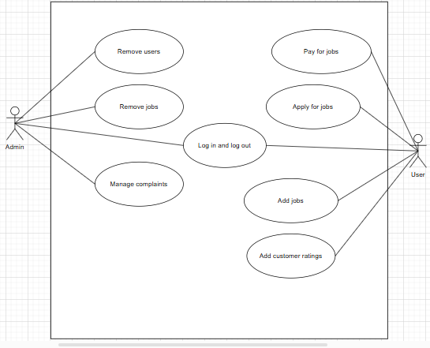

**5. Non-functional requirements**

* Available at all hours of the day including business hours.
* High performance: it should still function well by loading quickly while there is high traffic.
* Security: all the user's information is encrypted and secure.
* The portal must be compatible across a multiple of platforms including mobile phones, tablets, laptops, etc.
* Coding should be done in a way where it is easy to update and add improvements in the future.
* SEO Compliance: Meta tags, SEO-friendly URLs, sitemap generation.

**6. Risks, ethical and security considerations**

Ensuring that user data is securely maintained and shielded from data breaches is a critical function of the portal. Furthermore, it is important to carefully check the permissions that users with different roles, such as the admin and the job seeker, have been granted. This is because granting the admin permissions to a job seeker could pose an extreme risk

**7. Conclusion**

To conclude, the new and improved job management portal will provide a more efficient alternative to applying for jobs by creating a simple design which is easily accessible. The focus of the project is to make the system simpler rather than more advanced.

**8. Signatures**

|  |  |  |
| --- | --- | --- |
| **Name** | **Role** | **Signature** |
| Adam Akhtar | Team Leader | ____A A___ |
| Szymon Smolen | Client | __________ |