Adding a new attribute to your model in models.py:

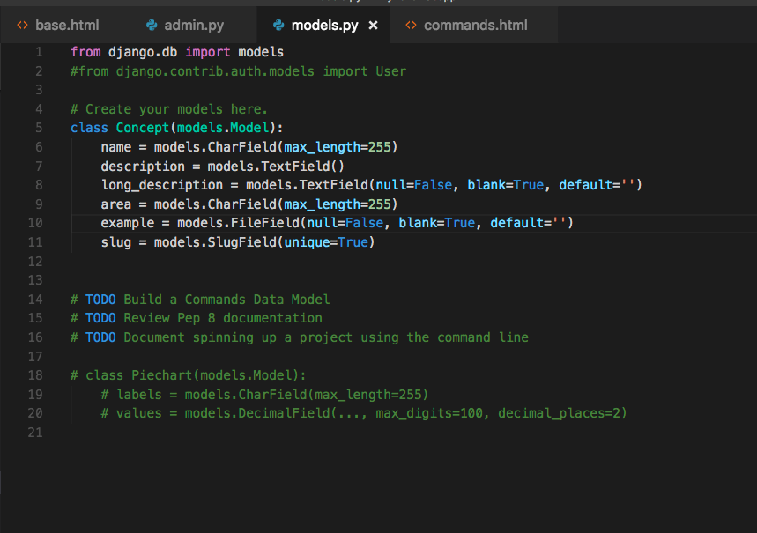

Add additional fields to the admin as desired in admin.py:

