FP.5
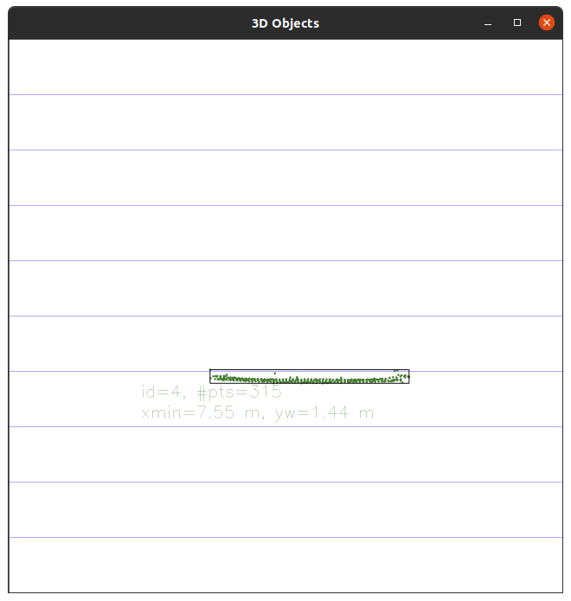
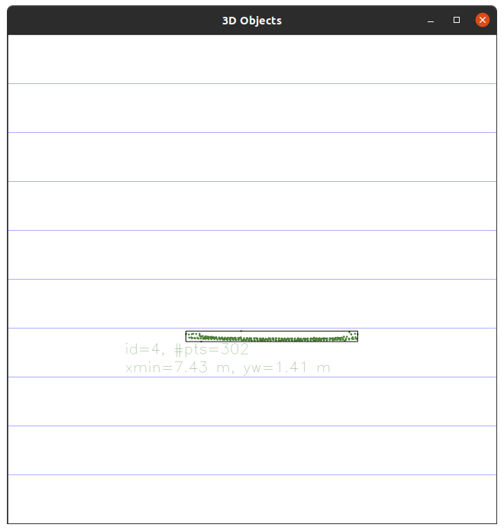
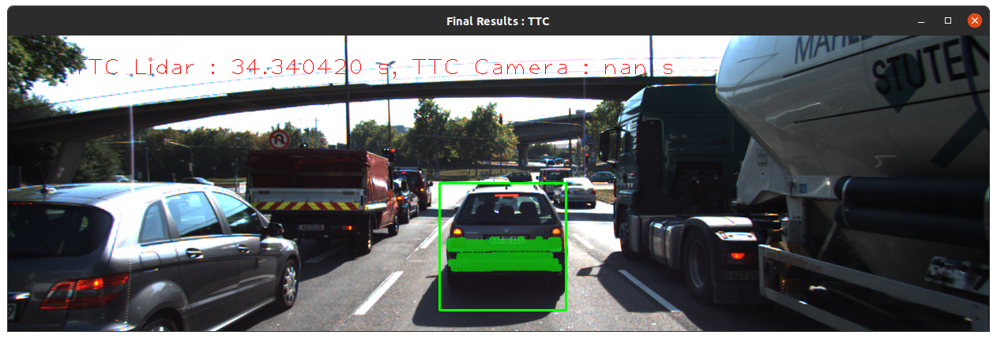
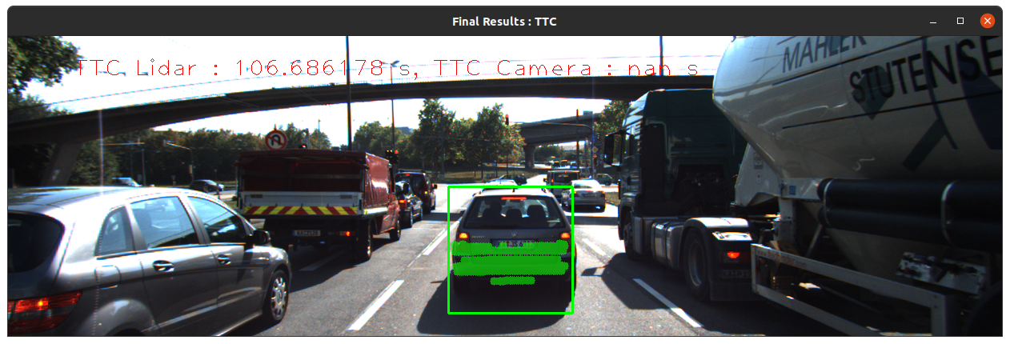
Usually TTC of Lidar is lies around 8-15 seconds in all images. However in below two image a computed TTC of Lidar measurement is way more higher (34.s and 106s ) then an average TTC on other image. I think that there might be some reflection of lidar point which could come from track or other object, and my implemented filter ( KD-Tree and Euclidean cluster based on distance threshold) could not detect them and could not remove. That why it occurred as error computation.

