Dear investors

**Performance**

The Fund was up 3.9% net of fees and costs for the month, ahead of both the S&P500 and ASX200.

|  |  |  |  |
| --- | --- | --- | --- |
|  | ASX 200 | S&P500 | Frazis Fund Net |
| 30-Jun-16 | -1.5% | 1.0% | -2.5% |
| 31-Jul-16 | 6.3% | 3.6% | 5.4% |
| 31-Aug-16 | -2.3% | -0.1% | 0.8% |
| 30-Sep-16 | 0.2% | -0.1% | 6.1% |
| 31-Oct-16 | -2.2% | -1.9% | -2.5% |
| 30-Nov-16 | 2.2% | 3.4% | 3.9% |
| **Total** | **2.4%** | **5.8%** | **11.4%** |



Major gross contributions to the portfolio were approximately:

|  |  |  |  |  |
| --- | --- | --- | --- | --- |
| Contributors |  |  | Detractors |  |
| Macro | 2.2% |  | Alkane Resources | -2.0% |
| Navios equity | 2.0% |  | Metals X | -1.5% |
| VIX trading | 1.5% |  | Tata Motors | -0.6% |
| Biotechnology ETF | 0.5% |  | Alibaba | -0.4% |
| Navios credit | 0.5% |  | Baidu | -0.3% |

**Exposure**

|  |  |
| --- | --- |
| **Country** | **%** |
| USA | 39% |
| Australia | 25% |
| UK | 13% |
| Europe | 10% |
| China | 8% |
| India | 4% |
| Asia | 2% |
| **Total** | **100%** |
|  |  |
| **Investment Theme** | **%** |
| Tech | 20% |
| Autos | 10% |
| Energy and Refining | 12% |
| Blue Chip Mining | 9% |
| Mining Development | 7% |
| Biotech and Pharmaceuticals | 10% |
| British Land Developers | 7% |
| Shipping | 3% |
| Financials | 13% |
| Other | 8% |
| **Total** | **100%** |
|  |  |
|  |  |
| **Hedge book** | **%** |
| S&P500 - covered with calls | -31% |
| Short equities | -5% |
| Short US Oil Fund | -2% |
| Net VIX | 2% |
| **Total ex VIX** | **-37%** |
| *Total including VIX at 4x beta* | *-29%* |

**Trump and Macro**

We said we were ready to be surprised in October, and surprised we were. I described Hilary as mid-term bad for markets, but did not seriously consider the corollary.

For once Australia was in a useful timezone. As the first results from Florida came through we hedged our entire book in the S&P500 futures market and closed these trades shortly after close to the lows. We are very quick to take profits in our hedge book, as we expect to make most of our money on the upside.

When the US market opened, we had two VIX trades open, one long and one short. We closed our long volatility position immediately while retaining our short position. The market promptly relaxed so we managed to make money on both sides. The reason we’re able to make these trades is due to our structural long position. We can be assured of multiple market scenarios in which we avoid losses and generate profits.

The Fund ended the month with a small net short VIX position, as we were comfortable our other volatility trade (long equity calls / short equity index) could handle a severe crash. As of writing this (mid December) we are running a solid net volatility long, as per usual.

I don’t like trading intraday and do it very rarely but sometimes it’s simply required, and both Brexit and Trump demanded this level of attention. The lesson from Brexit was learned. While I spent that day in June covering an over-extended position in GBP and UK stocks, I went into the US election more or less neutral in the macro hedge book, allowing considerably more flexibility and leading to a more enjoyable day, even though my election call and my expected market response were both wrong.

While I was hoping for the reverse result, the Trump shock was profitable for the Fund, and it’s incredible how fast the world has moved on.

**Core investment portfolio**

The mining stocks that provided such a tailwind in the first few months of the Fund’s operations were the major detractors in November. These stocks hold development assets and will continue to be volatile, but offer the prospect of serious returns if they can execute on their strategies.

Shipping was a big winner. We rotated most of our Navios equity position into Navios debt trading at 66c, on an IRR of 30% with a maturity of 2019. A lot can happen in a few years. These bonds would be comfortably repaid at par if rates stay where they are between now and then, and there is considerable value in the scrap value of Navios’s ships and liquid assets should a restructuring occur. The firm has incredibly operational leverage and is our favoured candidate should rates recover. Ofcourse this is still a risky position, as we have too little capital to influence the restructuring outcome.

However, the CEO Aggeliki Frangou appears honest and isn’t running any obvious scam, which is rare for the sector. On the macro level dry bulk shipping may finally be reaching the point of negative net fleet growth, after which it will only take a year or two of compounded growth in trade to return rates to historic norms. This scenario would put Navios bonds at par and lead to a >5x appreciation in the firm’s equity.

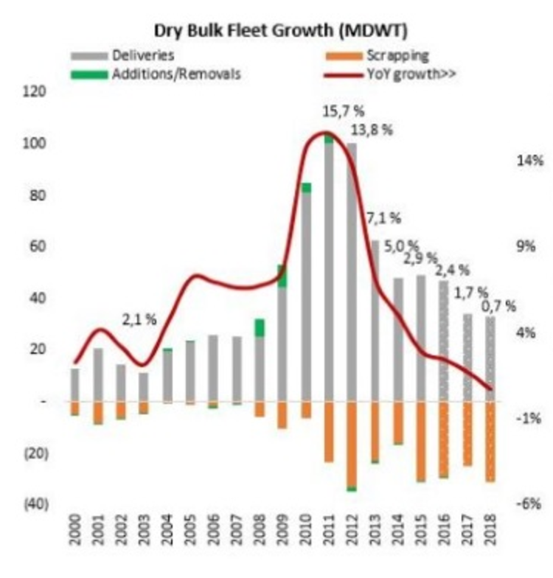

In other movements we exited Celgene at a modest profit to provide capital for higher return opportunities and cut our Glencore long by one third at substantial profits (not quite 100%, but close). I tried to avoid cutting our winners but we were beginning to be overexposed to the commodity complex, especially when including refiners.

New holdings were Match, a dating app holding company that owns Tinder and most of the common dating apps, and Smith and Wesson. We considered purchasing a prison company after Trump and while this would have been profitable, this was an ethical line we could not cross. It would be simply too bleak to cheer on management when they increase margins by pressing the boot on suffering American convicts.

I haven’t highlighted our take on ethics previously, but in general expect us to be comfortable with tobacco, liquor and cannabis stocks. We don’t have much of a taste for gambling - despite running a hedge fund. And clearly we are comfortable with oil and mining.

**Tactical short positions**

We are considering a short position in Australian retailers, as Amazon is about to hit our shores and will likely have the same devastating impact here as elsewhere, especially when combined with German discounters,. While this is well publicised companies, like Harvey Norman and perhaps even JB HiFi have barely traded down, and there is a strong case that Harvey Norman should write-off the support it has given its franchise stores which would lead to a 10% hit to its book value. Not quite enough to move the needle on the stock, but interesting.

We are short Deltic Timber, US Oil Fund, Santos as a hedge for Beach and Pandora Media. Pandora unfortunately surged due to takeover speculation, but as these things often fall through and we are appropriately and modestly sized, we will hold.

Deltic Timber has a new CEO and appreciated some 15% above our average purchase price. While this is a high conviction short, and we realised decent profits earlier in the year, we will manage ourselves out of the position if it rises much further.

We exited our short position in GoPro at a 16% profit. The 80% annualised borrow cost was too high to warrant a longer holding period, though the company is still in plenty of trouble. I now feel recompensed for a dodgy GoPro I bought once (though this is not why I put the position on!).

**Outlook and December positioning**

The Democrats wished war on some of the main industries of the US. Top Democrats seemed keen to regulate away the profits of the oil, gas and mining sectors, the financial sector, and the pharmaceutical sector. All these industries can now relax (somewhat). Trump has so far saved most of his attacks for technology companies, which is one of the few areas of commerce lionized by the Dems.

In one day Trump achieved what no economist or politician has managed since the crisis and moved the bond market. US long rates are now over 3%, which is not bad for an asset with no credit risk. This vastly affects the assessment of long term assets, and our best bet is that the move has only just begun.

Lest we be wrong however, we have invested ~4.5% of our excess cash in long term treasuries. This is a great situation for us as it is win/win: if rates increase further we will earn a higher return on our substantial cash balance – perhaps even 1% of the Fund per annum – and this will more than account for any mark-to-market Treasury losses. On the flipside, if this proves to be another misleading market turn and rates collapse again, the 4.5% position will benefit.

As is well noted, Trump’s infrastructure plans are inflationary. He has taken a conventional approach to political HR and stacked his team with ex Goldman personnel.

It sometimes takes a left wing politician to implement good right wing policies, and vice versa. Trump is far more likely to implement infrastructure spending than his predecessor, as the Republicans will support it and the Democrats will struggle to fight the policies they have been arguing for for eight years. Perhaps unfairly, Trump will get the credit and Obama will look ineffective, but perhaps it’s also fair to judge left wing politicians on the quality of their right wing agenda and right wing politicians by what they achieve for the left. On this metric Trump may offer quite a bit.

This is already bullish enough, but the most important factor may be Trump’s take on tax, namely, that it should be paid as little as possible. A steep cut in corporate tax beckons, and if this goes ahead the equity rally has only just begun.

Those scary multiple charts (I shared some in a previous letter) that indicate we are at a cyclical top must be adjusted for an increased after tax take-home. Removing inheritance taxes will be harder to swallow.

This story seems intact for the short term. The mid-term, as ever, depends on rates. With a 3% differential between long European and US rates, USD appreciation may well continue with immense consequences for commodities, emerging markets and indeed regions as large as Europe.

The Fund is oddly placed for this environment. We are USD denominated, but currently hold 15% in Sterling and 30% in AUD, so are actually 45% net short USD. Since we only have Aussie investors right now, our current positioning benefits everyone when the USD appreciates. But this is a drag on our USD performance. From the view of our Australian investors, we are 55% long US dollar, and we must keep this in mind. For now this 45/55 split seems appropriate and gives us plenty of scope to lean against any movements, knowing that in the long-term these things tend to mean-revert, and a higher environment with an appreciating USD already holds the seeds of its own eventual reversal.

There is plenty of scepticism in the market as to whether this post-Trump move is overdone, but there was already clear evidence that wage growth had finally started to increase in the US before Trump was elected, which combined with his tax cuts and clear desire to spend some cash suggests that the current market trend will continue.

(As an aside I was never impressed with those who dismissed increasing employment in the US by pointing to reduced participation. Yes, this matters, but it was quite clearly not the dominant factor.)

It is striking how far behind Europe and the UK seem from the US, but rest assured, macro flows into currencies and rates will right the balance and at some stage US inflation and higher rates will hit the rest of the world. This is precisely the kick the most economies need right now, and we may have a year (or more) of goldilocks macro variables. There are some intriguing macro opportunities in Europe. It seems only a matter of time before an anti-EU politician is elected on the continent. German Schatz, Bobl and Bund may almost be seen as Bund FX options.

In terms of risk, rising benchmark rates offer the most serious threat right now, and these will come in due course. There are also plenty of political events approaching ready to stir the blood.

At the best of times markets are two steps forward and one step back, and we’ve moved quite a few steps forward. Fortunately we can play the market as we see it, knowing that our equities themselves are generating profits and executing on their strategies, while our long volatility position will cover us should market sentiment turn sharply negative.

Warmest regards   
Michael Frazis