

Analysing Seismic Data with Multidimensional Scaling: Towards Earthquake Prediction – A Visual Approach

Adam Arany
Van Mildert College

Supervisor: Professor Stefan Nielsen
A report submitted for the degree of
Master of Data Science
September 2024
Introduction
The distribution of seismic activity in general and earthquakes in particular is globally unequal: while people living in certain regions or countries rarely experience seismicity on a scale that would affect their lives, those living in earthquake-prone areas of the globe continuously suffer damages to their homes, buildings and infrastructure along with personal injuries and tragically, loss of life. The World Health Organization estimates that between 1998 and 2017, ‘earthquakes caused nearly 750 000 deaths globally, more than half of all deaths related to natural disasters.’ The deadliest earthquake of the 20th century, hitting Tangshan, China in 1976 took 242 000 lives alone, while the one in Haiti in 2010 also killed more than 220 000 people, suggesting that during the 34 years between the two events, humanity’s ability to predict earthquakes did not improve sufficiently – or earthquake prediction tools and know-how has not been utilised or made accessible globally – enough to save potentially hundreds of thousands of lives. This report aims to use metric multidimensional scaling (MDS), a dimensionality reduction-based visual representation approach for the analysis seismic data collected by stations in Japan with the hope that the findings contribute to the refining and continuous improvement of seismology and earthquake prediction around the globe. While the present research is insufficient in scope to provide a full account of the possibilities of multidimensional scaling for seismic research, it may provide a snapshot of what could be expected from this technique in the near future as geophysicist and earth scientists develop novel theories and methods for predictive purposes.
Literature review: Earthquake prediction
Predicting where and when earthquakes may occur is such a complicated and technologically demanding scientific task that noted American geophysicist Frank Press remarked that it was only in the middle of the 20th century that earthquake prediction had “parted company with soothsaying and astrology to become a scientifically rigorous pursuit.” Stein and Wysession define earthquake prediction as ‘specifying within certain ranges the location, time, and size of an earthquake a few years to days before it occurs’, and note that many earthquakes tend to follow periods of ‘anomalous seismicity’, however, they add that while ‘earthquake prediction would be seismology’s greatest triumph, it is either far away or will never happen.’ Prediction is not necessarily made easier by a geographic focus on seismicity along fault lines, as, according to Jackson, ‘most seismologists agree that earthquakes are clustered both in space and in time. Even along a major plate boundary, some regions are considerably more active than others’, adding that a quantitative predictive analysis, such as hypothesis testing, is ‘easier said than done’ partly due to insufficient available seismic data in certain regions of the world. In a 2013 paper, Ogata concurred with the assessment that there were ‘unachievable challenges in deterministic earthquake prediction’ due to the ‘diversity and complexity of the earthquake phenomenon’, despite noting the major technological and theoretical advances in the field of Earth science and geophysics since the 1960s. Ogata’s probabilistic analysis of seismic data concluded that ‘the method of statistical science is essential to elucidate movement leading to prediction of a complex system’ and stressed the need for a forecasting model capable of handling and processing complex data with various covariates. Recent technological advances, such as the surge of machine-learning based statistical models could open new horizons for earthquake prediction science, after a period at the end of the last century when a number of countries reduced funding and resources for such research deeming it unreliable, with Japan being one of the few exceptions in continuously investing in predictive seismology even as University of Tokio seismologist Robert Geller claimed that prediction was ‘impossible’ and the claims of its supporters were ‘irresponsible’.
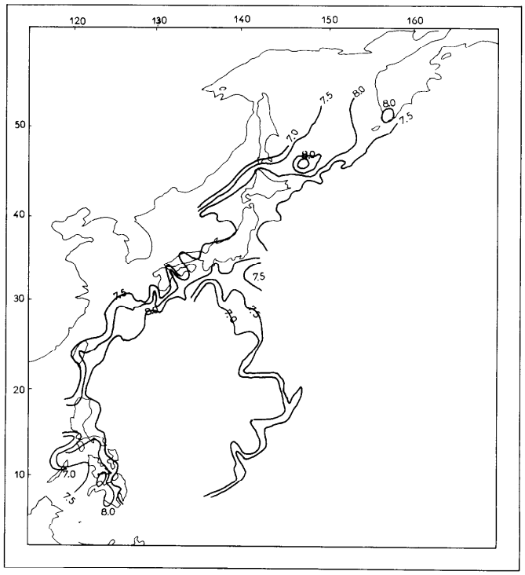
Figure 1: Seismic hazard contour map of Japan and East Asia in Tsapanos and Burton (1991:163)
Nevertheless, the desperation of the Japanese leadership for reliable predictive methods is justified: In Tsapanos and Burton’s seismic hazard evaluation paper, which ranked countries in terms of the largest magnitude earthquake expected in the next 85 years – using a probabilistic analysis of past earthquake magnitude data based on Gumbel’s third asymptotic distribution – Japan ranked 1st with an expected largest magnitude of 8.6.
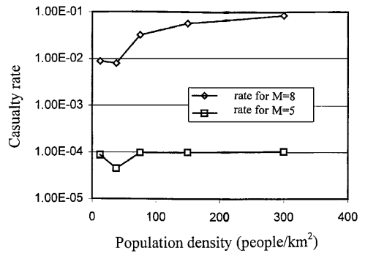
Figure 2: Correlation between earthquake casualty rates and population density in Samardjieva and Badal (2002: 2318)
As Japan has some of the world’s most densely populated urban areas, it is no surprise that the refining of earthquake prediction is a priority along the Japan trench, considering that there appears to be a positive correlation between population density and fatalities in the case of major earthquakes and it has been estimated that for an earthquake of magnitude 8, around 9% of the population could be killed in a densely populous area (D ~ 300 people/km²), as displayed on Figure 2. There is, however, some hope for Japan and other seismically active areas of the world that significant progress can be made in coming years, partly as a consequence of advances in data science. Over the past half a decade, a vast number of machine learning methods have been deployed by researchers in predictive seismology, and various machine learning tools have been used to predict ‘intensity of ground motion’, ‘earthquake magnitude within 7 days’ and ‘ground motion duration’ among other areas of prediction. Deep learning techniques such as long short-term memory neural networks (LSTM) and convolutional neural networks (CNN) have recently been used by seismologist and data scientists to predict magnitude from precursory seismic phenomena, with the CNN model reaching a 97.88% accuracy in doing so. A neural networks study by Mousavi and Beroza showed that ‘site‐speciﬁc learning can be an effective strategy for improving performance, while region‐speciﬁc training might not be important’, suggesting that deep learning models constructed from data from seismic stations in a given location could be generalized on a global scale for predictive research.

Data & Methodology
This report uses a seismic dataset consisting of seven earthquakes recorded in Japan during the past decade. The two earthquakes included in this report occurred in 2016 near Kumamoto and Fukushima. Each earthquake was recorded by multiple seismic stations operated across the country by the High Sensitivity Seismograph Network (Hi-net) of the National Research Institute for Earth Science and Disaster Resilience. The dataset includes the distance of the epicentre of the earthquake from each station it was recorded by, of which the closest one is included in this analysis. Each station records seismic movement simultaneously through three channels (north-south, east-west and vertical) of which only the vertical component is included in the multidimensional scaling analysis. The seismogram takes 100 samples per second and the dataset includes one month of data before the earthquake – 31.25 days, or 750 hours, which works out for $750*3600*100=270000000$, that is 270 million total samples. To clear the data from low-frequency background noise and signals that are likely caused by human and industrial activity, it was fed through a high pass filter that only allows seismicity higher than 2 Hz frequency passing through.
Multidimensional Scaling
This report utilises multidimensional scaling (MDS) for the analysis of the seismic time-series data obtained from the stations. Rather than building a direct predictive model like in the case of LSTM or CNN, MDS is used to visually represent high-dimensional data in a lower-dimensional space – two and three dimensions for practical purposes. As defined by Cliff et al:
‘Multidimensional scaling (MDS) refers to a family of statistical methods by which the information contained in a set of data is represented by a set of points in multidimensional space. These points are located in the space in such a way that the geometrical relationships between them reflect empirical relationships in the data.’
With its mathematical foundations being laid in the 1930s, MDS was principally developed for the purposes of dimension reduction of high-dimensional data – i.e. datasets with a high number of variables – and has often been used in the field or the social sciences, archaeology, and general classification problems.
As laid out by Buja et al. following the theoretical work of Kruskal,,, MDS takes objects labelled $i=1, …,N$ of M dimensions with pairwise distances (dissimilarity values) $D_{i,j}$ and maps the objects to embedding points $x_{1},…,x_{N }ϵ R^{k}$ such that given dissimilarities $D_{i,j}$ are well-approximated by the distances $\left\|x_{i}-x_{j}\right\|$. While the number of new dimensions, $k$, may take any value smaller than the original dimension of the objects, in practice $k=1, 2, or 3$ in most cases, to facilitate the visual representation of the embedding points. For an M dimensional dataset, the original pairwise distances between objects $(x,y)$ can be given by Euclidean distances $d\left(a,b\right)=\sqrt{\sum_{i=1}^{M}{{(a_{i}-b_{i})}^{2}}}$, however, for higher dimensional data, such as a seismic time-series dataset, Manhattan distances $d\left(a,b\right)=\sum_{i=1}^{M}{\left|a_{i}-b_{i}\right|}$ are better operationalizable and it is therefore the preferred method for this paper. From the obtained original Manhattan distances a dissimilarity matrix $(D)$ is created which then can be mapped in an arbitrary number of dimensions.
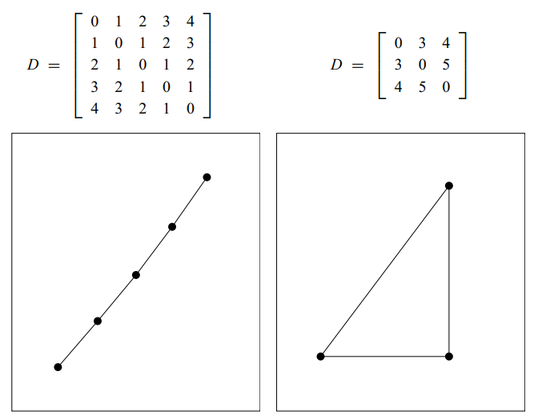
Figure 3: Simple dissimilarity matrices and their optimal 2-dimensional scaling solutions in Buja et al. (2008: 446)
MDS is defined in terms of the minimization of the ‘stress’ $\left(S\right)$loss function defined as a measure of lack of fit, between original dissimilarities $D_{i,j}$ and fitted distances $\left\|x_{i}-x_{j}\right\|$. Stress can be expressed as a residual sum of squares: $S_{D}\left(x_{1},…, x_{N}\right)=\sqrt{\sum_{i≠j=1}^{N}{{(D_{i,j}-\left\|x_{i}-x_{j}\right\|)}^{2}}}$. Lower values of $S$ mean that the original dissimilarities are accurately represented in the new lower-dimensional space. As a goodness-of-fit statistic, it is generally observed that stress increases as $k$, the number of new dimensions decreases as it is increasingly difficult to preserve the original dissimilarities in a lower dimensional space. Figure 4 shows one of Kruskal’s original scree plots representing that relationship, with distinct ‘elbow’ after 3 dimensions meaning that for new dimension values $k≥4$ stress does not decrease significantly, especially in the case of lower original dimensions.
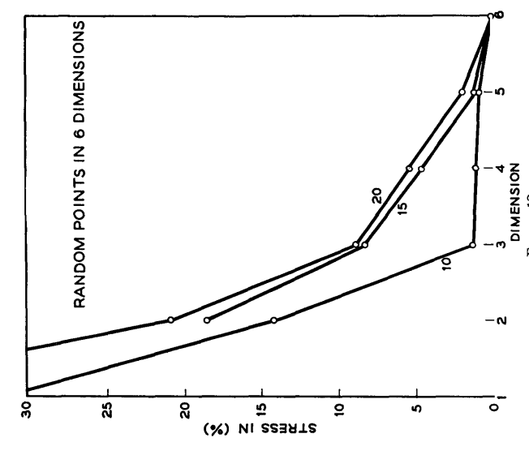
Figure 4: Scree plot of stress by dimension in Kruskal (1964: 17)
Stress values may also be normalized to return values of between 0 and 1, with lower values corresponding to a better fit, however, for metric scaling, that solution is less operationalizable within the software used, therefore this paper will report raw stress values that can be interpreted as the relative accuracy of different scaling solutions within the analysis.
Multidimensional scaling methods have previously been used in the field of seismology and geophysics for clustering seismic occurrences in time and space and advanced nonlinear MDS for predictive analysis and visualisation. The present paper deployed MDS for the visual representation analysis and clustering of the filtered seismic data by rendering different time periods before – and including – the earthquakes into $N$ equal-length time windows containing $M$ samples i.e. $N$ objects of $M$ original dimensions and representing them in a $k=2 or k=3$ dimensional embedding space with the aim of identifying clusters within the observations in order improve the statistical understanding of earthquake precursor phenomena and facilitate an visual mapping of seismic data, a key step in fine-tuning earthquake prediction methods. The same MDS models will be applied to both earthquakes in order to detect any statistical consistencies across seismic events separated by time and space.
Code
All codes for the report were written in Python 3 and all multidimensional scaling was conducted by the scikit-learn machine learning MDS module for stress optimisation with Matplotlib Pyplot visualisation tools. The codes are available in a Jupyter notebook: https://github.com/adamarany/adamarany.git
Results

- Kumamoto earthquake 2016
The first earthquake observed had its epicentre to the southeast of Kumamoto on the island of Kyushu and hit on the 14th of April 2016.
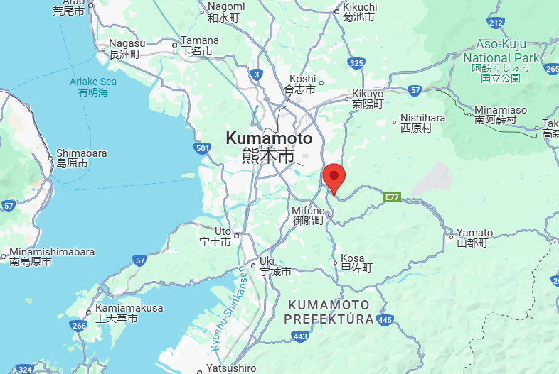
Figure 5: Epicentre of 2016 Kumamoto earthquake

The earthquake had magnitude 6.5 and the closest Hi-net seismic station it was detected by was ‘MSIH’ 6.193 km away from the epicentre.
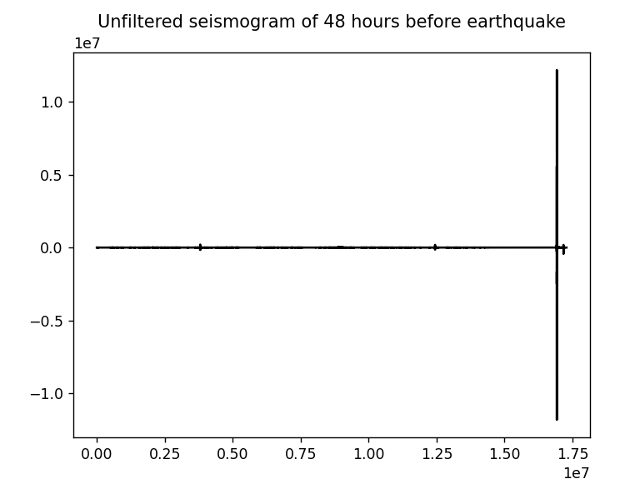
Figure 6
To provide an example of the filtering process, the above snippet of the unfiltered seismogram displaying the last 2 days of data shows the massive impact of the surface wave as well as two smaller waves around the 1st and 3rd quarter of the plot.
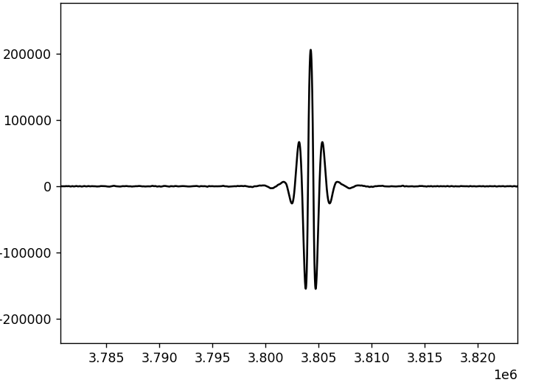
Figure 7
However, zooming in on one of the smaller wave on Figure 7 it becomes apparent that it was not caused by tectonic activity as the signal is symmetrical, in contrast to the clear earthquake structure of the main wave displayed on Figure 8 below.
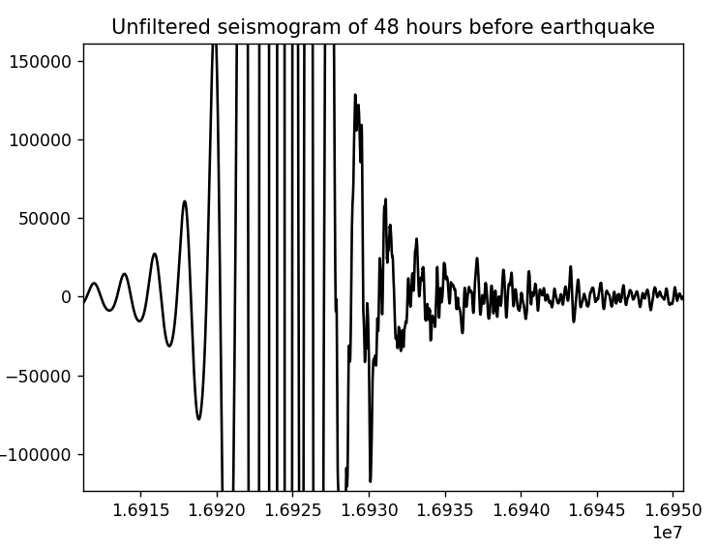
Figure 8
Accordingly, after the data had been passed through the 2 Hz high pass filter, the two smaller waves are no longer detectable, and the earthquake wave structure is more accentuated:
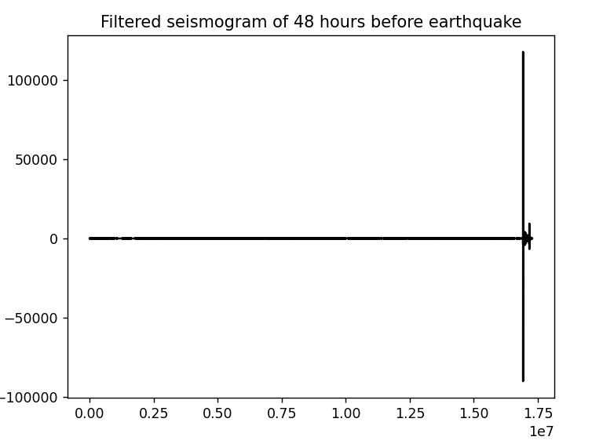
Figure 9
Scaling 1.1
The first scaling takes the entire 750 hours length of the data and breaks it down into $N=100$ original objects of $M=\frac{270000000}{100}=2700000$ dimensions (2.7 million samples), creating a 2-dimensional feature space with each embedding point corresponding to 7.5 hours of data.
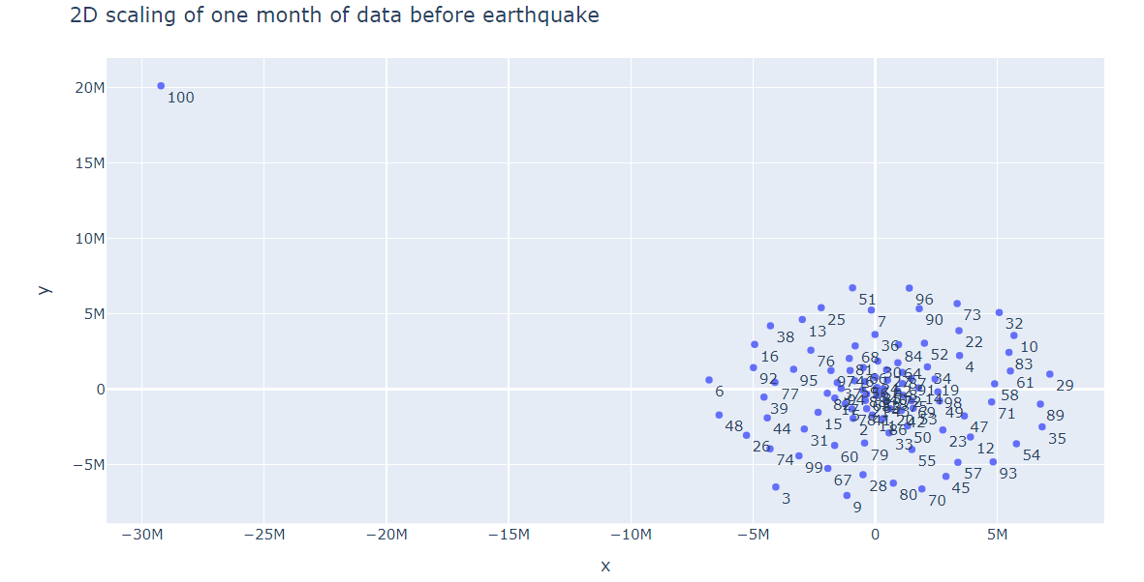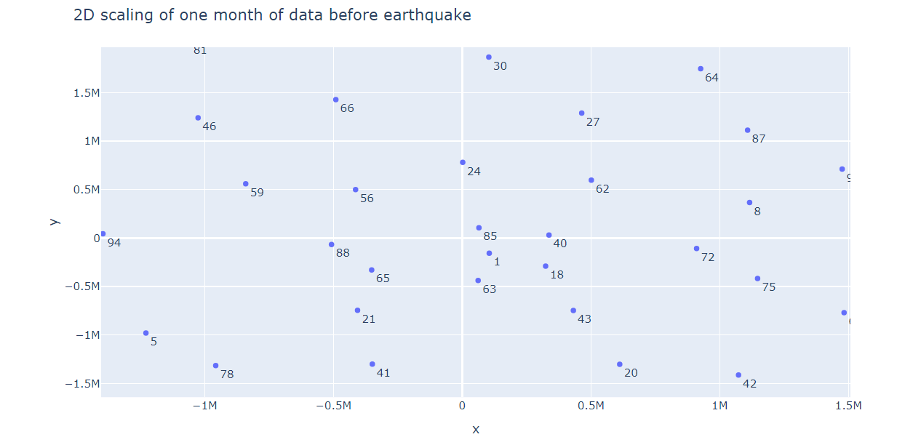
Figure 10: MDS 1.1 and zoom
As shown on Figure 10, MDS 1.1. makes visible the dissimilarity in seismicity between the last 1.5 hours which includes the magnitude 6.5 earthquake and the other 99 time windows but does not provide much extra information beyond that as there are no clearly distinguishable clusters in the 2-dimensional feature space, apart from some circularity within the main cluster with some data points more sparsely situated, forming a ring around the centre. Zooming in, the embedding points representing temporarily similar time windows do not appear to cluster together. MDS 1.1. gives a stress value of $S= 2.1701*{10}^{16}$.
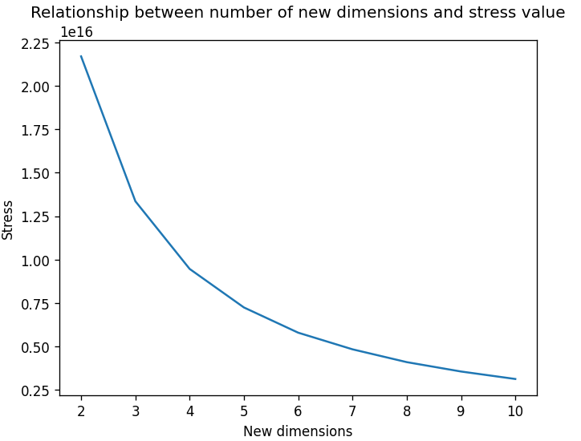
Figure 11: MDS 1.1 scree plot

The scree plot for MDS 1.1 suggests a relatively slow but steady decrease in stress value as the number of embedding dimensions increases.

Scaling 1.2
The second scaling keeps the entire 750 hours as the original data but creates $N=1000$ objects of $M=\frac{270000000}{1000}=270000$ dimensions (270000 samples), building a 2-dimensional feature space with each embedding point corresponding to 45 minutes of data for more temporal specificity.
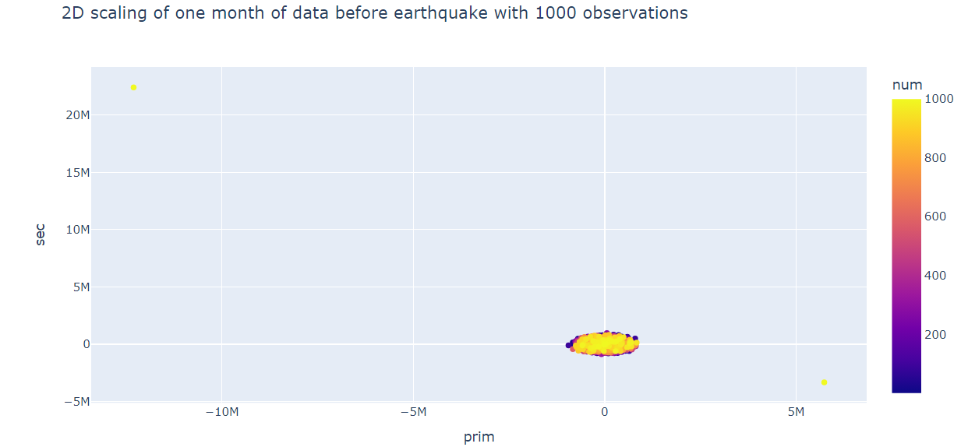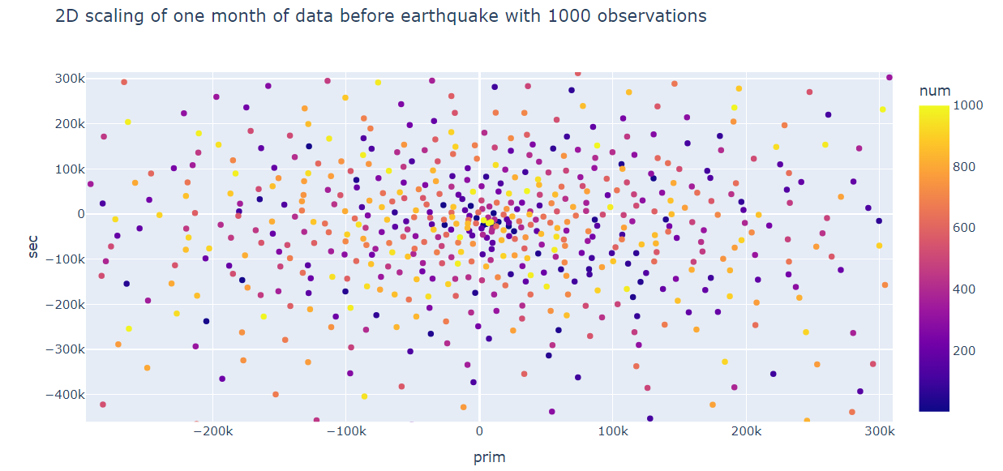
Figure 12: MDS 1.2 and zoom
Figure 12 on the previous page uses a colour scale to represent the temporality of the embedding points, however, the sole improvement upon MDS 1.2 is that there are two outliers representing the earthquake period, but the rest are still forming a single cluster, which does not show distinguishable subclusters or colour groupings. MDS 1.2. gives a stress value of $S= 2.1103*{10}^{16}$, hardly improving upon MDS 1.1.
Scaling 1.3
The third scaling takes a different analytical approach by adding a categorical variable distinguishing between daytime and nighttime periods of the last 30 days (720 hours) of the data, thus creating $N=60$ objects of $M=\frac{720*3600*100}{60}=4320000$ dimensions, constructing a 2-dimensional feature space with each embedding point corresponding to 12 hours of data recorded from 9 am until 9 pm or vice versa, in order to examine whether, despite the filter applied, the effect of increased daytime human and industrial activity can be detected in the observed seismicity.
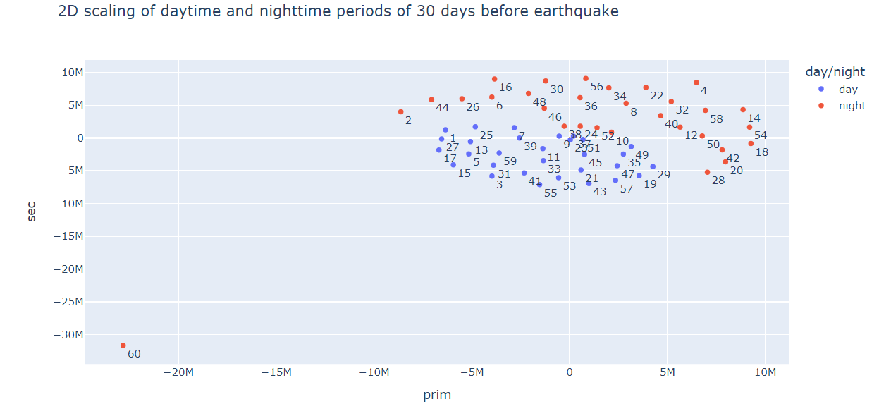
Figure 12: MDS 1.3
In an improved clustering result compared to MDS 1.1. and 1.2., Figure 12 shows that the daytime/nighttime differentiated scaling creates two distinguishable clusters, with embedding points representing daytime periods somewhat more closely clustered together and the 60th nighttime period, which includes the earthquake, being the sole outlier, suggesting that multidimensional scaling is a useful tool for detecting day/night patterns of seismicity. MDS 1.3. gives a stress value of $S= 2.1803*{10}^{16}$, a similar figure to that of the previous two models.
Scaling 1.4
The fourth scaling is the 3-dimensional representation $(k=3)$ of MDS 1.3. with the same timescale and parameters.
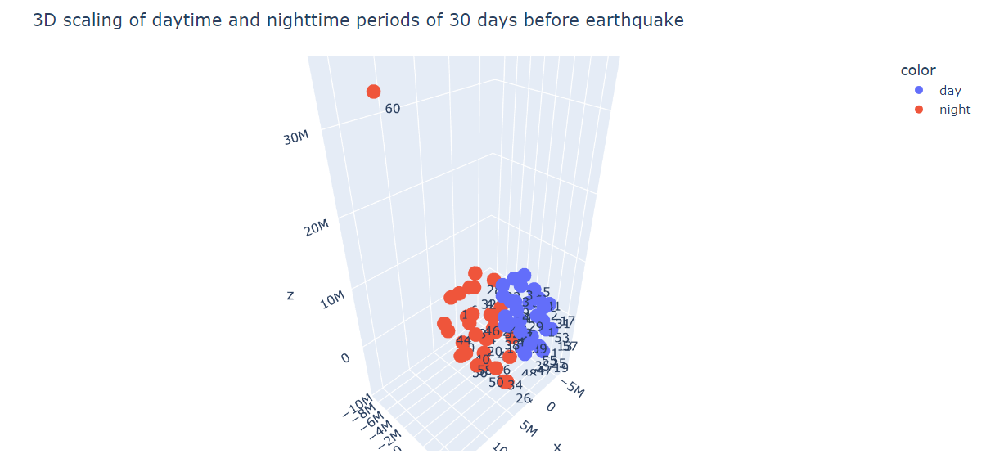
Figure 13: MDS 1.4
Figure 13 represents a similar but more accurate clustering of the time periods, with the stress value of the model decreasing to $S= 1.3097*{10}^{16}$, a $40\%$ decrease in stress compared to the 2-dimensional model.
Scaling 1.5
The fifth scaling brings in the focus to the last two hours of the data, which includes the main seismic activity, in order to find patterns and clusters around the earthquake itself. MDS 1.5. breaks down the 120 minutes of data into $N=120$ original objects of $M=\frac{2*3600*100}{120}=6000$ dimensions, creating a 2-dimensional embedding space with each embedding point corresponding to 1 minute of original data.
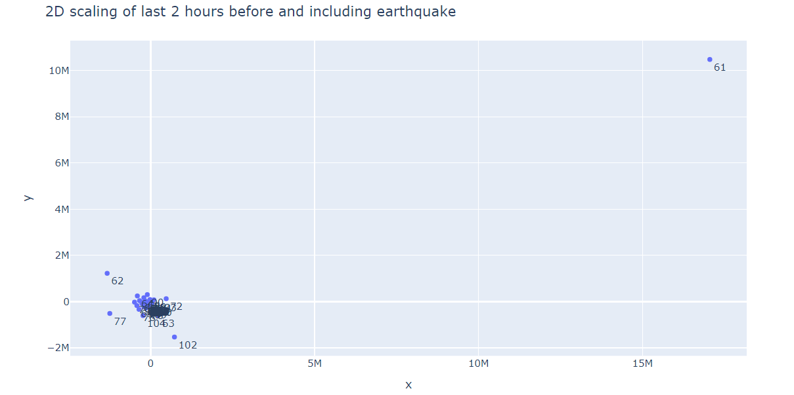
Figure 14: MDS 1.5.
In a similar pattern to MDS 1.1. and 1.2, the fifth scaling also creates a single cluster, however, data points are more closely clustered, pointing to more similar patterns of seismicity around the main seismic event. Outlier data points do not form a cluster as they a widely separated around the main bunch, which suggests MDS 1.5. struggles to identify specific patterns of seismic activity that could be used for short-notice prediction. The stress value of this model is $S= 1.4024*{10}^{13}$, a 1000-fold improvement compared to the previous models which worked with higher original dimensions.
Scaling 1.6
As in the case of MDS 1.2., the sixth model increases the number of time windows from MDS 1.5 to $N=1000$ do decrease the number of original dimensions to $M=\frac{2*3600*100}{1000}=720$, creating a 2-dimensional embedding space with each embedded point representing 7.2 seconds of original data.
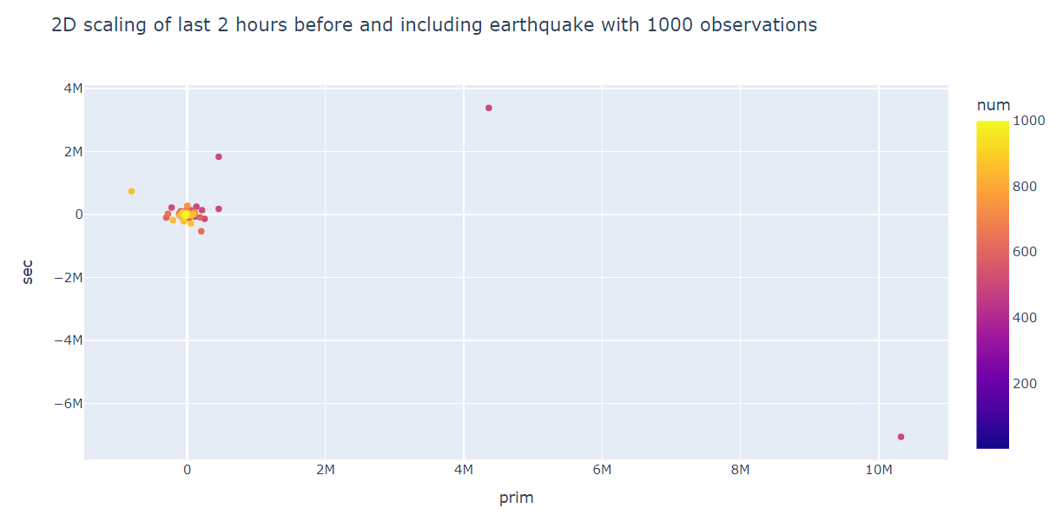
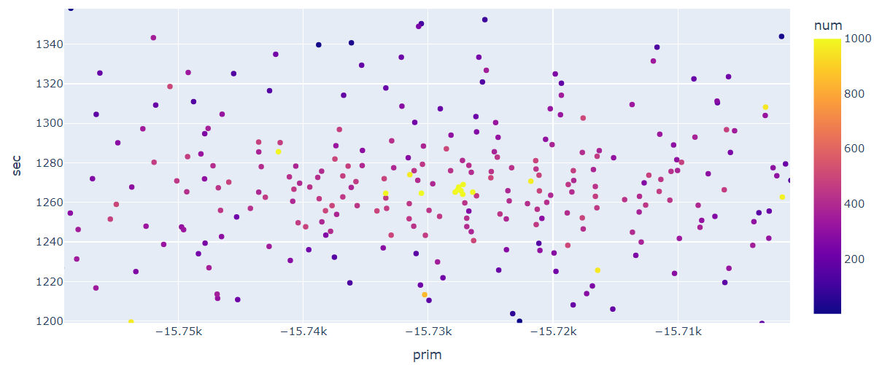
Figure 15: MDS 1.6 and zoom
Figure 15, representing the 2-dimensional model shows and even tighter-clustered image, however, upon closely observing the middle of the cluster it appears that some of the data points at the very end of the 2-hour period, after the main wave, shown in yellow, are closely clustered in the centre, while immediately outside is a ring of magenta embedding points which correspond to an earlier time section around the 45-minute mark. Therefore, there appears some clustering possibility in the model but without an indication of utility for predictive purposes. The stress value is $S= 1.6853*{10}^{13}$, a minor increase upon MDS 1.5.
Scaling 1.7
The seventh and final model fitted for the Kumamoto earthquake data is the 3-dimensional representation $(k=3)$ of MDS 1.6. with the timescale and parameters left unchanged.
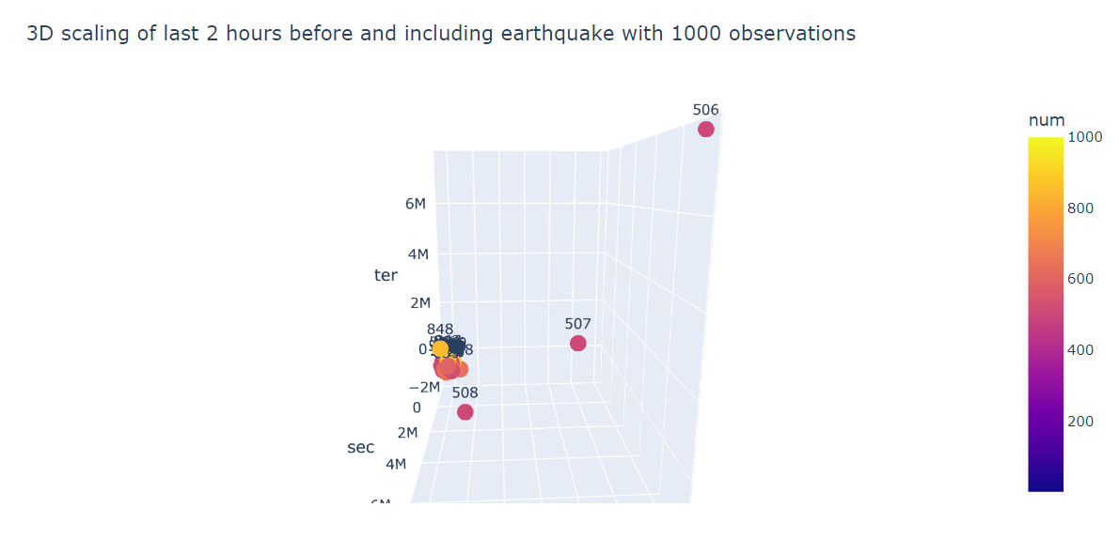
Figure 16: MDS 1.7
On figure 16, the added labels show that the main seismic event occurred just after the one-hour mark, but otherwise the embedding points are too tightly clustered to facilitate a predictive analysis. With the increase in the dimensionality of the embedding space, the stress value decreased by about $40\%$ to $S= 1.0323*{10}^{13}$.

- Fukushima earthquake 2016
The second earthquake included in the analysis had its epicentre in the Pacific Ocean southeast of Fukushima and northeast of the port of Iwaki (Honshu) on the 21st of November 2016 with a magnitude of 7.4.
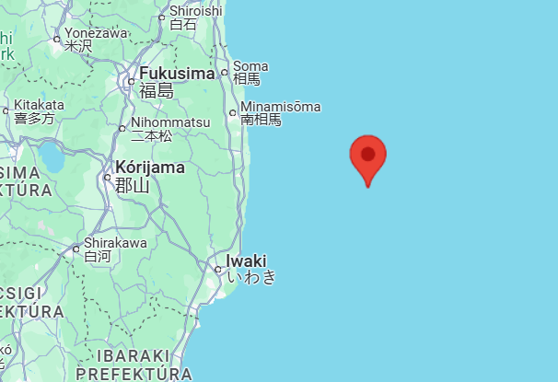
Figure 17: Epicentre of Fukushima earthquake
The closest Hi-net station it was detected by was codenamed ‘NMEH’, situated 56.68 km away from the epicentre.
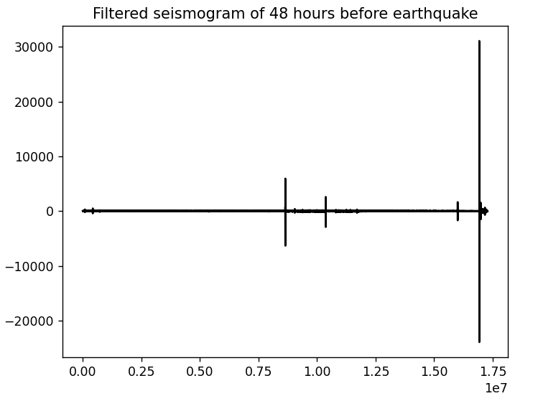
Figure 18
The last two-hour snippet of the high pass filtered seismogram displays several smaller earthquakes preceding the main event, suggesting different patterns of seismicity from the Kumamoto earthquake seven months prior.
Scaling 2.1
$$N=100, M=2700000, k=2$$
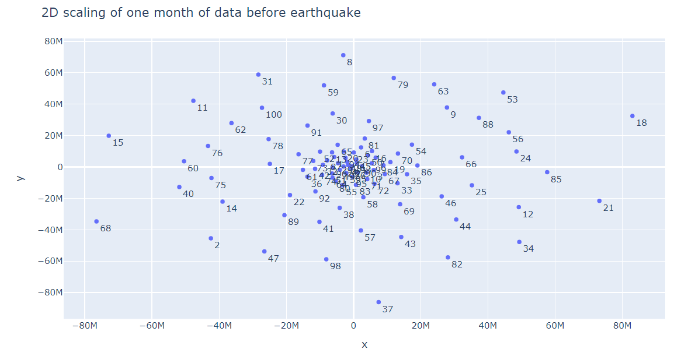
Figure 19: MDS 2.1
In a similar vein to the seismographic image displaying more seismic activity, the first model shows a cluster with no single outlier but rather a tight middle bunch and several embedding points showing more variance around the main cluster without further apparent clustering. The stress value is $S= 1.1674*{10}^{18},$thus the model is performing worse than in the case of the Kumamoto dataset, which holds up across all dimensions up to $k=10$, as shown on the scree plot below.

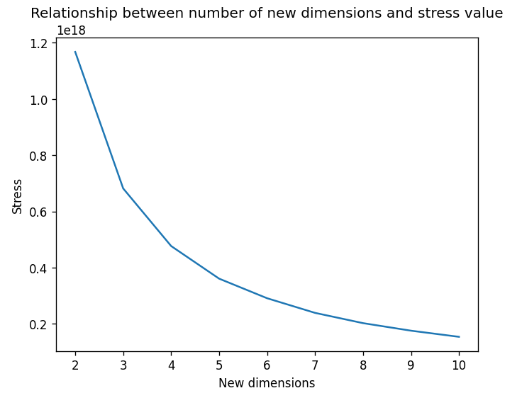
Figure 20: MDS 2.1 scree plot

Scaling 2.2
$$N=1000, M=270000, k=2$$
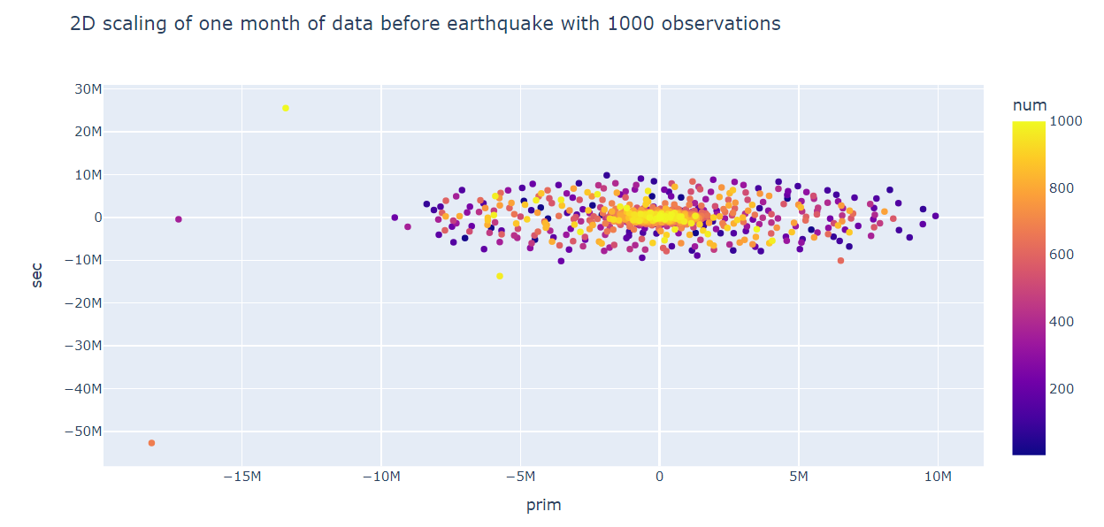
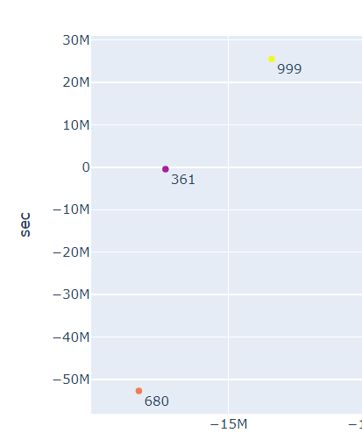
Figure 21: MDS 2.2 and zoom
The second model preserves the one main oval-shaped cluster of MDS 2.1. but it is made more accurate by the representation of three outlier embedding points as seen on Figure 21, with the yellow dot representing the main event, while the two other outliers likely corresponding to earlier periods of heightened seismicity. The stress value for the model is $S=1.0517*{10}^{18}$, a $10\%$ improvement upon MDS 2.1.
Scaling 2.3
$$N=60, M=4320000, k=2$$
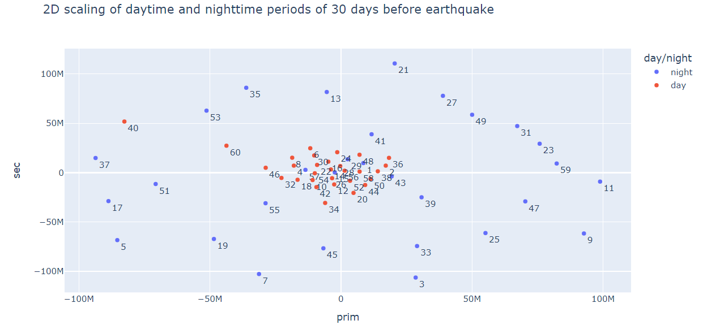
Figure 22: MDS 2.3
As in the case of the Kumamoto earthquake, the daytime/nighttime MDS model yields a more meaningful result by separating the 12-hour time windows into a cluster of daytime periods displaying less variance while nighttime periods forming a more dispersed ring around the inner cluster, with the last 12 hours of daytime – including the main earthquake – being one of the several outliers. The returned stress value is $S=1.043*{10}^{18}$.

Scaling 2.4
$$N=60, M=4320000, k=3$$
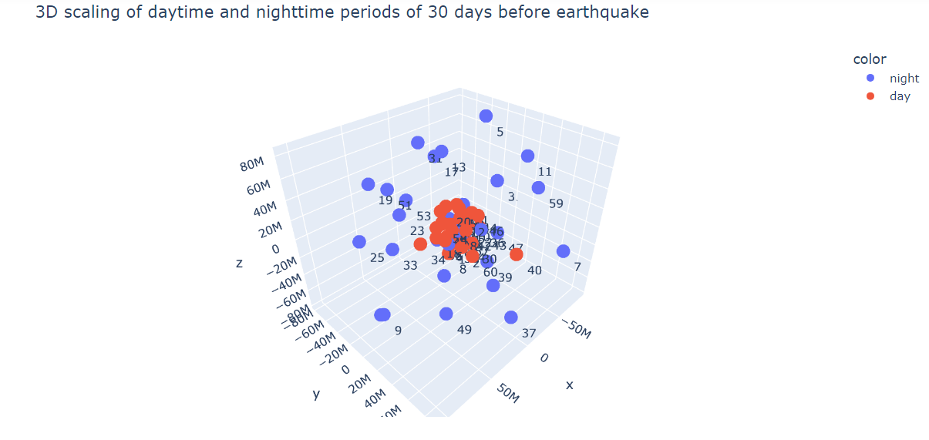
Figure 23: MDS 2.4

The structure of the previous 2-dimensional model is made more apparent by MDS 2.4., with embedding points representing daytime forming a tight spheric cluster while nighttime periods being dispersed around the 3-dimensional embedding space. Nevertheless, it has to be noted that in the case of both MDS 2.3. and 2.4., there is less of a separation between the two clusters and more day-night ‘mixing’ in the middle cluster than in the case of the Kumamoto dataset. The returned stress value is $S=6.0952*{10}^{17}$, a $42\%$ improvement in terms of goodness of fit upon the 2-dimensional model.

Scaling 2.5
$$N=120, M=6000, k=2$$
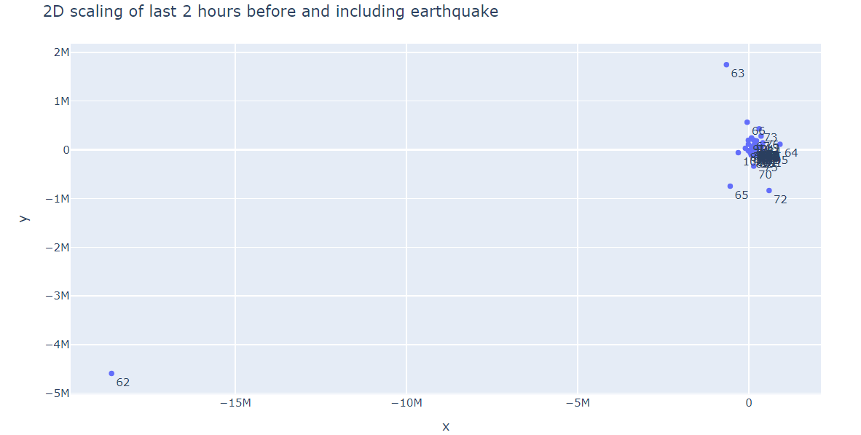
Figure 24: MDS 2.5.

Zooming in on the last hour of data, Figure 24 displays once again the formation of a single cluster of embedded data points each representing one minute of seismic activity, and the several outlier data points corresponding to heightened seismic activity around the middle of the 2-hour time period, when the main seismic wave hit. The stress value comes back as $S=1.1556*{10}^{13}$.

Scaling 2.6
$$N=1000, M=720, k=2$$
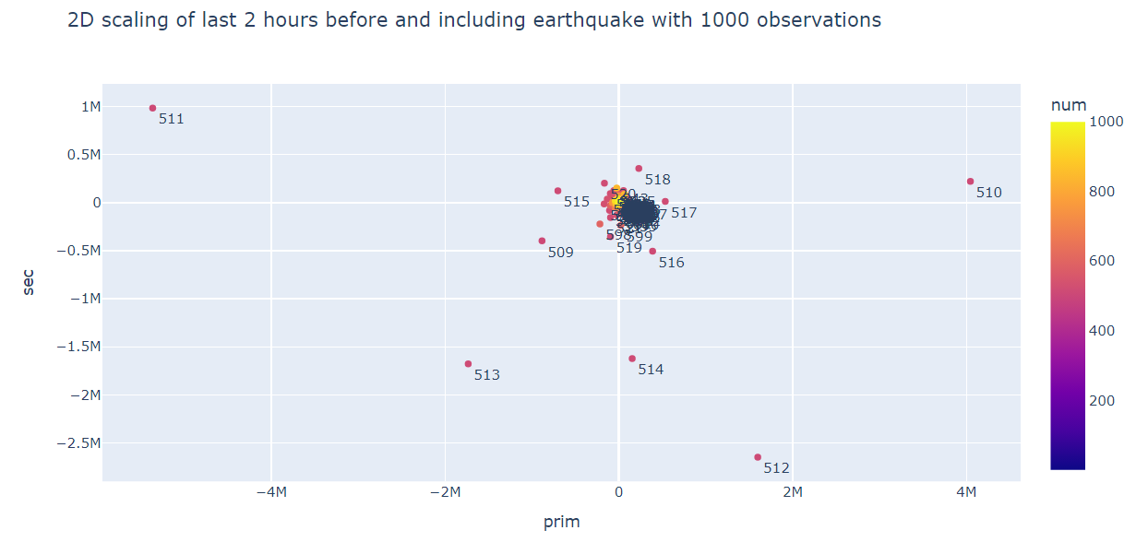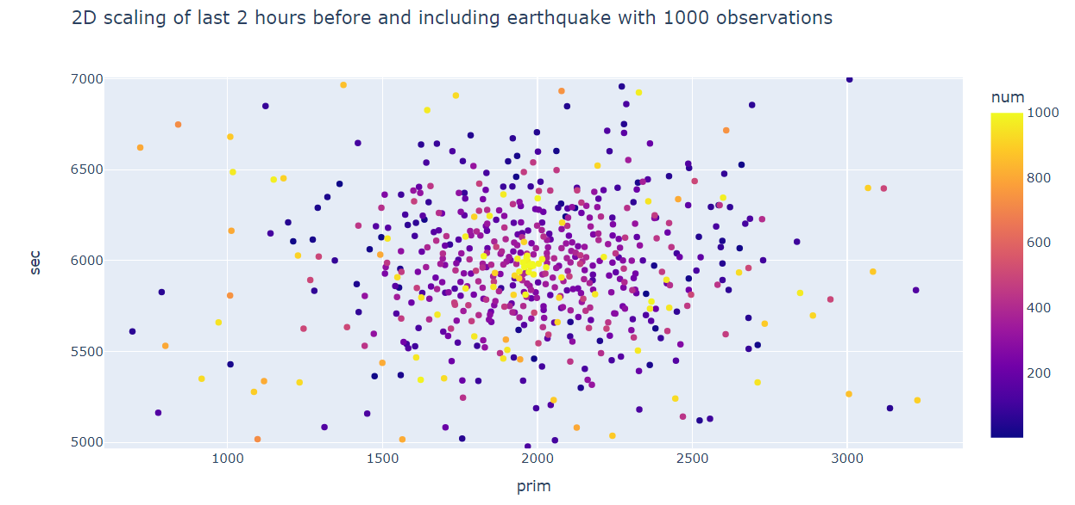
Figure 25: MDS 2.6. and zoom
Increasing the number of observed time windows upon MDS 2.5., the visual representation of the main earthquake becomes more distinguishable as all of the outlier data points are around the one-hour mark with only $9*7.2s=64.8 seconds$, a little more than a minute passed between the two main outliers furthest away in time (labelled ‘509’ and ‘518’ on Figure 25), therefore, at first glance it could be assessed that the MDS model only carries any meaningful information for one minute of the 2-hour time series. However, zooming in on the main cluster, the ellipticity of the embedding becomes apparent – similarly to MDS 2.2. – and there appears to be a ring of magenta points around the centre representing the period just before the main wave, which is more promising in terms of the utility of MDS models for short-term prediction. The stress value is $S=4.1233*{10}^{13}$, more than a $250\%$ increase in stress upon MDS 2.5. with the increased number of fitted distances.
Scaling 2.7
$$N=1000, M=720, k=3$$
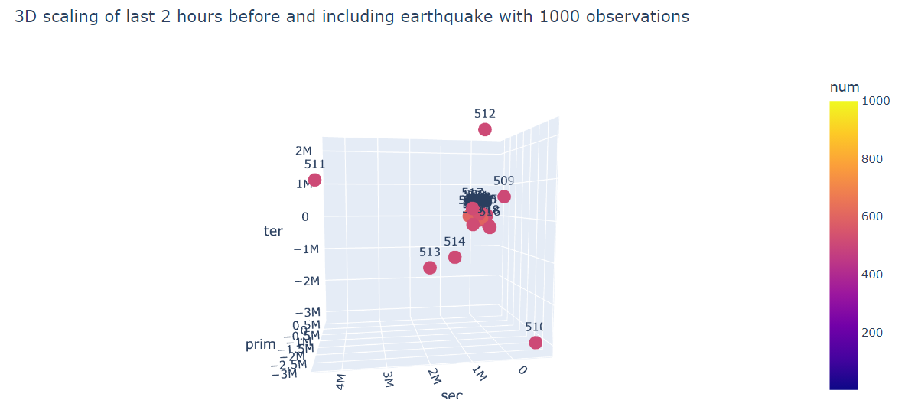
Figure 26: MDS 2.7.
For the 7th and final model, adding a third dimension to MDS 2.6. does not provide much additional information to the data interpretation as only the outlier embedded points are distinguishable on the 3D plot and deep zooming is not possible due to the computational limitations of the software. Nevertheless, it does provide a visual representation of the temporal decomposition of the main seismic event. The computed stress value comes back as $S=2.5665*{10}^{13}$, a $38\%$ improvement in goodness of fit upon MDS 2.6.

Conclusion
This report aimed to summarize the results of fitting metric multidimensional scaling models on time-series data obtained from two different earthquakes in the same year, the first with its epicentre in the Japanese mainland, the second off-shore in the Pacific Ocean. With a multitude of models applied, taking as input different lengths of time series data and scales of dimensionality reduction, the visual outputs do not appear to greatly favour the general applicability of MDS in the computationally complicated and technologically demanding field of earthquake prediction. The principal objective of the visual analysis was to distinguish clusters in the two- and three-dimensional embedding spaces in order to gain a more refined understanding of seismic activities preceding earthquakes to facilitate the advancement of predictive science. However, the vast majority of the models produced a single, oval cluster of embedded data points with several outliers representing heightened seismic activity, with some circular convergence of data representing similar time periods which may yet provide some predictive value once observed within a more thorough study. Where MDS did seem to yield results was in the domain of distinguishing between nighttime and daytime periods of seismic activity. Therefore, if combined with a different set of machine learning methods, multidimensional scaling could be successfully used for classification purposes as an element of a broader predictive analysis in future seismological research.
Bibliography
Bao, Zhenyu, Jingyu Zhao, Pu Huang, Shanshan Yong, and Xin’an Wang. ‘A Deep Learning-Based Electromagnetic Signal for Earthquake Magnitude Prediction’. Sensors 21, no. 13 (January 2021): 4434. https://doi.org/10.3390/s21134434.
B.Kruskal, Joseph, and Myron Wish. Multidimensional Scaling. SAGE Publications, Inc., 1978. https://doi.org/10.4135/9781412985130.
Buja, Andreas, Deborah F Swayne, Michael L Littman, Nathaniel Dean, Heike Hofmann, and Lisha Chen. ‘Data Visualization With Multidimensional Scaling’. Journal of Computational and Graphical Statistics 17, no. 2 (1 June 2008): 444–72. https://doi.org/10.1198/106186008X318440.
Cao, Chen, Xiangbin Wu, Lizhi Yang, Qian Zhang, Xianying Wang, David A. Yuen, and Gang Luo. ‘Long Short-Term Memory Networks for Pattern Recognition of Synthetical Complete Earthquake Catalog’. Sustainability 13, no. 9 (January 2021): 4905. https://doi.org/10.3390/su13094905.
Centre for Research on the Epidemiology of Disasters (CRED). ‘Death Toll in Great Earthquakes 1900-2023’, n.d. https://www.statista.com/statistics/266325/death-toll-in-great-earthquakes/.
Cliff, A. D., P. Haggett, M. R. Smallman-Raynor, D. F. Stroup, and G. D. Williamson. ‘The Application of Multidimensional Scaling Methods to Epidemiological Data’. Statistical Methods in Medical Research 4, no. 2 (June 1995): 102–23. https://doi.org/10.1177/096228029500400202.
Dzwinel, W., D. A. Yuen, K. Boryczko, Y. Ben-Zion, S. Yoshioka, and T. Ito. ‘Nonlinear Multidimensional Scaling and Visualization of Earthquake Clusters over Space, Time and Feature Space’. Nonlinear Processes in Geophysics 12, no. 1 (28 January 2005): 117–28. https://doi.org/10.5194/npg-12-117-2005.
Jackson, David D. ‘Hypothesis Testing and Earthquake Prediction’. Proceedings of the National Academy of Sciences of the United States of America 93, no. 9 (1996): 3772–75. https://www.jstor.org/stable/39143.
Kruskal, J. B. ‘Multidimensional Scaling by Optimizing Goodness of Fit to a Nonmetric Hypothesis’. Psychometrika 29, no. 1 (1 March 1964): 1–27. https://doi.org/10.1007/BF02289565.
Lopes, António M., J. A. Tenreiro Machado, C. M. A. Pinto, and A. M. S. F. Galhano. ‘Multidimensional Scaling Visualization of Earthquake Phenomena’. Journal of Seismology 18, no. 1 (1 January 2014): 163–79. https://doi.org/10.1007/s10950-013-9409-9.
Mousavi, S. Mostafa, and Gregory C. Beroza. ‘A Machine-Learning Approach for Earthquake Magnitude Estimation’. Geophysical Research Letters 47, no. 1 (2020): e2019GL085976. https://doi.org/10.1029/2019GL085976.
National Research Institute for Earth Science and Disaster Resilience. ‘NIED Hi-Net β Ver. [High Sensitivity Seismograph Network Japan]’. Accessed 4 September 2024. https://www.hinet.bosai.go.jp/.
Normile, Dennis. ‘Japan Holds Firm to Shaky Science’. Science 264, no. 5166 (1994): 1656–58. https://www.jstor.org/stable/2883897.
Ogata, Yosihiko. ‘A Prospect of Earthquake Prediction Research’. Statistical Science 28, no. 4 (2013): 521–41. https://www.jstor.org/stable/43288434.
Press, Frank. ‘Earthquake Prediction’. Scientific American 232, no. 5 (1975): 14–23. https://www.jstor.org/stable/24949794.
Rabinowitz, George B. ‘An Introduction to Nonmetric Multidimensional Scaling’. American Journal of Political Science 19, no. 2 (1975): 343–90. https://doi.org/10.2307/2110441.
Ridzwan, Nurafiqah Syahirah Md, and Siti Harwani Md. Yusoff. ‘Machine Learning for Earthquake Prediction: A Review (2017–2021)’. Earth Science Informatics 16, no. 2 (1 June 2023): 1133–49. https://doi.org/10.1007/s12145-023-00991-z.
Samardjieva, Elena, and José Badal. ‘Estimation of the Expected Number of Casualties Caused by Strong Earthquakes’. Bulletin of the Seismological Society of America 92, no. 6 (1 August 2002): 2310–22. https://doi.org/10.1785/0120010112.
Seth Stein and Michael Wyesession. An Introduction to Seismology, Earthquakes, and Earth Structure. Blackwell Publishing Ltd., 2003.
Tsapanos, Theodoros M., and Paul W. Burton. ‘Seismic Hazard Evaluation for Specific Seismic Regions of the World’. Tectonophysics 194, no. 1 (20 July 1991): 153–69. https://doi.org/10.1016/0040-1951(91)90278-Z.
World Health Organization. ‘Earthquakes’, n.d. https://www.who.int/health-topics/earthquakes.

World Health Organization, ‘Earthquakes’, n.d., https://www.who.int/health-topics/earthquakes.
Centre for Research on the Epidemiology of Disasters (CRED), ‘Death Toll in Great Earthquakes 1900-2023’, n.d., https://www.statista.com/statistics/266325/death-toll-in-great-earthquakes/.
Frank Press, ‘Earthquake Prediction’, Scientific American 232, no. 5 (1975): 14, https://www.jstor.org/stable/24949794.
Seth Stein and Michael Wyesession, An Introduction to Seismology, Earthquakes, and Earth Structure (Blackwell Publishing Ltd., 2003), 24–26.
David D. Jackson, ‘Hypothesis Testing and Earthquake Prediction’, Proceedings of the National Academy of Sciences of the United States of America 93, no. 9 (1996): 3775, https://www.jstor.org/stable/39143.
Yosihiko Ogata, ‘A Prospect of Earthquake Prediction Research’, Statistical Science 28, no. 4 (2013): 521, https://www.jstor.org/stable/43288434.
Ogata, 539.
Dennis Normile, ‘Japan Holds Firm to Shaky Science’, Science 264, no. 5166 (1994): 1656, https://www.jstor.org/stable/2883897.
Theodoros M. Tsapanos and Paul W. Burton, ‘Seismic Hazard Evaluation for Specific Seismic Regions of the World’, Tectonophysics 194, no. 1 (20 July 1991): 153–69, https://doi.org/10.1016/0040-1951(91)90278-Z.
Elena Samardjieva and José Badal, ‘Estimation of the Expected Number of Casualties Caused by Strong Earthquakes’, Bulletin of the Seismological Society of America 92, no. 6 (1 August 2002): 2318, https://doi.org/10.1785/0120010112.
Nurafiqah Syahirah Md Ridzwan and Siti Harwani Md. Yusoff, ‘Machine Learning for Earthquake Prediction: A Review (2017–2021)’, Earth Science Informatics 16, no. 2 (1 June 2023): 1144, https://doi.org/10.1007/s12145-023-00991-z.
Chen Cao et al., ‘Long Short-Term Memory Networks for Pattern Recognition of Synthetical Complete Earthquake Catalog’, Sustainability 13, no. 9 (January 2021): 4905, https://doi.org/10.3390/su13094905.
Zhenyu Bao et al., ‘A Deep Learning-Based Electromagnetic Signal for Earthquake Magnitude Prediction’, Sensors 21, no. 13 (January 2021): 4434, https://doi.org/10.3390/s21134434.
Bao et al., 14.
S. Mostafa Mousavi and Gregory C. Beroza, ‘A Machine-Learning Approach for Earthquake Magnitude Estimation’, Geophysical Research Letters 47, no. 1 (2020): 6, https://doi.org/10.1029/2019GL085976.
National Research Institute for Earth Science and Disaster Resilience, ‘NIED Hi-Net β Ver. [High Sensitivity Seismograph Network Japan]’, accessed 4 September 2024, https://www.hinet.bosai.go.jp/.
A. D. Cliff et al., ‘The Application of Multidimensional Scaling Methods to Epidemiological Data’, Statistical Methods in Medical Research 4, no. 2 (June 1995): 102, https://doi.org/10.1177/096228029500400202.
Cliff et al., 102.
Andreas Buja et al., ‘Data Visualization With Multidimensional Scaling’, Journal of Computational and Graphical Statistics 17, no. 2 (1 June 2008): 447–48, https://doi.org/10.1198/106186008X318440.
Buja et al., 445–46.
J. B. Kruskal, ‘Multidimensional Scaling by Optimizing Goodness of Fit to a Nonmetric Hypothesis’, Psychometrika 29, no. 1 (1 March 1964): 1–27, https://doi.org/10.1007/BF02289565.
Joseph B.Kruskal and Myron Wish, Multidimensional Scaling (SAGE Publications, Inc., 1978), https://doi.org/10.4135/9781412985130.
Buja et al., ‘Data Visualization With Multidimensional Scaling’, 446.
Kruskal, ‘Multidimensional Scaling by Optimizing Goodness of Fit to a Nonmetric Hypothesis’, 16.
George B. Rabinowitz, ‘An Introduction to Nonmetric Multidimensional Scaling’, American Journal of Political Science 19, no. 2 (1975): 369, https://doi.org/10.2307/2110441.
António M. Lopes et al., ‘Multidimensional Scaling Visualization of Earthquake Phenomena’, Journal of Seismology 18, no. 1 (1 January 2014): 163–79, https://doi.org/10.1007/s10950-013-9409-9.
W. Dzwinel et al., ‘Nonlinear Multidimensional Scaling and Visualization of Earthquake Clusters over Space, Time and Feature Space’, Nonlinear Processes in Geophysics 12, no. 1 (28 January 2005): 117–28, https://doi.org/10.5194/npg-12-117-2005.

