

Probing Neuro-Glial Interactions via Over-Extremities Stimulation and Hybrid EEG-fNIRS Neuroimaging

Adam Emile Aske

ACIT4300 – Masters Project

XX.XX.XXXX

Supervisors

Peyman Mirtaheri

Ali lastname

Haroon Khan

Oslo Metropolitan University, Department of Biomedical Engineering, Art design technology ??

**Contents**

1. Introduction 4

2. Background 4

3. Methods 4

4. Conclusion 4

5. References 4

**Figures**

Figure 1 AI Generated Brain Art. 2

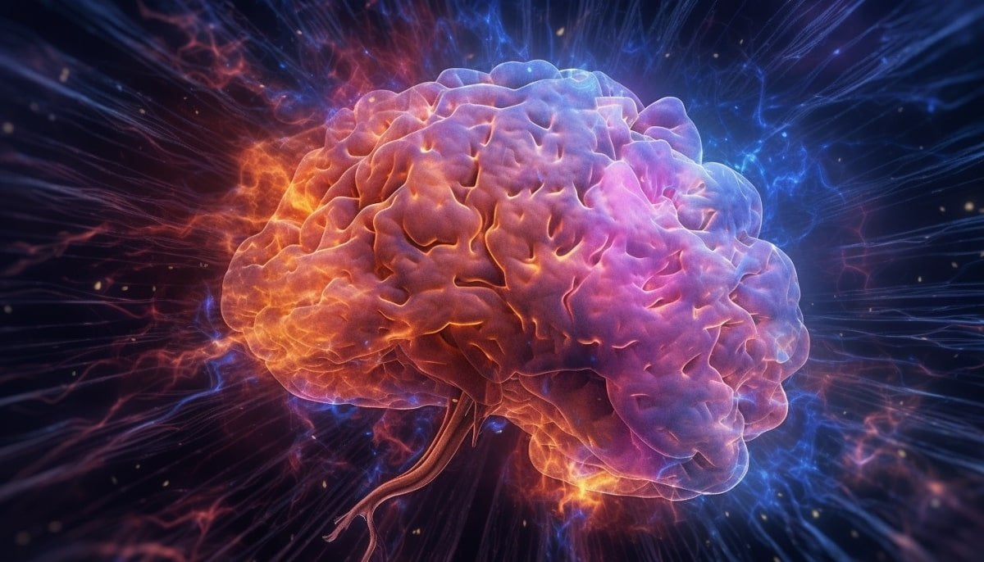

Figure 1 AI Generated Brain Art.

# Acknowledgements

# Introduksjon

Electroencephalogram (EEG)

Functional near-infrared spectroscopy (fNIRS)

Functional mangetic resconace imaging (fMRI)

# Background

Neuroimaging

Data analysists

## Hybrid EEG-fNIRS

* (Paulo et al., 2023) Task-related brain activity in upper limb dystonia revealed by simultaneous fNIRS and EEG
* (Nakano et al., 2012) Brain activity during the observation, imagery, and execution of tool use: an fNIRS/EEG study
* (Zhou et al., 2023) Friction and neuroimaging of active and passive tactile touch

# Methods

# Conclusion

# References

1.(Bourguignon et al., 2022)

2.(Chen & Xu, 2023)

3.(Khan et al., 2021)

4.(Lan et al., 2018)

5.(Nakano et al., 2012)

6.(Paulo et al., 2023)

7.(Sedrak et al., 2020)

8.(Taheri, Aske, & Tan, 2023) – the swapped Tan and Aske is correct.

9.(Taheri, Tan, & Aske, 2023)

10.(Teo et al., 2024)

11.(Zhou et al., 2023)

Bourguignon, N. J., Bue, S. L., Guerrero-Mosquera, C., & Borragán, G. (2022). Bimodal EEG-fNIRS in Neuroergonomics. Current Evidence and Prospects for Future Research [Review]. *Frontiers in Neuroergonomics*, *3*. <https://doi.org/10.3389/fnrgo.2022.934234>

Chen, S., & Xu, K. L. X. Q. W. R. L. (2023). Tactile perception of fractal surfaces: An EEG-fNIRS study. *Tribology International*, *180*. <https://doi.org/10.1016/j.triboint.2023.108266>

Khan, H., Naseer, N., Yazidi, A., Eide, P. K., Hassan, H. W., & Mirtaheri, P. (2021). Analysis of Human Gait Using Hybrid EEG-fNIRS-Based BCI System: A Review [Review]. *Frontiers in Human Neuroscience*, *14*. <https://doi.org/10.3389/fnhum.2020.613254>

Lan, A. K. J. L., Tremblay, J., Vannasing, P., Dehbozorgi, M., Pouliot, P., Gallagher, A., Lesage, F., Sawan, M., & Nguyen, D. K. (2018). Multichannel wearable fNIRS‐EEG system for long‐term clinical monitoring. *Human Brain Mapping*, *39*(1), 7-23. <https://doi.org/10.1002/hbm.23849>

Nakano, H., Osumi, M., Ueta, K., & Morioka, S. (2012). Brain activity during the observation, imagery, and execution of tool use: an fNIRS/EEG study. *J Nov Physiother*, *S1:009*. <https://doi.org/10.4172/2165-7025.S1-009>

Paulo, A. J. M., Sato, J. R., Faria, D. D. d., Balardin, J., Borges, V., Silva, S. M. A., Ferraz, H. B., & Aguiar, P. d. C. (2023). Task-related brain activity in upper limb dystonia revealed by simultaneous fNIRS and EEG. <https://doi.org/10.1016/j.clinph.2023.12.008>

Sedrak, M., Alaminos-Bouza, A. L., & Srivastava, S. (2020). Coordinate Systems for Navigating Stereotactic Space: How Not to Get Lost. *Cureus*, *12*(6). <https://doi.org/10.7759/cureus.8578>

Taheri, M., Aske, A. E., & Tan, K. (2023). Developing a Serious Game for Acute Pain Detection by Utilizing Virtual Reality and Brain-Computer Interfaces. *Springer - something*, *Pending*(Pending). <https://doi.org/pending>

Taheri, M., Tan, K., & Aske, A. (2023). A Behavior Analysis Tool Using Pitch Presentation Training Virtual Reality Simulation (Serious Game) By Employing Brain Computer Interface Technology. <https://doi.org/10.21125/iceri.2023.0257>

Teo, W.-P., Tan, C. X., Goodwill, A. M., Mohammad, S., Ang, Y.-X., & Latella, C. (2024). Brain activation associated with low- and high-intensity concentric versus eccentric isokinetic contractions of the biceps brachii: An fNIRS study. *Scandinavian Journal of Medicine & Science in Sports*, *34*(1), e14499. <https://doi.org/https://doi.org/10.1111/sms.14499>

Zhou, X., Li, Y., Tian, Y., Masen, M. A., Li, Y., & Jin, Z. (2023). Friction and neuroimaging of active and passive tactile touch. *Scientific Reports*, *13*(1), 13077. <https://doi.org/10.1038/s41598-023-40326-y>